

10nm Chassis

Micro Architectural Specification (MAS)

POK Manager MAS

<Date Created>

Revision <Revision>
Repository Version <Version>

Phani kumar Kandula

Intel Top Secret
Document Number: XXXXX

Information in this document is provided in connection with Intel® products. No license, express or implied, by estoppel or otherwise, to any intellectual property rights is granted by this document. Except as provided in Intel’s Terms and Conditions of Sale for such products, Intel assumes no liability whatsoever, and Intel disclaims any express or implied warranty, relating to sale and/or use of Intel products including liability or warranties relating to fitness for a particular purpose, merchantability, or infringement of any patent, copyright or other intellectual property right. Intel products are not intended for use in medical, life saving, or life sustaining applications.
Intel may make changes to specifications and product descriptions at any time, without notice.
Designers must not rely on the absence or characteristics of any features or instructions marked "reserved" or "undefined." Intel reserves these for future definition and shall have no responsibility whatsoever for conflicts or incompatibilities arising from future changes to them.
The Intel® <product name> may contain design defects or errors known as errata which may cause the product to deviate from published specifications. Current characterized errata are available on request.
Contact your local Intel sales office or your distributor to obtain the latest specifications and before placing your product order.
Use only if applicable: I2C is a two-wire communications bus/protocol developed by Philips. SMBus is a subset of the I2C bus/protocol and was developed by Intel. Implementations of the I2C bus/protocol may require licenses from various entities, including Philips Electronics N.V. and North American Philips Corporation.
Use only if applicable: Alert on LAN is a result of the Intel-IBM Advanced Manageability Alliance and a trademark of IBM
Copies of documents which have an ordering number and are referenced in this document, or other Intel literature, may be obtained from:
Intel Corporation
www.intel.com
or call 1-800-548-4725
Intel, [ include any Intel trademarks which are used in this document] and the Intel logo are trademarks or registered trademarks of Intel Corporation or its subsidiaries in the United States and other countries.
*Other names and brands may be claimed as the property of others.
Copyright © 200x, Intel Corporation
Contents

1 Introduction 6
2 Functional Description 7
3 Glossary 8
4 Open issues 9
5 Wish list 10
6 Reference 11
Figures
No table of figures entries found.
Tables
No table of figures entries found.
Revision History

Document No. | Rev. No. | Description | Rev. Date
<XXXX> | 0.1 | Initial Release. | June 2016

This page intentionally left blank

Introduction
For ICX-D & SNR, Network Accelerator Complex (NAC) Subsystem has been integrated into CPU Die. Ethernet IP which is part of NAC subsystem has Wake on LAN (WoL) requirements to detect magic packet coming on network during S5 state and cause system wake to S0 state. For more details related to NAC subsystem, please look at NAC HAS pointed in Reference chapter.
During S5 state, CPU North Host is down (Powered off and if not powered off, it is held in reset). Only NAC subsystem and some global chassis components (like CCI-S5, CLTAP, GPIO etc.) are out of reset. For detailed description on what components are up in CPU Die in S5 for ICX-D/SNR, please look at CCI-S5 HAS pointed in Reference chapter.
GPSB fabric for ICX-D/SNR is a single monolithic fabric including NAC subsystem as well. For IPs inside NAC to do fuse pull operations etc, certain portion of GPSB network needs to be out of reset and functioning during S5 state. It resulted in S5 portion and Non-S5 portion of the GPSB network. So while going from S0 to S5, two GPSB networks need to be isolated. “POK Manager” aids in doing that.
Link for ICX-D CPU Die GPSB Fabric is available in Reference chapter. For ICX-D/SNR in cpu die, Non-S5 portion of GPSB Fabric runs on Vccinfaon which doesn’t go down during S5 state. So it just held in reset. The isolation being referred to above is functional isolation and not an electrical isolation.

Functional Description

Functional Isolation of GPSB Fabric
Figure 1 below is a conceptual diagram and helps in getting to the problem statement and the need for “POK Manager”.

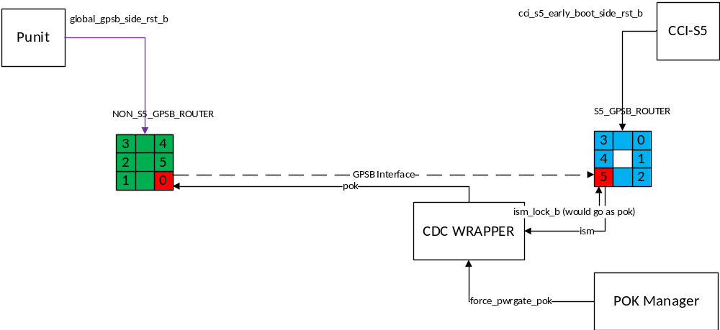
Figure 1: Conceptual Diagram describing POK Manager Functionality

For a Router to Endpoint connection, Router port is called as Fabric Port and Endpoint Port is called as Agent Port. For a Router to Router connection, anyone can be “Fabric Port” and the other side then should be “Agent Port”. For the above example, “Port0” of NON_S5_GPSB_ROUTER is Fabric Port and “Port5” of S5_GPSB_ROUTER is Agent Port.
NON_S5_GPSB_ROUTER is in the non-S5 portion of the fabric whereas S5_GPSB_ROUTER is in the S5 portion of the fabric. Reset for NON_S5_GPSB_ROUTER is controlled by “global_gpsb_side_rst_b” which gets asserted (1 0) during S5 whereas reset for S5_GPSB_ROUTER is controlled by “cci_s5_early_boot_side_rst_b” which won’t get asserted during S5 (It will be 1).
Any transactions coming from IPs in S5 domain towards non-S5 domain during S5 state, they can get struck clogging the S5 portion of the GPSB network. To avoid this problem, GPSB fabric which uses IOSF-SB protocol adds a port named “POK” at each router port. When POK is de-asserted (i.e. 0), then that router port is responsible for completing the transactions instead of forwarding them on the router port. In such a state, Posted transactions will be dropped by the router port and non-posted transactions will be responded with Completion with Status field as “Powered Down”.
So while in S5, “POK” for port 5 of S5_GPSB_ROUTER should be driven 0. IOSF specification mandates certain rules to be followed before POK can get de-asserted (1 0).
- An agent may only de-assert pok when The agent ISM is in the idle state (ISMPM.067)
- The fabric must not assert the interface reset to the agent unless the pok signal is de-asserted or the fabric is also being reset. (ISMPM.076)
- When the fabric observes pok equal to 0 it must perform the following steps. If the fabric ISM is in ACTIVE_REQ or CREDIT_REQ, it must transition to IDLE. If the fabric ISM is in IDLE, it must remain in IDLE. Take ownership of the interface by terminating all posted and completion transactions targeting the interface, and generating a completion for any Non-Posted transactions targeting the interface. (ISMPM.072)

S5 GPSB network won’t get reset during warm/cold resets as well. So Every Reset Entry will be treated in the same way and there is no special case.
Chassis 2.0 Reset Specification defines a message called “ForcePwrGatePOK” which will be sent by Reset Controller (Punit, PMC etc.) as a preparation for Reset Entry which will be used by POK Manager to de-assert POK (1->0) satisfying above rules.
CDC_WRAPPER is a standard 10nm server chassis IP which is used in 10nm Server North Subsystems to generate POK by looking at ISM Indications from Agent and acts upon triggers from PMA.
- Reset Exit Transition: POK should be asserted. “ip_pg_wake” is the trigger.
- Reset Entry Transition: POK should get de-asserted. “forcepgpok_pok/ forcepgpok_pgreq” is the trigger.
In 10nm Server North Subsystems, it is used for Endpoint to Router Connections. Now in this scenario, it will be used for Router to Router connection. Upon receiving Reset Entry Trigger, It waits for “ISM” from Agent Port to go to Idle and then makes “ism_lock_b” Low (value of 0). It will go as “POK” for Agent Port. It is a combinational path and no flops are allowed. So CDC_WRAPPER should be physically placed closer to the Agent Router Port. It will lock Agent Port’s ISM in IDLE state. CDC_WRAPPER also generates “POK” which should be hooked to Fabric Port. This signal can be flopped on gpsb clock used for the corresponding Router to Router Interface.
At SoC level, we don’t have a PMA to generate triggers to CDC_Wrapper. POK Manager will have a PMSB endpoint and hooks to PMSB Fabric. It decodes “ForcePwrGatePOK” message sent by Punit and gives Reset Entry trigger to CDC_WRAPPER. It observes de-assertion of “global_gpsb_side_rstb” (0 ->1), forms a pulse and gives Reset Exit Trigger to CDC_WRAPPER.

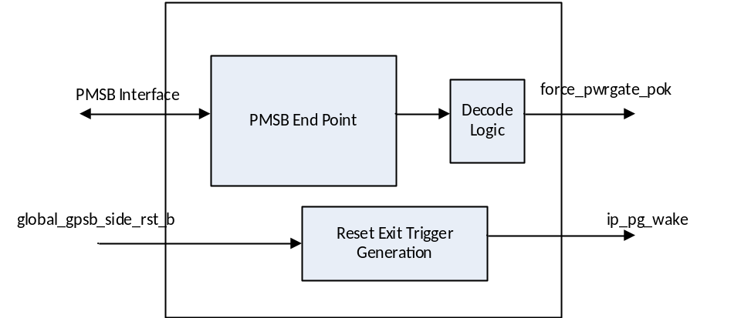
Figure 2: POK Manager Block Diagram
Format for ForcePwrGatePOK is available in IOSF sideband Usage Specification

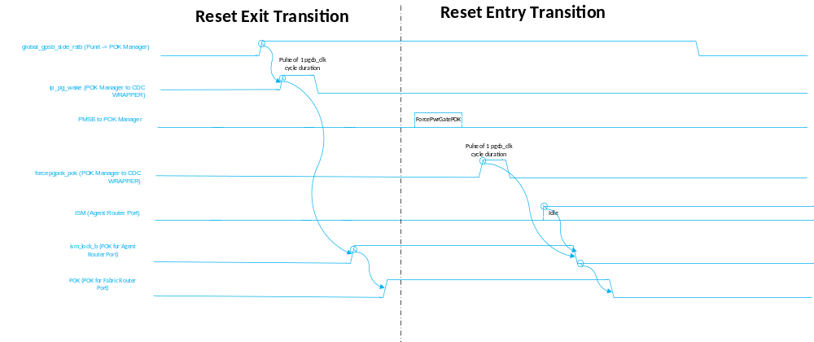
Figure 3: Waveform Diagram for Critical Signals

Reset Exit Transition:
This can be either Sx S0 transition or Warm/Cold Reset Exit transition. “global_gpsb_side_rstb” is the reset for most of the non-s5 GPSB fabric in 10nm. Its de-assertion (0 -> 1) is detected by POK Manager and gives a pulse “ip_pg_wake” to CDC Wrapper. Then it drives a value of high (i.e. 1) on “ism_lock_b” and “POK” outputs.
“ism_lock_b” goes as “POK” for Agent Router Port. “POK” o/p from CDC Wrapper goes as “POK” to Fabric Router port. As both are high, Communication can be exchanged between S5 and non-S5 domains.

Reset Entry Transition:
This can be either S0 Sx transition or Warm/Cold Reset Entry transition. Punit sends “ForcePwrgatePOK” message on PMSB to POK Manager. POK Manager decodes it and provides a pulse on “forcepgpok_pok”/ “forcepgpok_pgreq”. CDC_Wrapper acts on that trigger and waits for “ISM” of Agent Router Port to go Idle and then drives 0 on “ism_lock_b” and “pok” outputs.
“ism_lock_b” goes as “POK” for Agent Router Port. “POK” o/p from CDC Wrapper goes as “POK” to Fabric Router port. As both are low, both portions of GPSB network are properly isolated.

Interface Details of POK Manager:
Interface Name | Direction | Description
pmsb_clk, | Input | Clock for PMSB endpoint in POK Manager
agent_clk | Input | pgcb_clk should be same as the one used for cdc_wrapper used in conjunction with POK Manager. Sideband Endpoint in POK Manager operates in Async Mode with “pmsb_clk” on Fabric side and “agent_clk” on Agent side.
side_rst_b, | Input | reset for PMSB endpoint
pok_mgr_side_ism_fabric, | Input | Endpoint Interface with PMSB router
pok_mgr_side_ism_agent, | Output | Endpoint Interface with PMSB router
side_clkreq, | Output | clkreq for pmsb_clk. For ICX-D/SNR, feed it back to “side_clkack”.
side_clkack, | Input | clkack for pmsb_clk
pok_mgr_mpccup, | Input | Endpoint Interface with PMSB router
pok_mgr_mnpcup, | Input | Endpoint Interface with PMSB router
pok_mgr_mpcput, | Output | Endpoint Interface with PMSB router
pok_mgr_mnpput, | Output | Endpoint Interface with PMSB router
pok_mgr_meom, | Output | Endpoint Interface with PMSB router
pok_mgr_mpayload, | Output | Endpoint Interface with PMSB router
pok_mgr_tpccup, | Output | Endpoint Interface with PMSB router
pok_mgr_tnpcup, | Output | Endpoint Interface with PMSB router
pok_mgr_tpcput, | Input | Endpoint Interface with PMSB router
pok_mgr_tnpput, | Input | Endpoint Interface with PMSB router
pok_mgr_teom, | Input | Endpoint Interface with PMSB router
pok_mgr_tpayload, | Input | Endpoint Interface with PMSB router
pok_mgr_side_pok, | Output | Endpoint Interface with PMSB router
jta_clkgate_ovrd, | Input | DFX interface for Sideband endpoint in Pok Manager
jta_force_clkreq, | Input | DFX interface for Sideband endpoint in Pok Manager
jta_force_idle, | Input | DFX interface for Sideband endpoint in Pok Manager
jta_force_notidle, | Input | DFX interface for Sideband endpoint in Pok Manager
jta_force_creditreq, | Input | DFX interface for Sideband endpoint in Pok Manager
fscan_latchopen, | Input | Scan Interface for Sideband endpoint in Pok Manager
fscan_latchclosed_b, | Input | Scan Interface for Sideband endpoint in Pok Manager
fscan_clkungate, | Input | Scan Interface for Sideband endpoint in Pok Manager
fscan_clkungate_syn, | Input | Scan Interface for Sideband endpoint in Pok Manager
fscan_rstbypen, | Input | Scan Interface for Sideband endpoint in Pok Manager
fscan_byprst_b, | Input | Scan Interface for Sideband endpoint in Pok Manager
fscan_shiften, | Input | Scan Interface for Sideband endpoint in Pok Manager
fscan_mode, | Input | Scan Interface for Sideband endpoint in Pok Manager
fdfx_rst_b, | Input | DFX Pwrgood
forcepgpok_pgreq, | Output | Goes to CDC_WRAPPER
forcepgpok_pok, | Output | Goes to CDC_WRAPPER
global_gpsb_side_rstb, | Input | for generating ip_pg_wake to cdc wrapper
ip_pg_wake | Output | Goes to CDC_WRAPPER

Interface Details of CDC Wrapper used in Conjunction with POK Manager
Interface Name | Direction | Description
pgcb_clk | Input | PGCB clock.
pgcb_rst_b | Input | PGCB Reset.
clock | Input | Clock for GPSB Interface between S5 and Non-S5 domain.
reset_b | Input | Can be used to synchronize any resets.
reset_sync_b | Output | Can be used to synchronize any resets.
clkreq | Output | clkreq for “clock” input.
clkack | Input | clkack for “clock” input.
pok_reset_b | Input | Deepest sideband reset
pok | Output | Connect as POK for fabric port. Can add flops if needed on this path on GPSB interface clock between two domains.
gclock_req_async | Input | clkreq from agent router port
gclk_async_ack_synced | Output | clkack back to agent router port
ism_fabric | Input | Tie low as this is not used for dynamic power gating functionality.
ism_agent | Input | ism o/p Agent router Port. Should not have any flops on this path.
cfg_clkgate_disabled | Input | Disables any clock gating due to idle conditions.  Tie low. Should be same value as being used in other subsystems.
cfg_clkreq_ctl_disabled | Input | When set high, this prevents the CDC from de-asserting ‘clkreq’ due to idle conditions. Has no effect on clkreq de-assertion during a forced power gate entry flow.  Tie low. Should be same value as being used in other subsystems.
cfg_clkgate_holdoff | Input | Minimum time from the CDC detects all clock reqs deasserting  until gclock is gated.  Tie with value of 4. Should be same value as being used in other subsystems.
cfg_pwrgate_holdoff | Input | Time from gating gclock until the CDC will start the lock entry and allow power gating. Used only when power gating is enabled (pwrgate_disabled=0).  Tie with value of 4. Should be same value as being used in other subsystems.
cfg_clkreq_off_holdoff | Input | Time from locking the domain and preparing for power gating until the CDC will de-assert clkreq. Used only when power gating is enabled (pwrgate_disabled=0) and cfg_clkreq_ctl_disabled=0.  Tie with value of 4. Should be same value as being used in other subsystems.
cfg_clkreq_syncoff_holdoff | Input | Time from gating gclock until the CDC will de-assert clkreq (with synchronous ISM wake detection). Used only when power gating is disabled (pwrgate_disabled=1) and cfg_clkreq_ctl_disabled=0.  Tie with value of 4. Should be same value as being used in other subsystems.
forcepgpok_pok | Input | Would be coming from POK Manager.
forcepgpok_pgreq | Input | Would be coming from POK Manager.
ism_lock_b | Output | Should go as POK for agent router port. Should not have any flops on this path.
ip_pg_wake | Input | Would be coming from POK Manager.
fismdfx_force_clkreq | Input | DFX interface
fscan_byprst_b | Input | Scan Interface
fscan_rstbypen | Input | Scan Interface
fdfx_rst_b | Input | DFX Pwrgood Reset
fvisa_serstrb | Input | Visa Interface
fvisa_frame | Input | Visa Interface
fvisa_serdata | Input | Visa Interface
avisa_debug_data_clk | Input | Visa Interface
avisa_debug_data_pgcb_clk | Input | Visa Interface
avisa_strb_clk_pgcb_clk | Input | Visa Interface

Name | Value for POK Manager Usage | Valid Values | Description
DEF_PWRON | 0 | 0,1 | Default Power On: Determines whether the initial state after reset_b de-assertion is powered on or powered off. Should be set to match the value of the same parameter in the PGCB.
DEF_PWRON | 0 | 0,1 | If this is set to one clkreq and pok will be asserted and gclock will be ungated while reset is asserted (gclock_active will be deasserted until the clock is confirmed active by clkack assertion). When set to zero, clkreq, pok and gclock_active will be de-asserted and gclock would be gated during reset.
DEF_PWRON | 0 | 0,1 | This parameter is SOC-specific (may need to change depending on SOC where SIP is being used).
RST | 1 | ≥1 | Reset Count: Determines the number of reset signals that will be managed for this domain.
AREQ | 1 | ≥1 | Asynchronous Clock Requests: Determines the number of asynchronous clock request inputs. Providing dedicated inputs for different asynchronous sources ensures glitch free aggregation of different requests but will require per-request synchronization, increasing design area/cost.
AREQ | 1 | ≥1 | This parameter is SIP-specific (does not depend on SOC where SIP is being used).
NUM_EP_ATTACHED | 1 | ≥1 | Number of endpoints attached - used to size the bitwise OR of the ISM bits

Assumptions for ICX-D / SNR Use Case

- ICX-D/SNR has only 1 place where there is crossing from S5 Domain to Non-S5 Domain. So POK Manager + CDC Wrapper will be placed at only place in SoC. But this can be extended if any other SoC has these kind of crossings at multiple places.

- When CDC_WRAPPER is being used for Sideband Endpoint, “ISM_COMPLETION_FENCING” is set for endpoint so that endpoint doesn’t take ISM to IDLE until the completions are received for the pending non-posted transactions. Router doesn’t support this parameter. But it is okay for ICX-D/SNR use case. Rationale is the next lines.

- These are the messages that cross between Non-S5 and S5 boundary.
- Non-S5 domain to S5 domain:
  - Read/Write requests from OOB-MSM (Can be posted/non-posted).
  - TSC download handshakes between Punit and CPK (Ethernet IP) (Can be posted/non-posted).

- S5 Domain to Non-S5 Domain:
  - Completions to requests from OOB-MSM. (Completion)
  - TSC download handshakes between Punit and CPK (Ethernet IP) (Posted and Completion)
  - Error Messages from NAC IPs to IEH’s in North (Posted).
- As per 10nm North Global RCF HAS, RSTPREP to Rlink/PCIE/NAC at one shot. And After that, “ForcePwrGatePOK” to those subsystems.
    - So after this step, there will no outstanding requests from OOB-MSM.
    - CPK after acknowledging to RESET PREP, it won’t be sending any TSC download requests and acknowledges to RESET PREP only after previous pending TSC download requests are completed.
  - So the only messages after that would be Error Messages from NAC IPs to IEH’s in North are Posted which is not bound to the problem of “ism_completion_fencing”.

- For any future SoC, if it needs “ism_completion_fencing” feature for this use case, they need to work with Fabric Automation team to support “ism_completion_fencing” feature and set those parameters accordingly.

- It is good for central reset controller in SoC to observe POK before asserting reset for GPSB fabric. But for ICX-D/SNR, we are following same strategy as uncore subsystems i.e. not observing POK as there is good amount of delay from “ForcePwrGatePOK” to GPSB fabric reset assertion

Timing of ForcePwrGatePOK to POK Manager
For ICX-D/SNR use case, ForcePwrGatePOK to POK Manager should be sent after RSTPREP, ForcePwrgatePOK is sent to Rlink, PCIE & NAC.
For dirty warm reset also, it should be sent at the same point in the warm reset preamble flow after RSTPREP, ForcePwrgatePOK is sent to Rlink, PCIE & NAC.

Glossary
Any needed explanations or definitions could be put here.

Open issues
List all pending open issues that must be closed.
Table Of Open Issues
No table of figures entries found.

Wish list
Things that were considered in path finding stage but were dropped for whatever reason (performance, ROI, area, power)

Reference
NAC HAS: https://sharepoint.amr.ith.intel.com/sites/10nmServer/IPs/NAC/Arch/Shared%20Documents/HAS/NAC-HAS-0.80.pdf
CCI-S5 HAS: https://hsdes.intel.com/appstore/article/#/1604156510

ICX-D CPU Die GPSB Fabric: https://sharepoint.amr.ith.intel.com/sites/CNX/CNXDE/Shared%20Documents/Architecture/SoC%20HAS/0p5%20docs/ICX-D%20GPSB%20Fabric_16WW18_repeatersl.vsd

IOSF Specification:
https://sharepoint.amr.ith.intel.com/sites/MDGArchMain/Converged/SIGA/IOSF%20Specs/Spec%20Release/1.2%20Spec%20Release/IOSF%20spec%201.2.pdf

IOSF Compliance Rules:
https://sharepoint.amr.ith.intel.com/sites/MDGArchMain/Converged/SIGA/IOSF%20Specs/Spec%20Release/1.2%20Spec%20Release/IOSF%20Compliance%20Rules%201.2.xlsx

Chassis 2.0 Reset Architecture Spec:
https://sharepoint.amr.ith.intel.com/sites/MDGArchMain/Converged/chassisWG/Gen%202%2009%20HAS%20Releases/Chassis%20Reset%20Architecture%20HAS%20v0.9.pdf

CDC Wrapper Documentation:
$IP_MODELS/rcf_widget_library/rcf_widget_library-srvr10nm-latest/doc/rcf_widgets_IntegrationGuide.docx
$IP_MODELS/rcf_widget_library/rcf_widget_library-srvr10nm-latest/doc/CDC\ Integration\ Guide_notes.docx

IOSF sideband Usage Specification:
https://sharepoint.amr.ith.intel.com/sites/MDGArchMain/Converged/SIGA/IOSF%20Sideband%20Usage/Latest%20Spec/IOSF%20Sideband%20Usage%20Spec.docx

10nm North Global RCF HAS:
https://sharepoint.amr.ith.intel.com/sites/10nmCon/HAS/Revision%2008%20Released%2010nm%20Server%20HAS/10nm%20Global%20RCF%20HAS%200p8.pdf

