**USER MANUAL FOR ICL GENERATION EXCEL TOOL**

Open **ICL_GENERATION_TOOL.xlsm file** and accept if there is any pop ups . The xlsm file is macro based, select “Enable Content” if below SECURITY WARNING occurs.

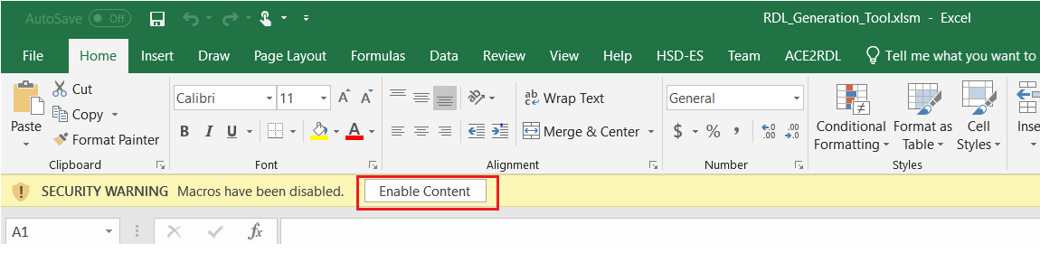

You can delete all sheets except the **Parameters** sheet for a fresh start.

Click on **TAP Spec** tab:

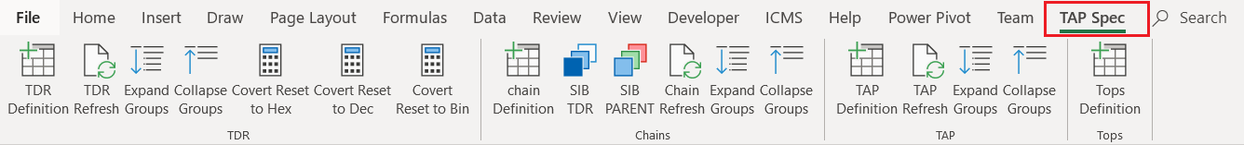

**TDR**

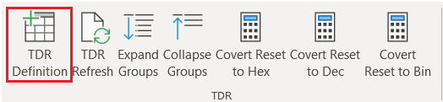

click on **TDR Definition**.

If the **Registers** sheet does not exist, then the **Resisters** sheet will be auto created. The following table appears. Fill the TDR definition details, appropriate dropdowns are provided:

NOTE: Do not enter any value in grey box they will get auto calculate on Refresh

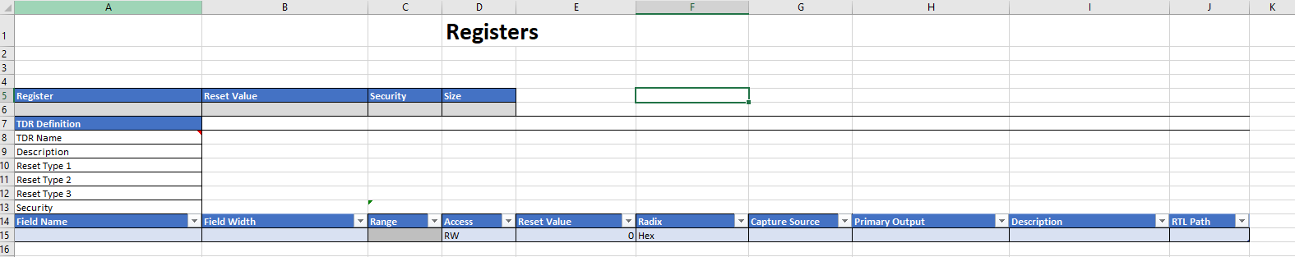

To create another TDR definition , click on **TDR Definition.** A new table gets added to the sheet **“Registers”.**

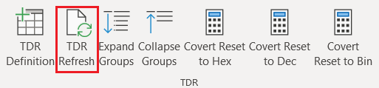

Once the registers are created , click on **TDR refresh** , this will create grouping, autoload of the grey cells. Make sure to click **TDR refresh** every time there is a change, as the entered values are used in other sheets and all the data consolidations are taken care by the **refresh** button.

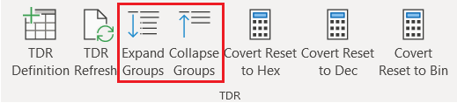

Now you can use the **Expand groups** and **Collapse groups** buttons for better view and search.

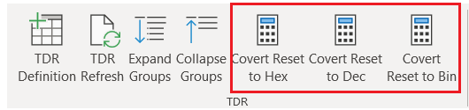

The above base conversion buttons are provided for the **Reset Value** . You can enter the reset values in either Hex, Dec or Bin and convert them to required base. While entering the reset values select the appropriate **Radix.**

**CHAINS**

click on **TDR Definition**.

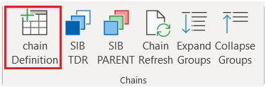

If the **Chains** sheet does not exist then the **Chains** sheet will be auto created. The following table appears:

Below sheet appears:

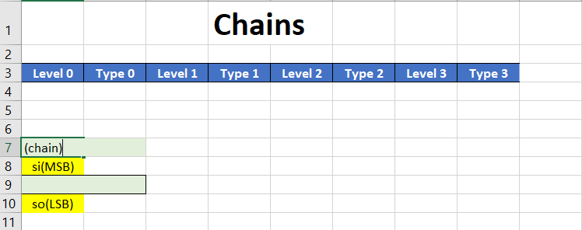

Enter the chain name in line 7, the Row 9 under level 0 is to provide the TDR instantiation name , the Row 9 under Type 0 provides the drop down of the entered TDR Definitions in sheet **Registers.**

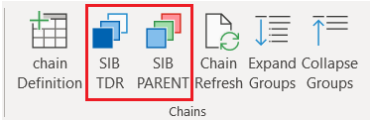

To provide a new TDR instantiation, **select the cell row 9 under Type 0** and click on SIB TDR button.

NOTE: selection of correct cell is a must before clicking on above buttons else irregular chains will get formed.

To create a parent SIB , select the register cell and click on the parent SIB button.

Example chain:

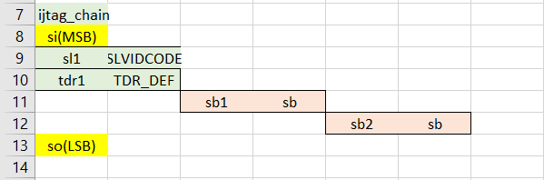

To create a new SIB in the same chain, click on the SIB TDR button.

To create a new chain, click on the Chain Definition button.

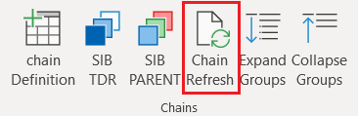

Once the chains are created . Click on **Chain refresh**, this will create grouping. Make sure to click **Chain Refresh** button every time there is a change, as the entered values are used in other sheets and all the data consolidations are taken care by the **refresh** button.

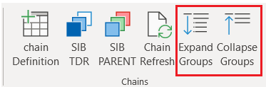

We can use the **Expand groups** and **Collapse groups** buttons for better view and search.

**TAPs**

click on **TAP Definition**.

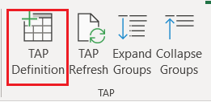

If the **TAPs** sheet does not exist, then the **TAPs** sheet will be auto created. The following table appears.

Please enter the values and appropriate drop downs are provided:

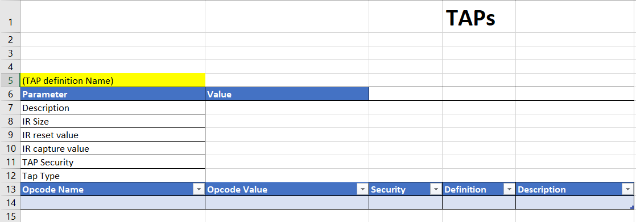

To create a new TAP definition, click on the TAP Definition button.

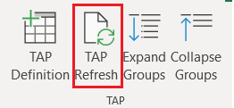

Once the TAPs are created , click on **TAP refresh** , this will create grouping. Make sure to click **TAP Refresh** button every time there is a change , as the entered values are used in other sheets and all the data consolidations are taken care by the **refresh** button.

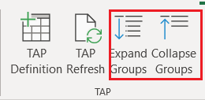

We can use the **Expand groups** and **Collapse groups** buttons for better view and search.

**TOP**

click on **TOP Definition**.

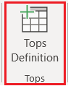

If the **TOPs** sheet does not exist, then the **TOPs** sheet will be auto created. The following table appears.

Please enter the required values and appropriate drop downs are provided:

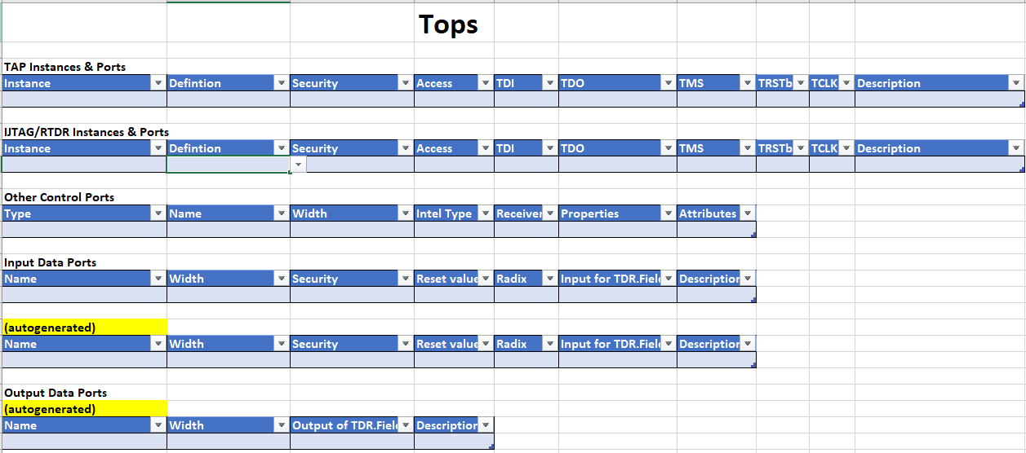

If the Tops sheet already exists, then clicking on TOP Definition will provide message:

