pok_gen

Integration Guide

IP Rev. 0.3

Intel Restricted Secret

Copyright © 2014, Intel Corporation. All rights reserved.

Intel and the Intel logo are trademarks of Intel Corporation in the U.S. and other countries.

* Other names and brands may be claimed as the property of others.

This document contains information on products in the design phase of development.

INFORMATION IN THIS DOCUMENT IS PROVIDED IN CONNECTION WITH INTEL PRODUCTS. NO LICENSE, EXPRESS OR IMPLIED, BY ESTOPPEL OR OTHERWISE, TO ANY INTELLECTUAL PROPERTY RIGHTS IS GRANTED BY THIS DOCUMENT. EXCEPT AS PROVIDED IN INTEL'S TERMS AND CONDITIONS OF SALE FOR SUCH PRODUCTS, INTEL ASSUMES NO LIABILITY WHATSOEVER AND INTEL DISCLAIMS ANY EXPRESS OR IMPLIED WARRANTY, RELATING TO SALE AND/OR USE OF INTEL PRODUCTS INCLUDING LIABILITY OR WARRANTIES RELATING TO FITNESS FOR A PARTICULAR PURPOSE, MERCHANTABILITY, OR INFRINGEMENT OF ANY PATENT, COPYRIGHT, OR OTHER INTELLECTUAL PROPERTY RIGHT.

UNLESS OTHERWISE AGREED IN WRITING BY INTEL, THE INTEL PRODUCTS ARE NOT DESIGNED OR INTENDED FOR ANY APPLICATION IN WHICH THE FAILURE OF THE INTEL PRODUCT COULD CREATE A SITUATION WHERE PERSONAL INJURY OR DEATH MAY OCCUR.

Intel may make changes to specifications and product descriptions at any time, without notice. Designers must not rely on the absence or characteristics of any features or instructions marked “reserved” or “undefined.” Intel reserves these for future definition and shall have no responsibility whatsoever for conflicts or incompatibilities arising from future changes to them. The information here is subject to change without notice. Do not finalize a design with this information.

The products described in this document may contain design defects or errors known as errata which may cause the product to deviate from published specifications. Current characterized errata are available on request.

Contact your Intel account manager or distributor to obtain the latest specifications and before placing your product order.

Copies of documents that have an order number and are referenced in this document or in other Intel literature can be obtained from your Intel account manager or distributor.

Contents

1 Introduction 4

1.1 Audience 4

1.2 Supported Projects 4

1.3 Terminology 4

1.4 Related Documents 4

1.5 Opens, Risks, and Assumptions 4

1.6 Contact Information 4

1.7 Document Revision History 4

2 Overview 5

2.1 Goal 5

2.2 I/O 5

2.3 Parameters 6

2.4 State Machine 6

2.5 Timing diagrams 7

2.6 Integration details 8

2.7 IOSF requirements for the deassertion of side_pok 8

3 SS impact of implementing this module in an IP 10

4 User Registry 12

# Introduction

## Audience

The information in this document is intended for an integration or design team that is using this reference design.

## Supported Projects

## Terminology

## Related Documents

If you need more information on this IP, you may find these documents helpful.

|  |  |
| --- | --- |
| Document Title | Location |
| IOSF spec 1.2 | <https://sharepoint.amr.ith.intel.com/sites/MDGArchMain/Converged/SIGA/IOSF%20Specs/Spec%20Release/1.2%20Spec%20Release/IOSF%20spec%201.2.pdf> |
| Widget block diagrams.vsdx | In widget repo doc/widget block diagrams.vsdx |
|  |  |

## Opens, Risks, and Assumptions

|  |  |  |  |
| --- | --- | --- | --- |
| Item # | Description | Comment | Status (Open or Closed)/Date |
|  |  |  |  |

## Contact Information

If you need additional help, use the contact information below.

|  |  |  |
| --- | --- | --- |
| Function | Name | Email |
| IP Integration | Ken Correll | [ken.correll@intel.com](mailto:ken.correll@intel.com) |
| Doc Template Owner | Susann Flowers | [susann.flowers@intel.com](mailto:susann.flowers@intel.com) |

## Document Revision History

|  |  |  |  |
| --- | --- | --- | --- |
| Revision Number | Description of Change | Date | Revised By |
| 0.1 | Initial Release |  | Ken Correll |
| 0.2 | Modified equation generating fpgpok_req_held to only look at bit[0] of the Type field, since that bit indicates whether pok should be deasserted or not | 5/17/18 | Ken Correll |
| 0.3 | Corrected typo in section 3 where I incorrectly had ADL, not SBBRIDGE | 1/7/19 | Ken Correll |

# Overview

## Goal

The pok_gen.sv file was created as a reference design for adoption by IP’s that include an IOSF_SB interface and do not currently support generation of side_pok. It is hoped that many such chassis IP’s adopt this reference design

## I/O

|  |  |  |
| --- | --- | --- |
| Signal Name | Direction | Discription |
| side_clk | input | Side_clk that is connected to the local iosf sideband endpoint |
| side_rst_b | input | Side_rst_b that is connected to the local iosf sideband endpoint with it’s deasserting edge synchronized to side_clk |
| ism_agent[2:0] | input | Side_ism_agent produced by the local iosf sideband endpoint  This must come directly from the endpoint with a single cycle path from ism_agent to ism_lock_b back to endpoint |
| wake | Input | Optional input, from the local pma, must be sync’ed to side_clk outside this module. If not used tie to ‘0. If used, the parameter ACCESSIBLE_ON_WAKE must be set to ‘1.  It is recommended to not use this input. |
| fpgpok_req[1:0] | input | The user must decode the ForcePwrGatePOK message and output the type field to these inputs. These should be reset to 2’b00 with side_rst_b. They must be held by the decoding logic for a minimum of 1 side_clk cycle.  If bit 0 is set, then POK de-assertion is required.  If bit 1 is set, then PGReq assertion is required.  This circuit only acts on type field 2’b01 |
| sbe_idle | Input | Connect to the sideband endpoints output of the same name. |
| fpgpok_holdoff | input | To be connected to the IP’s NP queue status so that the endpoint remains in the Accessible state until all NP completions have been received.  Also can be used (with external OR’ing with above) as an optional input that will delay sequencing to ism_lock assertion until local IP conditions are meet outside the status of the sideband endpoint. |
| ism_lock_b | output  (not flopped) | Use as the ism_lock_b input to the local iosf sideband ep  This must go directly to the endpoint with a single cycle path from ism_agent to ism_lock_b back to endpoint |
| pok | output  (flopped) | Use as the pok output, part of the iosf sb standard interface, to be connected to the router and to the local PMA on ip_pm_pok – a vectored input (non-pmrc related). |

## Parameters

|  |  |  |
| --- | --- | --- |
| PARAMETER NAME | DEFAULT VALUE | DESCRIPTION |
| ACCESSIBLE_ON_WAKE | 0 | Determines whether a pm_ip_wake signal must be used to to transition from INACCESSIBLE state |

## State Machine



|  |  |  |  |
| --- | --- | --- | --- |
| pok_state | next_pok_state | Condition to move to next state | Outputs |
| INACCESSIBLE | ASSERT_POK | Deassertion of side_rst_b or  Assertion of wake if side_rst_b is asserted | ism_lock_b = 0  pok = 0 |
| ASSERT_POK | ASSESSIBLE | automatic | ism_lock_b = 0  pok = 1 |
| ASSESSIBLE | LOCK | fpgpok_req &&  ism_agent[2:0] == IDLE &&  !fpgpok_holdoff &&  sbe_idle | ism_lock_b = 1  pok = 1 |
| LOCK | INACCESSIBLE | !side_rst_b | ism_lock_b = 0  pok = (pok_state == ACCESSIBLE) |
| ASSERT_POK  Or  ACCESSIBLE | INACCESSIBLE | !side_rst_b | Ism_lock_b = 0  Pok = 0  Both transition one clock cycle after side_rst_b asserts |

## Timing diagrams

Coming out of reset with no wake:

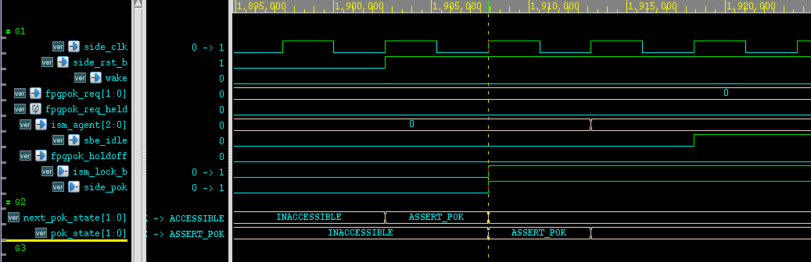

Receipt of ForcePwrGatePOK message:

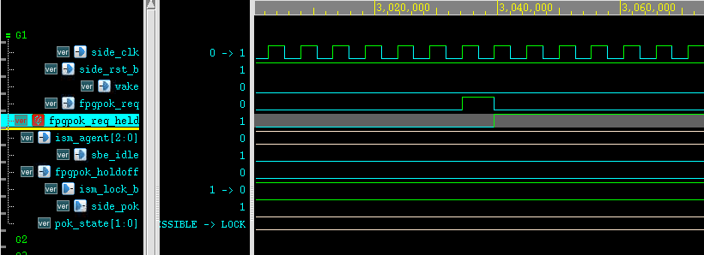

Transition to LOCK:

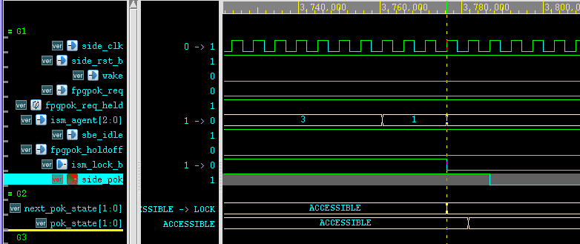

Transition to INACCESSIBLE:

## Integration details

Copy the Verilog file from /nfs/sc/disks/sdg74_0279/kcorrell/pok_gen/pok_gen.sv

Edit the Verilog filename and module name to uniquify it for your application.

The pok_gen_Integration_Guide.docx is located at:

Checkout/edit/checkin: Register as a user in the pok_gen registery at the end of this document so that you can be notified of any findings.

Note that for the IOSF_SB_SBRIDGE, the ForcePwrGatePOK message is already decoded with the type field exported as outputs. This message is not addressed to the SBBridge, it is forwarded to endpoints on the local gpsb bus.

If the SBBridge incorporates this design, it should only forward the type field to the pok_gen if the ForcePwrGatePOK message is addressed to the SBBridge.

## IOSF requirements for the deassertion of side_pok

Requirements in the IOSF spec for deasserting pok are:

Rule 5. An agent may only deassert pok when:  
a) The agent ISM is in the idle state.  
b) The agent is not waiting for a completion to an outstanding NP request.

c) The agent has returned all credits.[RA490]

Items a & c are met by monitoring the agent_ism bits directly and by connecting sbe_idle.

Item b) refers to incoming and outgoing NP requests.

Incoming NP requests are satisfied by setting the endpoints ISM_COMPLETION_FENCING and EXPECTED_COMPLETIONS_COUNTER parameters both to ‘1. This keeps the ism_agent state machine from transitioning to the IDLE state while a NP request is outstanding.

Outgoing NP requests are satisfied by the integrator connecting the local IP’s NP queue status to the fpgpok_holdoff input pin. The pin is active high meaning that if the NP queue has an empty status it should be inverted before connecting.

# SS impact of implementing this module in an IP

Many chassis IP’s did not implement the logic required to generate side_pok. For wave1 and wave2, a module created by the RCF group was used as a helper block, connecting in-between the gpsb endpoint and the global router – the rcfwl_cdc_wrapper.

The generation of side_pok is basically the same as implemented in this logic block, but the ClockDomainController inside the rcfwl_cdc_wrapper was designed to work with the PGCB, and have clock control.

To make this change, the SS should –

* Connect the clkreq/clkack from the endpoint to the clkreqaggr that the cdc_wrapper connects to
* Connect the pok output to the PMA input pin that the cdc_wrapper’s pok is connected to
* Connect the pok output as part of the standard iosf_sb collage interface to the router
* Remove the cdc_wrapper and all connections associated with it.

In chassis, if the iosf_sb_bridge were to implement this logic, these are the steps that would need to be taken, using scf_mem as an example.

In tools/collage/common/subsystems/scf_mem_chassis/create.tcl:

Remove lappend ip_instance_list rcfwl_cdc_wrapper vcfcx12_cdc_wrapper

In tools/collage/common/subsystems/scf_mem_chassis/init.tcl:

Remove reference to rcfwl_cdc_wrapper

In tools/collage/common/subsystems/scf_mem_chassis/adhoc_connection.txt:

1. Disconnect the clkreq/clkack from the cdc_wrapper to the clkreqaggr and instead connect the clkreq/clkack from the endpoint directly to the clkreqaggr:

From:

C gpsb_mem_sbbridge{%hier_str}/gbl_agent_side_clkreq

vcfcx12_cdc_wrapper{%hier_str}/gclock_req_async

C vcfcx12_cdc_wrapper{%hier_str}/clkreq side_vcfc_vdom_clkreqaggr{%hier_str}/iclkreq[1]

C side_vcfc_vdom_clkreqaggr{%hier_str}/oclkack[1] vcfcx12_cdc_wrapper{%hier_str}/clkack

C vcfcx12_cdc_wrapper{%hier_str}/gclk_async_ack_synced

gpsb_mem_sbbridge{%hier_str}/gbl_agent_side_clkack

To:

C gpsb_mem_sbbridge{%hier_str}/gbl_agent_side_clkreq

side_vcfc_vdom_clkreqaggr{%hier_str}/iclkreq[1]

C side_vcfc_vdom_clkreqaggr{%hier_str}/oclkack[1]

gpsb_mem_sbbridge{%hier_str}/gbl_agent_side_clkack

1. Remove all connections from the vcfcx12_cdc_wrapper to the sbbridge and vice versa
2. Remove the connections:

C vcfcx12_cdc_wrapper{%hier_str}/ism_lock_b

gpsb_mem_sbbridge{%hier_str}/gbl_agent_side_ism_lock_b

gpsb_mem_sbbridge{%hier_str}/gbl_agent_side_ism_lock_b is unused, tie low or hi

1. Change side_pok connect to the PMA:

From:

C vcfcx12_cdc_wrapper{%hier_str}/pok mspmas0{%hier_str}/ip_pm_pok[0]

To:

C gpsb_mem_sbbridge{%hier_str}/gbl_agent_side_pok mspmas0{%hier_str}/ip_pm_pok[0]

1. Remove all other connections to the vcfcx12_cdc_wrapper
2. Add side_pok to the collage standard connection

In tools/collage/common/subsystems/scf_mem_chassis/std_connection.cfg

Remove connections to the sbbridge

In tools/collage/common/subsystems/scf_mem_chassis/

Remove tie-offs to the vcfcx12_cdc_wrapper

In tools/collage/common/subsystems/scf_mem_dft_chassis/adhoc_connection.txt

Remove clock connections to the vcfcx12_cdc_wrapper

In tools/collage/soc_mini/integ_specs/soc_cdc_wrapper_adhoc_connection.txt,

soc_dfx_std_connection.cfg,

soc_soc_par.txt,

soc_upf_config.tcl:

Remove all connects to/from vcfcx12_cdc_wrapper_scf_mem_c0_r1

# User Registry

|  |  |
| --- | --- |
| Name | IP pok_gen is used in |
| Michael Dejesus | All PM blocks |
| Smitha Bmv | IEH |