VISVESVARAYA TECHNOLOGICAL UNIVERSITY
“JnanaSangama”, Belgaum -590014, Karnataka.


LAB REPORT

On

ANALYSIS AND DESIGN OF ALGORITHMS (23CS4PCADA)

Submitted by

KESHAV TOSHNIWAL (1BF24CS135)

in partial fulfillment for the award of the degree of
BACHELOR OF ENGINEERING
in
COMPUTER SCIENCE AND ENGINEERING



B.M.S. COLLEGE OF ENGINEERING
(Autonomous Institution under VTU)
BENGALURU-560019
February to June 2026
CERTIFICATE

B. M. S. College of Engineering,
Bull Temple Road, Bangalore 560019
(Affiliated To Visvesvaraya Technological University, Belgaum)
Department of Computer Science and Engineering



This is to certify that the Lab work entitled “ANALYSIS AND DESIGN OF ALGORITHMS” carried out by KESHAV TOSHNIWAL (1BF24CS135), who is a bonafide student of B. M. S. College of Engineering. It is in partial fulfillment for the award of Bachelor of Engineering in Computer Science and Engineering of the Visvesvaraya Technological University, Belgaum during the year 2025-26. The Lab report has been approved as it satisfies the academic requirements in respect of Analysis and Design of Algorithms Lab - (23CS4PCADA) work prescribed for the said degree.

Manjula S Dr. Kavitha Sooda
Assistant Professor Professor and Head
Department of CSE Department of CSE
BMSCE, Bengaluru BMSCE, Bengaluru

Index Sheet
Sl.  No. | Experiment Title | Page No.
1 | Write a program to obtain the Topological ordering of vertices in a given digraph. | 4-7
2 | Implement Johnson Trotter algorithm to generate permutations. | 8-9
3 | Sort a given set of N integer elements using Merge Sort technique and compute its time taken. Run the program for different values of N and record the time taken to sort. | 10-13
4 | Sort a given set of N integer elements using Quick Sort technique and compute its time taken. | 14-17
5 | Sort a given set of N integer elements using Heap Sort technique and compute its time taken. | 18-20
6 | Implement 0/1 Knapsack problem using dynamic programming. (5 Marks) | 21-22
7 | Implement All Pair Shortest paths problem using Floyd’s algorithm. | 23-26
8 | - Find Minimum Cost Spanning Tree of a given undirected graph using Prim’s algorithm.  - Find Minimum Cost Spanning Tree of a given undirected graph using Kruskal’s algorithm. | 27-28  28-30
9 | Implement Fractional Knapsack using Greedy technique. | 31-34
10 | From a given vertex in a weighted connected graph, find shortest paths to other vertices using Dijkstra’s algorithm. | 35-36
11 | Implement “N-Queens Problem” using Backtracking. | 37-38

Course outcomes:
CO1 | Analyze time complexity of algorithms using asymptotic notations.
CO2 | Apply various algorithm design techniques for the given problem.
CO3 | Evaluate the appropriate algorithm/design technique for solving a given problem.
CO4 | Conduct practical experiments by applying appropriate algorithm design technique to solve problems.

Lab program 1:
Topological Sorting

#include <stdio.h>
#define MAX 10
int graph[MAX][MAX], indegree[MAX], queue[MAX];
int n;
void topologicalSort() {
int front = 0, rear = 0;
int count = 0, i, j;
// Find indegree of each vertex
for (i = 0; i < n; i++) {
indegree[i] = 0;
for (j = 0; j < n; j++)
indegree[i] += graph[j][i];
}
// Insert all vertices with indegree 0 into queue
for (i = 0; i < n; i++)
if (indegree[i] == 0)
queue[rear++] = i;
printf("Topological Ordering: ");
while (front < rear) {
int v = queue[front++];
printf("%d ", v);
count++;
// Reduce indegree of adjacent vertices
for (i = 0; i < n; i++)
if (graph[v][i] == 1) {
indegree[i]--;
if (indegree[i] == 0)
queue[rear++] = i;
}

}

// Check for cycle
if (count != n)
printf("\nGraph contains a cycle. Topological sort not possible.\n");
}

int main() {
int i, j;

printf("Enter number of vertices: ");
scanf("%d", &n);
printf("Enter adjacency matrix:\n");
for (i = 0; i < n; i++)
for (j = 0; j < n; j++)
scanf("%d", &graph[i][j]);
topologicalSort();

return 0;
}
OUTPUT:
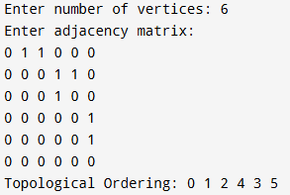

LEETCODE 207
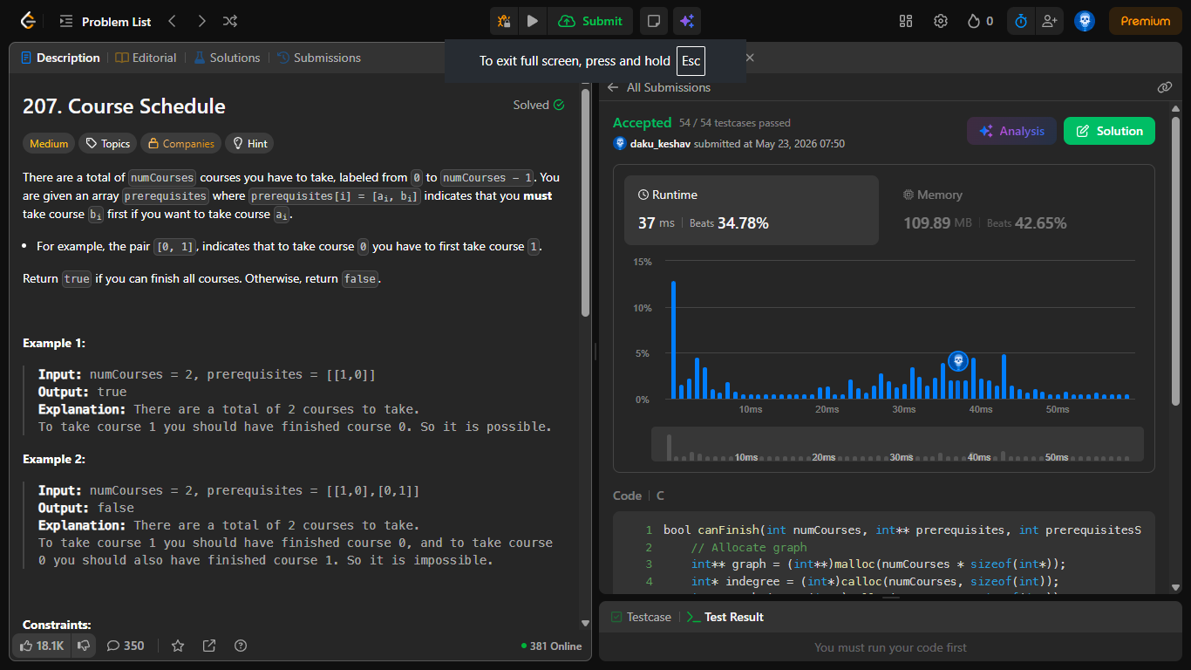
bool canFinish(int numCourses, int** prerequisites, int prerequisitesSize, int* prerequisitesColSize) {
int** graph = (int**)malloc(numCourses * sizeof(int*));
int* indegree = (int*)calloc(numCourses, sizeof(int));
int* graphSize = (int*)calloc(numCourses, sizeof(int));
for (int i = 0; i < numCourses; i++)
graph[i] = (int*)malloc(numCourses * sizeof(int));

for (int i = 0; i < prerequisitesSize; i++) {
int course = prerequisites[i][0];
int prereq = prerequisites[i][1];
graph[prereq][graphSize[prereq]++] = course;
indegree[course]++;
}
int* queue = (int*)malloc(numCourses * sizeof(int));
int front = 0, rear = 0;

for (int i = 0; i < numCourses; i++)
if (indegree[i] == 0)
queue[rear++] = i;

int count = 0;
while (front < rear) {
int node = queue[front++];
count++;

for (int i = 0; i < graphSize[node]; i++) {
int neighbor = graph[node][i];
indegree[neighbor]--;
if (indegree[neighbor] == 0)
queue[rear++] = neighbor;
}
}
return count == numCourses;
}

Lab program 2:
Johnson Trotter
#include <stdio.h>
// -1 means left
int mobile(int p[], int d[], int n){
int m = 0;
for (int i = 0; i < n; i++) {
if (d[i] == -1 && i > 0 && p[i] > p[i - 1] && p[i] > m)
m = p[i];
if (d[i] == 1 && i < n - 1 && p[i] > p[i + 1] && p[i] > m)
m = p[i];
}
return m;
}

int main(){
int n;
int p[10], d[10];
int i, m, pos, next, temp;
printf("Enter n:");
scanf("%d", &n);
for (i = 0; i < n; i++){
p[i] = i + 1;
d[i] = -1;
}

while (1)
{
for (i = 0; i < n; i++){
printf("%d ", p[i]);
}

printf("\n");
m = mobile(p, d, n);
if (m == 0)
break;
for (i = 0; i < n; i++)
if (p[i] == m)
pos = i;
next = pos + d[pos];
temp = p[pos];
p[pos] = p[next];
p[next] = temp;

temp = d[pos];
d[pos] = d[next];
d[next] = temp;

for (i = 0; i < n; i++)
if (p[i] > m)
d[i] = -d[i];
}
return 0;
}
OUTPUT
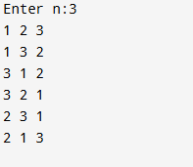

Lab Program 3:
Merge Sort
#include<stdlib.h>
#include <stdio.h>
#include <time.h>

void merge (int low,int mid,int high, int *a){
int i=low, j=mid+1,k=low;
int arr[high+1];
while(i<=mid && j<= high){
if(a[i]< a[j]) arr[k++]=a[i++];
else arr[k++]=a[j++];
}

while(i<=mid) arr[k++]=a[i++];
while(j<=high) arr[k++]=a[j++];

for(i=low;i<=high;i++) a[i]=arr[i];
}

void mergeSort(int low,int high, int *a){
if(low == high) return;

int mid =(low + high)/2;
mergeSort(low,mid,a);
mergeSort(mid+1,high,a);
merge(low, mid, high, a);
}

int main(){
int n;
printf("Enter size :");
scanf("%d",&n);
int a[n];
// printf("Enter %d items:\n",n);
for(int i=0; i<n;i++)
a[i]=rand();
// scanf("%d",&a[i]);

double stTime =clock();
mergeSort(0,n-1,a);
double endTime =clock();
double t= (endTime -stTime)/CLOCKS_PER_SEC;
// printf("Sorted Array :\n");
// for(int i=0;i<n;i++)
// printf("%d\t",a[i]);
printf("\nTime Taken: %.4f ms",t*1000);
return 0;
}
OUTPUT:
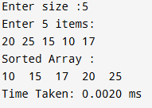
GRAPH:
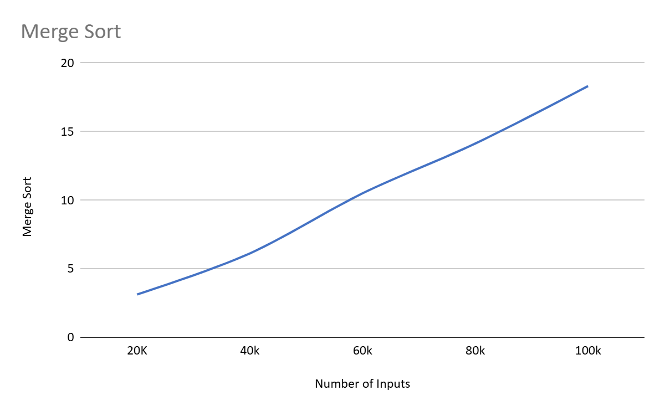
LEETCODE 148 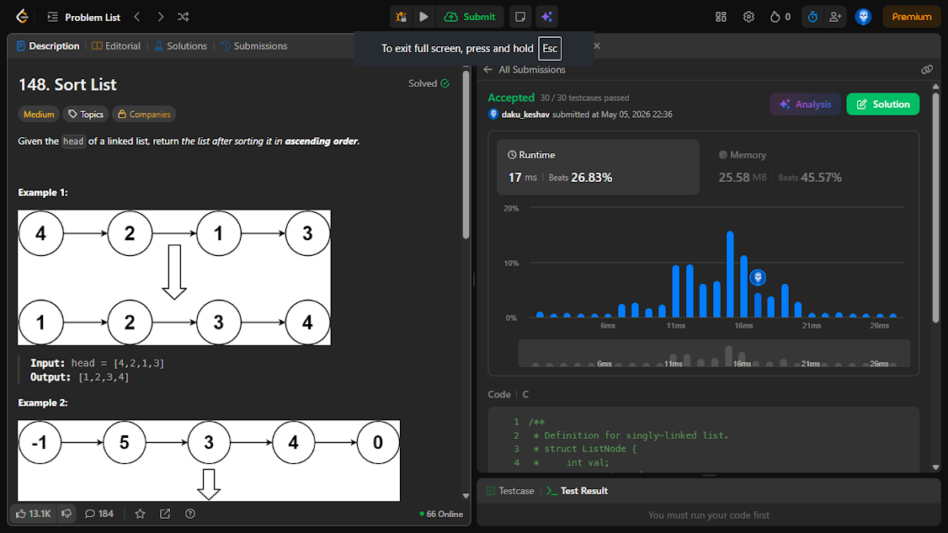
/**
* Definition for singly-linked list.
* struct ListNode {
* int val;
* struct ListNode *next;
* };
*/

struct ListNode* merge(struct ListNode * pehla , struct ListNode * dusra){
struct ListNode head;
struct ListNode * temp = &head ;
head.next = NULL ;

while(pehla && dusra){
if(pehla->val < dusra->val){
temp->next = pehla;
pehla = pehla->next;
}
else{
temp->next =dusra;
dusra = dusra->next;
}
temp = temp->next;
}

temp->next= pehla ? pehla : dusra ;

return head.next;
}

struct ListNode* sortList(struct ListNode* head) {
if(!head || !head->next) return head;

struct ListNode * slow =head , *fast = head , * prev = NULL;
while(fast && fast->next){
prev = slow;
slow = slow->next;
fast = fast->next->next ;
}

prev-> next=NULL;
struct ListNode* h = sortList(head);
struct ListNode* s = sortList(slow);
return merge(h,s);
}

Lab program 4:
Quick Sort
#include<stdlib.h>
#include <stdio.h>
#include <time.h>

void swap(int a[], int i,int j){
int t=a[i];
a[i]=a[j];
a[j]=t;
}

int sort(int a[],int st,int end){
int p=a[st],i=st,j=end;
while (1) {
while (i <= end && a[i] <= p) i++;
while (j >= st && a[j] > p) j--;

if (i >= j) break;
swap(a, i, j);
}
swap(a,st,j);
return j;
}

void quickSort(int a[],int st,int end ){
if(st >= end) return;

int mid = sort(a,st,end);
quickSort(a,st,mid-1);
quickSort(a,mid+1,end);
}

int main(){
int n;
printf("Enter size :");
scanf("%d",&n);
int a[n];
// printf("Enter %d items :\n", n);
for(int i=0; i<n;i++)
a[i]=rand();
// scanf("%d",&a[i]);

double stTime =clock();
quickSort(a,0,n-1);
double endTime =clock();
double t= (endTime -stTime)/CLOCKS_PER_SEC;
// printf("Sorted Array :\n");
// for(int i=0;i<n;i++)
// printf("%d\t",a[i]);
printf("\nTime Taken: %.4f ms",t*1000);
return 0;
}
OUTPUT:
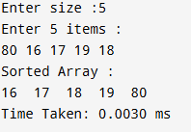
GRAPH:
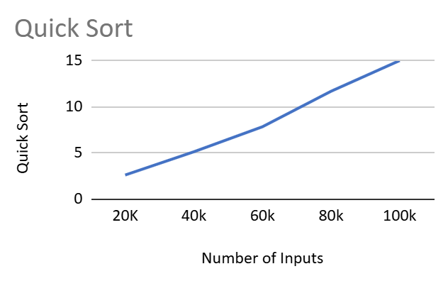
LEETCODE 455
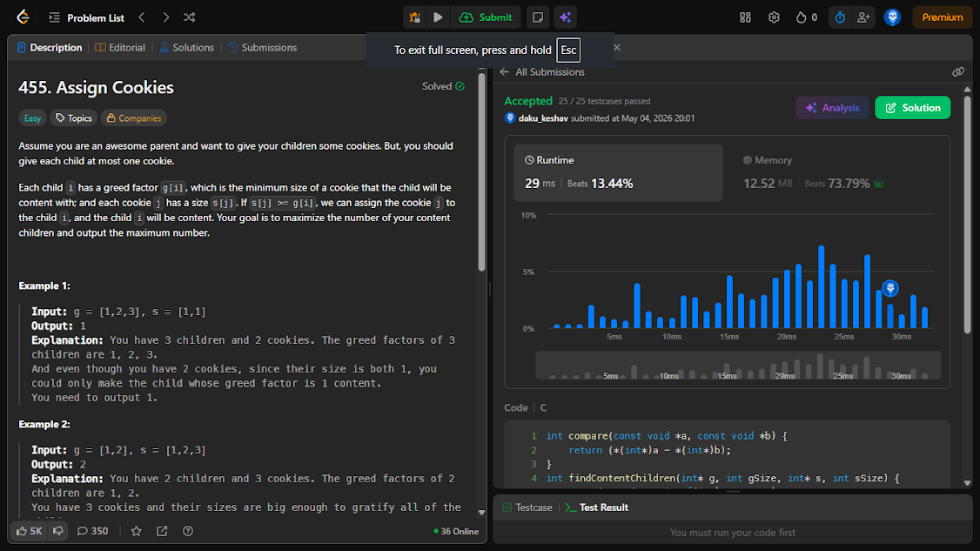
void swap(int a[], int i,int j){
int t=a[i];
a[i]=a[j];
a[j]=t;
}

int sort(int a[],int st,int end){
int p=a[st],i=st,j=end;
while (1) {
while (i <= end && a[i] <= p) i++;
while (j >= st && a[j] > p) j--;

if (i >= j) break;
swap(a, i, j);
}
swap(a,st,j);
return j;
}

void quickSort(int a[],int st,int end ){
if(st >= end) return;

int mid = sort(a,st,end);
quickSort(a,st,mid-1);
quickSort(a,mid+1,end);
}
int findContentChildren(int* g, int gSize, int* s, int sSize) {
quickSort(g, 0, gSize-1);
quickSort(s, 0, sSize-1);
int count=0, i=0, j=0;
while(i<gSize && j<sSize){
if(g[i]<=s[j]) {
count++;i++;j++;
}
else j++;
}
return count;
}

Lab program 5:
Heap Sort
#include <stdio.h>
#include <stdlib.h>
#include <time.h>

void heapify(int arr[], int n, int i) {
int lar = i;
int left = 2 * i + 1;
int right = 2 * i + 2;

if (left < n && arr[left] > arr[lar])
lar = left;
if (right < n && arr[right] > arr[lar])
lar = right;
if (lar != i) {
int t = arr[i];
arr[i] = arr[lar];
arr[lar] = t;
heapify(arr, n, lar);
}
}

void heapSort(int arr[], int n) {
for (int i = n / 2 - 1; i >= 0; i--)
heapify(arr, n, i);
for (int i = n - 1; i > 0; i--) {
int t = arr[0];
arr[0] = arr[i];
arr[i] = t;
heapify(arr, i, 0);
}
}

int main() {
int n;
printf("Enter number of elements: ");
scanf("%d", &n);
if (n <= 0) {
printf("Invalid number of elements.\n");
return 1;
}
int *arr = (int *)malloc(n * sizeof(int));
if (arr == NULL) {
printf("Memory allocation failed.\n");
return 1;
}
// printf("Enter %d integer elements:\n", n);
for (int i = 0; i < n; i++)
arr[i]=rand();
// scanf("%d", &arr[i]);
clock_t start = clock();
heapSort(arr, n);
clock_t end = clock();
double time_taken = (double)(end - start) / CLOCKS_PER_SEC;
// printf("\nSorted elements:\n");
// for (int i = 0; i < n; i++)
// printf("%d ", arr[i]);
printf("\n\nTime taken: %.3f ms\n", time_taken*1000);
return 0;
}

OUTPUT:
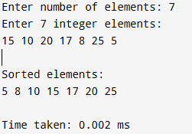
GRAPH:
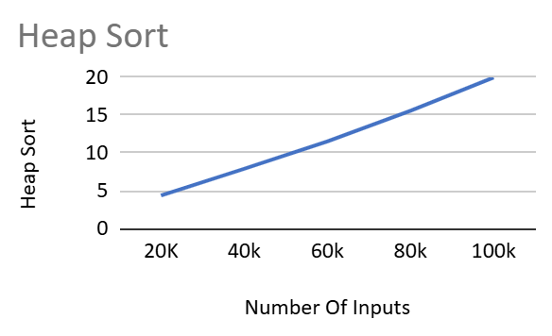

Lab program 6:
Knapsack 0/1 (using DP)
#include <stdio.h>
int max(int a , int b){
return (a>b)?a:b;
}
int knapsack(int W, int wt[], int val[], int n){
int dp[n+1][W+1];
for(int i=0;i<=n;i++)
for(int w=0;w<=W;w++)
if(i==0 || w==0) dp[i][w]=0;
else if(wt[i-1]<=w) dp[i][w]=max(val[i-1]+dp[i-1][w-wt[i-1]], dp[i-1][w]);
else dp[i][w]= dp[i-1][w];
for(int i=0;i<=n;i++){
for(int w=0;w<=W;w++)
printf("%d\t",dp[i][w]);
printf("\n");
}
return dp[n][W];
}

void main(){
int n, W;
printf("Enter number of items:");
scanf("%d",&n);
printf("Enter max capacity:");
scanf("%d",&W);
int val[n];
int wt[n];
printf("Enter wt and value for %d items:\n",n);
for(int i=0;i<n;i++)
scanf("%d %d",&wt[i], &val[i]);
printf("Result = %d", knapsack(W, wt, val ,n));
}
OUTPUT:
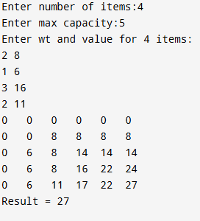
LEETCODE 70
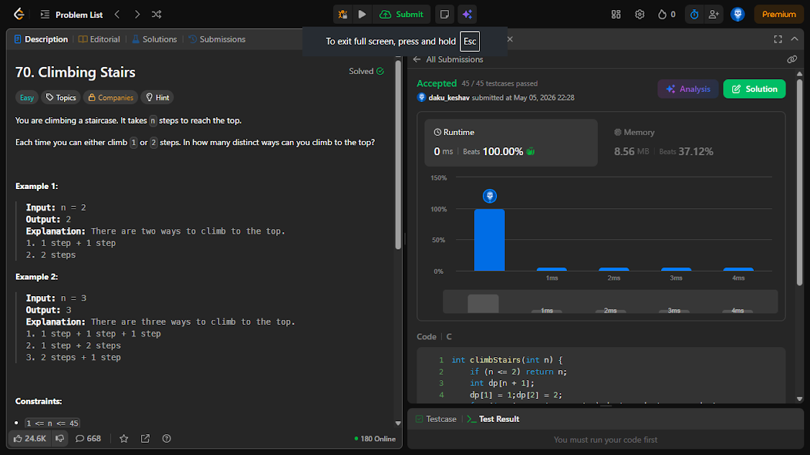
int climbStairs(int n) {
if (n <= 2) return n;
int dp[n + 1];
dp[1] = 1;dp[2] = 2;
for (int i = 3; i <= n; i++) dp[i] = dp[i - 1] + dp[i - 2];
return dp[n];
}

Lab program 7:
Floyd’s Algorithm
#include <stdio.h>
#define N 10
#define INFI 99999
int min(int a, int b){
return (a<b)? a: b;
}
void floyd(int d[N][N], int n){
for (int k=0;k<n;k++)
for(int i=0;i<n;i++)
for(int j=0;j<n;j++)
d[i][j] = min(d[i][j], d[i][k] + d[k][j]);

printf("\nUpdated Path :\n");
for (int i = 0; i < n; i++){
for(int j = 0; j < n; j++)
if (d[i][j] == INFI) printf("INF\t");
else printf("%d\t", d[i][j]);
printf("\n");
}
}

void main(){
int path[N][N];
int n;
printf("Enter number of nodes:");
scanf("%d",&n);
printf("Enter distance matrix\n(enter -1 for infinity):\n");
for (int i=0;i<n;i++)
for(int j=0;j<n;j++){
int a;
scanf("%d",&a);
if(a==-1) path[i][j] = INFI;
else path[i][j]= a;
}
floyd(path, n);
}
OUTPUT :
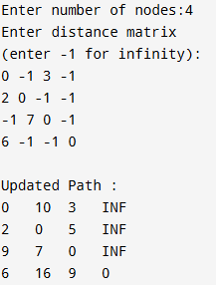
LEETCODE 3243
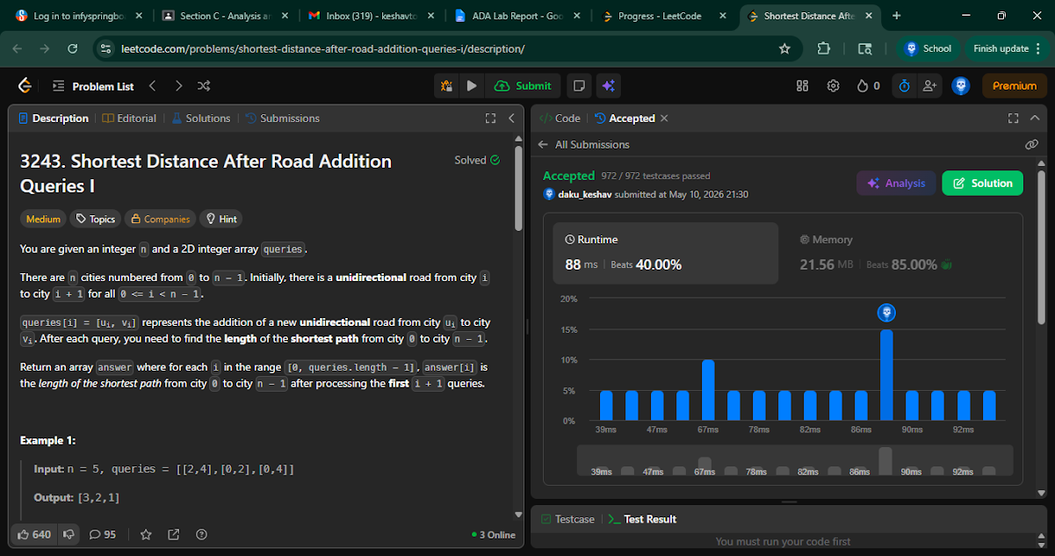
/**
* Note: The returned array must be malloced, assume caller calls free().
*/
#define MAXN 505
int adj[MAXN][MAXN];
int adjSize[MAXN];

int bfs(int n) {
int dist[MAXN];
for (int i = 0; i < n; i++) dist[i] = -1;

int queue[MAXN];
int front = 0, back = 0;

queue[back++] = 0;
dist[0] = 0;

while (front < back) {
int u = queue[front++];
for (int i = 0; i < adjSize[u]; i++) {
int v = adj[u][i];
if (dist[v] == -1) {
dist[v] = dist[u] + 1;
queue[back++] = v;
}
}
}

return dist[n - 1];
}

int* shortestDistanceAfterQueries(int n, int** queries, int queriesSize, int* queriesColSize, int* returnSize) {
for (int i = 0; i < n; i++) adjSize[i] = 0;

for (int i = 0; i < n - 1; i++)
adj[i][adjSize[i]++] = i + 1;

int* result = (int*)malloc(sizeof(int) * queriesSize);

for (int i = 0; i < queriesSize; i++) {
int u = queries[i][0];
int v = queries[i][1];

adj[u][adjSize[u]++] = v;
result[i] = bfs(n);
}

*returnSize = queriesSize;
return result;

}

Lab program 8a :
Prim’s Algorithm
#include <stdio.h>
#define MAX 100
#define INF 999999

void prims(int cost[MAX][MAX], int n){
int visited[MAX] = {0}, minCost = 0, edges = 0;
visited[0] = 1;

while (edges < n - 1){
int min = INF, u, v;
for (int i = 0; i < n; i++)
if (visited[i])
for (int j = 0; j < n; j++)
if (!visited[j] && cost[i][j] < min){
min = cost[i][j]; u = i; v = j;
}

printf("%d - %d : %d\n", u, v, min);
minCost += min;
visited[v] = 1;
edges++;
}
printf("Minimum Cost = %d\n", minCost);
}

void main(){
int n, cost[MAX][MAX];
printf("Enter the number of vertices: ");
scanf("%d", &n);
printf("Enter the adjacency matrix:\n");
for (int i = 0; i < n; i++)
for (int j = 0; j < n; j++){
scanf("%d", &cost[i][j]);
if (i != j && cost[i][j] == 0) cost[i][j] = INF;
}

prims(cost, n);
}
OUTPUT:
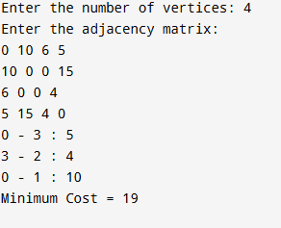

Lab program 8b:
Kruskal’s Algorithm
#include <stdio.h>
#define MAX 100
#define INF 999999

int parent[MAX];

int find(int v){
while(parent[v])
v = parent[v];
return v;
}

void kruskal(int cost[MAX][MAX], int n){
int edges = 0, minCost = 0;

while(edges < n - 1){
int min = INF, u = -1, v = -1;

for(int i = 0; i < n; i++)
for(int j = 0; j < n; j++)
if(cost[i][j] < min){
min = cost[i][j];
u = i;
v = j;
}

int ru = find(u), rv = find(v);

if(ru != rv){
parent[rv] = ru;
printf("%d - %d : %d\n", u, v, min);
minCost += min;
edges++;
}

cost[u][v] = cost[v][u] = INF;
}

printf("Minimum Cost = %d\n", minCost);
}

int main(){
int n, cost[MAX][MAX];

printf("Enter the number of vertices: ");
scanf("%d", &n);

printf("Enter the adjacency matrix:\n");

for(int i = 0; i < n; i++)
for(int j = 0; j < n; j++){
scanf("%d", &cost[i][j]);
if(i == j || cost[i][j] == 0)
cost[i][j] = INF;
}

kruskal(cost, n);
return 0;
}
OUTPUT:
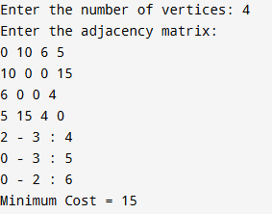

Lab program 9:
Fractional Knapsack
#include <stdio.h>
#define MAX 15

struct item{
char name;
int profit;
int wt;
float ratio;
}a[MAX];

void swap(struct item *a, int i, int j){
int t[2];char ch;float f;
t[0]=a[i].profit;
t[1]=a[i].wt;
ch = a[i].name;
f=a[i].ratio;

a[i].profit = a[j].profit;
a[i].wt = a[j].wt;
a[i].ratio = a[j].ratio;
a[i].name = a[j].name;

a[j].name = ch;
a[j].profit = t[0];
a[j].wt = t[1];
a[j].ratio = f;
}

int sort(struct item* a,int st,int end){
float p=a[st].ratio;
int i=st,j=end;
while (1) {
while (i <= end && a[i].ratio >= p) i++;
while (j >= st && a[j].ratio < p) j--;
if (i >= j) break;
swap(a, i, j);
}
swap(a,st,j);
return j;
}

void quickSort(struct item* a,int st,int end ){
if(st >= end) return;

int mid = sort(a,st,end);
quickSort(a,st,mid-1);
quickSort(a,mid+1,end);
}

void fillUp(struct item* a, int cap, int n){
quickSort(a,0, n-1);
float pro=0.0;
for(int i=0;i<n && cap>0 ; i++){
if(cap- a[i].wt >= 0){
cap-=a[i].wt;
pro+= a[i].profit;
}
else {
pro += cap * a[i].ratio;
cap=0;
}
printf("%c ,",a[i].name);
}
printf("\nProfit = %.2f", pro);
}

int main(){
printf("Enter size:");
int n;
scanf("%d",&n);

printf("Enter wt, profit and name resp :\n");
for(int i=0;i<n;i++){
scanf("%d",&a[i].wt);
scanf("%d",&a[i].profit);
scanf(" %c",&a[i].name);
a[i].ratio = (float)a[i].profit / a[i].wt;
}
int cap;
printf("\nEnter capacity :");
scanf("%d",&cap);
fillUp(a, cap, n);
return 0;
}
OUTPUT:
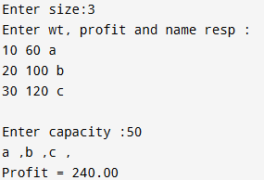

LEETCODE
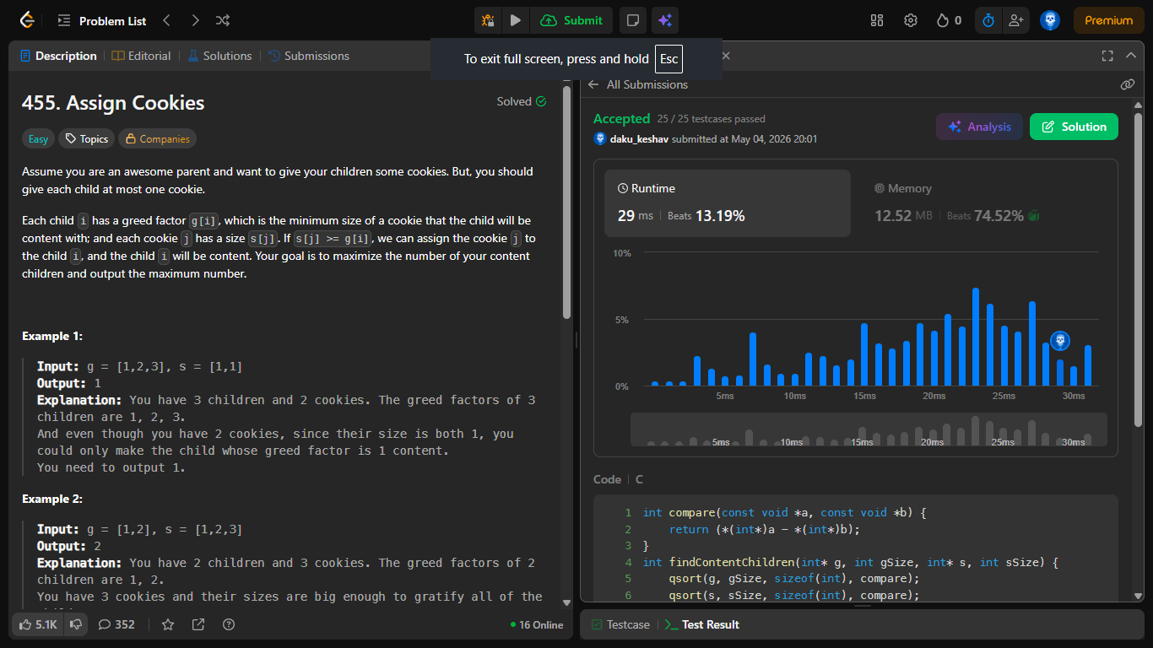
int compare(const void *a, const void *b) {
return (*(int*)a - *(int*)b);
}
int findContentChildren(int* g, int gSize, int* s, int sSize) {
qsort(g, gSize, sizeof(int), compare);
qsort(s, sSize, sizeof(int), compare);
int i = 0;
int j = 0;
while (i < gSize && j < sSize) {
if (s[j] >= g[i]) i++;
j++;
}
return i;
}

Lab program 10:
Dijkstra’s Algorithm
#include <stdio.h>
#define V 10;

int minDist(int visited[], int dist[], int n){
int min = 10000, minIdx = -1;
for(int v=0;v<n;v++)
if(!visited[v] && dist[v]<min){
min= dist[v]; minIdx = v;
}
return minIdx;
}

void Dijkstra(int n, int graph[n][n] ,int src){
int dist[n];
int visited[n];
for(int i=0;i<n;i++){
dist[i]= 10000;
visited[i]=0;
}

dist[src] = 0;
for(int i=1;i<n;i++){
int u= minDist(visited, dist , n);
visited[u] = 1;

for(int v=0;v<n;v++){
if(!visited[v] && graph[u][v] && graph[u][v]+ dist[u] < dist[v])
dist[v] = dist[u] + graph[u][v];
}
}

printf("Vertex\tDistance from Source :\n");
for(int i=0;i<n;i++) printf("%d\t%d\n", i, dist[i]);

}

void main(){
int n;
printf("Enter number of vertex:");
scanf("%d", &n);

int graph[n][n];
printf("Enter weights:\n");
for(int i=0;i<n;i++)
for(int j=0;j<n;j++)
scanf("%d", &graph[i][j]);
// int graph[n][n] = {
// {0, 10, 0, 30, 100},
// {10, 0, 50, 0, 0},
// {0, 50, 0, 20, 10},
// {30, 0, 20, 0, 60},
// {100, 0, 10, 60, 0}
// };
Dijkstra(n, graph, 0);
}
OUTPUT:
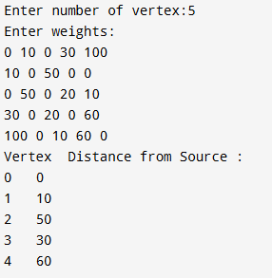
Lab Program 11:
N Queens Problem
#include <stdio.h>
#include <stdlib.h>

int x[20];
int sol = 0;

int place(int k, int i){
for (int j = 1; j < k; j++)
if (x[j] == i || abs(j - k) == abs(x[j] - i))
return 0;
return 1;
}

void NQueens(int k, int n){
for (int i = 1; i <= n; i++) {
if (place(k, i)){
x[k] = i;
if (k == n){
sol++;
printf("\nSolution %d:\n", sol);

for (int row = 1; row <= n; row++) {
for (int col = 1; col <= n; col++){
if (x[row] == col)
printf("1 ");
else
printf("0 ");
}
printf("\n");
}
}
else
NQueens(k + 1, n);
}
}
}

int main(){
int n;
printf("Enter number of queens: ");
scanf("%d", &n);
NQueens(1, n);
printf("\nTotal solutions = %d\n", sol);
return 0;
}

OUTPUT:
