Measuring the Health-Protection Gap and Actuarially Pricing Informal-Sector Health Insurance under Nigeria’s NHIA Act 2022
Oluwatosin Dorcas Babalola¹ (corresponding author), Oluwakemi Elizabeth Iroko¹, Oluwakemi Oyinlade¹
¹ Independent researcher.
Email. Oluwatosin Dorcas Babalola: oluwatosinbabalola99@gmail.com; Oluwakemi Elizabeth Iroko: Oluwakemi2345@gmail.com; Oluwakemi Oyinlade: kemisola.oyinlade@gmail.com.
Date. December 2023.
Word count. 5,071 excluding abstract, tables and references.

Abstract
Background. Nigeria’s National Health Insurance Authority Act 2022 mandates health insurance and creates a Vulnerable Group Fund, but informal-sector workers remain almost entirely uncovered. No study has priced the statutory package, tested the solvency of a pool providing it, and measured the protection it would buy.
Methods. Using the General Household Survey-Panel 2018/19 (4,968 households, 25,134 individuals), we estimated catastrophic health expenditure (CHE) on the published consumption aggregate, with bounds for the annualized outpatient recall. We priced the NHIA basic package from individual cost models with induced demand and simulated pool ruin under alternative take-up, contribution schedules and reinsurance, with design-based bootstrap intervals.
Results. CHE at the 10% budget-share threshold affects 14.0% of the population (4.2% to 14.0% across recall bounds) and 6.6% on capacity to pay, the only measure concentrated among the poor. Informal-sector households are more affected on both measures, and the gap survives controls. The gross premium is ₦24,413 per person-year (95% interval ₦22,636 to ₦26,707) against a contribution ceiling of ₦10,665. A 20,000-life pool needs a subsidy of ₦11,704 per enrollee under random take-up and ₦34,356 under strong adverse selection at low take-up. Graded contributions cut the subsidy by more than half; reinsurance does not reduce it. Fully subsidized coverage cuts CHE to 3.7%; a flat contribution leaves it at 9.6%.
Conclusions. The statutory package costs 2.3 times what intended beneficiaries can pay. The gap is expected cost, not volatility: enrollment mechanism, contribution design and the size of the Vulnerable Group Fund decide whether coverage protects poor households.
Keywords. catastrophic health expenditure; informal sector; health insurance pricing; Tweedie model; ruin probability; universal health coverage; Nigeria

1. Introduction
Out-of-pocket payments financed 71.5% of Nigeria’s current health expenditure in 2019, among the highest shares recorded anywhere (WHO Global Health Expenditure Database). The National Health Insurance Authority (NHIA) Act 2022 was meant to change this: it makes health insurance mandatory, requires every state to run a scheme, obliges employers with five or more staff to enroll their workers, and creates a Vulnerable Group Fund to pay for those who cannot pay for themselves (Federal Republic of Nigeria 2022). Enrollment remains low and most Nigerian workers are informally employed. The survey analyzed here, fielded in 2018/19, describes the population the Act set out to cover.
A substantial Nigerian literature measures catastrophic health expenditure (Aregbeshola and Khan 2018; Edeh 2022; Opeloyeru and Lawanson 2023), and a commentary literature assesses the Act (Ipinnimo et al. 2022; Ahmad and Lucero-Prisno 2022). Neither tells a state scheme what the statutory package costs per enrollee, how much of that cost informal workers can carry, how large a subsidy keeps a voluntary pool solvent, or how much financial protection the package would deliver once the newly insured use more care. Those are actuarial questions, and this paper answers them on one nationally representative dataset collected before the Act, which fixes the baseline its schemes inherited.
The paper makes three contributions. First, it measures the protection gap under both the budget-share and the capacity-to-pay definitions, with an explicit treatment of the two measurement choices that dominate Nigerian estimates: the annualization of a four-week recall window and the construction of the consumption denominator. Second, it builds a transparent actuarial premium for the NHIA basic package from individual cost models, with design-based bootstrap intervals. Third, it embeds the cost distribution in a collective-risk model and asks what subsidy, take-up rate, contribution schedule and reinsurance arrangement a state pool needs to stay solvent, then recomputes catastrophic expenditure under each financing design. The central finding is that the gap between the actuarial price and what informal households can pay is an expected-value gap, not a volatility gap: it cannot be pooled, reinsured or diversified away, and it is multiplied by voluntary enrollment.

2. Background

2.1 The NHIA Act 2022
The Act replaced the National Health Insurance Scheme with an Authority and changed four things that matter here. Coverage became mandatory in law. Each state became the operative risk-bearing unit through a State Health Insurance Scheme. Employers with five or more staff were obliged to enroll their workers, a threshold we use to define formal employment. And the Vulnerable Group Fund, financed in part from the Basic Health Care Provision Fund, was created to subsidize those who cannot contribute. Ipinnimo et al. (2022) review the Act’s provisions and list low government funding, workforce shortages and enforcement of the mandate as its main implementation risks; Ahmad and Lucero-Prisno (2022) call for an explicit definition of the vulnerable group and sustainable funding for the Authority. Neither attaches a number to the subsidy the Act’s design requires. State schemes set informal-sector contribution rates administratively rather than actuarially. A survey of insurance firms in Lagos, on which the present author worked, assessed social insurance as a strategy for extending social protection in Nigeria (Shogunro et al. 2023).

2.2 Measuring catastrophic expenditure
Two traditions coexist. The budget-share approach flags a household when health spending exceeds a fixed share of total consumption; it underlies SDG indicator 3.8.2 at the 10% and 25% thresholds and the global monitoring of Wagstaff et al. (2018) and WHO and World Bank (2023). The capacity-to-pay approach of Xu et al. (2003) compares health spending with consumption net of subsistence needs. Cylus et al. (2018) show for 14 European countries that the budget-share measure identifies richer households more often than poorer ones, while a normative-subsistence denominator concentrates catastrophic spending among the poor; Quintal (2019) makes the same point for Portugal and argues that distribution must be reported alongside incidence. Wagstaff and van Doorslaer (2003) introduced the overshoot measures used here, O’Donnell et al. (2008) codified their survey-based estimation, and Erreygers (2009) supplies the correction for binary outcomes. Shrime et al. (2015) show that catastrophic-expenditure estimates are sensitive to the definition adopted.
For Nigeria, Aregbeshola and Khan (2018) report an incidence of 16.4% at the 10% threshold for 2009/10, and Edeh (2022) reports a rise across three later survey rounds.

2.3 Informal workers, willingness to pay, and pricing
Extending coverage to informal workers is the binding problem for universal coverage in most low- and middle-income countries. Contributions cannot be collected through payroll and enrollment is voluntary in practice whatever the statute says, so who joins is decided by the household. Onasanya (2020) argues for demography-specific communication to raise informal-sector enrollment in Nigeria. Artignan and Bellanger (2021) review 16 studies of community-based health insurance in sub-Saharan Africa and find strong evidence that it raises outpatient use, weak evidence for inpatient use, and little evidence on equity. Jofre-Bonet and Kamara (2018) elicit willingness to pay among informal workers in Sierra Leone and find a mean of about USD 3.6 per adult per month, close to 5% of average monthly business income; they do not cost the package such a premium would fund. The 5% share is the same figure used as the affordability ceiling here.
Aggregate annual health cost per person has a point mass at zero and a long right tail, the structure the Tweedie compound Poisson-gamma family was built for (Smyth and Jørgensen 2002; Dunn and Smyth 2005). Klugman, Panjer and Willmot (2019) give the collective-risk and premium-principle framework, and Wüthrich (2015) links classical ruin probability to solvency capital. The demand response to insurance is the parameter that most affects a price: the RAND Health Insurance Experiment gives an arc elasticity near −0.2 (Manning et al. 1987), and Boes and Gerfin (2016) estimate about −0.14 from a Swiss policy change together with a rise in the probability of any cost.

3. Data
Source and sample. The Nigeria General Household Survey-Panel (GHS-Panel) is collected by the National Bureau of Statistics with the World Bank LSMS-ISA program. Wave 4 (2018/19) is the analysis file. It holds 4,968 households with a consumption record and 25,134 individuals with a health record, in 402 enumeration areas across six strata. The wave-4 weight grosses to 26.9 million households and 149 million people, below the national population, so shares and rates are the quantities reported and population totals should be read as lower bounds. Household characteristics are weighted by the household weight; catastrophic-expenditure rates weight households by household size, so they are the share of people living in an affected household, following the SDG 3.8.2 convention. Household-weighted rates are reported alongside.
Out-of-pocket spending. The health module, fielded at the post-harvest visit, asks every member whether they were ill or injured in the past four weeks, whom they consulted, what they paid for the consultation, and what they spent on medicines in the same four weeks, and separately about hospitalization and its cost over twelve months. The medicine question is put to everyone, so it captures self-treatment as well as prescribed drugs; medicines are 86.13% of measured outpatient spending. Transport is excluded, following WHO practice, and tested as a variant. The published consumption aggregate carries its own health components; replacing them with the health-module measure changes CHE at the 10% threshold by 0.1 points (Table A10).
Annualization. Outpatient spending observed in a four-week window is scaled by 13; inpatient spending is already annual. Scaling the window assumes the other twelve windows repeat the observed one, which maximizes the dispersion of annual spending across households and therefore the share crossing any threshold. The published aggregate scales its own one-month health item by about twelve, so the convention is shared with the official statistics. Section 5.6 bounds its effect.
Consumption. The denominator is the World Bank’s published wave-4 consumption aggregate: food from a seven-day recall with own production and gifts valued at local unit values, non-food items, education and imputed rent, which is 6.1% of consumption. Its health components are replaced by health-module spending, so that health enters the numerator and the denominator from the same instrument.
Coverage and sector. Wave 4 has no health-insurance module, so coverage is not measured. A wage worker is formal when the employer is a government body, or any other employer with five or more workers, the Act’s threshold; a household is informal if it contains no formal worker. On this rule 82.5% of households are informal (80.1% of the population). Three alternative rules are tested.
Prices and poverty line. Wave-4 naira are carried to August-2023 prices with the composite CPI (factor 2.31), so the premium is stated at the prices the Act’s schemes faced. The 2019 national poverty line of ₦137,430 per person per year (National Bureau of Statistics 2020), which was set on the same 2018/19 prices as the survey, becomes ₦317,463.

4. Methods

4.1 Catastrophic expenditure and inequality
Under the budget-share definition a household is catastrophic if OOP/C exceeds 10%, 25% or 40% of total consumption C. Under the capacity-to-pay definition (Xu et al. 2003) household size is equivalized as size^0.56, subsistence spending per equivalent adult is the weighted mean food spending of households whose food share lies between the 45th and 55th percentiles, capacity to pay is consumption net of subsistence (or net of actual food spending where that is smaller), and the threshold is 40% of it. Intensity is the mean overshoot among affected households (Wagstaff and van Doorslaer 2003). Impoverishment compares poverty headcounts gross and net of out-of-pocket payments.
Inequality is summarized by the concentration index, CI = 2 cov(y, r)/mean(y), where r is the weighted fractional rank in per-capita consumption, with the Erreygers (2009) correction for binary outcomes and design-based standard errors from linearizing each index as a function of totals. All standard errors are Taylor-linearized for a stratified single-stage cluster design with enumeration areas as primary sampling units (Lumley 2004); domain estimates zero the weights outside the domain rather than dropping rows. Changes between scenarios are tested on the household-level difference, since the same households appear under both regimes.

4.2 Cost models
The unit is the individual-year and the models are survey-weighted with standard errors clustered on the enumeration area. Outpatient contact within the four-week window is modeled as a Poisson count with an offset of log(4/52), so fitted values are annual rates; inpatient episodes are modeled over twelve months without an offset. Cost per episode is modeled with gamma and lognormal GLMs. Annual cost per person is modeled with a Tweedie compound Poisson-gamma GLM with a log link, the variance power chosen by profile likelihood over 1.20 to 1.85; its fitted values are the predicted cost that drives the adverse-selection scenarios. Covariates are age band, sex, zone, urban residence, consumption quintile, severe functional difficulty from the Washington Group short set, and household size. Diagnostics are randomized quantile residuals (Dunn and Smyth 1996) and an observed-against-predicted lift table.

4.3 Benefit mapping and premium
The NHIA tariff schedule is not published in machine-readable form, so the package is defined by parameters, each a robustness lever. Traditional and spiritual care is excluded. Of the remainder, 85% of outpatient and 90% of inpatient spending is assumed to fall inside the package. Covered outpatient spending is split into drugs, which carry the NHIA’s 10% co-payment, and services, which are free at the point of use. Induced demand uses the arc (midpoint) elasticity: with e = −0.20 and the patient’s price falling from 1.0 to zero, use rises by a factor (1 + x)/(1 − x) with x = e(p1 − p0)/(p0 + p1), which is 1.50 for services and 1.39 for drugs. The insurer’s expected cost per enrollee is the pure premium. A risk margin is added on the standard-deviation principle (0.10 σ/√n) or, alternatively, as a 95% CVaR margin on the simulated pool mean; an administrative load of 15% and an adverse-selection load of 10% then give the gross premium. Affordability is judged against 5% of per-capita consumption; the contribution ceiling for the target population is 5% of the mean per-capita consumption of informal-sector members of the bottom three quintiles.

4.4 Pool solvency and financing designs
A discrete-time collective-risk model tracks the surplus of a pool of n enrollees, U_t = U_(t−1) + n(C + s)(1 − e) − S_t, where C is the mean member contribution, s the subsidy per enrollee, e the expense ratio (10%), and S_t aggregate claims in year t, drawn by resampling annual insurer costs from the informal-sector population with survey weights (Klugman et al. 2019). Ruin is a negative surplus in any year of a one- or three-year horizon. The minimum subsidy holding the ruin probability below 5% or 1% is found by bisection on a fixed set of 10,000 simulated claim paths, so every financing scenario faces the same simulated experience. The empirical cost distribution is collapsed to its distinct values and each pool-year is drawn as one multinomial, which is exact and is checked against direct resampling (Table A11).
Adverse selection tilts enrollment odds by a factor of 1.5 or 2.0 per standard deviation of log predicted cost. Because a tilt is only possible when some people stay out, a take-up grid sets the enrollment probability to min(1, k × tilt) with k chosen so mean take-up equals 10%, 25%, 50%, 75% or 100%; at 100% take-up no selection is possible, which is the mandatory case. Three contribution schedules are compared: flat (the bottom-three-quintile ceiling for everyone), graded (each quintile’s own ceiling) and exempt (Q1 and Q2 pay nothing, Q3 to Q5 graded). Per-life excess-of-loss reinsurance at retentions of ₦250,000, ₦500,000 and ₦1 million is priced at 1.3 times the expected ceded cost. A permanent 25% rise in claims from year 2 is the stress scenario.

4.5 Coverage counterfactual
Covered individuals pay the drug co-payment plus anything outside the package on the higher utilization induced demand implies; uncovered individuals keep their observed spending. Non-health consumption is held fixed and any contribution is a new call on the same budget. Catastrophic expenditure is recomputed on two bases: out-of-pocket payments alone (the SDG convention) and out-of-pocket payments plus the contribution. The exercise is an accounting simulation, not a causal estimate.

4.6 Recall bounds and bootstrap
The annualization is bounded by two extremes. The upper case scales each person’s observed window to a year (full within-year persistence). The lower case draws each person’s annual outpatient cost as a sum of N independent four-week windows, N ~ Poisson(13 × p̂), where p̂ is the fitted contact probability, with episode costs resampled from observed episodes in the person’s quintile; 20 replicates are averaged. Both are carried through CHE, the premium and the subsidy, with the ×12 and ×10 multipliers alongside. A Rao-Wu rescaled bootstrap over enumeration areas within strata (200 replicates) gives percentile intervals for the premium, the expected claim and the minimum subsidy, quantities for which no linearized standard error exists.

5. Results

5.1 Sample and catastrophic expenditure
Mean household size is 5.5, mean annual consumption ₦2.07 million, and out-of-pocket health payments average 4.7% of consumption (Table 1). Informal-sector households are poorer (per-capita consumption ₦457,486 against ₦594,697, p < 0.001), more rural (28.4% against 46.3% urban) and more often female-headed (18.9% against 14.2%).
Catastrophic expenditure affects 14.0% of the population at the 10% threshold (95% CI 12.1 to 15.9), 2.6% at 25% and 0.6% at 40%; 6.6% (5.3 to 8.0) exceed 40% of capacity to pay (Table 2, Figure 1). The household-weighted rate at the 10% threshold is 14.2%. Rural residents are more affected than urban (15.4% against 10.2%), and the North East most of all zones at 23.1% (Table A1). Affected households do not cross the line narrowly: the mean overshoot is 8.4 points at the 10% threshold and 14.1 points on capacity to pay. Out-of-pocket payments raise the poverty headcount from 54.0% to 57.1%, an impoverishing effect of 3.1 points that stays between 1.9 and 3.1 points across poverty lines from half to one and a half times the national line while the headcount itself does not (Table A2).
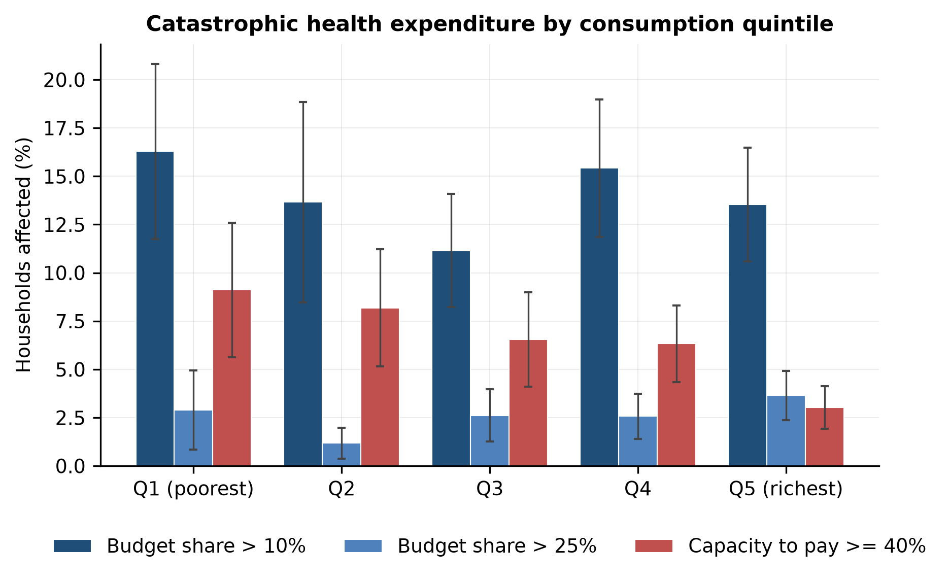
Figure 1. Catastrophic health expenditure by consumption quintile at the 10% and 25% budget-share thresholds and the 40% capacity-to-pay threshold. Bars are survey-weighted incidence; whiskers are 95% design-based confidence intervals.

5.2 The two definitions disagree about who is affected
The concentration index for budget-share CHE at 10% is −0.026 (95% CI −0.099 to +0.047), not distinguishable from zero; for capacity-to-pay CHE it is −0.174 (−0.265 to −0.084), pro-poor (Table 3, Figure 2). By sector, informal households are more affected on both measures: 15.1% against 9.5% on the budget share (p = 0.005) and 7.8% against 2.1% on capacity to pay (p < 0.001). Part of that gap is composition. In a population-weighted linear probability model the informal coefficient on capacity-to-pay CHE falls from 5.7 points unadjusted to 5.0 points with quintile controls and to 3.8 points (p < 0.001) with quintile, zone, residence and household-size controls; on budget share it is 5.3 points (p = 0.004) with the same controls (Table 3). Informal households are more exposed partly because they are poorer and more rural, and a gap of about four points remains after those differences are held fixed. The divergence between the two definitions is arithmetic. Richer households consume more and buy more care, so the ratio to total consumption does not sort by hardship; net of subsistence, the same naira registers as a much larger shock for a poor household. A linear decomposition (Table A3) attributes the capacity-to-pay index mainly to rural residence and the residual, and the budget-share index is too close to zero for shares to be meaningful, so the decomposition is reported for completeness only.
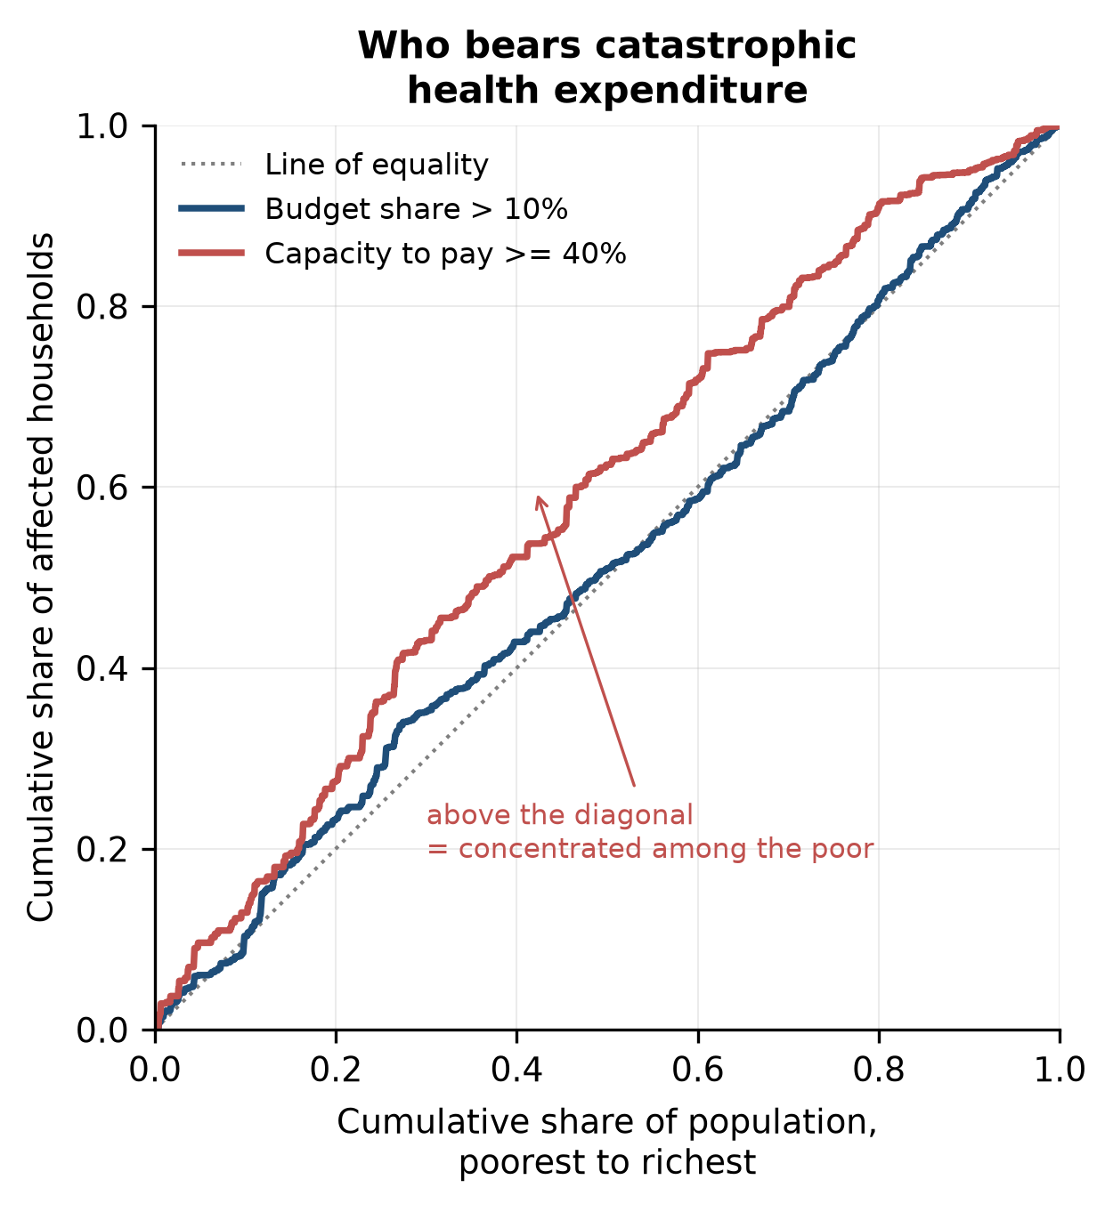
Figure 2. Concentration curves for the two definitions. A curve above the diagonal indicates a burden concentrated among the poor.

5.3 Cost models
Individuals average 2.69 outpatient contacts and 0.031 inpatient episodes a year, at mean costs of ₦4,332 per outpatient episode and ₦42,161 per inpatient episode, giving a mean annual cost of ₦18,214 with 69% of individuals recording no cost. The contact model is underdispersed (Pearson dispersion 0.79), as expected when a binary indicator is modeled as a count, so the negative binomial adds nothing. The gamma and lognormal fit episode cost almost equally (AIC 96,300 against 96,297). The profile likelihood selects a Tweedie variance power of p = 1.70 (Tables A5 and A6). Calibration by decile of prediction is close, with observed-to-predicted ratios between 0.85 and 1.13 and a top-decile mean of ₦67,375 against a bottom-decile mean of ₦4,372. Randomized quantile residuals have mean 0.12, standard deviation 0.99 and skew −0.15; the normality test rejects at n = 25,134, as it will for any parametric model. Risk relativities are large (Table A4): people aged 60 or over cost 2.95 times the community mean and those with a severe functional difficulty 3.99 times; cost rises from 0.39 of the mean in the poorest quintile to 2.11 in the richest, a demand effect that also means observed spending understates the health needs of the poor.

5.4 The premium and what people can pay
Observed cost of ₦18,214 per person-year falls to ₦14,773 once traditional care and services outside the package are removed; induced demand adds ₦6,107 and the drug co-payment returns ₦1,638, leaving a pure premium of ₦19,242 (Table 4, Figure 3). Loadings take a 20,000-life pool to a gross premium of ₦24,413 on the standard-deviation margin and ₦25,876 on the CVaR margin. The risk margin is ₦57 and falls to ₦25 at 100,000 lives; administration and the selection load, not claims volatility, separate the gross from the pure premium. The bootstrap interval for the gross premium is ₦22,636 to ₦26,707 (Table 8).
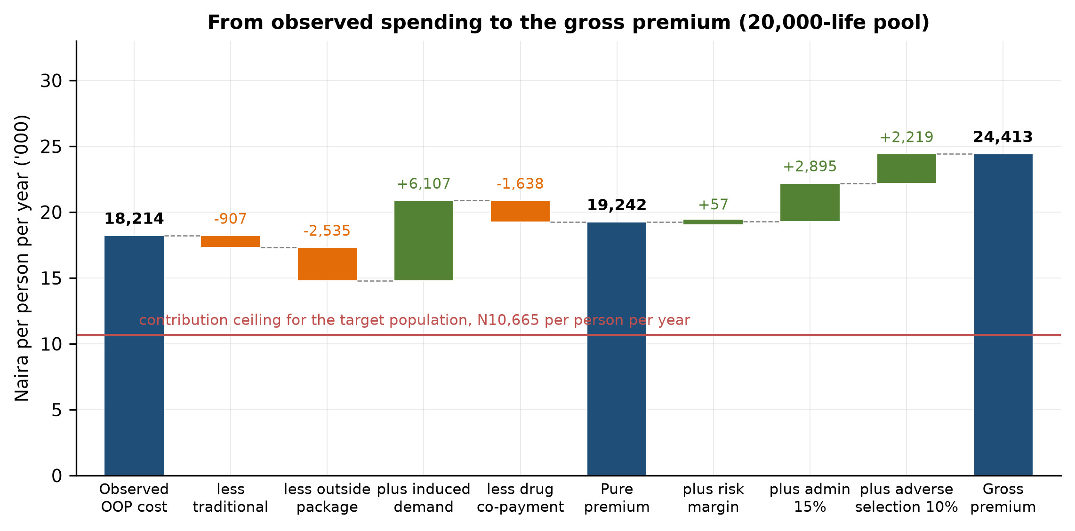
Figure 3. From observed spending to the gross premium for a 20,000-life pool. The horizontal line is the contribution ceiling for informal-sector members of the bottom three quintiles.
Measured against per-capita consumption the gross premium is 18.1% in the poorest quintile, 11.6% in Q2, 8.2% in Q3, 5.8% in Q4 and 3.0% in Q5, above the 5% ceiling in four quintiles out of five (Table 4). Billed per household it is ₦218,716 a year for an average household in Q1, which has 9.0 members. The contribution ceiling for informal-sector members of the bottom three quintiles is ₦10,665 per person-year, 44% of the gross premium.

5.5 Solvency, take-up and financing design
At the flat contribution of ₦10,665, a 20,000-life pool with no opening capital needs a subsidy of ₦11,704 per enrollee to hold its three-year ruin probability below 5% under random take-up, ₦12,083 for a 1% target, and ₦34,356 under strong adverse selection (Table 5, Figure 4). Most of the subsidy is expected value: the expected claim of ₦19,227 divided by (1 − e) less the contribution gives ₦10,698, so process risk adds about ₦1,000 at this scale. Moving from a 5% to a 1% ruin target costs ₦379 per enrollee; moving from 5,000 to 100,000 lives lowers the subsidy under random take-up by 13%; moving from random to strong adverse selection raises it by a factor of 2.9. Opening capital equal to a quarter of a year’s income at the gross premium lowers the random-take-up subsidy to ₦8,006, and a permanent 25% rise in claims from year 2 raises it to ₦14,915 (Table A7).
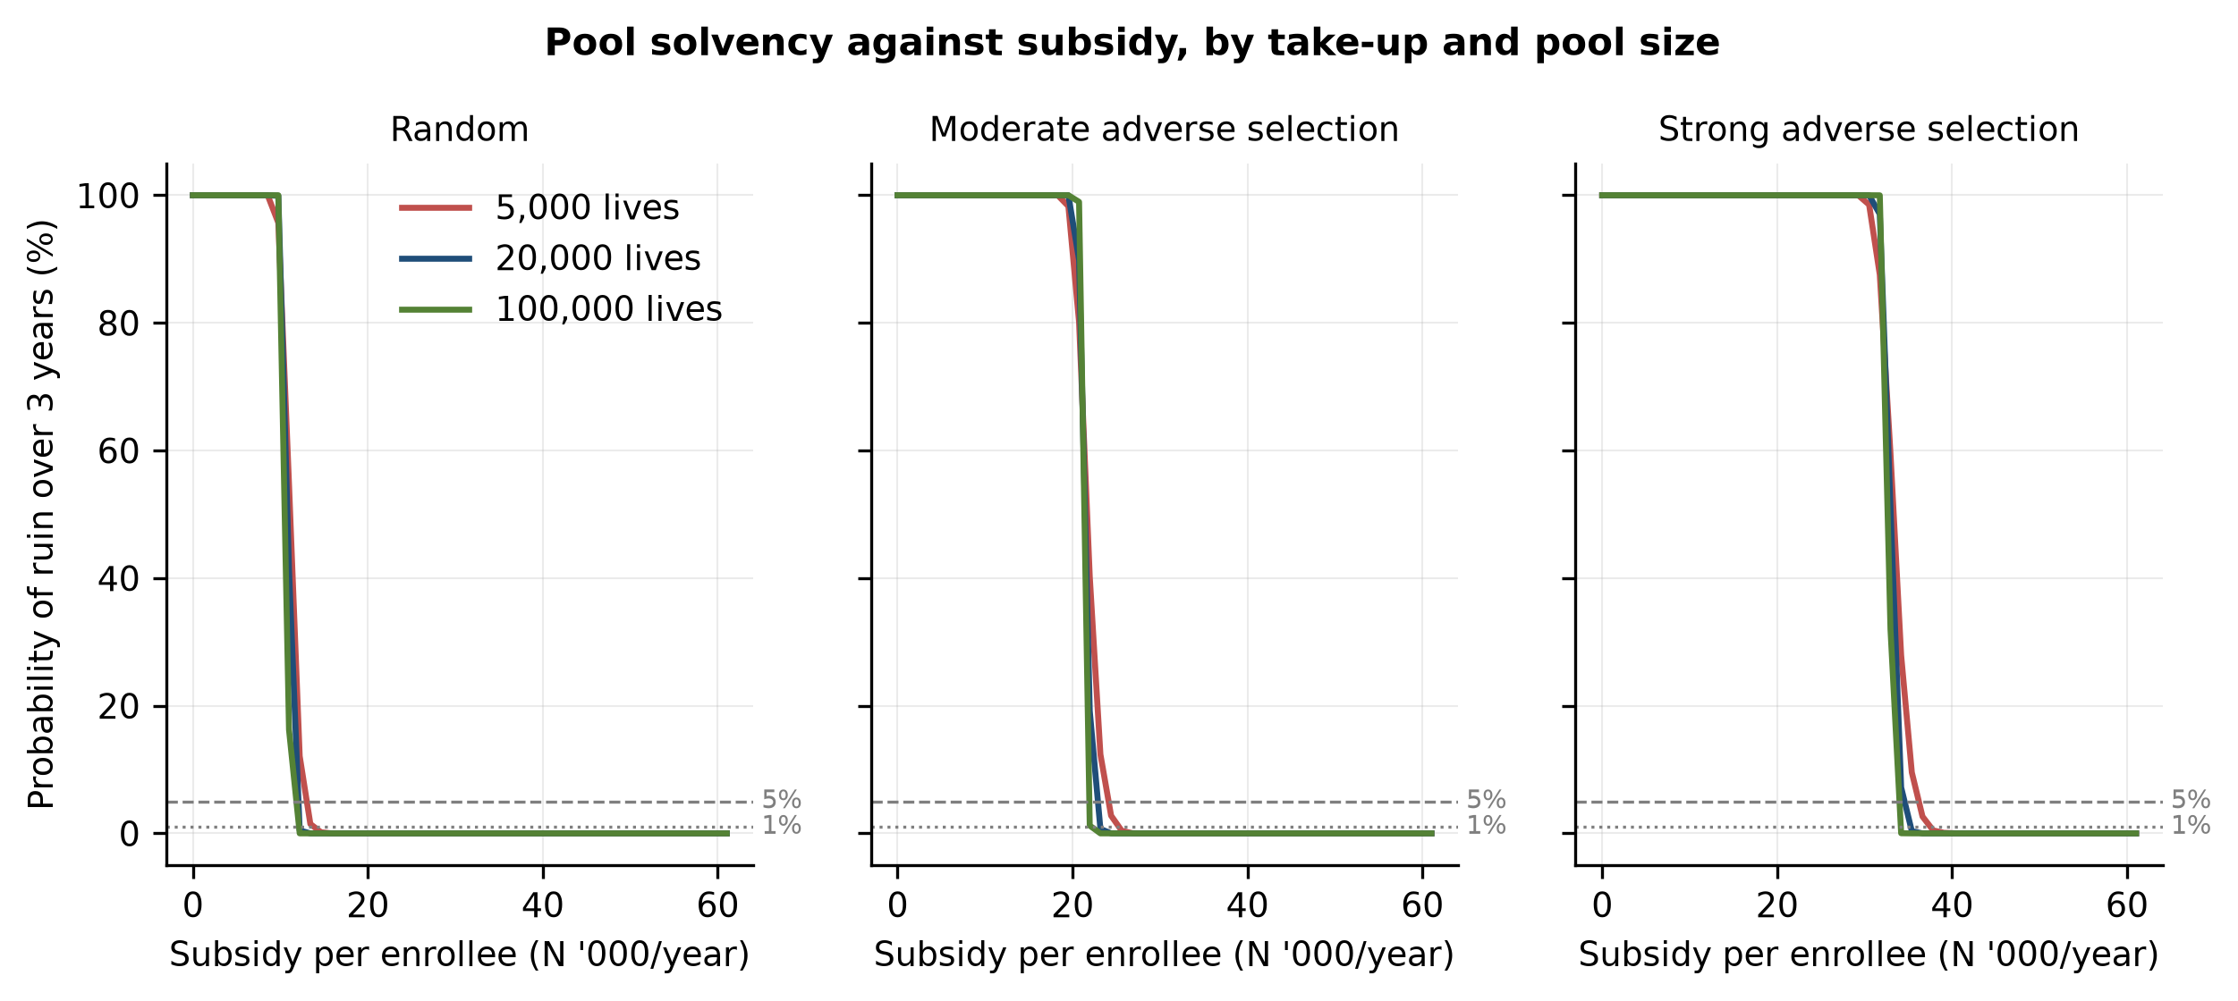
Figure 4. Probability of ruin over three years against subsidy per enrollee, by pool size and take-up pattern.
The take-up grid shows why enrollment mechanism matters more than pool size (Table 5, Figure 5). With a strong tilt the selection loading on expected claims is 102% at 10% take-up, 47% at 50%, 21% at 75% and zero at 100%; the corresponding subsidy falls from ₦34,173 to ₦16,182 at 75% take-up and ₦11,723 at full take-up. The moderate tilt converges on the same path at high take-up, because almost everyone is then enrolled whatever their predicted cost. The adverse-selection scenarios in the upper panel of Table 5 are therefore low-take-up scenarios, and the mandate in the Act, if enforced through group enrollment, is worth more to solvency than any plausible increase in pool size.
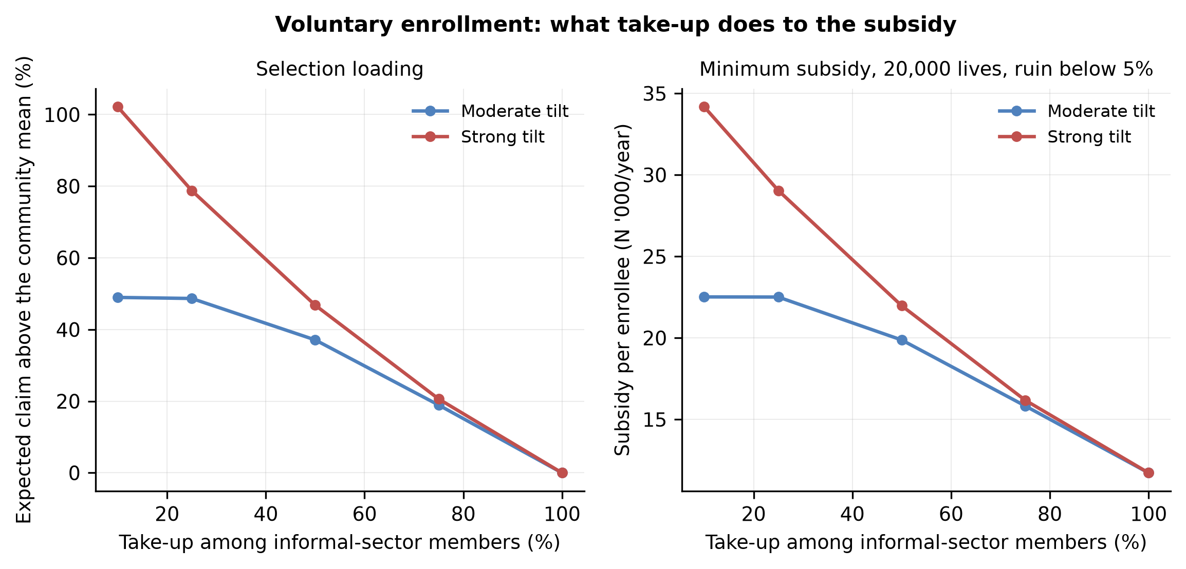
Figure 5. Voluntary enrollment: selection loading on the expected claim, and the subsidy needed for a 20,000-life pool, against the take-up rate among informal-sector members.
Contribution design changes the subsidy by more than reinsurance does (Table 6). A graded schedule in which each quintile pays its own 5% ceiling raises the mean contribution to ₦17,402 and lowers the subsidy under random take-up to ₦4,966; exempting the bottom two quintiles and grading the rest gives ₦13,675 and ₦8,693. Under strong selection the graded schedules collect more because the sick are disproportionately in the richer quintiles, and the subsidy falls from ₦34,356 to about ₦21,700 to ₦23,700. Per-life excess-of-loss reinsurance at a ₦250,000 retention cuts the standard deviation of pool claims per enrollee from ₦521 to ₦306, but the loaded reinsurance premium of ₦4,133 exceeds the process-risk saving and the required subsidy rises to ₦12,338; at higher retentions the effect is smaller in both directions. Reinsurance protects a pool against volatility, and volatility is not this pool’s problem.

5.6 How much protection coverage buys
Measured on out-of-pocket payments alone, full coverage of the informal sector cuts CHE at the 10% threshold from 14.0% to 3.5% and capacity-to-pay CHE from 6.6% to 1.1% (Table 7). Measured on what households actually pay, the same coverage financed by the flat contribution cuts CHE only to 9.6% (a reduction of 4.4 points, p < 0.001) and capacity-to-pay CHE to 4.5%: the contribution removes from poor households much of what the coverage gives them, every year rather than only in years of illness. By quintile, the flat contribution raises CHE in the poorest quintile from 16.3% to 26.6% while lowering it elsewhere (Figure 6, Tables A8 and A9). Fully subsidized coverage cuts CHE to 3.7% (a reduction of 10.3 points) and capacity-to-pay CHE to 1.3%. Exempting the bottom two quintiles and grading the rest reaches 5.9% and 1.8%, and subsidizing only the vulnerable group reaches 9.4% and 3.7%. On the out-of-pocket-only basis the contributory scheme scores marginally better than the fully subsidized one (3.5% against 3.7%) because the contribution enlarges the consumption denominator; that is a property of the SDG indicator, and it is why both bases are reported.
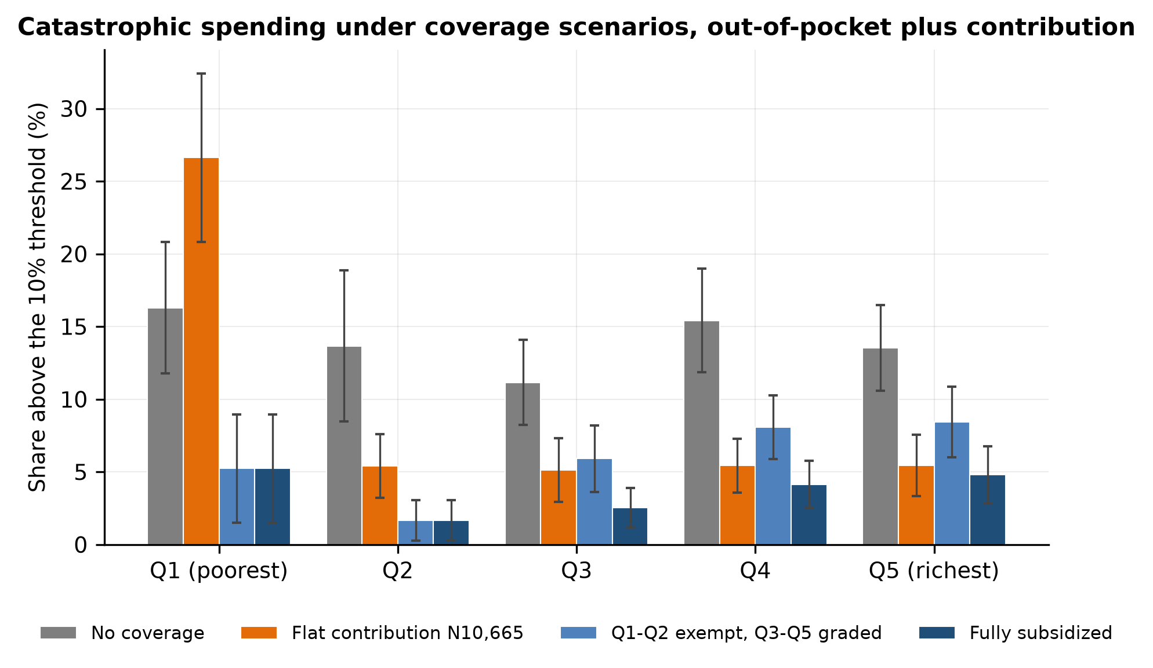
Figure 6. Catastrophic spending at the 10% threshold under coverage scenarios, by consumption quintile, on out-of-pocket payments plus the member contribution.

5.7 Bounds, intervals and robustness
The recall treatment is the largest single uncertainty (Table 8). With independent four-week windows in place of full persistence, CHE at the 10% threshold falls from 14.0% to 4.2% and capacity-to-pay CHE from 6.6% to 1.4%, because a household’s annual spending is then the sum of many small pieces rather than thirteen copies of one. The premium moves less (₦22,528 against ₦24,413), since it is a mean, and the random-take-up subsidy falls by about ₦2,600 through lower process risk and a lower expected claim. Multipliers of 12 and 10 lower CHE to 12.8% and 9.7% and the gross premium to ₦22,698 and ₦19,267. The truth lies between the persistence bounds; chronic conditions make some persistence certain.
The bootstrap gives a standard error of 0.96 points on CHE at the 10% threshold, matching the linearized 0.98, and intervals of ₦22,636 to ₦26,707 for the gross premium, ₦10,152 to ₦13,886 for the random-take-up subsidy and ₦29,819 to ₦40,876 under strong selection. The 95% interval for the random-take-up subsidy is about a sixth as wide as the gap between random take-up and strong selection.
Across the 25 rows of the robustness grid (Table A10), equivalence-scale exponents from 0.5 to 1.0 move capacity-to-pay CHE by under 0.3 points; alternative informality rules change the subsidy by under 5%; fixing the Tweedie power at 1.4, 1.5 or 1.7 changes nothing material; including transport raises CHE to 15.0% and the premium by 5%; trimming the top 1% of costs lowers the premium by 11% and the subsidy by 22%, which is why the tail is kept. Benefit-design parameters behave monotonically: the elasticity range −0.10 to −0.35 spans gross premiums of ₦20,491 to ₦32,139.

6. Discussion
What the numbers say to a state scheme. The pure premium for the basic package is about ₦19,200 per person-year in August-2023 prices and the gross premium about ₦24,400, with a sampling interval of roughly ₦22,600 to ₦26,700. The most the target population can contribute is about ₦10,700. The difference is the subsidy, ₦11,700 per enrollee under random take-up and up to ₦34,400 under strong selection, or ₦1.2 to ₦3.4 billion a year per 100,000 enrollees. Nine tenths of that subsidy is the expected-value gap between the price of the package and the contribution, which no pooling, reinsurance or capital arrangement can remove. The operative policy question is the size and reliability of the Vulnerable Group Fund, not the contribution rate.
Design. Three design results follow. First, selection dominates scale: enrolling whole groups (cooperatives, market associations, transport unions, which the Act’s recognition of Mutual Health Associations permits) at 75% take-up or better needs less than half the subsidy of individual voluntary enrollment at 10% take-up under a strong tilt. Second, a flat contribution undoes much of the protection it finances. Capacity-to-pay CHE falls only from 6.6% to 4.5% when coverage is paid for by a uniform ₦10,665 contribution, and CHE in the poorest quintile rises from 16% to 27%. Contributions should be graded and the bottom two quintiles exempt; under random take-up that design lowers the subsidy by 26% relative to the flat schedule (a fully graded schedule lowers it by 58%) and delivers about four fifths of the reduction in CHE that full subsidy delivers. Third, reinsurance is the wrong instrument for this pool: its premium exceeds the volatility it removes.
Measurement. Our 14.0% at the 10% threshold sits close to Aregbeshola and Khan’s 16.4% for 2009/10. The level depends heavily on how it is measured. Within our own pipeline the annualization moves CHE between 4.2% and 14.0%, and the instrument (health module against the published aggregate’s health items) moves it by 0.1 points. The level of catastrophic expenditure in Nigeria is dominated by the treatment of the recall window, and any subsidy calculation built on a single level inherits that. What is stable across our specifications is the ordering: the capacity-to-pay measure is pro-poor, and the budget-share measure shows no significant gradient. Monitoring should report both definitions rather than rely on either alone.
Limitations. The counterfactual holds total consumption fixed, applies one elasticity from a US experiment, and assumes the package is delivered as specified; Boes and Gerfin’s smaller elasticity would lower the premium, while their extensive-margin effect would raise it. The package parameters are assumptions until the NHIA publishes a tariff. Wave 4 measures no insurance coverage, so coverage is assigned rather than estimated. The survey predates the Act by three years; the cost structure it describes is the one the Act’s schemes inherited, and price changes since are carried by the CPI alone. The selection scenarios are modeled tilts, not observed take-up. Households that forgo care appear as zero spenders, so every measure understates unmet need.

7. Conclusion
Catastrophic health expenditure affects between 4% and 14% of Nigerians at the 10% budget-share threshold depending on how a four-week recall window is treated, and between 1% and 7% on capacity to pay; only the capacity-to-pay measure locates the burden among poor households, and informal-sector households are more affected even after their lower consumption is held fixed. The NHIA basic package costs about ₦19,200 per person-year before loadings and ₦24,400 after, against a contribution ceiling of ₦10,700 for the households the Act intends to protect. Closing the gap is public expenditure, not insurance sold to informal workers: about ₦12,000 per enrollee under group enrollment and three times that under individual voluntary enrollment. Grading contributions and exempting the poorest two quintiles cuts the subsidy by a quarter and preserves most of the protection; a flat contribution preserves much less of it.

Declarations
Data availability. The GHS-Panel microdata are publicly available from the World Bank Microdata Library subject to registration and are not redistributed. All analysis code is available at https://github.com/tosin-babs/nigeria-health-protection-gap and will be archived with a Zenodo DOI on submission. An interactive calculator that reruns the pricing and solvency model in the browser is available at https://nigeria-health-protection-gap.vercel.app.
Code availability. Complete, seeded reproduction code in Python at the repository above; the README gives the script order and environment. The pipeline runs end to end from the raw survey files in about fifteen minutes.
Competing interests. None declared.
Ethics. The analysis uses de-identified secondary survey data and did not require ethical approval.

References
- Ahmad, D., & Lucero-Prisno III, D. E. (2022). The new National Health Insurance Act of Nigeria: how it will insure the poor and ensure universal health coverage. Population Medicine, 4(December), 1–2. doi:10.18332/popmed/157139
- Aregbeshola, B. S., & Khan, S. M. (2018). Out-of-pocket payments, catastrophic health expenditure and poverty among households in Nigeria 2010. International Journal of Health Policy and Management, 7(9), 798–806. doi:10.15171/ijhpm.2018.19
- Artignan, J., & Bellanger, M. (2021). Does community-based health insurance improve access to care in sub-Saharan Africa? A rapid review. Health Policy and Planning, 36(4), 572–584. doi:10.1093/heapol/czaa174
- Boes, S., & Gerfin, M. (2016). Does full insurance increase the demand for health care? Health Economics, 25(11), 1483–1496. doi:10.1002/hec.3266
- Cylus, J., Thomson, S., & Evetovits, T. (2018). Catastrophic health spending in Europe: equity and policy implications of different calculation methods. Bulletin of the World Health Organization, 96(9), 599–609. doi:10.2471/BLT.18.209031
- Dunn, P. K., & Smyth, G. K. (1996). Randomized quantile residuals. Journal of Computational and Graphical Statistics, 5(3), 236–244. doi:10.1080/10618600.1996.10474708
- Dunn, P. K., & Smyth, G. K. (2005). Series evaluation of Tweedie exponential dispersion model densities. Statistics and Computing, 15(4), 267–280. doi:10.1007/s11222-005-4070-y
- Edeh, H. C. (2022). Exploring dynamics in catastrophic health care expenditure in Nigeria. Health Economics Review, 12(1), 22. doi:10.1186/s13561-022-00366-y
- Erreygers, G. (2009). Correcting the concentration index. Journal of Health Economics, 28(2), 504–515. doi:10.1016/j.jhealeco.2008.02.003
- Federal Republic of Nigeria (2022). National Health Insurance Authority Act, 2022. Abuja. Gazetted copy available at nhia.gov.ng.
- Ipinnimo, T. M., Durowade, K. A., Afolayan, C. A., Ajayi, P. O., & Akande, T. M. (2022). The Nigeria National Health Insurance Authority Act and its implications towards achieving universal health coverage. Nigerian Postgraduate Medical Journal, 29(4), 281–287. doi:10.4103/npmj.npmj_216_22
- Jofre-Bonet, M., & Kamara, J. (2018). Willingness to pay for health insurance in the informal sector of Sierra Leone. PLOS ONE, 13(5), e0189915. doi:10.1371/journal.pone.0189915
- Klugman, S. A., Panjer, H. H., & Willmot, G. E. (2019). Loss Models: From Data to Decisions (5th ed.). Hoboken, NJ: Wiley.
- Lumley, T. (2004). Analysis of complex survey samples. Journal of Statistical Software, 9(8). doi:10.18637/jss.v009.i08
- Manning, W. G., Newhouse, J. P., Duan, N., Keeler, E. B., Leibowitz, A., & Marquis, M. S. (1987). Health insurance and the demand for medical care: evidence from a randomized experiment. American Economic Review, 77(3), 251–277.
- National Bureau of Statistics (2020). 2019 Poverty and Inequality in Nigeria: Executive Summary. Abuja: NBS.
- O’Donnell, O., van Doorslaer, E., Wagstaff, A., & Lindelow, M. (2008). Analyzing Health Equity Using Household Survey Data. Washington, DC: World Bank.
- Onasanya, A. A. (2020). Increasing health insurance enrolment in the informal economic sector. Journal of Global Health, 10(1), 010329. doi:10.7189/jogh.10.010329
- Opeloyeru, O. S., & Lawanson, A. O. (2023). Determinants of catastrophic household health expenditure in Nigeria. International Journal of Social Economics, 50(6), 876–892. doi:10.1108/IJSE-02-2022-0132
- Quintal, C. (2019). Evolution of catastrophic health expenditure in a high income country: incidence versus inequalities. International Journal for Equity in Health, 18(1), 145. doi:10.1186/s12939-019-1044-9
- Shogunro, A., Olaniyan, S., Udobi-Owoloja, P. I., & Babalola, D. (2023). An assessment of social insurance as a strategy for enhancing social protection effectiveness in Nigeria. Global Journal of Accounting, 8(2), 1–15.
- Shrime, M. G., Dare, A. J., Alkire, B. C., O’Neill, K., & Meara, J. G. (2015). Catastrophic expenditure to pay for surgery worldwide: a modelling study. The Lancet Global Health, 3(Suppl 2), S38–S44. doi:10.1016/S2214-109X(15)70085-9
- Smyth, G. K., & Jørgensen, B. (2002). Fitting Tweedie’s compound Poisson model to insurance claims data: dispersion modelling. ASTIN Bulletin, 32(1), 143–157. doi:10.2143/AST.32.1.1020
- Wagstaff, A., & van Doorslaer, E. (2003). Catastrophe and impoverishment in paying for health care: with applications to Vietnam 1993–1998. Health Economics, 12(11), 921–933. doi:10.1002/hec.776
- Wagstaff, A., Flores, G., Hsu, J., Smitz, M.-F., Chepynoga, K., Buisman, L. R., van Wilgenburg, K., & Eozenou, P. (2018). Progress on catastrophic health spending in 133 countries: a retrospective observational study. The Lancet Global Health, 6(2), e169–e179. doi:10.1016/S2214-109X(17)30429-1
- WHO and World Bank (2023). Tracking Universal Health Coverage: 2023 Global Monitoring Report. Geneva: World Health Organization.
- WHO Global Health Expenditure Database. Out-of-pocket expenditure as a share of current health expenditure, Nigeria, 2019 (World Bank indicator SH.XPD.OOPC.CH.ZS).
- Wüthrich, M. V. (2015). From ruin theory to solvency in non-life insurance. Scandinavian Actuarial Journal, 2015(6), 516–526. doi:10.1080/03461238.2013.858401
- Xu, K., Evans, D. B., Kawabata, K., Zeramdini, R., Klavus, J., & Murray, C. J. L. (2003). Household catastrophic health expenditure: a multicountry analysis. The Lancet, 362(9378), 111–117. doi:10.1016/S0140-6736(03)13861-5

Tables
Generated from output/tables/.csv by python/make_tables.py. All estimates are survey-weighted with Taylor-linearized standard errors for a stratified single-stage cluster design. Naira are in constant August 2023 prices. Consumption is the published wave-4 aggregate.*
Table 1. Sample characteristics, weighted by household weight.
p is a design-based Wald test of the informal-formal difference.
Characteristic | Overall | SE | Informal | Formal | p
Household size | 5.53 | 0.13 | 5.37 | 6.29 | 0.004
Head’s age (years) | 48.84 | 0.38 | 49.27 | 46.79 | 0.002
Female-headed (%) | 18.05 | 1.13 | 18.87 | 14.21 | 0.041
Urban (%) | 31.49 | 2.82 | 28.36 | 46.26 | 0.001
Children under 5 (n) | 0.81 | 0.04 | 0.81 | 0.81 | 0.963
Members aged 60+ (n) | 0.37 | 0.01 | 0.40 | 0.21 | 0.000
Any member with severe functional difficulty (%) | 11.99 | 0.83 | 11.75 | 13.12 | 0.548
Total annual consumption (N) | 2,066,835.43 | 50,274.62 | 1,886,307.08 | 2,919,210.15 | 0.000
Consumption per capita (N) | 481,467.34 | 12,900.99 | 457,485.94 | 594,696.86 | 0.000
Food share of consumption (%) | 65.59 | 0.43 | 66.96 | 59.11 | 0.000
Annual out-of-pocket health spending (N) | 95,680.60 | 3,692.59 | 93,367.03 | 106,604.28 | 0.165
OOP as share of consumption (%) | 4.74 | 0.16 | 4.98 | 3.62 | 0.000
Any member sought care in past 4 weeks (%) | 60.39 | 1.35 | 60.13 | 61.65 | 0.607
Any member hospitalized in past 12 months (%) | 13.57 | 0.82 | 13.69 | 13.01 | 0.749
Table 2. Catastrophic health expenditure: incidence and intensity.
Population-weighted rates are the share of people living in an affected household; the household-weighted row is the share of households. The denominator is the published consumption aggregate. Zone and residence breakdowns are in Table A1.
Measure | Dimension | Group | Incidence % | 95% low | 95% high | Mean positive overshoot pp | n
Budget share > 10% | Overall | All households | 14.0 | 12.1 | 15.9 | 8.4 | 4,968
Budget share > 10% | Overall (household-weighted) | All households | 14.2 | 12.6 | 15.8 | 8.9 | 4,968
Budget share > 10% | Sector | Formal | 9.5 | 6.2 | 12.8 | 6.0 | 861
Budget share > 10% | Sector | Informal | 15.1 | 13.0 | 17.3 | 8.8 | 4,107
Budget share > 10% | Consumption quintile | Q1 (poorest) | 16.3 | 11.8 | 20.8 | 7.5 | 632
Budget share > 10% | Consumption quintile | Q2 | 13.7 | 8.5 | 18.9 | 6.1 | 706
Budget share > 10% | Consumption quintile | Q3 | 11.2 | 8.2 | 14.1 | 10.3 | 960
Budget share > 10% | Consumption quintile | Q4 | 15.4 | 11.9 | 19.0 | 8.7 | 1,085
Budget share > 10% | Consumption quintile | Q5 (richest) | 13.5 | 10.6 | 16.5 | 10.0 | 1,585
Budget share > 25% | Overall | All households | 2.6 | 1.9 | 3.3 | 9.7 | 4,968
Budget share > 25% | Overall (household-weighted) | All households | 2.7 | 2.1 | 3.3 | 10.7 | 4,968
Budget share > 25% | Sector | Formal | 0.7 | 0.2 | 1.3 | 19.1 | 861
Budget share > 25% | Sector | Informal | 3.0 | 2.2 | 3.9 | 9.2 | 4,107
Budget share > 25% | Consumption quintile | Q1 (poorest) | 2.9 | 0.8 | 5.0 | 7.7 | 632
Budget share > 25% | Consumption quintile | Q2 | 1.2 | 0.4 | 2.0 | 5.7 | 706
Budget share > 25% | Consumption quintile | Q3 | 2.6 | 1.3 | 4.0 | 9.2 | 960
Budget share > 25% | Consumption quintile | Q4 | 2.6 | 1.4 | 3.7 | 10.6 | 1,085
Budget share > 25% | Consumption quintile | Q5 (richest) | 3.7 | 2.4 | 4.9 | 12.4 | 1,585
Budget share > 40% | Overall | All households | 0.6 | 0.3 | 0.8 | 8.0 | 4,968
Budget share > 40% | Overall (household-weighted) | All households | 0.7 | 0.4 | 0.9 | 10.1 | 4,968
Budget share > 40% | Sector | Formal | 0.4 | -0.0 | 0.8 | 15.3 | 861
Budget share > 40% | Sector | Informal | 0.6 | 0.3 | 0.9 | 6.8 | 4,107
Budget share > 40% | Consumption quintile | Q1 (poorest) | 0.4 | -0.4 | 1.1 | 0.7 | 632
Budget share > 40% | Consumption quintile | Q2 | 0.1 | -0.0 | 0.2 | 2.3 | 706
Budget share > 40% | Consumption quintile | Q3 | 0.5 | 0.1 | 0.9 | 6.9 | 960
Budget share > 40% | Consumption quintile | Q4 | 0.8 | 0.3 | 1.3 | 6.0 | 1,085
Budget share > 40% | Consumption quintile | Q5 (richest) | 1.2 | 0.5 | 1.8 | 12.5 | 1,585
Capacity to pay >= 40% | Overall | All households | 6.6 | 5.3 | 8.0 | 14.1 | 4,968
Capacity to pay >= 40% | Overall (household-weighted) | All households | 6.7 | 5.6 | 7.8 | 14.2 | 4,968
Capacity to pay >= 40% | Sector | Formal | 2.1 | 0.8 | 3.3 | 11.1 | 861
Capacity to pay >= 40% | Sector | Informal | 7.8 | 6.2 | 9.3 | 14.3 | 4,107
Capacity to pay >= 40% | Consumption quintile | Q1 (poorest) | 9.1 | 5.6 | 12.6 | 15.8 | 632
Capacity to pay >= 40% | Consumption quintile | Q2 | 8.2 | 5.2 | 11.2 | 9.8 | 706
Capacity to pay >= 40% | Consumption quintile | Q3 | 6.5 | 4.1 | 9.0 | 16.6 | 960
Capacity to pay >= 40% | Consumption quintile | Q4 | 6.3 | 4.3 | 8.3 | 12.0 | 1,085
Capacity to pay >= 40% | Consumption quintile | Q5 (richest) | 3.0 | 1.9 | 4.1 | 19.4 | 1,585
Table 3. Concentration indices and the informal-formal gap.
Indices are ranked on per-capita consumption; a negative value means the outcome is concentrated among the poor. Erreygers is the bounded correction for binary outcomes. The sector gap is tested with a design-based Wald test; the bottom panel reports the informal coefficient from a population-weighted linear probability model with standard errors clustered on the enumeration area.
Outcome | Mean | CI | 95% low | 95% high | Erreygers | SE
CHE, budget share > 10% | 0.140 | -0.026 | -0.099 | 0.047 | -0.015 | 0.021
CHE, budget share > 25% | 0.026 | 0.104 | -0.067 | 0.275 | 0.011 | 0.008
CHE, capacity to pay >= 40% | 0.066 | -0.174 | -0.265 | -0.084 | -0.046 | 0.015
OOP share of consumption | 0.048 | -0.013 | -0.051 | 0.026
Sought care when ill (any member) | 0.670 | -0.033 | -0.052 | -0.014 | -0.089 | 0.026

Outcome (%) | Informal | SE | Formal | SE | Difference pp | p
CHE > 10% | 15.1 | 1.1 | 9.5 | 1.7 | 5.6 | 0.005
CHE > 25% | 3.0 | 0.4 | 0.7 | 0.3 | 2.3 | 0.000
CHE, CTP >= 40% | 7.8 | 0.8 | 2.1 | 0.6 | 5.7 | 0.000
OOP share of consumption | 5.0 | 0.2 | 3.9 | 0.3 | 1.1 | 0.001

Outcome | Controls | Informal coefficient pp | SE | p
CHE > 10% | Unadjusted | 5.6 | 1.9 | 0.003
CHE > 10% | Consumption quintile | 5.6 | 1.8 | 0.002
CHE > 10% | Quintile, zone, residence, household size | 5.3 | 1.8 | 0.004
CHE, CTP >= 40% | Unadjusted | 5.7 | 1.0 | 0.000
CHE, CTP >= 40% | Consumption quintile | 5.0 | 0.9 | 0.000
CHE, CTP >= 40% | Quintile, zone, residence, household size | 3.8 | 1.1 | 0.000
Table 4. From observed spending to the gross premium, and what households can pay.
Naira per person per year. Second panel: loadings for a 20,000-life pool on the two risk-margin conventions (other pool sizes in Table A4). Third panel: the gross premium against per-capita consumption by quintile; quintiles rank people, and household size is the household-weighted mean since a premium is billed once per household. Fourth panel: the contribution ceiling, 5% of the mean per-capita consumption of informal-sector members of each quintile.
Step | Naira | Change
Observed out-of-pocket cost per person-year | 18,214
less traditional and spiritual care | 17,308 | -907
less services outside the basic package (outpatient 85% / inpatient 90% covered) | 14,773 | -2,535
plus induced demand (arc elasticity -0.20) | 20,880 | 6,107
less member co-payment on drugs (10%) | 19,242 | -1,638

Risk-margin basis | Pure premium | Risk margin | Admin 15% | Selection 10% | Gross premium
Standard deviation | 19,242 | 57 | 2,895 | 2,219 | 24,413
CVaR 95% | 19,242 | 1,213 | 3,068 | 2,352 | 25,876

Quintile | Consumption per capita | Household size | Premium as % of consumption | Premium per household
Q1 (poorest) | 134,549 | 9.0 | 18.1 | 218,716
Q2 | 210,522 | 7.7 | 11.6 | 188,516
Q3 | 296,959 | 5.8 | 8.2 | 142,194
Q4 | 420,713 | 5.0 | 5.8 | 121,579
Q5 (richest) | 805,931 | 3.4 | 3.0 | 84,028

Informal-sector group | Consumption per capita | Contribution ceiling (5%)
All informal households | 351,194 | 17,560
Informal, quintile 1 | 134,946 | 6,747
Informal, quintile 2 | 209,754 | 10,488
Informal, quintile 3 | 295,175 | 14,759
Informal, quintile 4 | 419,655 | 20,983
Informal, quintile 5 | 791,608 | 39,580
Table 5. Minimum subsidy per enrollee for a ruin probability below the target over three years, no opening capital.
Upper panel: by pool size and take-up pattern, at the flat contribution. Lower panel: a 20,000-life pool by take-up rate, where enrollment probability rises with predicted cost by the tilt factor per standard deviation of log predicted cost; at 100% take-up everyone enrolls and no selection is possible.
Pool size | Take-up | Ruin target | Subsidy | % of gross premium | N bn per 100,000 enrollees
5,000 | Moderate adverse selection | 1% | 25,108 | 103 | 2.51
5,000 | Moderate adverse selection | 5% | 23,971 | 98 | 2.40
5,000 | Random | 1% | 13,686 | 56 | 1.37
5,000 | Random | 5% | 12,746 | 52 | 1.27
5,000 | Strong adverse selection | 1% | 37,328 | 153 | 3.73
5,000 | Strong adverse selection | 5% | 36,053 | 148 | 3.61
20,000 | Moderate adverse selection | 1% | 23,096 | 95 | 2.31
20,000 | Moderate adverse selection | 5% | 22,523 | 92 | 2.25
20,000 | Random | 1% | 12,083 | 49 | 1.21
20,000 | Random | 5% | 11,704 | 48 | 1.17
20,000 | Strong adverse selection | 1% | 35,053 | 144 | 3.51
20,000 | Strong adverse selection | 5% | 34,356 | 141 | 3.44
100,000 | Moderate adverse selection | 1% | 22,009 | 90 | 2.20
100,000 | Moderate adverse selection | 5% | 21,756 | 89 | 2.18
100,000 | Random | 1% | 11,334 | 46 | 1.13
100,000 | Random | 5% | 11,147 | 46 | 1.11
100,000 | Strong adverse selection | 1% | 33,726 | 138 | 3.37
100,000 | Strong adverse selection | 5% | 33,409 | 137 | 3.34

Tilt | Take-up | Expected claim | Selection loading % | Subsidy, ruin < 5% | % of gross premium
Moderate tilt | 10% | 28,642 | 49 | 22,515 | 92
Moderate tilt | 25% | 28,585 | 49 | 22,507 | 92
Moderate tilt | 50% | 26,361 | 37 | 19,873 | 81
Moderate tilt | 75% | 22,868 | 19 | 15,832 | 65
Moderate tilt | 100% | 19,227 | 0 | 11,723 | 48
Strong tilt | 10% | 38,867 | 102 | 34,173 | 140
Strong tilt | 25% | 34,373 | 79 | 29,045 | 119
Strong tilt | 50% | 28,224 | 47 | 21,973 | 90
Strong tilt | 75% | 23,194 | 21 | 16,182 | 66
Strong tilt | 100% | 19,227 | 0 | 11,723 | 48
Table 6. Financing designs for a 20,000-life pool: contribution schedules and per-life excess-of-loss reinsurance.
Minimum subsidy holds the three-year ruin probability below 5%. Reinsurance cedes each person’s annual cost above the retention for a premium of 1.3 times the expected ceded cost.
Contribution schedule | Take-up | Mean contribution | Expected claim | Minimum subsidy | Subsidy share
Flat (Q1-Q3 ceiling for all) | Random | 10,665 | 19,227 | 11,704 | 52%
Flat (Q1-Q3 ceiling for all) | Strong adverse selection | 10,665 | 38,982 | 34,356 | 76%
Graded (each quintile’s own ceiling) | Random | 17,402 | 19,227 | 4,966 | 22%
Graded (each quintile’s own ceiling) | Strong adverse selection | 23,332 | 38,982 | 21,689 | 48%
Q1-Q2 exempt, Q3-Q5 graded | Random | 13,675 | 19,227 | 8,693 | 39%
Q1-Q2 exempt, Q3-Q5 graded | Strong adverse selection | 21,273 | 38,982 | 23,747 | 53%

Take-up | Retention | Reinsurance premium | SD of claims per enrollee | p99 of claims per enrollee | Minimum subsidy
Random |  | 0 | 521 | 20,457 | 11,678
Random | 250,000 | 4,133 | 306 | 20,899 | 12,338
Random | 500,000 | 1,709 | 396 | 20,576 | 11,873
Random | 1,000,000 | 576 | 453 | 20,390 | 11,708
Strong adverse selection |  | 0 | 916 | 41,143 | 34,394
Strong adverse selection | 250,000 | 13,127 | 417 | 43,015 | 36,787
Strong adverse selection | 500,000 | 6,367 | 590 | 41,862 | 35,372
Strong adverse selection | 1,000,000 | 2,263 | 751 | 41,213 | 34,658
Table 7. Change in catastrophic expenditure under coverage scenarios.
Paired design-based test of the change on the same households. A negative reduction means catastrophic expenditure rises. Levels for every scenario and quintile are in Tables A9 and A10.
Scenario | Payment basis | Measure | Baseline % | Counterfactual % | Reduction pp | SE | p
Vulnerable group only, fully subsidised | Out-of-pocket only | Budget share > 10% | 14.0 | 9.4 | 4.6 | 0.7 | 0.000
Vulnerable group only, fully subsidised | Out-of-pocket only | Capacity to pay >= 40% | 6.6 | 3.7 | 2.9 | 0.4 | 0.000
Vulnerable group only, fully subsidised | OOP plus member contribution | Budget share > 10% | 14.0 | 9.4 | 4.6 | 0.7 | 0.000
Vulnerable group only, fully subsidised | OOP plus member contribution | Capacity to pay >= 40% | 6.6 | 3.7 | 2.9 | 0.4 | 0.000
Informal sector, 50% take-up | Out-of-pocket only | Budget share > 10% | 14.0 | 8.6 | 5.4 | 0.6 | 0.000
Informal sector, 50% take-up | Out-of-pocket only | Capacity to pay >= 40% | 6.6 | 3.7 | 3.0 | 0.4 | 0.000
Informal sector, 50% take-up | OOP plus member contribution | Budget share > 10% | 14.0 | 11.7 | 2.3 | 0.6 | 0.000
Informal sector, 50% take-up | OOP plus member contribution | Capacity to pay >= 40% | 6.6 | 5.5 | 1.1 | 0.3 | 0.001
Informal sector, full coverage | Out-of-pocket only | Budget share > 10% | 14.0 | 3.5 | 10.5 | 0.8 | 0.000
Informal sector, full coverage | Out-of-pocket only | Capacity to pay >= 40% | 6.6 | 1.1 | 5.6 | 0.6 | 0.000
Informal sector, full coverage | OOP plus member contribution | Budget share > 10% | 14.0 | 9.6 | 4.4 | 0.8 | 0.000
Informal sector, full coverage | OOP plus member contribution | Capacity to pay >= 40% | 6.6 | 4.5 | 2.1 | 0.5 | 0.000
Informal sector, full coverage, no contribution | Out-of-pocket only | Budget share > 10% | 14.0 | 3.7 | 10.3 | 0.8 | 0.000
Informal sector, full coverage, no contribution | Out-of-pocket only | Capacity to pay >= 40% | 6.6 | 1.3 | 5.3 | 0.5 | 0.000
Informal sector, full coverage, no contribution | OOP plus member contribution | Budget share > 10% | 14.0 | 3.7 | 10.3 | 0.8 | 0.000
Informal sector, full coverage, no contribution | OOP plus member contribution | Capacity to pay >= 40% | 6.6 | 1.3 | 5.3 | 0.5 | 0.000
Informal sector, full coverage, graded contribution | Out-of-pocket only | Budget share > 10% | 14.0 | 3.6 | 10.4 | 0.8 | 0.000
Informal sector, full coverage, graded contribution | Out-of-pocket only | Capacity to pay >= 40% | 6.6 | 1.1 | 5.5 | 0.5 | 0.000
Informal sector, full coverage, graded contribution | OOP plus member contribution | Budget share > 10% | 14.0 | 7.6 | 6.4 | 0.6 | 0.000
Informal sector, full coverage, graded contribution | OOP plus member contribution | Capacity to pay >= 40% | 6.6 | 3.0 | 3.6 | 0.4 | 0.000
Informal sector, full coverage, Q1-Q2 exempt | Out-of-pocket only | Budget share > 10% | 14.0 | 3.6 | 10.4 | 0.8 | 0.000
Informal sector, full coverage, Q1-Q2 exempt | Out-of-pocket only | Capacity to pay >= 40% | 6.6 | 1.2 | 5.4 | 0.5 | 0.000
Informal sector, full coverage, Q1-Q2 exempt | OOP plus member contribution | Budget share > 10% | 14.0 | 5.9 | 8.2 | 0.7 | 0.000
Informal sector, full coverage, Q1-Q2 exempt | OOP plus member contribution | Capacity to pay >= 40% | 6.6 | 1.8 | 4.8 | 0.5 | 0.000
Universal coverage | Out-of-pocket only | Budget share > 10% | 14.0 | 1.8 | 12.2 | 0.9 | 0.000
Universal coverage | Out-of-pocket only | Capacity to pay >= 40% | 6.6 | 0.7 | 5.9 | 0.6 | 0.000
Universal coverage | OOP plus member contribution | Budget share > 10% | 14.0 | 8.8 | 5.3 | 1.0 | 0.000
Universal coverage | OOP plus member contribution | Capacity to pay >= 40% | 6.6 | 4.2 | 2.4 | 0.5 | 0.000
Table 8. Recall-treatment bounds and design-based bootstrap intervals.
Upper panel: the 4-week outpatient window scaled to a year (full within-year persistence) against annual cost drawn as independent 4-week windows from the fitted frequency model (no persistence), and two smaller annualizers. Subsidies are for a 20,000-life pool over three years, ruin below 5%. Lower panel: Rao-Wu rescaled bootstrap over enumeration areas within strata, 200 replicates, percentile intervals.
Recall treatment | CHE10 % | CTP40 % | Pure premium | Gross premium | Subsidy, random | Subsidy, strong selection
x13, window scaled to a year (headline, full persistence) | 14.0 | 6.6 | 19,242 | 24,413 | 11,666 | 34,293
x13, independent 4-week windows (no persistence) | 4.2 | 1.4 | 17,781 | 22,528 | 9,098 | 23,546
x12, window scaled | 12.8 | 6.0 | 17,890 | 22,698 | 10,150 | 31,311
x10, window scaled | 9.7 | 4.9 | 15,185 | 19,267 | 7,056 | 25,134

Quantity | Point estimate | Bootstrap SE | 2.5% | 97.5%
CHE, budget share > 10% (%) | 14.0 | 1.0 | 12.3 | 15.8
CHE, capacity to pay >= 40% (%) | 6.6 | 0.7 | 5.4 | 8.0
Pure premium (N) | 19,242.5 | 769.9 | 17,847.5 | 21,054.0
Gross premium (N) | 24,413.2 | 977.3 | 22,636.0 | 26,706.6
Flat contribution (N) | 10,664.6 | 44.1 | 10,572.2 | 10,745.0
Expected claim, random take-up (N) | 19,227.0 | 808.8 | 17,953.4 | 21,120.0
Minimum subsidy, random take-up (N) | 11,689.3 | 943.0 | 10,151.9 | 13,885.8
Expected claim, strong selection (N) | 38,981.8 | 2,425.8 | 34,907.1 | 44,659.5
Minimum subsidy, strong selection (N) | 34,324.5 | 2,802.1 | 29,819.0 | 40,876.0

Appendix tables
Table A1. Catastrophic expenditure by residence and zone.
The 25% and 40% budget-share thresholds are in output/tables/table2_che.csv.
Measure | Dimension | Group | Incidence % | 95% low | 95% high | n
Budget share > 10% | Residence | Rural | 15.4 | 13.2 | 17.7 | 3,377
Budget share > 10% | Residence | Urban | 10.2 | 6.5 | 13.9 | 1,591
Budget share > 10% | Zone | North Central | 9.4 | 6.9 | 11.9 | 842
Budget share > 10% | Zone | North East | 23.1 | 16.1 | 30.2 | 824
Budget share > 10% | Zone | North West | 12.7 | 8.9 | 16.4 | 842
Budget share > 10% | Zone | South East | 17.1 | 14.1 | 20.2 | 822
Budget share > 10% | Zone | South South | 12.5 | 8.6 | 16.3 | 814
Budget share > 10% | Zone | South West | 9.4 | 5.6 | 13.3 | 824
Capacity to pay >= 40% | Residence | Rural | 8.2 | 6.5 | 9.9 | 3,377
Capacity to pay >= 40% | Residence | Urban | 2.5 | 1.2 | 3.7 | 1,591
Capacity to pay >= 40% | Zone | North Central | 4.9 | 2.8 | 7.0 | 842
Capacity to pay >= 40% | Zone | North East | 11.2 | 5.9 | 16.4 | 824
Capacity to pay >= 40% | Zone | North West | 7.3 | 4.4 | 10.2 | 842
Capacity to pay >= 40% | Zone | South East | 8.1 | 5.4 | 10.9 | 822
Capacity to pay >= 40% | Zone | South South | 3.8 | 2.2 | 5.4 | 814
Capacity to pay >= 40% | Zone | South West | 2.9 | 1.3 | 4.4 | 824
Table A2. Impoverishment from out-of-pocket payments, and its sensitivity to the poverty line.
The headcount is a level and depends on the line and on the consumption aggregate; the impoverishing effect is a difference and moves much less.
Indicator | Estimate | SE
Poverty line (N per person per year, August 2023 prices) | 317,463.30
Poverty headcount before OOP (%) | 54.00 | 1.87
Poverty headcount after OOP (%) | 57.14 | 1.85
Impoverished by OOP (pp) | 3.14
Newly impoverished households (%) | 3.14 | 0.45
Normalized poverty gap before OOP (%) | 19.92 | 0.91
Normalized poverty gap after OOP (%) | 21.76 | 0.96
Increase in poverty gap (pp) | 1.83

Poverty line | x national line | Headcount before % | Headcount after % | Impoverishment pp | Millions
158,732 | 0.50 | 15.1 | 17.4 | 2.27 | 3.38
238,097 | 0.75 | 38.0 | 41.0 | 2.99 | 4.45
317,463 | 1.00 | 54.0 | 57.1 | 3.14 | 4.68
396,829 | 1.25 | 67.7 | 70.3 | 2.65 | 3.94
476,195 | 1.50 | 76.7 | 78.6 | 1.88 | 2.79
Table A3. Decomposition of the concentration indices.
Descriptive, not causal. Contributions are in index units; shares are not shown for the budget-share index because it is not distinguishable from zero and shares of a near-zero total are not interpretable.
Outcome | Variable | Beta | Mean x | CI of x | Contribution
CHE, budget share > 10% | Rural | 0.0498 | 0.728 | -0.1135 | -0.0294
CHE, budget share > 10% | Household size | -0.0038 | 7.734 | -0.1575 | 0.0327
CHE, budget share > 10% | Female head | 0.0261 | 0.112 | 0.2457 | 0.0051
CHE, budget share > 10% | Head aged 60+ | 0.0774 | 0.226 | 0.0324 | 0.0040
CHE, budget share > 10% | Any child under 5 | 0.0117 | 0.614 | -0.1608 | -0.0083
CHE, budget share > 10% | Any member 60+ | -0.0312 | 0.292 | -0.0221 | 0.0014
CHE, budget share > 10% | Severe functional difficulty | 0.1132 | 0.142 | -0.0810 | -0.0093
CHE, budget share > 10% | Informal sector | 0.0457 | 0.801 | -0.0465 | -0.0121
CHE, budget share > 10% | Hospitalization in past year | 0.2973 | 0.160 | 0.0139 | 0.0047
CHE, budget share > 10% | Residual |  |  |  | -0.0151
CHE, capacity to pay >= 40% | Rural | 0.0524 | 0.728 | -0.1135 | -0.0652
CHE, capacity to pay >= 40% | Household size | -0.0035 | 7.734 | -0.1575 | 0.0635
CHE, capacity to pay >= 40% | Female head | 0.0103 | 0.112 | 0.2457 | 0.0043
CHE, capacity to pay >= 40% | Head aged 60+ | 0.0271 | 0.226 | 0.0324 | 0.0030
CHE, capacity to pay >= 40% | Any child under 5 | 0.0147 | 0.614 | -0.1608 | -0.0219
CHE, capacity to pay >= 40% | Any member 60+ | 0.0036 | 0.292 | -0.0221 | -0.0003
CHE, capacity to pay >= 40% | Severe functional difficulty | 0.0728 | 0.142 | -0.0810 | -0.0126
CHE, capacity to pay >= 40% | Informal sector | 0.0448 | 0.801 | -0.0465 | -0.0252
CHE, capacity to pay >= 40% | Hospitalization in past year | 0.1380 | 0.160 | 0.0139 | 0.0046
CHE, capacity to pay >= 40% | Residual |  |  |  | -0.1244
Table A4. Gross premium by pool size, risk margins and risk relativities.
Relativities are relative to the community average; the premium itself is community-rated.
Pool size | Risk-margin basis | Risk margin | Gross premium
5,000 | Standard deviation | 113 | 24,485
5,000 | CVaR 95% | 2,588 | 27,616
20,000 | Standard deviation | 57 | 24,413
20,000 | CVaR 95% | 1,213 | 25,876
100,000 | Standard deviation | 25 | 24,374
100,000 | CVaR 95% | 520 | 24,999

Pool size | SD principle | CVaR 95% | SD of the pool mean
5,000 | 113 | 2,588 | 1,140
20,000 | 57 | 1,213 | 566
100,000 | 25 | 520 | 248

Dimension | Class | n | Mean insurer cost | Relativity
Age band | 0-4 | 3,386 | 15,493 | 0.81
Age band | 15-24 | 4,300 | 12,319 | 0.64
Age band | 25-44 | 5,556 | 23,390 | 1.22
Age band | 45-59 | 2,639 | 35,489 | 1.84
Age band | 5-14 | 7,409 | 8,245 | 0.43
Age band | 60+ | 1,844 | 56,813 | 2.95
Sex | Male | 12,483 | 17,970 | 0.93
Sex | Female | 12,651 | 20,495 | 1.07
Residence | Rural | 17,950 | 18,347 | 0.95
Residence | Urban | 7,184 | 21,635 | 1.12
Consumption quintile | 1 | 5,117 | 7,525 | 0.39
Consumption quintile | 2 | 4,826 | 10,047 | 0.52
Consumption quintile | 3 | 5,207 | 15,306 | 0.80
Consumption quintile | 4 | 4,961 | 23,582 | 1.23
Consumption quintile | 5 | 5,023 | 40,668 | 2.11
Severe functional difficulty | No | 24,412 | 17,648 | 0.92
Severe functional difficulty | Yes | 722 | 76,762 | 3.99
Sector | Formal | 4,807 | 19,304 | 1.00
Sector | Informal | 20,327 | 19,227 | 1.00
Table A5. Frequency, severity and Tweedie model estimates, as multiplicative effects on the fitted mean.
exp(coef); marks p < 0.05. Survey-weighted, standard errors clustered on the enumeration area. Coefficients, standard errors and z statistics are in output/tables/table4_cost_models.csv. Reference categories: age 25-44, North Central, quintile 1.*
Term | Outpatient rate | Inpatient rate | Outpatient cost | Inpatient cost | Annual cost (Tweedie)
Intercept | 1.824* | 0.023* | 2987.199* | 27036.456* | 7174.542*
age_band 0-4 | 1.221* | 0.608* | 0.603* | 0.884 | 0.713*
age_band 15-24 | 0.656* | 0.630* | 0.799* | 0.900 | 0.531*
age_band 45-59 | 1.244* | 1.025 | 1.143 | 0.980 | 1.377*
age_band 5-14 | 0.707* | 0.473* | 0.656* | 0.682* | 0.433*
age_band 60+ | 1.563* | 1.357 | 1.116 | 1.878* | 1.828*
zone North East | 1.661* | 1.310 | 1.066 |  | 1.624*
zone North West | 1.514* | 1.059 | 0.981 |  | 1.287*
zone South East | 1.633* | 0.605* | 0.847 |  | 1.334*
zone South South | 1.388* | 0.571* | 0.860 |  | 1.228
zone South West | 1.091 | 0.663 | 0.783 |  | 1.003
quintile 2 | 1.206* | 1.320 | 1.120 | 1.202 | 1.285*
quintile 3 | 1.388* | 1.411 | 1.480* | 1.276 | 1.884*
quintile 4 | 1.523* | 2.481* | 1.837* | 1.328 | 2.752*
quintile 5 | 1.667* | 3.007* | 2.962* | 1.998* | 4.456*
female | 1.076 | 1.405* | 1.004 | 0.864 | 1.117*
urban | 0.905 | 0.907 | 0.953 | 1.279 | 0.864
chronic | 1.505* | 2.260* | 1.913* |  | 2.966*
hhsize | 0.967* | 0.986 | 1.035* |  | 0.998
Table A6. Cost-model fit statistics, the Tweedie profile likelihood near its maximum, and calibration by decile of prediction.
The full profile is in output/tables/tableA2_tweedie_profile.csv.
Statistic | Value
Outpatient contact rate per person-year (weighted) | 2.685
Inpatient episodes per person-year (weighted) | 0.031
Mean cost per outpatient episode (N) | 4,332.465
Mean cost per inpatient episode (N) | 42,161.172
Mean annual cost per person (N) | 18,214.392
Tweedie variance power p | 1.700
Tweedie dispersion phi | 209.286
Pearson dispersion, frequency model | 0.788
AIC gamma severity | 96,299.600
AIC lognormal severity | 96,296.741
Quantile-residual KS p-value | 0.000

p | Log-likelihood | Deviance
1.50 | -111,131.0 | 12,616,001.3
1.55 | -110,101.5 | 8,233,944.2
1.60 | -109,422.2 | 5,456,089.6
1.65 | -109,058.5 | 3,682,594.4
1.70 | -109,017.3 | 2,543,945.7
1.75 | -109,362.2 | 1,812,135.1
1.80 | -110,263.9 | 1,347,920.6

Decile | n | Predicted mean | Observed mean | Observed / predicted | Lift
1 | 2,514 | 4,199 | 4,372 | 1.041 | 0.24
2 | 2,513 | 5,659 | 5,268 | 0.931 | 0.29
3 | 2,513 | 7,292 | 8,228 | 1.128 | 0.45
4 | 2,514 | 9,084 | 8,513 | 0.937 | 0.47
5 | 2,513 | 11,265 | 12,140 | 1.078 | 0.67
6 | 2,513 | 13,823 | 11,805 | 0.854 | 0.65
7 | 2,514 | 17,476 | 16,357 | 0.936 | 0.90
8 | 2,513 | 22,491 | 22,315 | 0.992 | 1.23
9 | 2,513 | 32,045 | 31,460 | 0.982 | 1.73
10 | 2,514 | 62,851 | 67,375 | 1.072 | 3.70
Table A7. Probability of ruin over three years for a 20,000-life pool with no opening capital, and the medical-inflation stress.
The full grid across pool sizes of 5,000 to 100,000, take-up patterns, subsidy levels in 5% steps, horizons and capital multiples is in output/tables/table6b_ruin_scenarios.csv. The stress is a permanent 25% rise in claims from year 2.
Pool size | Take-up | Subsidy | Per enrollee | Ruin probability | MC SE
20,000 | Random | 0% | 0 | 1.0000 | 0.0000
20,000 | Random | 50% | 12,207 | 0.0047 | 0.0007
20,000 | Random | 100% | 24,413 | 0.0000 | 0.0000
20,000 | Random | 150% | 36,620 | 0.0000 | 0.0000
20,000 | Random | 200% | 48,826 | 0.0000 | 0.0000
20,000 | Moderate adverse selection | 0% | 0 | 1.0000 | 0.0000
20,000 | Moderate adverse selection | 50% | 12,207 | 1.0000 | 0.0000
20,000 | Moderate adverse selection | 100% | 24,413 | 0.0001 | 0.0001
20,000 | Moderate adverse selection | 150% | 36,620 | 0.0000 | 0.0000
20,000 | Moderate adverse selection | 200% | 48,826 | 0.0000 | 0.0000
20,000 | Strong adverse selection | 0% | 0 | 1.0000 | 0.0000
20,000 | Strong adverse selection | 50% | 12,207 | 1.0000 | 0.0000
20,000 | Strong adverse selection | 100% | 24,413 | 1.0000 | 0.0000
20,000 | Strong adverse selection | 150% | 36,620 | 0.0000 | 0.0000
20,000 | Strong adverse selection | 200% | 48,826 | 0.0000 | 0.0000

Claims shock | Take-up | Minimum subsidy
0% | Random | 11,704
0% | Moderate adverse selection | 22,523
0% | Strong adverse selection | 34,356
25% | Random | 14,915
25% | Moderate adverse selection | 27,367
25% | Strong adverse selection | 40,993
Table A8. Catastrophic spending under each coverage scenario, on both payment bases.
Scenario | Payment basis | Covered | CHE10 % | CHE25 % | CTP40 % | Poverty after % | Mean payments
Baseline (no coverage) | Out-of-pocket only | 0.0% | 14.0 | 2.6 | 6.6 | 57.1 | 109,423
Baseline (no coverage) | OOP plus member contribution | 0.0% | 14.0 | 2.6 | 6.6 | 57.1 | 109,423
Vulnerable group only, fully subsidised | Out-of-pocket only | 33.0% | 9.4 | 1.8 | 3.7 | 57.1 | 90,500
Vulnerable group only, fully subsidised | OOP plus member contribution | 33.0% | 9.4 | 1.8 | 3.7 | 57.1 | 90,500
Informal sector, 50% take-up | Out-of-pocket only | 38.3% | 8.6 | 1.4 | 3.7 | 56.1 | 77,728
Informal sector, 50% take-up | OOP plus member contribution | 38.3% | 11.7 | 1.6 | 5.5 | 57.1 | 109,042
Informal sector, full coverage | Out-of-pocket only | 76.0% | 3.5 | 0.4 | 1.1 | 55.7 | 49,401
Informal sector, full coverage | OOP plus member contribution | 76.0% | 9.6 | 0.7 | 4.5 | 57.1 | 110,429
Informal sector, full coverage, no contribution | Out-of-pocket only | 76.0% | 3.7 | 0.5 | 1.3 | 57.1 | 49,401
Informal sector, full coverage, no contribution | OOP plus member contribution | 76.0% | 3.7 | 0.5 | 1.3 | 57.1 | 49,401
Informal sector, full coverage, graded contribution | Out-of-pocket only | 76.0% | 3.6 | 0.4 | 1.1 | 55.0 | 49,401
Informal sector, full coverage, graded contribution | OOP plus member contribution | 76.0% | 7.6 | 0.7 | 3.0 | 57.1 | 133,640
Informal sector, full coverage, Q1-Q2 exempt | Out-of-pocket only | 76.0% | 3.6 | 0.4 | 1.2 | 55.0 | 49,401
Informal sector, full coverage, Q1-Q2 exempt | OOP plus member contribution | 76.0% | 5.9 | 0.6 | 1.8 | 57.1 | 106,864
Universal coverage | Out-of-pocket only | 95.0% | 1.8 | 0.3 | 0.7 | 55.2 | 31,270
Universal coverage | OOP plus member contribution | 95.0% | 8.8 | 0.6 | 4.2 | 57.1 | 109,649
Table A9. Counterfactual catastrophic spending by consumption quintile, out-of-pocket plus contribution basis (percent).
Design-based 95% intervals for every cell are in output/tables/table7c_by_quintile.csv.
Scenario | Measure | Q1 (poorest) | Q2 | Q3 | Q4 | Q5 (richest)
Baseline (no coverage) | CHE > 10% | 16.3 | 13.7 | 11.2 | 15.4 | 13.5
Baseline (no coverage) | CHE, CTP >= 40% | 9.1 | 8.2 | 6.5 | 6.3 | 3.0
Informal sector, 50% take-up | CHE > 10% | 21.9 | 8.7 | 8.8 | 10.3 | 9.0
Informal sector, 50% take-up | CHE, CTP >= 40% | 11.9 | 5.2 | 4.7 | 3.6 | 2.2
Informal sector, full coverage | CHE > 10% | 26.6 | 5.4 | 5.1 | 5.4 | 5.5
Informal sector, full coverage | CHE, CTP >= 40% | 14.2 | 2.8 | 2.4 | 1.9 | 1.3
Informal sector, full coverage, Q1-Q2 exempt | CHE > 10% | 5.2 | 1.7 | 5.9 | 8.1 | 8.4
Informal sector, full coverage, Q1-Q2 exempt | CHE, CTP >= 40% | 2.2 | 0.5 | 2.8 | 2.1 | 1.6
Informal sector, full coverage, graded contribution | CHE > 10% | 10.2 | 5.3 | 5.9 | 8.1 | 8.4
Informal sector, full coverage, graded contribution | CHE, CTP >= 40% | 5.9 | 2.8 | 2.8 | 2.1 | 1.6
Informal sector, full coverage, no contribution | CHE > 10% | 5.2 | 1.7 | 2.5 | 4.2 | 4.8
Informal sector, full coverage, no contribution | CHE, CTP >= 40% | 2.2 | 0.5 | 0.9 | 1.8 | 1.2
Universal coverage | CHE > 10% | 28.2 | 4.5 | 4.7 | 3.2 | 3.2
Universal coverage | CHE, CTP >= 40% | 13.7 | 2.6 | 2.4 | 1.0 | 1.3
Vulnerable group only, fully subsidised | CHE > 10% | 5.2 | 1.7 | 11.2 | 15.4 | 13.5
Vulnerable group only, fully subsidised | CHE, CTP >= 40% | 2.2 | 0.5 | 6.5 | 6.3 | 3.0
Table A10. Robustness grid.
Each row changes one decision. Subsidies are for a 20,000-life pool over three years, ruin below 5%, 4,000 simulations.
Check | CHE10 % | CTP40 % | Pure premium | Gross premium | Contribution | Subsidy, random | Subsidy, strong selection
Main specification | 14.0 | 6.6 | 19,242 | 24,413 | 10,665 | 11,666 | 34,293
Equivalence scale hhsize^0.5 | 14.0 | 6.6 | 19,242 | 24,413 | 10,665 | 11,666 | 34,293
Equivalence scale hhsize^0.75 | 14.0 | 6.6 | 19,242 | 24,413 | 10,665 | 11,666 | 34,293
Equivalence scale hhsize^1.0 | 14.0 | 6.4 | 19,242 | 24,413 | 10,665 | 11,666 | 34,293
Outpatient annualiser x12 | 12.8 | 6.0 | 17,890 | 22,698 | 10,635 | 10,150 | 31,311
Outpatient annualiser x10 | 9.7 | 4.9 | 15,185 | 19,267 | 10,586 | 7,056 | 25,134
Outpatient annualiser x6 | 5.1 | 2.1 | 9,776 | 12,408 | 10,429 | 983 | 12,993
OOP including transport | 15.0 | 7.2 | 20,267 | 25,712 | 10,688 | 12,912 | 36,622
OOP from the published aggregate’s health items | 14.2 | 6.7 | 19,242 | 24,413 | 10,682 | 11,648 | 34,276
Top 1% of costs trimmed | 13.3 | 5.8 | 17,102 | 21,678 | 10,650 | 9,139 | 26,172
Formal = public-sector employee only | 14.0 | 6.6 | 19,242 | 24,413 | 10,689 | 12,138 | 34,622
Formal = any wage employee | 14.0 | 6.6 | 19,242 | 24,413 | 10,649 | 11,451 | 34,566
Sector set by the household head | 14.0 | 6.6 | 19,242 | 24,413 | 10,682 | 11,972 | 34,022
Tweedie p fixed at 1.4 | 14.0 | 6.6 | 19,242 | 24,413 | 10,665 | 11,666 | 34,398
Tweedie p fixed at 1.5 | 14.0 | 6.6 | 19,242 | 24,413 | 10,665 | 11,666 | 34,382
Tweedie p fixed at 1.7 | 14.0 | 6.6 | 19,242 | 24,413 | 10,665 | 11,666 | 34,293
Induced-demand elasticity -0.10 | 14.0 | 6.6 | 16,151 | 20,491 | 10,665 | 8,070 | 27,083
Induced-demand elasticity -0.20 | 14.0 | 6.6 | 19,242 | 24,413 | 10,665 | 11,666 | 34,293
Induced-demand elasticity -0.35 | 14.0 | 6.6 | 25,331 | 32,139 | 10,665 | 18,774 | 48,681
Outpatient covered share 70% | 14.0 | 6.6 | 16,140 | 20,478 | 10,665 | 8,084 | 27,319
Outpatient covered share 85% | 14.0 | 6.6 | 19,242 | 24,413 | 10,665 | 11,666 | 34,293
Outpatient covered share 100% | 14.0 | 6.6 | 22,345 | 28,349 | 10,665 | 15,318 | 41,391
Drug co-payment 0% | 14.0 | 6.6 | 22,159 | 28,113 | 10,665 | 15,104 | 41,042
Drug co-payment 10% | 14.0 | 6.6 | 19,242 | 24,413 | 10,665 | 11,666 | 34,293
Drug co-payment 20% | 14.0 | 6.6 | 16,818 | 21,338 | 10,665 | 8,871 | 28,825
Table A11. The multinomial simulation shortcut checked against direct resampling.
Statistic | Multinomial | Direct resampling | Relative difference
mean | 96,173,381.6038 | 96,327,030.2940 | -0.0016
sd | 5,269,141.4258 | 5,149,058.1353 | 0.0233
p95 | 105,222,354.1185 | 104,723,517.9520 | 0.0048
p99 | 108,983,393.2212 | 108,745,506.9520 | 0.0022

