EC – Lab 2 Report
1. Description of the problem
There is a given set of nodes in the plane, each node with x, y coordinates and an integer cost. We have to choose half of them (100) and connect them into a closed path (Hamiltonian cycle) so that the objective (total length + total cost of selected nodes) is minimal.
Distances are Euclidean, rounded to integers. The distance matrix is computed once after reading an instance, and the algorithms use only this matrix and the node costs. We use two instances (TSPA and TSPB), each with 200 nodes.
Lab 2 extends the greedy methods from lab 1 with the regret criterion. We implemented two new methods and each of them on two bases: the nearest neighbor with adding at any position (NN any) and the greedy cycle:
- Greedy 2-regret.
- Greedy method with a weighted sum criterion: 2-regret + best change of the objective function.
Notation: V – all nodes, U – nodes not yet selected, d[i][j] – distance, c[j] – node cost, k – number of nodes to select (100), s – starting node.
2. Description and source code of the implemented algorithms
The methods from lab 1 (random, NN end only, NN any position and greedy cycle) are unchanged and are included in the results for comparison. All new methods use one function, greedyRegret. Its parameters decide which method it is.
Insertion cost and regret
The insertion cost of node j at a given position is the increase of the objective after the insertion: the new edges, minus the removed edge, plus the cost c[j]. The best cost of node j is its lowest insertion cost over all positions in the current solution. The 2-regret of node j is the difference between its second best insertion cost and its best insertion cost. A node with a high regret loses a lot if it is not inserted now, because its best position can disappear after other insertions.
Greedy 2-regret
In each iteration the method calculates the regret of every free node and inserts the node with the highest regret at its best position. It repeats this until the solution has k nodes.
Greedy with weighted sum
In each iteration the method calculates a score for every free node: score = w1 × regret − w2 × best cost. It inserts the node with the highest score at its best position. The minus sign is used because a low insertion cost is good. With w1 = w2 = 1 (default) both criteria have the same weight. We also tested 1:2 and 2:1 (w1:w2).
The two bases
- Greedy cycle: the solution is a closed cycle. It starts with node s and the node nearest to it (distance + cost). Each new node is inserted into one of the edges of the cycle, including the closing edge.
- NN any position: the solution is an open path that starts with node s only. A new node can be inserted between two nodes or at the beginning or at the end of the path.
The 2-regret method is the weighted method with w1 = 1 and w2 = 0. Each method was started once from every node (200 starts per method and instance).
Source code
// Insertion cost of node j at position p.
// cycleMode: p in [0, m-1], node goes between seq[p] and seq[(p+1)%m] (closed cycle).
// path mode: p in [0, m], node goes before seq[p]; p=0 and p=m extend the ends of the open path.
int insertionDelta(const Instance& I, const vector<int>& seq, int j, int p, bool cycleMode) {
int m = seq.size();
int delta;
if (cycleMode) {
int a = seq[p];
int b = seq[(p + 1) % m];
delta = I.d[a][j] + I.d[j][b] - I.d[a][b];
} else if (p == 0) {
delta = I.d[j][seq[0]];
} else if (p == m) {
delta = I.d[seq[m - 1]][j];
} else {
int a = seq[p - 1];
int b = seq[p];
delta = I.d[a][j] + I.d[j][b] - I.d[a][b];
}
return delta + I.cost[j];
}

// Greedy construction with a weighted criterion: score = wRegret * regret - wCost * bestDelta.
// regret = (2nd best insertion cost) - (best insertion cost) of the node.
// wRegret=1, wCost=0 gives pure 2-regret.
// cycleMode=true -> base is greedy cycle (start with 2 nodes, insert into cycle edges)
// cycleMode=false -> base is nearest neighbor any position (start with 1 node, insert at any path position)
vector<int> greedyRegret(const Instance& I, int start, double wRegret, double wCost, bool cycleMode) {
vector<int> seq;
seq.push_back(start);
vector<char> used(I.n, 0);
used[start] = 1;

if (cycleMode) {
int second = -1;
int bestVal = INT_MAX;
for (int j = 0; j < I.n; j++) {
if (used[j]) continue;
int v = I.d[start][j] + I.cost[j];
if (v < bestVal) {
bestVal = v;
second = j;
}
}
seq.push_back(second);
used[second] = 1;
}

while ((int)seq.size() < I.k) {
int m = seq.size();
int positions = cycleMode ? m : m + 1;
int chosenJ = -1;
int chosenPos = -1;
double bestScore = -1e18;
for (int j = 0; j < I.n; j++) {
if (used[j]) continue;
int best = INT_MAX, second = INT_MAX, bestPos = -1;
for (int p = 0; p < positions; p++) {
int delta = insertionDelta(I, seq, j, p, cycleMode);
if (delta < best) {
second = best;
best = delta;
bestPos = p;
} else if (delta < second) {
second = delta;
}
}
int regret = second - best;
double score = wRegret * regret - wCost * best;
if (score > bestScore) {
bestScore = score;
chosenJ = j;
chosenPos = bestPos;
}
}
int insertAt = cycleMode ? chosenPos + 1 : chosenPos;
seq.insert(seq.begin() + insertAt, chosenJ);
used[chosenJ] = 1;
}
return seq;
}

Registration of the new methods in main():
// 2-regret only
{"nn_any_regret", [](const Instance& I, int s, mt19937&) { return greedyRegret(I, s, 1.0, 0.0, false); }, true},
{"greedy_cycle_regret", [](const Instance& I, int s, mt19937&) { return greedyRegret(I, s, 1.0, 0.0, true); }, true},
// weighted sum: regret and best objective change, equal weights
{"nn_any_weighted", [](const Instance& I, int s, mt19937&) { return greedyRegret(I, s, 1.0, 1.0, false); }, true},
{"greedy_cycle_weighted", [](const Instance& I, int s, mt19937&) { return greedyRegret(I, s, 1.0, 1.0, true); }, true},
// weight experiments (regret weight : cost weight)
{"nn_any_weighted_1_2", [](const Instance& I, int s, mt19937&) { return greedyRegret(I, s, 1.0, 2.0, false); }, true},
{"greedy_cycle_weighted_1_2", [](const Instance& I, int s, mt19937&) { return greedyRegret(I, s, 1.0, 2.0, true); }, true},
{"nn_any_weighted_2_1", [](const Instance& I, int s, mt19937&) { return greedyRegret(I, s, 2.0, 1.0, false); }, true},
{"greedy_cycle_weighted_2_1", [](const Instance& I, int s, mt19937&) { return greedyRegret(I, s, 2.0, 1.0, true); }, true}
3. Results of a computational experiment: for each instance and method min, max and average value of the objective function
Each greedy method was run once from every node as the starting node (200 solutions per instance). The random method generated 200 random solutions. The best value in each column group (per instance) is in bold. The first four methods are the results from lab 1.
Instance | Method | Min | Max | Avg
TSPA | Random | 242549 | 285144 | 262271.5
TSPA | NN (end only) | 84362 | 90075 | 87476.6
TSPA | NN (any position) | 72328 | 77022 | 74347.0
TSPA | Greedy cycle | 72590 | 75281 | 73797.4
TSPA | NN any + 2-regret | 111527 | 133181 | 122860.7
TSPA | Greedy cycle + 2-regret | 112654 | 130924 | 121007.2
TSPA | NN any + weighted (1:1) | 72419 | 78504 | 75561.2
TSPA | Greedy cycle + weighted (1:1) | 72011 | 75532 | 73348.7
TSPA | NN any + weighted (1:2) | 72134 | 78210 | 75296.9
TSPA | Greedy cycle + weighted (1:2) | 72049 | 75232 | 73192.6
TSPA | NN any + weighted (2:1) | 73614 | 79873 | 76416.4
TSPA | Greedy cycle + weighted (2:1) | 72575 | 76095 | 74283.9
TSPB | Random | 181419 | 236900 | 206684.8
TSPB | NN (end only) | 56007 | 63166 | 59397.3
TSPB | NN (any position) | 52915 | 66164 | 59475.5
TSPB | Greedy cycle | 53016 | 63736 | 59709.5
TSPB | NN any + 2-regret | 69032 | 80767 | 74763.4
TSPB | Greedy cycle + 2-regret | 69455 | 78142 | 73403.4
TSPB | NN any + weighted (1:1) | 50485 | 61406 | 55698.3
TSPB | Greedy cycle + weighted (1:1) | 52731 | 63370 | 57895.5
TSPB | NN any + weighted (1:2) | 52302 | 63489 | 56151.0
TSPB | Greedy cycle + weighted (1:2) | 52099 | 62556 | 55678.6
TSPB | NN any + weighted (2:1) | 51286 | 60794 | 54739.9
TSPB | Greedy cycle + weighted (2:1) | 52780 | 63809 | 59663.9
4. 2D visualization of the best solution for each instance and method
The cost of a node is shown by the color and the size of the marker. Grey points are nodes that were not selected.
TSPA
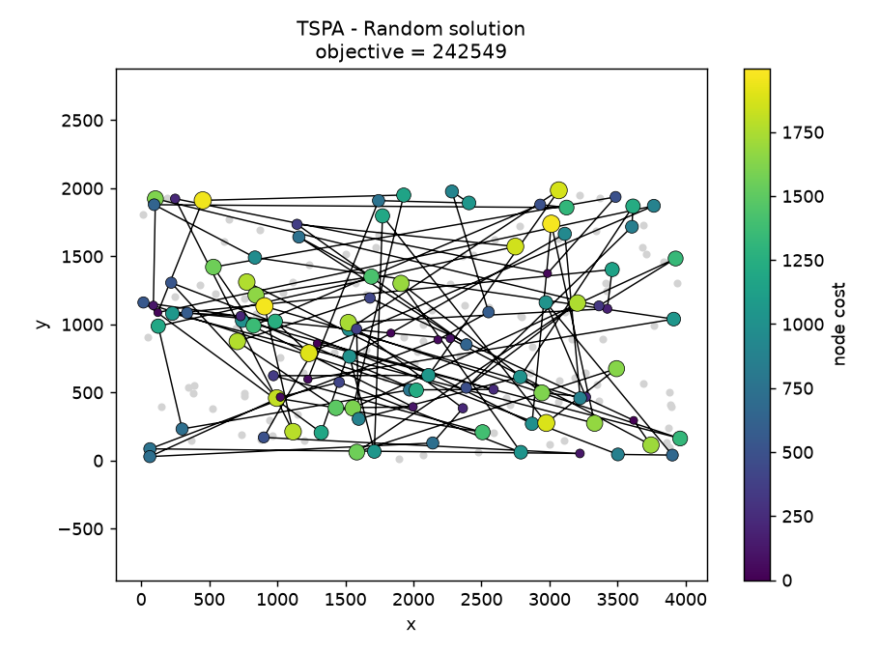 | 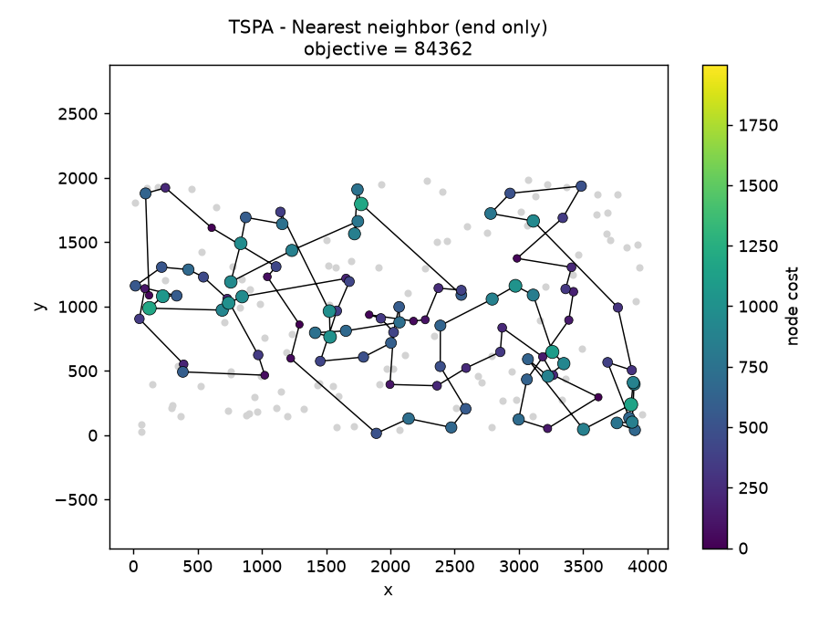
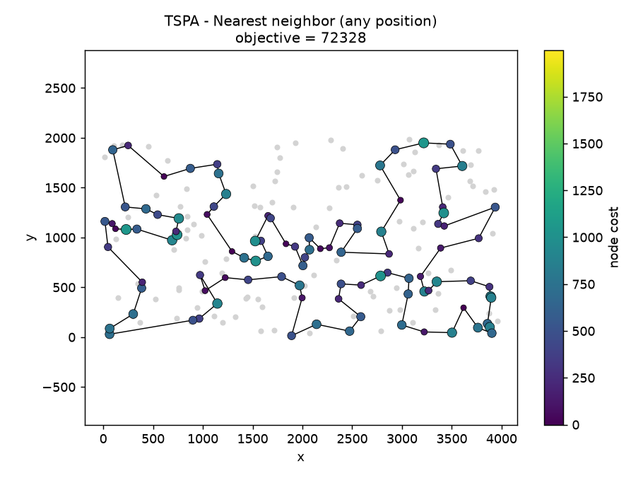 | 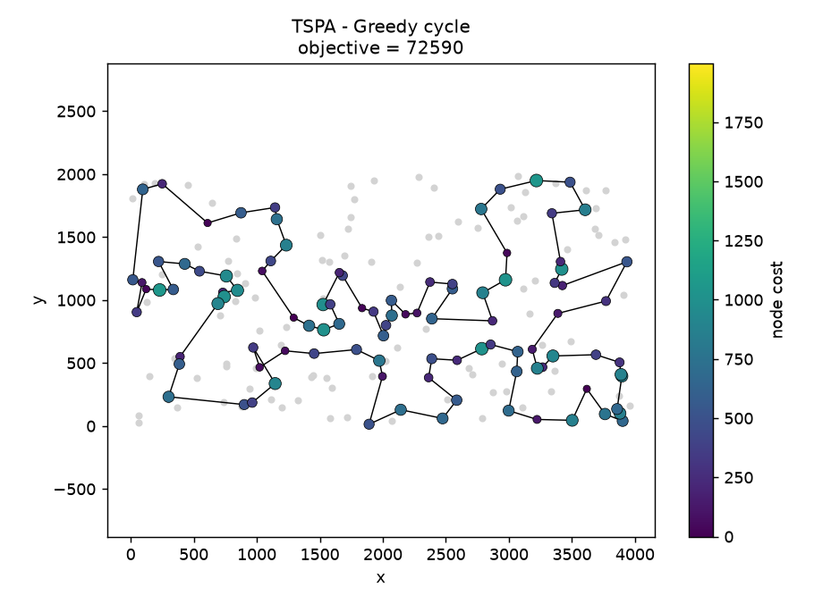
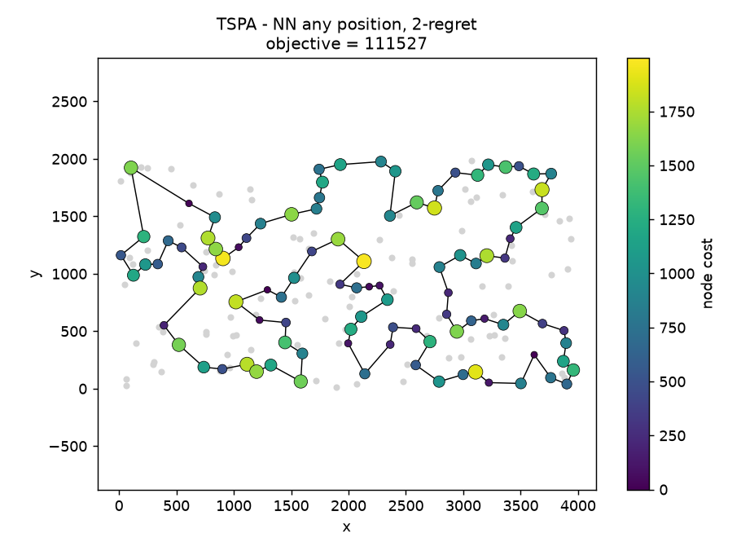 | 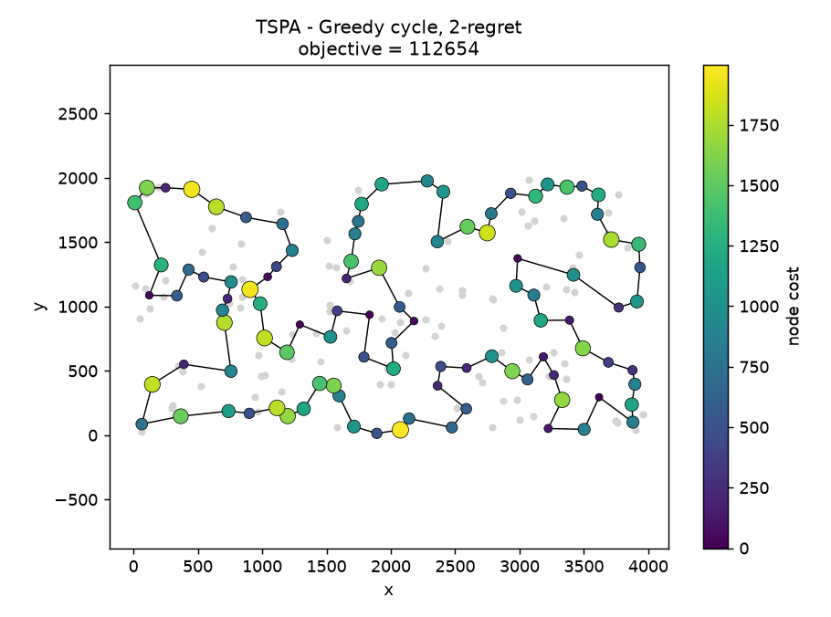
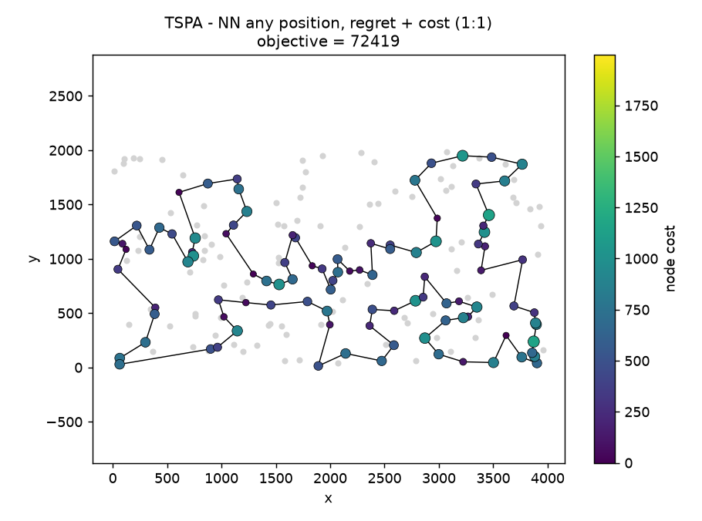 | 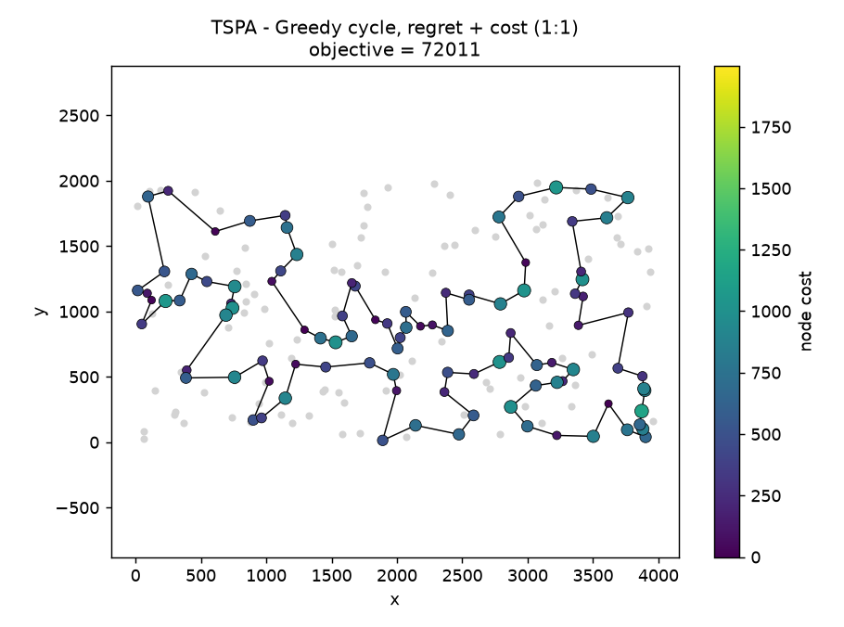
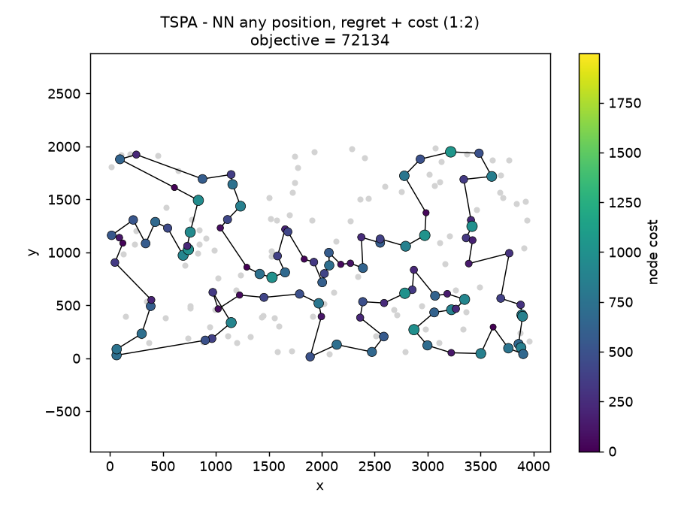 | 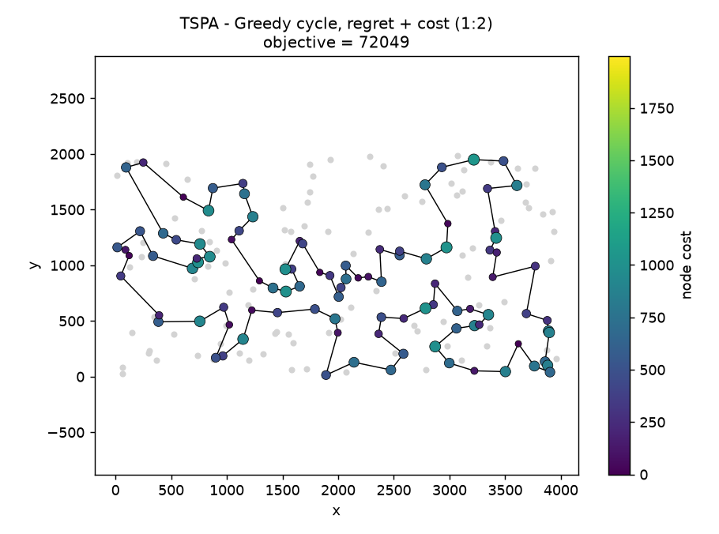
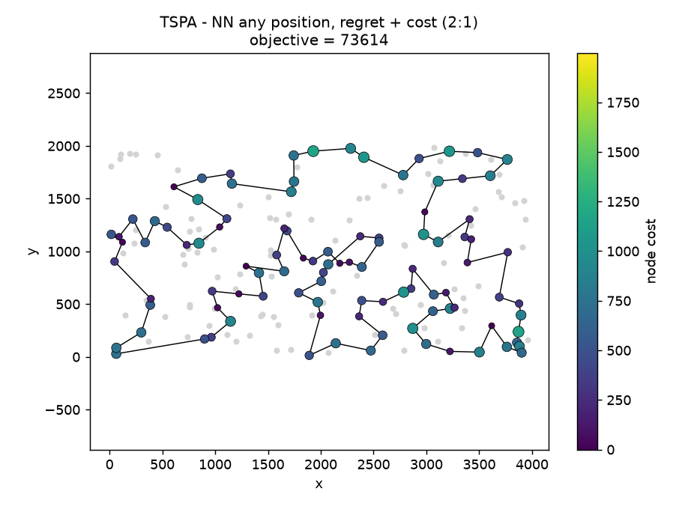 | 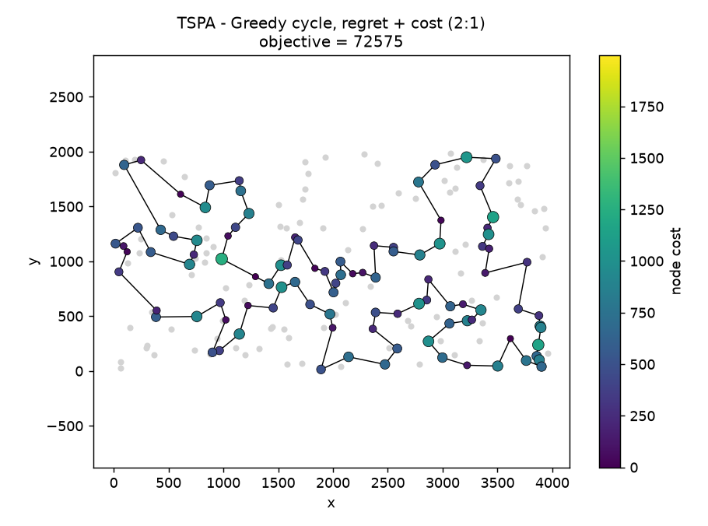
TSPB
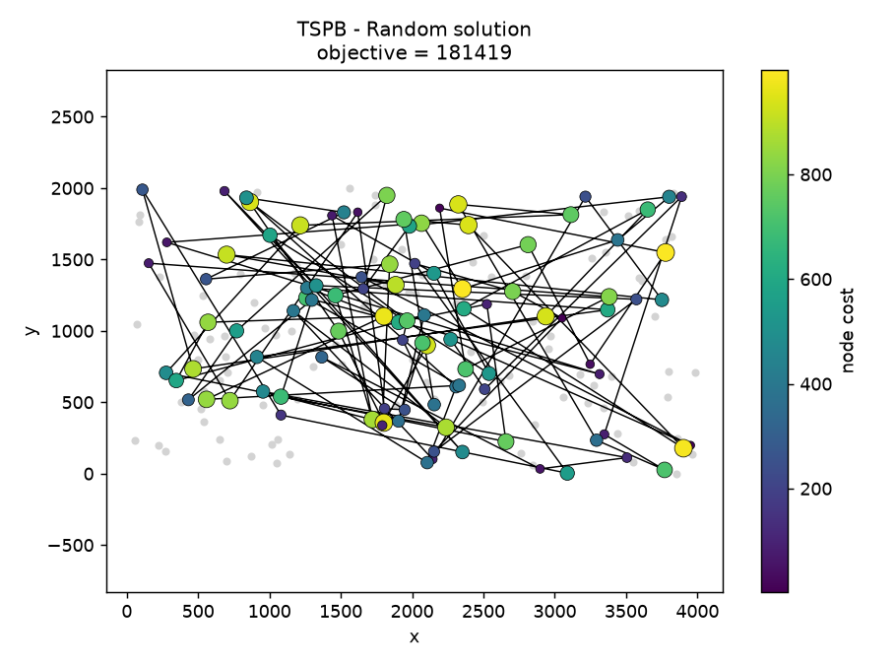 | 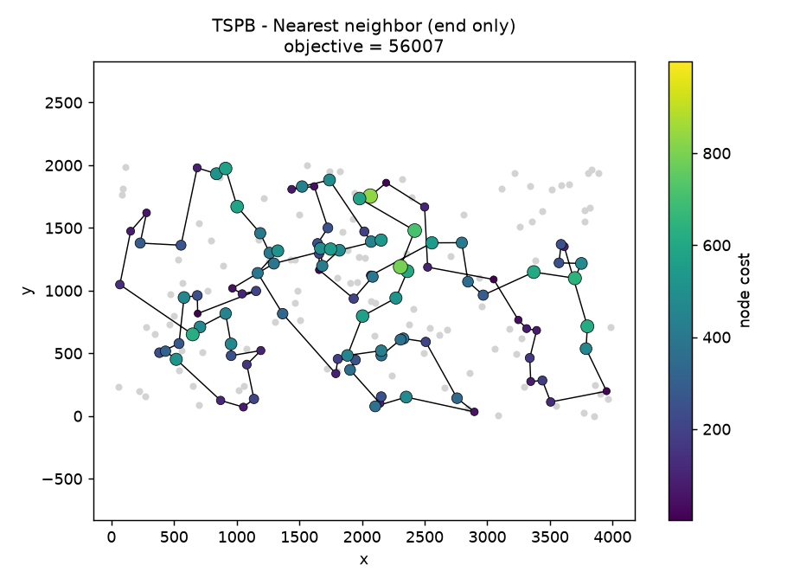
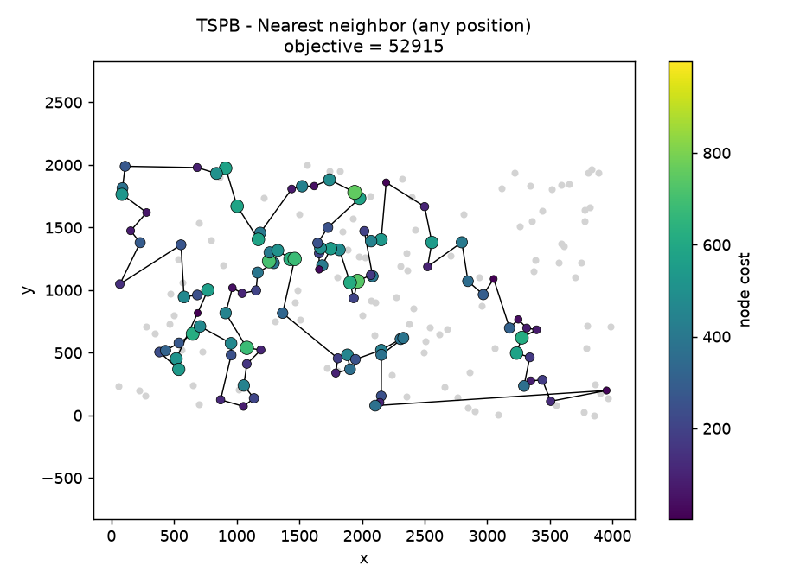 | 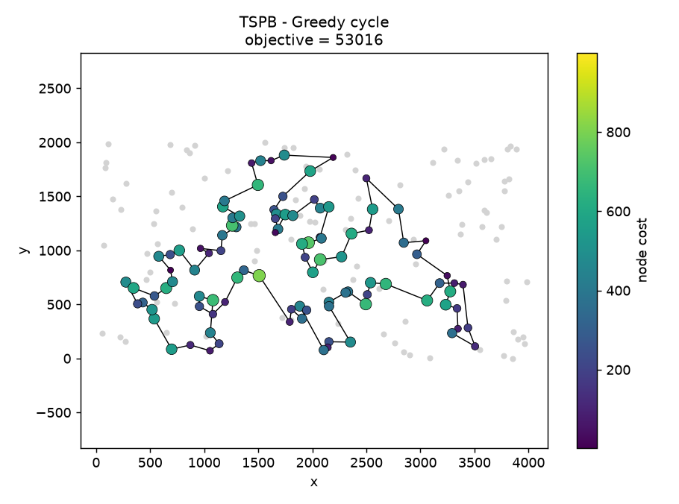
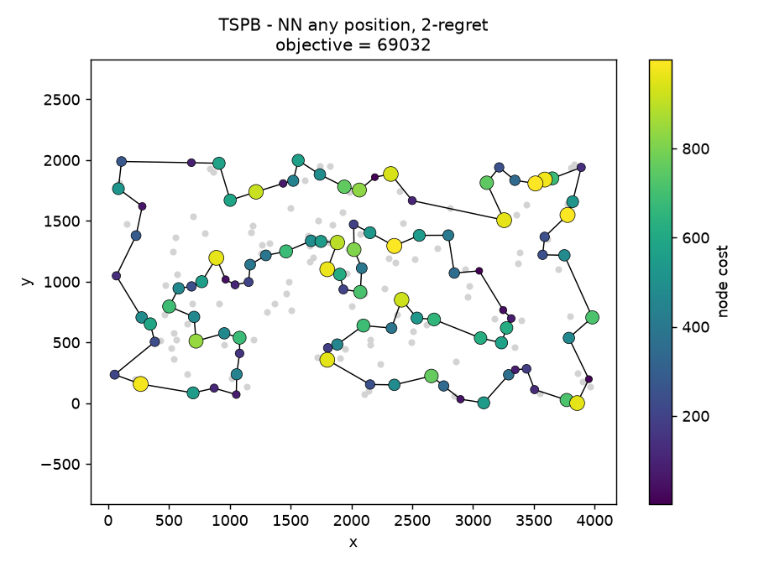 | 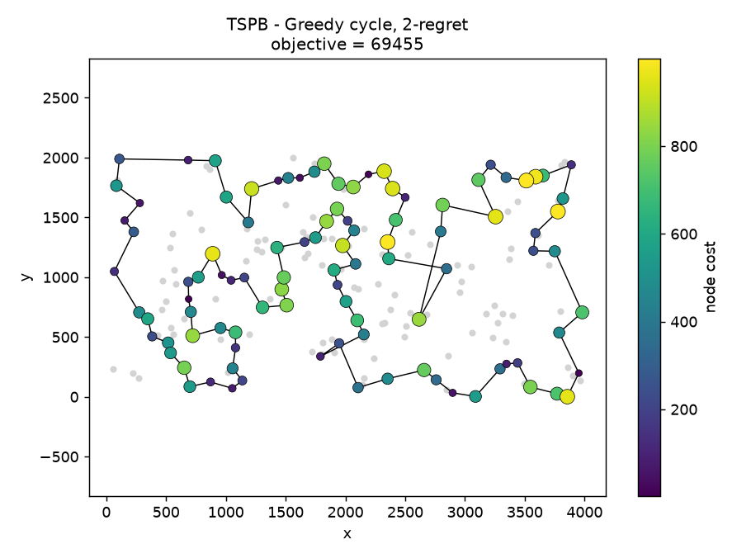
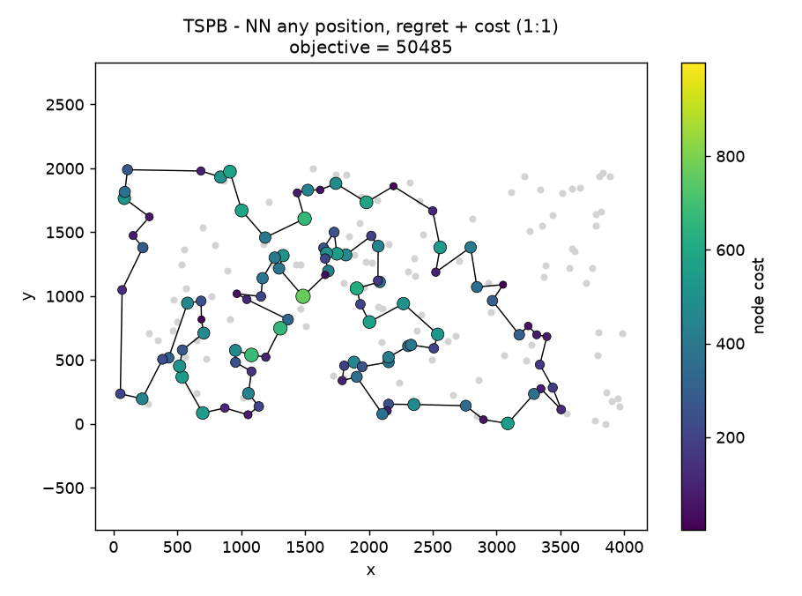 | 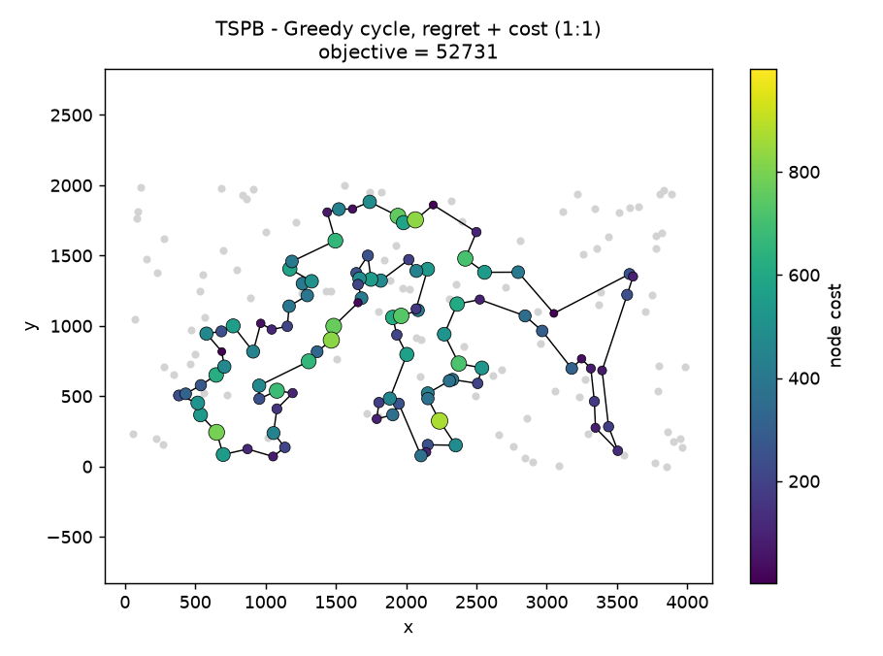
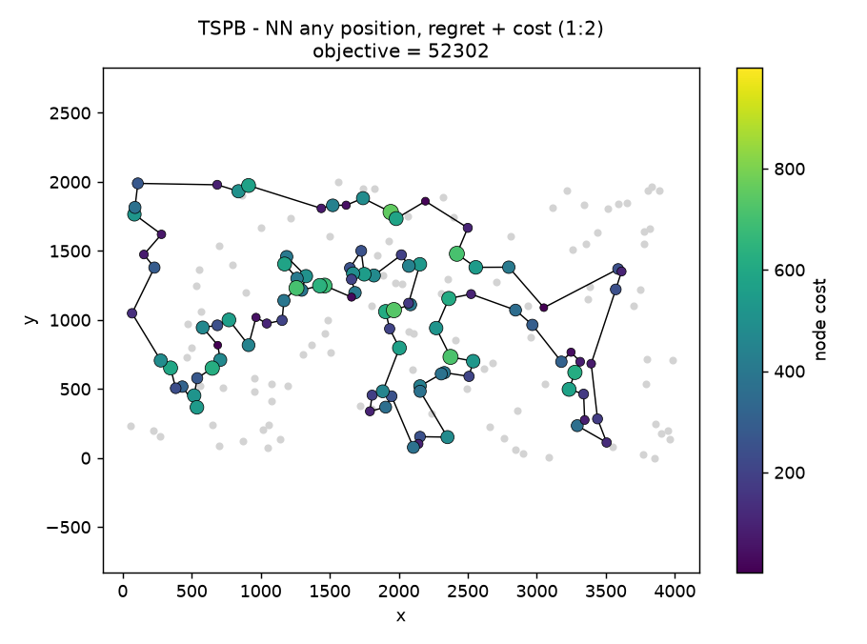 | 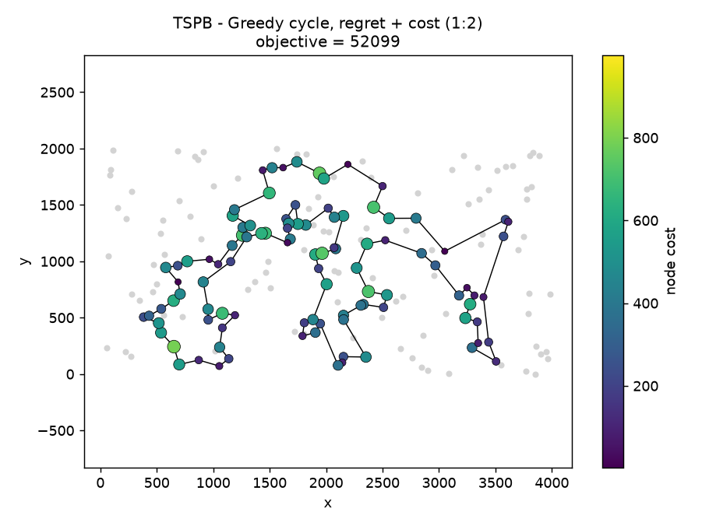
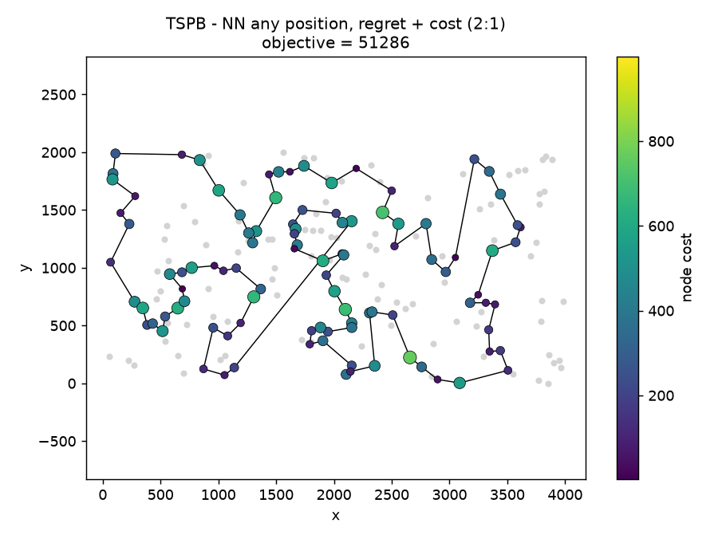 | 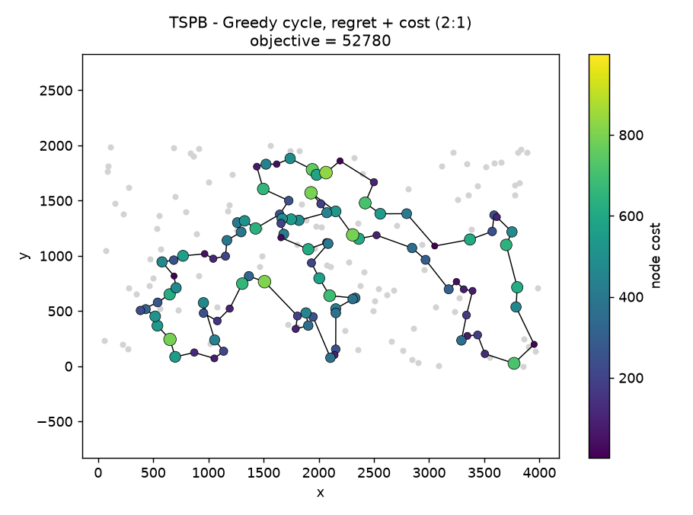
5. The best solutions for each instance and method (node indices starting from 0) with objective values
TSPA:
- Random 242549: 54,177,129,57,171,180,26,156,197,41,30,20,40,60,64,78,142,89,0,190,111,87,187,104,181,58,172,50,59,11,124,195,138,14,44,133,71,131,157,109,119,69,73,134,83,135,96,12,16,107,122,36,67,49,123,61,149,199,3,21,70,175,126,63,55,191,162,116,10,35,98,72,17,101,84,128,22,117,165,5,25,102,184,42,68,166,48,164,29,66,148,136,24,31,38,37,141,115,154,39
- NN (end only) 84362: 54,9,33,36,177,67,144,53,135,58,134,176,174,106,89,107,57,182,151,93,50,3,1,164,178,29,136,186,184,47,159,130,153,78,88,193,170,146,75,64,150,42,113,43,85,142,8,131,84,158,192,181,114,141,180,132,76,80,48,31,63,149,168,97,127,187,30,123,152,108,60,116,49,11,119,160,83,90,51,16,35,87,45,140,52,179,185,28,102,156,157,71,91,38,100,4,112,139,115,5
- NN (any position) 72328: 104,129,69,127,97,168,116,149,63,11,49,160,83,123,100,152,108,60,31,48,80,91,157,71,4,76,132,180,28,102,185,35,156,51,16,67,144,140,53,179,52,177,36,33,9,54,131,174,8,164,186,136,163,29,101,178,1,169,3,50,147,47,93,106,42,89,113,130,159,146,170,153,193,78,88,107,64,57,182,151,150,176,72,134,84,58,158,192,181,114,135,73,45,87,141,187,30,189,2,171
- Greedy cycle 72590: 31,116,149,168,63,11,49,60,108,152,100,90,123,83,160,97,127,69,171,2,189,30,187,141,87,45,73,135,114,181,192,158,58,84,134,72,176,150,151,182,57,64,107,88,78,193,153,170,146,159,130,113,89,42,106,93,47,147,50,3,169,1,178,101,29,163,136,186,164,142,8,174,131,54,9,33,36,177,52,179,53,140,144,67,16,51,156,35,185,102,28,180,132,76,4,71,157,91,80,48
- NN any + 2-regret 111527: 199,82,116,119,11,49,108,152,123,160,12,97,120,92,171,166,183,10,22,98,27,87,141,23,180,28,156,16,190,74,144,179,177,36,99,41,61,135,181,58,84,134,65,158,111,182,105,57,64,107,88,78,26,75,170,159,130,117,113,106,150,0,176,174,8,142,85,128,3,1,59,46,86,55,17,29,19,163,24,136,186,109,34,62,154,39,175,115,5,112,139,18,4,76,132,68,44,14,38,80
- Greedy cycle + 2-regret 112654: 133,139,112,5,175,39,154,62,34,109,186,136,24,163,19,29,17,101,155,21,147,37,47,169,164,142,85,81,93,117,130,159,170,75,193,107,64,57,124,89,106,151,0,72,134,84,58,158,192,181,118,114,25,98,70,27,10,183,166,171,92,110,129,188,97,161,12,160,123,100,152,108,49,63,82,77,199,48,126,137,91,71,4,76,132,68,162,23,145,180,102,35,67,45,61,140,177,52,190,51
- NN any + weighted (1:1) 72419: 171,2,189,187,30,141,87,45,73,135,114,181,192,158,58,84,134,72,176,174,150,106,113,89,42,151,138,182,57,64,107,88,78,193,153,75,170,146,159,130,47,93,50,3,169,1,59,178,101,55,29,163,136,186,164,142,8,9,54,33,131,36,177,52,179,53,140,144,67,16,51,35,185,102,28,180,132,76,4,71,157,91,80,100,123,83,160,152,108,49,60,116,149,63,168,97,127,69,129,104
- Greedy cycle + weighted (1:1) 72011: 31,60,116,149,63,168,11,49,108,152,100,123,83,160,97,127,161,30,187,171,2,189,141,87,45,73,135,114,181,192,158,58,84,134,72,176,174,150,106,113,89,42,151,138,182,57,64,107,88,78,193,153,75,170,146,159,130,47,93,50,3,169,1,178,101,55,29,163,136,186,164,142,8,9,54,33,131,36,177,52,179,53,140,144,67,16,51,35,185,102,28,180,132,76,4,71,157,91,80,48
- NN any + weighted (1:2) 72134: 104,129,69,127,97,168,63,149,116,60,49,108,152,160,83,123,100,38,80,31,48,91,157,71,4,76,132,180,28,102,185,35,51,16,67,144,140,53,179,52,177,36,131,33,54,9,8,142,164,186,136,163,29,101,178,1,169,3,50,93,47,130,159,146,170,153,193,78,88,107,64,57,182,138,151,42,89,113,106,150,174,176,72,134,84,58,158,192,181,114,135,73,45,87,141,187,30,189,2,171
- Greedy cycle + weighted (1:2) 72049: 38,91,157,71,4,76,132,180,28,102,185,35,156,51,16,67,144,140,53,179,52,177,36,131,33,54,9,8,142,164,186,136,163,29,101,178,1,169,3,50,93,47,130,159,146,170,153,193,78,88,107,64,57,182,138,151,42,89,113,106,150,174,176,72,134,84,58,158,192,181,114,135,73,45,87,141,189,2,171,187,30,161,127,97,168,63,149,116,60,49,160,83,123,90,100,152,108,31,48,80
- NN any + weighted (2:1) 73614: 104,129,69,127,97,168,63,116,149,60,49,108,152,123,90,132,76,38,80,91,157,71,139,112,115,175,39,154,186,136,163,29,55,101,178,184,164,142,85,1,3,50,93,47,130,159,170,75,153,193,78,88,107,64,57,182,138,151,42,89,106,150,174,176,72,134,84,58,158,192,181,114,135,73,45,140,53,179,33,9,54,131,36,177,52,144,67,16,51,35,185,180,28,87,141,30,187,189,2,171
- Greedy cycle + weighted (2:1) 72575: 102,87,141,189,2,171,187,30,161,127,97,168,63,149,116,60,49,160,123,100,152,108,31,48,80,38,91,157,71,4,76,132,162,180,28,156,35,51,16,67,144,140,53,179,52,177,36,131,33,9,54,8,142,164,186,136,163,29,178,59,1,169,3,50,93,47,130,159,146,170,75,153,193,78,88,107,64,57,182,138,151,42,89,113,106,150,174,176,72,134,84,58,158,192,181,114,135,73,45,185
TSPB:
- Random 181419: 176,129,149,32,0,187,81,156,172,164,26,29,21,141,126,38,87,190,148,123,95,133,110,27,67,105,20,93,74,44,194,195,178,163,76,122,30,78,97,82,34,7,173,151,181,43,83,100,135,169,159,102,37,60,17,72,144,54,179,10,183,116,88,50,66,86,121,107,168,77,127,193,89,11,41,28,113,96,59,167,64,171,2,155,101,124,147,198,158,92,85,22,111,51,3,103,55,128,5,24
- NN (end only) 56007: 32,89,57,76,54,127,129,90,153,20,14,2,110,118,56,114,196,10,148,143,78,192,162,104,185,184,3,151,69,172,133,120,96,121,198,48,72,46,86,117,160,136,8,21,154,140,47,170,125,177,6,132,29,197,175,134,45,60,40,71,155,97,115,180,65,28,149,145,158,116,147,42,50,130,30,183,38,64,85,59,167,51,87,179,82,88,171,99,67,24,34,181,152,73,98,27,135,75,79,156
- NN (any position) 52915: 110,2,14,20,74,153,182,52,90,129,127,80,54,192,162,104,76,185,57,89,86,46,72,3,184,173,151,122,117,8,160,69,172,136,133,120,156,43,48,96,198,121,130,191,50,42,147,116,37,146,13,149,28,145,65,158,177,125,26,170,197,36,132,29,6,180,115,155,71,175,134,45,157,60,40,141,97,154,140,47,38,21,176,30,183,189,168,64,59,85,51,73,167,152,34,24,181,179,87,82
- Greedy cycle 53016: 49,64,33,40,60,71,155,141,157,45,134,175,62,36,197,29,132,178,103,6,180,115,170,177,125,26,97,140,154,47,38,21,176,30,183,191,130,63,121,198,96,48,89,156,120,133,136,172,160,69,8,117,72,46,86,184,3,173,122,151,98,111,27,135,76,185,57,104,162,54,192,127,52,182,153,20,74,2,14,90,129,80,150,84,66,67,31,24,34,152,181,88,179,87,82,73,167,51,59,85
- NN any + 2-regret 69032: 57,44,89,32,43,48,58,198,121,195,50,42,116,37,13,149,145,65,178,103,132,1,108,62,175,134,157,60,141,155,113,115,19,177,125,26,161,154,140,47,38,21,168,136,8,95,128,122,151,111,3,137,72,86,0,185,104,162,54,127,129,52,182,150,84,66,35,24,25,73,59,101,179,88,163,99,171,17,74,20,14,2,93,23,110,118,131,148,10,196,193,61,105,169,165,199,70,190,194,12
- Greedy cycle + 2-regret 69455: 167,82,88,163,99,171,17,74,20,14,9,93,23,110,118,131,148,10,196,193,61,105,169,165,199,70,190,194,12,77,104,119,162,135,0,79,57,83,44,89,32,43,164,48,96,198,121,195,130,50,42,116,37,13,149,28,145,65,178,103,132,197,36,91,62,175,134,45,157,60,141,155,113,115,170,125,26,161,154,140,47,33,49,4,124,189,172,8,92,166,72,46,109,3,122,151,98,25,152,85
- NN any + weighted (1:1) 50485: 65,145,28,149,13,146,37,116,147,42,50,130,63,121,198,96,48,156,89,57,185,76,104,162,54,192,80,127,129,90,153,14,2,20,74,17,171,99,88,179,87,82,51,85,59,73,167,181,152,34,24,67,66,27,98,151,122,3,184,46,72,117,8,120,133,136,172,160,69,124,21,183,30,38,47,154,140,64,33,40,141,155,71,60,157,45,134,175,62,36,197,6,115,170,125,177,29,132,174,1
- Greedy cycle + weighted (1:1) 52731: 91,36,197,132,29,6,180,115,170,177,125,26,97,154,140,47,38,21,30,183,191,130,63,121,198,96,48,43,156,32,89,57,79,185,104,54,196,114,10,90,14,2,20,153,129,127,80,192,162,76,135,27,11,66,67,24,34,152,181,126,88,179,87,82,167,51,85,59,73,98,151,122,173,3,184,86,46,72,117,8,120,133,136,172,160,69,124,4,64,33,155,71,141,40,60,157,45,134,175,62
- NN any + weighted (1:2) 52302: 121,198,96,48,43,156,89,57,79,185,104,54,196,114,10,90,14,2,74,20,153,182,52,129,127,80,192,162,76,135,27,11,66,67,24,34,152,181,88,179,87,82,167,51,85,59,73,98,151,122,173,3,184,86,46,72,117,8,120,133,136,172,160,69,168,189,21,183,130,191,30,176,38,47,140,154,97,26,125,177,170,115,180,6,197,36,29,132,103,178,65,145,28,149,13,146,37,116,147,42
- Greedy cycle + weighted (1:2) 52099: 91,36,197,132,29,6,180,115,170,177,125,26,154,140,38,176,30,183,191,130,63,121,198,96,48,43,156,89,57,79,185,104,54,196,114,10,90,14,2,74,20,153,182,52,129,127,80,192,162,76,135,27,11,66,67,24,34,152,181,88,179,87,82,167,51,85,59,73,98,151,122,173,3,184,86,46,72,117,8,120,133,136,172,160,69,168,189,21,47,97,155,71,141,40,60,157,45,134,175,62
- NN any + weighted (2:1) 51286: 86,46,72,120,133,136,172,160,69,122,184,3,151,98,25,152,181,167,73,59,85,51,179,82,87,88,34,24,67,163,99,171,17,2,14,20,153,90,129,80,127,78,10,114,196,187,70,190,54,192,162,104,76,185,79,57,89,156,48,96,198,121,63,183,21,30,130,50,147,116,37,146,13,149,28,145,65,178,103,132,29,197,6,180,115,170,177,125,26,154,140,47,64,33,40,60,71,175,134,45
- Greedy cycle + weighted (2:1) 52780: 49,64,33,40,60,71,155,157,45,134,175,62,91,36,197,29,132,6,180,115,170,177,125,26,154,140,47,38,21,30,183,189,133,120,63,121,198,96,48,43,156,32,89,57,79,185,104,54,78,10,196,114,148,143,56,118,110,93,2,14,20,74,153,90,129,127,80,192,162,76,135,75,86,166,72,46,117,8,136,172,160,69,122,184,3,151,98,25,24,34,152,181,179,87,82,167,73,51,85,59
6. Information whether the best solutions have been checked with the solution checker
We checked all of the best solutions with the solution checker. The objective value computed by the checker equaled the best value from Section 3 in every case.
7. (Link to) the source code
https://github.com/toska05/EC_laboratories (directory lab2)
8. Conclusions
Pure 2-regret does not work for this problem
Both 2-regret methods are much worse than the lab 1 greedy methods. On TSPA the average is about 121 000–123 000 against about 74 000 for NN any and greedy cycle (around 65% worse). On TSPB it is about 73 000–75 000 against about 59 500 (around 23–26% worse). The 2-regret methods are still about 53–54% (TSPA) and 64% (TSPB) better than random, so it is a valid construction method, but it is not competitive with the plain greedy.
The reason is probably the form of the criterion. Regret tells how much we lose by waiting. It does not tell how expensive the insertion is. A node that is far from the current solution or has a high cost has a big difference between its best and second best position, so it gets a high regret and is inserted early, even when its insertion cost is large. This was a bad choice in our instances, where every selected node also adds its own cost. (This is our explanation. We did not run a test to prove it.)
The weighted criterion fixes the problem
When the best insertion cost is added to the criterion, the results come back to the level of the lab 1 methods and in most cases get better. With equal weights the greedy cycle improved its average on TSPA from 73797 to 73349 (−0.6%) and on TSPB from 59710 to 57896 (−3.0%). NN any with equal weights improved the average on TSPB from 59476 to 55698 (−6.4%), but it was worse on TSPA (74347 to 75561, +1.6%).
The best single solutions also come from the weighted methods: 72011 on TSPA (greedy cycle, 1:1) against 72328 for the best lab 1 method, and 50485 on TSPB (NN any, 1:1) against 52915 (−4.6%).
Influence of the weights
Weights have a clear influence on the results, but the best weights depend on the instance and on the base method:
- Greedy cycle: the more weight on the objective change, the better on both instances. The 1:2 variant has the best average on TSPA (73193) and the second best on TSPB (55679). The 2:1 variant is the worst of the three on both instances; on TSPB (59664) it gives almost the same average as the plain greedy cycle (59710).
- NN any: the result differs between instances. On TSPB more weight on regret (2:1) is the best (avg 54740, −8.0% against plain NN any), while on TSPA it is the worst (76416), and 1:2 is better there.
We tested only three weight pairs, so we cannot say which weights are optimal. A finer search (for example, a grid over w1/w2) could give better results, but it would need to be done separately for each instance.
Comparison of the two bases
On TSPA the greedy cycle base is better than NN any in all variants (the average is lower by about 2.8–2.9% for the weighted variants and by 0.7% for the plain methods), and it also has a smaller spread between min and max. On TSPB the picture is mixed: NN any gives better averages with weights 1:1 (3.9%) and 2:1 (9.0%) and the best single solution, but the greedy cycle is better with weights 1:2 (0.8%) and for the plain methods (0.4%). The greedy cycle is therefore the more stable choice, and NN any can give better results, but it is more sensitive to the instance and to the weights. The different behavior of the two bases is probably connected with the path model: in NN any the first and last positions of the path are evaluated with only one new edge, so the closing edge of the final cycle is not considered during the construction.
General remarks
- All greedy methods except the pure 2-regret are about 67–72% (TSPA) and 71–74% (TSPB) better on average than random solutions. The differences between these methods (a few percent) are much smaller than the difference to random.
- The starting node still matters. For every method the difference between min and max over all starting nodes is between about 4% and 25% of the min value, so running a method from every node and keeping the best solution is worthwhile.
- Regret and the weighted criterion need more calculation than the plain greedy methods because the second best insertion must be found for every free node. In our experiment, the whole program with all 12 methods and both instances ran in about 7 seconds, so this is not a problem for instances of this size.
- All methods are still constructive: they never change an earlier decision. The next step could be to use these solutions as starting points for a local search, which would probably give better results than any of the tested weights.

