EC – Lab 1 Report
- Description of the problem
There is a given set of nodes in the plane, each node with x, y coordinates and an integer cost. We have to choose half of them (100) and connect them into a closed path (Hamiltonian cycle) so that the objective (total length of the cycle + total cost of the selected nodes) is minimal.

Distances are Euclidean, rounded to integers. The distance matrix is computed once after reading an instance, and the algorithms use only this matrix and the node costs. We use two instances (TSPA and TSPB), each with 200 nodes.

In this assignment we implemented local search in the steepest and the greedy version, with two kinds of intra-route moves (exchange of two nodes and exchange of two edges) and with two kinds of starting solutions (random and the best greedy construction heuristic from the previous assignments). This gives 8 local search methods. The results are compared with all methods from the previous assignments.

Notation: V – all nodes, S – current solution (cycle of k = 100 selected nodes), U – nodes not selected, d[i][j] – distance, c[j] – node cost.

- Pseudocode of all implemented algorithms
Neighborhood and deltas. A move is stored only as a definition (type, a, b), without any modified solution. The change of the objective function (delta) is calculated only from the few edges and nodes that change, so the objective is never recalculated from scratch.

Inter-route move (exchange of nodes): the selected node S[i] (neighbors a = S[i-1], b = S[i+1]) is replaced by a not selected node u.

delta = d[a][u] + d[u][b] - d[a][S[i]] - d[S[i]][b] + c[u] - c[S[i]]

Intra-route move 1, exchange of two nodes S[i] and S[j]: the set of nodes does not change, so costs cancel out. For non-adjacent nodes four edges change, for adjacent ones (also S[k-1] and S[0]) three.

pi, ni = neighbors of S[i]; pj, nj = neighbors of S[j]
delta = d[pi][S[j]] + d[S[j]][ni] + d[pj][S[i]] + d[S[i]][nj]
- d[pi][S[i]] - d[S[i]][ni] - d[pj][S[j]] - d[S[j]][nj]
adjacent (j = i+1): delta = d[pi][S[j]] + d[S[i]][nj] - d[pi][S[i]] - d[S[j]][nj]
Intra-route move 2, exchange of two edges: edges (S[i], S[i+1]) and (S[j], S[j+1]) are replaced by (S[i], S[j]) and (S[i+1], S[j+1]); the part of the cycle between them is reversed. Edges sharing a node are not used.

delta = d[S[i]][S[j]] + d[S[i+1]][S[j+1]] - d[S[i]][S[i+1]] - d[S[j]][S[j+1]]

The neighborhood has 10 000 inter-route moves (100 selected × 100 not selected) and 4 950 intra-route moves for the nodes exchange (4 850 for the edges exchange), so 14 950 (14 850) moves in total.

Steepest local search

STEEPEST-LS(S, intraType)
M <- definitions of all moves (inter-route + intra-route of type intraType)
repeat
best <- 0; m* <- none
for each move m in M:
delta <- DELTA(m, S)
if delta < best then best <- delta; m* <- m
if m* = none then return S // local optimum
apply m* to S

Greedy local search

GREEDY-LS(S, intraType)
M <- definitions of all moves (inter-route + intra-route of type intraType)
repeat
improved <- false
for idx <- 0 to |M| - 1:
r <- random integer from [idx, |M| - 1]
swap M[idx] and M[r] // lazy Fisher-Yates step
delta <- DELTA(M[idx], S) // the move is evaluated only now
if delta < 0 then
apply M[idx] to S; improved <- true; break
until improved = false // local optimum

Randomization in the greedy version. The moves of both kinds (inter- and intra-route) are kept in one list, so the first checked move can be of any kind and we never start with one kind of moves. The list is not shuffled in advance. We use the lazy (on-line) version of the Fisher–Yates shuffle: at position idx one move is drawn uniformly from the not yet visited part of the list, put at position idx and evaluated immediately. Therefore the delta is calculated only for the moves that were really checked (until the first improving one), not for the whole neighborhood. After an improving move is applied, a new pass starts and the draws are repeated, so every pass uses a new uniformly random order and there is no bias towards any move. The generator has a fixed seed (777), so the results can be reproduced.

Starting solutions

Random: a random permutation of V, the first k = 100 nodes (200 random solutions).
Greedy: the best construction heuristic from the previous assignments (chosen by the average objective over 200 starts), built from a given starting node s; each of the 200 nodes was used once as s. For TSPA it was the greedy cycle with the weighted criterion (w1:w2 = 1:2), for TSPB the nearest neighbor with insertion at any position and the weighted criterion (2:1).

WEIGHTED-REGRET(s, w1, w2, base) // base = greedy cycle or NN any position
S <- [s] (greedy cycle: [s, nearest node by d[s][j] + c[j]]); U <- V \ S
while |S| < k:
for each j in U:
best1(j), best2(j) <- best and second best insertion cost of j over all positions in S
regret(j) <- best2(j) - best1(j)
score(j) <- w1 * regret(j) - w2 * best1(j)
j* <- node with the highest score; insert j* at its best position; U <- U \ {j*}
return S

(2-regret is the case w2 = 0.)

Implementation check. In a debug build, for every applied move the delta was compared with the difference of the objective calculated from scratch; no difference was found.

- Results of a computational experiment: for each instance and method min, max and average value of the objective function.
Each of the eight local search methods was run 200 times: from 200 random solutions, or from the greedy construction started from each of the 200 nodes. The results of all previous methods (200 solutions each) are included. Cells show average (min – max) over 200 runs.

Table 1. Objective function value
Inst. | Method | Min | Max | Avg
TSPA | Random | 242549 | 285144 | 262271.5
TSPA | NN (end only) | 84362 | 90075 | 87476.6
TSPA | NN (any position) | 72328 | 77022 | 74347.0
TSPA | Greedy cycle | 72590 | 75281 | 73797.4
TSPA | NN any + 2-regret | 111527 | 133181 | 122860.7
TSPA | Greedy cycle + 2-regret | 112654 | 130924 | 121007.2
TSPA | NN any + weighted (1:1) | 72419 | 78504 | 75561.2
TSPA | Greedy cycle + weighted (1:1) | 72011 | 75532 | 73348.7
TSPA | NN any + weighted (1:2) | 72134 | 78210 | 75296.9
TSPA | Greedy cycle + weighted (1:2) | 72049 | 75232 | 73192.6
TSPA | NN any + weighted (2:1) | 73614 | 79873 | 76416.4
TSPA | Greedy cycle + weighted (2:1) | 72575 | 76095 | 74283.9
TSPA | Steepest, nodes, random start | 81898 | 96995 | 89890.4
TSPA | Steepest, nodes, greedy start | 71955 | 74976 | 72862.7
TSPA | Steepest, edges, random start | 73958 | 80341 | 76301.1
TSPA | Steepest, edges, greedy start | 71925 | 74612 | 72812.1
TSPA | Greedy, nodes, random start | 81382 | 96000 | 88219.7
TSPA | Greedy, nodes, greedy start | 71955 | 74976 | 72865.7
TSPA | Greedy, edges, random start | 73890 | 78611 | 76162.5
TSPA | Greedy, edges, greedy start | 71955 | 74612 | 72819.4
TSPB | Random | 181419 | 236900 | 206684.8
TSPB | NN (end only) | 56007 | 63166 | 59397.3
TSPB | NN (any position) | 52915 | 66164 | 59475.5
TSPB | Greedy cycle | 53016 | 63736 | 59709.5
TSPB | NN any + 2-regret | 69032 | 80767 | 74763.4
TSPB | Greedy cycle + 2-regret | 69455 | 78142 | 73403.4
TSPB | NN any + weighted (1:1) | 50485 | 61406 | 55698.3
TSPB | Greedy cycle + weighted (1:1) | 52731 | 63370 | 57895.5
TSPB | NN any + weighted (1:2) | 52302 | 63489 | 56151.0
TSPB | Greedy cycle + weighted (1:2) | 52099 | 62556 | 55678.6
TSPB | NN any + weighted (2:1) | 51286 | 60794 | 54739.9
TSPB | Greedy cycle + weighted (2:1) | 52780 | 63809 | 59663.9
TSPB | Steepest, nodes, random start | 59950 | 74899 | 66172.7
TSPB | Steepest, nodes, greedy start | 49986 | 57418 | 52764.8
TSPB | Steepest, edges, random start | 50091 | 55600 | 52561.8
TSPB | Steepest, edges, greedy start | 49529 | 56952 | 51876.8
TSPB | Greedy, nodes, random start | 58693 | 70762 | 63785.0
TSPB | Greedy, nodes, greedy start | 49986 | 57418 | 52727.6
TSPB | Greedy, edges, random start | 50699 | 56829 | 53048.9
TSPB | Greedy, edges, greedy start | 49488 | 56342 | 51917.0

Table 2. Running time of one run [ms], average (min – max)
Method | TSPA | TSPB
Random | 0.002 (0.002 – 0.011) | 0.003 (0.002 – 0.095)
NN (end only) | 0.071 (0.055 – 0.69) | 0.094 (0.081 – 0.17)
NN (any position) | 1.30 (1.24 – 2.41) | 2.43 (2.10 – 4.66)
Greedy cycle | 3.62 (3.07 – 6.69) | 5.42 (3.98 – 9.21)
NN any + 2-regret | 6.55 (4.12 – 10.52) | 6.32 (3.48 – 9.41)
Greedy cycle + 2-regret | 9.20 (6.46 – 13.63) | 5.50 (5.03 – 10.44)
NN any + weighted (1:1) | 4.30 (3.40 – 8.11) | 3.83 (3.34 – 6.63)
Greedy cycle + weighted (1:1) | 5.42 (5.00 – 8.79) | 5.34 (4.83 – 8.87)
NN any + weighted (1:2) | 3.78 (3.36 – 6.51) | 3.65 (3.23 – 5.75)
Greedy cycle + weighted (1:2) | 5.38 (5.00 – 8.93) | 5.32 (4.83 – 8.85)
NN any + weighted (2:1) | 3.79 (3.52 – 5.33) | 3.80 (3.39 – 6.50)
Greedy cycle + weighted (2:1) | 5.36 (4.96 – 9.30) | 5.35 (4.76 – 8.76)
Steepest, nodes, random start | 38.30 (24.04 – 72.59) | 39.19 (25.37 – 67.03)
Steepest, nodes, greedy start | 1.17 (0.63 – 4.43) | 3.43 (1.08 – 6.62)
Steepest, edges, random start | 19.61 (16.65 – 31.35) | 19.61 (16.64 – 30.02)
Steepest, edges, greedy start | 0.87 (0.50 – 1.98) | 2.86 (0.82 – 7.12)
Greedy, nodes, random start | 4.76 (2.87 – 11.45) | 4.68 (2.65 – 9.65)
Greedy, nodes, greedy start | 1.27 (0.74 – 3.13) | 2.20 (0.98 – 4.89)
Greedy, edges, random start | 3.01 (1.88 – 6.45) | 3.81 (1.91 – 9.04)
Greedy, edges, greedy start | 1.38 (0.67 – 3.07) | 3.11 (1.52 – 5.98)

- 2D visualization of the best solution for each instance and method. Cost of nodes should be presented e.g. by a color, greyscale, or size.
The selected nodes are connected by the black cycle. The cost of a node is shown by the color and the size of the marker; grey points are the nodes that were not selected. The title of each plot contains the instance, the method and the objective value.

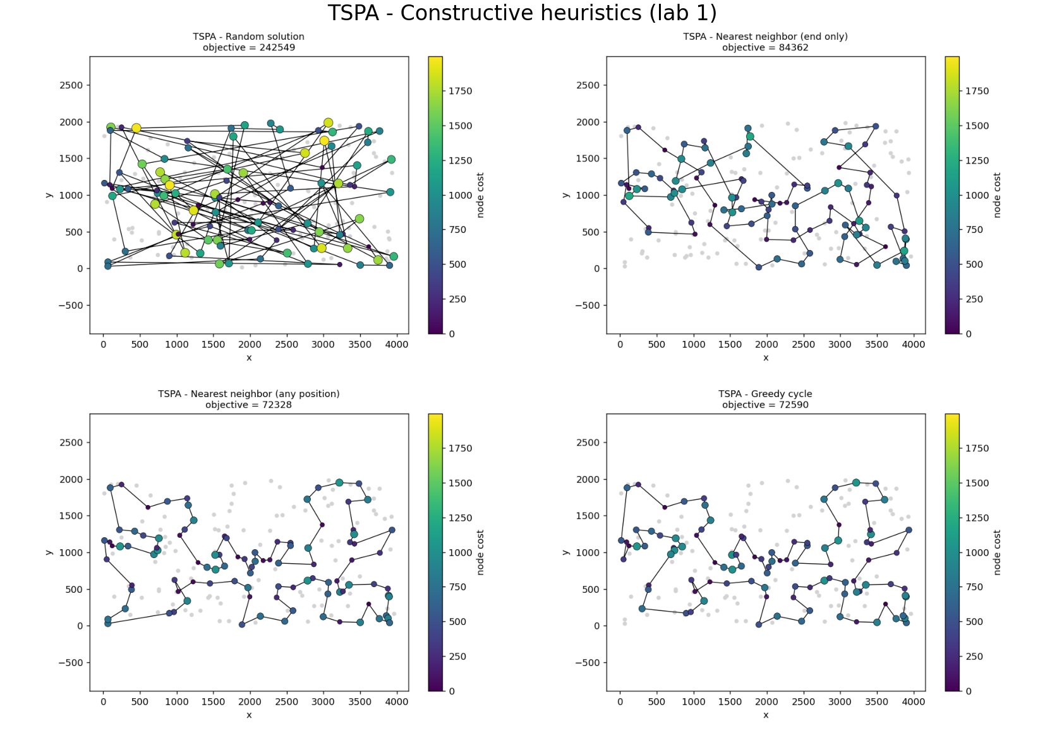
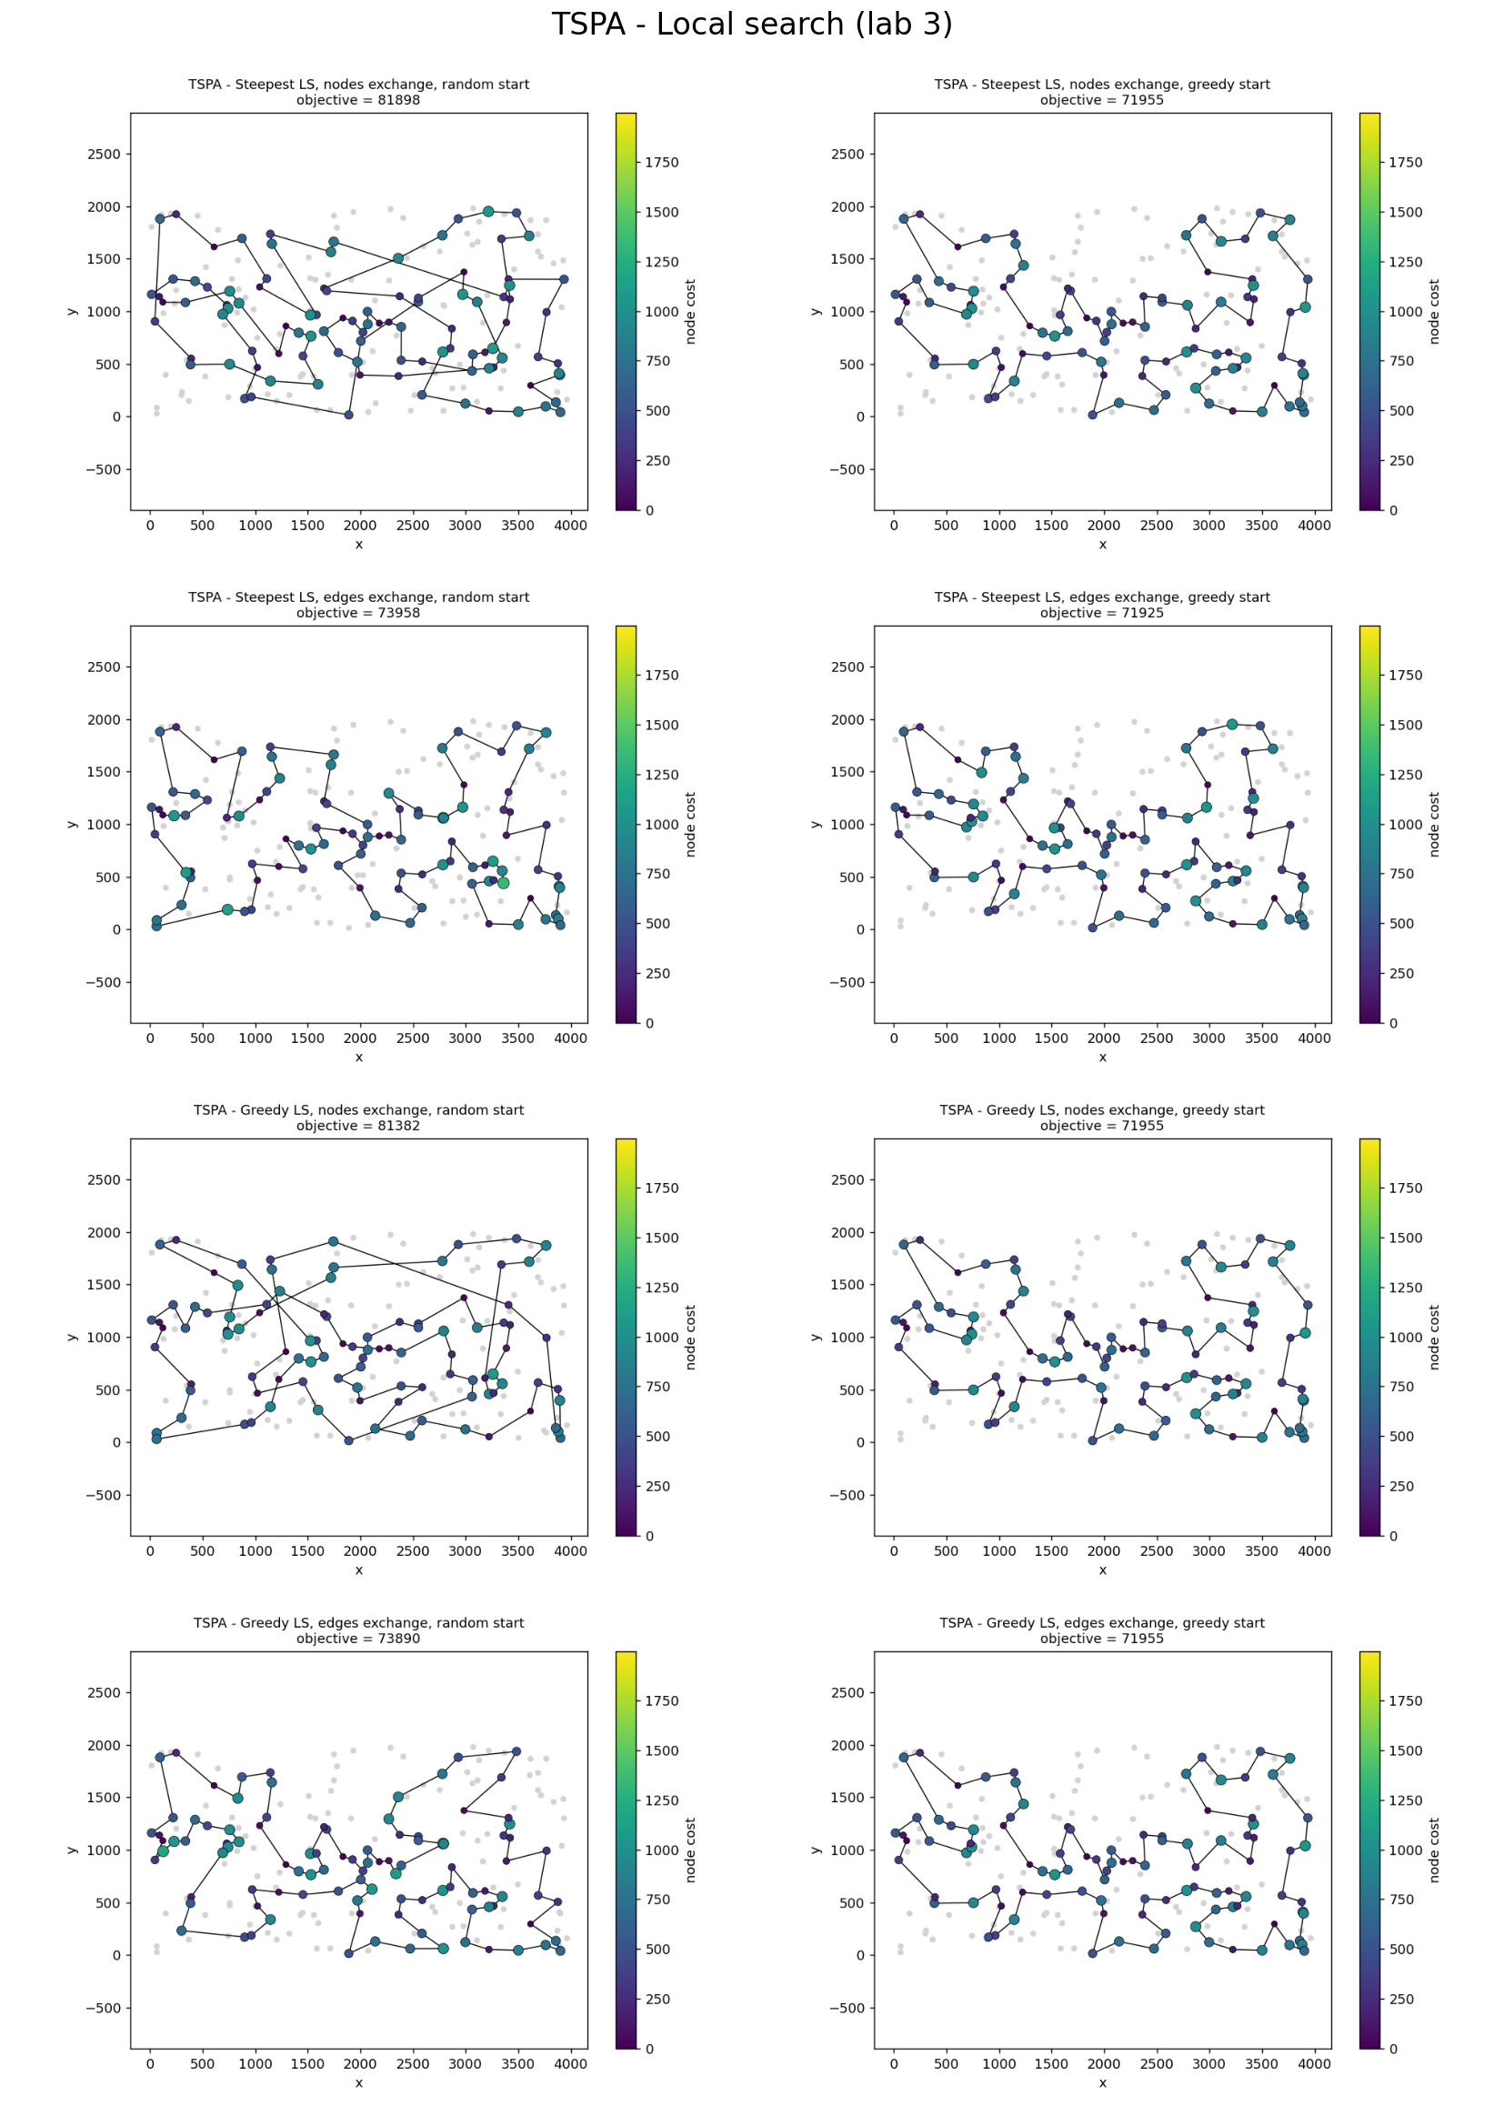
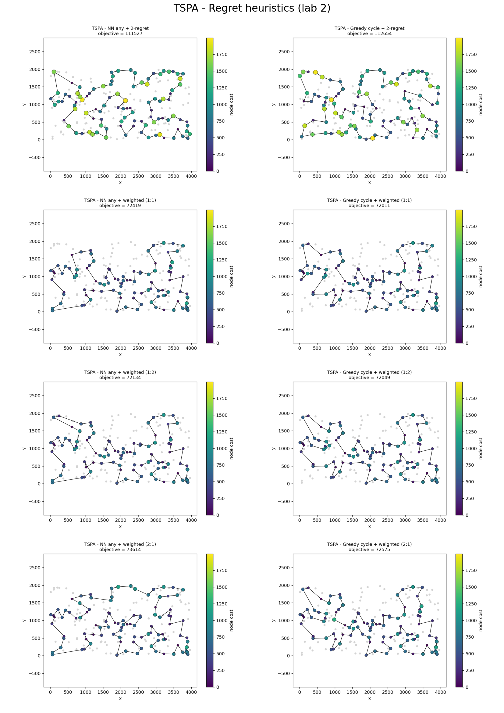
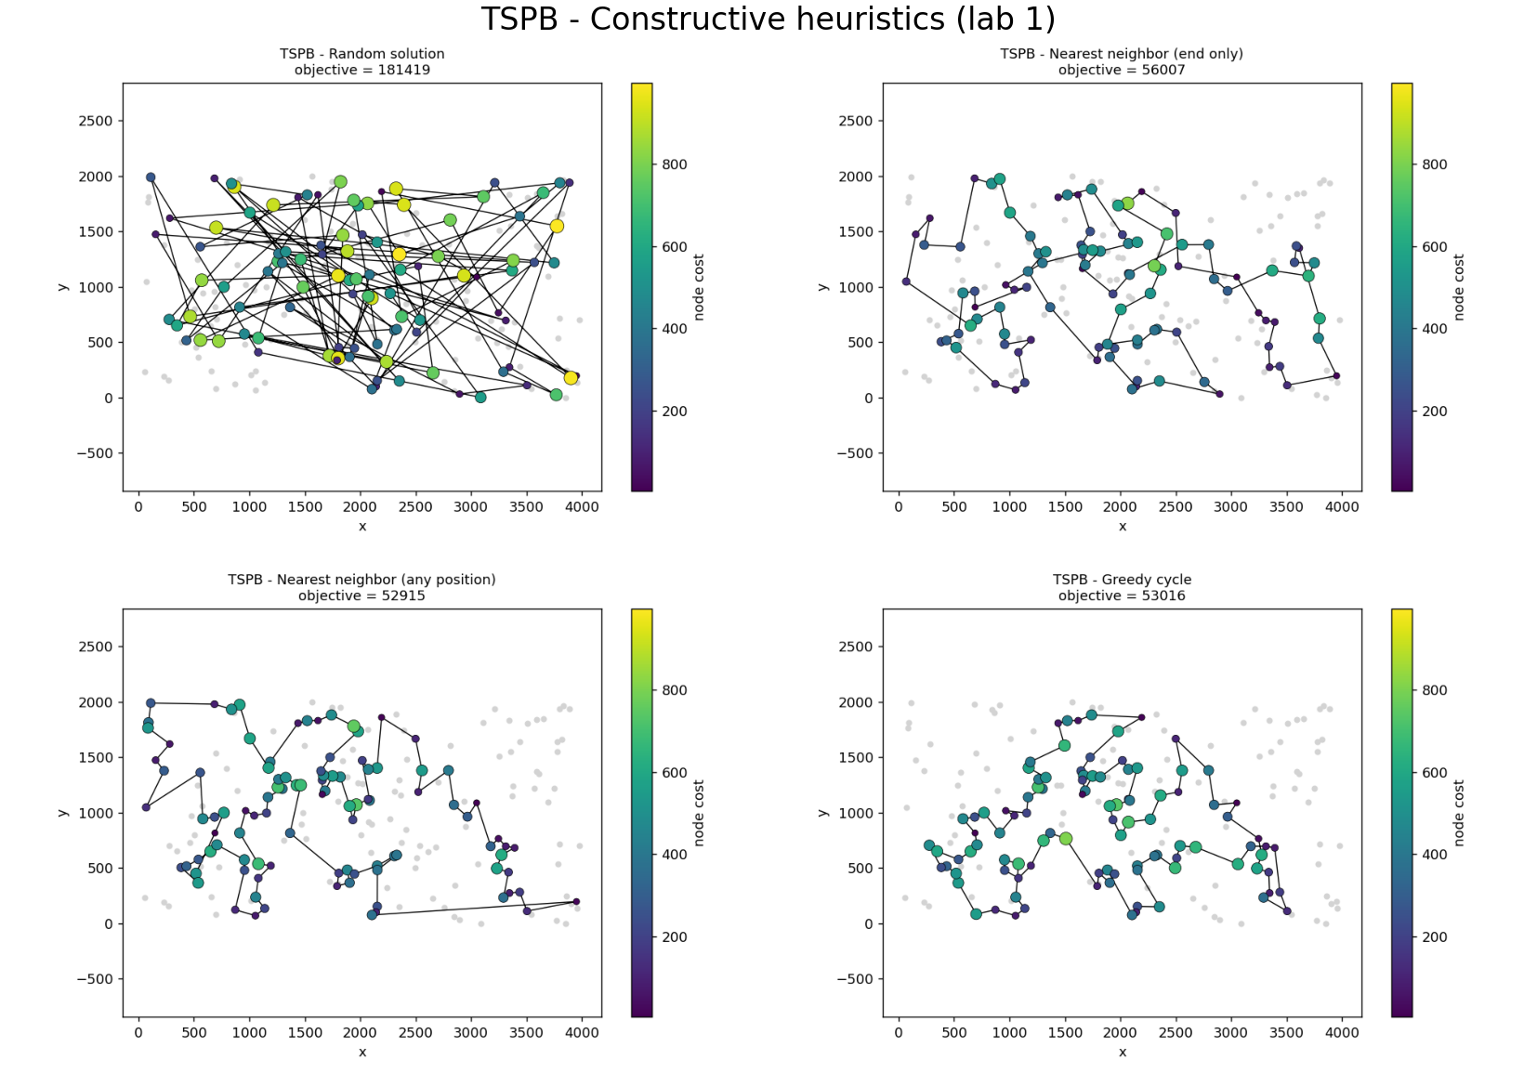

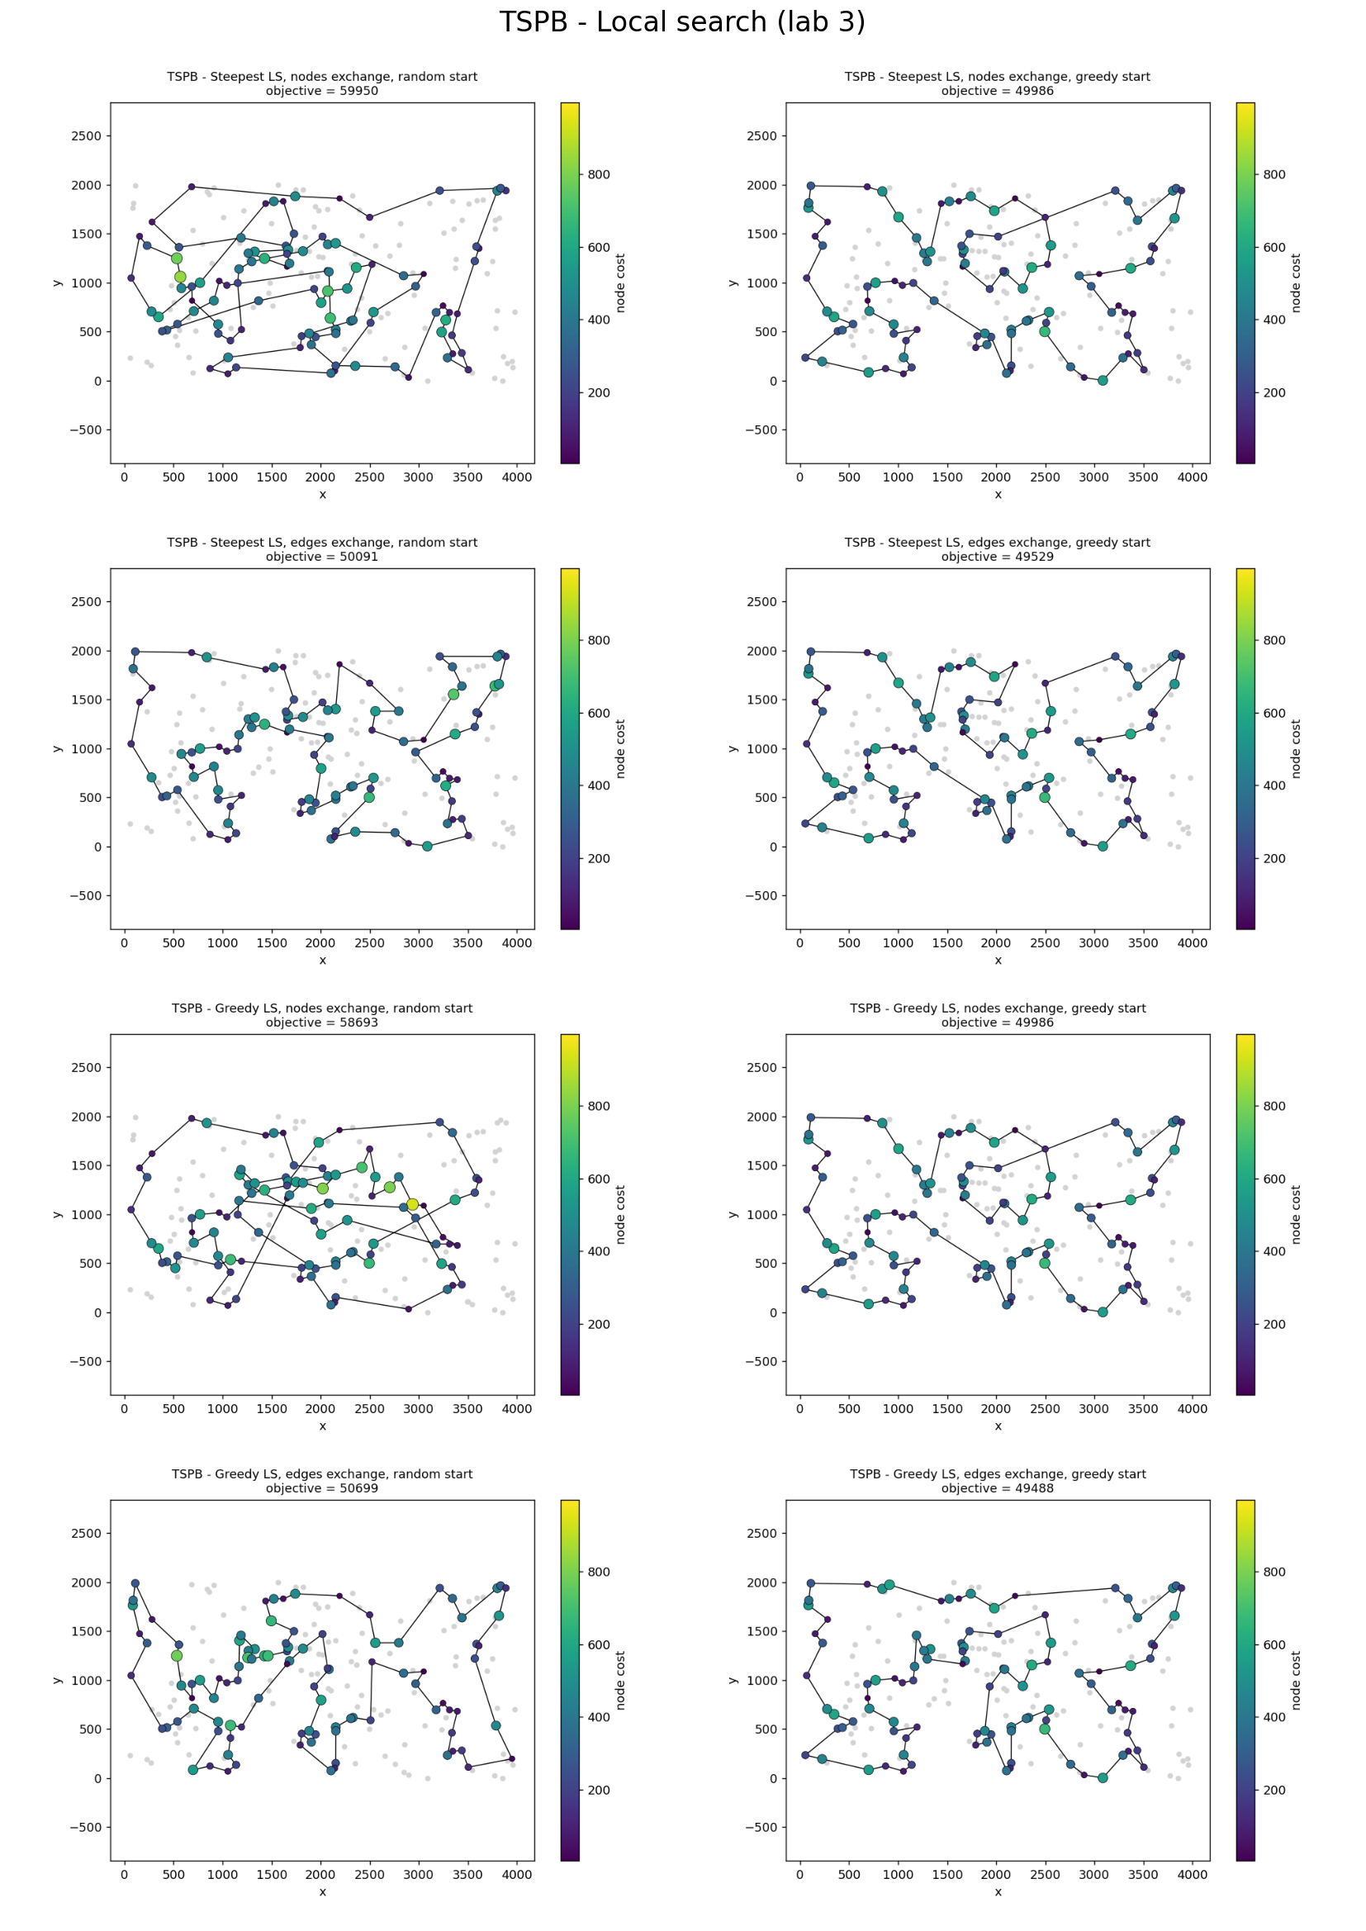
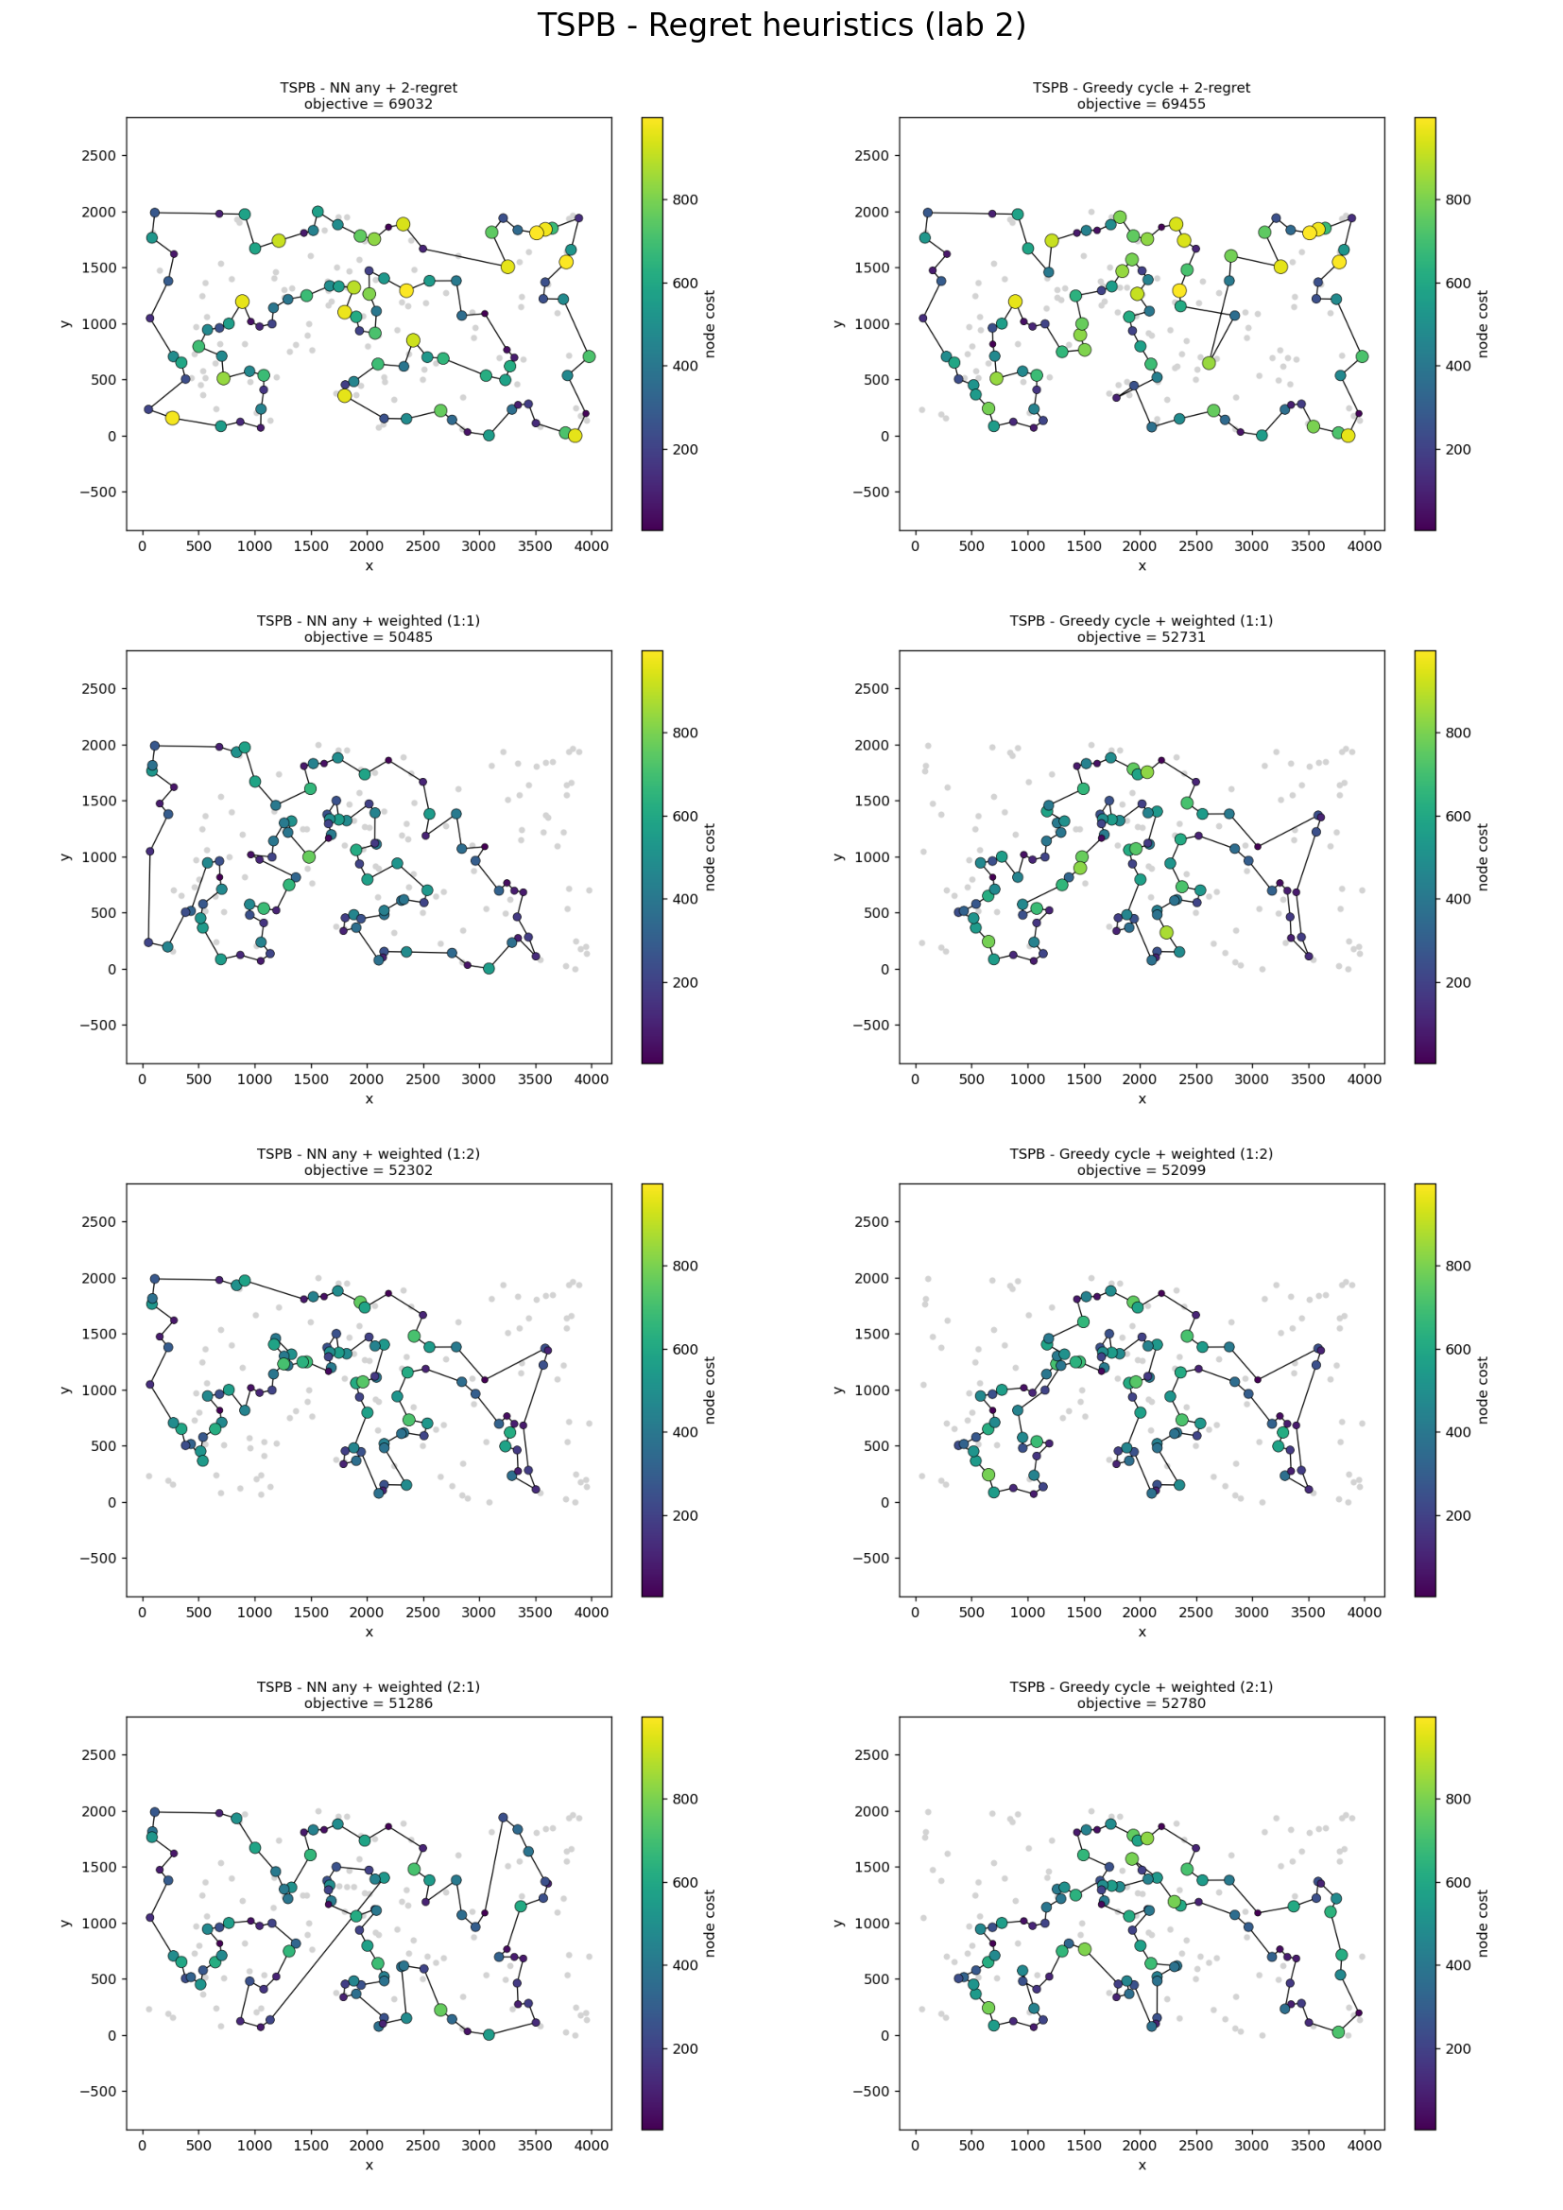
- The best solutions for each instance and method presented as a list of nodes indices (starting from 0). (TSPA/TSPB)
- Random: 242549 / 181419
- NN (end only): 84362 / 56007
- NN (any position): 72328 / 52915
- Greedy cycle: 72590 / 53016
- NN any + 2-regret: 111527 / 69032
- Greedy cycle + 2-regret: 112654 / 69455
- NN any + weighted (1:1): 72419 / 50485
- Greedy cycle + weighted (1:1): 72011 / 52731
- NN any + weighted (1:2): 72134 / 52302
- Greedy cycle + weighted (1:2): 72049 / 52099
- NN any + weighted (2:1): 73614 / 51286
- Greedy cycle + weighted (2:1): 72575 / 52780
- Steepest, nodes, random start: 81898 / 59950
- Steepest, nodes, greedy start: 71955 / 49986
- Steepest, edges, random start: 73958 / 50091
- Steepest, edges, greedy start: 71925 / 49529
- Greedy, nodes, random start: 81382 / 58693
- Greedy, nodes, greedy start: 71955 / 49986
- Greedy, edges, random start: 73890 / 50699
- Greedy, edges, greedy start: 71955 / 49488

- Information whether the best solutions have been checked with the solution checker.
We checked all of the best solutions (20 methods × 2 instances) with the solution checker. The objective value computed by the checker equaled the best (min) value from Section 3 in every case.

- (Link to) the source code
Link

- Conclusions
- Local search improves every starting solution and gives the best results so far. The best solutions of the whole experiment are 71925 on TSPA (steepest, edges exchange, greedy start) and 49488 on TSPB (greedy, edges exchange, greedy start). Compared with the best constructive heuristics (72011 and 50485) this is 0.12% and 1.97% better. The best average of local search (72812.1 and 51876.8) is 0.52% and 5.23% better than the best average of the constructive methods (73192.6 and 54739.9).
- The starting solution matters a lot, in particular for the exchange of nodes. With the nodes exchange the greedy start gives an average 17–20% better than the random start (e.g. TSPA, steepest: 72863 vs 89890). With the edges exchange the difference is smaller: 4.4–4.6% on TSPA and 1.3–2.1% on TSPB. The greedy start also makes local search much faster (0.9–3.4 ms instead of 3.0–39 ms), because only a few improving moves are needed (about 3 on TSPA and 14–28 on TSPB, against 130–420 from a random solution). This does not include the construction time (about 4–7 ms), so the whole procedure with the greedy start (6.0–9.8 ms) is still faster than the steepest search from a random solution (19.6–39.2 ms), but slower than the greedy search from a random solution (3.0–4.8 ms), which gives clearly worse solutions.
- The exchange of edges is much better than the exchange of nodes when the start is poor. From random solutions the edges exchange gives results 13.7–20.6% better, and it is also about twice faster for the steepest version (19.6 ms vs 38–39 ms). From a greedy solution the difference almost disappears (0.1% on TSPA and 1.5–1.7% on TSPB). A probable reason (we did not test it) is that exchanging two nodes cannot remove crossing edges in one step, while exchanging two edges does exactly this; a random solution contains many crossings, a greedy solution only few of them.
- Steepest and greedy local search give solutions of similar quality, but greedy is much cheaper from a random start. From a random start the greedy version is 5.2–8.4 times faster (3.0–4.8 ms vs 19.6–39.2 ms) and evaluates 16–21 times fewer moves (96 000–140 000 vs 2.0–2.3 million), although it applies about three times more moves (about 410–420 vs 130–150), because it takes the first improvement and not the best one. The average objective values differ only slightly: the greedy version is better by 1.9% and 3.6% for the nodes exchange, while for the edges exchange it is better by 0.2% on TSPA and worse by 0.9% on TSPB. From a greedy start the two versions are practically equal (difference below 0.1%).
- The number of evaluated moves does not always translate into time. From the greedy start the greedy version evaluates fewer moves (about 1.8–1.9 times fewer on TSPA and about 4 times fewer on TSPB), but this does not make it faster: on TSPA it was slower (1.27 and 1.38 ms vs 1.17 and 0.87 ms), and on TSPB the times are close (2.20 and 3.11 ms vs 3.43 and 2.86 ms). Only a few improving moves exist, so the steepest version needs just one or a few passes over the neighborhood, and the greedy version pays for generating random numbers and for swapping the moves at every evaluation (our explanation, not tested).
- The two instances behave differently. On TSPA the constructive solutions are already close to a local optimum of both neighborhoods (only about 3 improving moves and 0.5% improvement of the average), so local search from random solutions with the edges exchange (76 163–76 301) cannot beat the best construction (73 193). On TSPB local search from random solutions with the edges exchange (52 562–53 049) is already better on average than any constructive method (the best is 54 740), and from the greedy start it improves the average by more than 5%.
- The starting node still matters. Even after local search the results differ, e.g. on TSPB for steepest, edges, greedy start: 49529 (min), 51877 (average) and 56952 (max). The best of 200 runs is 1.2% (TSPA) and 4.5% (TSPB) better than the average run, so repeating the method from many starts and taking the best solution is worthwhile. The differences between the four variants with the greedy start on TSPA (below 0.1%) are of the order of this variability, so we do not claim that one of them is better.
- Limitations. Local search ends in a local optimum of the given neighborhood and cannot leave it, and the result of one run depends strongly on the start. All variants were run with one fixed random seed, so differences of a few tenths of a percent should not be treated as significant. In every iteration all moves are evaluated again; faster variants (candidate moves, reusing deltas from previous iterations) and methods that escape local optima are natural next steps.

