EC – Lab 1 Report
- Description of the problem
There is a given set of nodes in the plane, each node with x, y coordinates and integer cost. We had to choose half of them (100) and connect them into a closed path (Hamiltonian cycle) and minimize the objective (total length + total cost).
Distances were Euclidean, rounded to integers, the distance matrix was computed once after reading an instance, and the algorithms used only this matrix and the node costs.
We used two instances (TSPA and TSPB), each with 200 nodes.
Notation: V – all nodes, U – not yet selected nodes, d[i][j] – distance, c[j] – node cost, k – number of nodes to select.

- Pseudocode of all implemented algorithms
- Random solution
RANDOM()
P <- random permutation of V
return first k nodes of P
- NN – adding only at the end
NN-END(s)
path <- [s]
while |path| < k:
last <- last node of path
j* <- argmin over j in U of d[last][j] + c[j]
append j* to path
return path
- NN – adding at any position
NN-ANY(s)
path <- [s]
while |path| < k:
for each j in U and each position p in path:
p = beginning: delta = d[j][first] + c[j]
p = end: delta = d[last][j] + c[j]
p = between a,b: delta = d[a][j] + d[j][b] - d[a][b] + c[j]
insert the pair (j*, p*) with the smallest delta
return path
- Greedy cycle
GREEDY-CYCLE(s)
second <- argmin over j in V\{s} of d[s][j] + c[j]
cycle <- [s, second]
while |cycle| < k:
for each j in U and each edge (a,b) of the cycle (including the closing edge):
delta = d[a][j] + d[j][b] - d[a][b] + c[j]
insert j* between a and b for the smallest delta
return cycle

- Results of a computational experiment: for each instance and method min, max and average value of the objective function.
Each greedy method was run once from every node as the starting node (200 solutions per instance). The random method generated 200 random solutions.
Instance | Method | Min | Max | Avg
TSPA | Random | 242549 | 285144 | 262271.5
TSPA | NN (end only) | 84362 | 90075 | 87476.6
TSPA | NN (any position) | 72328 | 77022 | 74347.0
TSPA | Greedy cycle | 72590 | 75281 | 73797.4
TSPB | Random | 181419 | 236900 | 206684.8
TSPB | NN (end only) | 56007 | 63166 | 59397.3
TSPB | NN (any position) | 52915 | 66164 | 59475.5
TSPB | Greedy cycle | 53016 | 63736 | 59709.5

- 2D visualization of the best solution for each instance and method. Cost of nodes should be presented e.g. by a color, greyscale, or size.
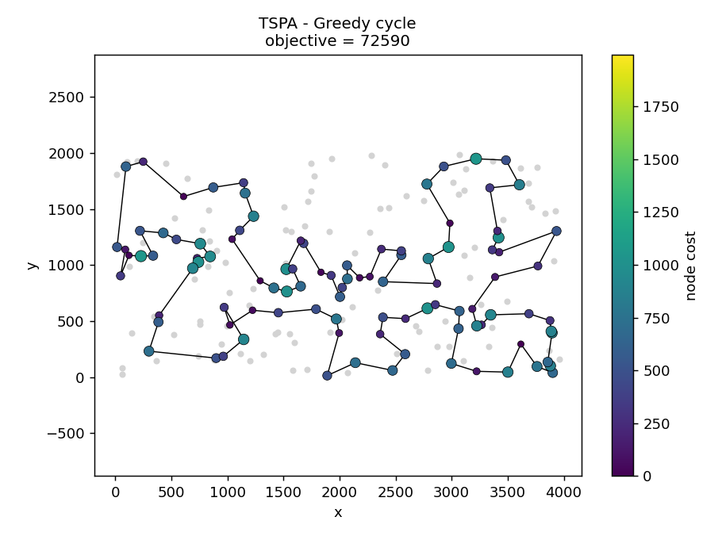
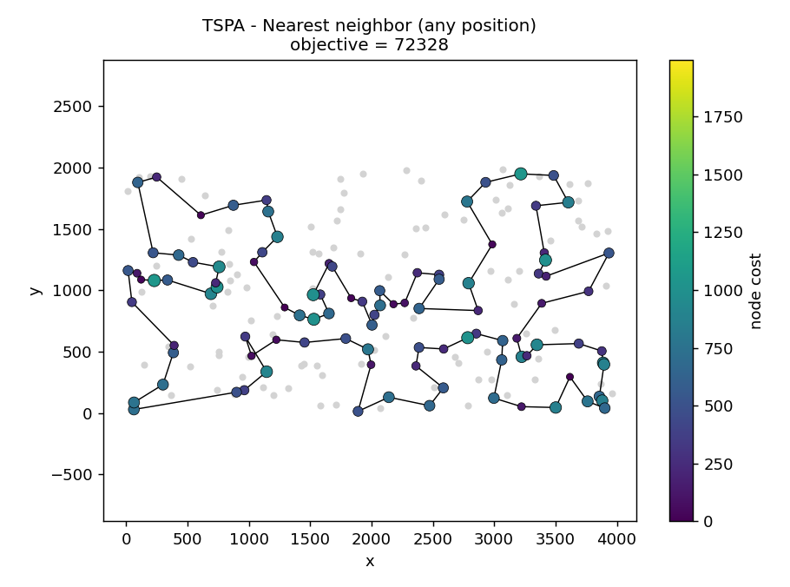
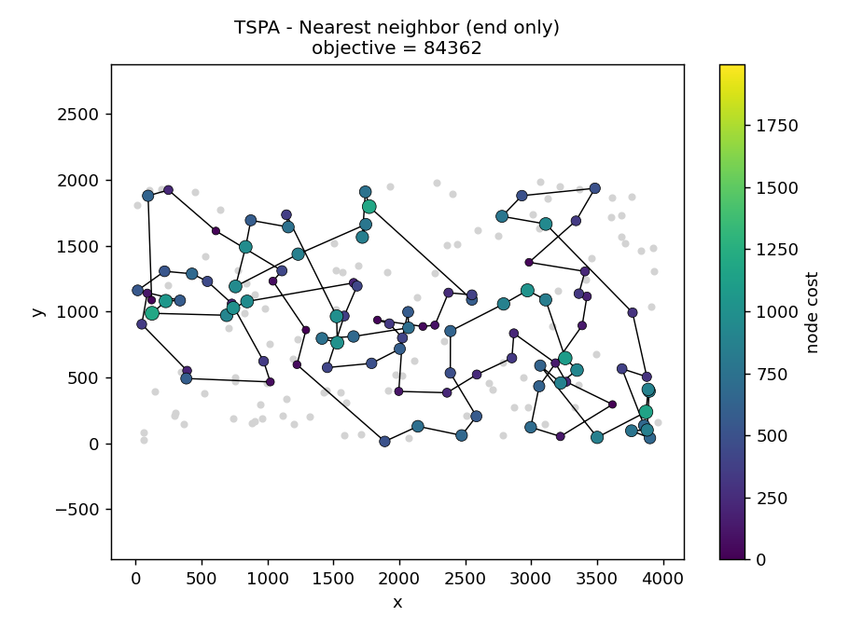
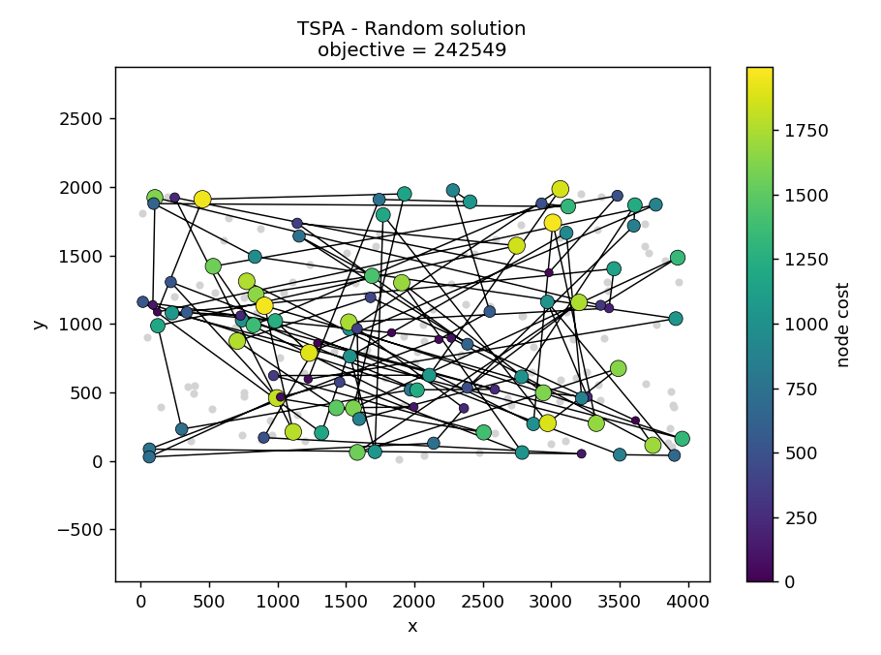
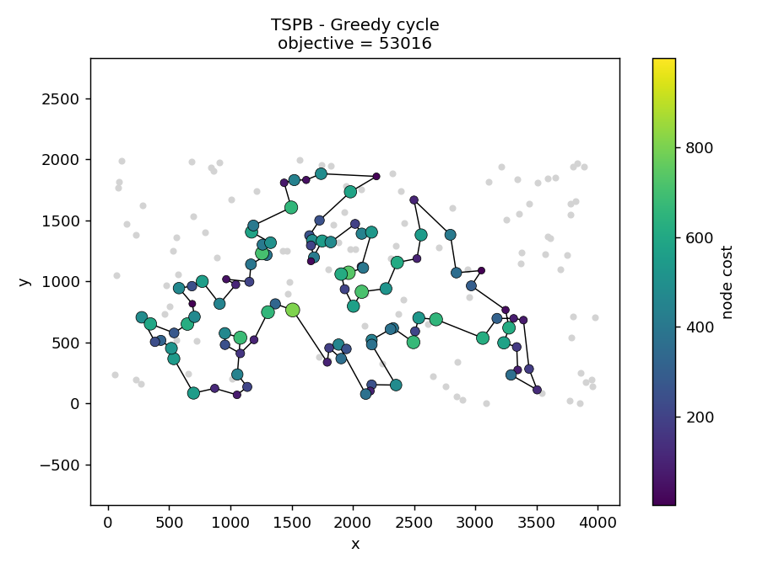
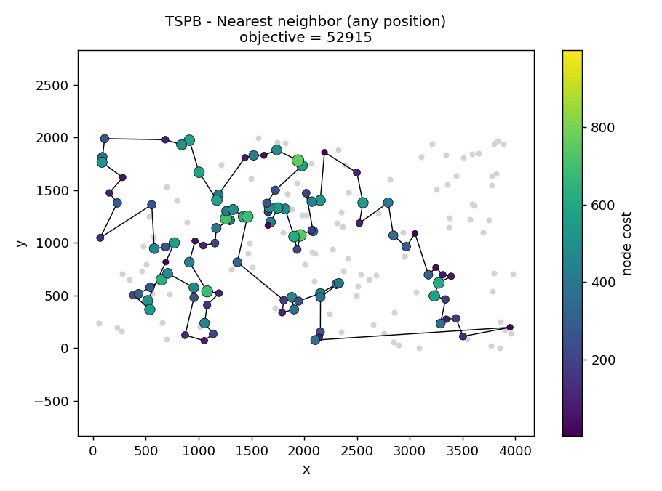
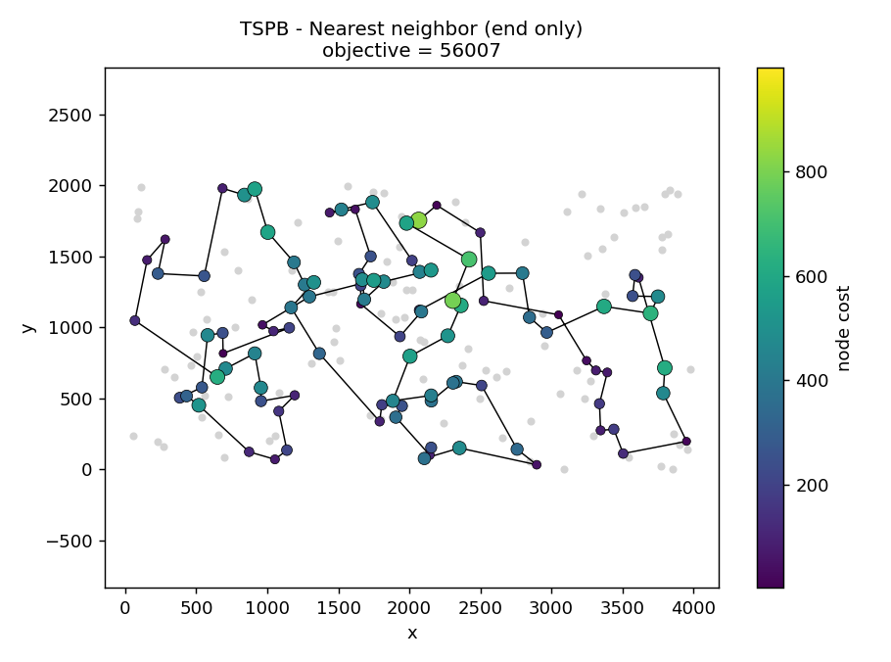
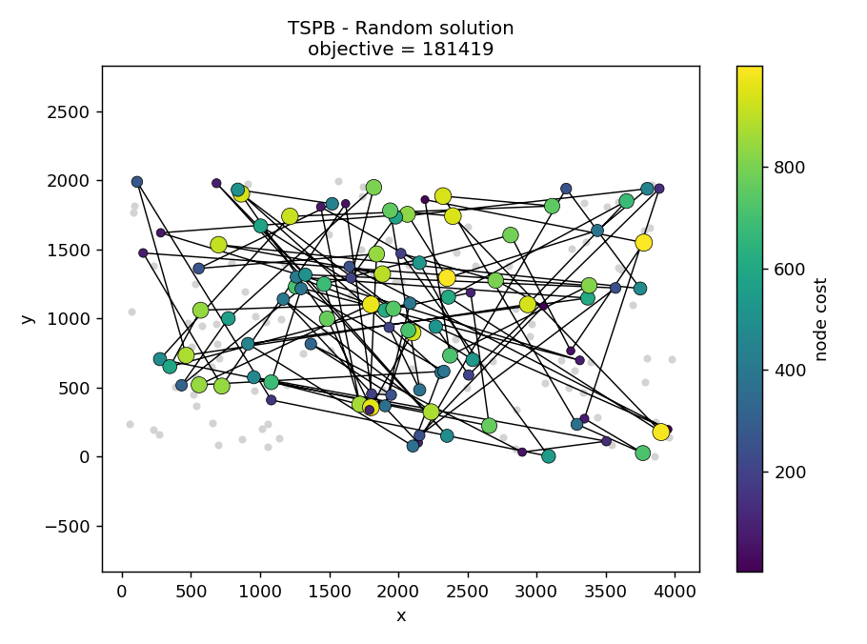
- The best solutions for each instance and method presented as a list of nodes indices (starting from 0). + added objectives
TSPA:
- Greedy cycle 72590: 31,116,149,168,63,11,49,60,108,152,100,90,123,83,160,97,127,69,171,2,189,30,187,141,87,45,73,135,114,181,192,158,58,84,134,72,176,150,151,182,57,64,107,88,78,193,153,170,146,159,130,113,89,42,106,93,47,147,50,3,169,1,178,101,29,163,136,186,164,142,8,174,131,54,9,33,36,177,52,179,53,140,144,67,16,51,156,35,185,102,28,180,132,76,4,71,157,91,80,48
- nn_any 72328: 104,129,69,127,97,168,116,149,63,11,49,160,83,123,100,152,108,60,31,48,80,91,157,71,4,76,132,180,28,102,185,35,156,51,16,67,144,140,53,179,52,177,36,33,9,54,131,174,8,164,186,136,163,29,101,178,1,169,3,50,147,47,93,106,42,89,113,130,159,146,170,153,193,78,88,107,64,57,182,151,150,176,72,134,84,58,158,192,181,114,135,73,45,87,141,187,30,189,2,171
- nn_end 84362: 54,9,33,36,177,67,144,53,135,58,134,176,174,106,89,107,57,182,151,93,50,3,1,164,178,29,136,186,184,47,159,130,153,78,88,193,170,146,75,64,150,42,113,43,85,142,8,131,84,158,192,181,114,141,180,132,76,80,48,31,63,149,168,97,127,187,30,123,152,108,60,116,49,11,119,160,83,90,51,16,35,87,45,140,52,179,185,28,102,156,157,71,91,38,100,4,112,139,115,5
- random 242549: 54,177,129,57,171,180,26,156,197,41,30,20,40,60,64,78,142,89,0,190,111,87,187,104,181,58,172,50,59,11,124,195,138,14,44,133,71,131,157,109,119,69,73,134,83,135,96,12,16,107,122,36,67,49,123,61,149,199,3,21,70,175,126,63,55,191,162,116,10,35,98,72,17,101,84,128,22,117,165,5,25,102,184,42,68,166,48,164,29,66,148,136,24,31,38,37,141,115,154,39
TSPB:
- greedy 53016: 49,64,33,40,60,71,155,141,157,45,134,175,62,36,197,29,132,178,103,6,180,115,170,177,125,26,97,140,154,47,38,21,176,30,183,191,130,63,121,198,96,48,89,156,120,133,136,172,160,69,8,117,72,46,86,184,3,173,122,151,98,111,27,135,76,185,57,104,162,54,192,127,52,182,153,20,74,2,14,90,129,80,150,84,66,67,31,24,34,152,181,88,179,87,82,73,167,51,59,85
- nn_any 52915: 110,2,14,20,74,153,182,52,90,129,127,80,54,192,162,104,76,185,57,89,86,46,72,3,184,173,151,122,117,8,160,69,172,136,133,120,156,43,48,96,198,121,130,191,50,42,147,116,37,146,13,149,28,145,65,158,177,125,26,170,197,36,132,29,6,180,115,155,71,175,134,45,157,60,40,141,97,154,140,47,38,21,176,30,183,189,168,64,59,85,51,73,167,152,34,24,181,179,87,82
- nn_end 56007: 32,89,57,76,54,127,129,90,153,20,14,2,110,118,56,114,196,10,148,143,78,192,162,104,185,184,3,151,69,172,133,120,96,121,198,48,72,46,86,117,160,136,8,21,154,140,47,170,125,177,6,132,29,197,175,134,45,60,40,71,155,97,115,180,65,28,149,145,158,116,147,42,50,130,30,183,38,64,85,59,167,51,87,179,82,88,171,99,67,24,34,181,152,73,98,27,135,75,79,156
- random 181419: 176,129,149,32,0,187,81,156,172,164,26,29,21,141,126,38,87,190,148,123,95,133,110,27,67,105,20,93,74,44,194,195,178,163,76,122,30,78,97,82,34,7,173,151,181,43,83,100,135,169,159,102,37,60,17,72,144,54,179,10,183,116,88,50,66,86,121,107,168,77,127,193,89,11,41,28,113,96,59,167,64,171,2,155,101,124,147,198,158,92,85,22,111,51,3,103,55,128,5,24

- Information whether the best solutions have been checked with the solution checker.
We checked all of the best solutions with the solution checker. The objective value computed by the checker equaled the best value from Section 3 in every case.
- (Link to) the source code
link
- Conclusions
All greedy methods were about 67-72% better on average than random solutions. Nearest neighbor with adding at any position and greedy cycle gave us very similar results and beat the end-only version on TSPA (about 15% better on average). On TSPB the averages of all three greedy methods are close. The starting node mattered, so running each method from every node is worthwhile. Greedy methods never revised earlier decisions, so the results could probably be improved by local search.

