**Title?**

Authors: Thodoris, Adriani, Anna, Georgia

Possibly: Orestis, Matthias

Acknowledgements: Gerta and Guido (or should we invite them?)

# Introduction

Network meta-analysis (NMA) is often used to synthesize evidence in systematic reviews of multiple interventions. The results of such syntheses can be highly important and are increasingly being used for decision making (1,2). Treatment comparisons in a network of interventions may be associated with particular characteristics. Such characteristics may be identified either in the stage of collecting relevant evidence, although theoretically the best efforts have been made to ensure the plausibility of transitivity, or when analysing and interpreting the results. For instance, a comparison may include studies which are on average of highest risk of bias compared to the rest of the network or a comparison may show evidence of inconsistency (alternatively termed incoherence), meaning that the direct studies feeding into it differs from the indirect evidence which also drives its estimation.

A method to identify the flow of evidence in a network of interventions (3) has been developed and is used to identify the degree in which direct comparisons drive the estimation of NMA treatment effects. In particular, it has been shown that network estimates can be derived as a linear combination of pairwise meta-analysis effects. The respective projection matrix is called $H$ matrix and provides insight regarding the flow of information in a network of interventions.

Several methodological developments have been based on $H$ matrix; among them, Krahn et al. constructed a tool, the net-heat plot, to identify hot spots of inconsistency in a network (4) and Krahn et al. introduced the independent path decomposition for visualizing potentially conflicting inferences of different sources of evidence (5). Salanti et al. proposed the use of $H$ matrix to facilitate the evaluation of the quality of evidence (6). In gross terms, Salanti et al. propose to 1) consider the quality of evidence of all pieces of direct evidence 2) derive the percentage contributions of each direct to each network effect and 3) judge upon the quality of evidence of each network estimate.

It is not straightforward how to translate the projection matrix $H$ into percentage contributions of each direct comparison to each NMA treatment effect. The approach implemented by Salanti et al., and described in Appendix S1 of (6), has turned out to have some flows [*ref erratum*]. In particular, it underestimates the percentage contribution of direct evidence while does not accurately specifies the percentage contributions of the rest (indirect) comparisons. In this paper, we present a method to translate the entries of the projection matrix into percentages taking into account the properties of the matrix as a flow matrix.

# Methods

Several models have been proposed for synthesizing evidence in a NMA model (7–12). Throughout this paper we will consider the NMA as a random-effects two-stage model described in (7). In the first stage, all pairwise meta-analysis treatment effects are derived and in the second stage evidence from the separate pairwise meta-analyses is synthesized to produce the NMA treatment effects.

## Notation

Consider a set $Ω=\{X,Y,Z,…\}$ of $T$ total treatments examined in $I$ studies. The letter $X$ is set to be the reference treatment. Studies are classified according to the treatments they compare and we denote the number of comparisons with direct data as $C$. The number of relative NMA treatment effects to be estimated is $\left(\begin{matrix}T \\ 2\end{matrix}\right)$ but the estimation of $T-1$ relative treatment effects allows the derivation of the rest as their linear combination. We collect the treatment effects of the $T-1$ relative treatment effects against the reference treatment $X$ in a vector of basic parameters $θ={\left(θ_{XY},θ_{XZ},⋯\right)}^{'}$.]

In the following, we will not take into account the correlation induced by multi-arm trials. That is because we want to end up with a matrix to infer how much each direct comparison impacts on each NMA treatment effect. The question of quantifying the influence of each design in the NMA results is of less interest for our purposes that include the investigation of the inheritance of certain comparison-specific characteristics to NMA treatment effects. Nevertheless, one can incorporate multi-arm trials by reducing accordingly their weights as proposed by Rücker et al. (10,11) and so by conserving the dimensions of $H$ our method and its interpretation is not constrained by the design of the network.

## Assumptions

We assume that the similarity of effect modifiers across comparisons is justified and thus the transitivity assumption is deemed plausible. The consistency assumption refers to the statistical manifestation of transitivity and implies that all sources of evidence are in agreement. Consistency is expressed in terms of a consistency equation

$$θ_{XY}=θ_{XZ}-θ_{YZ}$$

and implies that all trials, irrespective of whether they evaluate directly the ‘Y versus X’ comparison, are estimating the same ‘true’ average ‘Y versus X’ treatment effect, $θ_{XY}$.

## Model

Separate pairwise meta-analysis treatment effects are derived and collected in a vector ${\hat{θ}}^{D}$. The vector ${\hat{θ}}^{D}$ has $C$ elements. Note that if we were to take into account the correlation induced by multi-arm trials the length of ${\hat{θ}}^{D}$ would potentially be greater depending on the number of designs –set of treatments being compared- that appear in the studies.

At the second stage the network estimates are derived as

${\hat{θ}}^{N}=H{\hat{θ}}^{D}$ Equation 1

where $H$ is calculated as

$H=X_{full}{\left(X^{'}V^{-1}X\right)}^{-1}X^{'}V^{-1}$ Equation 2

where $X$ is the design matrix expressing the linear relationships between the available direct comparisons and the basic parameters, $V$ is a diagonal matrix containing the variances of the observed direct effects and $X_{full}$ is a design matrix that links the network estimates with the basic parameters. Thus, matrix $X$ will be of dimensions $C×\left(T-1\right)$, $V$ will be of dimensions $C×C$ and $X_{full}$ will be of dimensions $\left(\begin{aligned}T \\ 2\end{aligned}\right)×\left(T-1\right)$. Note that $X$ will be identical to $X_{full}$ only when there are direct studies for all pairwise comparisons in the network. It turns out that $H$ has dimensions $\left(\begin{aligned}T \\ 2\end{aligned}\right)×C$.

*Example*

For instance, consider a fully connected network with three treatments, A, B and C. Matrices $X$, $V$ and $X_{full}$ will be

$$X=\left(\begin{matrix}1 & 0 \\ 0 & 1 \\ -1 & 1\end{matrix}\right), V=\left(\begin{matrix}v_{AB} & 0 & 0 \\ 0 & v_{AC} & 0 \\ 0 & 0 & v_{BC}\end{matrix}\right), X_{full}=\left(\begin{matrix}1 & 0 \\ 0 & 1 \\ -1 & 1\end{matrix}\right)$$

where $v_{AB}$, $v_{AC}$ and $v_{BC}$ are the variances of the ‘B versus A’, ‘C versus A’ and ‘C versus B’ direct treatment effects.

## Interpretation of the $H$ matrix

Rows of $H$ contain the coefficients that map direct to network treatment effects ${\hat{θ}}^{N}=H{\hat{θ}}^{D}$ Equation 1. They can be viewed as generalized weights but should not be confused with weights from pairwise meta-analysis as they do not sum up to one and cannot be standardised to do so [ref erratum]. Matrix $H$ describes the influence of each comparison with direct data (specified by the columns) to the NMA results (specified by the rows). According to $H=X_{full}{\left(X^{'}V^{-1}X\right)}^{-1}X^{'}V^{-1}$ Equation 2, the matrix $H$ is a function of the variances of the direct effects and the network structure and therefore the exact contribution of each comparison depends on the **precision** of the available direct data and its **connectivity** to the rest of the network.

Absent of multi-arm studies, each network treatment effect i.e. ‘Y versus X’ can be written as a weighted average of the direct and the indirect estimate. We denote elements of $H$ as $h_{XY→ZW}$ where $XY$ is the indicated column and $ZW$ is the indicated row. Diagonal elements of $H$ $\left(h_{XY→XY}\right)$ represent the percentage contribution of the direct evidence for the particular network treatment effect. While we know that 1 minus the percentage contribution of direct evidence is the percentage contribution of indirect evidence, it is not straightforward how to derive the percentage contribution of each comparison providing indirect evidence to each network treatment effect. That is because, in the general case where indirect routes to obtain ‘Y versus X’ may not be independent between them, the indirect ‘Y versus X’ treatment effect is not a weighted average of all the separate indirect effects.

*Example*

In the example of a triangular ABC network, the matrix $H$ is

$$H=\left(\begin{matrix}h_{AB→AB} & h_{AC→AB} & h_{BC→AB} \\ h_{AB→AC} & h_{AC→AC} & h_{BC→AC} \\ h_{AB→BC} & h_{AC→BC} & h_{BC→BC}\end{matrix}\right)$$

turning out to be

$$H=\frac{1}{w_{AB}w_{BC}+{w_{AB}w}_{AC}+w_{AC}w_{BC}}\left(\begin{matrix}w_{AB}\left(w_{AC}+w_{BC}\right) & w_{AC}w_{BC} & -w_{AC}w_{BC} \\ w_{AB}w_{BC} & w_{AC}\left(w_{AB}+w_{BC}\right) & w_{BC}\left(w_{AB}\right) \\ {-w_{AB}w}_{AC} & {w_{AB}w}_{AC} & w_{BC}\left(w_{AB}+w_{AC}\right)\end{matrix}\right)$$

where $w_{XY}=1/v_{XY}$.

To estimate the NMA treatment effect for the ‘B versus A’ comparison, we get ${\hat{θ}}_{AB}^{N}=h_{AB→AB}{\hat{θ}}_{AB}^{D}+h_{AC→AB}{\hat{θ}}_{AC}^{D}+h_{BC→AB}{\hat{θ}}_{BC}^{D}$ Equation 3

showing that the contributions of the AB, AC and BC comparisons are $h_{AB→AB}$, $h_{AC→AB}$ and $h_{BC→AB}$ respectively.

# $H_{XY}$ row as a graph $G_{XY}$

By adopting the idea of evidence flow introduced by König et. al. (3), each row $H_{XY}$ can be seen as a flow graph $G_{XY}$. We present the algorithm to derive the proportional contribution for comparison $Y$ ` vs $X$ ` from the corresponding $H_{XY}$ row of the $H$ matrix:

1. Create network $G_{XY}$ from $H_{XY}$ matrix: Let $G_{XY}=(V,E)$ be the network (flow graph), where $V=\{x,y,z,…\}$ denotes the set of nodes (vertices) corresponding to $Ω=\{X,Y,Z,…\}$ the set of treatments and $E$ is the set of directed edges $E=\{(u,v)|u,v∈V,h_{UV→XY}>0 or h_{VU→XY}<0 \}$ corresponding to direct comparisons. We define as *evidence flow* or just flow of an edge the mapping $f:E→R^{+}$, where the flow of an edge $f(u,v)$ or $f_{uv}$ equals the corresponding value of the $H$ matrix $f\left(u,v\right)=\left\{\begin{aligned}h_{UV→XY}, &h_{UV→XY}>0 \\ {-h}_{VU→XY}, &h_{VU→XY}<0\end{aligned}\right.$

Equation 4



As shown by Rucker et al. as well as König et al. $G_{XY}$ constitutes a valid flow graph with source vertex $x$ and sink , since:

* 1. The sum of outflows out of node X is 1. $\sum_{u∈V}{f_{xu}}=1$
  2. The sum of inflows into node Y is 1. $\sum_{u∈V}{f_{uy}}=1$
  3. The flow passing through each internal node is conserved, alternatively put, the inflow equals the outflow of a node: $∀z∈V\backslash \{x,y\},\sum_{z∈V}{f_{zu}}=\sum_{v∈V}{f_{vz}}$
  4. $G_{XY}$ is acyclic or else a directed acyclic graph *(DAG)*.

Given the above properties we are able to decompose the flow into independent paths (routes) from $x$ to $y$ which we will call *streams*. A *stream $s_{i}$* is therefore defined by its flow $φ_{i}$ path $π_{i}$.

$s_{i}=(φ_{i},π_{i}),π_{i}∈\{(x,u),…,(z,y)\}⊆E$, π_i could also be the direct $(x,y)$ if that direct comparison exists. The sum of the stream flow is $1$: $\sum_{i}{φ_{i}}=1$ and also the flow of the streams traversing an edge $(u,v)$ equals the flow of that edge: $\sum_{i|(u,v)∈π_{i}}{φ_{i}}(u,v)=f(u,v)$ We translate the flow of an edge, ie the $H$ element of the corresponding direct comparison, by adding the contribution of each stream containing that edge. In order to do that we impose the following conditions concerning each stream.

* **Stream proportionality** which dictates that a stream's $s_{i}$ contribution $c_{i}$ equals its flow $c_{i}=φ_{i}$. Figure 1a
* **Edge equality**: the contribution of each edge in a stream is the same, so the contribution of an edge equals the flow of the stream divided by its length, $c_{i}(u,v)=φ_{i}/|π_{i}|$. Figure 1b

We can finally calculate the contribution of an edge $c_{i}(u,v)$ to the $Y$ vs $X$ comparison , from the streams $s_{i}$ as $c_{i}(u,v)=\sum_{i|(u,v)∈π_{i}}{f_{i}}/|π_{i}|$. The total contribution is given by summing each stream's contribution $c(u,v)=\sum_{n}{c_{i}}(u,v)$.

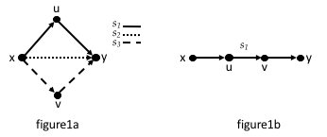

Figure 1

# Algorithm

As mentioned above we reduced the problem of calculating the contributions of direct comparisons of the ' $Y$ vs $X$' comparison, to evaluating the independent paths of flow or streams $s_{i}$ in the network $G_{XY}$. The process is similar to the maximum flow Edmonds Karp algorithm (13), of finding the shortest path between source and sink, but instead of increasing we subtract flow. The algorithm is iterative with each step finding a stream until all flow is accounted for.

We present the algorithm for the flow decomposition of a graph $G_{XY}$:

1. Set initial graph $G_{0}=G_{XY}$ and contribution of edges $c_{0}(u,v)=0 ∀ (u,v)∈E_{0}$.

Then by following the bellow process $n$ times until .

1. Remove the edges with no flow .

2. Calculate the weights $w_{i}(u,v)$ of each edge $(u,v)$ as follows:

3. Find the minimum weighted path from $x$ to $y$ in $G_{i}$. This path constitutes the stream $s_{i}=(φ_{i},π_{i})$, with flow $φ_{i}=min(f_{i-1}(u,v)),(u,v)∈π_{i}$ equal to the minimum flow of the edges in the path. The weights assure that this is the shortest path with the maximum sum of flow.

4. Recalculate the flow by subtracting $φ_{i}$ fom the edges of the stream found: $f_{i}\left(u,v\right)=f_{i-1}\left(u,v\right)-φ_{i} ∀ \left(u,v\right)∈π_{i}$ the rest flow remain unchanged

5. Calculate the contributions: $c_{i}(u,v)=c_{i-1}(u,v)+φ_{i}/\left|π_{i}\right|$

The final contribution of edge $(u,v)$ is therefor $c(u,v)=c_{n}(u,v)$. By having all $c(u,v)$ we can construct the contribution matrix $P$ with the same structure of $H$ where an element in the $XY$ row is $p_{UV→XY}=c(u,v)$.

The algorithm guarantees that $\sum_{i}{p_{i→XY}}=1$ and also that the contribution of the direct is $1$ minus the contribution of the indirect comparisons $p_{XY→XY}=1-\sum_{UV ≠ XY }{p_{UV→XY}}$, as expected.

# Results

To illustrate our method, we will use a previously published network of four topical antibiotics without steroids for chronically discharging ears (no treatment (A), quilone antibiotic (B), non-quilone antibiotic (C) and antiseptic (D)) (14). The outcome is whether or not patients had persistent discharge from the ear after one week and is measured as odds ratio (OR). The network plot is shown in figure 2a and suggests that direct evidence exists for all comparisons except ‘non-quilone antibiotic versus no treatment’.

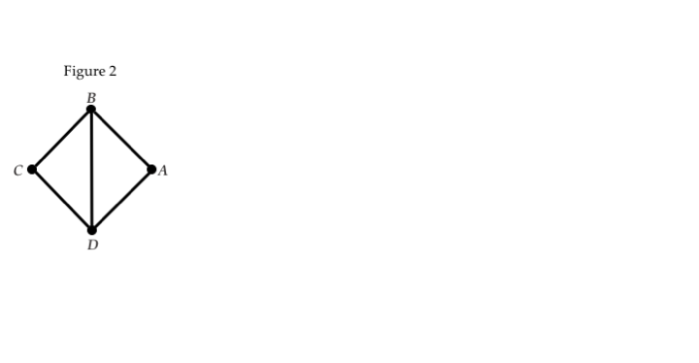

Figure 2

Figure 2. Network plot for the network of topical antibiotics without steroids for chronically discharging ears.

Treatment labels: A: no treatment, B: quilone antibiotic, C: non-quilone antibiotic, D: antiseptic

## Application to the ‘B versus A’ NMA treatment effect

In this example we will only focus on the ‘B versus A’ NMA treatment effect to illustrate the algorithm. The process is similar for the rest of the comparisons.

The row of the $H_{AB}$ matrix corresponding to the ‘B versus A’ NMA treatment effect turns out to be

Table 1

|  |  |  |  |  |  |
| --- | --- | --- | --- | --- | --- |
|  | AB | AD | BC | BD | CD |
| AB | $$0.24$$ | $$0.76$$ | $$-0.19$$ | $$-0.57$$ | $$-0.19$$ |
| AC | $$h_{AB→AC}$$ | $$h_{AD→AC}$$ | $$h_{BC→AC}$$ | $$h_{BD→AC}$$ | $$h_{CD→AC}$$ |
| AD | $$h_{AB→AD}$$ | $$h_{AD→AD}$$ | $$h_{BC→AD}$$ | $$h_{BD→AD}$$ | $$h_{CD→AD}$$ |
| BC | $$h_{AB→BC}$$ | $$h_{AD→BC}$$ | $$h_{BC→BC}$$ | $$h_{BD→BC}$$ | $$h_{CD→BC}$$ |
| BD | $$h_{AB→BD}$$ | $$h_{AD→BD}$$ | $$h_{BC→BD}$$ | $$h_{BD→BD}$$ | $$h_{CD→BD}$$ |
| CD | $$h_{AB→CD}$$ | $$h_{AD→CD}$$ | $$h_{BC→CD}$$ | $$h_{BD→CD}$$ | $$h_{CD→CD}$$ |

We begin by applying step 0 of the algorithm. We construct the network $G_{AB}$ corresponding the row $H_{AB}$ following Equation 4, Figure 3.

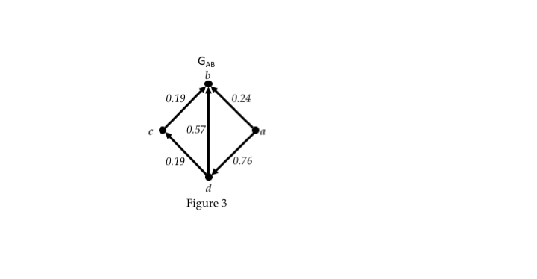

Figure 3

We then initialize the contribution row $P_{AB}$ (Table 2) and the corresponding edge attribute $c_{0}\left(u,v\right)=0 ∀\left(u,v\right)∈E$.

Table 2

|  |  |  |  |  |  |
| --- | --- | --- | --- | --- | --- |
|  | AB | AD | BC | BD | CD |
| AB | $$p_{AB→AB}=0$$ | $$p_{AD→AB}=0$$ | $$p_{BC→AB}=0$$ | $$p_{BD→AB}=0$$ | $$p_{CD→AB}=0$$ |

Flow decomposing into streams by following the steps 1-5 until there all flow is spent.

**Stream 1**:

Step 1: The graph remains unchanged since there are no edges without flow.

Step 2: We calculate the weights of the edges figure 4a: $w_{1}(u,v)=2-f_{0}(u,v)$.

Step 3: The shortest path between a and b is the direct (a,b) (figure 4b) so the stream its flow is $φ_{1}=0.24$.

Step 4: We recalculate the flow by subtracting the flow of the stream (6): $f_{1}\left(a,b\right)=f_{0}\left(a,b\right)-φ_{1}=0$ (figure 4c)

Step 5: We finally calculate edge contributions and fill the corresponding row. get that $p_{AB→AB}=c_{1}\left(a,b\right)=c_{0}\left(a,b\right)+\frac{φ_{1}}{1}=0.24$.

Table 3

|  |  |  |  |  |  |
| --- | --- | --- | --- | --- | --- |
|  | AB | AD | BC | BD | CD |
| AB | $$0.24$$ | $$p_{AD→AB}=0$$ | $$p_{BC→AB}=0$$ | $$p_{BD→AB}=0$$ | $$p_{CD→AB}=0$$ |

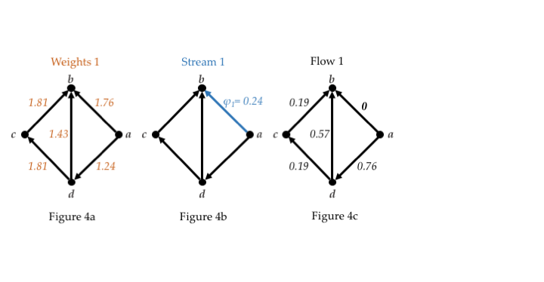

Figure 4

**Stream 2**:

Step 1: edge $(a,b)$ is removed since its flow is zero (figure 5a)

Step 2: calculate the weights (figure 5b)

Step 3: The minimum weighted path is $π_{2}=\{\left(a,d\right),\left(d,b\right)\}$ with flow $φ_{2}=0.57$

Step 4: $f_{2 }\left(a,d\right)=0.76-0.57=0.19$, $f_{2 }\left(d,b\right)=0.57-0.57=0$

Step 5: $c_{2}\left(a,d\right)=c_{0}\left(a,d\right)+\frac{φ_{2}}{2}=0.285 , c_{2}\left(d,b\right)=c_{0}\left(d,b\right)+\frac{φ_{2}}{2}=0.285$

Table 4

|  |  |  |  |  |  |
| --- | --- | --- | --- | --- | --- |
|  | AB | AD | BC | BD | CD |
| AB | $$0.24$$ | $$0.285$$ | $$0$$ | $$0.285$$ | $$0$$ |

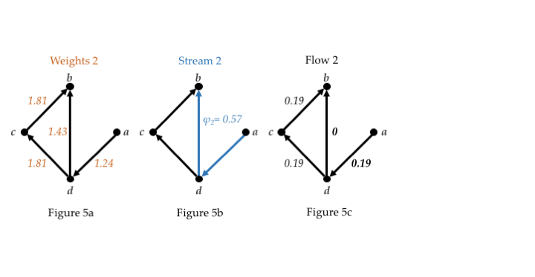

Figure 5

**Stream 3**:

Step 1: edge $(d,b)$ is removed since its flow is zero (figure 6a)

Step 2: calculate the weights (figure 6b)

Step 3: The minimum weighted path is $π_{3}=\left\{\left(a,d\right),\left(d,c\right),(c,b\right)\}$ with flow $φ_{3}=0.19$

Step 4: $f_{3 }\left(a,d\right)=f_{3}\left(d,c\right)=f_{3}\left(c,b\right)=0$ (figure 6c)

Step 5: $c_{3}\left(a,d\right)=c_{2}\left(a,d\right)+\frac{φ_{3}}{3}=0.285+0.0633=0.3483$

$$c_{3}\left(d,c\right)=c_{3}\left(c,b\right)=\frac{φ_{3}}{3}=0.0633$$

Table 5

|  |  |  |  |  |  |
| --- | --- | --- | --- | --- | --- |
|  | AB | AD | BC | BD | CD |
| AB | $$0.24$$ | $$0.3483$$ | $$0.0633$$ | $$0.285$$ | $$0.0633$$ |

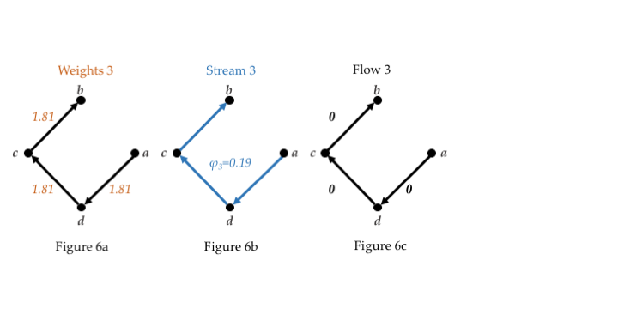

In this point we stop the procedure since there is no flow left.

So the final contribution row in percentages is

Table 6

|  |  |  |  |  |  |
| --- | --- | --- | --- | --- | --- |
|  | AB | AD | BC | BD | CD |
| AB | $$24\%$$ | $$34.83\%$$ | $$6.33\%$$ | $$28.5\%$$ | $$6.33\%$$ |

In a similar pattern one can fill the entire percentage contribution matrix and get Table 7

Table 7

|  |  |  |  |  |  |
| --- | --- | --- | --- | --- | --- |
|  | AB | AD | BC | BD | CD |
| AB | 24 | 34.83 | 6.33 | 28.5 | 6.33 |
| AC | 10.65 | 32.69 | 23.96 | 13.31 | 19.37 |
| AD | 6.65 | 85.46 | 1.24 | 5.41 | 1.24 |
| BC | 0.75 | 0.75 | 80.83 | 8.46 | 9.21 |
| BD | 4.5 | 4.5 | 11.65 | 67.69 | 11.66 |
| CD | 2.25 | 2.25 | 27.63 | 25.38 | 42.48 |

## Using percentage contributions to quantify the impact of a characteristic

Translating the $H$ matrix into percentage contributions of each direct comparison is particularly useful to quantify the influence that a characteristic pertaining to the direct comparisons has in the estimation of the NMA treatment effects. For instance, having risk of bias judgements per direct comparisons we can obtain the percentage of each NMA treatment effect that is coming from pairwise comparisons with ‘high’, ‘moderate’ or ‘low’ risk of bias. Salanti et al. proposed the visualisation of this information using a bar plot where direct comparisons of the same risk of bias have been grouped together (6). Figure 6 shows such a bar plot using the algorithm describe in Methods to obtain the percentage contributions of each direct comparison. Inspecting figure 6 can help derive judgements for the study limitations of the NMA treatment effects; i.e. direct comparisons with high risk of bias contribute more than 40% in the estimation of the ‘D versus C’ comparison, potentially impacting on the confidence that we can place on the particular NMA treatment effect.

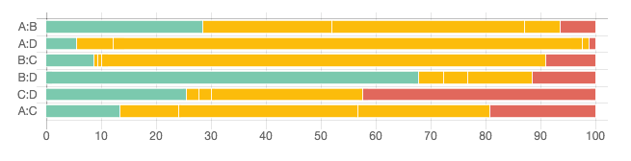Figure 7. Bar plot showing the percentage contributions of direct comparisons with low (green), moderate (yellow) and high (red) risk of bias. Risk of bias per direct comparison has been assumed to be the majority of per trial risk of bias. The bar plot has been produced in CINeMA (Confidence In Network Meta-Analysis) software (15). Studies are synthesized using the random effects model.

# Discussion

In this paper, we demonstrated an approach to derive percentage contributions of the direct comparisons to the NMA treatment effects. For obtaining the percentage contributions, we made use of the fact that the composition of network treatment effects can be interpreted as evidence flow. An assumption that underlies our algorithm is the equal split of the flow of each evidence path to the involved comparisons. Although indirect effects are not weighted averages, we find this approximation to be a pragmatic approach that reasonably reflects the amount that each comparison contributes to network effects.

Alternative methods to derive the relative contribution of all sources of evidence have been developed (3,16–18). Side splitting (also called node splitting and back calculation method) is a method to evaluate the assumption of consistency in NMA separating direct from indirect evidence (16,19). As in the absence of multi-arm trials, the network estimate can be written as a weighted average of the direct and the indirect estimate, this method implies ‘back-calculating’ the indirect estimate of a particular comparison as function of the direct and the NMA treatment effects and their variances. Equivalently, the indirect estimate is obtained excluding trials that compare the particular comparison and deriving the NMA –which will be indirect in this case- treatment effect. The idea underlying side splitting could be used to measure the change in the variance of the NMA treatment effect when excluding each comparison in the network. Such a procedure would lead to a matrix giving the impact of each direct comparison on the variances of the NMA estimates. While related to the percentage contribution matrix, the particular matrix would answer a different question, which is “to which proportion does the variance of the NMA estimate of the comparison in the row decrease due to the existence of the direct bridge in the column”. An alternative approach has been proposed to derive percentage study weights in a variety of meta-analysis models including meta-regression, network meta-analysis and individual patient data meta-analysis (17). This approach is based on the decomposition of Fisher’s information matrix and thus the derived weights are not influenced by the network structure. In (3) König et al. introduce the mean path length as a measure of indirectness; the mean path length grows as the indirect paths informing network effects are getting larger. Although the derivation of the particular measure has some similarities with the derivation of *streams* in this paper, the interpretation of the two measures is entirely different.

We offer an R package (20) which we also use in the software application CINeMA (Confidence In Network Meta-Analysis) (15) that aims to simplify the evaluation of confidence in the findings from NMA. While it largely follows the framework previously developed by Salanti et al. (6), the refinement of several methodological aspects is currently under development. Core aspects of the approach includes considerations of the relative contributions of each direct comparison to each NMA treatment effect. To this end, CINeMA uses the percentage contribution matrix as described in this paper (). The command *netweight* in Stata has also been updated to use the described approach; Chaimani et al [ref erratum] illustrates the problems related to the approach that was described in Salanti et al. and previously implemented in the *netgraphs* package in Stata.

We believe that the method described in this paper is a useful addition to the various applications of the $H$ matrix. The derivation of the percentage contributions of direct to network treatment effects can be particularly important when examining the impact of a particular characteristic to the findings of a NMA.

# References

1. Eichler H-G, Thomson A, Eichler I, Schneeweiss S. Assessing the relative efficacy of new drugs: an emerging opportunity. Nat Rev Drug Discov. 2015 Jul;14(7):443–4.

2. Jansen JP, Trikalinos T, Cappelleri JC, Daw J, Andes S, Eldessouki R, et al. Indirect Treatment Comparison/Network Meta-Analysis Study Questionnaire to Assess Relevance and Credibility to Inform Health Care Decision Making: An ISPOR-AMCP-NPC Good Practice Task Force Report. Value Health. 2014 Mar;17(2):157–73.

3. König J, Krahn U, Binder H. Visualizing the flow of evidence in network meta-analysis and characterizing mixed treatment comparisons. Stat Med. 2013 Dec 30;32(30):5414–29.

4. Krahn U, Binder H, König J. A graphical tool for locating inconsistency in network meta-analyses. BMC Med Res Methodol. 2013 Mar 9;13:35.

5. Krahn U, Binder H, König J. Visualizing inconsistency in network meta-analysis by independent path decomposition. BMC Med Res Methodol. 2014 Dec 16;14:131.

6. Salanti G, Del Giovane C, Chaimani A, Caldwell DM, Higgins JPT. Evaluating the quality of evidence from a network meta-analysis. PloS One. 2014;9(7):e99682.

7. Lu G, Welton NJ, Higgins JPT, White IR, Ades AE. Linear inference for mixed treatment comparison meta-analysis: A two-stage approach. ResSynthMeth. 2011;2(1):43–60.

8. White IR, Barrett JK, Jackson D, Higgins JPT. Consistency and inconsistency in network meta-analysis: model estimation using multivariate meta-regression. Res Synth Methods. 2012 Jun;3(2):111–25.

9. Salanti G, Higgins JPT, Ades AE, Ioannidis JPA. Evaluation of networks of randomized trials. Stat Methods Med Res. 2008 Jun;17(3):279–301.

10. Rücker G. Network meta-analysis, electrical networks and graph theory: NETWORK META-ANALYSIS USING GRAPH THEORY. Res Synth Methods. 2012 Dec;3(4):312–24.

11. Rücker G, Schwarzer G. Reduce dimension or reduce weights? Comparing two approaches to multi-arm studies in network meta-analysis. Stat Med. 2014 Nov 10;33(25):4353–69.

12. Lu G, Ades AE. Combination of direct and indirect evidence in mixed treatment comparisons. Stat Med. 2004 Oct 30;23(20):3105–24.

13. Cormen TH, editor. Introduction to algorithms. 2. ed., 8. printing. Cambridge, Mass.: MIT Press [u.a.]; 2007. 1180 p.

14. Macfadyen CA, Acuin JM, Gamble C. Topical antibiotics without steroids for chronically discharging ears with underlying eardrum perforations. Cochrane Database Syst Rev. 2005 Oct 19;(4):CD004618.

15. Confidence In Network Meta-Analysis [Internet]. Available from: cinema.ispm.ch

16. Dias S, Welton NJ, Caldwell DM, Ades AE. Checking consistency in mixed treatment comparison meta-analysis. Stat Med. 2010 Mar 30;29(7–8):932–44.

17. Riley RD, Ensor J, Jackson D, Burke DL. Deriving percentage study weights in multi-parameter meta-analysis models: with application to meta-regression, network meta-analysis and one-stage individual participant data models. Stat Methods Med Res. 2017 Feb 6;0962280216688033.

18. Noma H, Tanaka S, Matsui S, Cipriani A, Furukawa TA. Quantifying indirect evidence in network meta-analysis. Stat Med. 2017 Mar 15;36(6):917–27.

19. Dias S, Welton NJ, Sutton AJ, Caldwell DM, Lu G, Ades AE. Evidence synthesis for decision making 4: inconsistency in networks of evidence based on randomized controlled trials. Med Decis Mak Int J Soc Med Decis Mak. 2013 Jul;33(5):641–56.

20. Flow contribution R package [Internet]. Available from: https://github.com/esm-ispm-unibe-ch/flow_contribution