The TOS Protocol
Building the Internet for Autonomous Intelligence
A Theory and Reference Architecture for the Internet of Intelligence
TOS Network Research · Version 3.0 · July 2026

Abstract
The Internet was designed to address machines and retrieve information, not to address and coordinate autonomous intelligence. Current AI systems are therefore delivered through abstractions inherited from the Web: pages, applications, accounts, and proprietary APIs. This paper proposes a new Internet primitive, the AI Site, and a corresponding resource model in which intelligence becomes a first-class, persistent, addressable, policy-bounded, and economically active network resource. An AI Site is not a webpage with a chatbot attached. It is a sovereign operational envelope that combines a human-readable name, cryptographic identity, capabilities, memory, execution runtimes, policy, a wallet, and evidence. The TOS Protocol is introduced as an open communication layer for resolving, discovering, invoking, paying, and verifying AI Sites. The TOS blockchain functions as the trust and settlement substrate, while computation remains primarily on owner-operated or third-party edge nodes. The proposed architecture preserves Web compatibility through HTTPS gateways but adds AI-native semantics: capability discovery, authenticated sessions, delegated authority, metered invocation, signed receipts, and AI-to-AI composition. The resulting Internet of Intelligence is neither a replacement for the Web nor another centralized AI marketplace. It is an extension of the Internet in which anyone can publish, own, discover, and monetize autonomous intelligence as readily as they can publish a website today.
Keywords—AI Site; intelligence resource; TOS Protocol; autonomous agent; edge computing; native payment; blockchain; Internet architecture.

1. Introduction
The Web succeeded because it reduced publishing to a universal pattern: assign a name, expose a resource, and let any conforming client retrieve it. A website could move between servers, change its implementation, or serve users across the world while retaining a stable public identity. This separation of identity, protocol, and infrastructure allowed the Web to grow without requiring a single owner or application platform [1].
Artificial intelligence does not fit comfortably inside that pattern. A useful AI system is stateful rather than static; it may maintain memory, invoke tools, negotiate constraints, consume a budget, perform work over time, and collaborate with other systems. Yet it is usually exposed as a webpage, a mobile application, or an API endpoint controlled by a platform. These interfaces deliver access to AI, but they do not make the AI itself a native Internet object.
The distinction matters. A page can be retrieved, but an autonomous service must be identified, described, authorized, invoked, observed, paid, and held accountable. It also needs continuity: the same intelligence should remain reachable when its model, hardware, location, or operator changes. The Web gives documents stable names; it does not give autonomous intelligence a complete operational identity.
This paper advances the Resource Transition Thesis: major Internet eras emerge when the network standardizes a new primary resource. TCP/IP standardized communication among machines. DNS and HTTP made information resources globally addressable [2]-[4]. Blockchains made digitally scarce value transferable without a central ledger operator [5]. The next transition is to intelligence resources: persistent capabilities that transform goals and context into decisions, actions, and verifiable outcomes.
The proposed primitive is the AI Site. The proposed protocol is TOS. Their relationship is analogous, but not identical, to that between websites and HTTP. An AI Site is the object users and other agents encounter; TOS defines the common verbs and trust boundaries by which that object is resolved, described, invoked, and compensated. The TOS blockchain records ownership and settlement, while edge runtimes execute models and tools. This division keeps expensive and private computation off-chain without giving up global identity or portable trust.
The contribution of this paper is conceptual rather than merely product-specific. It defines an intelligence resource, formalizes the AI Site as a tuple of properties, proposes invariants for an open AI Internet, outlines a protocol grammar, and presents a deployable edge architecture. The objective is a compact theory that can guide an implementation while remaining broad enough to outlive any particular model, transport, or user interface.

2. From Information Resources to Intelligence Resources
The familiar Web1, Web2, and Web3 labels describe business models and participation patterns, but they obscure the deeper architectural transition. A more useful account follows the resource the network makes universally addressable. The early Internet connected machines. The Web organized information. An Internet of Intelligence will organize autonomous capabilities. Figure 1 summarizes this progression.
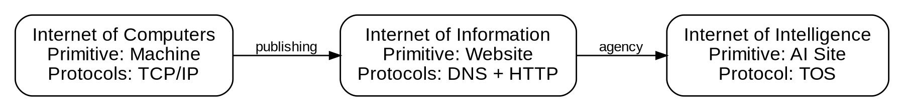
Figure 1. Resource transitions in the evolution of the Internet.
An information resource is primarily retrieved or updated. Its value is contained in a representation: a document, image, data object, or application state. HTTP can transport AI prompts and responses, but its general resource model does not express the full lifecycle of an intelligent service. It has no native concept of a capability promise, a spending envelope, an execution policy, an evidentiary receipt, or a persistent agent relationship. These can be layered on top of HTTP, as modern APIs do, but each provider reinvents them inside an account system.
Definition 1 — Intelligence Resource. A persistent, addressable, policy-bounded capability that transforms intent, context, constraints, and budget into results or actions.

We define an intelligence resource as a persistent, addressable, policy-bounded capability that transforms intent, context, constraints, and budget into results or actions. The output may be text, but it may also be a reservation, a signed transaction, a software patch, a robot instruction, or a completed multi-stage workflow. The resource is not the model weights alone. It is the entire accountable ability to perform work.
This definition separates intelligence from interface. A chat window is one interface to an intelligence resource, just as a visual browser is one interface to a website. The same AI Site may support human conversation, machine invocation, scheduled jobs, event subscriptions, or autonomous delegation. The protocol should therefore standardize semantics rather than mandate a user experience.
Three properties distinguish intelligence resources from conventional Web resources. First, they are generative: the value is produced at invocation time rather than fully stored in advance. Second, they are stateful: memory, permissions, budgets, and ongoing tasks influence future behavior. Third, they are economic actors: they can meter work, receive funds, purchase subordinate services, and issue receipts. These properties require a richer resource contract than a URL plus a media type.
The move from information to intelligence does not make the Web obsolete. It creates a higher-level resource model that can use Web transports where convenient. TOS is therefore designed as an AI-native application protocol that may initially operate over TLS, HTTPS, WebSocket, or QUIC. The innovation lies in common semantics and portable trust, not in replacing every mature transport layer.

3. AI Site: The Primitive of the AI Internet
An AI Site is the smallest complete unit of publishable autonomous intelligence. It is complete because it contains enough information for an unfamiliar client to answer seven questions: Who is this service? What can it do? Where can it run? Under what policy may it act? What will it cost? How can its result be verified? Who is accountable for it?
Formally, an AI Site S can be represented as the tuple S = <N, K, C, M, R, P, W, E>. N is a human-readable TOS name such as hotel.tos. K is the cryptographic key structure that identifies the owner and authorized controllers. C is the set of declared capabilities. M is the site's persistent and ephemeral memory model. R is the set of available runtimes and endpoint locators. P is policy: authorization, privacy, rate, jurisdiction, and safety constraints. W is the wallet and settlement configuration. E is evidence, including signed manifests, receipts, attestations, and reputation references.
Definition 2 — AI Site. The smallest complete unit of publishable autonomous intelligence, represented by S = <N, K, C, M, R, P, W, E>.

This tuple is an operational envelope, not a requirement that all data be public or stored on-chain. The blockchain should contain compact commitments and state that benefit from global consensus: name ownership, key rotation, manifest hashes, delegated authority, escrow, and settlement. Large models, private prompts, user memory, and tool data remain off-chain under the owner's chosen storage and privacy regime.
Four invariants define an AI Site. The Identity Invariant states that the site name and ownership survive changes in infrastructure. The Policy Invariant states that every consequential action is bounded by explicit authorization rather than trust in an opaque process. The Economic Invariant states that an invocation can carry a quote, budget, metering rule, and settlement receipt. The Composition Invariant states that an AI Site can invoke another AI Site using the same protocol available to a human client.
Table 1. The AI Site changes the primary network object, not merely the user interface.
Dimension | Website | AI Site
Primary resource | Information representation | Policy-bounded intelligence
Identity | Domain / URL | Name + keys + ownership
Interaction | Retrieve / update | Negotiate / invoke / stream
State | Application-defined | Memory + task + policy state
Economy | External account billing | Native quote, budget, receipt
Execution | Server or cloud application | Portable edge runtime(s)
Composition | Links and APIs | AI-to-AI delegated work
These invariants distinguish an AI Site from a hosted chatbot. A chatbot account generally inherits the platform's name, billing, discovery, and trust. An AI Site can move between providers, run on a local machine, use multiple models, or combine private and public tools while preserving one identity. The owner's relationship is therefore closer to owning a domain and operating a business than to creating a profile inside an application.
The human-readable name is central. A name such as lawyer.tos or alice.tos is not merely a shortcut to an IP address. It is the stable root of a signed site descriptor. The descriptor can reference multiple endpoints, supported protocol versions, a manifest hash, region constraints, controller keys, and health metadata. Resolution yields a verifiable identity plus candidate runtimes, not an untrusted redirect.
The site manifest is the public contract of the AI Site. It describes capabilities, inputs, outputs, languages, pricing, tool dependencies, model disclosures where appropriate, evidence policies, and user-facing metadata. The on-chain record binds the manifest hash to the site owner; the full manifest may be distributed through edge storage or ordinary Web infrastructure. This hybrid approach makes updates inexpensive while allowing clients to detect substitution or tampering.

4. The TOS Protocol
The TOS Protocol is a common interaction grammar for intelligence resources. It defines what participants mean when they resolve a name, inspect capabilities, establish a session, delegate authority, invoke work, receive evidence, and settle value. It does not require a particular model provider or transport, and it does not assume that every interaction is on-chain.
At a conceptual level, TOS exposes nine verbs. RESOLVE maps name.tos to a signed site descriptor. DESCRIBE retrieves and verifies the manifest. OPEN establishes an authenticated session and negotiates protocol features. QUOTE returns price, limits, deadlines, and evidence commitments for an intended operation. INVOKE submits intent, context references, constraints, and authorization. STREAM carries incremental output, progress, tool events, and metering. DELEGATE grants a bounded controller or sub-agent permission. VERIFY checks signatures, receipts, evidence, or external attestations. SETTLE finalizes payment and state transitions. CLOSE terminates or checkpoints a session.
Table 2. Conceptual verbs of the TOS interaction grammar.
TOS verb | Purpose
RESOLVE / DESCRIBE | Bind a name to a signed descriptor and manifest.
OPEN / QUOTE | Establish identity, features, price, limits, and evidence policy.
INVOKE / STREAM | Submit intent and receive result, progress, events, and metering.
DELEGATE / VERIFY | Grant bounded authority and validate receipts or attestations.
SETTLE / CLOSE | Finalize value and checkpoint or end the relationship.
The core request is richer than a conventional API call. It can be modeled as Q = <principal, intent, context references, constraints, budget, deadline, evidence policy>. The corresponding receipt can be modeled as Z = <result reference, cost, provenance, state delta, proof references, signature>. Standardizing these envelopes makes the interaction portable across clients and services. A user can understand what was authorized and paid for; an AI agent can compose another service without negotiating a bespoke billing account.
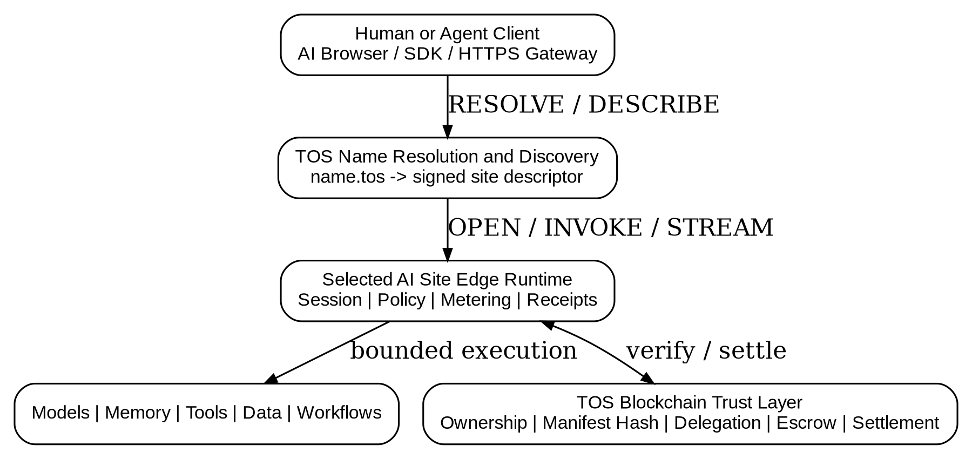
Figure 2. Reference architecture: AI Sites execute at the edge while TOS provides identity, protocol semantics, and settlement.
TOS separates identity from connection. A session may use HTTPS, WebSocket, QUIC, a local socket, or a relay, but the peer proves control of a key authorized by the resolved AI Site. Session establishment can bind a user wallet, a decentralized identifier, or an anonymous ephemeral key depending on policy. This permits privacy-preserving free access as well as authenticated commercial workflows.
Compatibility is essential. In the first deployment stage, https://name.tos can present a conventional Web interface and expose a well-known manifest endpoint, while an AI-native client interprets the same signed descriptor and opens a TOS session. A future tos://name.tos scheme may signal native behavior, but adoption should depend on capability rather than forcing users to install a new browser on day one.
Figure 3. A complete AI Site invocation includes discovery, authorization, evidence, and settlement.
Protocol versioning must be explicit and conservative. The manifest declares supported TOS versions and optional extensions. Clients ignore unknown non-critical fields, while security-critical changes require a version transition. The protocol should prefer signed canonical encodings for receipts and commitments, but allow human-readable JSON or CBOR representations at gateways. The specification must distinguish normative state from advisory metadata so that search descriptions cannot silently expand authority.
The TOS blockchain is the trust substrate beneath this grammar. It is used where shared finality is valuable: name ownership, authorization roots, bond or escrow state, settlement, and hashes of externally stored artifacts. It should not be used to place every token of a conversation into consensus. This architecture preserves privacy, throughput, and low latency while retaining auditability at boundaries that matter.

5. Discovery, Selection, and the AI Browser
The Web made information abundant, then search engines made it navigable. An AI Internet requires the equivalent transition from endpoint directories to capability discovery. Users should be able to express an objective such as 'find a Japanese-speaking hotel booking service near Yamanakako with a maximum fee of 0.2 TOS' and receive verifiable candidates rather than sponsored pages alone.
Discovery begins with manifests. Indexers can read public manifests and on-chain commitments, then build semantic indexes over declared capabilities, input types, geographic reach, languages, prices, availability, and evidence policies. Because the manifest is signed, an indexer cannot alter the service's claims without detection. Because registries are open, no single search company needs to become the gatekeeper of AI traffic.
Selection is necessarily multi-dimensional. Relevance alone is insufficient. A client may rank candidates by latency, price, privacy jurisdiction, owner reputation, model transparency, uptime, previous task success, or compatibility with a required evidence scheme. The ranking function can be local to the user or delegated to a trusted discovery AI Site. This turns discovery itself into an open service market.
Reputation should not be treated as one global score. A service that is reliable at translation may be untested at legal analysis. TOS should support signed, capability-specific receipts and attestations from users, verifiers, institutions, and other AI Sites. Clients can choose which issuers and historical signals matter. This avoids replacing a centralized platform reputation with a single on-chain popularity contest.
The AI Browser is the user agent for this environment. Its job is broader than rendering HTML. It resolves names, verifies manifests, negotiates sessions, presents capabilities and prices, enforces spending limits, manages private context, and displays receipts. It can orchestrate several AI Sites behind one user intent while making the flow of data and value visible. A conventional browser extension, desktop client, wallet, or embedded SDK can provide these functions before a dedicated AI Browser becomes common.
This model changes the meaning of navigation. Opening an AI Site is not merely loading a page; it is entering a policy-governed relationship with an intelligent service. The client should show which data will be shared, which tools may be invoked, what maximum amount may be spent, whether subcontracting is allowed, and what evidence will be returned. Consent becomes executable configuration rather than a static terms-of-service checkbox.

6. Edge-Native Execution and Node Deployment
Centralized cloud systems are efficient for model training and global services, but many AI workloads benefit from locality. Private knowledge may not be allowed to leave a home or enterprise. Robots and interactive assistants require low latency. Regional law may constrain where personal data is processed. Specialized operators may own underused GPUs, domain databases, or physical tools. AI Sites should therefore be edge-native rather than cloud-exclusive [7].
TOS already provides the foundational ability to direct a name.tos identity toward an owner-operated local edge IP. The protocol extends that ability from redirection to verifiable service resolution. Instead of trusting a mutable address alone, the resolver returns a signed site descriptor containing endpoint locators, transport options, public keys, regions, protocol versions, and expiry. A client selects an endpoint according to policy and verifies that the runtime is authorized by the site owner.
One logical AI Site may have several runtimes. hotel.tos might use a Tokyo edge for low-latency booking, a Frankfurt edge for European privacy requirements, and an owner-operated local node for access to private inventory. The name remains stable. Routing decisions can account for latency, load, jurisdiction, model availability, price, and task sensitivity. This is analogous to a content delivery network, but the routed object is an accountable execution capability rather than a cached file.
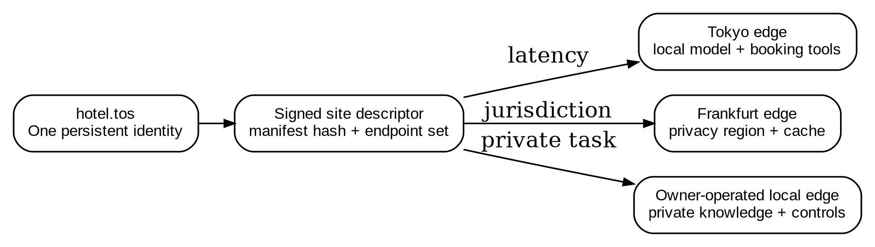
Figure 4. One persistent AI Site identity can route to multiple owner-authorized edge runtimes.
A reference TOS Edge Node contains eight components. The ingress and relay layer handles TLS, NAT traversal, and connection limits. The resolver agent proves that the node is authorized for one or more names. The runtime supervisor launches isolated site workloads. The model gateway connects local or remote models. The tool gateway exposes approved MCP-style tools, browsers, devices, and data services. The memory layer manages private state and retrieval. The wallet and policy service enforces budgets and controller permissions. The metering and receipt service records resource use and signs results. Observability monitors health without exposing private prompts.
Deployment can follow a simple sequence. First, the owner generates an offline owner key and a limited node controller key. Second, the owner binds name.tos to the site identity and publishes a manifest commitment. Third, the node starts the AI Site Runtime, loads models and tools, and creates a signed endpoint descriptor. Fourth, the resolver advertises the endpoint and health window. Fifth, incoming sessions are authenticated, evaluated against policy, executed inside a sandbox, metered, and returned with signed receipts. Finally, settlement is periodically committed to the TOS blockchain or resolved through an escrow channel.
Table 3. Minimum logical components of a production TOS Edge Node.
Edge component | Responsibility
Ingress / relay | TLS, NAT traversal, rate limits, denial-of-service controls
Runtime supervisor | Isolated lifecycle for each AI Site workload
Model and tool gateways | Approved models, data, browsers, devices, and services
Memory layer | Private state, retrieval, retention, and encryption
Wallet / policy service | Budgets, controller permissions, quoting, settlement
Metering / receipts | Usage measurement, provenance, signed result records
A practical implementation should support containers and ordinary Linux hosts before specialized hardware. A minimum node can run on a personal computer with CPU inference or remote model APIs. A production node may add GPUs, replicated storage, confidential computing, and regional relays. The protocol defines interoperability; operators decide the hardware and business model.
Local hosting introduces risks that must be addressed directly. Administrative ports and model backends should never be exposed merely because a name resolves to a local IP. The public ingress must be authenticated, rate-limited, and isolated from the management plane. Dynamic endpoints need short-lived signed descriptors. Nodes behind NAT may use an owner-selected relay or reverse tunnel without transferring site ownership to the relay. Private memory should be encrypted at rest, and high-impact tools should require explicit policy grants.

7. Native Payment and AI-to-AI Composition
The prevailing AI business model is provider-specific: create an account, obtain an API key, prepay or accept an invoice, and trust the provider's usage record. This is workable for human developers but poorly suited to autonomous agents that discover services dynamically. Native payment makes value part of invocation rather than an external commercial relationship.
TOS supports several payment patterns. Free quota allows anonymous or identified trial use. Pay-per-call attaches a signed authorization to an invocation. Metered payment settles according to tokens, compute time, tool cost, or a domain-specific unit. Subscription grants a time-bounded capability. Streaming payment releases value as output or work progresses. Escrow reserves a task budget and settles after acceptance, verification, timeout, or dispute.
The safe default is delegated spending rather than handing an AI the owner's primary key. An owner defines a spending envelope: maximum amount per call, daily total, permitted service categories, expiration, and whether subcontracting is allowed. A controller key used by the AI can authorize only operations within that envelope. Smart-contract policy is the final boundary; promises inside an off-chain prompt are not security controls.
Composition is the economic counterpart of hyperlinks. A travel AI Site can discover and hire translation, mapping, weather, insurance, and payment AI Sites. The user need not maintain five accounts or API keys. Each subcontract is a TOS invocation with its own quote, policy, evidence, and receipt. The parent site can return an aggregate receipt that exposes the cost and provenance chain according to user preference.
This creates an open AI supply network. Small operators can publish narrow but valuable capabilities without building a consumer brand or negotiating platform distribution. A local hotel can expose live inventory; a researcher can publish a scientific verifier; a GPU owner can serve a specialized model; a city can provide public transport intelligence. Revenue flows directly to the owners of useful capabilities.
Native payment also improves accountability. A signed receipt links a result to the service identity, manifest version, price rule, delegated authority, and optional evidence. It does not prove that every answer is true, but it establishes who performed the work under which declared conditions. Domain-specific verifiers, human review, reproducible computation, or future zero-knowledge proofs can strengthen that evidence without changing the basic interaction model.

8. Trust, Security, and Governance
An open AI Internet cannot assume that every AI Site is honest or competent. Its goal is not to eliminate trust but to make trust explicit, portable, and bounded. Cryptography can verify identity, ownership, authorization, and message integrity. It cannot by itself guarantee factual correctness, benevolent goals, or professional qualification. The protocol must expose these distinctions rather than hiding them behind a generic verified badge.
The primary key hierarchy separates owner authority from operational control. The owner key can rotate controllers, move endpoints, change settlement policy, and recover the site. It should normally remain offline or in secure custody. Controller keys operate edge nodes or automated agents under limited, revocable capabilities. This capability-oriented approach follows a long tradition of limiting authority to the minimum required operation [8].
Runtime isolation is equally important. Each AI Site should execute in a sandbox with explicit access to models, files, networks, devices, and tools. Tool declarations in a manifest are descriptive; actual grants are enforced locally by the runtime policy engine. High-risk actions can require multi-party approval, human confirmation, delay, or escrow. A malicious prompt must not be able to expand the controller's authority.
Privacy requires data minimization. A client should send references or selectively disclosed context instead of uploading an entire personal memory by default. The manifest states retention and region policies, while the session records the actual grant. Local AI Sites can keep sensitive memory on the user's device and invoke remote sites with derived or redacted context. On-chain records should contain commitments and settlement data, not confidential conversations.
Governance should occur at the protocol boundary, not through one mandatory marketplace. TOS names and core transaction rules require shared consensus. Discovery indexes, ranking algorithms, content policies, and user interfaces can remain plural. Different communities may maintain trusted lists, professional credential issuers, or safety profiles. Interoperability permits these institutions to compete without fragmenting identity and payment.
Abuse resistance remains an open systems problem. Rate limits, bonds, proof-of-work challenges, reputation, stake, and paid invocation can make spam more expensive, but each has tradeoffs. The protocol should expose hooks for admission policy rather than hard-code one universal solution. Likewise, dispute resolution may vary by task: deterministic code can be rerun, physical work may require witnesses, and subjective creative output may rely on contractual review.

9. Implications and Research Agenda
If AI Sites become common, the unit of Internet ownership changes. A company will not merely operate a website and subscribe to AI vendors; it can own a durable AI identity that combines its knowledge, workflows, tools, and customer relationships. Individuals can operate private personal AI Sites. Universities can publish research intelligence. Cities can expose public services. Machines and robots can become addressable sites with bounded authority.
The theory also changes competition. Model scale remains important, but value shifts toward the complete intelligence resource: domain data, reliable tools, memory, policy, proximity, reputation, and the ability to complete work. A small site using several models may outperform a larger generic system in a narrow domain. Open discovery and native payment lower the cost of reaching users and other agents.
Several research problems require disciplined work. Capability vocabularies must become expressive without turning into one rigid ontology. Semantic discovery must resist deceptive manifests and paid manipulation. Edge routing must balance latency, privacy, cost, and trust. Reputation must be Sybil-resistant yet allow new services to enter. Metering must be auditable across heterogeneous hardware. Verifiable inference and provenance remain incomplete. Multi-agent workflows need termination, budget, and recursion controls. Human legal responsibility must remain clear when autonomous services subcontract work.
The implementation path should therefore be incremental. Phase one can use existing browsers and transports: resolve name.tos, serve a signed manifest, connect to an authorized edge endpoint, and settle simple pay-per-call requests. Phase two adds the AI Browser or SDK, delegated budgets, semantic discovery, signed receipts, and AI-to-AI composition. Phase three develops interoperable verification, streaming settlement, multi-region routing, and richer task escrow. Each phase should be usable without requiring the entire future architecture.
Success should not be measured only by chain throughput or token activity. More meaningful metrics include the number of independently owned AI Sites, the share running outside dominant clouds, cross-provider composition, user-controlled memory, verified task completion, and the diversity of discovery services. The objective is an open market of intelligence, not merely a new payment rail for existing centralized APIs.

10. Conclusion
The Web connected information by making documents globally nameable, retrievable, and linkable. Autonomous intelligence demands an additional abstraction. It must be nameable, discoverable by capability, invokable under explicit policy, able to preserve memory and identity across infrastructure, economically composable, and accountable through portable evidence.
AI Sites provide that abstraction. An AI Site is an intelligence resource with its own name, keys, capabilities, memory, runtimes, policy, wallet, and evidence. The TOS Protocol supplies the interaction grammar. The TOS blockchain supplies global ownership and settlement. Edge nodes supply computation close to users, data, and physical tools. Existing Web transports remain useful gateways, but the semantics shift from retrieving representations to coordinating intelligent work.
The central proposition can therefore be stated compactly: the Web standardized information resources; the AI Internet must standardize intelligence resources. If this standard remains open, anyone can publish and own autonomous intelligence rather than merely renting access inside a platform. The Website democratized publishing. The AI Site can democratize intelligence.

References
[1] T. Berners-Lee, R. Cailliau, J.-F. Groff, and B. Pollermann, “World-Wide Web: The Information Universe,” Electronic Networking: Research, Applications and Policy, vol. 1, no. 2, pp. 52-58, 1992.
[2] P. Mockapetris, “Domain Names—Concepts and Facilities,” RFC 1034, Nov. 1987.
[3] P. Mockapetris, “Domain Names—Implementation and Specification,” RFC 1035, Nov. 1987.
[4] R. Fielding, M. Nottingham, and J. Reschke, “HTTP Semantics,” RFC 9110, June 2022.
[5] S. Nakamoto, “Bitcoin: A Peer-to-Peer Electronic Cash System,” 2008.
[6] W3C, “Decentralized Identifiers (DIDs) v1.0: Core Architecture, Data Model, and Representations,” W3C Recommendation, July 2022.
[7] M. Satyanarayanan, “The Emergence of Edge Computing,” Computer, vol. 50, no. 1, pp. 30-39, 2017.
[8] M. S. Miller, K.-P. Yee, and J. Shapiro, “Capability Myths Demolished,” Technical Report SRL2003-02, Johns Hopkins University, 2003.
[9] C. Hewitt, P. Bishop, and R. Steiger, “A Universal Modular ACTOR Formalism for Artificial Intelligence,” Proc. 3rd International Joint Conference on Artificial Intelligence, pp. 235-245, 1973.

