ø

Sensor Research

A comparison of sensors

University of Applied Sciences Rotterdam

TINPRJ03-1 : Project 1 Lift

# Contents

Contents 1

Introduction 2

Types of sensors 3

IR 3

LDR 4

Reed 5

Limit switch 6

Comparison 7

Conclusion 8

Bibliography 9

# Introduction

The goal of the current project is to build a scaled down version of an elevator shaft.  
This includes fabricating each story, making a control room and making the stories communicate with each other.

This research is written to find the optimal sensor to use for the detection of an elevator carriage.  
This will include:

* Describing how the sensor works.
* Describing current use cases of the sensor.
* Investigating the reliability of the sensor.
* Investigating the effectiveness of the sensor in the new use case.

# Types of sensors

## IR

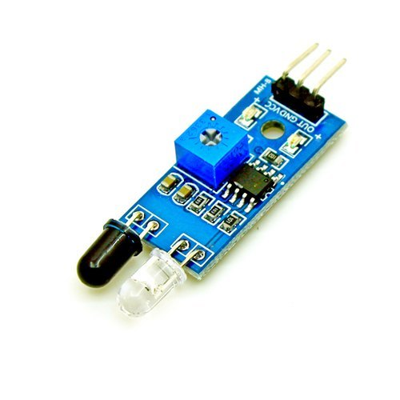

Figure : Active Infrared Sensor

#### Functionality

IR or infra-red sensors come in two varieties. Passive Infra-red (PIR) sensors and active infra-red sensors. Passive infra-red sensors have a photocell that detects infrared light radiating from other things, such as people or objects. An active IR sensor also has an infrared sensitive photocell to detect IR-radiation, however an active sensor also has an Infrared LED blasts infrared light that in turn gets reflected by objects.

#### Current use cases

PIR sensors are commonly used in automated doors to open the door when an object approaches.   
Active sensors are used in edge detectors.

#### Reliability

Infrared sensors are fairly reliable. To work properly they need a reflective surface or drastic contrast to detect changes in infrared light. The sensor however does not work in bright sunlight. The sunlight contains a lot of infrared and makes the sensor give a false positive.

#### New effectiveness

An active infrared sensor is ideal to use in a dark elevator shaft, granted the shaft is painted black to absorb all light coming in form outside the shaft. It is also recommended to have a contrasting stipe on the carriage.

## Photoresistor

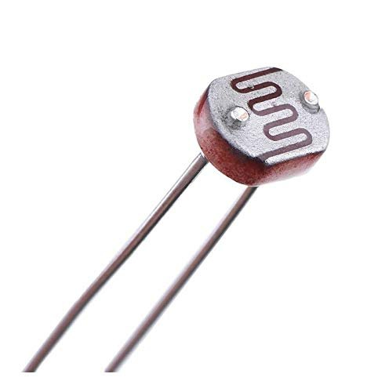

Figure : LDR

#### Functionality

A photoresistor, otherwise know as LDR (light dependant resistor) is a passive electronic component where the resistance is influenced by the amount of light it receives. The resistance decreases when the luminosity increases.

#### Current use cases

Photoresistors are inexpensive to produce and are used in: clock radios, nightlights and   
solar streetlamps.

#### Reliability

Photoresistors need a bright light source to function. They can get overwhelmed by ambient light just like infrared sensors.

#### New effectiveness

These sensors will definitely not be used in the elevator. They require no ambient light to be there.  
But a LDR will not function without light.

## Reed

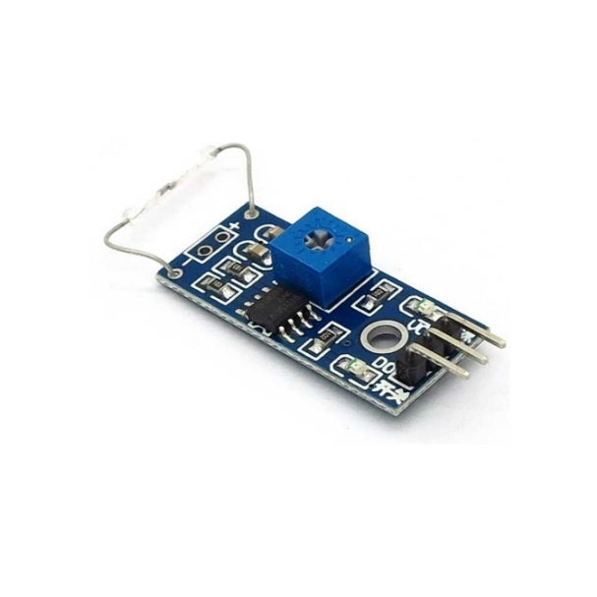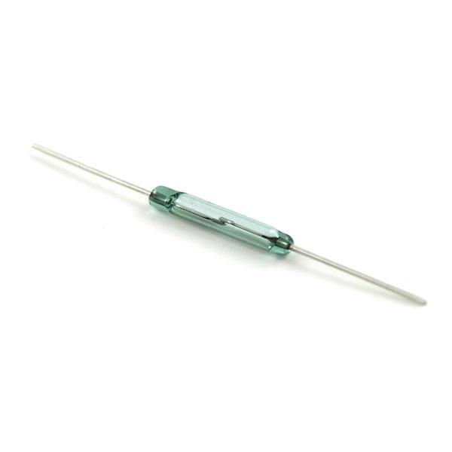

Figure : Reed switch on a PCB Figure 4: Loose Reedswitch

#### Functionality

Two or more small metal leaves are suspended in a vacuum. Bringing a magnetic field close will make the leaves touch each other, creating a closed circuit and allowing electricity to flow.

#### Current use cases

Reed switches are currently being used in: fluid level sensors, speed sensors and proximity sensors.

#### Reliability

A reed switch needs more finetuning to correctly configure. The placement needs to be exactly the same on all levels to ensure the correct functionality if the whole elevator uses reed switches.

#### New effectiveness

Reed switches do not need any conditioning except no magnetic interference. Otherwise they are an ideal sensor to use in this case. The only problem is that the glass tube is somewhat fragile and will require delicate handling.

# Comparison & Conclusion

There are two main contenders, the infrared sensor and the reed switch. The LDR is already out of the picture. It is annoying to implement and difficult to configure.   
An infrared sensor is relatively easy to install and use, but requires more finetuning and conditioning to function correctly. The reed switch is easy to install and implement. The only problem is that tube is fragile and needs to be handled with care.

Therefore, the sensor that will be used is the reed switch. It is easy to use and install. It is also easy to reach the best conditions to correctly function.

# Bibliography