Central Park’s Secret

[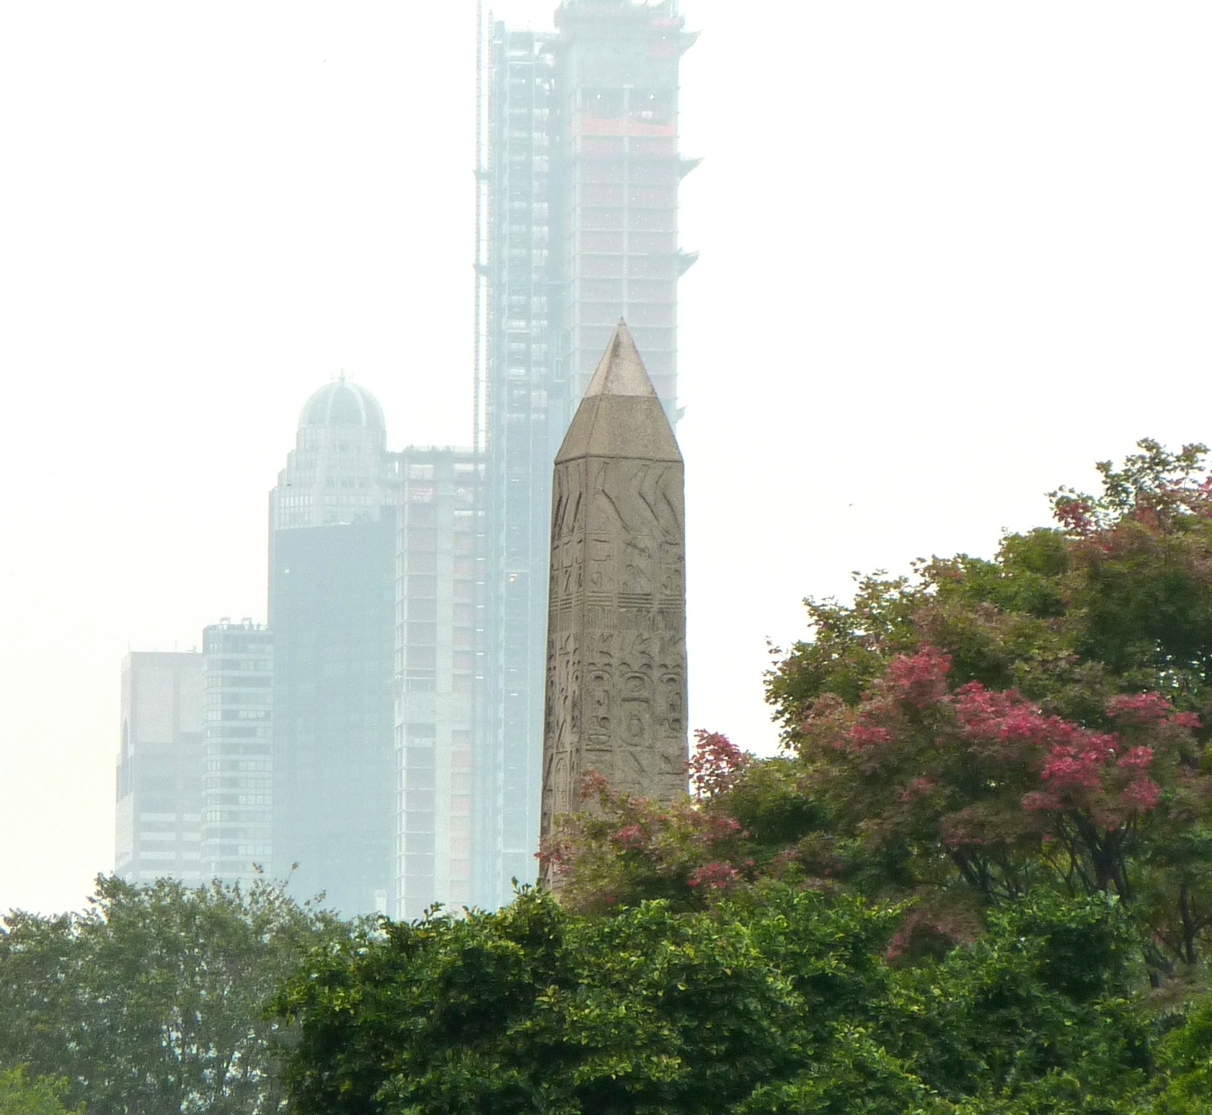](CryFromThePast.jpg)

This obelisk, an ancient Egyptian monolith – a single piece of rock split from its quarry 3500 years ago, stands a quarter of a mile from the eastern edge of the Park – far enough to be overlooked. I was not aware of it until a year ago when I read about the major engineering difficulties related its transport from Egypt in 1880-ies (the twin column standing now in London, for example, encased in a boat-like structure, was thought to have sunk in the Mediterranean until it washed up on the Italy’s coast). In contrast to the Place de la Concorde in Paris, where a similar obelisk is a focal point of the location, the New York monument stands completely unadvertised, waiting to be discovered, pre-school children playing around it on a picknic.

And the juxtaposition could not be more dramatic. Do you honestly believe that the skyscrapers visible in the background it will last 3 and half millennia? The hieroglyphs cry as they did in times of Ramesses II:

... the King of Upper and Lower Egypt, ...

mighty in years and great of victories,

the son of Ra, Ramesses, beloved of Amun,

who came forth from the womb in order to receive crowns of Ra,

who created him to be the sole lord,

the Lord of the Two Lands ...