Instituto Superior Técnico

Mestrado Integrado em Engenharia Electrotécnica e de Computadores

Sistemas de Informação e Bases de Dados

2015/2016

Project Assignment

(part 1)

Group: 16

Maria Margarida Dias dos Reis, nº 73099

Sofia Fidalgo da Silva, nº 73483

Tiago José Ribeiro Ricardo, nº 73649

Lisboa, 21 de Outubro de 2015

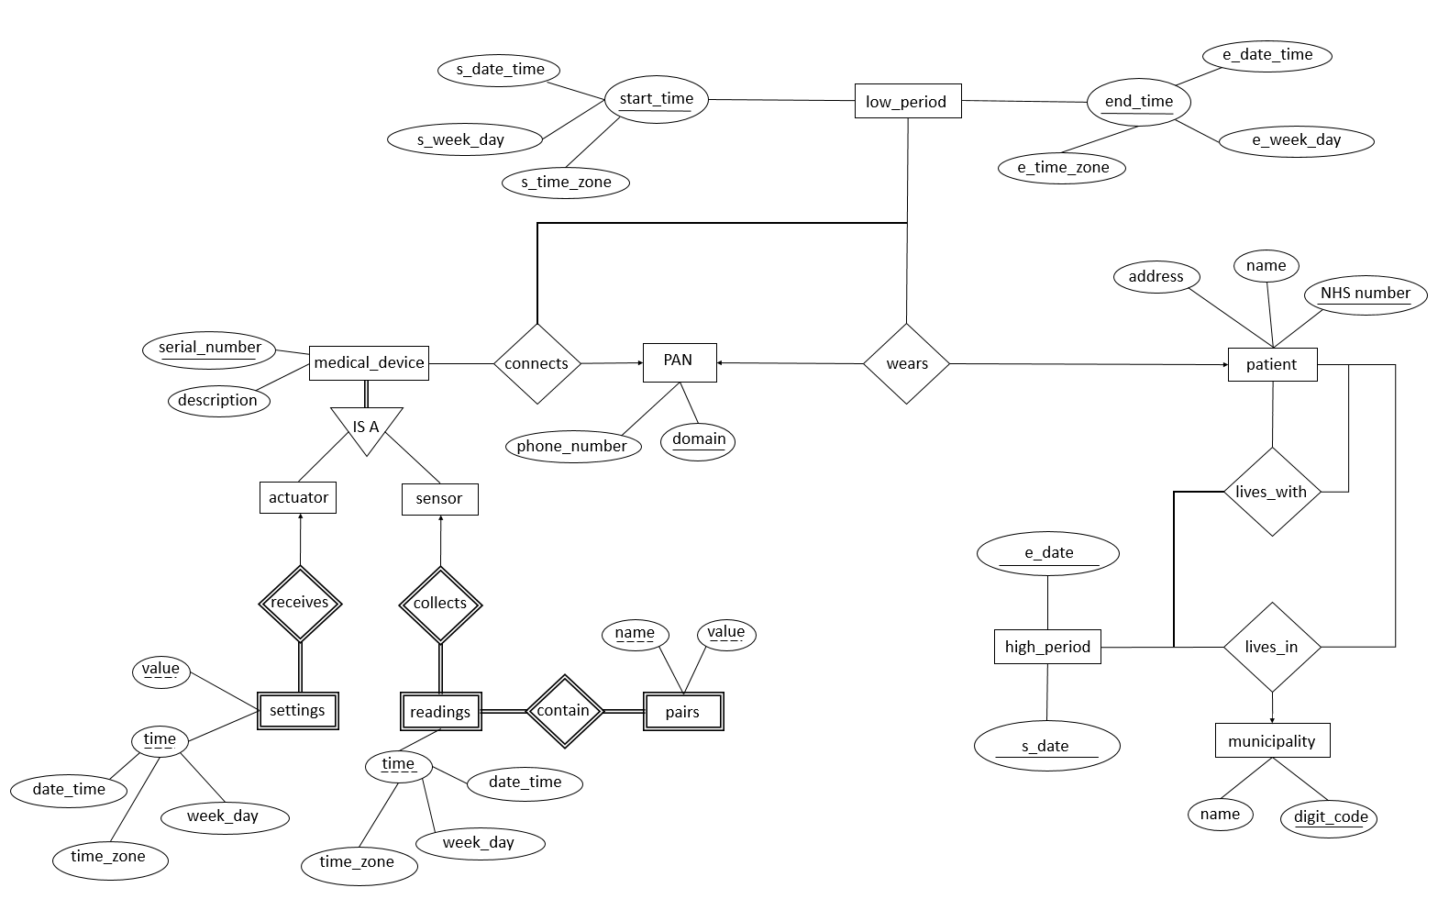

**E-R model**

**Notes about the ER-Model:**

* Medical devices connect to a patient through the PAN, and not directly. This makes sense to us because a patient doesn’t have a medical device by itself but only in the context of being connected to a PAN.
* We have two different time resolutions: a high level one and a low level one. The time period that defines the connection between a medical device and a PAN and also the one that defines the connection between the patient and the PAN should be descriptive, i.e., include hours, day of the week, time zone and date. However to know the time period in which two patients lived together it doesn’t make sense to have that low a resolution, we think that the date is enough.
* One thing that cannot be captured in the ER-Model regards time overlaps. Let’s consider the example: a medical device connects to a certain PAN from 01-01-2015 to 30-01-2015. However, the same medical device can be connected to another PAN from 02-01-2015 to 31-01-2015 and our ER-Model cannot prevent this from happening.

**Entities**

medical_device (serial_number, description)

actuator (serial_number)

serial_number: FK (medical_device)

sensor (serial_number)

serial_number: FK (medical_device)

low_period (s_week_day, s_time_zone, s_date_time, e_week_day, e_time_zone, e_date_time)

high_period (s_date, e_date)

PAN (domain, phone_number)

patient (NHS_number, name, address)

municipality (digit_code, name)

**Weak entities**

settings (week_day, time_zone, date_time, value, serial_number)

serial_number: FK (actuator)

readings (week_day, time_zone, date_time, serial_number)

serial_number: FK (sensor)

pairs (name, value, week_day, time_zone, date_time, serial_number)

week_day, time_zone, date_time, serial_number: FK (readings)

**Relationships**

connects (serial_number, s_week_day, s_time_zone, s_date_time, e_week_day, e_time_zone, e_date_time, domain)

serial_number: FK (medical_device)

s_week_day, s_time_zone, s_date_time, e_week_day, e_time_zone, e_date_time: FK (low_period)

domain: FK (PAN)

wears (NHS_number, s_week_day, s_time_zone, s_date_time, e_week_day, e_time_zone, e_date_time, domain)

or

wears (domain, s_week_day, s_time_zone, s_date_time, e_week_day, e_time_zone, e_date_time, NHS_number)

NHS_number: FK (patient)

s_week_day, s_time_zone, s_date_time, e_week_day, e_time_zone, e_date_time: FK (low_period)

domain: FK (PAN)

lives_with (NHS_number1, NHS_number2, s_date, e_date)

NHS_number1: FK (patient)

NHS_number2: FK (patient)

s_date, e_date: FK (high_period)

lives_in (NHS_number, s_date, e_date, digit_code)

NHS_number: FK (patient)

s_date, e_date: FK (high_period)

digit_code: FK (municipality)