PromptShield
Project Summary
Date: 2026-05-05 | Version: 1.0
Audience: Engineering Team, Architects, Stakeholders

Table of Contents
1. Executive Summary
2. Architecture Overview
System Boundaries
3. Processing Pipeline
Step-by-Step Flow
FastAPI Middleware Flow
4. Core Components
Detection Layer
Policy Layer
Actions Layer
Infrastructure Layer
5. API Contracts and Message Schemas
`Shield` Constructor
`Shield.scan(prompt)` / `Shield.scan_response(response)`
`PolicyConfig` Schema
`DetectedEntity` Schema
Audit Log JSON Line Schema
FastAPI Middleware — Block Response
6. Infrastructure and Deployment
Package Installation
Dependencies
Build System
Testing
7. Extension Patterns
Adding a Custom Detector
Adding a New Entity Type to `RegexDetector`
Enabling India PII Detection
Adding FastAPI Middleware
Custom Audit Logger
8. Rules and Anti-Patterns
Rules (Do)
Anti-Patterns (Do Not)
9. Dependencies
Core Dependencies
Optional Dependencies
Development Dependencies
10. Code Structure

1. Executive Summary
PromptShield is a Python middleware library (v0.1.0) that intercepts prompts before they reach a Large Language Model (LLM) API, detects sensitive personally identifiable information (PII) and secrets, and applies configurable privacy policies (mask, block, or allow). It produces structured JSON audit logs for compliance without persisting raw sensitive values. The library supports regex-based detection of global PII patterns (email, phone, credit card, API keys), an extended India-specific detector (Aadhaar, PAN, GSTIN, IFSC, Passport, Voter ID), a plug-in detector interface for custom patterns, and optional FastAPI/Starlette middleware for drop-in HTTP request sanitisation.

2. Architecture Overview
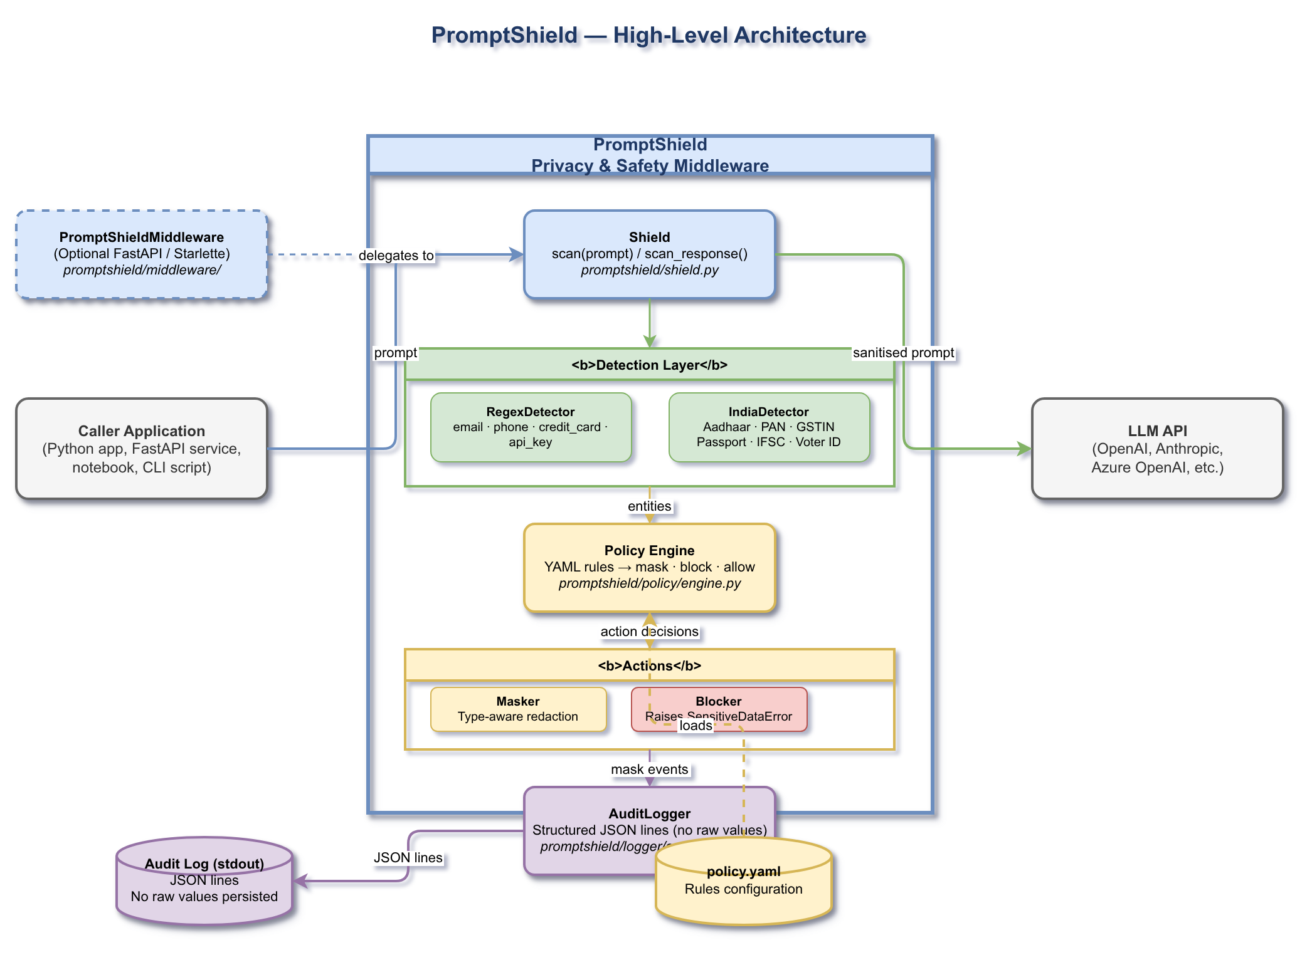
High-Level Architecture
PromptShield sits between the caller application and the LLM API. The caller invokes Shield.scan(prompt), which runs the detection pipeline, evaluates results against a YAML-driven policy, applies masking or blocking, emits a structured JSON audit log to stdout, and returns the sanitised string. The optional PromptShieldMiddleware wraps FastAPI/Starlette applications to intercept POST request bodies transparently.

System Boundaries
Boundary | Description
Caller Application | Any Python app, FastAPI service, notebook, or CLI script that calls Shield.scan()
PromptShield | Core library — detection, policy, actions, logging (this project)
LLM API | Downstream target: OpenAI, Anthropic, Azure OpenAI, etc. (not part of this project)
policy.yaml | YAML configuration file that drives the policy rules
Audit Log (stdout) | Structured JSON lines emitted for each scan event; raw values never stored

3. Processing Pipeline
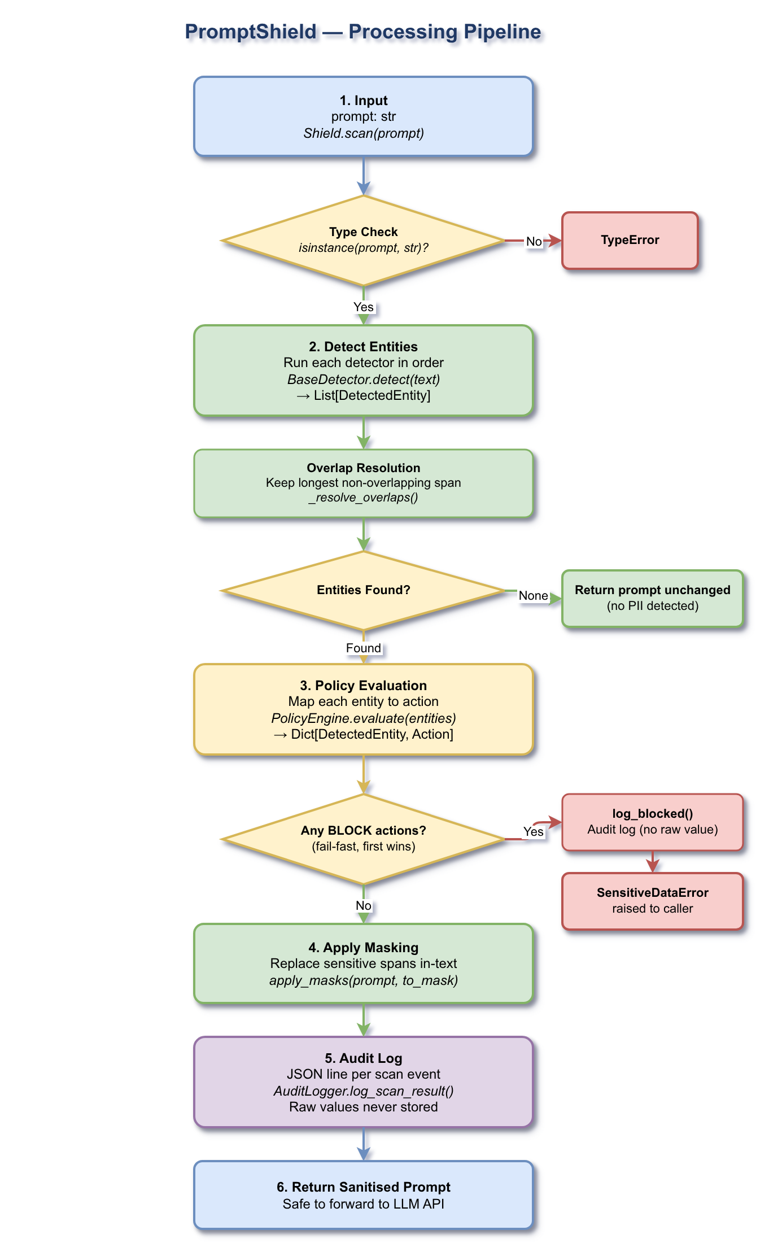
Processing Pipeline
Shield.scan(prompt) executes the following steps in strict order:

Step-by-Step Flow
Step 1 — Input Validation
Shield.scan() receives a prompt: str. If the argument is not a string, a TypeError is raised immediately before any processing begins.
Step 2 — Entity Detection
All registered BaseDetector instances are run against the prompt in sequence. Each detector returns a List[DetectedEntity]. Entities from all detectors are collected, then _resolve_overlaps() deduplicates them by keeping the longest non-overlapping span at each position (e.g. preventing a phone pattern from double-matching digits inside a credit card number). If no entities are found, the original prompt is returned unchanged.
Step 3 — Policy Evaluation
PolicyEngine.evaluate(entities) maps each detected entity to an Action (MASK, BLOCK, or ALLOW) by looking up the entity type in the rule map, falling back to PolicyConfig.default_action when no rule matches. The result is a Dict[DetectedEntity, Action].
Step 4 — Block (Fail-Fast)
Before any masking occurs, the engine iterates through evaluated entities and checks for any BLOCK actions. The first BLOCK entity triggers AuditLogger.log_blocked() (records entity type, no raw value) and then block() raises a SensitiveDataError immediately. The prompt is never forwarded to the LLM.
Step 5 — Apply Masking
Entities resolved to MASK are collected. apply_masks(prompt, to_mask) rebuilds the string by replacing each sensitive span with a type-aware redacted value from mask_value(). Replacements are applied right-to-left by position so earlier offsets remain valid.
Step 6 — Audit Logging
AuditLogger.log_scan_result() writes a JSON line to stdout recording the event: timestamp, prompt length, number of detections, entity types, actions applied, and masked previews. Raw values are never logged.
Step 7 — Return
The sanitised string is returned to the caller, ready to forward to the LLM API.

FastAPI Middleware Flow
When PromptShieldMiddleware is configured, it wraps dispatch() around every POST request with application/json content. It decodes the body, extracts the configured prompt_field, calls shield.scan(), and either rewrites the request with the sanitised value (mask path) or returns a 400 Bad Request JSON response immediately (block path). Non-JSON bodies and non-POST requests are forwarded untouched.

4. Core Components
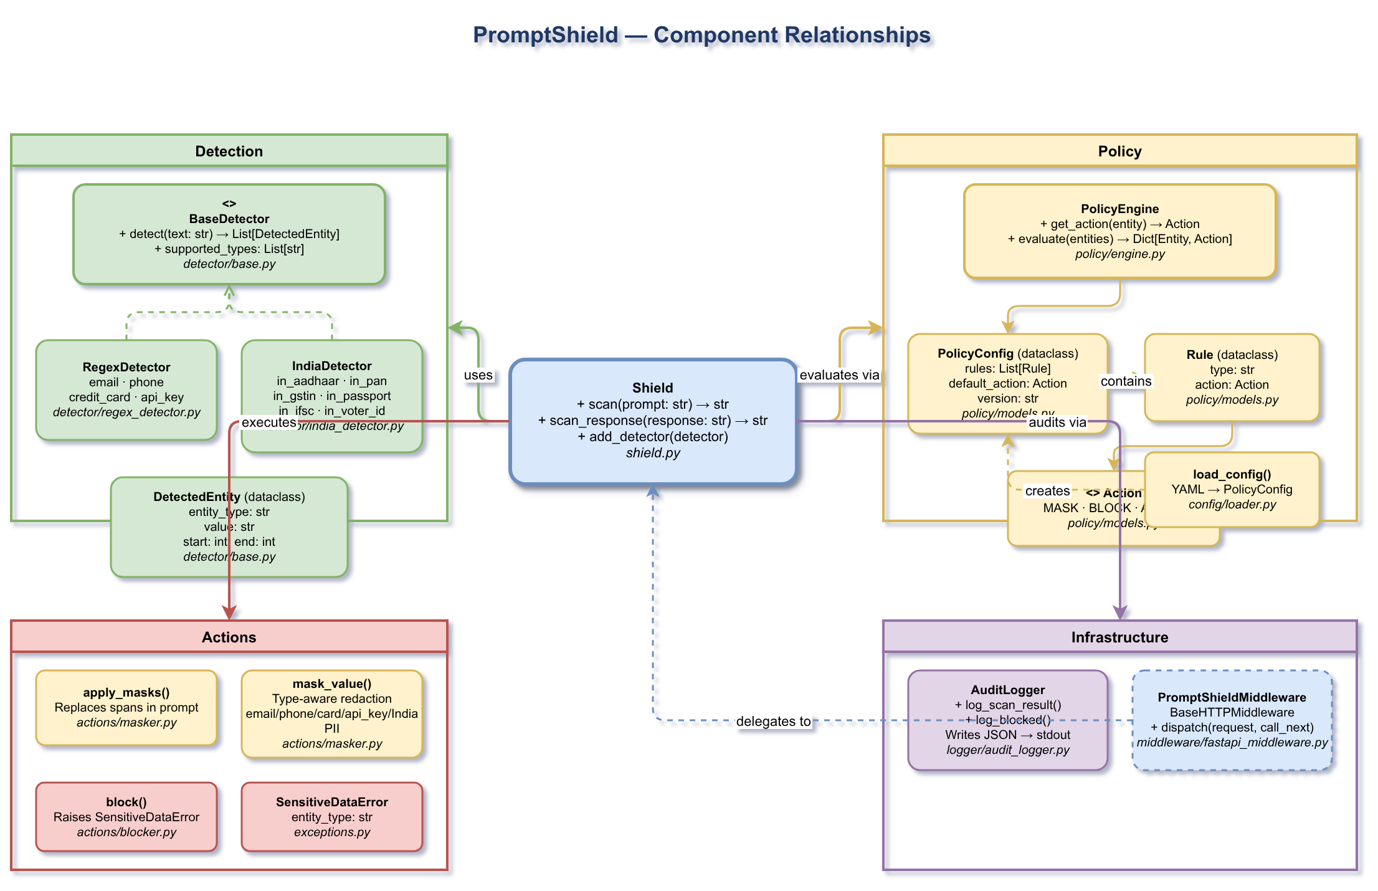
Component Relationships

Detection Layer
Class / Symbol | File | Responsibility
BaseDetector (ABC) | detector/base.py | Abstract base; defines detect(text) → List[DetectedEntity] and supported_types
DetectedEntity (dataclass) | detector/base.py | Immutable record: entity_type, value, start, end
RegexDetector | detector/regex_detector.py | Compiled regex patterns for email, phone, credit_card, api_key; overlap resolution
IndiaDetector | detector/india_detector.py | India-specific PII: in_aadhaar (Verhoeff checksum), in_pan, in_phone, in_passport, in_voter_id, in_ifsc, in_gstin

Policy Layer
Class / Symbol | File | Responsibility
Action (StrEnum) | policy/models.py | Values: MASK, BLOCK, ALLOW
Rule (dataclass) | policy/models.py | Maps type: str → action: Action
PolicyConfig (dataclass) | policy/models.py | Holds rules: List[Rule], default_action, version
PolicyEngine | policy/engine.py | O(1) rule lookup via dict; get_action(), evaluate()
load_config() | config/loader.py | Reads and validates YAML → PolicyConfig; rejects unknown actions

Actions Layer
Function | File | Responsibility
apply_masks(text, entities) | actions/masker.py | Rebuilds prompt with all masked spans substituted
mask_value(value, entity_type) | actions/masker.py | Dispatches to per-type masker (email: j***@domain.com, phone: ***-***-5309, card: ****-****-****-1111, api_key: sk-a...7890)
block(entity) | actions/blocker.py | Always raises SensitiveDataError

Infrastructure Layer
Class | File | Responsibility
AuditLogger | logger/audit_logger.py | Structured JSON lines to stdout; raw values never stored
PromptShieldMiddleware | middleware/fastapi_middleware.py | Starlette BaseHTTPMiddleware; intercepts POST bodies, rewrites or blocks
Shield | shield.py | Central orchestrator: wires detection → policy → actions → logging
SensitiveDataError | exceptions.py | Raised on block; carries entity_type for caller error handling
ConfigurationError | exceptions.py | Raised on invalid Shield construction or bad YAML

5. API Contracts and Message Schemas

`Shield` Constructor
Parameter | Type | Default | Description
config_path | str | Path | None | Path to a YAML policy file
config | PolicyConfig | None | Pre-built config object (alternative to config_path)
detectors | List[BaseDetector] | [RegexDetector()] | Ordered list of detectors to run
logger | AuditLogger | AuditLogger() | Custom audit logger

Exactly one of config_path or config must be provided; providing neither or both raises ConfigurationError.

`Shield.scan(prompt)` / `Shield.scan_response(response)`
Parameter | Type | Description
prompt | str | Raw input text to evaluate

Returns: str — Sanitised string with sensitive values masked.
Raises: SensitiveDataError if a block rule fires; TypeError if prompt is not a string.

`PolicyConfig` Schema
version: "1.0"
default_action: allow # mask | block | allow

rules:
- type: <entity_type> # string label e.g. "email"
action: <action> # mask | block | allow

`DetectedEntity` Schema
Field | Type | Description
entity_type | str | Category label, e.g. "email", "in_aadhaar"
value | str | Exact matched substring
start | int | Inclusive start index in source text
end | int | Exclusive end index in source text

Audit Log JSON Line Schema
{
"event": "prompt_scan",
"timestamp": "2026-05-05T10:00:00+00:00",
"prompt_length": 42,
"detections": 1,
"entities": [
{
"entity_type": "email",
"action": "mask",
"value_preview": "a***@example.com",
"position": { "start": 12, "end": 27 }
}
]
}

FastAPI Middleware — Block Response
{
"error": "Blocked: sensitive data detected in prompt.",
"detail": "Sensitive data of type 'credit_card' was detected and blocked by the active policy.",
"code": "SENSITIVE_DATA_BLOCKED"
}

HTTP status: 400 Bad Request.

6. Infrastructure and Deployment

Package Installation
# Core (regex detection, YAML policy)
pip install .

# With FastAPI/Starlette middleware
pip install ".[fastapi]"

# Development (includes pytest, pytest-cov)
pip install ".[dev]"

Requires: Python ≥ 3.10.

Dependencies
Package | Version | Category | Purpose
PyYAML | ≥ 6.0 | Core | YAML policy file loading
fastapi | ≥ 0.100.0 | Optional (fastapi) | FastAPI framework dependency
starlette | ≥ 0.27.0 | Optional (fastapi) | ASGI middleware base class
pytest | ≥ 7.4 | Development | Test runner
pytest-cov | ≥ 4.1 | Development | Coverage reporting

Build System
Tool | Version | Role
setuptools | ≥ 68 | Build backend
wheel | any | Distribution packaging
pyproject.toml | PEP 517/518 | Project metadata and dependency spec

Testing
The project ships 62 pytest tests across 7 test files with coverage for all core modules:
Test File | Coverage Area
tests/test_config.py | YAML loader — valid configs, missing files, invalid actions
tests/test_detector.py | Regex patterns — email, phone, credit card, API key, overlap resolution
tests/test_india_detector.py | India-specific PII patterns and Verhoeff Aadhaar checksum
tests/test_masker.py | Per-type masking functions and multi-entity substitution
tests/test_policy.py | PolicyEngine rule matching, default action, evaluation
tests/test_shield.py | End-to-end Shield.scan() — allow, mask, block, YAML config, scan_response
tests/test_middleware.py | FastAPI middleware — mask path, block path, non-JSON passthrough

Run tests:
pytest -v
# or with coverage:
pytest --cov=promptshield --cov-report=term-missing

7. Extension Patterns

Adding a Custom Detector
1. Subclass BaseDetector from promptshield.detector.base:
import re
from promptshield.detector.base import BaseDetector, DetectedEntity

class SSNDetector(BaseDetector):
_PATTERN = re.compile(r"\b\d{3}-\d{2}-\d{4}\b")

def detect(self, text: str) -> list[DetectedEntity]:
return [
DetectedEntity("ssn", m.group(), m.start(), m.end())
for m in self._PATTERN.finditer(text)
]

@property
def supported_types(self) -> list[str]:
return ["ssn"]

2. Register the detector when constructing Shield:
from promptshield import Shield
from promptshield.policy.models import Action, PolicyConfig, Rule

shield = Shield(
config=PolicyConfig(
rules=[Rule(type="ssn", action=Action.MASK)],
default_action=Action.ALLOW,
),
detectors=[SSNDetector()],
)

3. Or add it at runtime to an existing shield:
shield.add_detector(SSNDetector())

Adding a New Entity Type to `RegexDetector`
1. Open promptshield/detector/regex_detector.py
2. Add a key and regex pattern list to _RAW_PATTERNS
3. The pattern is compiled automatically at import time
4. Add a corresponding masking function to promptshield/actions/masker.py and register it in the _MASKERS dispatch table

Enabling India PII Detection
Instantiate IndiaDetector alongside RegexDetector and add rules for the India entity types:
from promptshield.detector.india_detector import IndiaDetector
from promptshield.detector.regex_detector import RegexDetector

shield = Shield(
config_path="policy.yaml",
detectors=[RegexDetector(), IndiaDetector()],
)

Uncomment and add rules in policy.yaml for any of: in_aadhaar, in_pan, in_phone, in_passport, in_voter_id, in_ifsc, in_gstin.

Adding FastAPI Middleware
from fastapi import FastAPI
from promptshield import Shield
from promptshield.middleware import PromptShieldMiddleware

app = FastAPI()
shield = Shield(config_path="policy.yaml")
app.add_middleware(PromptShieldMiddleware, shield=shield, prompt_field="prompt")

prompt_field defaults to "prompt" — change it to match your request body schema.

Custom Audit Logger
Subclass or wrap AuditLogger from promptshield.logger.audit_logger and pass it as the logger parameter to Shield. The logger receives log_scan_result() and log_blocked() calls.

8. Rules and Anti-Patterns

Rules (Do)
Rule | Rationale
Always provide either config_path or config — never both | The Shield constructor enforces mutual exclusivity
Catch SensitiveDataError at the call site | Block events raise and do not return; unhandled errors will propagate to the user
Use scan_response() for LLM output as well as input | LLMs can reproduce or hallucinate PII from training data
List detectors in priority order | _resolve_overlaps() keeps the longest span; order affects which pattern wins on ties
Keep policy.yaml under version control | Policy changes are security-relevant; treat them like code
Use structured audit log fields (entity_type, action) for alerting | Never parse free-text log lines for security events

Anti-Patterns (Do Not)
Anti-Pattern | Consequence
Logging entity.value directly | Persists raw PII/secrets in log storage
Setting default_action: block without specific allow rules | Will block all prompts that contain any detected entity
Passing non-string objects to scan() | Raises TypeError — validate upstream before calling
Sharing a Shield instance across threads without synchronisation | _detectors list is mutable; add detectors only at setup time
Disabling the block action for credit_card or api_key | These entity types are high-risk; masking is insufficient
Relying solely on regex detection for adversarial inputs | Regex can be evaded; combine with ML-based detectors for higher assurance

9. Dependencies

Core Dependencies
Package | Min Version | License | Purpose
PyYAML | 6.0 | MIT | Parse policy.yaml policy files

Optional Dependencies
Extra | Package | Min Version | Purpose
[fastapi] | fastapi | 0.100.0 | FastAPI route integration
[fastapi] | starlette | 0.27.0 | BaseHTTPMiddleware base class

Development Dependencies
Package | Min Version | Purpose
pytest | 7.4 | Test runner
pytest-cov | 4.1 | Code coverage reporting

10. Code Structure
PromptShield/
├── promptshield/ # Main package
│ ├── __init__.py # Public API: Shield, SensitiveDataError, ConfigurationError
│ ├── shield.py # Shield — central orchestrator
│ ├── exceptions.py # SensitiveDataError, ConfigurationError, PromptShieldError
│ ├── config/
│ │ ├── __init__.py
│ │ └── loader.py # load_config() — YAML → PolicyConfig
│ ├── detector/
│ │ ├── __init__.py
│ │ ├── base.py # BaseDetector (ABC), DetectedEntity (dataclass)
│ │ ├── regex_detector.py # RegexDetector — email, phone, credit_card, api_key
│ │ └── india_detector.py # IndiaDetector — Aadhaar (Verhoeff), PAN, GSTIN, etc.
│ ├── policy/
│ │ ├── __init__.py
│ │ ├── models.py # Action (enum), Rule, PolicyConfig (dataclasses)
│ │ └── engine.py # PolicyEngine — O(1) rule lookup + evaluate()
│ ├── actions/
│ │ ├── __init__.py
│ │ ├── masker.py # mask_value(), apply_masks() — type-aware redaction
│ │ └── blocker.py # block() — raises SensitiveDataError
│ ├── logger/
│ │ ├── __init__.py
│ │ └── audit_logger.py # AuditLogger — structured JSON lines, no raw values
│ └── middleware/
│ ├── __init__.py
│ └── fastapi_middleware.py # PromptShieldMiddleware (optional FastAPI extra)
├── tests/ # 62 pytest tests
│ ├── test_config.py
│ ├── test_detector.py
│ ├── test_india_detector.py
│ ├── test_masker.py
│ ├── test_middleware.py
│ ├── test_policy.py
│ └── test_shield.py
├── docs/
│ ├── quickstart.md # Developer quickstart guide
│ ├── project-summary.md # This document
│ └── diagrams/
│ ├── high-level-architecture.drawio # C4 Context diagram (editable)
│ ├── high-level-architecture.drawio.png # Rendered PNG
│ ├── processing-pipeline.drawio # C4 Container diagram
│ ├── processing-pipeline.drawio.png
│ ├── component-relationships.drawio # C4 Component diagram
│ └── component-relationships.drawio.png
├── example_usage.py # Runnable demo — 10 scenarios
├── policy.yaml # Default policy configuration
├── pyproject.toml # Package metadata + dependency spec
└── README.md # Project overview

