# FreshTrade Pre-Invoicing Module Deployment Instruction

|  |  |  |  |  |
| --- | --- | --- | --- | --- |
|  | ***Name*** |  |  | |
| **Author** | Andriy Vynnyk |  |  | |
| **Checked by** |  |  |  |  |
| **Approved by** |  |  | **Document Reference** |  |
| **Distribution** |  |  |  |  |
|  |  |  |  |  |
|  |  |  |  |  |
|  |  |  |  |  |

|  |  |  |  |
| --- | --- | --- | --- |
| Version # | Date | Modified by | Comments |
| 0.1 | 14/10/2014 | Andriy Vynnyk | Initial version |
| 0.2 | 26/11/2014 | Andriy Vynnyk | Including feedback from TPIE installation |

Contents

Application Server Deployment 2

Prerequisites 2

Database Upgrade 3

Web Service Deployment 3

Web Service Configuration Smoke Testing 9

Client Application Deployment 10

Prerequisites 10

Client Binaries Deployment 10

Smoke Testing 11

# Application Server Deployment

## Prerequisites

This installation instruction explains how to deploy the application server on a machine running Windows Server 2003.

***Note*** *Whenever possible, it is best to use more recent revisions of Windows Server, for example Windows Server 2008 R2. However, this instruction does not cover installation process on more recent Windows Server platforms, so if required such instructions can be prepared per request.*

***Note*** *This instruction assumes that for the application server deployment a new virtual server is installed. It is possible (though not suggested) to share the already existing server used for other infrastructure application hosting. However, in this case, while configuring Internet Information Services* (*IIS) or when installing or updating Microsoft .NET Framework, you should make sure that already installed applications are not impacted by this setup process.*

This installation instruction assumes that the following software components are already installed on the server machine:

1. Internet Information Services 6.0 (standard component of Windows Server) with ASP.NET.
2. Microsoft .NET Framework 4.0.

To download the standalone installation package, go to <http://www.microsoft.com/en-US/download/details.aspx?id=17718>.

Prior to installing IIS 6.0, it is recommended to install Microsoft .NET Framework 4.0, because in this case during Internet Information Services (IIS) installation ASP.NET automatically configures appropriately. If it is impossible, you may need to register ASP.NET manually. To find out if you need to register ASP.NET manually, check the following configuration settings of IIS:

My Computer -> Manage -> Services and Applications -> Internet Information Services (IIS) Manager -> Web Sites -> Default Web Site -> right click -> Properties -> ASP.NET tab.

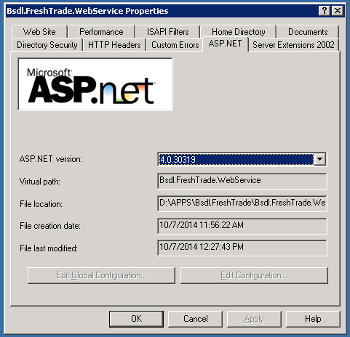

ASP.NET 4.0.30319 should be available in the dropdown list **ASP.NET version**. If it is unavailable, register ASP.NET in IIS using the following console command:

**C:\WINDOWS\Microsoft.NET\Framework\v4.0.30319\aspnet_regiis.exe -i**

## Database Upgrade

FreshTrade Oracle database needs to be upgraded in order to be compatible with PreInv application server.

The installation package contains cumulative database upgrade script *DB\DBUpdatesScript2014_09_18.sql*, which needs to be executed for all databases connected to the newly deployed PreInv Server.

## Web Service Deployment

***Note*** *To keep the amount of screenshots in this document reasonably small, we only provide screens where the user is required to make some modifications. All other screens or wizard steps can keep their default parameters.*

***Note*** *This installation instruction assumes that the TCP port 80 of the server is free. If you are installing web service on the sharing hosting and the port 80 is already busy, you can resolve this by doing one of the following:*

* *Use a different custom port (though this may require additional setup if you have firewalls or gateways in the communication path between your application server and the client machine).*
* *Use a Host Header and a new DNS name to resolve request to this particular site.*

*However, if this is your case, consult with a ProductFitter representative because this may significantly influence the deployment process.*

During the installation on the application server do the following:

1. Extract web server files from archive to web site root folder. In this guide it is assumed that “*D:\APPS\Bsdl.FreshTrade\Bsdl.FreshTrade.WebService” will be used as web site root.*
2. Open **Internet Information Services (IIS) Manager** tool.

My Computer -> Manage -> Services and Applications -> Internet Information Services (IIS) Manager.

1. Create a new Web Site.

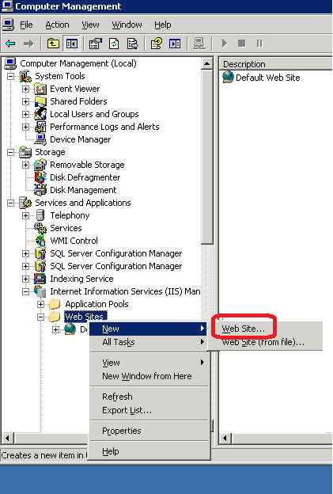

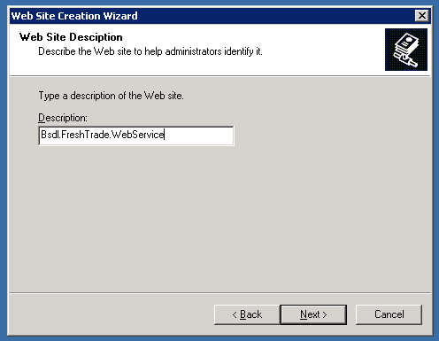

*Note: It is assumed that a site is placed in D:\APPS\Bsdl.FreshTrade\Bsdl.FreshTrade.WebService*

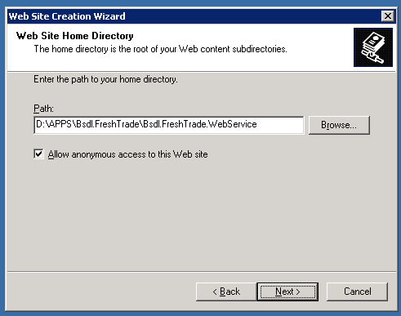

1. Create a new Application Pool Instance.

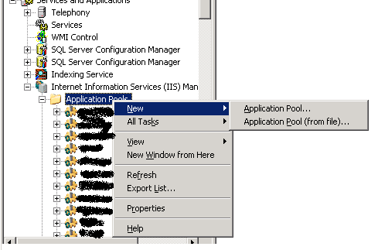

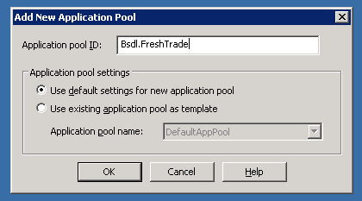

1. Finish Connection Pool configuration.

Application Pools -> Bsdl.FreshTrade -> Right click -> Properties.

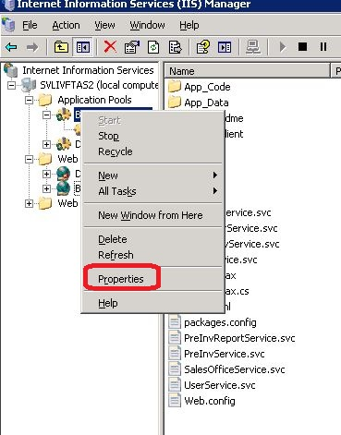

1. Select **Configurable** security account, leaving default user IWAM_... and the default password.

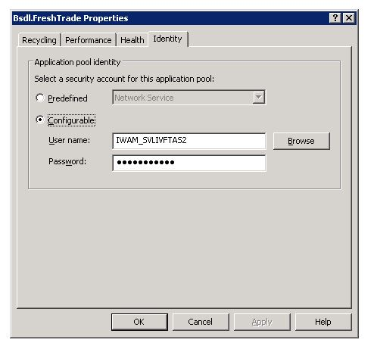

1. Finish web site configuration.

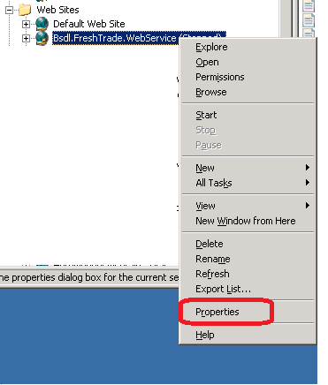

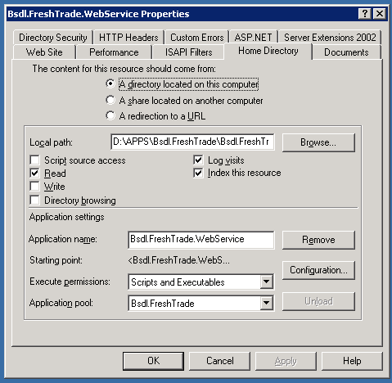

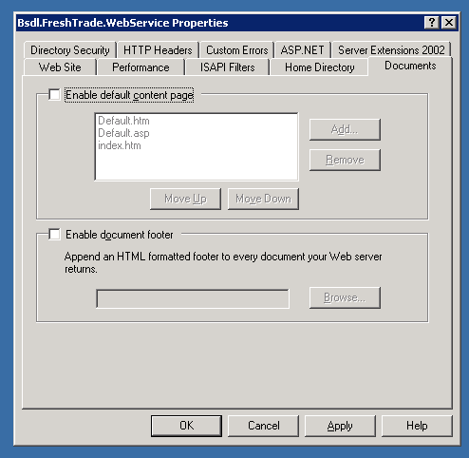

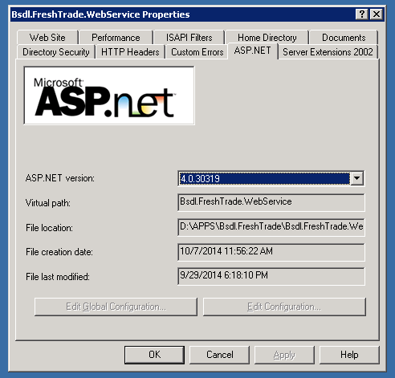

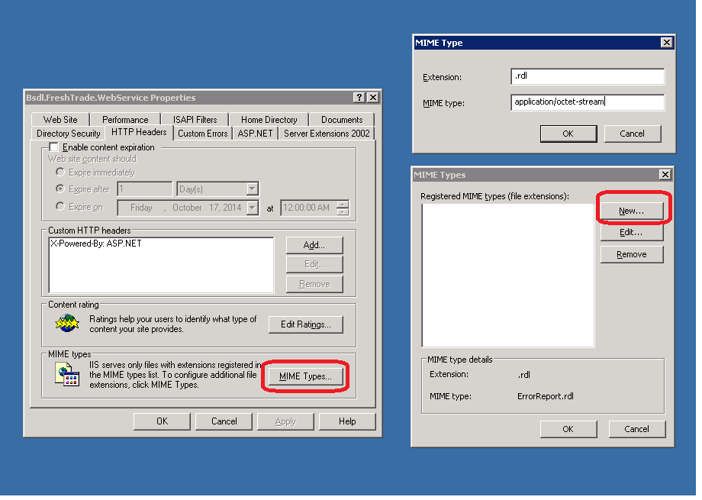

1. Configure the Web Service configuration file:

Edit *D:\APPS\Bsdl.FreshTrade\Bsdl.FreshTrade.WebService/Web.Config* file and make sure that:

* appSettings\bsdl.siteConnectionsFileLocation points to D:\APPS\Bsdl.FreshTrade\connection.txt
* nlog\logsDir points to D:\APPS\Bsdl.FreshTrade\Logs
* Elmah configuration section is similar to the following:

<elmah>

<security allowRemoteAccess="false" />

**<errorLog type="Elmah.XmlFileErrorLog, Elmah" logPath=" D:\APPS\Bsdl.FreshTrade\Logs\Elmah" />**

</elmah>

***Note*** *It is a good practice to put Logs and database connection settings outside of web site root folder (for example, D:\APPS\Bsdl.FreshTrade\Bsdl.FreshTrade.WebService) from the security perspective.*

1. Configure database connection settings.

Edit *D:\APPS\Bsdl.FreshTrade\connection.txt* and specify connection settings for the Oracle databases to be used.

**Note** *If there is no such file cmplist.txt can be used as a draft version, however you will have to modify it as described below.*

Note that unlike original FreshTrade connection file, you cannot use TNS names in this connection file settings. You need to specify the database server name and the service name instead in the following way:

[**DbID**],[*Name*],[*ServerName*],[*ServiceName*],[*UserName*],,[*EncriptedPassword*]

Password encryption algorithm is the same as in previously used FreshTrade modules, so you can just copy and paste other configuration files.

## Web Service Configuration Smoke Testing

1. Test access to your web service definition.

On the client workstation (or in a terminal server session) start a web browser and type the following address:

<http://YOUR-SERVER-NAME:80/UserService.svc>

In response you should see a page similar to the following:

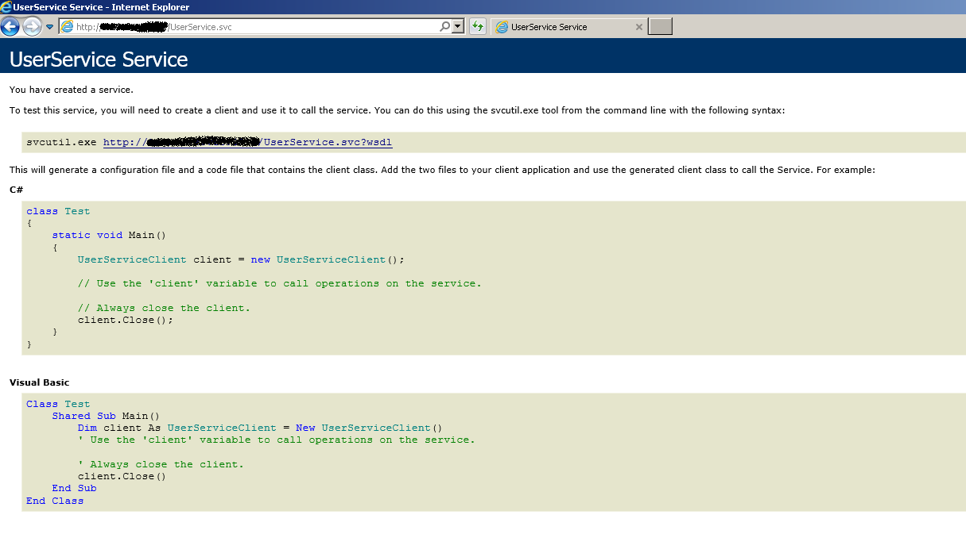

If you don’t see this page, repeat the same on the server machine:

<http://localhost:80/UserService.svc>

It will give you more extended information about the fault.

If the result page is not similar to the previous screenshot, please contact a ProductFitter representative.

1. Test reports definition file access.

On the client workstation (or in terminal server session) start web browser and type the following address:

<http://YOUR-SERVER-NAME:80/Reports/ErrorReport.rdl>

In response you should see a page similar to the following:

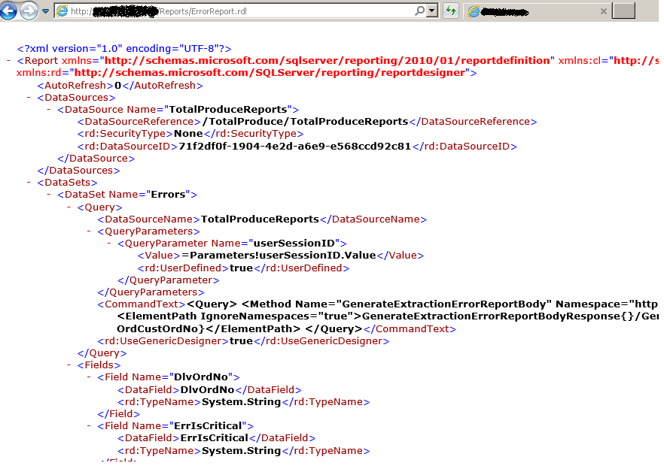

# Client Application Deployment

## Prerequisites

It is assumed that a Terminal Server based on **Windows Server 2003** will be used for client application execution. More recent versions of Windows should be supported as well, as long as they can run Microsoft .NET framework 4.

In the installation instruction we assume that following software components are already installed on the terminal server machine (client):

1. Microsoft .NET Framework 4.0

To download the standalone installation package, go to <http://www.microsoft.com/en-US/download/details.aspx?id=17718>.

1. Microsoft .NET Framework 4.0 Hotfix (KB2580188)

Hotfix description: <http://support2.microsoft.com/kb/2580188>

Download URL: <http://hotfixv4.microsoft.com/.NET%20Framework%204.0%20-%20Windows%20XP,%20Windows%202003,%20Windows%20Vista,%20Windows%20Server%202008,%20Win7,%20Windows%20Server%202008%20R2%20(MSI)/nosp/DevDiv952277/30319.498/free/435986_intl_i386_zip.exe>

***Note*** *If you use Terminal Server based on* ***Windows Server 2008 SP1*** *or later Windows Server versions, it is strongly suggested to install Microsoft .NET Framework 4.5.2 instead. In this case hotfix mentioned as item (2) is not required. Unfortunately Microsoft .NET Framework 4.5.2 revision is not compatible with Windows Server 2003. Download URL:* [*http://www.microsoft.com/en-US/download/details.aspx?id=42642*](http://www.microsoft.com/en-US/download/details.aspx?id=42642)

## 

## Client Binaries Deployment

1. Client binaries need to be copied to *Execs* folder of FreshTrade.
2. *PreInv.exe.config* file should be edited to point to recently installed PreInv web service.

Just replace all references to [**http://10.135.2.150:80**](http://10.135.2.150:80) with [**http://YourServerName:80**](http://YourServerName:80).

# Smoke Testing

To make sure the application was configured correctly, perform the following smoke tests:

1. Check if the client application starts.
2. Check extraction process for any sales office.
3. Try generating any report (summary or detailed).