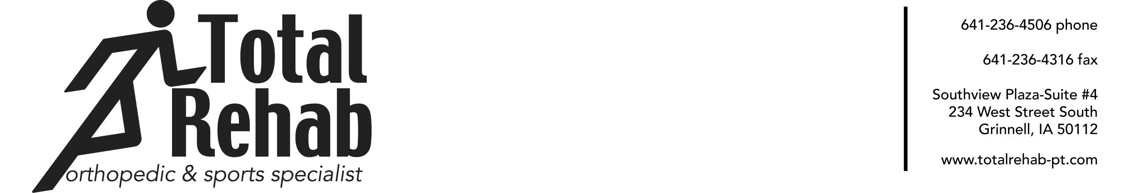

***Treats Scars, Adhesions and Muscle Injuries***

**(Name and Credentials) Completes 12-Hour Training Course**

**In Instrument-Assisted Soft Tissue Mobilization**

Linda Davis, OTR/L recently completed Graston Technique®  (GT) and is now treating patients with GT at Total Rehab.

The Technique uses specially designed stainless steel instruments to detect and treat areas exhibiting scar tissue or chronic inflammation.

Clinicians use the instruments with varying shapes to comb over and "catch" on fibrotic tissue, which immediately identifies areas of restriction. Once the tissue has been identified, the instruments break up scar tissue so the body can absorb it.

The Technique reduces pain and increases range of motion. It also:

* Improves diagnostic treatment
* Increases patient satisfaction by achieving notably better outcomes
* Speeds rehabilitation and recovery
* Reduces the need for anti-inflammatory medication
* Allows the patient to continue to engage in everyday activities.

The instruments are not meant to replace a clinician's hands, but to complement them. M1–Basic Training offers participants a comprehensive overview of the GT treatment approach with extensive laboratory practice.

More than 7,500 leading health care providers, more than 30 colleges and universities, major corporations and more than 125 professional/amateur sports organizations in the U.S. and around the world currently use Graston Technique®. Trainers and clinicians at these organizations are treating elite athletes, patients and employees every day to get them injury free to function at the highest level.

The Technique provides patients with a new option in the treatment of musculoskeletal complaints. For further information contact Total Rehab at 641-236-4506 or e-mail Linda Davis at linda@totalrehab-pt.com.

For more information, go to [GrastonTechnique.com.](http://www.grastontechnique.com/)

**(more)**

**Sidebar:**

The Graston Technique® instruments, while enhancing the clinician's ability to detect fascial adhesions and restrictions, have been clinically proven to achieve quicker and better outcomes in treating both acute and chronic conditions, including:

Achilles Tendinitis/osis (ankle pain)

Carpal Tunnel Syndrome (wrist pain)

Cervical Sprain/Strain (neck pain)

Fibromyalgia

Lateral Epicondylitis/osis (tennis elbow)

Lumbar Sprain/Strain (back pain)

Medial Epicondylitis/osis (golfer's elbow)

Patellofemoral Disorders (knee pain)

Plantar Fasciitis/osis (foot pain)

Rotator Cuff Tendinitis/osis (shoulder pain)

Scar Tissue

Shin Splints

Trigger Finger

Women’s Health (post-mastectomy and Caesarean scarring)