Tomislav Simic

Professor: D. Marrero

Class: 12P

Date: 2024-02-04

Name of the application: FurBabyBoarding

Overview

Keep track of available boarding spots based on actual events vs daily spot allocation. No real pet or owner information is gathered due to HIPPA-like vet patient data protection.

Reason

The current application in ‘use’ is being avoided as the tracking is based on static date entries, with disregard to actual occupancy at any given time. Current workaround implemented is sticky notes that don’t have a proper tracking and convoluted process that is difficult to train new hires on.

Target Audience

* Staff working with animals:
  + Young man and women, in their 20’s with completed high school and some college.
* Animal hospital management (if the application is found feasible):
  + Different age and gender doctors and managers

Objectives:

*Prompt 1*

Allow users to enter pet name and assign a specific type of kennel. This step has been completed.

*Prompt 2*

Calculate open spots based on live data and display all available spot and their quantities with 2-week look ahead.

*Prompt 3*

Display a warning if attempting to book a spot that has been already filled

Sample Wire Screen

*Window 1*

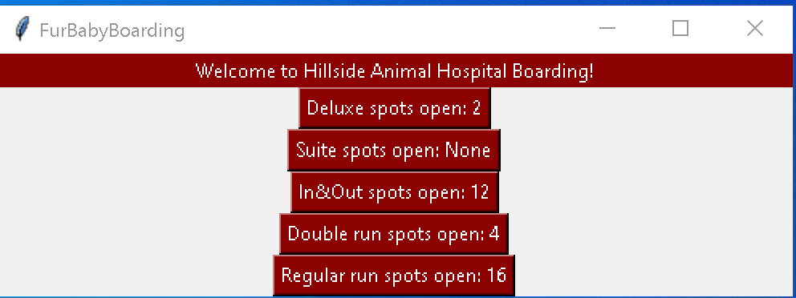

*Window 2*

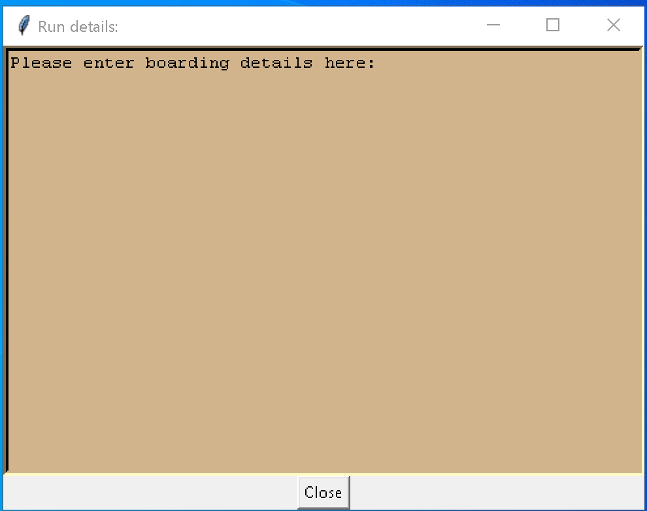

Types of kennels and their quantities:

* 2 -3 pets:
  + Deluxe = 2
  + Suites = 7
  + In/Out :
    - Front = 7
    - Back = 5
  + Regular = 16
* Single pet:
  + Cages:
    - Large = 2
    - Medium = 4
    - Cat = 7
    - Rabit = 2
  + Stalls = 2