
ADAMA SCIENCE AND TECHNOLOGY UNIVERSITY

SCHOOL OF ELECTRICAL ENGINEERING AND COMPUTING
DEPARTMENT OF COMPUTER SCIENCE AND ENGINEERING

INTERNSHIP REPORT

ON

DESIGN, DEVELOPMENT AND IMPLEMENTATION OF A UNIVERSITY STOCK
AND PROPERTY MANAGEMENT SYSTEM (SPMS)

Prepared By: Yonatan Gojjam
Student ID: UGR/31444/15
Department Advisor: Mr. Jemal Nuradis
Host Organization: ASTU ICT Centre
Company Supervisor: Mr. Daniel Asfaw
Internship Duration: June – August
Submission Date: September 21, 2026

Adama, Ethiopia
September 2026

TABLE OF CONTENTS

TABLE OF CONTENTS i
ACKNOWLEDGEMENT iii
EXECUTIVE SUMMARY iv
LIST OF ACRONYMS vi
CHAPTER ONE: INTRODUCTION 8
1.1 General Overview of the Internship 8
1.2 Background of the Organization 9
1.2.1 Description of the Organization 9
1.2.2 Mission of the Organization 9
1.2.3 Products and Services of the Organization 9
CHAPTER TWO: MANAGEMENT, TRAINING AND EMPLOYEE INFORMATION 11
2.1 Major Duty I Was Given to Perform 11
2.2 How I Became Oriented with the Responsibilities I Was Assigned 11
2.3 How My Supervisor Helped Me Succeed in My Assignment 11
2.4 Qualities I Developed Which Allowed Me to Succeed in My Daily Duties 12
CHAPTER THREE: SPECIFIC JOB INFORMATION 13
3.1 Daily Technical Duties and Responsibilities 13
3.2 Other Responsibilities I Had During My Internship 13
3.3 Technical Knowledge and Skills from My Coursework That Were Beneficial 14
3.4 The Project: University Stock and Property Management System (SPMS) 14
3.4.1 Problem Statement and the Existing System 14
3.4.2 Objectives of the Project 15
3.4.3 Requirement Analysis 16
Actors Identified 16
Selected Functional Requirements 17
Selected Non-Functional Requirements 17
Key Business Rules 17
3.4.4 System Architecture and Technology Stack 18
Presentation Layer (sms-frontend) 18
Application Layer (sms-backend) 18
Data Layer (PostgreSQL) 19
Summary of Technologies Used 19
3.4.5 Database Design 19
3.4.6 Core Modules and Workflows Implemented 20
3.4.7 Role-Based Access Control 21
3.4.8 Testing 22
3.4.9 My Individual Contribution 22
3.5 Selected System Screenshots 22
CHAPTER FOUR: REFLECTION AND CONCLUSION 29
4.1 How This Internship Fit My Career Goals 29
4.2 Did My Career Goals Change as a Result of This Internship? 29
4.3 The Value of This Internship 29
4.4 Challenges Faced During the Internship 29
4.5 Self-Evaluation: Strengths and Areas for Improvement 30
CHAPTER FIVE: RECOMMENDATIONS 31
5.1 Comments on the Company and the Internship 31
5.2 Recommendations for Improving the Internship Program 31
5.3 Should the Company Be Considered for Future Student Placement? 31
REFERENCES 32
ANNEXES 33
Annex A: Monthly Internship Activity Report (Template) 33
Annex B: Self-Evaluation Report (Template) 33
Annex C: Selected REST API Reference (SPMS Backend) 33

ACKNOWLEDGEMENT

I would like to express my sincere gratitude to the Almighty God for granting me the strength, patience and good health to complete this internship program successfully.
I am deeply grateful to my department advisor, Mr. Jemal Nuradis, for his continuous guidance, constructive feedback, and close follow-up throughout the internship period. His advice shaped the way I approached both the technical work and the writing of this report.
I would like to extend my heartfelt appreciation to ASTU ICT Centre for hosting me and giving me the opportunity to apply my academic knowledge to a real organizational problem. In particular, I am thankful to my company supervisor, Mr. Daniel Asfaw, for his patient mentorship, for sharing his practical experience in software engineering, and for the trust he placed in me and my teammates to design and build a system that the Centre could genuinely use.
My appreciation also goes to the staff of ASTU ICT Centre and the various departments who took the time to explain the existing stock and property handling procedures, respond to my questions during requirement gathering, and provide feedback on the prototypes as the system evolved.
I would also like to thank the Department of Computer Science and Engineering, School of Electrical Engineering and Computing, Adama Science and Technology University, for organizing the internship program and providing the academic foundation that made this practical experience possible.
Finally, I am grateful to my family, friends and fellow interns for their encouragement, moral support, and the many productive discussions that helped me overcome challenges during the internship period.

EXECUTIVE SUMMARY

This report documents my internship experience at ASTU ICT Centre, undertaken as a partial requirement of the internship program of the Department of Computer Science and Engineering, Adama Science and Technology University. During the internship, I was assigned to a small development team tasked with analyzing, designing and implementing a University Stock and Property Management System (SPMS) intended to replace the paper-based inventory and property handling procedures used across the university's stores, colleges and administrative units.
The report begins by introducing the internship program and giving background information about ASTU ICT Centre as the hosting organization, including its role, mission and the services it provides to the university community. It then discusses the management, supervision and orientation structure under which I worked, describing how my responsibilities were assigned and how my supervisor and advisor supported my professional growth.
The core of the report presents the specific technical work carried out during the internship. This includes a summary of the problems identified in the existing manual stock management process, the functional and non-functional requirements gathered through interviews and document review, and the resulting system design, which follows a three-tier architecture built with React, Node.js/Express, and PostgreSQL. The report explains the major modules delivered — including goods receiving and inspection, store requisition and issuing, fixed asset and custodian registration, inter-store transfers, material returns, the disposal committee workflow, stock control (reorder alerts, physical stock taking and reconciliation), FIFO-based inventory valuation, role-based access control for eleven institutional actor roles, and a cryptographically chained audit log — and describes my individual contribution to these modules.
The report closes with a reflection on how the internship related to my career goals, the challenges encountered and how they were resolved, a candid self-evaluation of my strengths and areas that still need improvement, and a set of recommendations for ASTU ICT Centre and for the Department regarding the future organization of the internship program.
Overall, the internship provided me with practical, end-to-end exposure to the software development lifecycle — from requirement gathering and system analysis through design, implementation, testing and deployment — and strengthened both my technical skills and my professional work habits.

LIST OF ACRONYMS
Acronym | Meaning
ASTU | Adama Science and Technology University
ICT | Information and Communication Technology
SPMS | Stock and Property Management System
SRS | Software Requirements Specification
UML | Unified Modeling Language
ERD | Entity Relationship Diagram
API | Application Programming Interface
REST | Representational State Transfer
RBAC | Role-Based Access Control
JWT | JSON Web Token
FIFO | First-In-First-Out
GRN | Goods Receiving Note
SIV | Store Issue Voucher
ISIV | Issued Store Issue Voucher (Final)
SRN | Store Return Note
PAO | Property Administration Officer
TEC | Technical Evaluation Committee
PRO | Property Registration Officer
CRUD | Create, Read, Update, Delete
UI/UX | User Interface / User Experience
SQL | Structured Query Language
HTTP | Hypertext Transfer Protocol
JSON | JavaScript Object Notation
CSE | Computer Science and Engineering

CHAPTER ONE: INTRODUCTION

1.1 General Overview of the Internship
The internship program of the Department of Computer Science and Engineering is designed to bridge the gap between the theoretical knowledge acquired in the classroom and the practical skills required in a real working environment. It gives students the opportunity to apply concepts learned in courses such as software engineering, database systems, web development and data structures to an authentic organizational problem, while also developing professional habits such as time management, teamwork, and effective communication with supervisors and colleagues.
I undertook my internship at ASTU ICT Centre, the unit of Adama Science and Technology University responsible for the university's information technology infrastructure and software systems. My internship was carried out under the direct supervision of Mr. Daniel Asfaw at the host organization and under the academic guidance of my department advisor, Mr. Jemal Nuradis.
The general objective of the internship, as set by the Department, was to expose me to a real software development environment, to strengthen my technical competency in modern web technologies, and to develop my ability to work as part of a team on a project of realistic scope and complexity. The specific scope of work assigned to me was to participate, together with a small team of fellow interns, in the requirement gathering, system analysis, design, implementation and testing of a computerized Stock and Property Management System (SPMS) for ASTU ICT Centre.
The expected outputs of the internship included: (i) a Software Requirements Specification document describing the existing manual system and the proposed computerized system; (ii) a working, full-stack web application implementing the core stock and property management workflows; and (iii) this internship report documenting the process, my individual contribution, and my professional reflections on the experience.

1.2 Background of the Organization

1.2.1 Description of the Organization
ASTU ICT Centre is the information and communication technology unit of Adama Science and Technology University. The Centre is responsible for supporting the university's digital infrastructure, maintaining network and computing resources, and developing or coordinating software systems that support the administrative and academic operations of the university. As part of its mandate to modernize internal administrative processes, the Centre identified the need for a computerized system to manage the stock, consumable materials, and fixed assets held across the university's central store, college stores and specialized units such as the cafeteria store.
The internship placement was organized so that a team of interns, working closely with ICT Centre staff, would take an existing paper-based stock and property management process and translate it into a modern, auditable, web-based system that could later be adopted by the university's Property Administration Directorate and its stores.

1.2.2 Mission of the Organization
The mission of ASTU ICT Centre is to provide reliable, secure and efficient information technology services and systems that support the teaching, research, and administrative functions of Adama Science and Technology University, and to promote the adoption of digital tools that improve transparency, accountability and efficiency across the university's operations.

1.2.3 Products and Services of the Organization
Among the services provided by ASTU ICT Centre are:
- Maintenance of the university's network, server and computing infrastructure.
- Support and administration of core university information systems.
- Technical guidance and hosting of student internship and project teams working on university software needs.
- Coordination of the design, development and deployment of internal administrative applications, such as the Stock and Property Management System developed during this internship.
- General ICT support and troubleshooting for university staff and departments.

CHAPTER TWO: MANAGEMENT, TRAINING AND EMPLOYEE INFORMATION

2.1 Major Duty I Was Given to Perform
My major duty during the internship was to serve as a full-stack developer within a small team of interns responsible for building the University Stock and Property Management System (SPMS). Concretely, this meant contributing to requirement analysis, participating in the design of the database and REST API, implementing backend modules using Node.js and Express, implementing the corresponding user interface screens in React, and testing the completed features against the roles and workflows defined in the requirement specification.

2.2 How I Became Oriented with the Responsibilities I Was Assigned
During the first days of the internship, my supervisor, Mr. Daniel Asfaw, introduced the team to the existing manual stock and property handling procedures used by the university stores, including how goods are received, inspected, recorded on bin cards and stock record cards, requisitioned by departments, and eventually issued or disposed of. This orientation involved short interviews with storekeepers and administrative staff, a walkthrough of sample paper forms such as requisition slips and goods receiving notes, and a review of the applicable public-sector stock management guidelines.
Once the manual process was clear, the team was oriented on the expected technology stack (React on the frontend, Node.js/Express with PostgreSQL on the backend) and the project's coding conventions, git workflow, and task division. I was assigned specific modules to work on and was given access to the shared project repository, a build specification document, and regular check-in meetings to track progress.

2.3 How My Supervisor Helped Me Succeed in My Assignment
Mr. Daniel Asfaw played a central role in helping me succeed during the internship. He clarified ambiguous requirements whenever the team was unsure how a particular business rule should behave, reviewed my code and design decisions, and gave direct, practical feedback that helped me avoid common mistakes such as neglecting input validation or failing to enforce role-based restrictions on the server side rather than only in the interface. He also encouraged the team to test each workflow end-to-end as different user roles, which taught me the importance of verifying access-control rules rather than assuming they work correctly.
My department advisor, Mr. Jemal Nuradis, complemented this technical mentorship with academic guidance, reviewing my progress periodically, advising me on how to document the requirement analysis and design work in a manner consistent with the Software Requirements Specification standards taught in the Software Engineering course, and giving feedback on the structure of this report.

2.4 Qualities I Developed Which Allowed Me to Succeed in My Daily Duties
Over the course of the internship, I developed a number of qualities and habits that contributed directly to my success:
- Discipline in following a structured development workflow — analyzing requirements before writing code, and testing each feature against the defined role permissions before considering it complete.
- Improved communication skills, gained through daily stand-ups with teammates and periodic reporting to my supervisor.
- Attention to detail, particularly around data integrity rules such as append-only ledgers and the correct handling of FIFO cost lots, where a small mistake could silently produce an incorrect inventory valuation.
- Patience and persistence when debugging issues that spanned both the frontend and backend, which required me to trace a single user action through several layers of the system.
- A stronger sense of ownership and accountability, since the system I helped build was intended for actual use by the organization rather than being a purely academic exercise.

CHAPTER THREE: SPECIFIC JOB INFORMATION

3.1 Daily Technical Duties and Responsibilities
On a typical day during the internship, my responsibilities included:
- Reviewing the task assigned for the day, whether it involved implementing a new backend endpoint, building a frontend page, fixing a defect, or writing/verifying database migration scripts.
- Writing and testing Express.js route handlers and controllers, including input validation, role-based access checks, and correct interaction with the PostgreSQL database through parameterized queries.
- Building and styling React components and pages with Tailwind CSS, and wiring them to the backend through the project's shared API client.
- Participating in short daily discussions with fellow interns to divide work, resolve merge conflicts in the shared Git repository, and agree on data contracts between frontend and backend.
- Manually testing completed features by logging in as different seeded user roles (for example, Store Head, Technical Evaluation Committee, Property Administration Officer, and Campus Security Officer) to confirm that each role could perform only the actions it was authorized to perform.
- Documenting completed work and any outstanding issues for review by my supervisor.

3.2 Other Responsibilities I Had During My Internship
Beyond direct software development, I also participated in requirement-gathering discussions with ICT Centre staff and, indirectly, with store and property administration personnel, to confirm that the system correctly reflected real organizational procedures such as the separation of duties between the store, the Technical Evaluation Committee, the Property Registration Officer and the Property Administration Officer. I contributed to writing and reviewing parts of the project's Software Requirements Specification document, helped prepare short demonstrations of completed modules for my supervisor, and assisted in basic system testing prior to internal review.

3.3 Technical Knowledge and Skills from My Coursework That Were Beneficial
Several courses from my academic program proved directly useful during the internship:
- Database Management Systems — for designing normalized relational tables, defining foreign-key relationships, and understanding transactions, which was essential when implementing operations such as goods receiving that must update multiple tables consistently.
- Software Engineering — for structuring the requirement analysis and design work using standard artifacts such as use-case descriptions, and for appreciating the value of following a defined development methodology.
- Web Programming / Internet Programming — for building REST APIs and single-page frontend applications, and for understanding client-server communication over HTTP.
- Data Structures and Algorithms — for reasoning correctly about the FIFO (First-In-First-Out) cost-lot consumption logic used in the inventory valuation engine.
- Computer Networks and Security fundamentals — for understanding authentication using JSON Web Tokens, password hashing, and the general principles behind securing a web application.

3.4 The Project: University Stock and Property Management System (SPMS)
The remainder of this chapter presents, in more detail, the project that formed the core of my internship — the design and development of the University Stock and Property Management System (SPMS) for ASTU ICT Centre.

3.4.1 Problem Statement and the Existing System
Prior to the project, inventory and property management at the university relied heavily on paper-based records — bin cards, stock record cards, requisition slips, and handwritten reports. Departments requested materials from the store by completing paper requisition forms, and storekeepers recorded stock movements manually. While functional, this approach suffered from several well-known problems that were confirmed during our requirement-gathering interviews:
- Difficulty tracking stock movement in real time and across multiple stores.
- Frequent human errors during manual data recording and calculation.
- Loss, duplication, or inconsistency of paper records.
- Slow report generation, particularly for stock valuation and reconciliation.
- Stock shortages and overstocking caused by poor visibility into reorder and safety-stock levels.
- Weak accountability, since there was no tamper-evident trail of who performed which transaction.
- Difficulty conducting physical stock taking and reconciling it against recorded balances.
These problems, and the actors who experience them (the Property Administration Officer, storekeepers, stock clerks, department heads, the accountant, and the security officer at the gate), formed the starting point of the requirement analysis documented in the project's Software Requirements Specification.

3.4.2 Objectives of the Project
The general objective of the project was to design and develop a computerized Stock and Property Management System that automates inventory and fixed-asset management activities and improves the operational efficiency, transparency and accountability of stock administration at the university. The specific objectives included:
- Developing a secure, role-based authentication and authorization system covering eleven distinct institutional actor roles.
- Automating goods receiving, technical inspection, and Goods Receiving Note (GRN / Model 19) generation.
- Automating store requisition, multi-level approval, and the Preliminary and Final Store Issue Voucher process (Model 20 / Model 22), including gate clearance by Campus Security.
- Maintaining organization-wide Stock Cards and per-store Bin Cards as perpetual, append-only ledgers.
- Implementing a genuine FIFO (First-In-First-Out) cost-lot valuation engine rather than an estimated average cost.
- Supporting fixed-asset registration, custodian User-Cards (Model 15), and custody transfer/verification history.
- Supporting material returns (Store Return Note), inter-store transfers, and a full Disposal Committee lifecycle (auction, destruction, donation, or financial write-off).
- Providing reorder-level, safety-stock and shelf-life/expiry alerting.
- Supporting physical stock taking, variance calculation, and authorized reconciliation.
- Producing operational and financial reports, and maintaining a cryptographically chained, tamper-evident audit log of all system activity.

3.4.3 Requirement Analysis
Requirements were gathered through structured interviews with the Property Administration Officer, storekeepers, stock clerks, department heads and the accountant, combined with direct observation of the existing paper-based workflow and review of public-sector stock management guidelines. This analysis produced a detailed Software Requirements Specification identifying the system's actors, functional requirements, non-functional requirements and business rules.

Actors Identified
The proposed system was designed around eleven institutional actor roles, each with a distinct set of responsibilities and server-enforced permissions:
- Administrator — system configuration, user accounts, backups and technical integrity.
- Property Administration Officer (PAO) — the university-wide senior approval authority for requisitions, transfers, evaluated returns and disposal forwarding.
- Store Head — day-to-day warehouse operations, including preparing preliminary and finalizing final issue vouchers.
- Stock Clerk — bin-location assignment, physical counting, and material handling support.
- Technical Evaluation Committee (TEC) technical/quality inspection of incoming deliveries and returned items.
- Property Registration Officer (PRO) Goods Receiving Note generation and fixed-asset tagging/registration.
- Department Head — endorsement of departmental requisitions and returns.
- Requesting Staff — submission of material requisitions and custodianship of assigned fixed assets.
- Accountant — FIFO valuation review and financial write-off approval.
- Disposal Committee — final disposal-method decisions (auction, destruction, donation, or write-off).
- Campus Security Officer — gate clearance verification for finalized issue vouchers leaving the campus.

Selected Functional Requirements
Among the functional requirements defined for the system were: user and role management; supplier registration; item/category master data management; stock receiving with inspection and automatic quantity update; stock issuing with request validation; stock transfer between stores; real-time inventory tracking; minimum/maximum/reorder/safety-stock control; physical stock taking and reconciliation; report generation (inventory, stock movement, supplier, and audit reports); and audit logging of all user activity.

Selected Non-Functional Requirements
Non-functional requirements addressed performance (the system should respond within a few seconds under normal load and support multiple concurrent users), security (mandatory authentication, encrypted/hashed passwords, role-based restriction of sensitive resources, and a complete audit trail), reliability and availability (continuous operation with data consistency and backup/recovery support), usability (a simple, consistent interface requiring minimal training), and maintainability/scalability (a modular codebase that can accommodate future modules).

Key Business Rules
- Every inventory item must have a unique item code.
- All goods received must be inspected by the Technical Evaluation Committee before being stored or accepted into stock.
- Inventory cannot be issued without an approved requisition.
- Every inventory transaction must be recorded, and stock/bin card records must be updated whenever goods are received, issued, transferred, returned or disposed of.
- Inventory valuation must follow the FIFO principle — the oldest cost lot is always consumed first.
- Physical stock taking must be conducted periodically, and discrepancies must be investigated and corrected through an authorized reconciliation entry rather than by silently editing existing records.
- No single actor may carry end-to-end authority over a transaction — for example, the officer who requests material cannot approve their own requisition, and storekeepers cannot generate the formal Goods Receiving Note themselves.

3.4.4 System Architecture and Technology Stack
The proposed and implemented system follows a three-tier architecture consisting of a presentation layer, an application (business logic) layer, and a data layer, which keeps the user interface, the business rules, and the persisted data separately and independently maintainable.

Presentation Layer (SMS-frontend)
The client is a single-page application built with React 18 and Vite 5, styled with Tailwind CSS and Lucide icons, and routed with React Router 6. A central application context manages authentication state and caches frequently used resources, while a shared API client automatically converts between the backend's snake_case JSON fields and the frontend's camelCase conventions. The interface also includes a dedicated print layout for the statutory model documents (GRN, SIV/ISIV, SRN and User-Cards) formatted for A4 printing.

Application Layer (SMS-backend)
The backend is a REST API built with Node.js 18+ and Express 4, secured with Helmet and logged with Morgan, communicating with PostgreSQL through the pg. connection-pool library. Authentication uses JSON Web Tokens (JWT) with bcrypt password hashing, and every protected route is guarded by role-based access-control middleware that checks the caller's role against an explicit allow-list — meaning permissions are enforced on the server, not merely hidden in the interface. Dedicated utility modules implement the FIFO cost-lot valuation engine, reference-number generation for statutory documents, and the cryptographic audit-log writer.

Data Layer (PostgreSQL)
The database schema defines 28 relational tables covering users and roles, stores and bins, suppliers, items and categories, goods receipts, cost lots, stock-card and bin-card entries, requisitions and issue vouchers, fixed assets and custody history, returns, transfers, disposal requests, stock takes and reconciliation entries, and the audit log — together with three computed database views and PL/pgSQL trigger functions that enforce append-only behavior on the ledger tables.

Summary of Technologies Used
Layer | Technology
Frontend | React 18, Vite 5, Tailwind CSS, React Router 6, Lucide Icons
Backend | Node.js 18+, Express 4, Helmet, Morgan, JSON Web Tokens, bcrypt
Database | PostgreSQL 14+ (28 tables, 3 views, append-only triggers)
API Style | RESTful JSON API secured with Bearer-token authentication
Version Control | Git and GitHub
Tooling | npm scripts for migration and seeding, a concurrency/latency performance-check script

3.4.5 Database Design
The database was designed around a set of core entities identified during object modeling: User, Role, Supplier, Item, Category, Store/Warehouse, Cost Lot, Stock Card Entry, Bin Card Entry, Requisition, Issue Voucher, Fixed Asset, Return, Transfer, Disposal Request, Stock Take, Reconciliation Entry, and Audit Log. Foreign-key constraints maintain referential integrity (for example, one supplier can supply many items, one category can contain many items, one store can hold many bin-card entries, and one item can accumulate many stock-transaction entries over time).
A deliberate design decision distinguishes between two ledgers with different scope: the Stock Card, which is an organization-wide ledger tracking an item's total institutional balance and FIFO valuation, and the Bin Card, which is a per-store, per-bin physical ledger. This distinction matters operationally — an inter-store transfer updates the Bin Cards at both the origin and destination stores but leaves the item's organization-wide quantity on the Stock Card unchanged, since the material never leaves the institution.
To protect the integrity of historical records, PostgreSQL trigger functions reject any direct UPDATE or DELETE statement issued against the Stock Card, Bin Card, audit-log and reconciliation tables; any correction must instead be entered as a new, time stamped, authorized compensating entry. Two database views, user_cards_view and reorder_alerts_view, are computed dynamically rather than stored, which guarantees that the custodian User-Card listing and the reorder/safety-stock alerts can never drift out of sync with the underlying transactional data.

3.4.6 Core Modules and Workflows Implemented
The completed system implements fourteen core modules, several of which I contributed directly during the internship:
- Authentication and session security, using JWT-based login, bcrypt password hashing, and role-aware navigation on the client.
- Master data management for stores, categories, storage bins, suppliers, and items (both consumables and fixed assets).
- Goods receiving and quality inspection, in which the Store Head or Stock Clerk records an incoming delivery, the Technical Evaluation Committee records an inspection decision, and the Property Registration Officer generates the formal Goods Receiving Note (Model 19), which simultaneously opens a new FIFO cost lot and appends Stock Card and Bin Card entries.
- Perpetual ledgers (Stock Cards and Bin Cards) that are updated automatically by every relevant transaction rather than maintained by hand.
- Requisition and issue fulfilment, moving a departmental request through endorsement, PAO approval, a Preliminary Issue Voucher (Model 20, printed with a 'do not dispatch' watermark), a Final Issue Voucher (Model 22) that consumes FIFO cost lots and updates both ledgers, and finally gate clearance recorded by the Campus Security Officer.
- Fixed-asset management and custodian User-Cards (Model 15), including asset tagging, custody assignment and transfer history, and periodic physical verification.
- Store return handling (Store Return Note / SRN), cross-referenced to the original issue voucher, inspected by the Technical Evaluation Committee, and either restocked or routed into the disposal workflow depending on physical condition.
- Inter-store transfers, which move stock between the university's stores while leaving the item's institution-wide quantity unchanged.
- The Disposal Committee lifecycle, which reserves the affected quantity from usable stock as soon as an item is flagged, routes the request through PAO review to the Disposal Committee, and records the chosen disposal method — auction, destruction, donation, or an accountant-approved financial write-off.
- Stock control: continuous reorder-level, safety-stock and shelf-life/expiry monitoring; scheduled physical stock takes; count entry; automatic variance calculation; and PAO-authorized reconciliation that posts a compensating ledger entry and adjusts the FIFO cost lots.
- Analytics and financial valuation, including real-time FIFO inventory valuation, stock-status reports, fixed-asset register summaries, supplier delivery summaries and disposal summaries.
- A cryptographically chained audit log — each entry stores the SHA-256 hash of the previous entry together with its own action details, so that any later tampering with a historical record breaks the hash chain and is immediately detectable.
- System health and maintenance endpoints for liveness/readiness checks and manual backup triggers.

3.4.7 Role-Based Access Control
Every protected API route is restricted to an explicit list of allowed roles, enforced in server-side middleware rather than only hidden in the user interface. For example, only the Store Head or Stock Clerk may record a new goods receipt; only the Technical Evaluation Committee may record its inspection decision; only the Property Registration Officer may generate the Goods Receiving Note; only the Store Head may prepare a Preliminary Issue Voucher, while the Property Administration Officer or Store Head may finalize it; and only the Campus Security Officer may record gate clearance. During testing, the team deliberately attempted actions with the wrong role logged in (for example, a Campus Security Officer attempting to approve a requisition) to confirm that the server correctly rejected the request with a 403 Forbidden response rather than silently failing.

3.4.8 Testing
Testing combined manual functional testing of each workflow — logging in as each of the eleven seeded demo roles and confirming that the correct actions were available and that unauthorized actions were rejected — with targeted checks of the FIFO valuation logic (verifying that the oldest cost lot was always consumed first) and of the append-only ledger triggers (confirming that a direct UPDATE or DELETE against a Stock Card, Bin Card or audit-log row raised a database exception as intended). A small performance-check script was also used to issue concurrent requests against the API's health endpoint and measure the response latency.

3.4.9 My Individual Contribution
Within the team, my specific contributions included implementing and testing selected backend controllers and routes (including their role-based access rules), building the corresponding React pages and reusable UI components (such as data tables, modals and dashboard cards), assisting with the database schema for selected modules, and verifying that the workflows I worked on matched the business rules defined in the requirement specification. I also participated in preparing demo data used to showcase the completed system to my supervisor.

3.5 Selected System Screenshots
The screenshots below were captured from the completed SPMS application running against a live PostgreSQL database seeded with representative university data, and illustrate several of the modules and workflows described above as they appear to an end user.
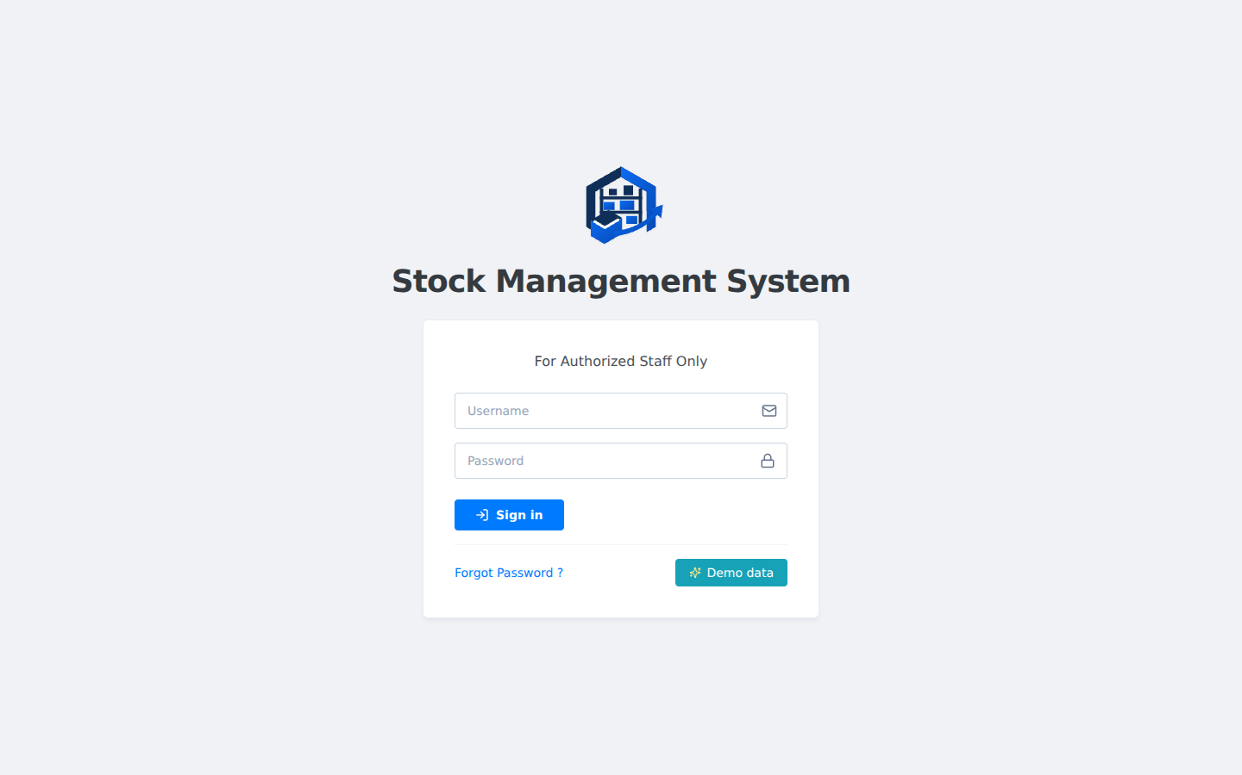
Figure 1: SPMS login screen, restricted to authorized institutional staff.
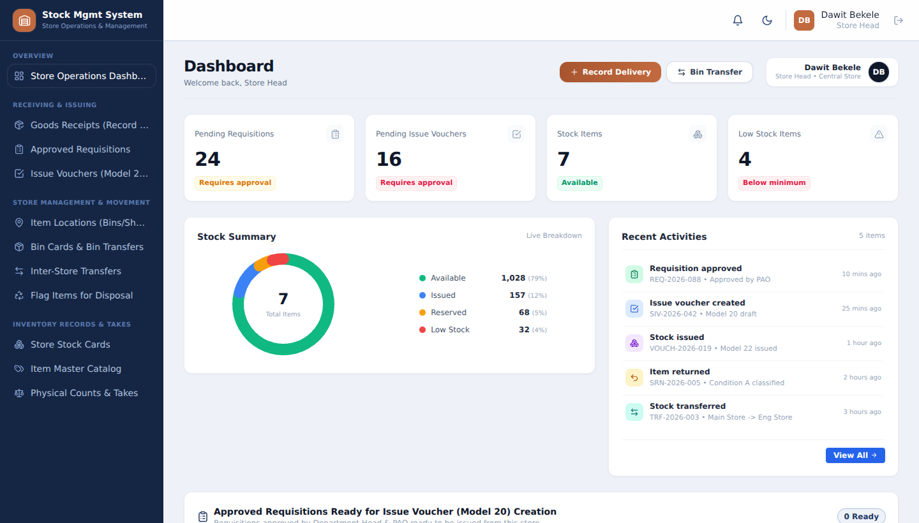
Figure 2: Store Head dashboard, showing pending requisitions, pending issue vouchers, a live stock summary, and recent activity.
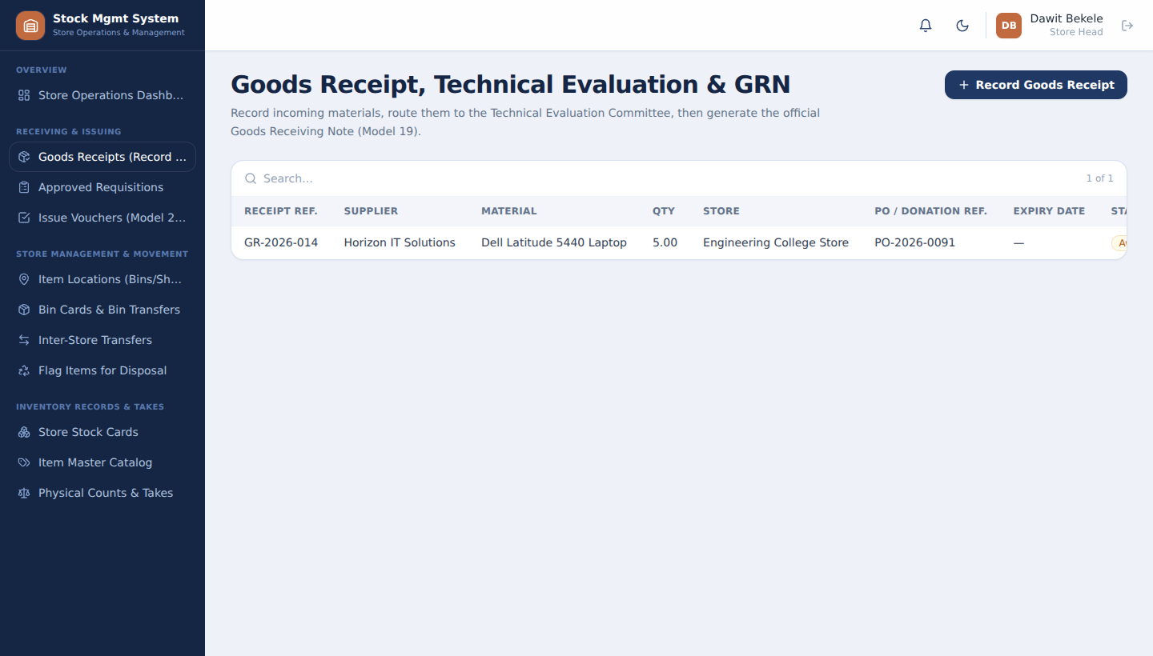
Figure 3: Goods Receipt, Technical Evaluation and GRN (Model 19) module.
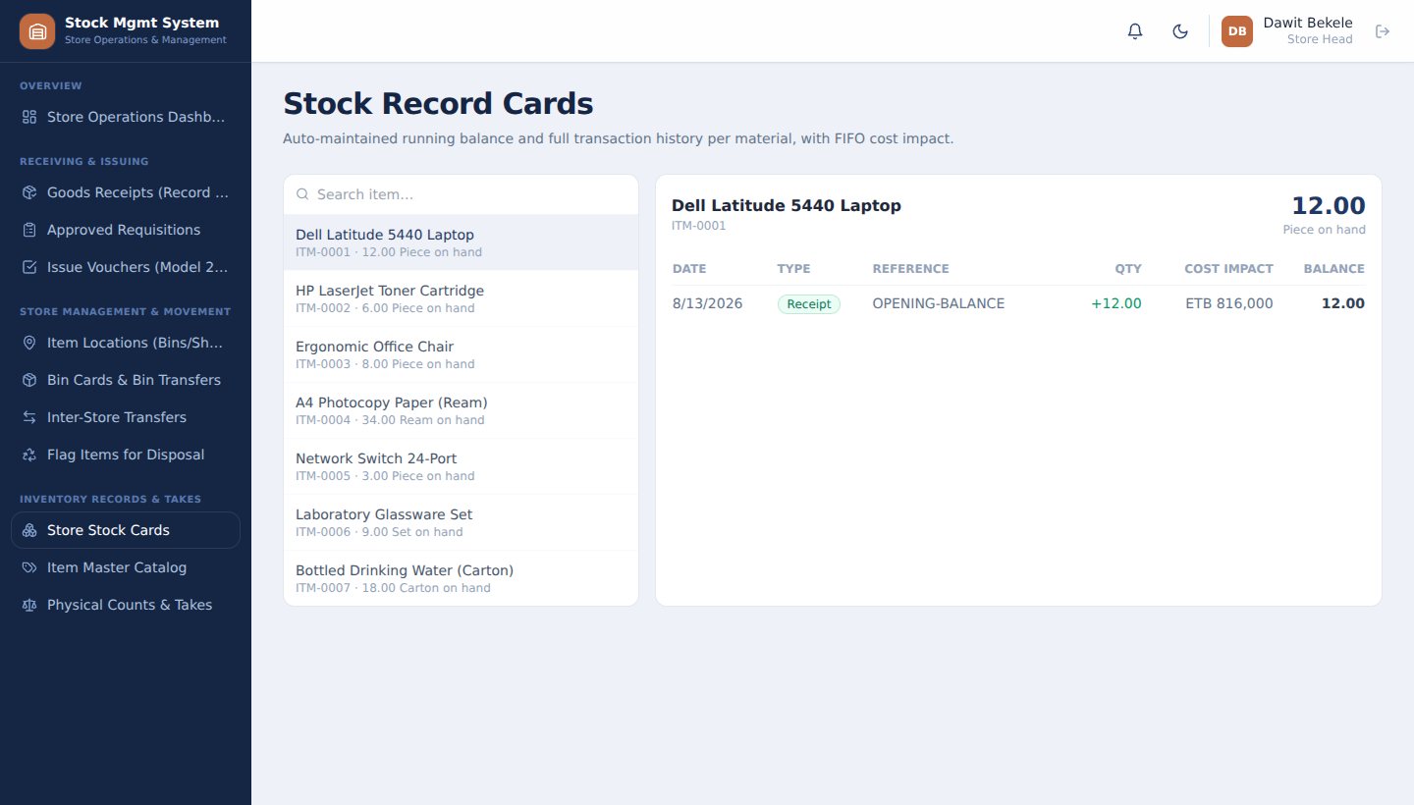
Figure 4: Organization-wide Stock Record Card for an item, showing FIFO cost impact per transaction.
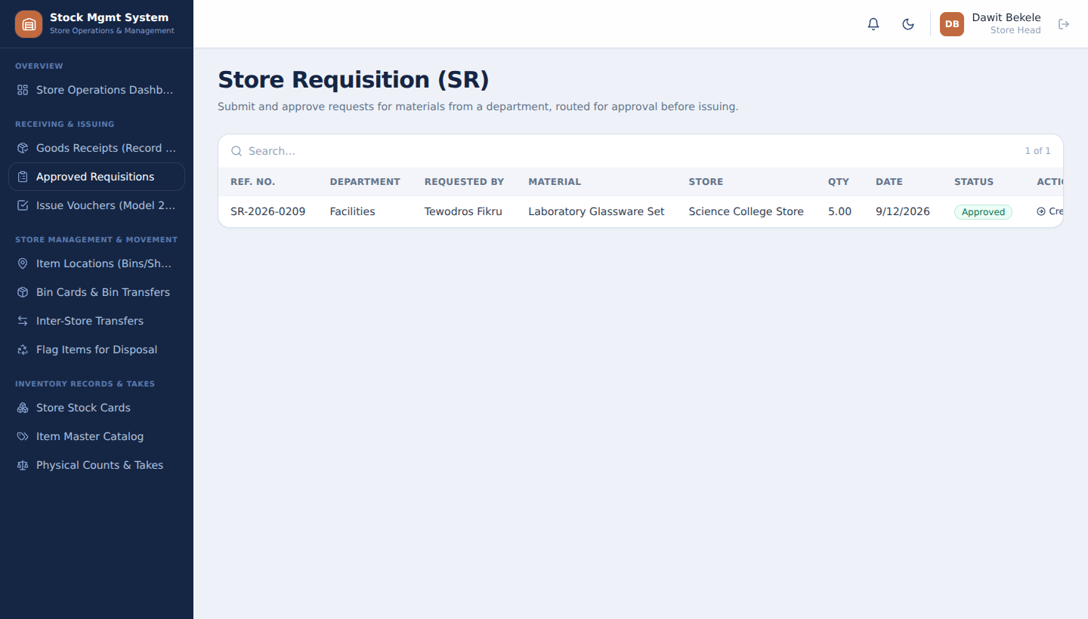
Figure 5: Store Requisition (SR) module used to submit and approve department material requests.
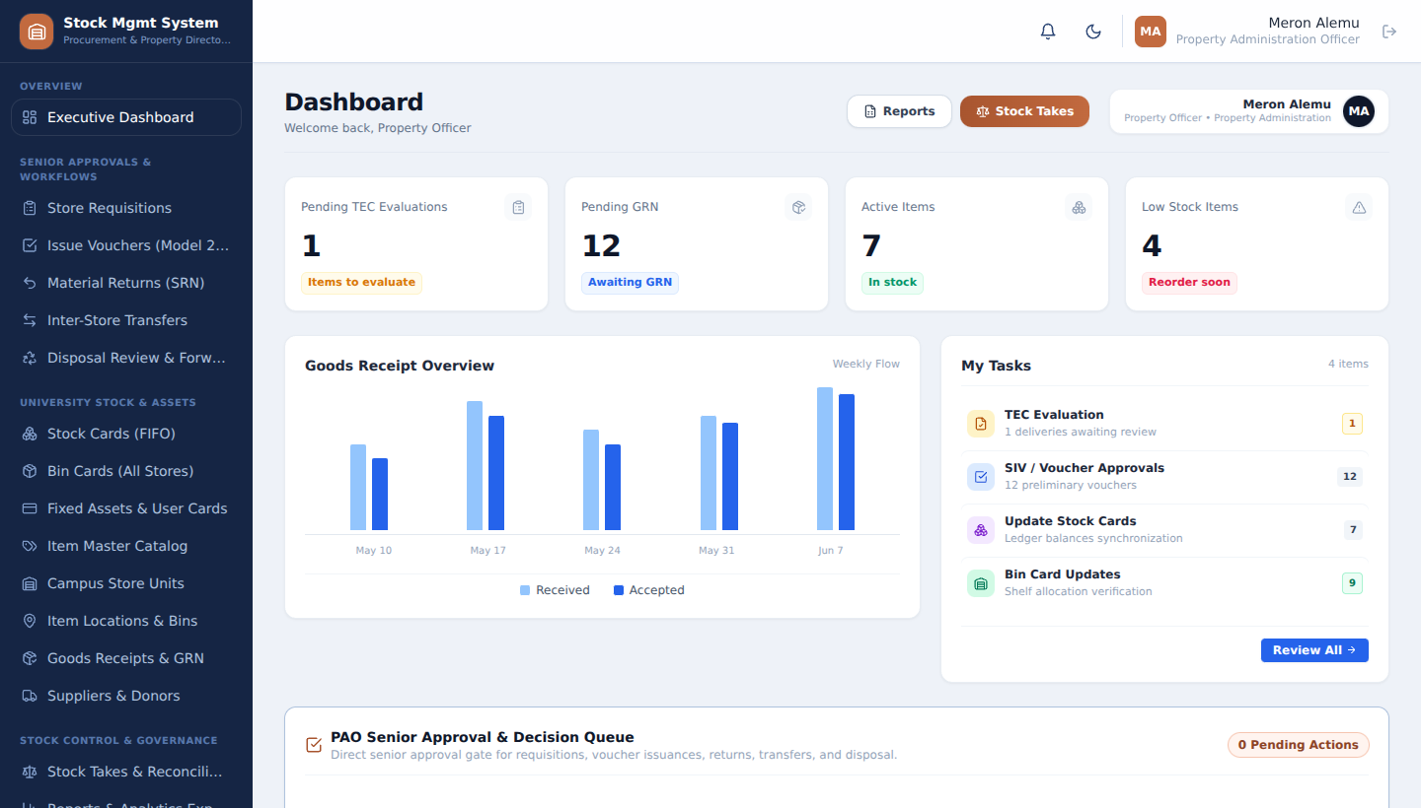
Figure 6: Property Administration Officer executive dashboard, with goods-receipt trend chart and senior approval queue.
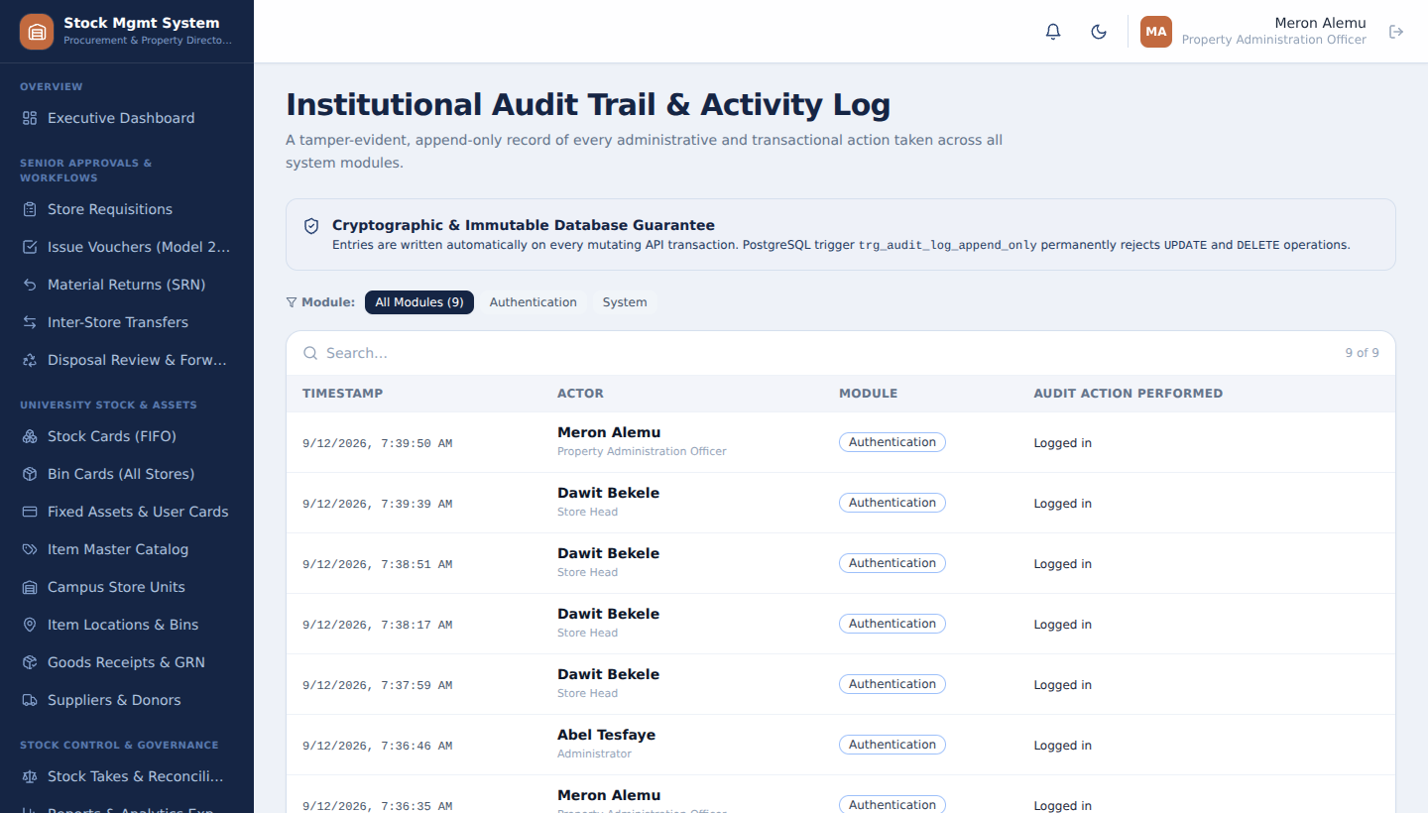
Figure 7: Institutional Audit Trail, showing the append-only, cryptographically chained activity log.
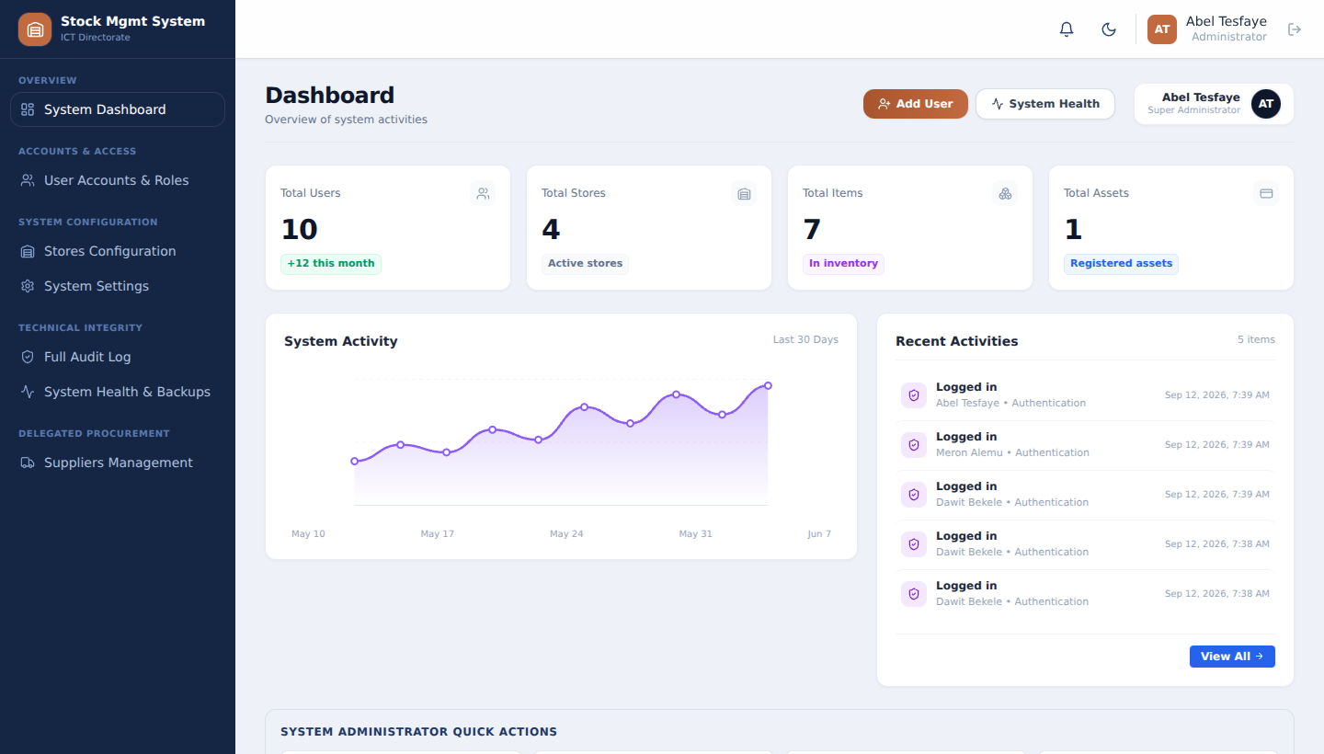
Figure 8: Administrator dashboard, showing system-wide user, store and asset counts and recent activity.
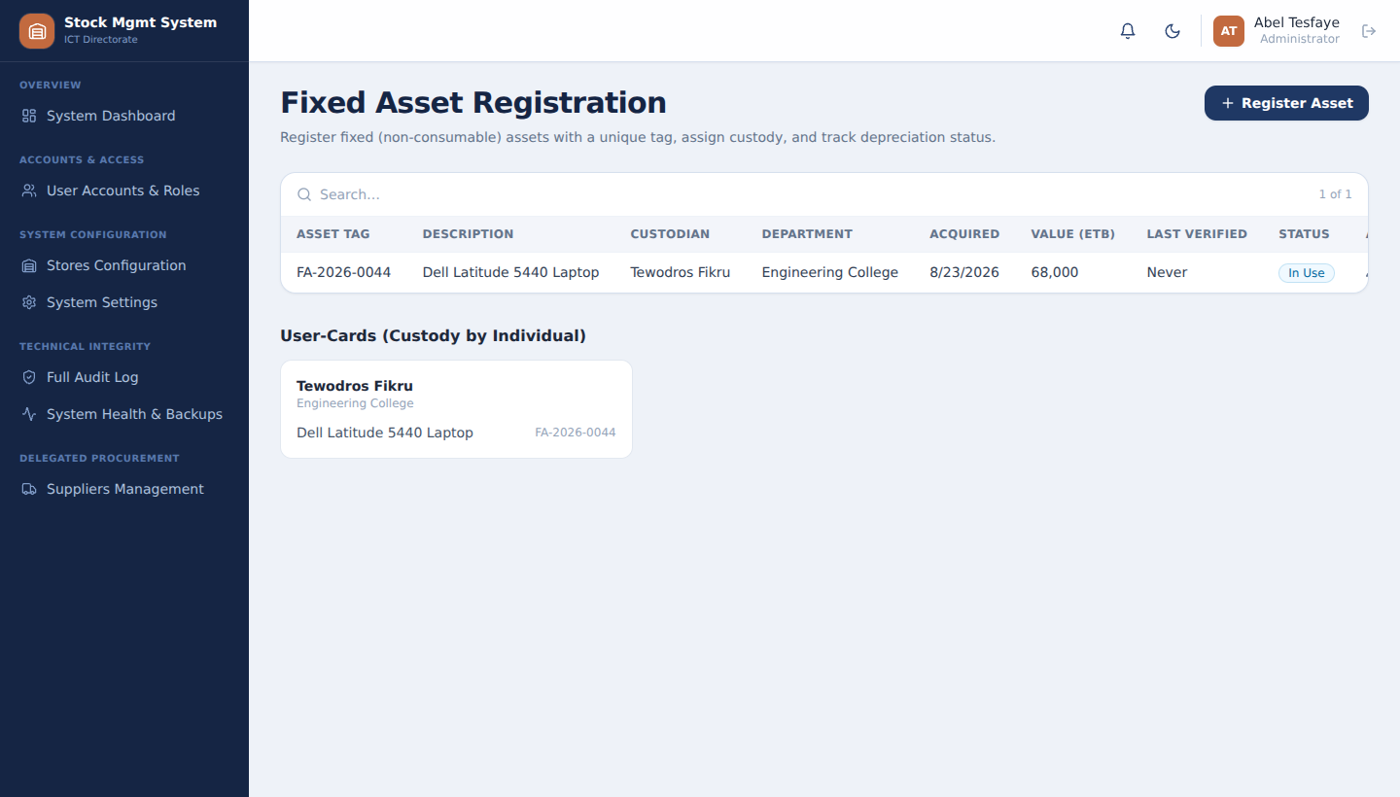
Figure 9: Fixed Asset Registration module with the associated custodian User-Card (Model 15).
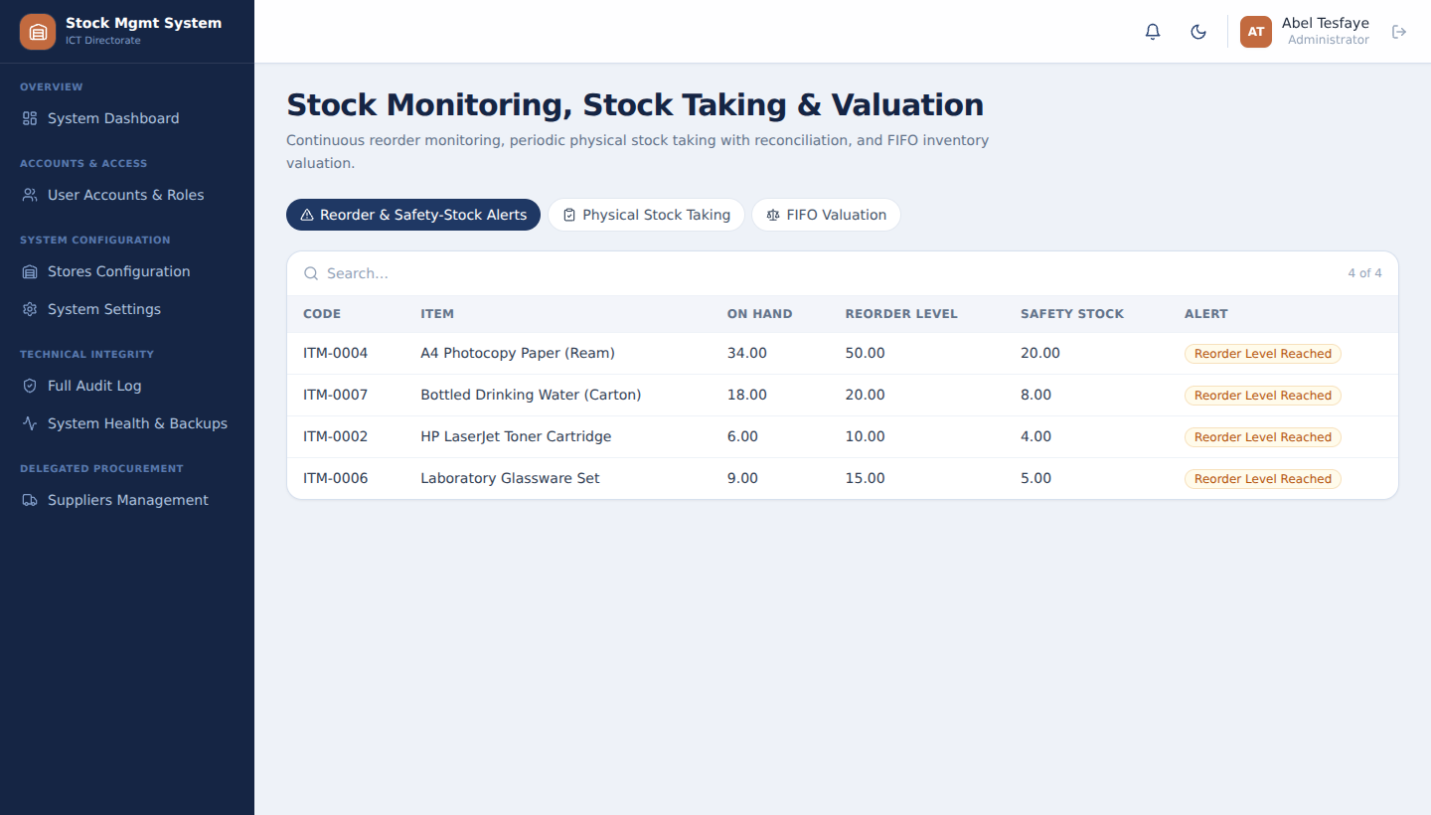
Figure 10: Stock Control module showing live reorder and safety-stock alerts.
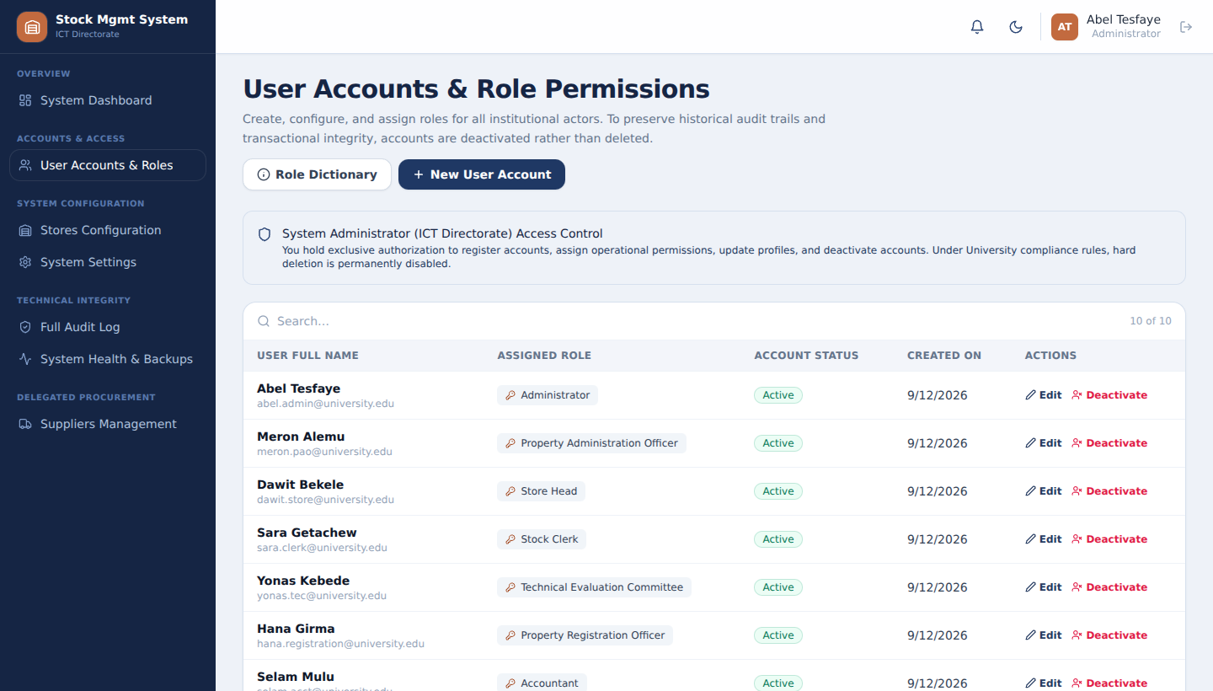
Figure 11: User Accounts and Role Permissions module, listing the seeded accounts across the system's institutional roles.

CHAPTER FOUR: REFLECTION AND CONCLUSION

4.1 How This Internship Fit My Career Goals
This internship fit closely with my career goal of becoming a proficient software engineer capable of designing and delivering complete, production-quality systems rather than isolated classroom exercises. Working on SPMS gave me first-hand experience with the entire software development lifecycle — from interviewing stakeholders and writing a Software Requirements Specification, through system and database design, to implementation, testing and demonstration — which is exactly the kind of end-to-end exposure I was hoping to gain before graduation.

4.2 Did My Career Goals Change as a Result of This Internship?
The internship did not change my overall career direction toward software engineering, but it did sharpen my interests within the field. Working on the FIFO valuation engine, the role-based access-control system, and the append-only audit trail increased my interest in backend systems, data integrity, and secure application design, areas I intend to explore further in coursework and personal projects going forward.

4.3 The Value of This Internship
I consider this internship highly valuable. Beyond the specific technical skills gained, it taught me how ambiguous, real-world requirements are gathered and refined into a concrete specification, how a small team coordinates its work through version control and code review, and how much discipline is required to keep a growing codebase consistent and secure. It also gave me confidence that the concepts I studied in my coursework are directly applicable to solving genuine organizational problems.

4.4 Challenges Faced During the Internship
- Translating a manual, paper-based process described informally by staff into precise, unambiguous system requirements and business rules.
- Coordinating a shared codebase with several interns working on interdependent modules at the same time, which required discipline around Git branching and clear API contracts between the frontend and backend.
- Correctly implementing the FIFO cost-lot consumption logic so that valuation remained accurate across receipts, issues, transfers, returns and disposals.
- Ensuring that role-based restrictions were enforced consistently on the server, not only hidden in the user interface, which required deliberately testing each workflow with the 'wrong' role to confirm it was rejected.
- Balancing the depth of a feature-rich system against the limited time available during the internship period, which required prioritizing the workflows most central to the organization's needs.

4.5 Self-Evaluation: Strengths and Areas for Improvement
Among my strengths, I would highlight my ability to break a complex requirement into smaller, testable implementation steps, my willingness to ask clarifying questions rather than guessing at ambiguous business rules, and my growing comfort with full-stack development across React, Express and PostgreSQL.
Areas I recognize as needing further improvement include writing more automated (rather than purely manual) tests, deepening my understanding of database performance tuning for larger datasets, and becoming faster at reading and safely modifying code written by teammates. I intend to address these areas through additional coursework, personal projects, and deliberate practice.

4.6 Technical Achievements and Innovations
During the internship, several advanced technical features were successfully implemented to meet the rigorous requirements of institutional stock management. One of the most significant achievements was the development of the Dual-Ledger Accounting system. By strictly separating the organization-wide Stock Card ledger from the physical Bin Card ledgers, the system provided an accurate valuation while maintaining precise physical locations across multiple campus stores.
Additionally, I contributed to the implementation of the Real FIFO Cost-Lot Engine and the Cryptographic SHA-256 Chained Audit Trail. The FIFO engine solved the problem of vague weighted-average estimations by tracking discrete cost lots per intake. The cryptographic audit trail acts as a blockchain-like ledger, ensuring that any unauthorized modifications to historical records are immediately detectable, which is crucial for public sector compliance and audits.

CHAPTER FIVE: RECOMMENDATIONS

5.1 Comments on the Company and the Internship
ASTU ICT Centre provided a genuinely useful and well-structured internship experience. Assigning interns to a real, needed project — rather than a purely simulated exercise — meaningfully increased my motivation and sense of responsibility, since the quality of the work had real consequences for how usable the resulting system would be. My supervisor, Mr. Daniel Asfaw, was consistently available for guidance and gave direct, actionable feedback that accelerated my learning.

5.2 Recommendations for Improving the Internship Program
- Provide interns with an initial orientation session that introduces the host organization's existing systems, coding standards and Git workflow before development work begins, to reduce the ramp-up time at the start of the internship.
- Schedule brief, regular joint check-ins between the department advisor and the company supervisor to align academic expectations with the pace of the practical project.
- Encourage host organizations to set aside time for interns to write basic automated tests, since manual testing alone becomes difficult to sustain as a system grows.
- Extend the internship period slightly, where feasible, for projects of this scope, since requirement gathering, design, implementation and testing together require more time than a purely observational internship.

5.3 Should the Company Be Considered for Future Student Placement?
Yes. I would recommend ASTU ICT Centre as a strong internship placement for future Computer Science and Engineering students. The Centre offers real, technically substantial projects, hands-on mentorship, and direct exposure to how software is used to solve genuine institutional problems, all of which make it a valuable environment for developing both technical and professional skills.

REFERENCES
Ministry of Finance and Economic Development (MoFED). Stock Management Manual, Addis Ababa, Ethiopia, 2010.
IEEE Computer Society. IEEE Recommended Practice for Software Requirements Specifications (IEEE 830-1998).
Sommerville, I. Software Engineering, 10th Edition, Pearson Education, 2015.
Pressman, R. S. Software Engineering: A Practitioner's Approach, 8th Edition, McGraw-Hill, 2014.
Silberschatz, A., Korth, H., and Sudarshan, S. Database System Concepts, 7th Edition.
Official documentation for React.js, Node.js, Express.js, and PostgreSQL.
Adama Science and Technology University, School of Electrical Engineering and Computing. Internship Guideline (For Interns, Only), July 2024.
Project Software Requirements Specification and Build Specification documents prepared for the SPMS project, ASTU ICT Centre internship program, 2026.

ANNEXES

Annex A: Monthly Internship Activity Report (Template)
Note to students: Attach one completed activity report per month of the internship, summarizing tasks performed, modules worked on, and hours logged, signed by the company supervisor. A suggested format is provided below.
Week | Tasks Performed | Module(s) | Supervisor's Remark
1 | Orientation; requirement gathering interviews; review of existing manual process | SRS
2 | Database schema design; API contract discussion with team | Design
3 | Implementation of assigned backend controllers and routes | Backend
4 | Implementation of corresponding frontend pages/components | Frontend
5 | Role-based access-control testing across seeded demo accounts | RBAC / Testing
6 | Bug fixing and refinement based on supervisor feedback | QA
7 | Integration testing of end-to-end workflows | Testing
8 | Final demonstration preparation and report writing | Documentation

Annex B: Self-Evaluation Report (Template)
Note to student: Complete and attach a self-evaluation covering: skills gained, confidence in technical areas before and after the internship, teamwork experience, and overall satisfaction with the internship, co-signed by the company supervisor.

Annex C: Selected REST API Reference (SPMS Backend)
The table below lists a representative subset of the API endpoints implemented in the SPMS backend, illustrating the role-based access-control model discussed in Chapter Three.
Module | Method & Path | Allowed Roles
Auth | POST /api/auth/login | Public
Goods Receipt | POST /api/goods-receipts | Store Head, Stock Clerk, Administrator
Goods Receipt | POST /api/goods-receipts/:id/evaluate | Technical Evaluation Committee, Administrator
Goods Receipt | POST /api/goods-receipts/:id/generate-grn | Property Registration Officer, Administrator
Requisitions | POST /api/requisitions | Department Head, Administrator
Requisitions | POST /api/requisitions/:id/decide | Department Head, PAO, Administrator
Issue Vouchers | POST /api/issue-vouchers/preliminary | Store Head
Issue Vouchers | POST /api/issue-vouchers/:id/finalize | Store Head, PAO
Issue Vouchers | POST /api/issue-vouchers/:id/gate-clearance | Campus Security Officer
Fixed Assets | POST /api/fixed-assets | Property Registration Officer, Administrator
Disposal | POST /api/disposal-requests/:id/decide | Disposal Committee
Stock Control | GET /api/stock-control/valuation | Accountant, PAO, Administrator
Audit Log | GET /api/audit-logs | Administrator, PAO

