|  |  |
| --- | --- |
| Open syn*gw GUI | 1. Enable interface handler **mail.** 2. Enable all data stores (including mail). |
| Mercury mail |  |
| phpmyAdmin | 1. Import SQL **test/helper/rc-reset-user.sql in RoundCube data base.** 2. Import SQL **test/helper/rc-reset-data.sql in RoundCube data base.** 3. **Change user** [**t1@dev.fd**](mailto:t1@dev.fd) **to t1 in table user in RoundCube data base.** |
| RoundCube | Install Plugin **select_for_sync** from <https://plugins.roundcube.net/#/packages/syncgw/roundcube-select_for_sync>. |
| Login to RoundCube | Enable all data stores for synchronization in settings panel. |
| Go to | <https://testconnectivity.microsoft.com> |
| Select |  |
| Select |  |

# Trace: 810

|  |
| --- |
|  |
| [t1@dyn.wb28.de](mailto:t1@dyn.wb28.de)  tst\t1 mamma |
| [Results](Trace%20810%20-%20RCA%204.0.18.html) |

# Trace: 811

|  |
| --- |
|  |
| [dyn.wb28.de](mailto:t1@dyn.wb28.de)  tst\t1 mamma |
| [Results](Trace%20811%20-%20RCA%204.0.18.html) |

# Trace: 812

|  |  |
| --- | --- |
| Select |  |

|  |
| --- |
|  |
| [t1@dyn.wb28.de](mailto:t1@dyn.wb28.de)  tst\t1 mamma |
|  |

This test should work (according to documentation). MicroSoft promised to change test behavior to accept a response MAPI over HTTP only (no EXCH or EPR protocol).

# Trace: 813

|  |  |
| --- | --- |
| Select |  |

|  |
| --- |
|  |
| [t1@dyn.wb28.de](mailto:t1@dyn.wb28.de)  tst\t1 mamma |
| [Results](Trace%20813%20-%20RCA%204.0.18.html) |

This test should work (according to documentation). MicroSoft promised to change test behavior to accept a response MAPI over HTTP only (no EXCH or EPR protocol).

# Trace: 814

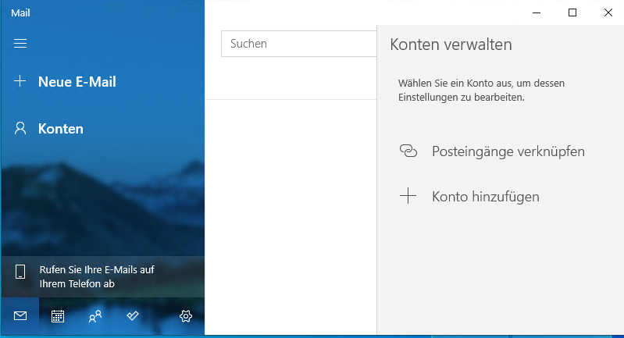

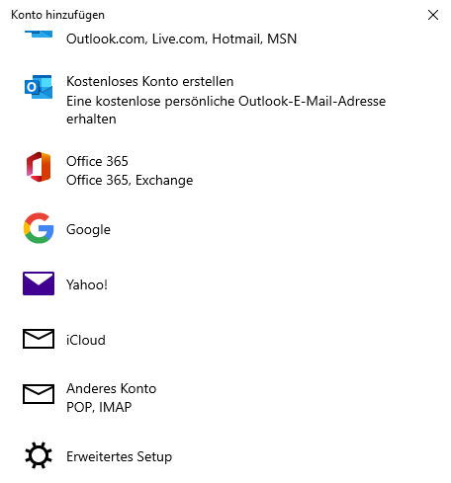 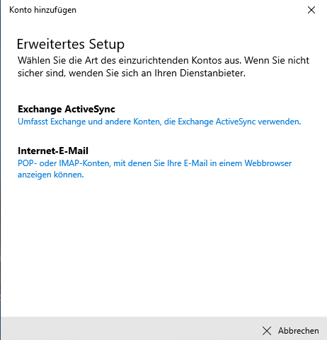

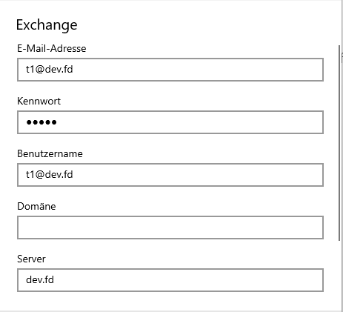

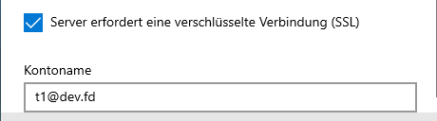

|  |
| --- |
| t1@dev.fd mamma t1@dev.fd  dev.fd t1@dev.fd |

This test does run without any error, but at the end the it does not synchronize.