MID-TERM 1 · ENGLISH 9
REVISION WORKSHEET | 80 QUESTIONS | UNITS 1–3
Full name: ___________________ | Class: __________ | Date: __________
Time suggested: 100 minutes • From basic to advanced • Global Success 9
REVISION MAP · Kiến thức trọng tâm
UNIT 1 · LOCAL COMMUNITY | Artisans, crafts, phrasal verbs, question words + to-infinitive.
UNIT 2 · CITY LIFE | Urban services, transport, city problems, double comparatives.
UNIT 3 · HEALTHY LIVING FOR TEENS | Study-life balance, managing stress, first/second conditionals, reported speech.
Instructions: For Questions 1–70, circle A, B, C or D. For Questions 71–80, rewrite the sentences without changing their meanings.
I. PHONETICS · Câu 1–8
Choose the word with a different underlined sound (1–4) or a different primary stress (5–8).
1. Choose the word whose underlined sound is different.
A. hat | B. father | C. map | D. cat

2. Choose the word whose underlined sound is different.
A. child | B. chair | C. cheap | D. chemistry

3. Choose the word whose underlined sound is different.
A. book | B. moon | C. food | D. school

4. Choose the word whose underlined sound is different.
A. think | B. thank | C. this | D. three

5. Choose the word with a different main stress.
A. crowded | B. village | C. market | D. cartoon

6. Choose the word with a different main stress.
A. attractive | B. exciting | C. wonderful | D. expensive

7. Choose the word with a different main stress.
A. energy | B. solution | C. tradition | D. pollution

8. Choose the word with a different main stress.
A. remember | B. organise | C. describe | D. develop

II. VOCABULARY, GRAMMAR & COMMUNICATION · Câu 9–32
Choose the best option A, B, C or D.
9. The villagers invited a local _____ to teach children how to make clay pots.
A. artisan | B. gardener | C. athlete | D. passenger

10. My grandfather still _____ the traditional method of weaving baskets.
A. gets over | B. brings up | C. takes off | D. passes down

11. We should _____ these old buildings because they tell stories about our town.
A. replace | B. preserve | C. borrow | D. prevent

12. This neighbourhood is famous _____ its colourful weekend market.
A. with | B. on | C. for | D. at

13. After moving to the city, Mai found it difficult to _____ the noise.
A. turn down | B. run out | C. deal with | D. look after

14. There is a lot of _____ on the roads during rush hour.
A. traffic congestion | B. peacefulness | C. happiness | D. craftsmanship

15. The new metro line makes it easier for residents to _____ the city.
A. look up | B. put off | C. turn into | D. get around

16. Many teenagers feel _____ when they have too much homework and little rest.
A. cheerful | B. stressed | C. curious | D. generous

17. You should _____ your tasks instead of doing everything at the last minute.
A. interrupt | B. prioritise | C. decorate | D. persuade

18. My parents remind me to maintain a healthy _____ between study and relaxation.
A. traffic | B. facility | C. balance | D. material

19. I can't decide _____ to ask for advice about the conflict.
A. who | B. what | C. where | D. when

20. Could you show me _____ to get to the community centre?
A. which | B. who | C. what | D. how

21. They are discussing _____ to organise a craft fair next month.
A. whose | B. whom | C. why | D. how

22. The _____ the streets are, the _____ it is to cross safely.
A. busiest / hardest | B. more busy / more hard | C. busier / harder | D. busy / hard

23. The more time you spend on your phone at night, _____.
A. the less sleep you may get | B. less sleep you get
C. the more sleepy you are get | D. you may sleep more

24. The more carefully you plan your day, _____.
A. the efficient you work | B. the more efficiently you can work
C. the more efficient you work | D. you can work more efficient

25. If it rains tomorrow, we _____ the outdoor workshop indoors.
A. would move | B. move | C. moved | D. will move

26. If I _____ a bicycle, I would ride to school every day.
A. will have | B. have | C. had | D. am having

27. If you want to feel less stressed, you _____ take short breaks during study time.
A. should | B. mustn’t | C. would | D. can’t

28. Lan said she _____ an English club the following week.
A. joins | B. would join | C. has joined | D. had joined

29. The teacher asked Minh _____ he had finished his assignment.
A. that | B. what | C. if | D. where

30. She asked me where _____.
A. did I buy my notebook | B. do I buy my notebook
C. had I bought my notebook | D. I had bought my notebook

31. Nam: “Could you tell me where the nearest bus stop is?” — Hoa: “_____”
A. No, you aren’t. | B. It’s next to the post office.
C. I will be there tomorrow. | D. Yes, I do.

32. Teen: “I feel exhausted after studying for hours.” — Friend: “_____”
A. You should take a short break. | B. You ought to skip every meal.
C. You must study all night. | D. You can stop sleeping.

III. NOTICES & ANNOUNCEMENTS · Câu 33–44
Read each short announcement and choose the best word to complete each blank.
LOCAL CRAFT WEEKEND
Join our pottery workshop this Saturday! The event (33) ______ at 9 a.m. at the Community Centre. Visitors can learn (34) ______ to shape clay bowls from local artisans. All materials are provided, so you do not need to bring (35) ______. Please register early because the number of places is (36) ______.
33. Choose the best word or phrase for blank (33).
A. begins | B. began | C. begin | D. beginning

34. Choose the best word or phrase for blank (34).
A. who | B. where | C. what | D. how

35. Choose the best word or phrase for blank (35).
A. everything | B. something | C. anything | D. nothing

36. Choose the best word or phrase for blank (36).
A. limiting | B. limited | C. limit | D. limitation

GREEN STREETS DAY
Our neighbourhood is planning a clean-up next Sunday. Everyone is (37) ______ to join. We will pick (38) ______ litter near the bus station and plant trees along the street. (39) ______ we work together, our area will become cleaner and safer. Remember to wear comfortable shoes and (40) ______ a bottle of water.
37. Choose the best word or phrase for blank (37).
A. welcomes | B. welcome | C. welcoming | D. welcomed

38. Choose the best word or phrase for blank (38).
A. on | B. into | C. off | D. up

39. Choose the best word or phrase for blank (39).
A. If | B. Without | C. Unless | D. Despite

40. Choose the best word or phrase for blank (40).
A. bringing | B. brought | C. bring | D. brings

HEALTHY HABITS CHALLENGE
Do you feel tired after a long school day? Try (41) ______ your phone away at least 30 minutes before bedtime. Getting enough sleep helps you (42) ______ better at school. The (43) ______ regularly you exercise, the healthier you may become. Ask a friend to join you so you can (44) ______ each other.
41. Choose the best word or phrase for blank (41).
A. put | B. to putting | C. puts | D. putting

42. Choose the best word or phrase for blank (42).
A. concentrated | B. concentrating | C. concentrate | D. concentration

43. Choose the best word or phrase for blank (43).
A. more | B. much | C. many | D. most

44. Choose the best word or phrase for blank (44).
A. ignore | B. encourage | C. discourage | D. delay

IV. SIGNS & PUBLIC NOTICES · Câu 45–50
Look at each sign or notice and choose its correct meaning.
45. What does the LIBRARY sign mean?  A. Only teachers may use phones.  B. Students must use phones quietly.  C. Phone calls are not allowed in the library.  D. The library offers free phone calls. | 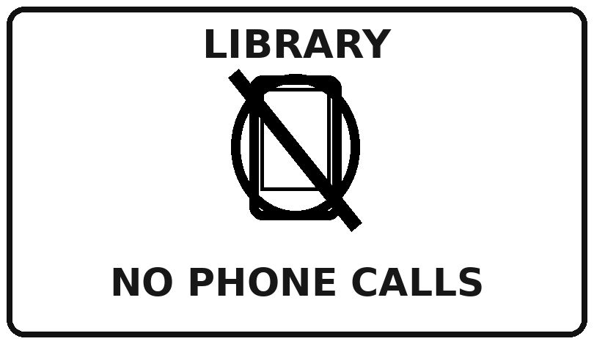

46. What does this SCHOOL ZONE sign tell drivers?  A. Children must run across the road quickly.  B. Drivers should slow down because children may cross.  C. Cars can travel faster in this area.  D. Drivers may park anywhere near the school. | 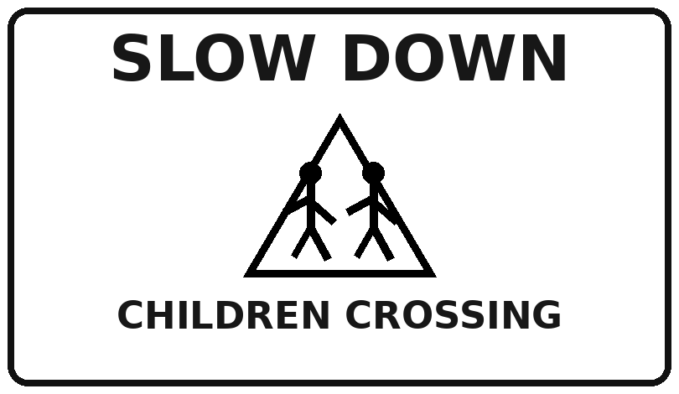

47. What does the KEEP OFF THE GRASS sign mean?  A. Children may play football on the grass.  B. Visitors should water the grass.  C. People must cut the grass today.  D. People should not walk on the grass. | 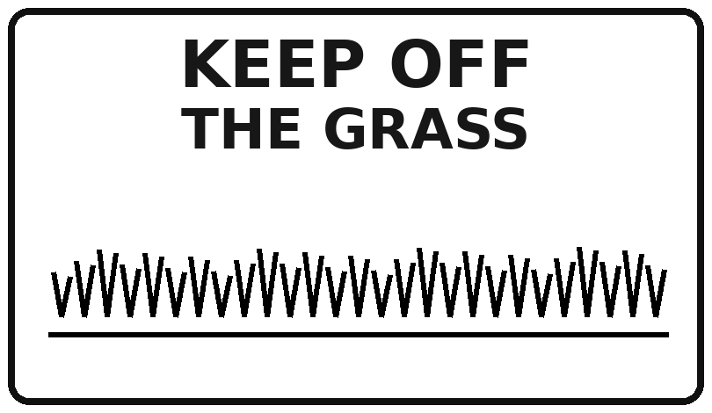

48. What should visitors do at the FIRE EXIT?  A. Keep bags and boxes away from the exit.  B. Use the exit as a storage area.  C. Leave their bags in front of the door.  D. Lock the exit from the outside. | 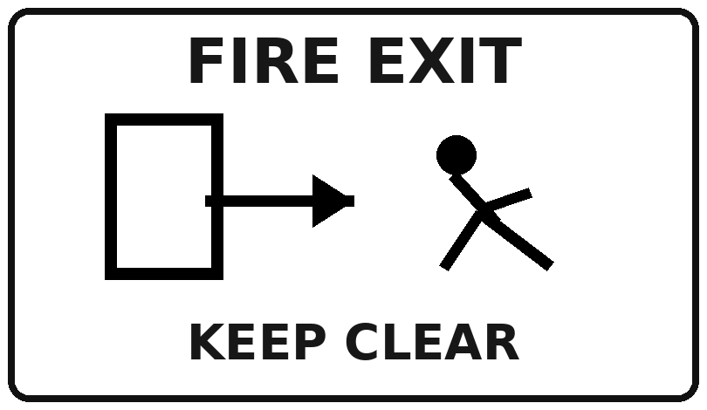

49. What does the ENGLISH CLUB notice say?  A. The club always meets in Room 205.  B. The club meets in Room 205 today only.  C. The club will move to Room 203 tomorrow forever.  D. The club has been cancelled today. | 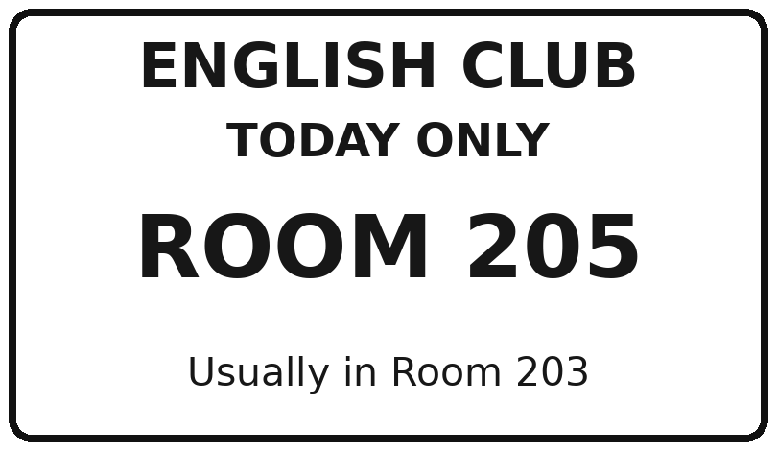

50. What must students do to join SPORTS DAY?  A. Wait until the event starts to register.  B. Pay for entry after Friday.  C. Register by 4 p.m. on Friday.  D. Register on Saturday morning. | 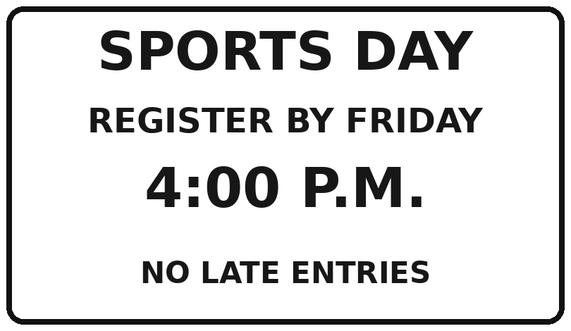

V. READING COMPREHENSION · Câu 51–64
Read the two passages carefully. Choose the best answer to each question.
READING A · KEEPING LOCAL CRAFTS ALIVE
At the edge of An Hoa, a small town known for bamboo products, there is a street that becomes a craft market every Saturday. For many years, local artisans sold baskets only to nearby shops. When online orders started to grow, some of them worried that traditional techniques would disappear because young people preferred factory jobs.
Last autumn, the town council invited experienced artisans to run short workshops for students. The workshops are free, but visitors pay a small amount if they take home a product they make. The council also closed the street to cars during market hours after residents complained about noise and traffic. Teen volunteers now guide visitors and show them where to put rubbish. They also help older craftspeople post photos of their products online.
Fourteen-year-old Linh first joined because her teacher encouraged her. She expected the work to be boring, but she enjoyed learning how to weave a small basket. “I used to think these skills belonged only to the past,” she said. “Now I see that they can bring people together.” The project has increased interest in local crafts, although organisers are still trying to make workshops affordable while paying artisans fairly.
51. What is the main purpose of Reading A?
A. To persuade all teenagers to leave school.
B. To explain how a factory produces baskets.
C. To compare every market in Viet Nam.
D. To describe a project that connects young people with traditional crafts.

52. Before the project, where did artisans mainly sell their baskets?
A. At nearby shops. | B. In foreign supermarkets.
C. At airports. | D. Only through a mobile app.

53. Why was the craft street closed to cars during market hours?
A. The market was too far from town. | B. The artisans wanted more car parking.
C. Residents had complained about noise and traffic. | D. A new bridge had been built.

54. Which task do teen volunteers NOT do according to the passage?
A. Show visitors where to put rubbish. | B. Set the prices of products sold at the market.
C. Guide people visiting the market. | D. Help artisans post photos online.

55. In paragraph 2, “They” in “They also help older craftspeople...” refers to _____.
A. residents | B. the town council | C. visitors | D. teen volunteers

56. The word “affordable” in the last paragraph is closest to _____.
A. not too expensive | B. made by hand | C. very old-fashioned | D. difficult to understand

57. What can be inferred about the project?
A. It has completely replaced factory work.
B. It has ended because visitors dislike crafts.
C. It forces students to pay for every workshop.
D. It has achieved some success but still faces financial challenges.

READING B · SMALL STEPS, HEALTHIER STUDENTS
During exam periods, some teenagers believe the only way to improve grades is to study for more hours. However, teachers at Green Hill School noticed that students who slept too little often struggled to concentrate. To explore simple ways to help, they invited 60 volunteers to join a four-week Healthy Habits Challenge.
Each student chose two habits to improve. Some put their phones away half an hour before bed; others took short walks after school or planned their homework in smaller tasks. Every student kept a short diary, recording their bedtime and how energetic they felt the next day. The school did not ask them to buy special food or pay for exercise classes.
At the end of the programme, most students said they felt more prepared for lessons, but not everyone reported better test results. The teachers warned families against expecting instant changes. They said healthy habits need time and regular practice. One participant, Huy, said, “I still have difficult days, but now I know what to do before I feel overwhelmed.”
58. Why did Green Hill School start the Healthy Habits Challenge?
A. To make every student study all night.
B. To sell special exercise equipment.
C. To help students improve everyday habits that support learning.
D. To replace all school examinations.

59. What did participants record in their diaries?
A. Their parents’ working hours. | B. Their bedtime and energy level the following day.
C. The prices of all their meals. | D. Only their test results.

60. Which activity was an example of a habit change?
A. Putting phones away before going to bed. | B. Studying with a phone until midnight.
C. Skipping every afternoon break. | D. Buying expensive sports equipment.

61. The word “overwhelmed” in the last paragraph is closest to _____.
A. unable to cope with too much pressure | B. free from any responsibility
C. extremely excited about a prize | D. willing to travel long distances

62. Which statement is NOT true about the programme?
A. Students selected two habits to improve. | B. The programme lasted four weeks.
C. Sixty volunteers joined the programme. | D. Students had to pay for exercise classes.

63. What happened at the end of the programme?
A. Every student received perfect marks.
B. Most students felt better prepared, but not all had better test results.
C. All students stopped having difficult days.
D. Teachers told families that results would be immediate.

64. Which lesson best matches Reading B?
A. Only the number of study hours affects grades. | B. Healthy habits work immediately for everyone.
C. Small healthy changes need time and regular practice. | D. Teenagers should avoid making daily plans.

VI. TEXT ORGANISATION · Câu 65–70
Choose sentences to complete a paragraph, then arrange and conclude ideas.
Living in a busy city can be exciting, but teenagers sometimes find it hard to relax. (65) ______ This helps them avoid doing everything at the last minute. Next, (66) ______ A short walk or a game outside can improve their mood. They should also keep their phones away while doing homework. (67) ______ Finally, (68) ______ Talking to someone they trust can help them see problems more clearly.
A. They should make a simple plan for each day.
B. they should spend some time being physically active.
C. This can reduce unnecessary distractions.
D. they can ask friends or family members for advice.
65. Blank (65): A / B / C / D
66. Blank (66): A / B / C / D
67. Blank (67): A / B / C / D
68. Blank (68): A / B / C / D
69. Arrange the sentences to make a logical paragraph about recycling.
a. First, students placed collection boxes in three schools.
b. Then volunteers explained how to sort paper and plastic.
c. As a result, more families began recycling at home.
A. b – c – a | B. a – b – c | C. a – c – b | D. c – a – b

70. Choose the best ending: “The local park was once full of litter. Students cleaned it, planted flowers and asked neighbours to protect the area. Now many families spend time there.”
A. Their shared efforts made the park a pleasant place for everyone.
B. No one in the area likes parks.
C. The park was built many years ago.
D. Only students should use the park.

VII. WRITING · Câu 71–80
Rewrite each sentence using the given keyword or structure. Do not change the original meaning.
71. I don't know where I should buy traditional lanterns. (WHERE TO)
→ ...........................................................................................................................................
72. Could you tell me how I can get to the history museum? (HOW TO)
→ ...........................................................................................................................................
73. If you study more carefully, you will make fewer mistakes. (THE ... THE ...)
→ ...........................................................................................................................................
74. As the city gets bigger, its roads become more crowded. (THE ... THE ...)
→ ...........................................................................................................................................
75. You need to leave now, or you will miss the bus. (IF)
→ ...........................................................................................................................................
76. I don't have enough free time, so I can't join the pottery club. (IF)
→ ...........................................................................................................................................
77. My grandmother taught my mother the traditional skill of weaving baskets. (PASS DOWN)
→ ...........................................................................................................................................
78. Because the buses were crowded, we couldn't travel easily around the city. (GET AROUND)
→ ...........................................................................................................................................
79. Lan said, “I am preparing for the community festival.” (REPORTED SPEECH)
→ ...........................................................................................................................................
80. The teacher asked Nam, “Have you finished the project?” (REPORTED SPEECH)
→ ...........................................................................................................................................

