MASTER THÚY
Thạc sĩ · Giảng viên tiếng Anh | Zalo: 0836 686 874
SIGNS AROUND US
GRADE 6 • GLOBAL SUCCESS • 50 QUESTIONS • EASY TO CHALLENGING
Name: ....................................... | Class: ................ | Date: ......................

Instructions: Look at each sign. Choose ONE correct answer (A, B, C or D).
Suggested time: 60 minutes · 50 questions × 0.2 = 10 points · No listening section
PART A · EASY
Recognise the meaning of common signs | Questions 1–15
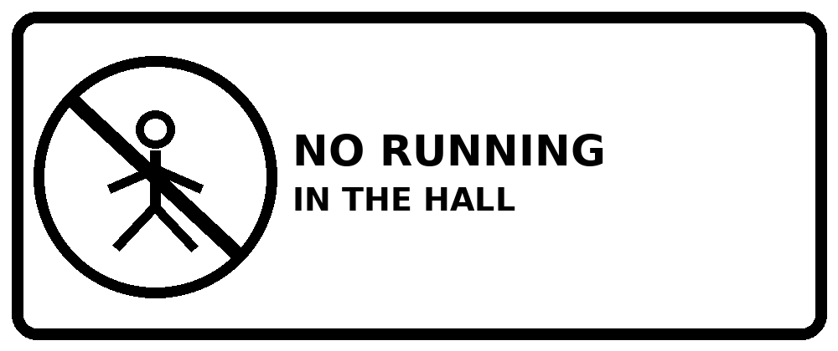 | 01. What does the sign mean?
  A. Students can run in the hall. | B. Students must walk in the hall.
  C. Students must stay at home. | D. Students can play football here.
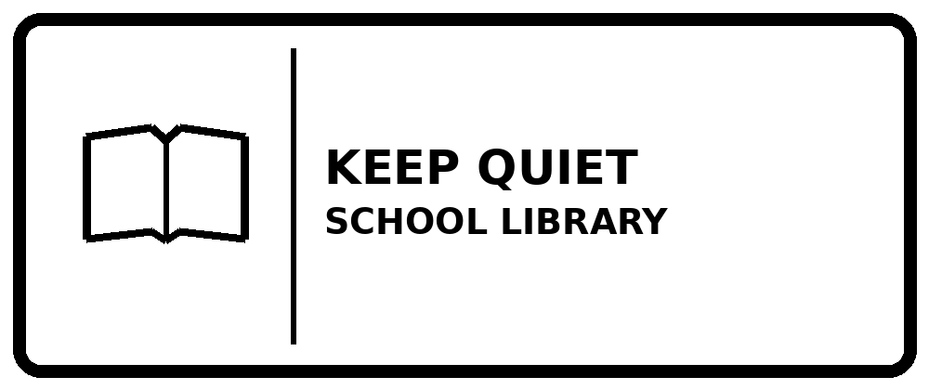 | 02. What does the sign mean?
  A. You should speak quietly here. | B. You should sing loudly.
  C. You must close the library. | D. You can play loud music.
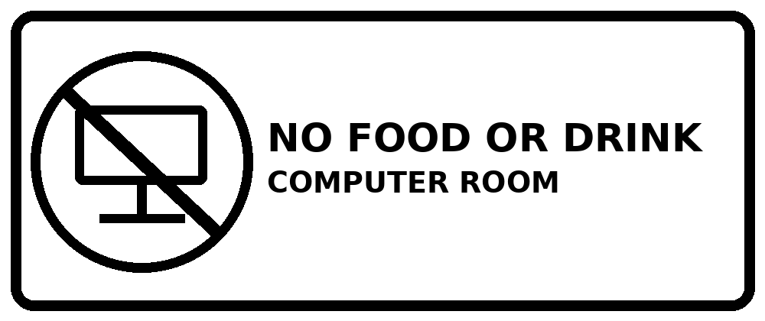 | 03. What does the sign mean?
  A. You can eat lunch here. | B. You must bring some food.
  C. You can drink water here. | D. You cannot eat or drink here.
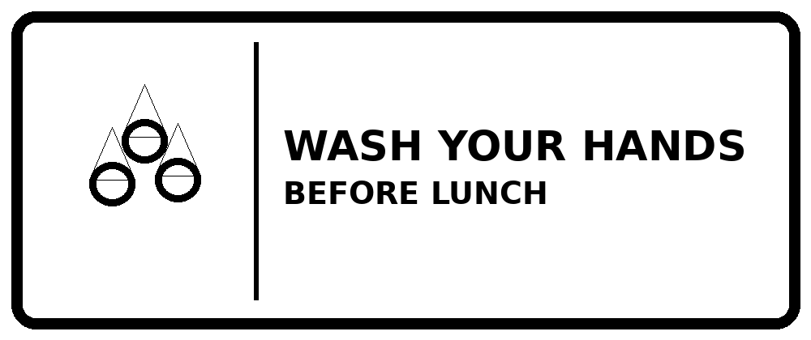 | 04. What does the sign mean?
  A. You should wash your shoes. | B. You must skip lunch.
  C. You should wash your hands before eating. | D. You can eat before washing your hands.
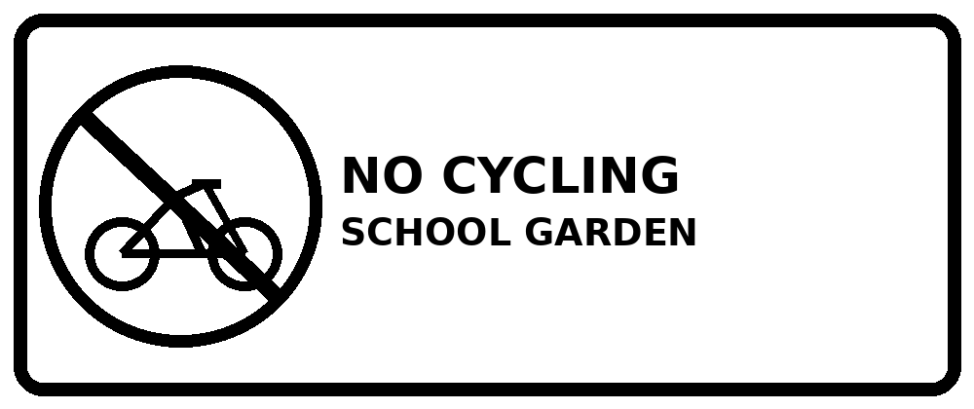 | 05. What does the sign mean?
  A. You can cycle in the garden. | B. You must not ride a bike in the garden.
  C. You must buy a bike. | D. You should wash your bike.
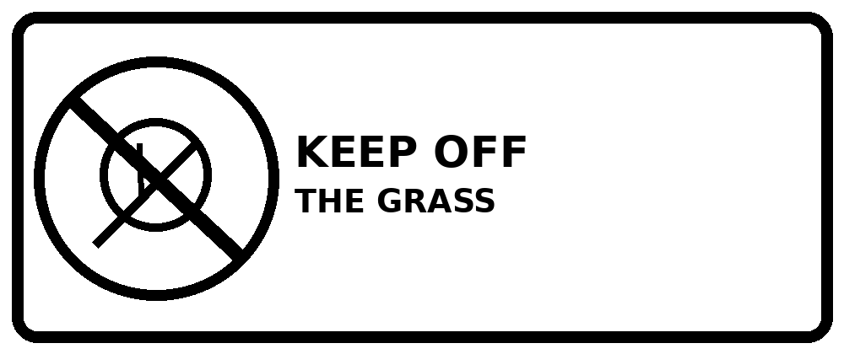 | 06. What does the sign mean?
  A. You must not walk on the grass. | B. You can play on the grass.
  C. You should water the grass now. | D. You must sit on the grass.
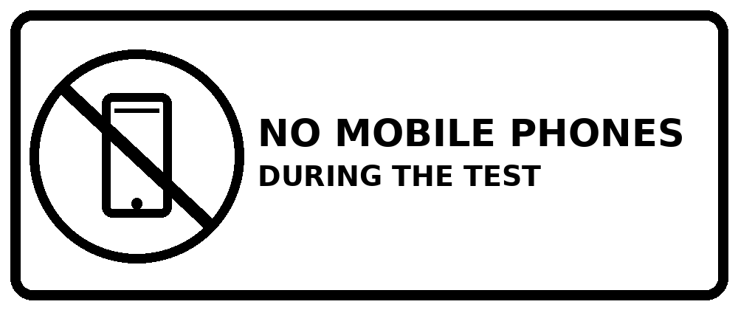 | 07. What does the sign mean?
  A. You can call friends during the test. | B. You should take photos.
  C. You must bring two phones. | D. You must not use a phone in the test.
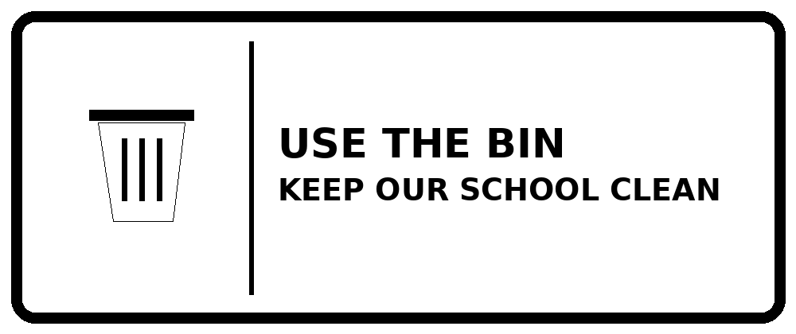 | 08. What does the sign mean?
  A. Leave your rubbish on the floor. | B. Put your books in the bin.
  C. Put your rubbish in the bin. | D. Throw rubbish into the garden.
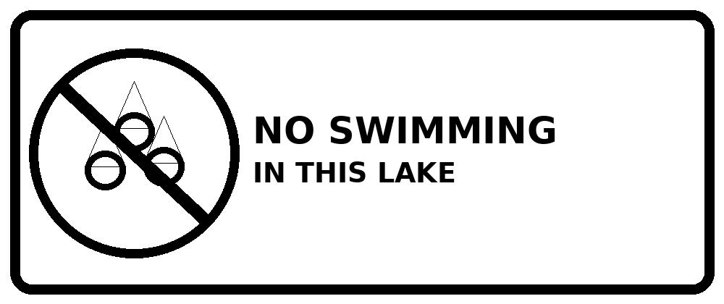 | 09. What does the sign mean?
  A. You can swim here every day. | B. You must not swim in this lake.
  C. You must drink lake water. | D. You should bring a boat here.
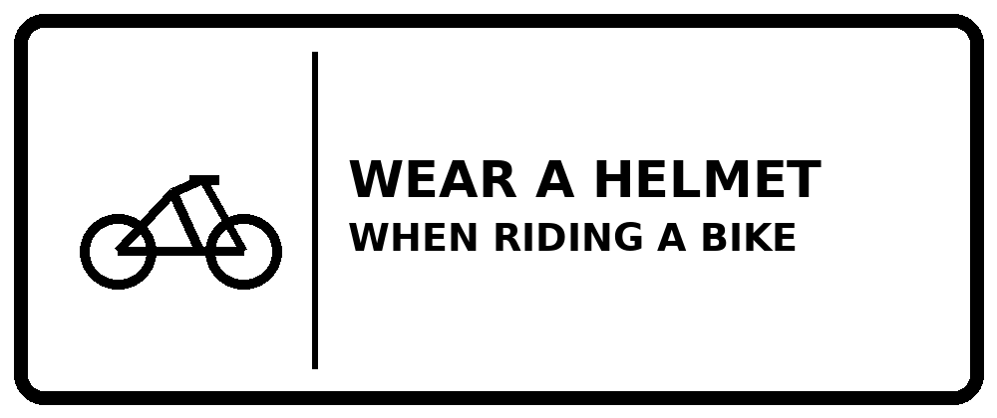 | 10. What does the sign mean?
  A. You should wear a helmet when cycling. | B. You should ride without a helmet.
  C. You must carry a big bag. | D. You should walk with a helmet in class.
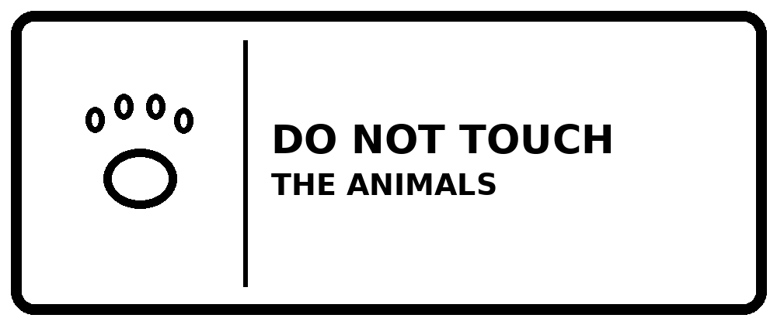 | 11. What does the sign mean?
  A. You can feed every animal. | B. You can touch the animals.
  C. You must take an animal home. | D. You must not touch the animals.
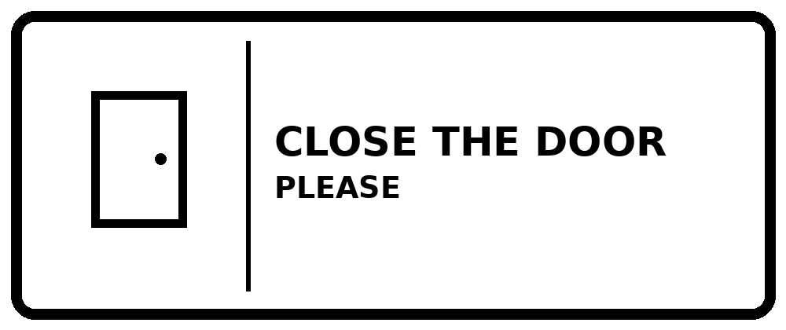 | 12. What does the sign mean?
  A. You must open all windows. | B. You must leave the door open.
  C. You should close the door. | D. You should paint the door.
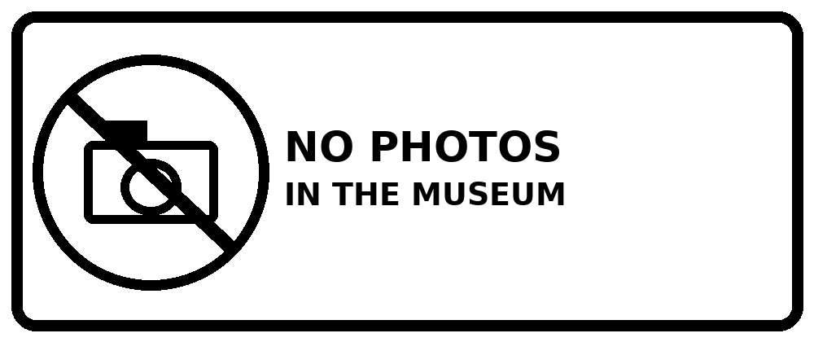 | 13. What does the sign mean?
  A. You can take photos here. | B. You must not take photos in the museum.
  C. You must bring a camera. | D. You can watch TV here.
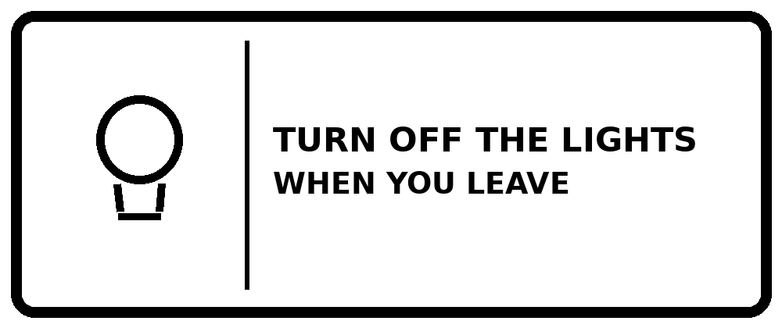 | 14. What does the sign mean?
  A. Switch off the lights before leaving. | B. Keep the lights on all day.
  C. Turn on every light when you leave. | D. Close the windows at lunchtime.
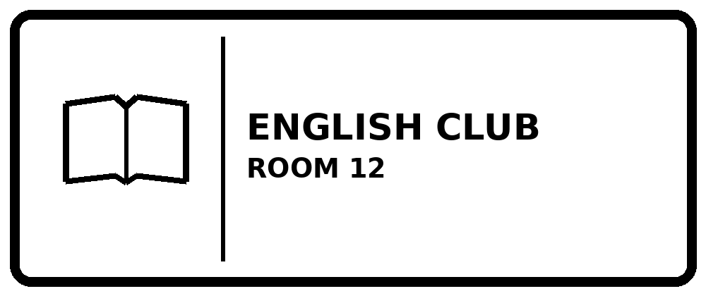 | 15. What does the sign mean?
  A. The English Club is in Room 21. | B. There is no English Club.
  C. The Maths Club is in Room 12. | D. The English Club is in Room 12.
PART B · INTERMEDIATE
Read the place, time and simple rules | Questions 16–35
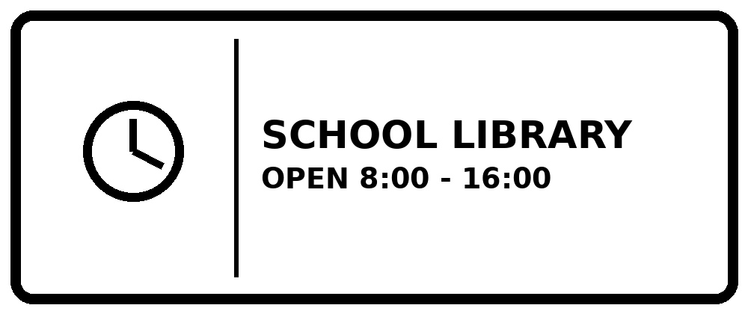 | 16. Which statement is correct?
  A. You can go there at 7 a.m. | B. It opens at 5 p.m.
  C. You can go to the library at 3 p.m. | D. It closes at 8 a.m.
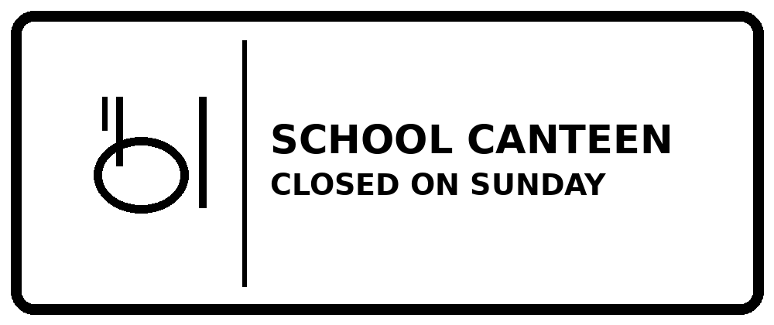 | 17. Which statement is correct?
  A. The canteen opens every Sunday. | B. The canteen is not open on Sunday.
  C. The canteen closes on Monday only. | D. You must eat there on Sunday.
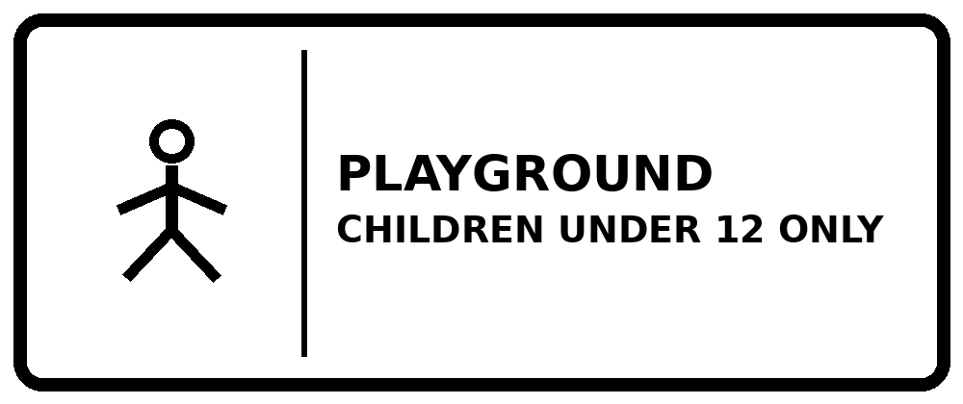 | 18. Who can use this playground?
  A. An 11-year-old child can play here. | B. A 13-year-old child can play here.
  C. Only teachers can play here. | D. Children under 12 cannot enter.
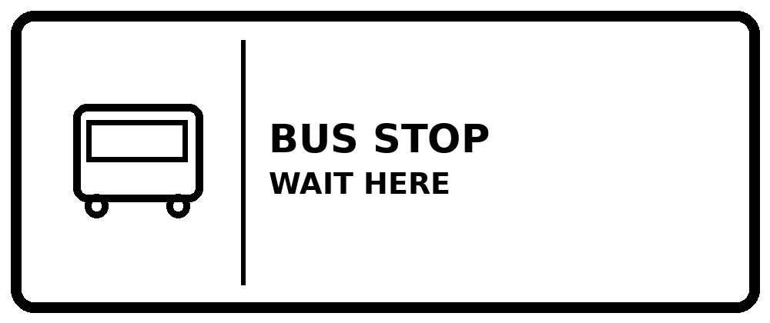 | 19. What should you do?
  A. You should park your bike here. | B. You must run after the bus.
  C. You should wait in the library. | D. You should wait here for the bus.
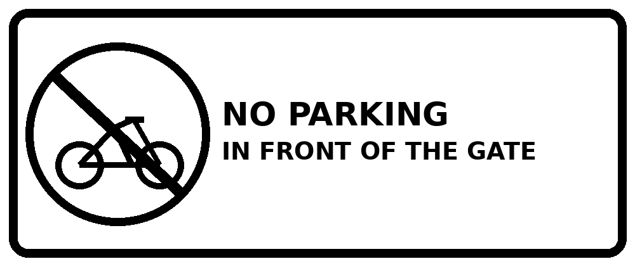 | 20. What does the sign mean?
  A. You can leave your bike by the gate. | B. You must wash your bike at the gate.
  C. You must not park in front of the gate. | D. You can park a car in front of the gate.
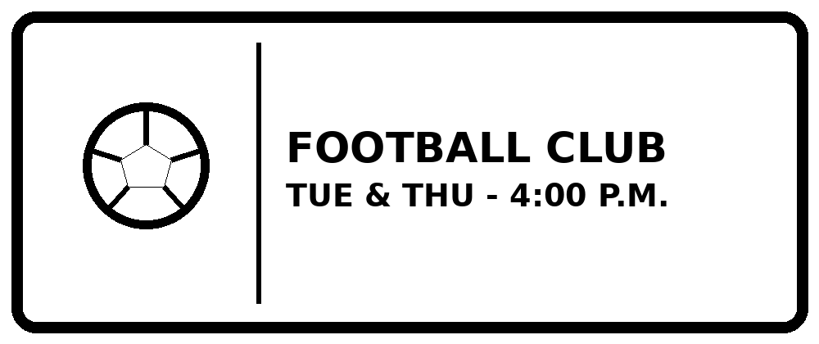 | 21. When does the club meet?
  A. The club meets every morning. | B. The club meets twice a week at 4 p.m.
  C. The club meets on Monday only. | D. The club starts at 4 a.m.
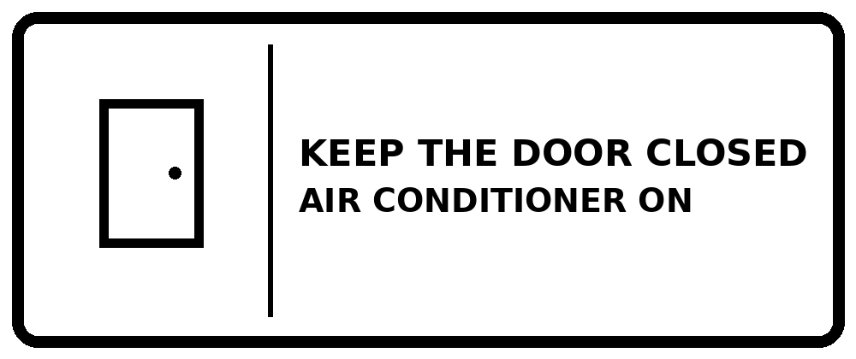 | 22. What does the sign mean?
  A. Keep the door closed when the air conditioner is on. | B. Open the door when the air conditioner is on.
  C. Switch off all the lights. | D. Open the window and the door.
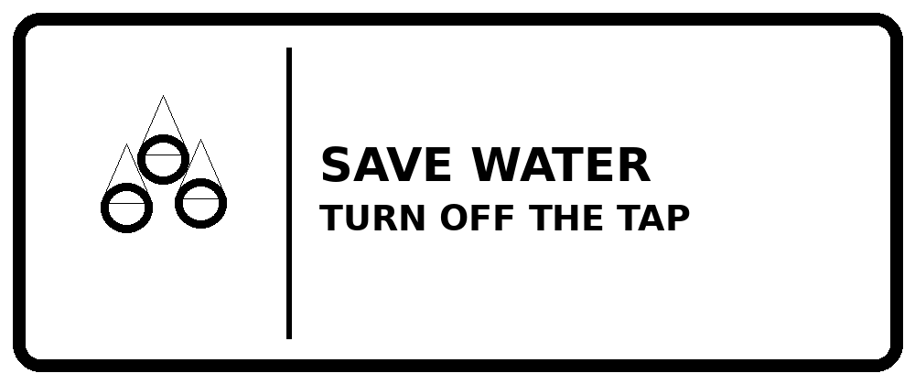 | 23. What should you do?
  A. Leave the tap on all day. | B. Use more water than you need.
  C. Wash your shoes in class. | D. Turn off the tap when you finish.
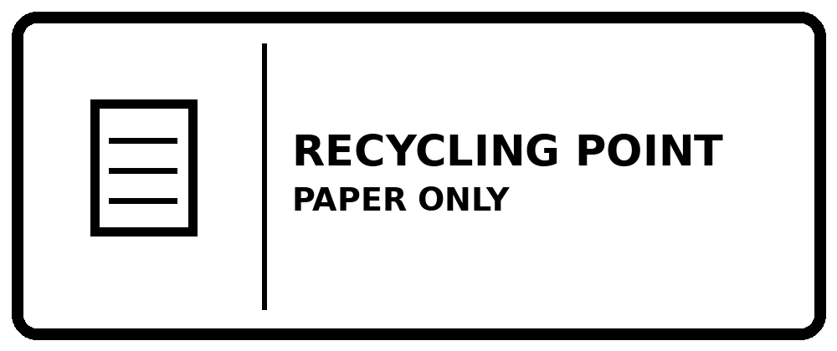 | 24. What can you put here?
  A. You can put plastic bottles here. | B. You can leave food here.
  C. You can put used paper here. | D. You can put old shoes here.
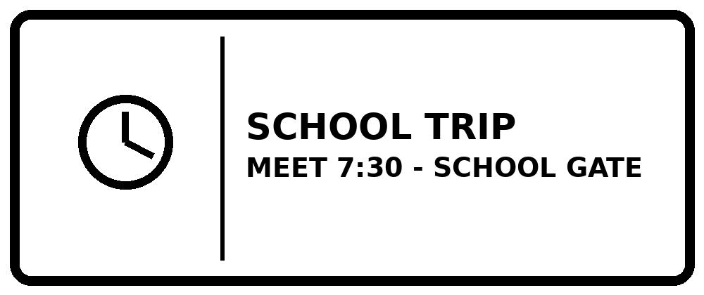 | 25. Where and when should you meet?
  A. Meet in the classroom at 7:30. | B. Meet at the school gate at 7:30.
  C. Meet at the school gate at 8:30. | D. Stay at home until 7:30.
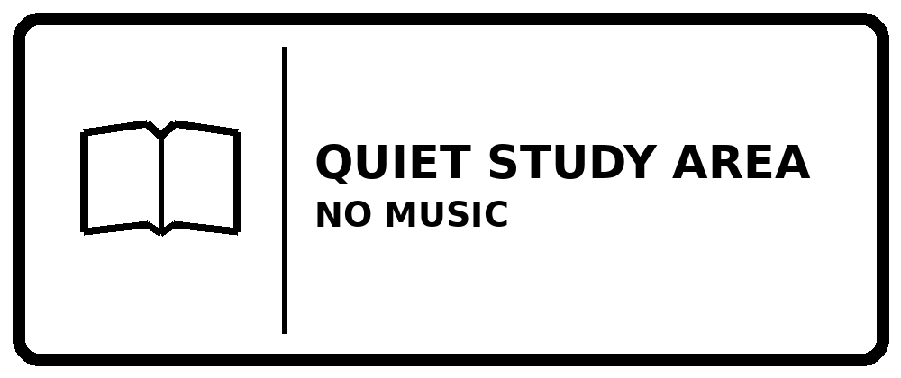 | 26. What does the sign mean?
  A. Students can study here without loud music. | B. Students can play music loudly.
  C. Students should have a party here. | D. Students must practise singing here.
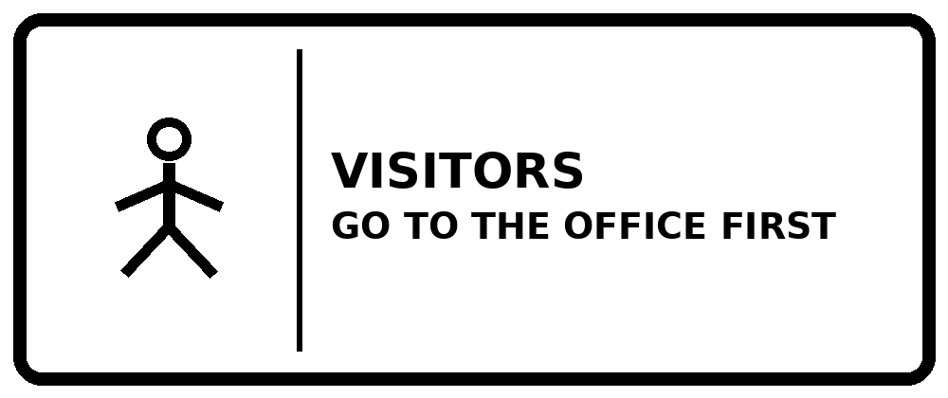 | 27. What does the sign mean?
  A. Visitors can go straight to any classroom. | B. Visitors must leave their bags at home.
  C. Only visitors can use the playground. | D. Visitors must go to the office before entering.
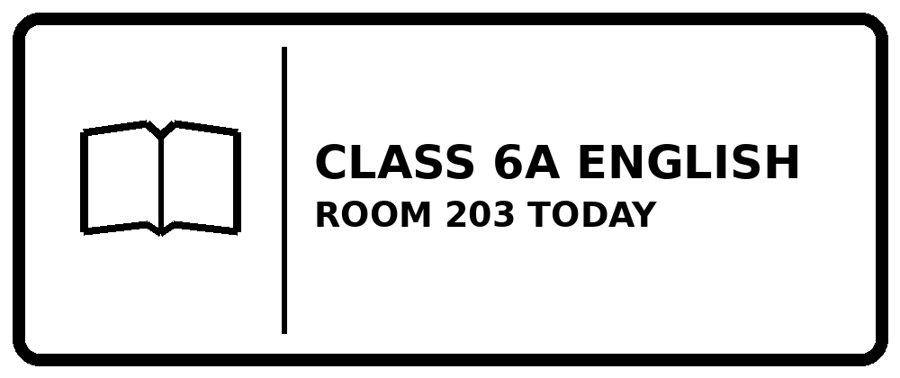 | 28. Which statement is correct?
  A. Class 6A has Maths in Room 203. | B. English is in Room 302 today.
  C. Class 6A has English in Room 203 today. | D. Class 6A has no English lesson today.
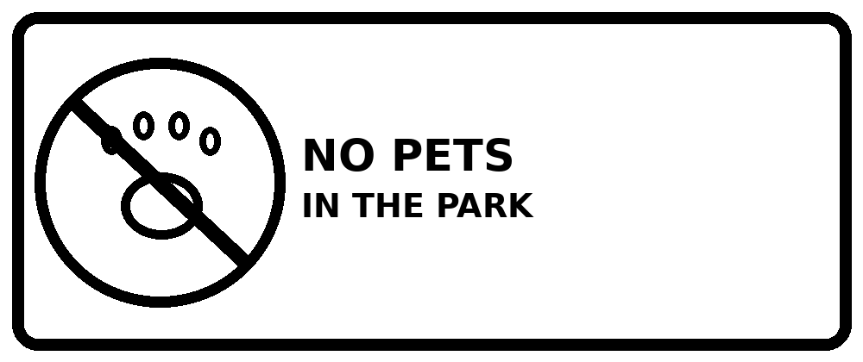 | 29. What does the sign mean?
  A. You can bring your dog into the park. | B. You must leave your pet at home.
  C. You must feed your dog in the park. | D. Only big dogs can enter the park.
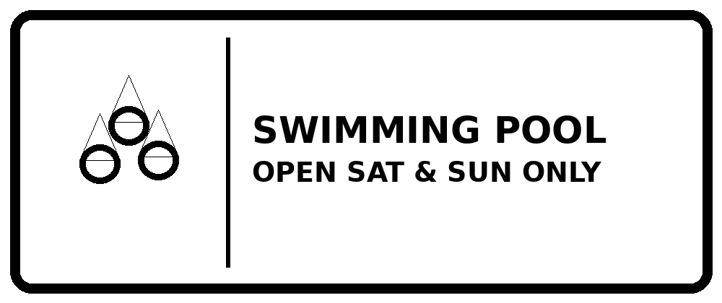 | 30. When is the pool closed?
  A. The pool is closed from Monday to Friday. | B. The pool opens on Tuesday.
  C. The pool is closed every Sunday. | D. The pool is open every day.
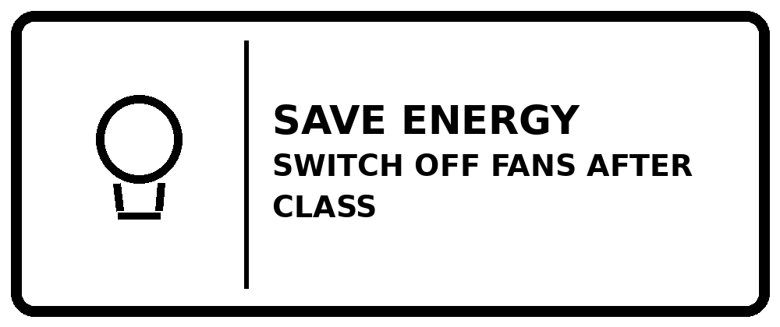 | 31. What should students do?
  A. Keep all fans on after class. | B. Turn off the fans before every lesson starts.
  C. Take the fans home after class. | D. Turn off the fans when the lesson finishes.
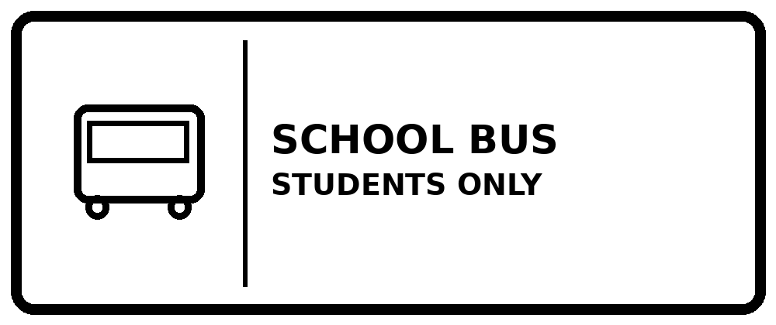 | 32. Who can take this bus?
  A. Anyone can travel on this bus. | B. Only teachers can travel on this bus.
  C. Only students can travel on this bus. | D. Students must walk instead of taking the bus.
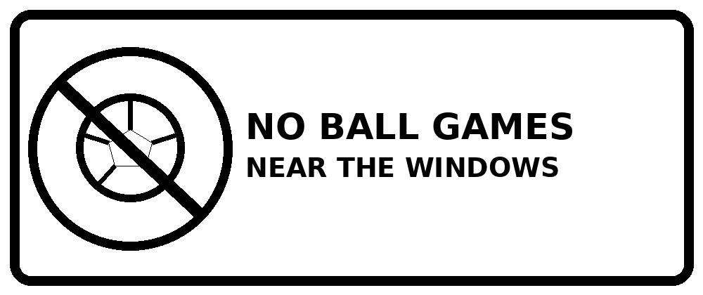 | 33. What does the sign mean?
  A. Play football next to the windows. | B. Play ball games away from the windows.
  C. You must open the windows to play. | D. You can break the windows when you play.
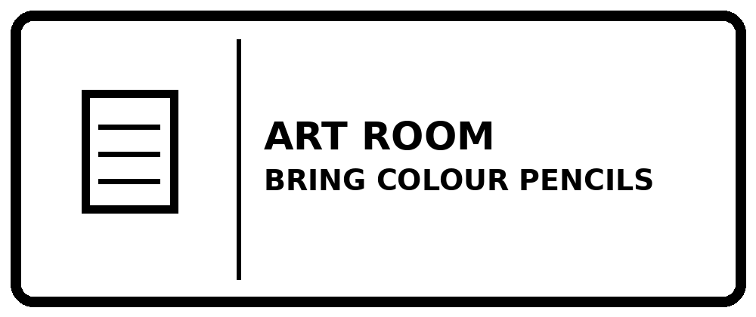 | 34. What should students bring?
  A. Students should bring colour pencils. | B. Students should bring a football.
  C. Students must leave pencils at home. | D. Students should bring swimming clothes.
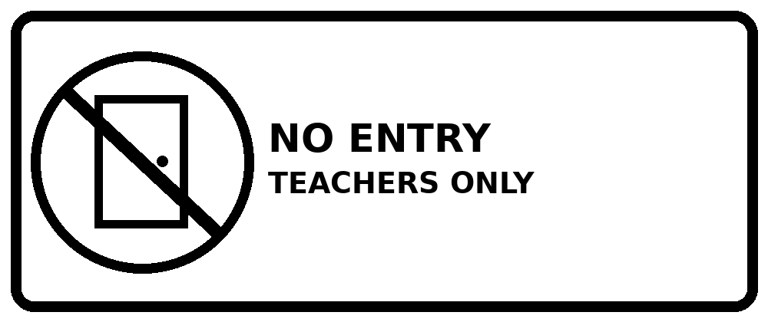 | 35. What does the sign mean?
  A. Students can come into this room. | B. This room is for students only.
  C. Teachers cannot enter this room. | D. Students must not enter this room.
PART C · CHALLENGING
Combine two pieces of information | Questions 36–50
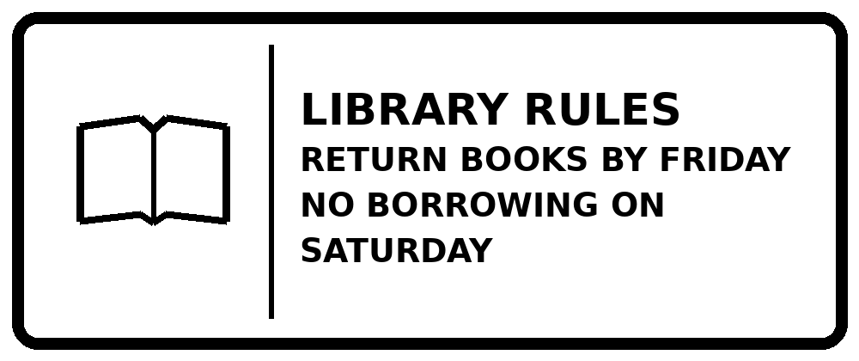 | 36. Which action follows the rules?
  A. Borrow more books on Saturday. | B. Return your books next Monday.
  C. Return your books by Friday. | D. Visit the library to borrow books on Saturday.
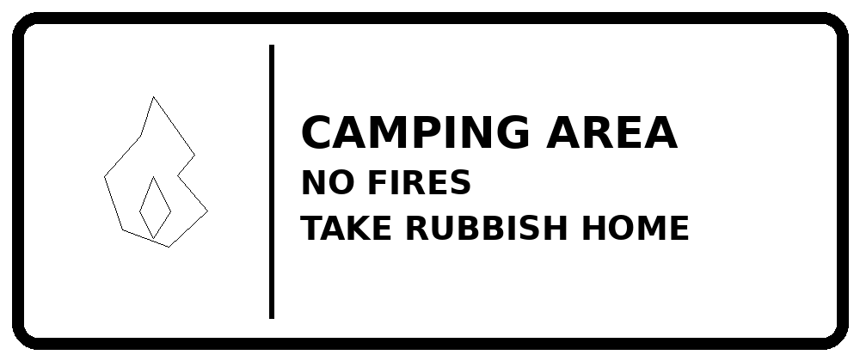 | 37. What must campers do?
  A. Make a fire and leave your rubbish. | B. Do not make a fire and take your rubbish home.
  C. Make a small fire near your tent. | D. Leave rubbish at the camping area.
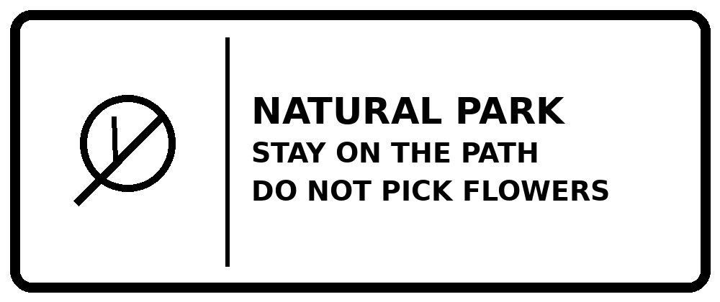 | 38. Which action is allowed?
  A. Walk on the path and leave the flowers alone. | B. Pick flowers and walk on the grass.
  C. Leave the path to take photos of flowers. | D. Take some flowers home.
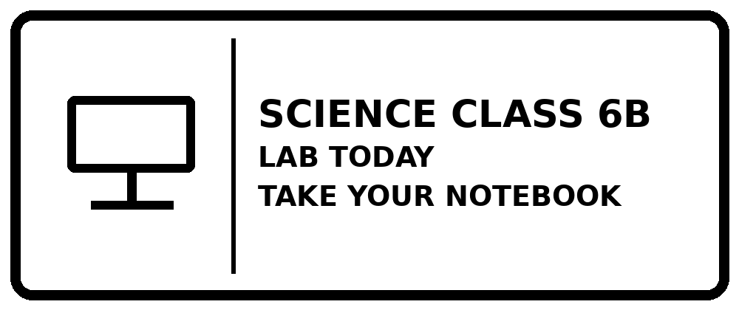 | 39. What should students do?
  A. Stay in the classroom all day. | B. Play football in the science lab.
  C. Go to the lab without your notebook. | D. Go to the lab with your notebook.
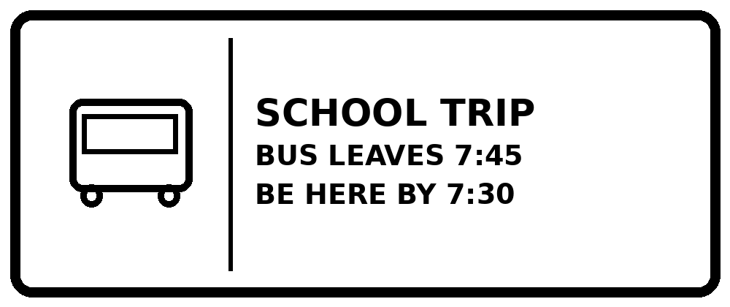 | 40. Which statement is correct?
  A. You can arrive at 8:00. | B. The bus leaves at 7:30.
  C. You should arrive at or before 7:30. | D. You must arrive at 7:50.
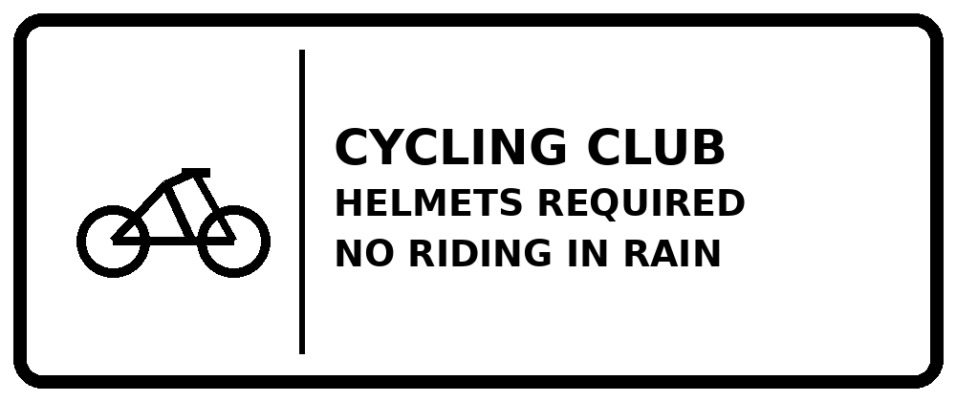 | 41. It is raining. What should you do?
  A. Ride in the rain if you have a helmet. | B. Do not ride if it is raining.
  C. Ride without a helmet on sunny days. | D. You must cycle in the rain.
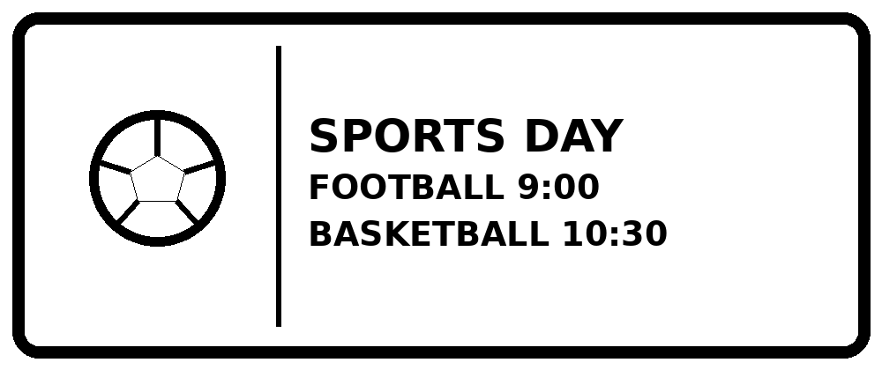 | 42. You want to watch both games. What should you do?
  A. Come by 9:00 if you want to watch both games. | B. Come at 11:00 to watch both games.
  C. Football begins after basketball. | D. Both games begin at 10:30.
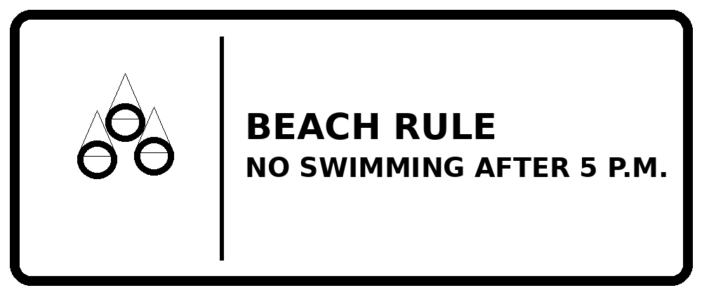 | 43. Which statement is correct?
  A. You may swim at 5:30 p.m. | B. You can swim at 6 p.m.
  C. Swimming is not allowed all day. | D. You may swim at 4:30 p.m.
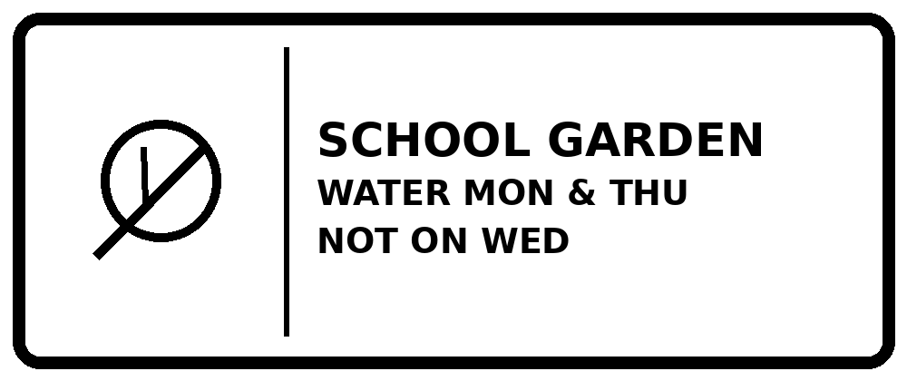 | 44. Today is Wednesday. What should you do?
  A. Water the plants every Wednesday. | B. Water the plants only on Saturday.
  C. Do not water the plants on Wednesday. | D. Water the plants at school on Tuesday only.
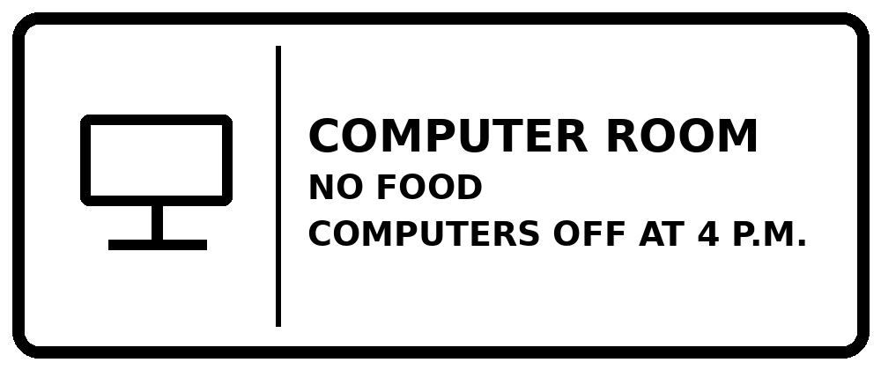 | 45. Which action follows both rules?
  A. Eat snacks at your computer at 3:30. | B. Use a computer at 3:30 without eating.
  C. Use the computers at 5:00. | D. Eat lunch here after 4:00.
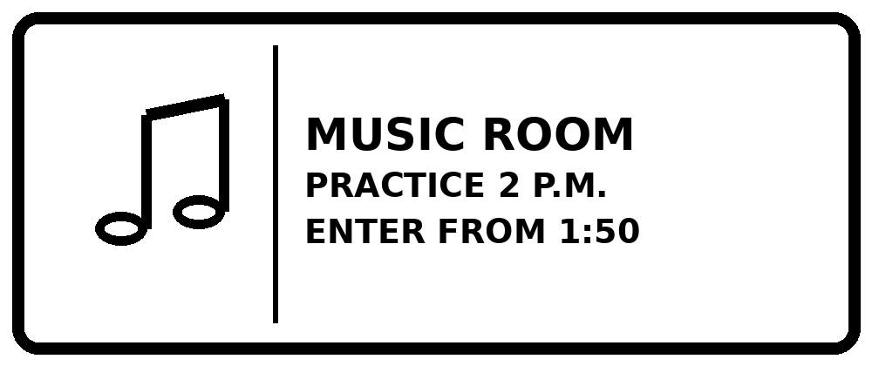 | 46. Which statement is correct?
  A. You may enter at 1:50 for the 2:00 practice. | B. You must enter at 1:30.
  C. Practice starts at 1:50. | D. You cannot enter at 2:00.
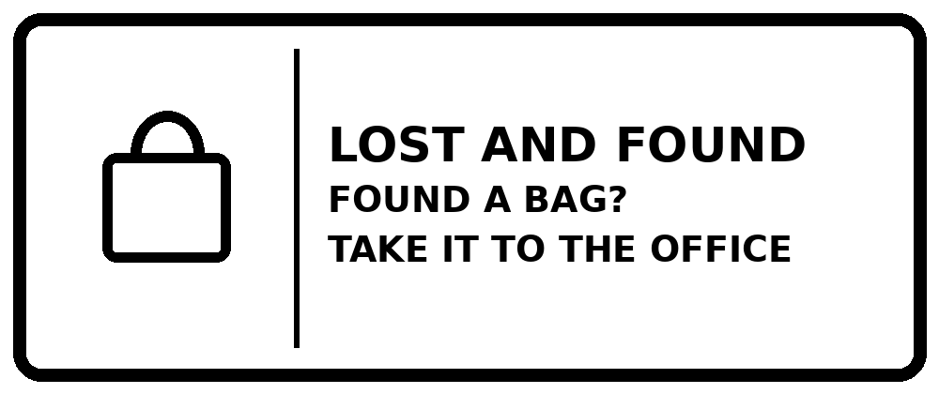 | 47. You find a school bag. What should you do?
  A. Keep the bag for yourself. | B. Put the bag in the rubbish bin.
  C. Take the bag home. | D. Give the found bag to the school office.
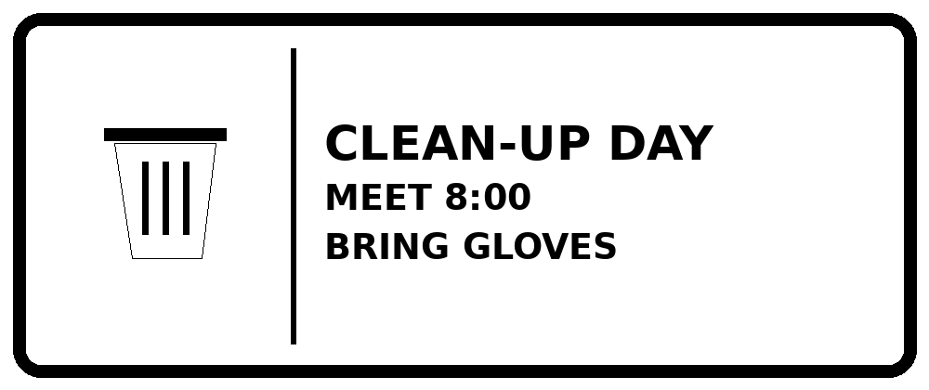 | 48. Which action is correct?
  A. Arrive at 9:00 without gloves. | B. Bring football shoes at 8:00.
  C. Arrive at 8:00 with gloves. | D. Stay at home until 8:00.
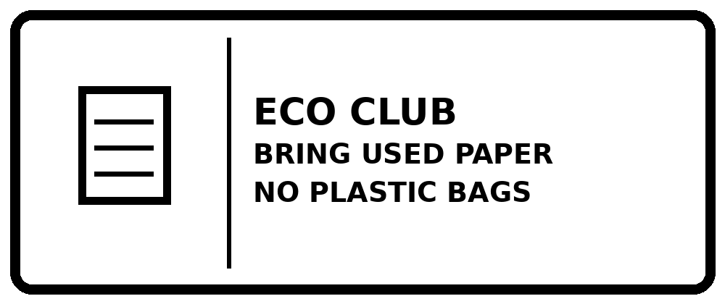 | 49. What can you bring?
  A. Bring new plastic bags without paper. | B. Bring used paper in your school bag.
  C. Bring used paper in a plastic bag. | D. Bring only plastic bottles.
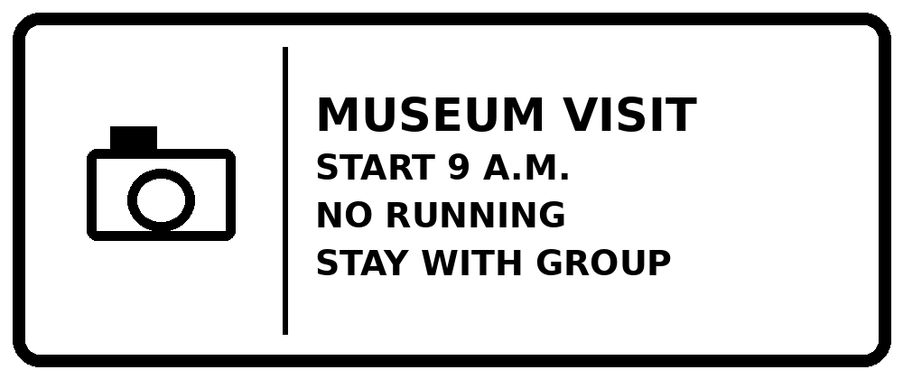 | 50. What should you do during the visit?
  A. Stay with your group and walk. | B. Run around and leave the group.
  C. Run in the museum alone. | D. Leave your group to play outside.

