PROIECT PS-StackOverflow
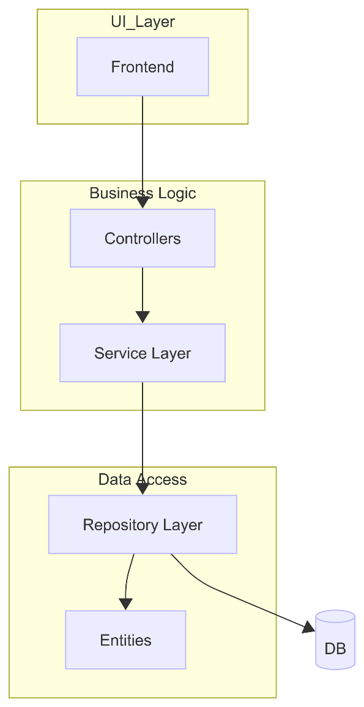
ARCHITECTURE:

The application follows N-Layer architecture:
- Entity Layer – represents the structure of objects that are mapped in the database
- Repository Layer – interacts with the database using CRUD
- Service Layer – contains business logic
- Controller Layer – handles HTTP requests and responses

TECH STACK:
- Java/SpringBoot (Backend)
- React (Frontend)
- MySQL (DB)

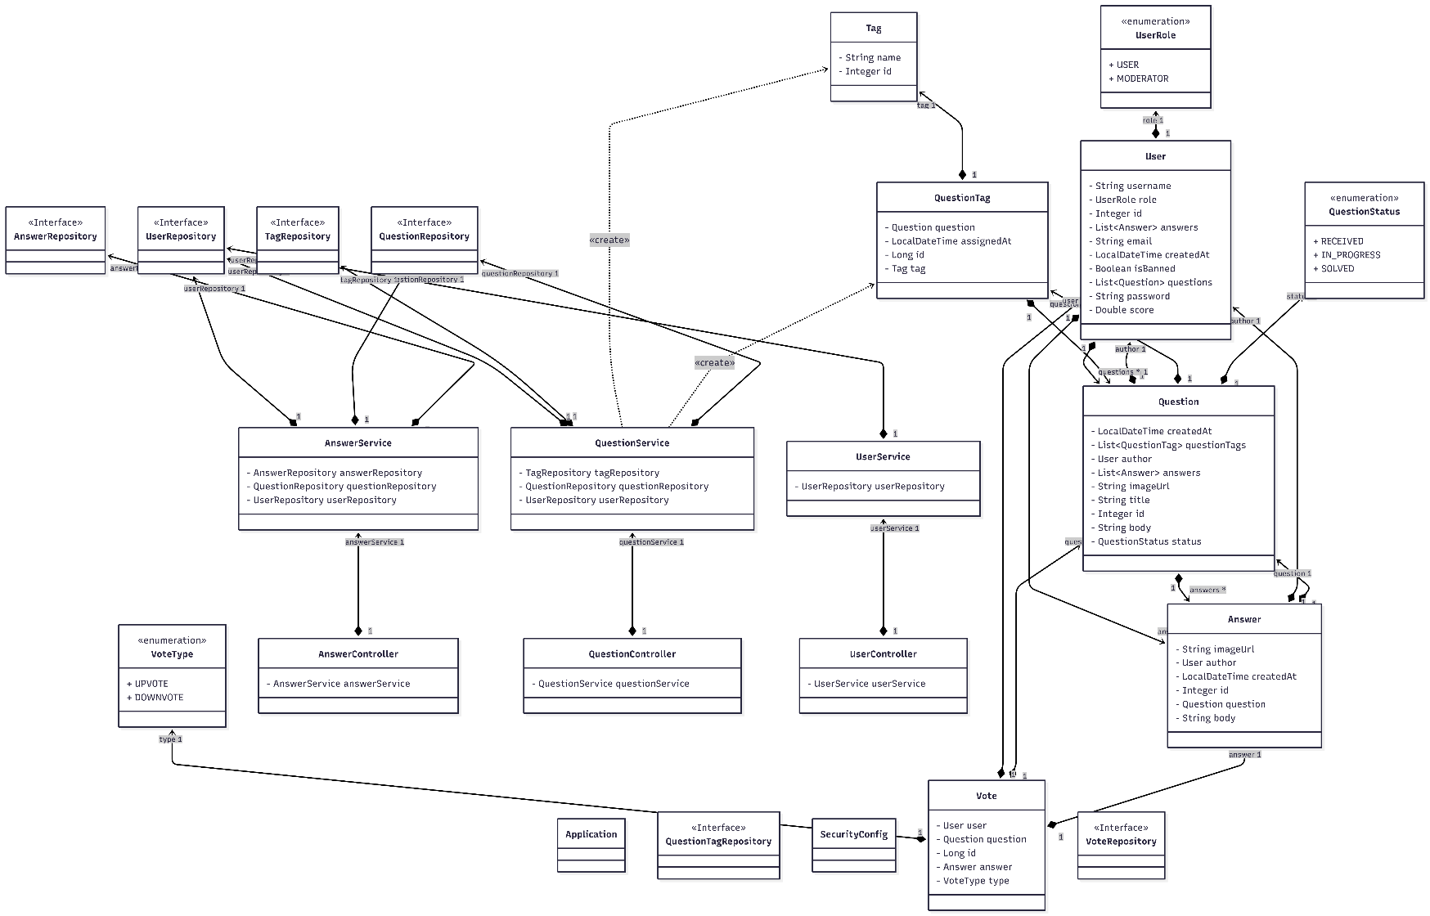
Class diagram:

