LABORATORY WORK NO. 5

Network Layer – IPv4 Routing and DHCP

1. Objectives

At the end of the lab, students will be able: to explain the routing process, to describe the operation of the DHCPv4 protocol, and to implement basic IPv4 network configurations.

2. Theoretical considerations

2.1 Routing

IP packets are created at the source host and are directed to the destination. Forwarding IP packets to the destination is based on the routing process. This is a distributed process: each node, which is forwarding packets based on the IP address, will choose the next node according to its own routing table. Forwarding IP packets is a hop-by-hop process, each node forwarding the packet to the next node.

Hosts and routers forward packets based on the destination IP address. Switches and access points are layer 2 devices and do not forward packets based on the destination IP address.

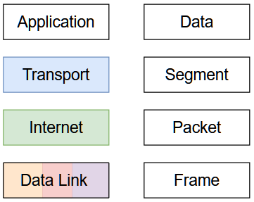

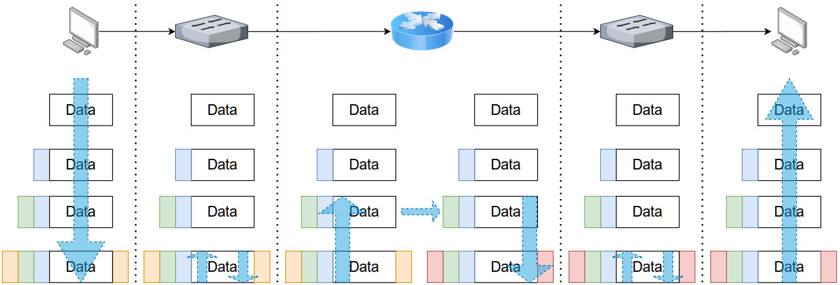

The host or the router examines the destination IP address of the packet and searches its routing table to determine where to forward the packet. The routing table contains a list of all known network addresses (prefixes) and where to forward the packets belonging to the corresponding networks. These entries are known as route entries or routes. The host or the router will forward the packet using the best (longest) matching route entry. The hosts and most routers also include a default route entry, 0.0.0.0/0. The default route is used when there is no better (longer) match in the IP routing table.

To identify the network address of an IPv4 host, the IPv4 address is logically ANDed, bit by bit, with the subnet mask. ANDing between the address and the subnet mask yields the network address. Exercise: find the network address for the host configured with 192.168.50.106 IPv4 address and 255.255.255.0 subnet mask.

IPv4 host  address |  | 192 | . | 168 | . | 50 | . | 106
 |  | 11000000 |  | 10101000 |  | 00110010 |  | 01101010
 | AND
Subnet  Mask |  | 255 | . | 255 | . | 255 | . | 0
 |  | 11111111 |  | 11111111 |  | 11111111 |  | 00000000
IPv4 network  address | Equals | 192 | . | 168 | . | 50 | . | 0
 |  | 11000000 |  | 10101000 |  | 00110010 |  | 00000000

A host can send a packet to:
- Itself – to the loopback interface, 127.0.0.1 IPv4 address or ::1 IPv6 address;
- Local host - the destination host is on the same local network as the sending host, the source and destination hosts share the same network address;
- Remote host - the destination host is on a remote network, the source and destination hosts do not share the same network address.

The default gateway is the network device that can route traffic to other networks. It has a local IP address in the same address range as other hosts on the local network, accepts data into the local network, forwards data out of the local network and routes traffic to other networks.

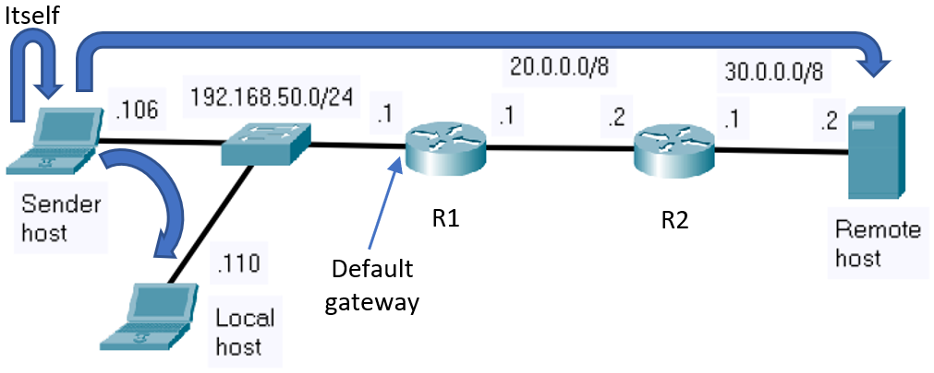

When a host is configured with IPv4 address, subnet mask and default gateway, it updates its routing table accordingly.

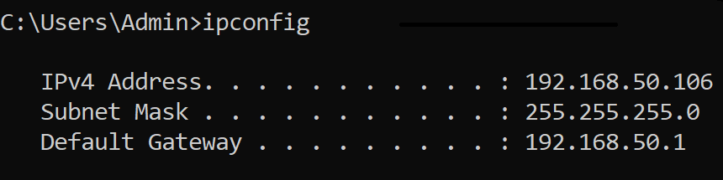

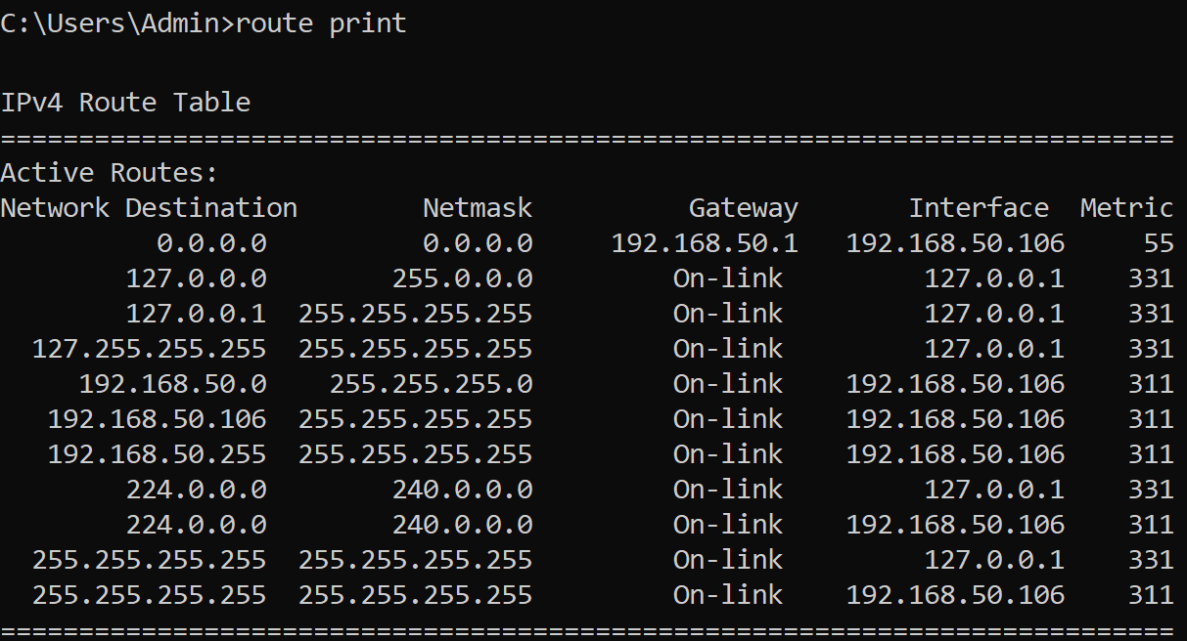

If a host is sending a packet to a device that is configured with the same IP network as the host device, the packet is forwarded out of the host interface, through the intermediary device, and to the destination device directly. Consider the network below, the packet is transmitted from 192.168.50.106 to 192.168.50.110. The best (longest) matching route entry in this case is marked with red.

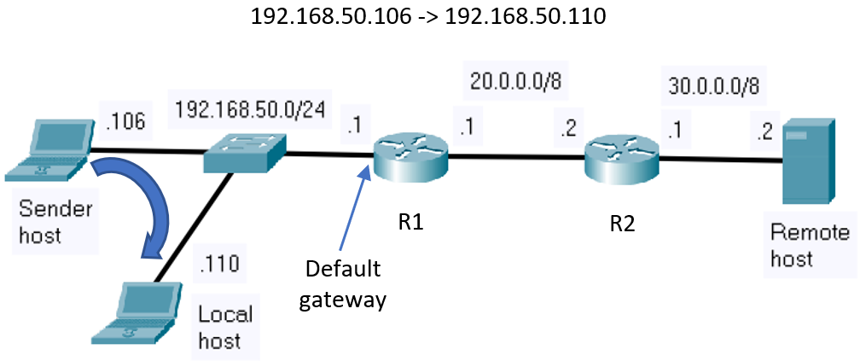

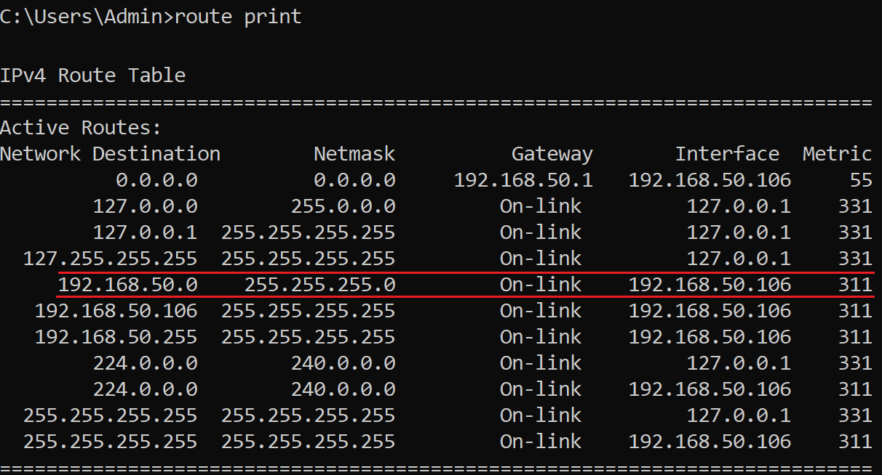

If a host is sending a packet to a remote host, the packet is forwarded out of the host interface, through the intermediary device, and to the gateway. Consider the network below, the packet is transmitted from 192.168.50.106 to 30.0.0.2. The best (longest) matching route entry in this case is the default route, marked with red.

When the packet arrives on the interface of a router, the router de-encapsulates the Layer 2 header and trailer. Then, it examines the destination IPv4 address of the packet and searches for the best match in its IPv4 routing table. When the best match in the routing table is found, the router forwards the packet according to the information in the route entry, encapsulating it in the new Layer 2 header and trailer. In our example, the best (longest) matching route entry is a static route, marked with red.

And the hop-by-hop forwarding process continues until the packet reaches the destination.

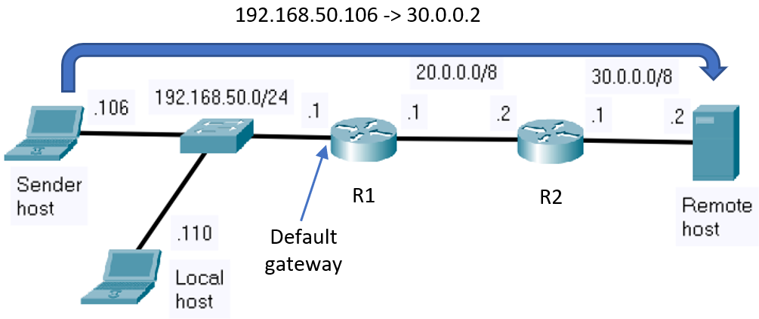

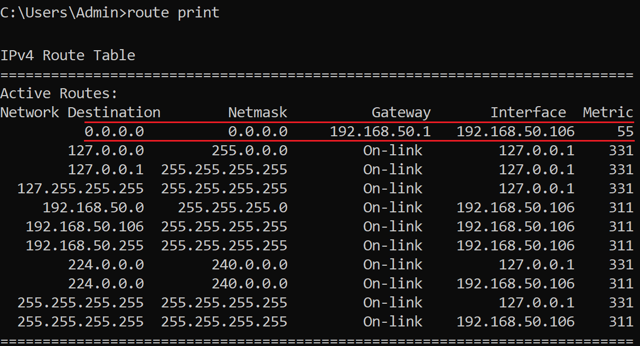

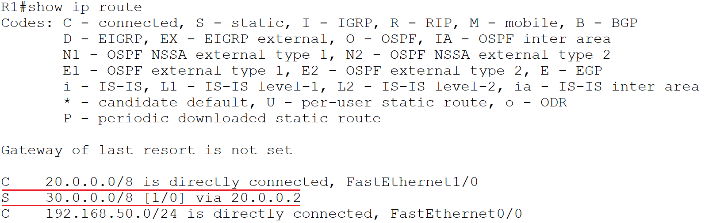

When a router is configured with an IPv4 address and a subnet mask, it updates its routing table accordingly. Additionally, a router can learn about remote networks in one of two ways: manually and dynamically. In the first case, the remote networks are manually entered into the routing table using static routes. In the second case, remote networks are automatically learned using a dynamic routing protocol.

In the previous example, R1 router was manually configured with a static route to reach the remote network address, 30.0.0.0/8, through (via) the IP address of the next hop router, 20.0.0.2.

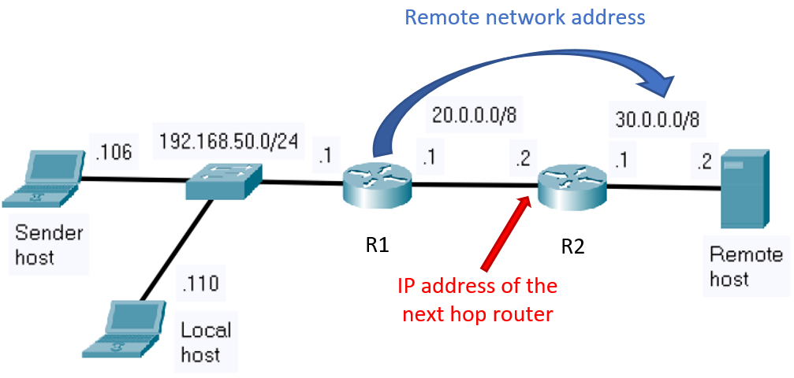

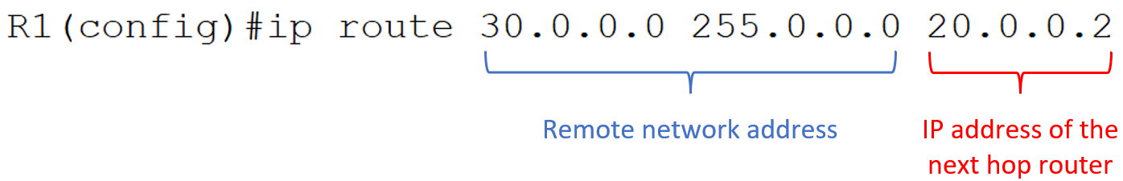

2.2 Dynamic Host Configuration Protocol v4

Dynamic Host Configuration Protocol v4 (DHCPv4) assigns network configuration information dynamically. The IPv4 address is assigned, or leased, for a limited period of time. When the lease expires, the client must ask for another address. Usually, the server reassigns the same address to the client.

The DHCPv4 service can run on various devices such as a dedicated server or a router. The DHCP process starts when the client joins a network. The client sends a DHCPDISCOVER broadcast message to find the DHCPv4 server. The DHCPv4 server reserves an available IPv4 address to lease to the client and sends the binding DHCPOFFER message to the client. The client sends a DHCPREQUEST broadcast message as a binding acceptance notice. The server replies with a DHCPACK message.

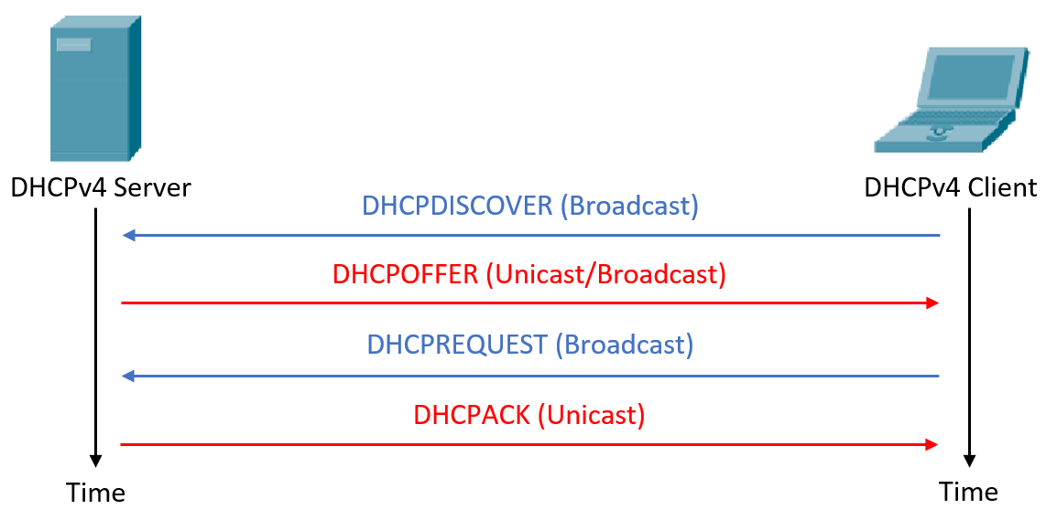

The previous sequence of operations can also be observed in Wireshark when using the ipconfig /release and ipconfig /renew (on Windows OS) and dhclient (on Linux OS) commands:

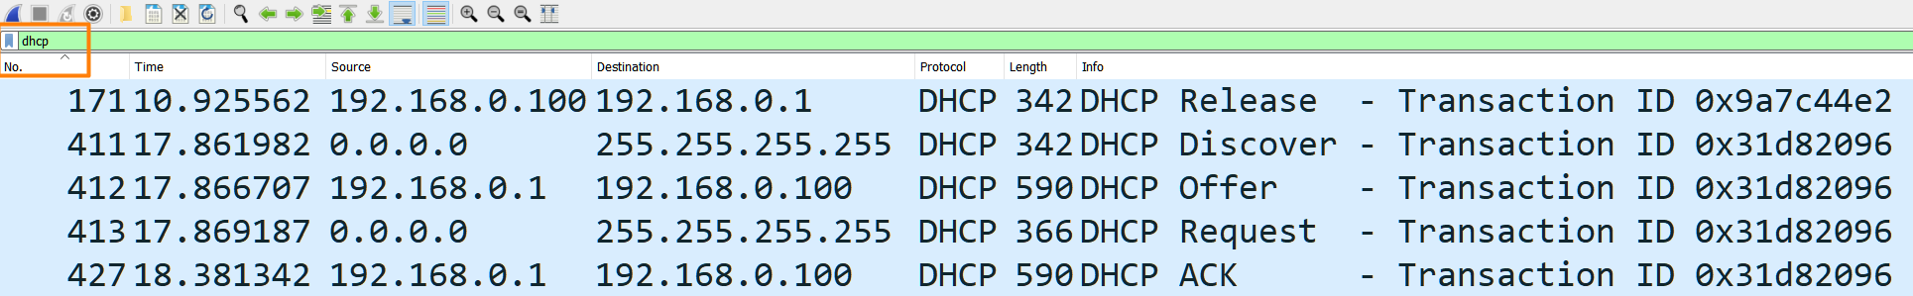

3. Lab activity

3.1 Discuss the theoretical aspects.

3.2 Visualize the DHCP network packets that are delivered by your local machine. For this do the following:
- Start a Wireshark capture
- Apply the “dhcp” packet filter in the Wireshark window
- Open a command prompt (terminal)
- Run the following commands: ipconfig /release and ipconfig /renew (on Windows OS) and dhclient (on Linux OS)
- Inspect the Wireshark capture which shows the DHCP sequence of operations
- In the Wireshark capture identify the broadcast address in the Layer 2 encapsulation (Ethernet encapsulation)

3.3 Consider the network topology below:

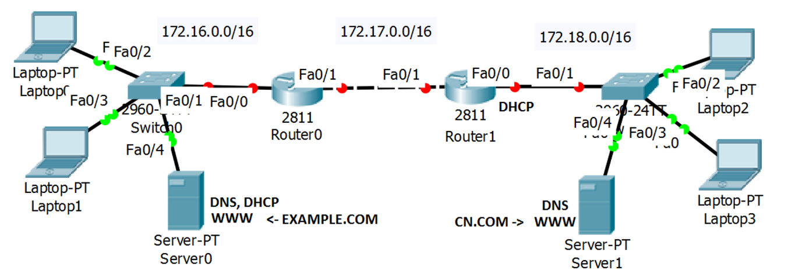

Step 1: Before configuring the network devices, assign a unique IP address and the corresponding subnet mask to each network interface:

Device | Interface | IP Address | Subnet mask | Default gateway
Laptop0 | Fa | ___ . ___ . ___ . ___ | ___ . ___ . ___ . ___ | ___ . ___ . ___ . ___
Laptop1 | Fa | ___ . ___ . ___ . ___ | ___ . ___ . ___ . ___ | ___ . ___ . ___ . ___
Server0 | Fa | ___ . ___ . ___ . ___ | ___ . ___ . ___ . ___ | ___ . ___ . ___ . ___
Router0 | Fa0/1 | ___ . ___ . ___ . ___ | ___ . ___ . ___ . ___ | -
Router0 | Fa0/0 | ___ . ___ . ___ . ___ | ___ . ___ . ___ . ___ | -
Router1 | Fa0/1 | ___ . ___ . ___ . ___ | ___ . ___ . ___ . ___ | -
Router1 | Fa0/0 | ___ . ___ . ___ . ___ | ___ . ___ . ___ . ___ | -
Laptop2 | Fa | assigned by DHCP | assigned by DHCP | assigned by DHCP
Laptop3 | Fa | assigned by DHCP | assigned by DHCP | assigned by DHCP
Server1 | Fa | ___ . ___ . ___ . ___ | ___ . ___ . ___ . ___ | ___ . ___ . ___ . ___

Note*: pay attention to the interface names of the router you are using, some routers may only have GigabitEthernet interfaces.

Step 2: Assign static IPv4 addresses to router interfaces

Router1>enable

Router1#configure terminal

Router1(config)#interface _________

Router1(config-if)#ip address ____________ ____________

Router1(config-if)#no shutdown

Router1(config-if)#exit

Step 3: Configure DHCP

The table below contains the configuration steps and the corresponding commands to configure the DHCP functionality on a Cisco router

No | Operation | Command | Example
1 | Exclude IP addresses | Router(config)#ip dhcp excluded-address start_address end_address | ip dhcp excluded-address 172.18.0.1 172.18.0.5
2 | Configure the pool name | Router(config)# ip dhcp pool name | ip dhcp pool TestDHCP
3 | Configure the addresses (specifying the network address and the mask to be used) | Router(dhcp-config)# network network-number [mask|prefix-length] | network 172.18.0.0 255.255.0.0
4 | Configure the Default Router (the Gateway) for the Clients | Router(dhcp-config)# default-router address | default-router 172.18.0.1
5 | Set up the IP Domain Name System Servers for the Clients | Router(dhcp-config)# dns-server address [address2 ...address5] | dns-server 8.8.8.8
6 | Visualize the DHCP pools information and DHCP address bindings | Router#show ip dhcp pool | show ip dhcp binding

Step 4: Set the static routes

Step 4.1: Identify the static route needed on each router:

Device | Destination network | Destination mask | Next hop
Router0 | ___ . ___ . ___ . ___ | ___ . ___ . ___ . ___ | ___ . ___ . ___ . ___
Router1 | ___ . ___ . ___ . ___ | ___ . ___ . ___ . ___ | ___ . ___ . ___ . ___

Step 4.2: Configure the static routes on the Cisco routers

General syntax: Router(config)#ip route netw_dest_address next_hop_address/interface

Example: Router0(config)#ip route 172.18.0.0 255.255.0.0 172.17.0.2

Note*: use your own IP addresses and mask when configuring the devices, not the one provided in this example

Visualize the routing table: Router1#show ip route

Step 5: Test the connectivity between end devices from opposite networks

a. ping <target IP>

b. tracert <target IP>

Notes

