**PostgreSQL adatbázis**

EK-diagram:

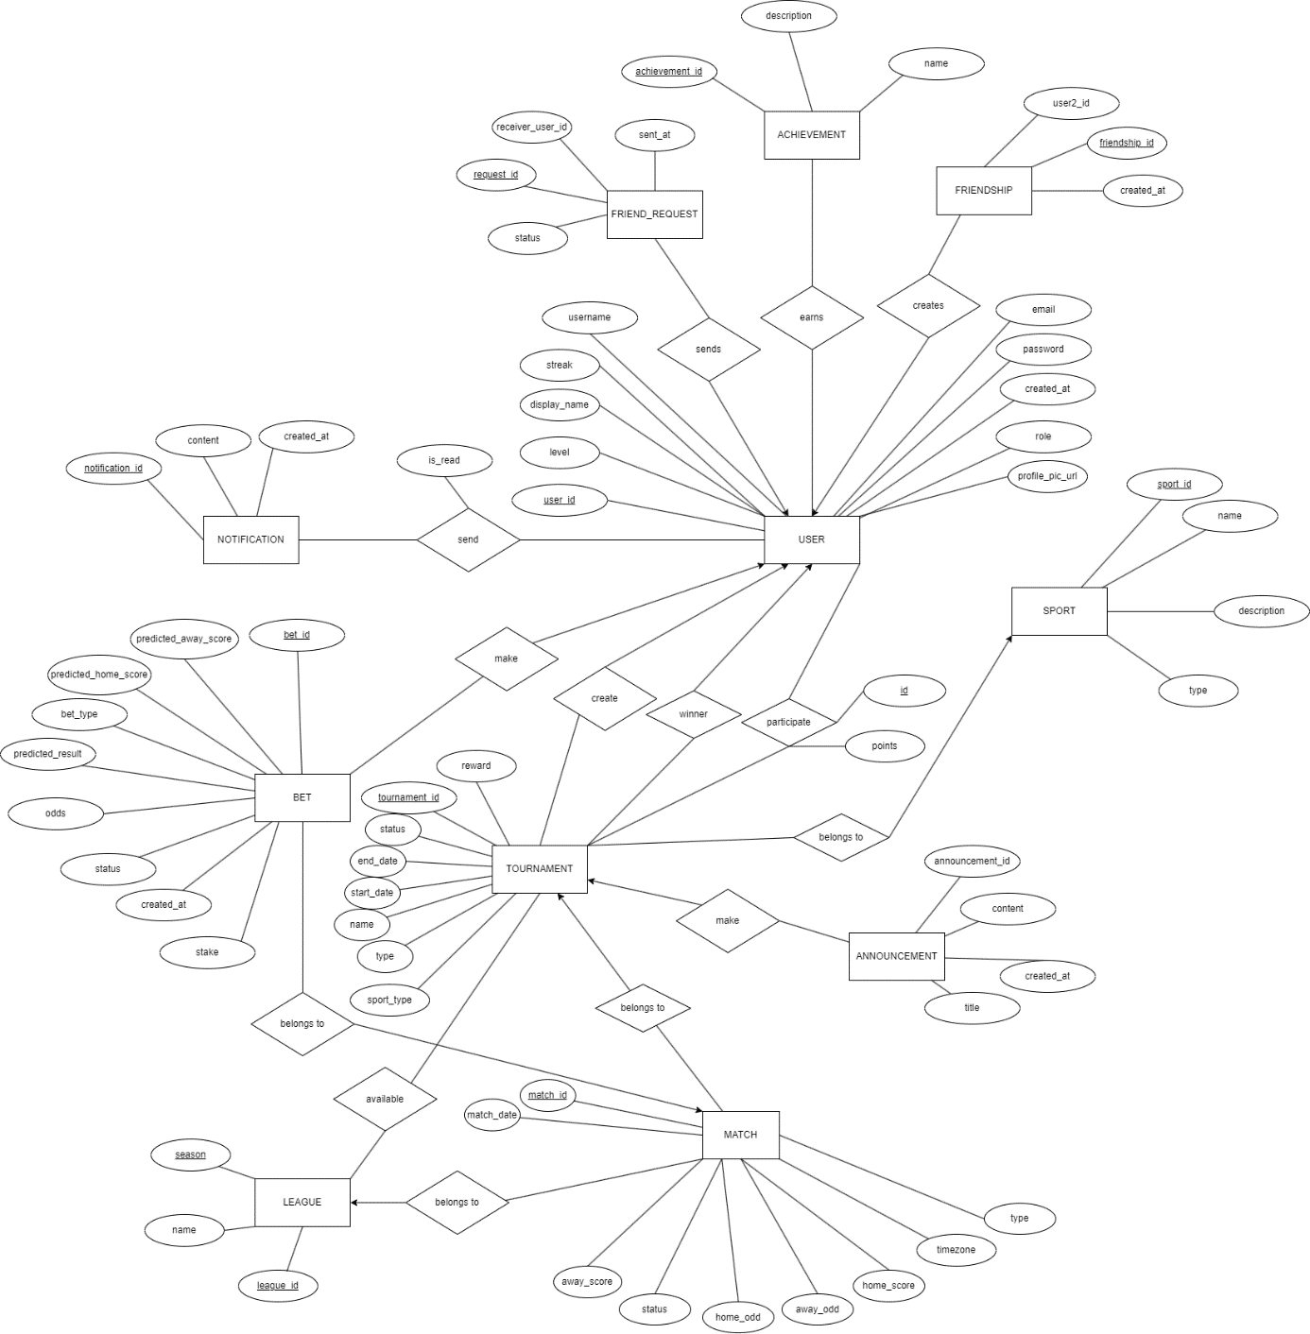

Adatbázis táblák:

1. USER

* user_id (PK)
* username
* email
* password
* role
* created_at
* profile_pic_url
* streak
* level
* display_name

2. ACHIEVEMENT

* achievement_id (PK)
* name
* description

3. REL_ACHIEVMENT_USER

* id (PK)
* achievement_id(FK)
* user_id(FK)

4. FRIEND_REQUEST

* request_id (PK)
* receiver_user_id (FK)
* sender_user_id (FK)
* status
* sent_at

5. FRIENDSHIP

* friendship_id (PK)
* user1_id (FK)
* user2_id (FK
* created_at

6. TOURNAMENT

* tournament_id (PK)
* reward
* creator_user (FK)
* name
* status
* type
* start_date
* end_date
* sport_type
* sport_id
* winner_id

7. ANNOUNCEMENT

* announcement_id (PK)
* tournament_id (FK)
* title
* created_at
* content

8. REL_USER_TOURNAMENT

* participant_id (PK)
* tournament_id (FK)
* user_id (FK)
* points

9. REL_TOURNAMENT_LEAGUE

* id (PK)
* league_id (FK)
* season(FK)
* tournament_id (FK)

10. MATCH

* match_id (PK)
* league_id (FK)
* season (FK)
* match_date
* home_score
* away_score
* home_odd
* away_odd
* status
* type (tornamenten fogadnak rá, vagy csak simán)

11. BET

* bet_id (PK)
* user_id (FK)
* match_id (FK)
* bet_type (EXACT vagy csak győztes)
* predicted_result
* predicted_home_score
* predicted_away_score
* status
* created_at
* stake
* odds (ki kell számolni, bet_type ból, amikor elmentődik)

12. SPORT

* sport_id (PK)
* name
* description
* type

13. NOTIFICATION

* notification_id (PK)
* content
* created_at

14. REL_NOTIFICATION_USER

* id (PK)
* notification_id (FK)
* user_id (FK)