**NavBar**



* Clickable logo, name and Home which take you to the Home page
* Sticky
* Height decreases on scroll down
* Search icon stretches out to input field on click
* Dropdown list appears with the categories listed in it when Shop is hovered
* Cart fades in from aside as a side navbar on click

**NavBar ~ SearchBar**

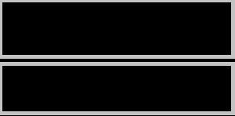

Mens Casual Premium Slim Fit T-Shirts

shirt

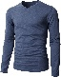

Mens Casual Slim Fit

**NavBar ~ Cart**

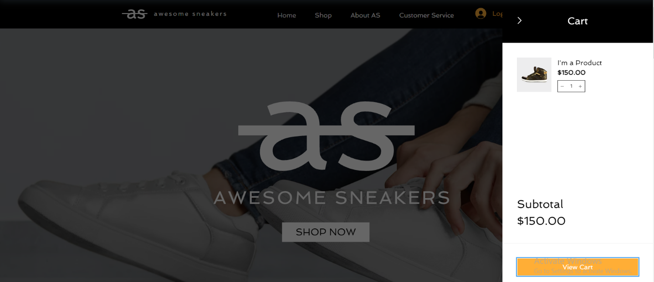

**Banner**

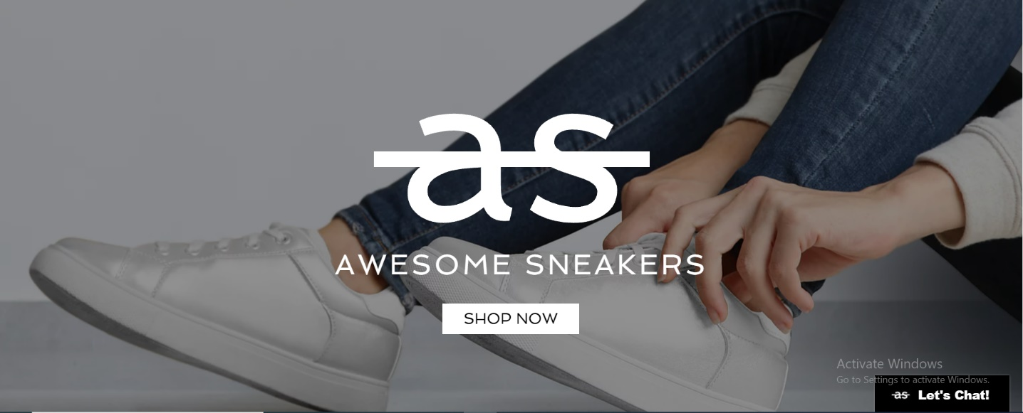

* Awesome Sneakers design
* Logo click takes you to the top
* Logo fades in when the page has finished loading
* Shop now takes you to the Categories section

**Categories**

* Images zoom in on hover
* Images float in on scroll



