TOTIMEH JAMES TETTEH

**RPA STUDIO FUNDAMENTALS**

**Introduction:**

This documentation presents my completed assignment on RPA Studio Fundamentals. The assignment focused on variables and basic concepts of Robotic Process Automation using UiPath Studio. I have provided an overview in my approach to each task below.

**Task 1: Creating and Initializing Variables**

For this task, I designed a workflow that takes a user’s name and displays the name with a greeting message. Here are the steps I followed:

* I created a new project in UiPath Studio and named it ‘*RPAAssignmentOne’*.
* I declared and initialized all the variables needed to develop this program where necessary (as shown in the picture; ***Fig 1.0*** below). But for this task, I only need to use the variable named ‘***userName’***.

***Fig 1.0***

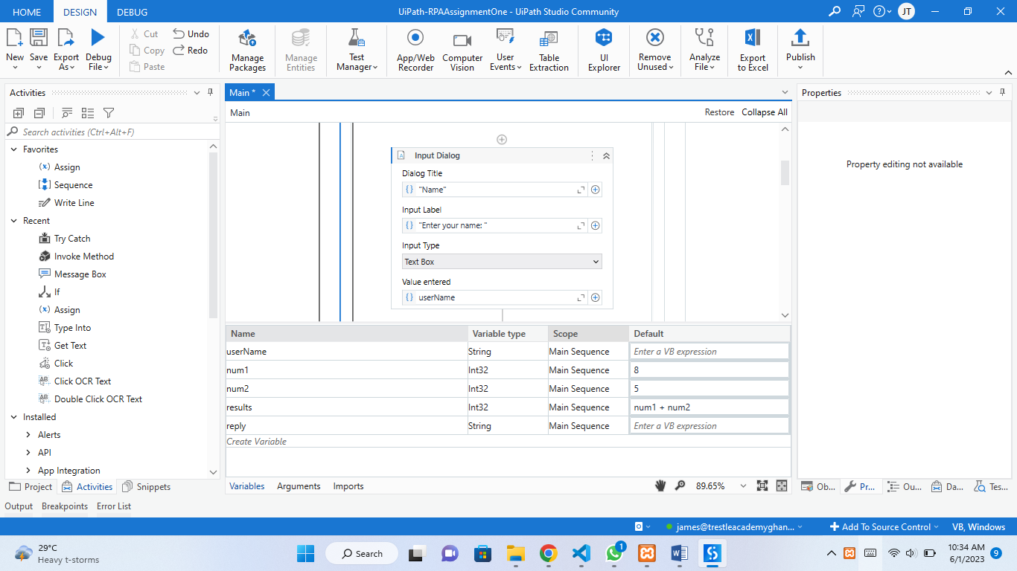

* Next, I added a ***Try Catch*** activity to the Main Sequence to be able to handle runtime errors in the program when user provides an invalid input.
* Now, my goal is to accept input from the user and display a message with the user’s name in it. So, I added the ***Input Dialog*** activity onto the ***Try Catch*** activity in order to accept user input without having runtime errors (as shown in ***Fig 1.1*** below).
* I filled in the fields; Dialog Title, Input Label with ‘String-typed’ information to guide the user on what to do next (as shown in ***Fig 1.1*** below).
* The data collected from this Input Dialog is being stored in the ***userName*** variable (as shown in ***Fig 1.1*** below).
* Finally, I added a ***Message Box*** activity to display the user’s name from the ***userName*** variable concatenated with a piece of message (as shown in ***Fig 1.1*** below).

***Fig 1.1***

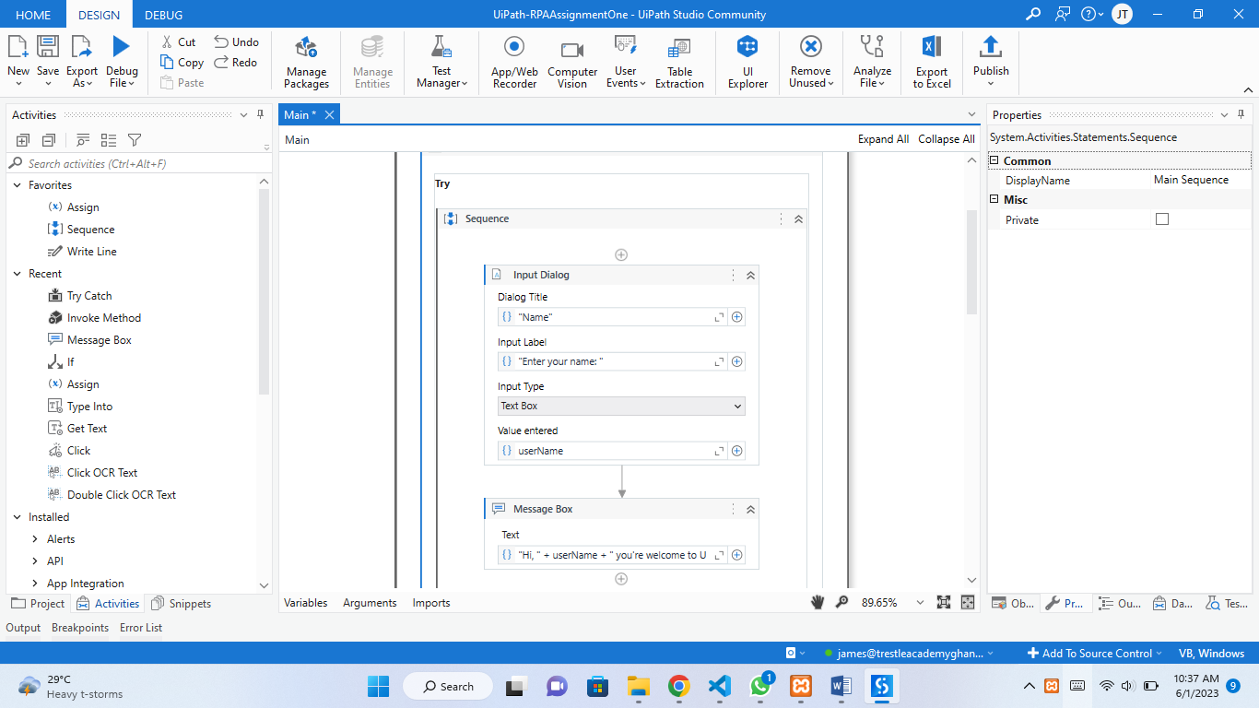

**Results for Task 1**

Stage 3

Stage 1

Stage 2

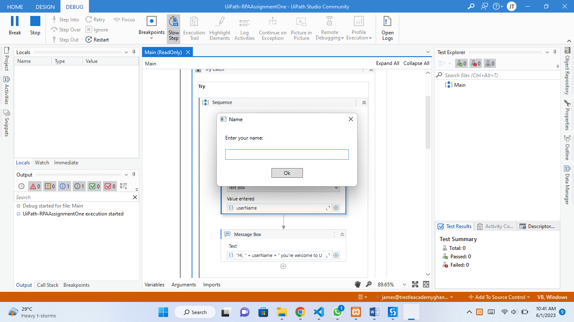 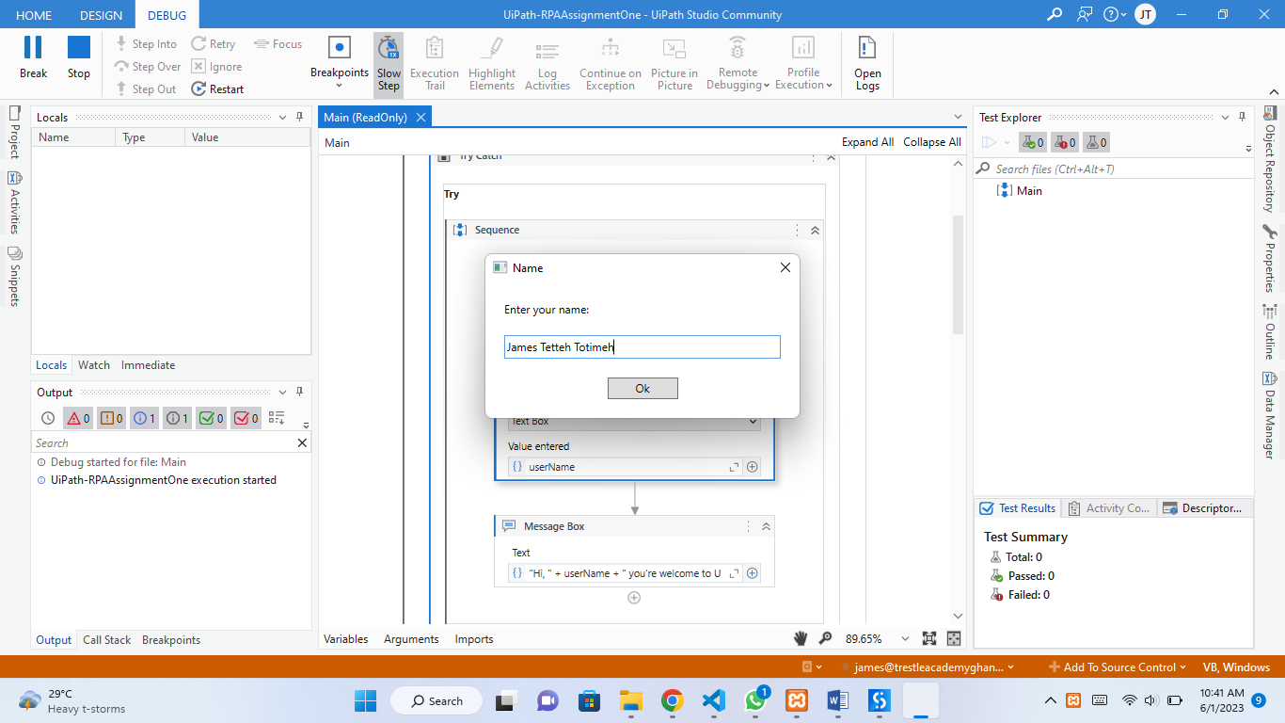 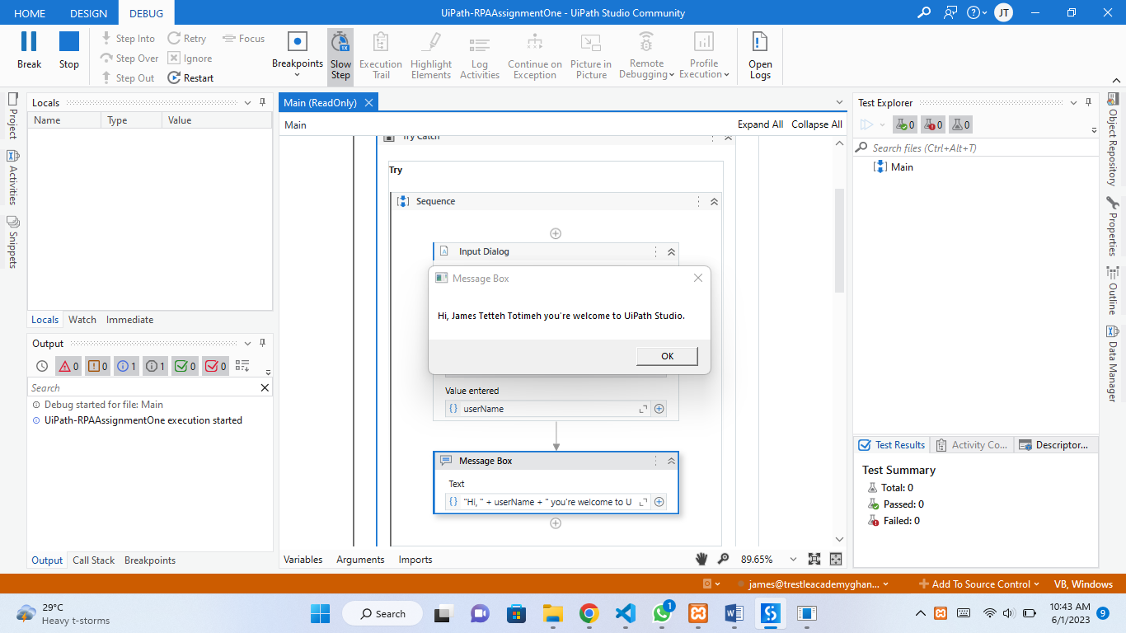

**Task 2: Utilizing Variables in Automation Logic**

For this task, I designed a workflow that adds two numbers. Here are the steps I followed:

* Since I have already defined and assigned values to all the variables needed for this program (as shown in ***Fig. 1.0*** above), there is no need for me to recreate them again.
* In ***Fig. 1. 0***, ***num1*** and ***num2*** variableshas been assigned values; **8** and **5** respectively.
* I created a variable named ***results*** and assigned itto store the sum of the values of ***num1*** and ***num2*** variables which has been written as ***num1 + num2*** as ***default*** value of the ***results*** variable (as shown in ***Fig. 1.0*** above).
* Here I had to display the value of the ***results*** variable, so I added a ***Message Box*** activity to the Main Sequence beneath the first ‘Try Catch’ activity.
* Then passed a message into the Message Box which contains text strings and variables concatenated at their respective portions of display within the text.
* In this message I type casted those integer variables to String which prevents syntax errors and also make the whole message act just like a String using ***ToString()*** (as shown in ***Fig. 2. 0*** below).

***Fig 2. 0***

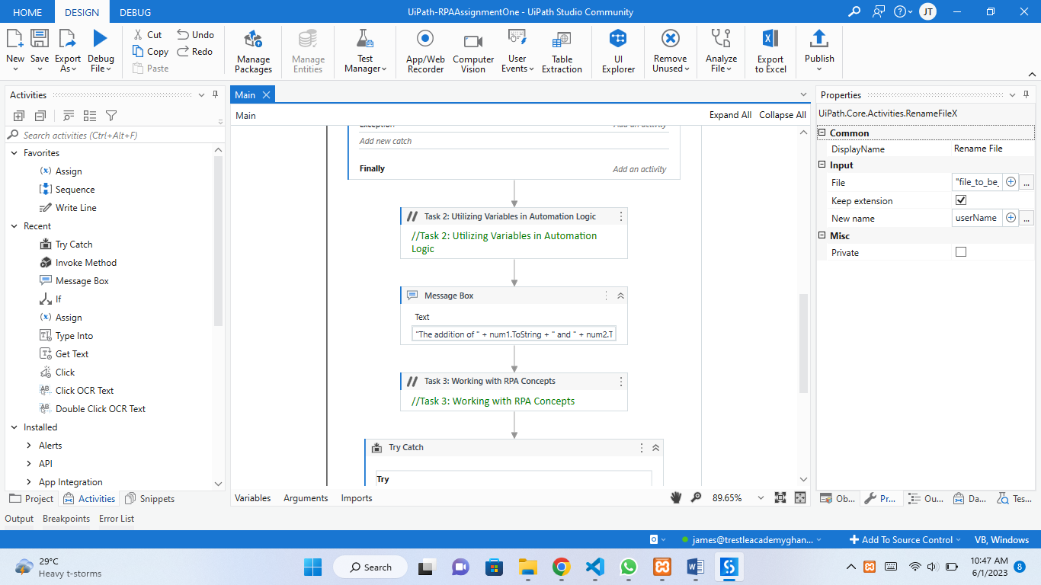

**Results for Task 2**

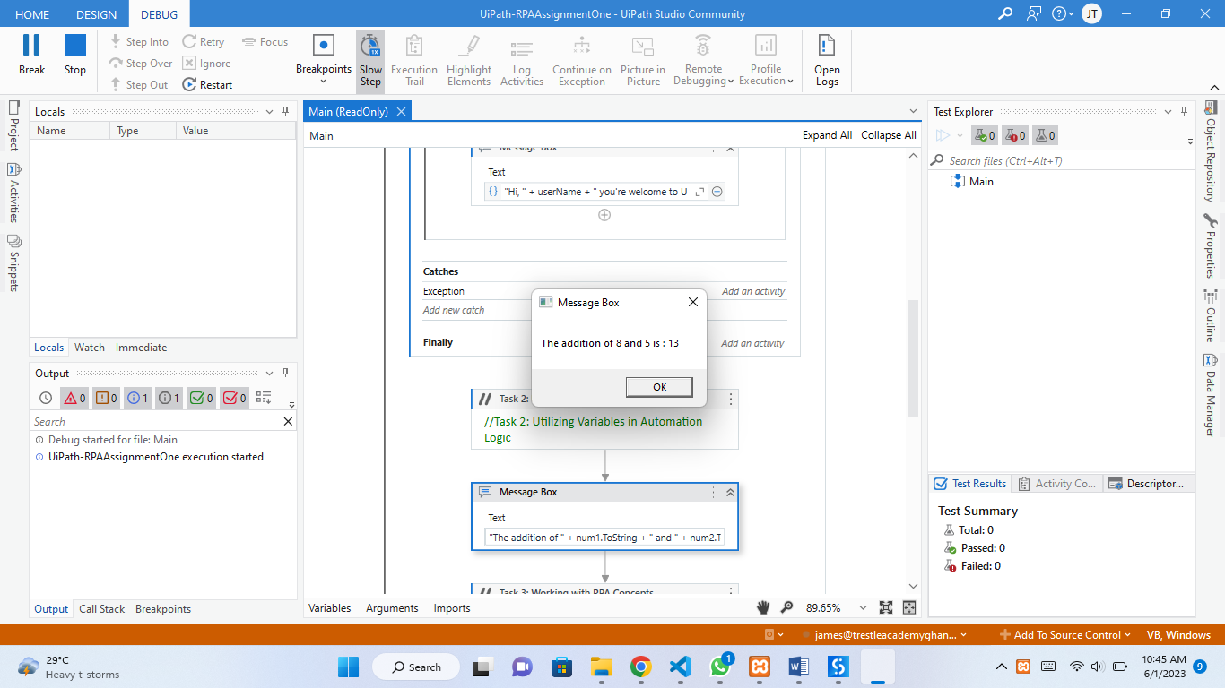

**Task 3: Working with RPA Concepts**

For this task, I designed a workflow to rename a file. Here are the steps I followed.

* Just beneath the Message Box of Task 2, I added a **Try Catch** activity.
* And on the **Try Catch** activity, I added a **Rename file** activity which has two fields that takes the file path of the file I want to rename (‘**file_to_be_renamed.txt’**) in the first field. And takes the new file name **(*userName* + “_renamed_this_file”)** in the last field where ***userName*** is a variable which had already stored the user’s name as “**James Tetteh Totimeh**” from the Input dialog (see ***Fig 3.0*** below).

***Fig 3.0***

***NB:*** I initially had “file_to_be_renamed.txt” file in my working directory before using it in this process. Otherwise, there will be an exception which will definitely be handled by the **Catches** block of the **Try Catch** activity (as shown in ***Fig 3.1*** below).

***Fig 3.1***

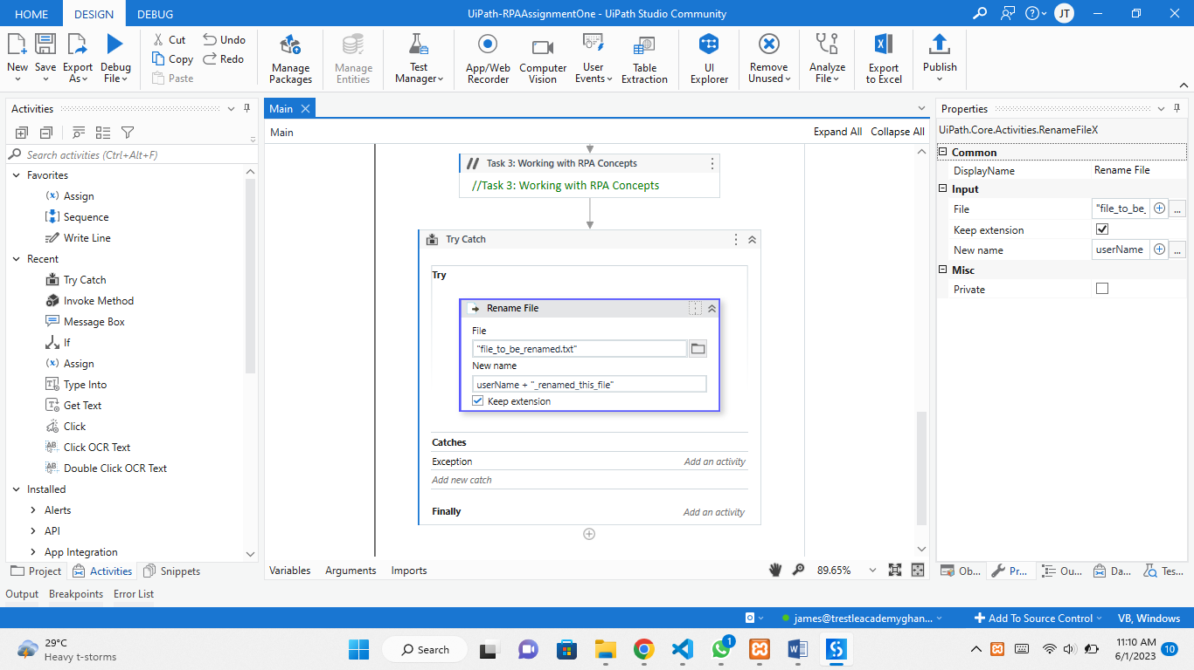

**Results for Task 3**

***Fig 3.2:*** *After execution*

***Fig 3.1:*** *Before execution*

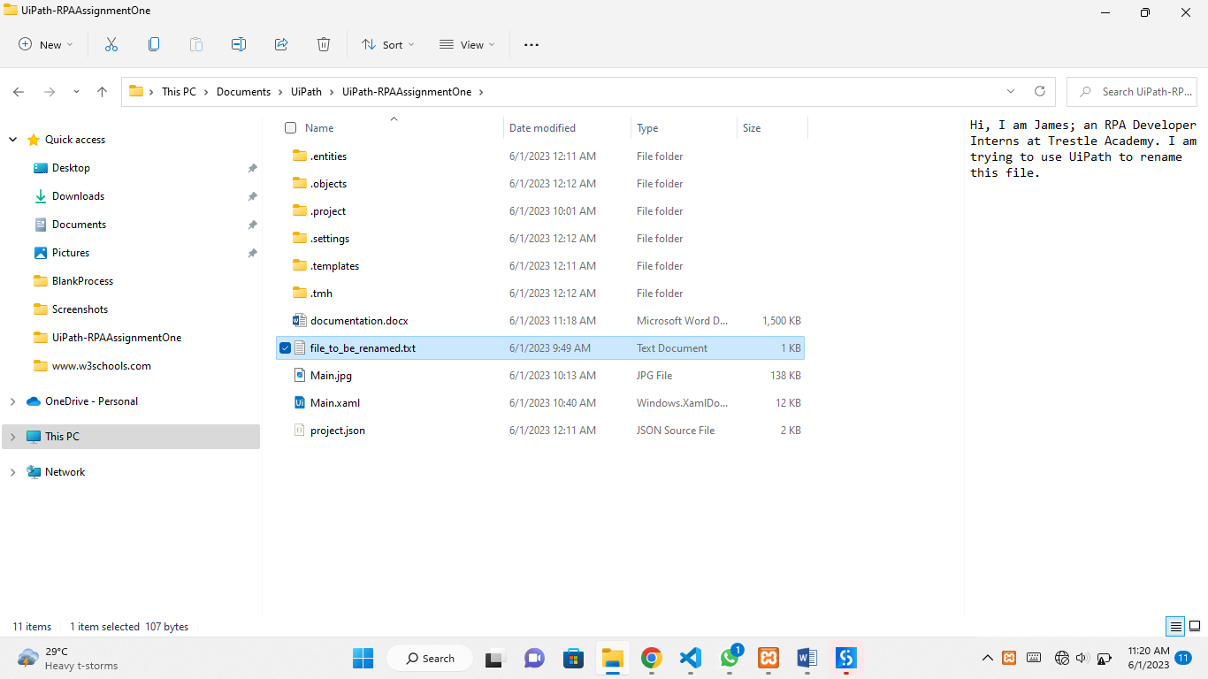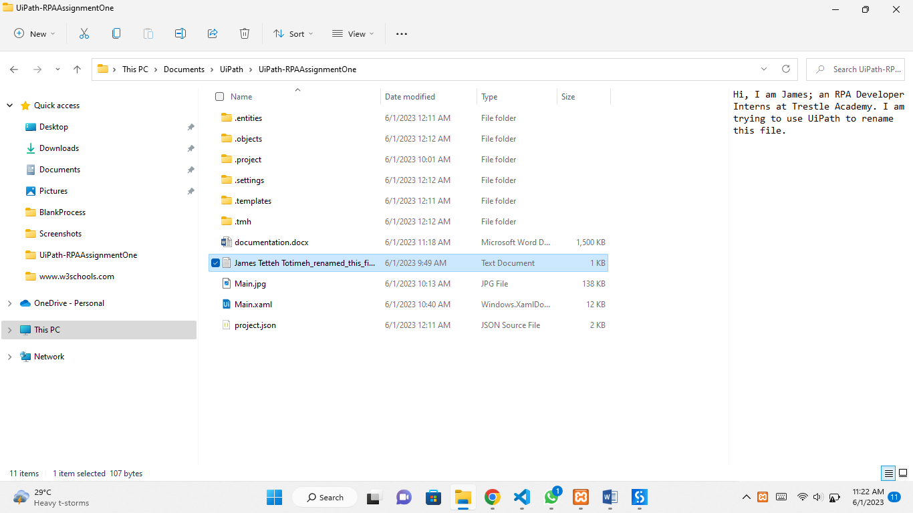

**CHALLENGES FACED DURING THIS ASSIGNMENT**

I did not really find things tough like I expected, while doing this assignment but I would say that, because I am not familiar with all the Activities in UiPath Studio, I though renaming a file would be a bigger task which would involve me in many processes. But I went into the Activities’ search box and searched for words related to ‘rename file’ and I finally found the right activity for renaming a file.