Navigation in
SAP Analytics Cloud
Introduction to navigating SAP cloud solutions using SAP Analytics Cloud as an example.

Product  SAP Analytics Cloud  Level  Beginner  Focus  Navigation  Authors  Katerina Drizi  Stefan Weidner  Version  3.0  Last Change  March 2025 | MOTIVATION  This navigation course explains how to navigate in SAP Analytics Cloud (SAC). The course addresses students at universities, vocational schools and other educational institutions with no previous knowledge in cloud solution for data analysis and visualization. The content is suitable for frontal lessons as well as as a self-learning unit.  After completing this course, learners will be able to navigate the SAC user interfaces to independently edit various exercises and case studies. All preparations required for later courses are available after completion of this course.  This course can also be used as a reference for occasional users. |  | DELIVERY METHOD  To edit this case study, a user account for SAP Analytics Cloud is required.  The learning method used is guided learning in the form of a descriptive case study.  The advantages of this learning method are the rapid and comprehensive transfer of expertise and the acquisition of competence for action. Step-by-step instructions and screenshots are used to explain essential operational tasks and processes to learners in detail.  With the help of simple exercises, the learned system knowledge is practically applied and sustainably consolidated.  


Table of Contents
Step 1: Log on to SAC 3
Step 2: Make Profile Settings in SAC 5
Step 3: Build SAP Analytics Cloud 8
Step 4: Create your own folders 13
Step 5: [OPTIONAL] Share Folder 15
Step 6: Log out of SAC 18
Tips and Tricks for Operation 19

 | Step 1: Log on to SAC
Task Log on to SAP Analytics Cloud. |  | Time 10 min.
Clicking on the following link takes you to the Identity Management System of SAP UCC Magdeburg. This provides anonymous identities for logging on to SAP cloud solutions according to valid data protection rights.  https://ucc-pilot-sac.eu10.hcs.cloud.sap/ |  | Initial Screen
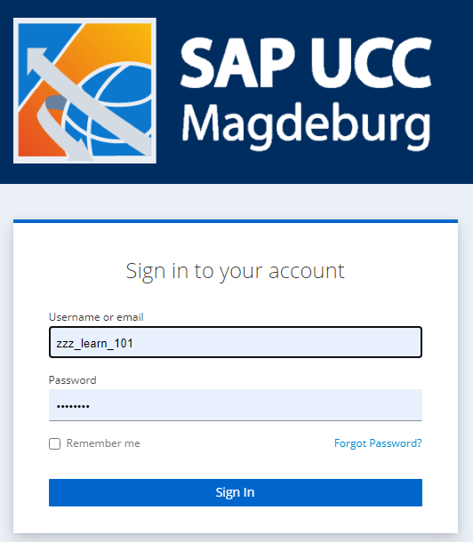
On the login screen, enter the user and password provided by your instructor. Then click Sign In. |  | User  Password  Sign In
Note If you log on to SAC with this user for the first time and with an initial password, you are prompted to enter a personal password for this user.
After you have entered your new password twice in the Update password window, confirm with Submit. |  | Password of your choice
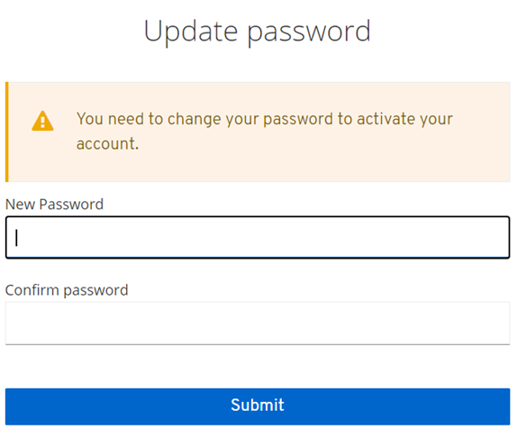
After logging on, you will be taken to the home screen. |  | Home Screen
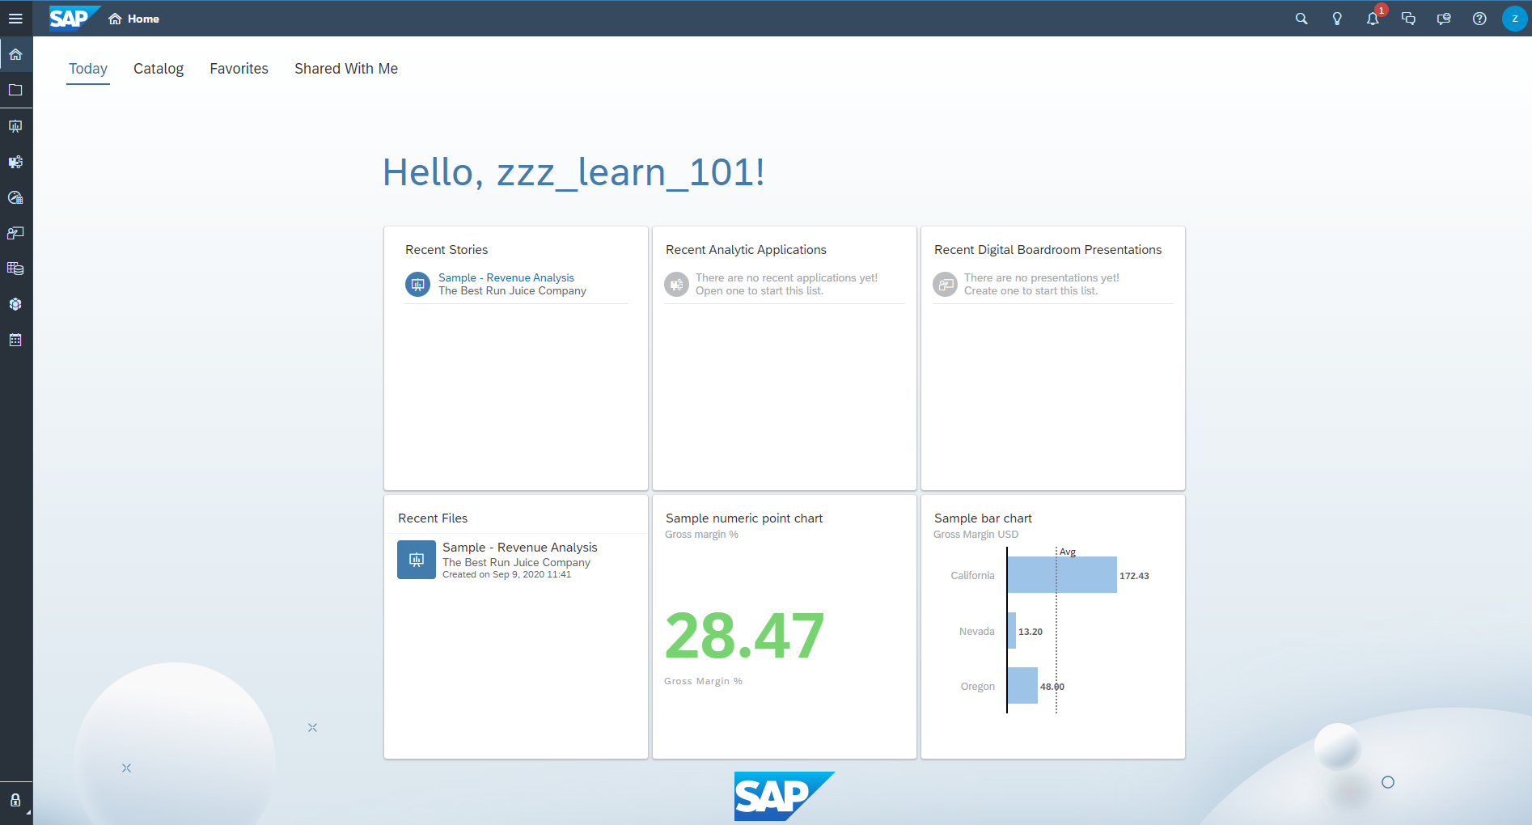

 | Step 2: Make Profile Settings in SAC
Task Make profile settings in SAC. |  | Time 5 min.
Right after logging in, you first set some important things in SAC. To do so, click  in the upper-right corner and then click Profile Settings to make your profile settings in SAC. |  | Initial Screen
Note Your personal data is stored exclusively in the Identity Management System in the SAP University Competence Center Magdeburg in compliance with data protection regulations. Define your e-mail address there urgently. If you forget your password, you can have it reset. |  | Personal Data
To do so, click Edit Profile. |  | Edit Profile
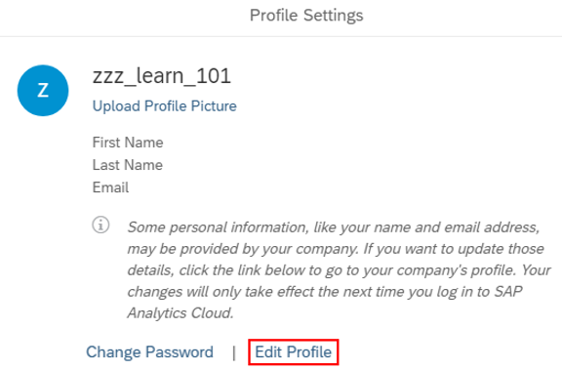
You will now be taken to the UCC Magdeburg Identity Management System where your personal data will be stored in a gdpr compliant manner. Click Account here. |  | Account
Enter your email address. Optionally, you can also enter your first and last name. |  | Email Address  First Name  Last Name
Save your changes with 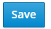. From now on, you can reset your password yourself if necessary. |  | Save
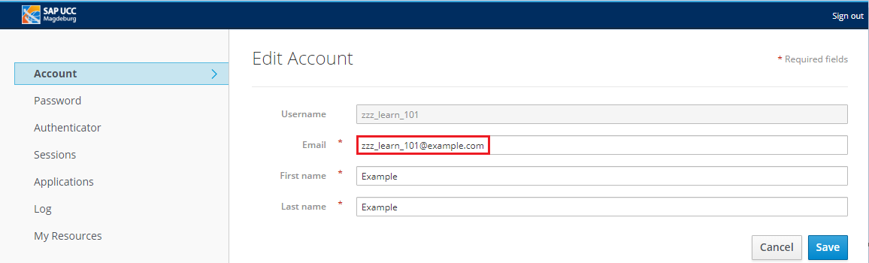
With the settings you have made, you have also ensured that you can edit the following exercises and case study according to the instructions and can be informed by email when another user shares content in SAC with you.
Now close the browser tab with the Ucc Magdeburg Identity Management System. You should see the SAC Profile Settings window again. |  | Profile Settings
Please change the User Preferences. To do this, choose Edit ( ) on the right-hand side of the screen. |  | Edit
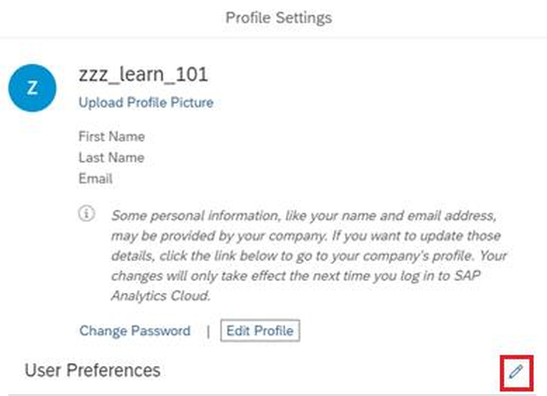
Change the settings in the dropdown menus as shown below and then confirm your entries by choosing Save. |  | Save
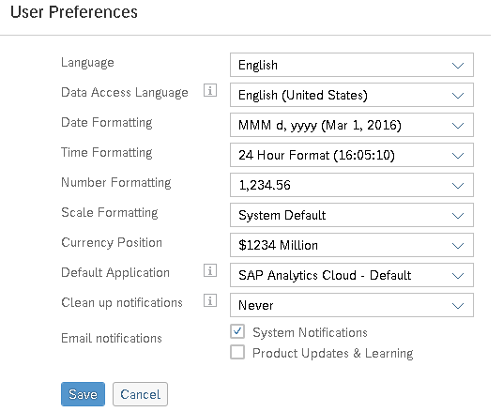

 | Step 3: Build SAP Analytics Cloud
Task Familiarize yourself with the individual areas and functions of SAC. |  | Time 10 min.
You should now be back on the home screen, as you can see in the top left menu bar. |  | Initial Screen
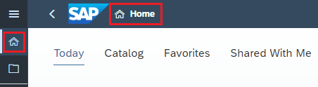
On the SAC home page, the icon (Search), (Just Ask), (Notifications), (Collaborations), Feedback, (Help), and your profile symbol (Profile) are displayed one after the other in the upper right corner. Click the icon. You have already made settings for your profile. By clicking home screen settings, you can set your home screen as you like. |  | Home Screen Settings
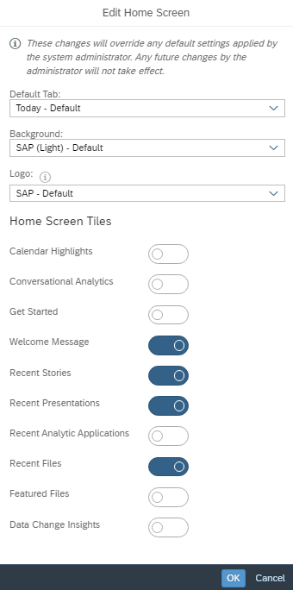
Confirm your changes with  if necessary.
SAP Analytics Cloud has interactive help. If you click the icon to the left of your profile icon, the SAP help topics open. |  | Help
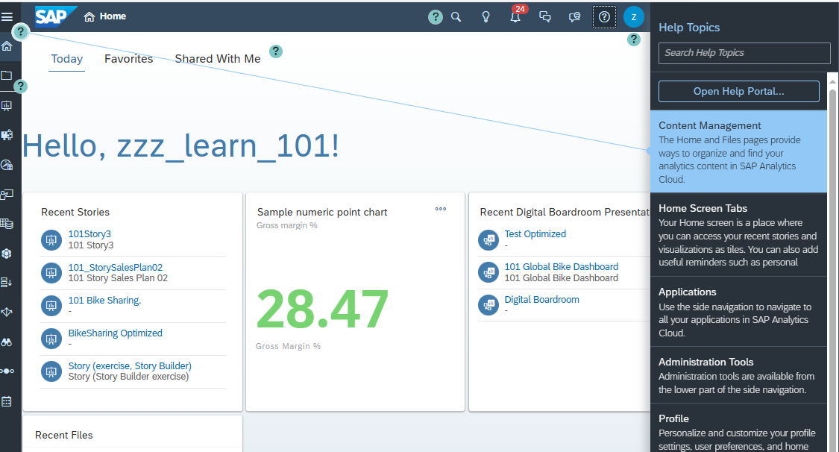
Other buttons take you to content management, home screen tabs, applications, administration tools, profiles, learning videos, and other helpful content, as needed. Take a look around. Clicking Open Help Portal takes you to the SAP Analytics Cloud Help page. |  | Open Help Portal
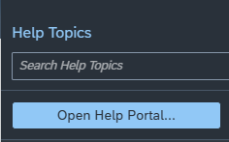
If you click the Help icon again, the SAP help topics close again. |  | Help
Use the icon to open the Discussions area. Here you can start and manage new conversations with individual or groups of users. The functions available are similar to those of a classic chat. Please only start conversations with people you know. By clicking on you hide the area again. |  | Collaboration
Click the  icon to open the SAP Analytics Cloud feedback page in Internet Explorer, where you can write your personal feedback about the SAP product SAP Analytics Cloud. |  | Feedback
By clicking on the icon you get relevant notifications about new functions as well as important system information. You can delete them individually or collectively. |  | Notifications
The just Ask feature in SAP Analytics Cloud allows to access natural language inputs to quickly get answers or insights from their data. You can ask simple questions, and the function converts them into queries, which then provide visual results or charts. This facilitates access to data analysis without deep technical knowledge. |  | Just Ask
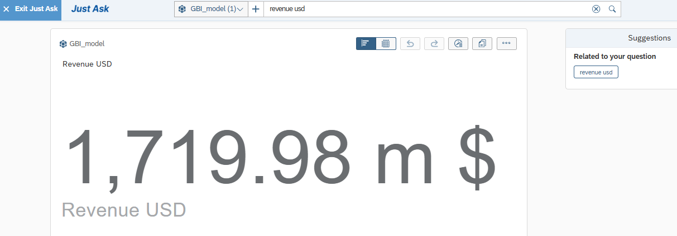
To search for all types of SAC objects, you can use the search icon . In the text field that opens, you can use any characters, for example: Your personal ID ###, which you have received from your instructor. If you have already worked in this SAC tenant, the system displays a list of all objects for this character string. |  | Search
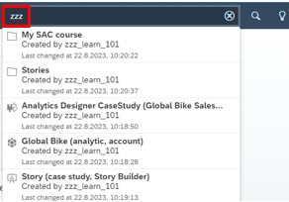
In the upper left corner, you can choose the SAP icon  to return to the home screen.
On the left is the main menu. Clicking on the Expand Navigation Bar icon displays all menu items and their descriptions. |  | Navigation Bar
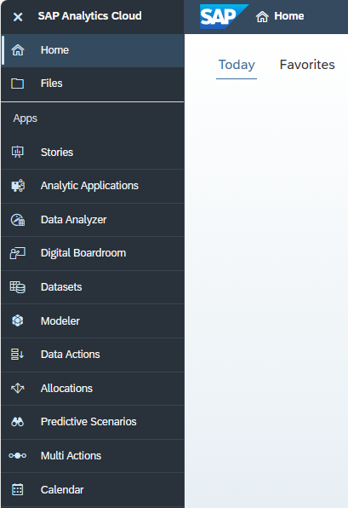
As with the SAP icon, clicking Home always brings you back to the Home screen.
Files  contains all SAC documents that you can access in a folder structure.
In Stories , you can create a story and add charts, tables, text, and other objects.
With analytic applications, you analyze your data by interacting with applications for data analysis and planning.
Data Analyzer is an analytics tool that allows you to perform ad-hoc queries and data analysis on live data connections as interactively as possible.
The Digital Boardroom allows you to create responsive boardroom presentations as an agenda or dashboards.
With datasets 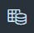, you prepare your raw data with a flexible table format and start with scenario analysis.
Under Modeler , you can prepare your raw data with a structured view.
Data actions enable you to automate data processes and perform complex data management tasks within planning applications.
The Allocations feature in the SAP Analytics Cloud is a tool within the planning module that allows you to allocate or allocate costs and revenues within your financial models.
With Predictive Scenarios answer business questions that require predictions and predict future events, outcomes, or behavior patterns using data analysis, statistical algorithms, and machine learning
The Multi Actions feature allows you to combine different data-related actions and implement them as an end-to-end workflow, making the planning process more efficient and error-resistant.
Calendar  allows you to maintain a private or group calendar, Gantt charts, and task lists.
In the menu option Security , you can display teams, roles, and requests for rights, but you cannot change them.
Under Connections , you can add and manage new connections.
After clicking system , you can get up-to-date information about the SAC tenant under About 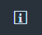.

 | Step 4: Create your own folders
Task Create a personal folder structure for the exercises and case studies. |  | Time 10 min.
On the home screen, click (Files) in the upper left corner. |  | Initial Screen
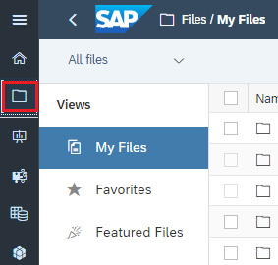
Note Make sure you are in the main My Files folder.
In the menu bar on the right, click (Folder actions) and then click New Folder…. |  | New Folder…
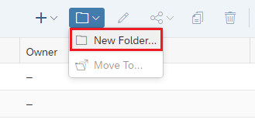
To make it easier to distinguish your folder from others, enter a name of your choice in the Name field, for example: My SAC course and in the Description field, enter an optional description. Confirm your entries by choosing OK to create the folder. |  | Description  Description  Ok then
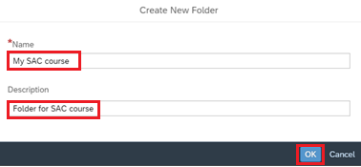
Open the new folder by clicking it. In the top bar, you can see the respective folder path. By clicking on My Files, you can go back to the general overview of all folders and documents. But stay in this folder at first.
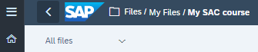
For better structuring, create subfolders. To do this, create the following folders, as you have just done:  - Models  - Stories |  | Subfolders
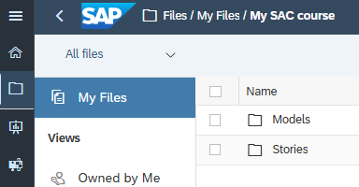

 | Step 5: [OPTIONAL] Share Folder
Task Share a newly created folder. |  | Time 10 min.
You can share both the overall folder and the subfolders in SAC with other users or release them for different activities. You then create another folder that you share with your instructor, for example: Submit your results of a case study for evaluation. |  | Release
Click on My Files to return to the general overview of all documents that are visible to you. Choose the main folder of your course, indicated by the three identification letters of your university (XYZ) and a three-digit sequential number. |  | [XYZ]123
If necessary, you can find an additional folder for your part course or Your group called [XYZ]123_Group#, where [XYZ]123 should be your team and # should be your group. If you see more than one folder, ask your instructor for the right one. Click on this folder. |  | [XYZ]123_Group#
Now create another folder as described above. For the name, use the user with which you are logged on to SAC. The Description field can remain empty. Confirm with Create. |  | User  Create
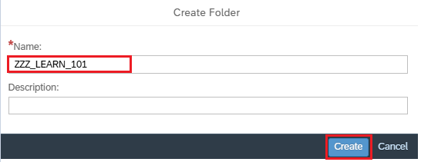
Note This folder initially inherits the same rights as the main folder. Normally, this should mean that all users of your institution can see objects in this folder and possibly even manipulate them. Please follow the instructions below carefully to restrict access rights only to your instructor and yourself.
To do this, click to share the new folder. |  | Share Folder
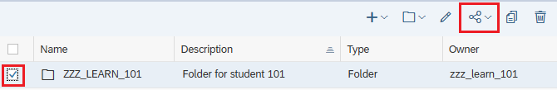
In the Share Folder pop-up window, in the Shared with 1 Team area, delete the Team: XYZ from the list by selecting the entry and then clicking . |  | Authorizations
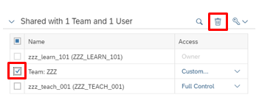
In the next confirmation window, choose To the selected folder, its subfolders, and files and click Apply Changes. |  | To the selected …  Apply Changes
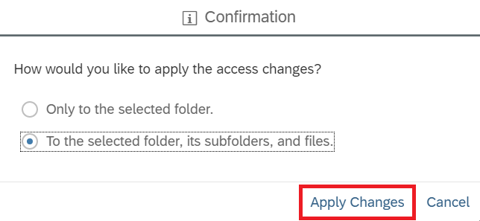
Only your instructor and you should now have access to this folder. Make sure that your instructor has full control in the Access column.
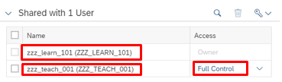
Note If the entry for your instructor is missing, click in the Add Users or Teams area and select the user of your instructor in the format [XYZ]_TEACH_###. If you do not know the account, contact your instructor. |  | [XYZ]_TEACH_###
In the Access dropdown menu, choose Full Control. |  | Full Control
Deselect the Email new recipients checkbox and click Share. |  | E-mail new recipients  Share
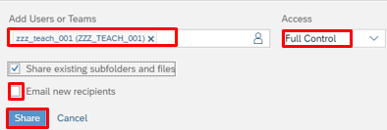
Finally, click Close. |  | Close
Note You have created two different folders. One for yourself (My SAC course) and a second, which your instructor can also view (XYZ_LEARN_###). |  | Explanation
When you edit the exercises and case studies, you first save your objects in your personal folder. |  | Personal Folder
If your instructor asks you to submit your work result, copy your object to the instructor folder. At the end of each exercise and case study, there is an optional step that explains the procedure. |  | Instructor Folder
Note It is important to note that you share your folders, subfolders, and files with users of your institution at the most. If you are not sure, please ask your instructor in advance.

 | Step 6: Log out of SAC
Task Log off from SAC successfully. |  | Time 5 min.
You are logged on to SAC and want to log off. |  | Initial Screen
To log out of SAC, you need to click on in the upper right corner. Then choose Sign out. |  | Sign Out
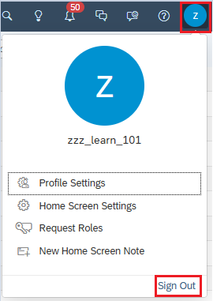
Once you have logged off successfully, you return to the logon screen for the Identity Management System of SAP UCC Magdeburg.
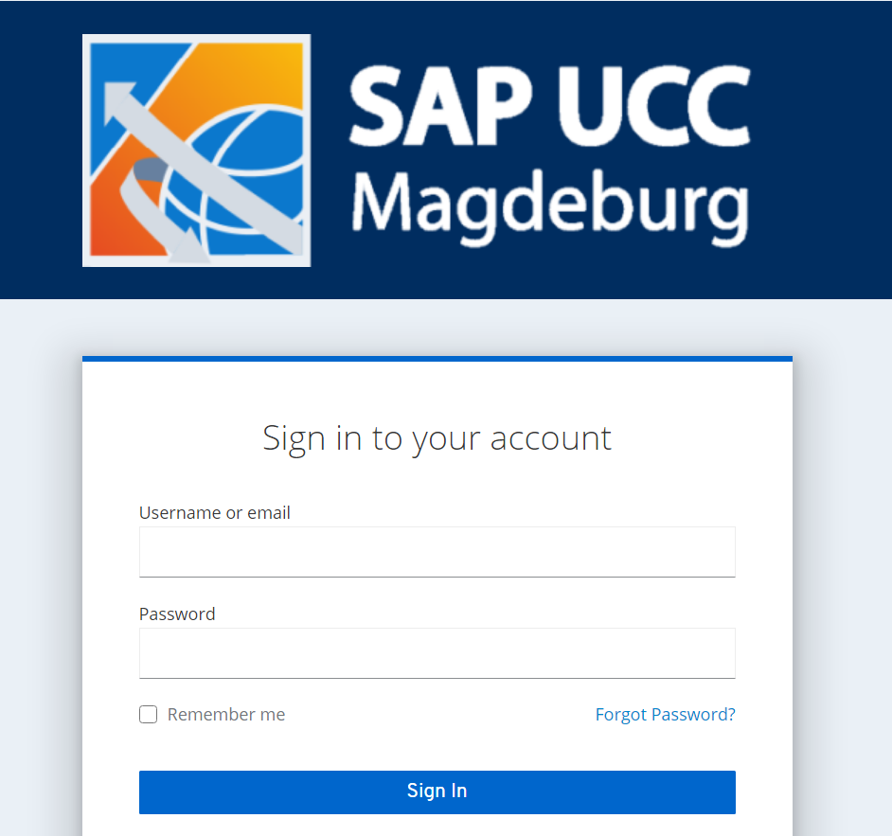

Tips and Tricks for Operation
This section provides you with additional useful information for using SAP Analytics Cloud.
Display of main menu for relatively small screens
If your screen is relatively small, it may happen that not all entries of the main menu are visible, but are truncated.
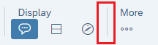
If you click on More, the missing menu entries are displayed in a hierarchical menu.
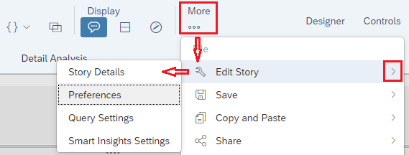
Display of page elements for relatively small screens
If your screen is relatively small, it can happen that not all data of a table becomes visible, even after using the page scrollbars.
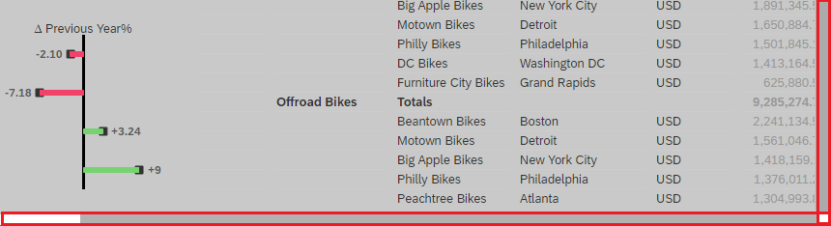
With a single click on any table cell, further scroll bars appear. This takes you to the end of the table.
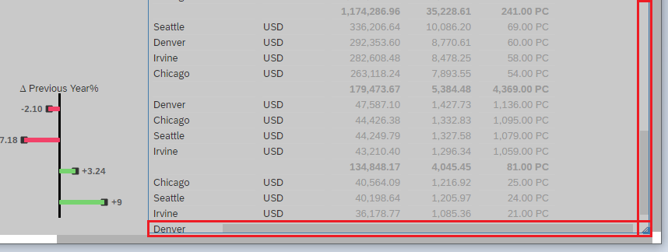
The same applies if you want to use the context menu (More Actions) next to a page element such as a table or chart and this is not visible due to your screen size. Again, click in the page element and scroll all the way to the right.
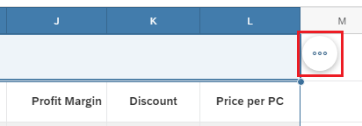
Exporting a Story
In SAP Analytics Cloud (SAC), stories provide a comprehensive way to analyze and visualize data. You can create interactive reports and dashboards that visualize key business metrics. A useful feature of SAC is the exportability of these stories.
You can export stories in various formats, including:
- PDF: For a non-interactive, static report that is good for presentations or printing.
- PowerPoint (.pptx): This allows you to convert your stories directly into presentation formats, for example, for business presentations.
- CSV: if you want to extract raw data from a story to further process it in other applications.
When exporting, you can select which parts of the story they want to include, such as specific pages or charts. You can also adjust the layout and formatting settings to meet the requirements of the report recipient.
It is important to note that when exporting to static formats such as PDF, interactivity is lost, that is, filter actions or drill-down functions are no longer applicable in the exported document. For this reason, you should carefully consider which format is most suitable for your purpose before exporting.
Open the story you want to expose and make sure you are in view mode.
Navigate to File and click Export.
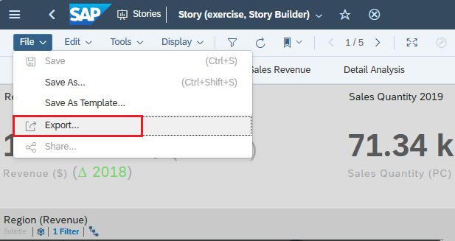
You can now choose the file type and make general settings for your export.
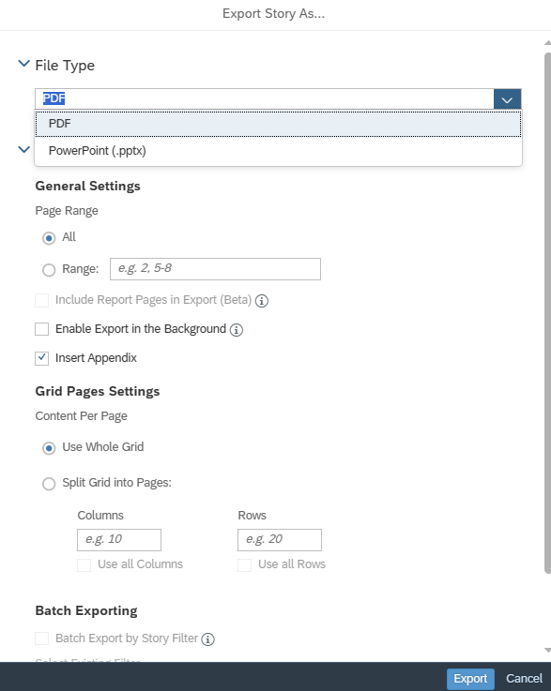

Exporting a Table
Click the tables you want to export and then click the More Actions 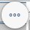 icon. Choose Export.
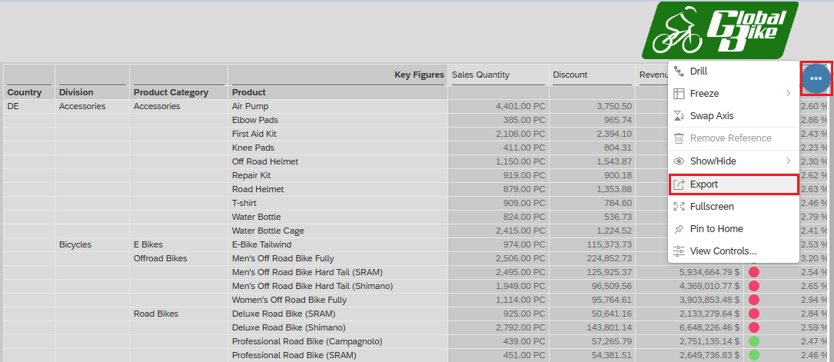
You can choose between the file type CSV and XLSX and make further general settings.
