 | Process Overview
Learning objective Familiarize yourself with an existing story.  Scenario In the SAP Analytics Cloud (SAC), a dashboard for sales already exists. Alex Kuhn (Vice President Marketing and Sales) asks you to familiarize yourself with it and make minor adjustments. |  | Time 60 min.
Specifications Alex Kuhn: “On the Sales Quantity page, I want to have a filter for the calendar month in addition to the filter for the year.“
“On the Sales Revenue page, in the bar charts, exchange the Price per PC key figure with the Contribution Margin. In this context, you also remove the key figure Price per Piece from the table.“
I would also like to ask you, for the above Bar chart to choose a different color display.“

Table of Contents
Process Overview 1
SAC 1: Log on to SAC 2
SAC 2: Opening an existing SAC Story 4
SAC 3: Using an existing Story 6
SAC 4: Copy Story 9
SAC 5: Add Page Filter 10
SAC 6: Change Key Figures 13
SAC 7: Change color display of a table 16

 | SAC 1: Log on to SAC
Logon to SAC task.  Description Log on to the SAC tenant in a web browser and make the described settings. |  | Time 10 min.
Note To be able to use SAC in its entirety, please use Google Chrome only. |  | Browser Selection
Clicking on the following link takes you to the Identity Management System of SAP UCC Magdeburg. This provides anonymous identities for logging on to SAP cloud solutions according to valid data protection rights.  https://ucc-pilot-sac.eu10.hcs.cloud.sap/ |  | Initial Screen
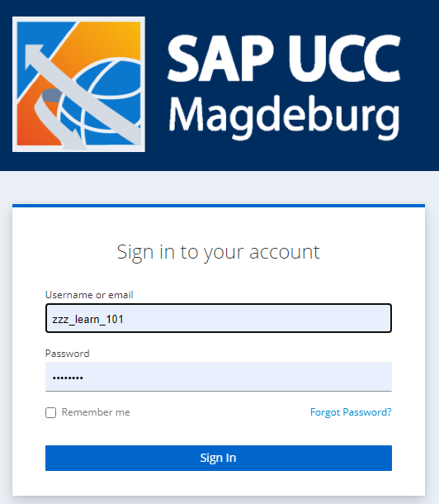
On the login screen, enter the user named by your instructor and your personal password, which you should have already defined. |  | User  Password
Then click Sign In. |  | Sign In
Note If you log on to SAC with this user for the first time and with an initial password, you are prompted to enter a personal password for this user. |  | Password Change
After you have entered your new password twice in the Update password window, confirm with Submit. |  | Submit
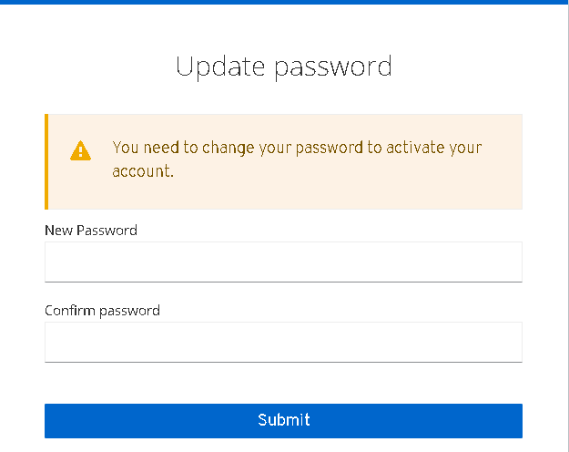
After logging on, you will be taken to the home screen. |  | Home Screen
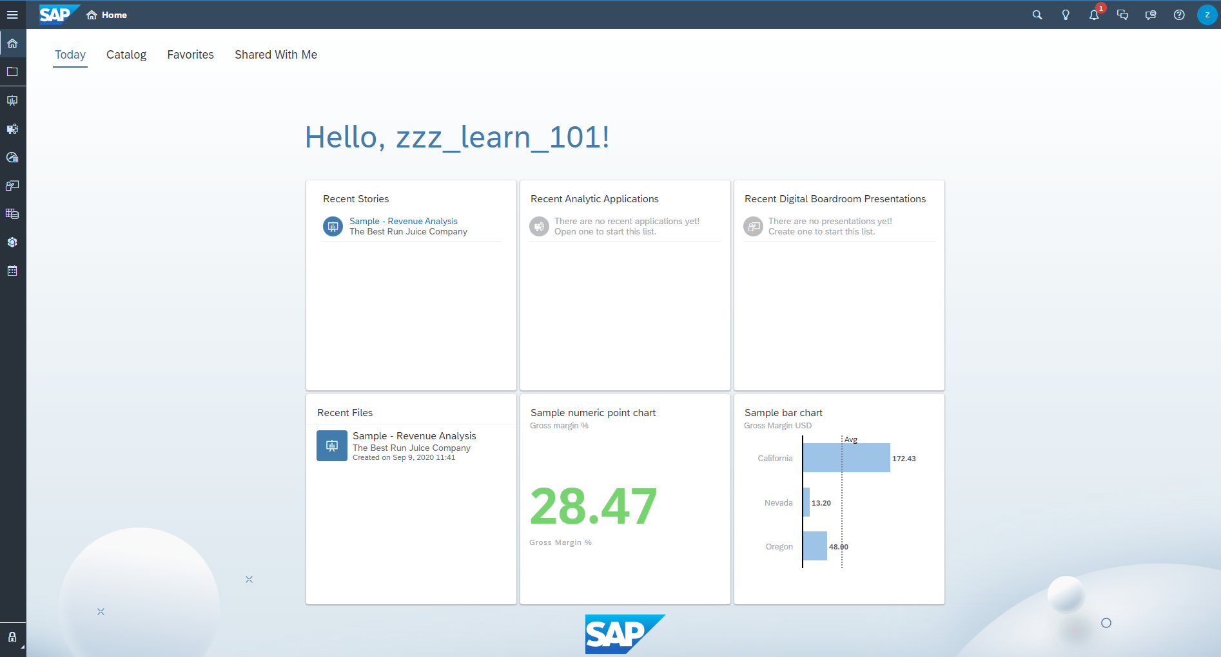

 | SAC 2: Opening an existing SAC Story
Opening an SAC Story Task  Description In SAC, open the story Story (exercise, Story Builder). |  | Time 5 min.
On the home screen, choose (Files) on the upper left. |  | Initial Screen
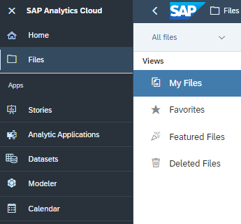
Now find and open the public folder and the folder Curriculum 3.0. |  | Public Ordner -> Curriculum 3.0
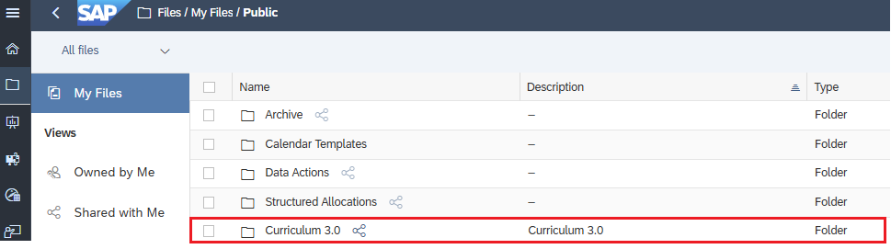
Simply click to open the Story Story (exercise, Story Builder). |  | Story (exercise, Story Builder)
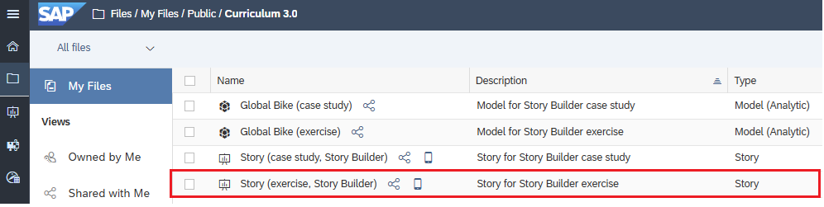
This opens the story with its Overview page.
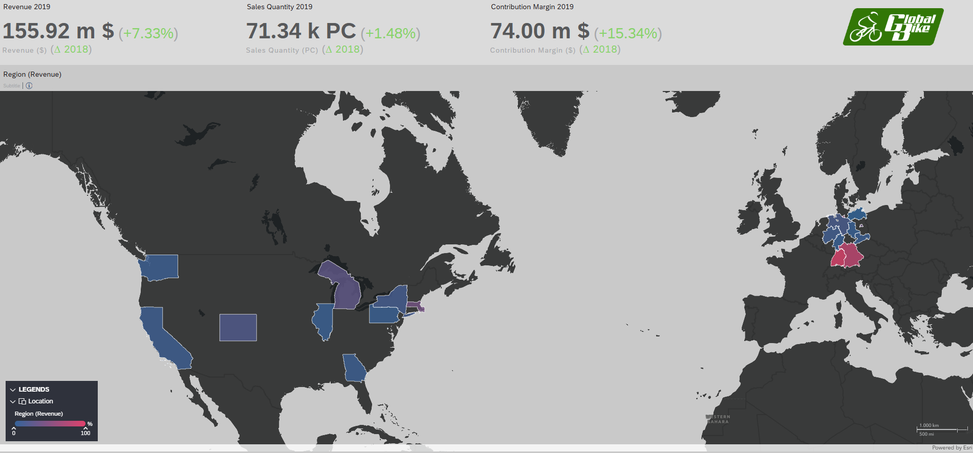

 | SAC 3: Using an existing Story
Task Use an existing story.  Description Test the different pages of the story as well as the interactions. |  | Time 15 min.
Open the exercise (Story Builder) as shown in the previous exercise. |  | Initial Screen
To better navigate through the pages of the story, choose Tab Bar from the Display menu. |  | Tab Bar
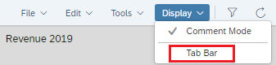
On the first page (Overview), the header area displays the three most important key figures, including a comparison of the previous year, in percent. On the world map, you can see the sales by U.S. states. The colors represent the sales volume. If you are driving over a colored area, the system displays detailed information about this region. |  | Overview
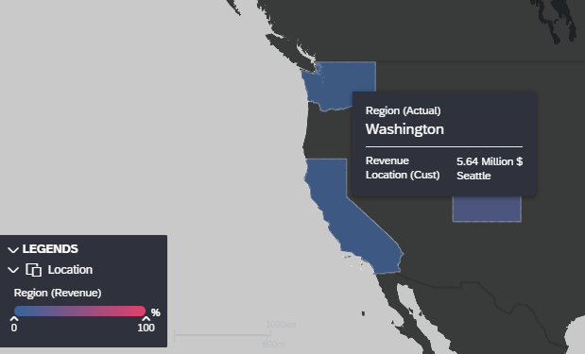
On the second page (timeline), you can see the realized sales and production costs or the profit margin by year. |  | Timeline
Note If you only see the report for the last 12 months, click All at the top left above the chart. |  | All
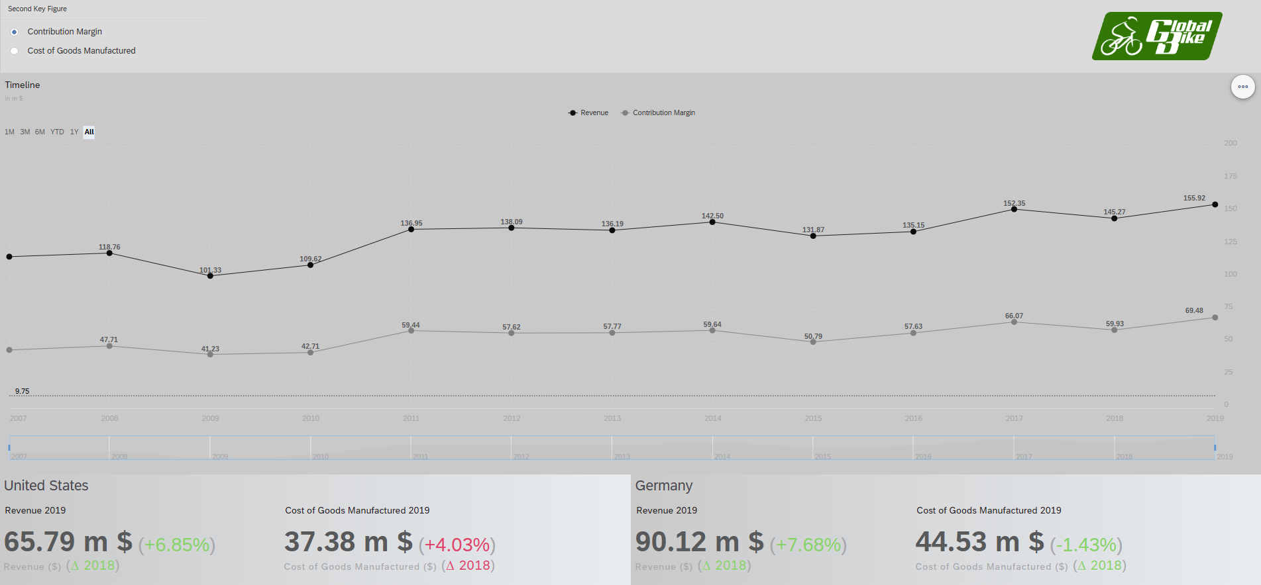
In the lower part of the page, the system displays the two selected key figures by country (United States and Germany) and the change from the previous year. Since the data record used ends in 2019, the previous year is 2018.
The third side (Sales Quantity) contains detailed evaluations of the quantities and discounts. If you click a bar in the left chart, the data in the table is filtered accordingly. |  | Sales Quantity
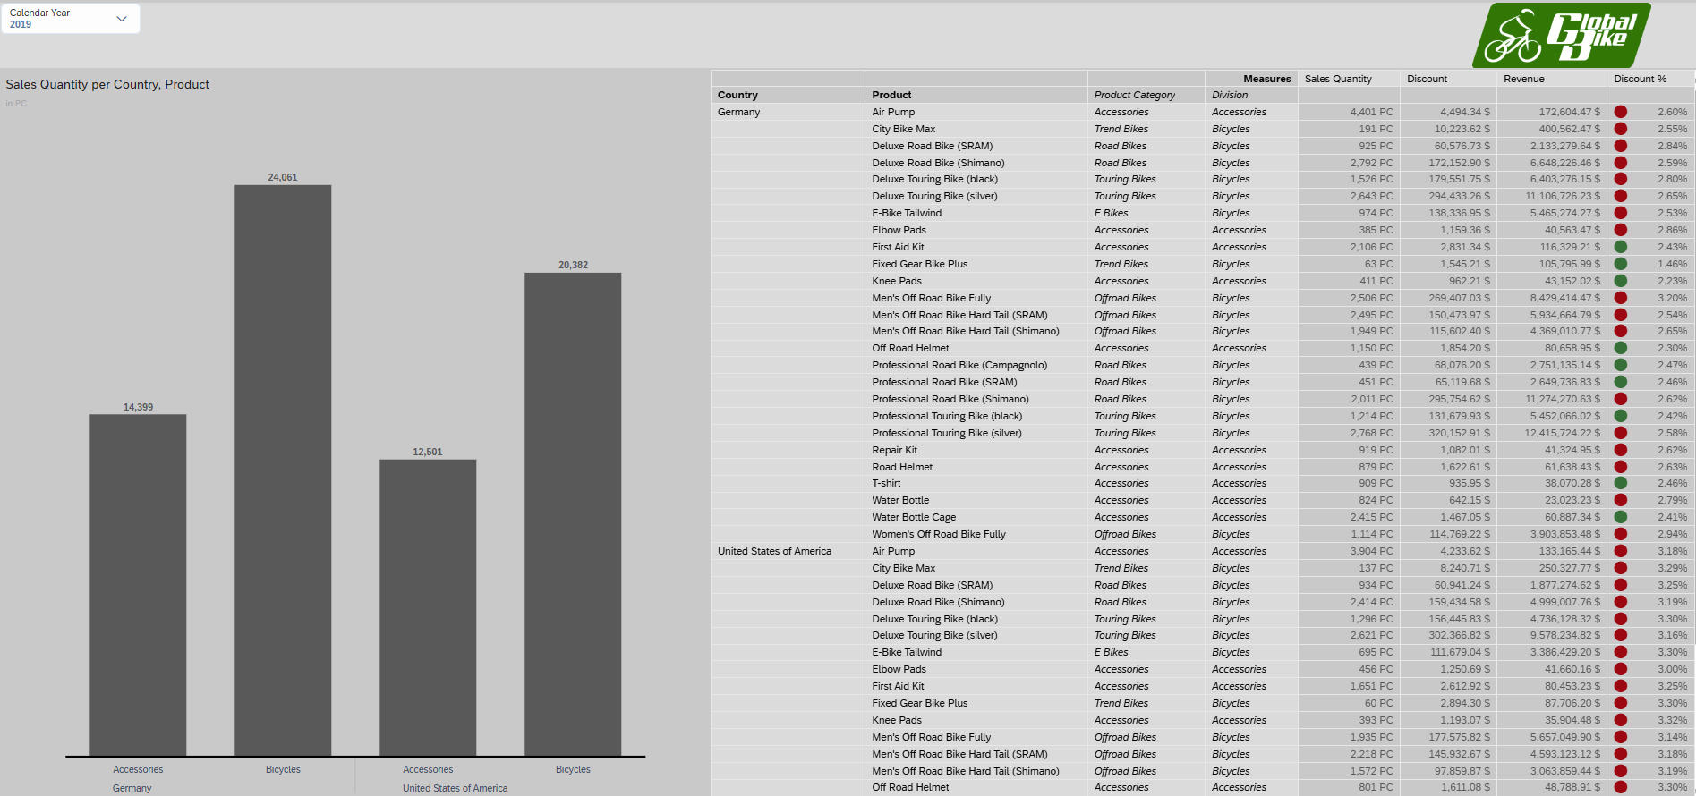
Click a bar to drill up or down its product hierarchy levels. To do this, use the button Drill Up on Product or Drill Down on Product in the context menu. |  | Drill Up on Product  Drill Down on Product

The total sales figures for each country are displayed at the highest hierarchy level. This is followed by the Accessories and Bicycles divisions. On the third level you will find the product categories E-Bikes, Offroad Bikes, Road Bikes, Touring Bikes and Trend Bikes. At the lowest level, the sales figures for each product are displayed.
On the fourth page (Sales Revenue), you can find detailed information about the revenue. In the header area, you can filter by country. Clicking on the entry Germany displays the data for Germany. |  | Sales Revenue  Germany
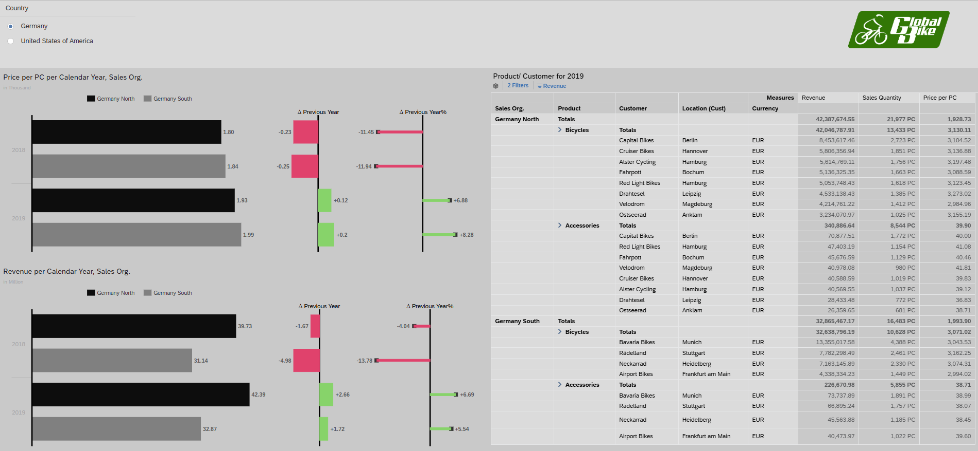
On the fifth page (Detail Analysis), you can evaluate the data in tabular form within the product hierarchy. In addition to the total amount, these include the division, the product category, and the individual product.  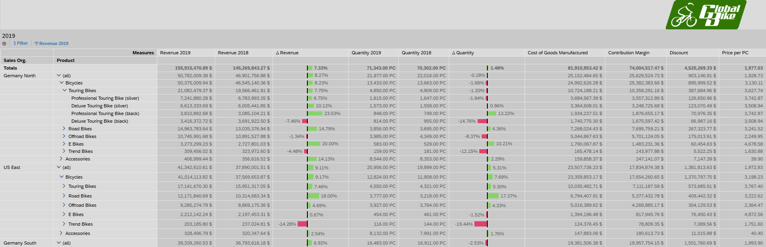 |  | Detail Analysis

 | SAC 4: Copy Story
Task Save Story as Own Story.  Description Save the opened story as your own story in your folder to prepare for the following exercises. |  | Time 5 min.
You have still opened the exercise (Story Builder) from the previous exercise. If you have closed them, open them again as described above. |  | Initial Screen
In the ribbon, go to File and choose Save As…. |  | Save As…
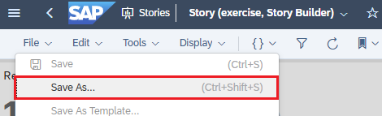
Select your personal subfolder Story as the location. You can access this via My Files ► [your personal folder] ► Stories.
In the Name field, add your three-character ID [###] as a prefix to the name of the story. Finally, confirm the window with Save. |  | ###  Save
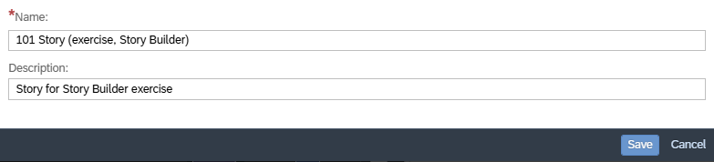
The story has now been saved as a copy in your subfolder and you'll continue working in your own story from here.
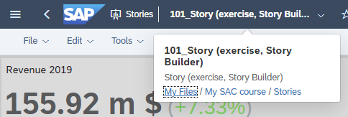

 | SAC 5: Add Page Filter
Task Add another page filter.  Description On the third page (Sales Quantity), additionally add a filter by calendar month. |  | Time 10 min.
You have still opened your story ### Story (exercise, Story Builder) from the previous exercise. If you have closed them, open them again as described above. |  | Initial Screen
In comparison to the template story, in which you only had display rights, you now see the button in the menu bar at the top right. You can use this to switch back and forth between edit and view modes. Click on Edit so that this part of the button is colored . As a result, you now see the menu bar for editing. |  | Edit vs. View Mode  Edit
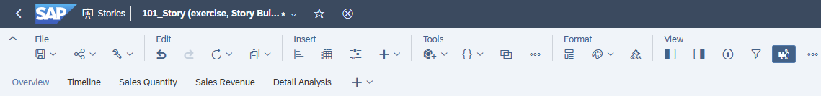
Switch to the Sales Quantity tab page.
In the Insert ribbon, choose the Icon Input Control . After clicking on the Dimensions menu item, choose Calendar month and then Filter by Member…. |  | Input Control  Dimensions  Calendar month  Filter by Member…
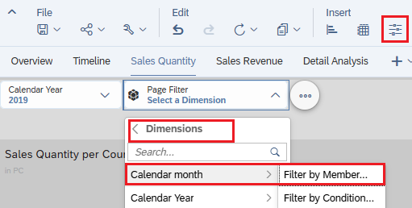
Now you define which data is visible during execution. To be able to select dynamically later which month(s) of the calendar year is used for the evaluation, choose All Members, leave the remaining settings and confirm the window with OK. |  | All Members  Ok then
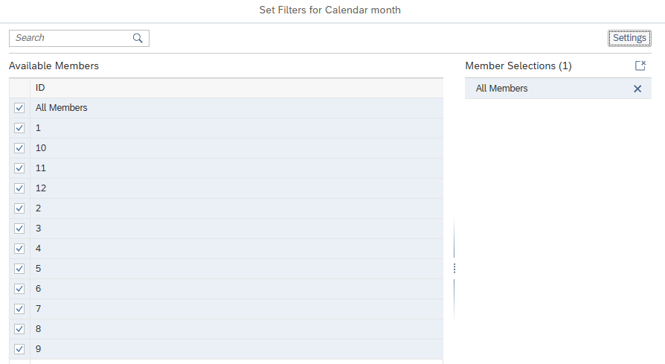
Make a default setting for the fourth quarter by selecting the relevant months. To do so, click your filter. In the dropdown menu that appears, deselect the entry All and select the months 10, 11, and 12 instead. |  | All  10  11  12
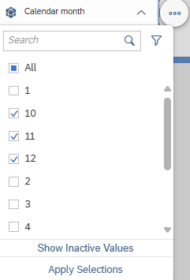
In the menu bar in the File area, choose Save icon to save your changed story. You then switch to the mode view to test your new filter. |  | Save  View
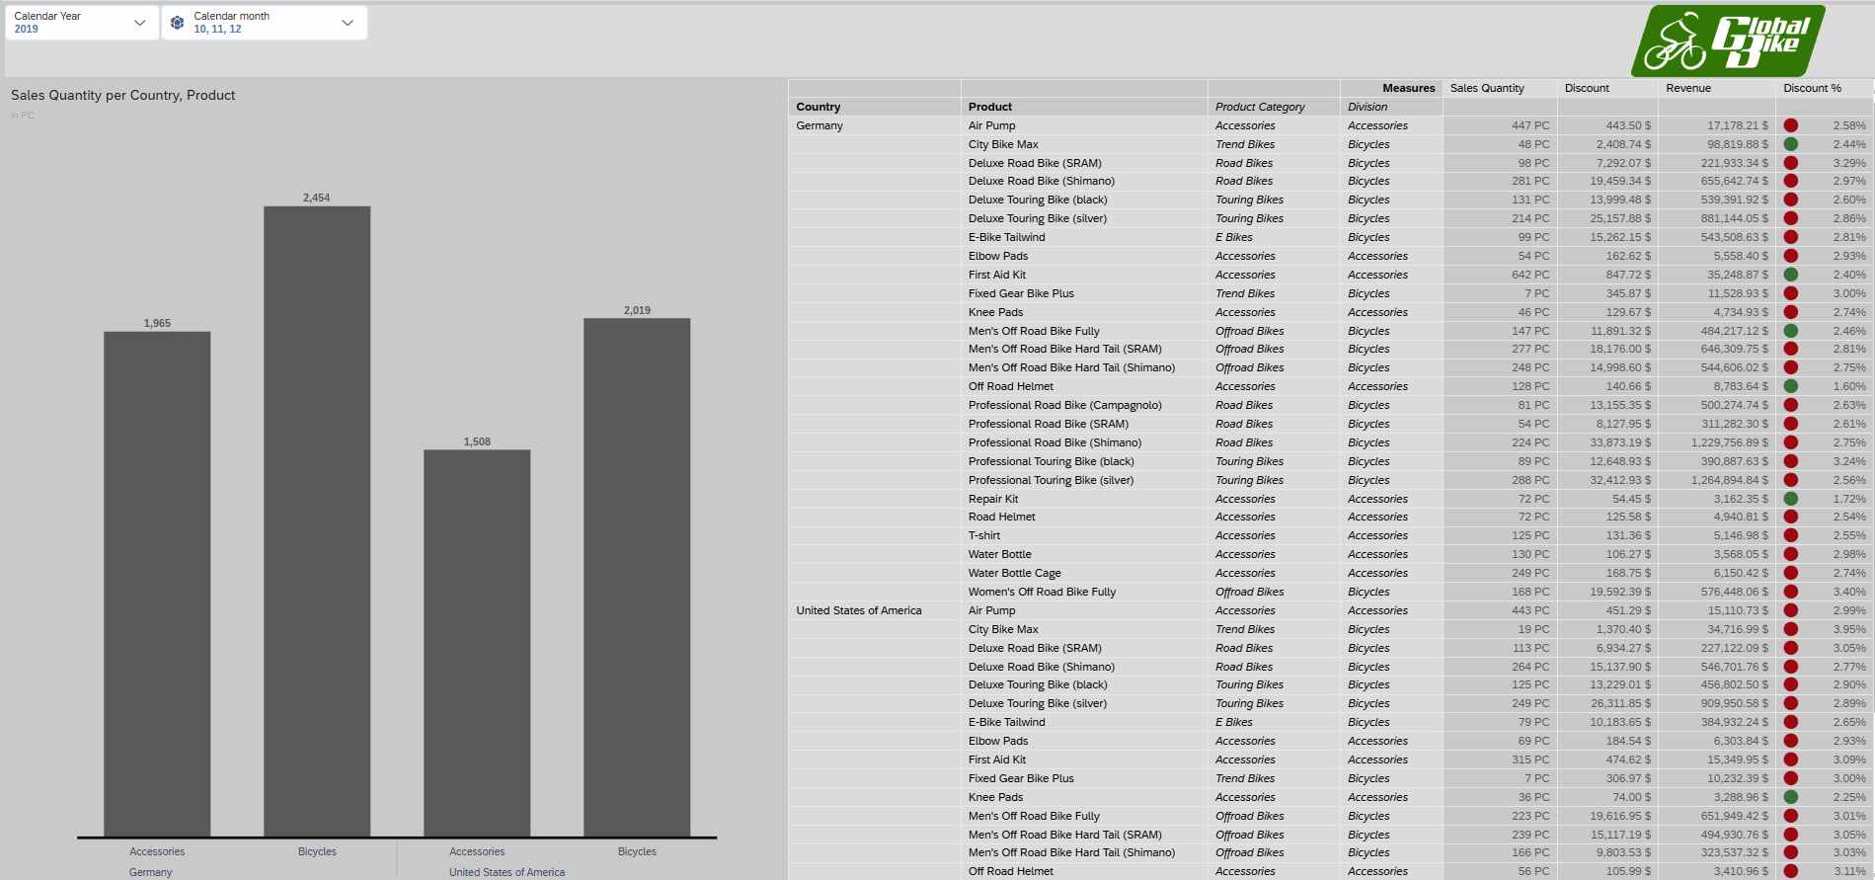

 | SAC 6: Change Key Figures
Task to change the displayed key figures in a table and in a graphic.  Description On the fourth page (Sales Revenue) in the first graphic, change the key figure displayed from Price per Piece to Contribution Margin and remove the key figure Price per Piece in the table. |  | Time 10 min.
You are still in your story ### Story (exercise, Story Builder). If you have closed it, open it again. |  | Initial Screen
Close view mode by closing the tab.
Go to the fourth page (Sales Revenue) and select the area of the graphic Price per PC per Calendar Year and Sales Organization by clicking on it. This results in a fine blue border.
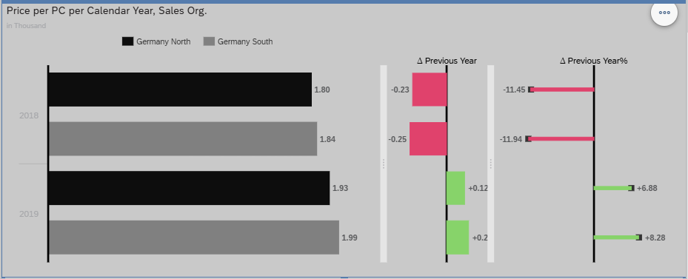
To edit the settings of the graphic, click Right Side Panel in the View area. The right side panel opens in the Builder panel . |  | Right Side Panel  Builder
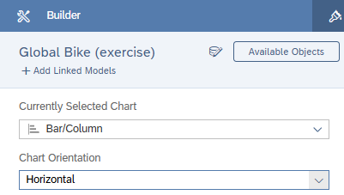
In the Measures pane, choose Add Measure. |  | Add Measure
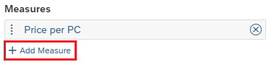
Select the Contribution Margin key figure and then remove the Price per PC key figure. |  | Contribution Margin  Price per PC
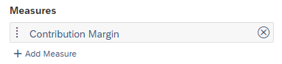
To make the graphic more meaningful, you now change the scaling of the key figure from thousand to million. To do this, first select Styling in the upper right-hand side panel. Now scroll down to the Number Format area and select Million as scale. |  | Styling  Million
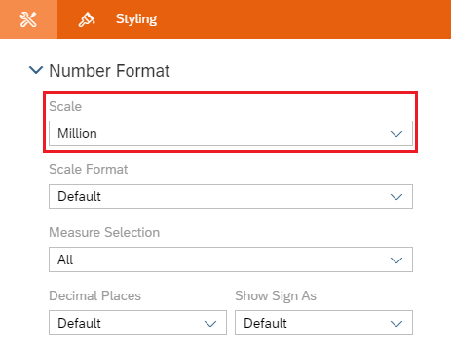
Now you have replaced Price per PC with Contribution Margin.
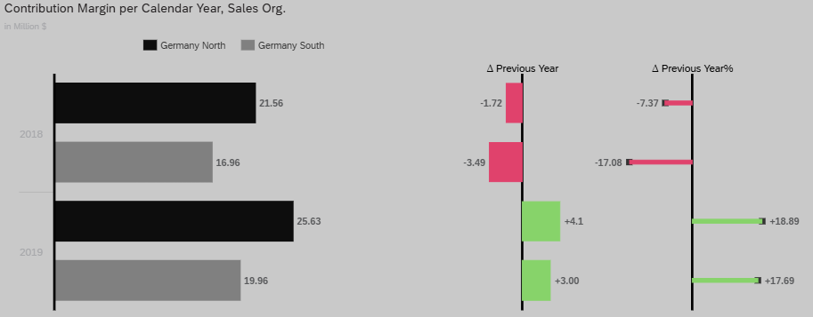
In the File area of the menu bar, choose Save icon to save your changed story. |  | Save
Next, click in the table area and in the Designer window, go to the Builder panel . Scroll down to the Columns section. Hover over the Key Figures entry directly. As a result, it is grayed out and additional icons are displayed. Click Manage Filters . |  | Builder  Manage Filters
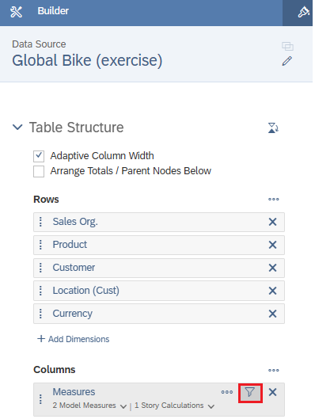
Deselect the key figure Price per Piece and confirm the window with OK. |  | Price per PC  Ok then
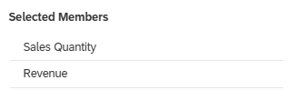
This removes the Price per Piece column from the table.
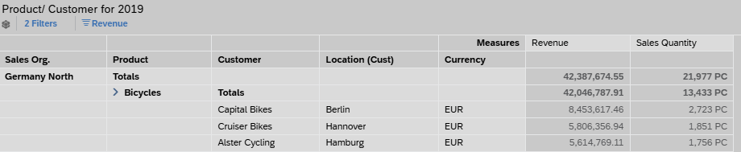
In the menu bar in the File area, choose Save icon to save your changed story. You then switch to the mode view to test your changes. |  | Save  View

 | SAC 7: Change color display of a table
Change the color palette used for a graphic.  Description On the fourth page (Sales Revenue), in the first graphic, change the color palette used. |  | Time 5 min.
You are still in your story ### Story (exercise, Story Builder). If you have closed it, open it again. |  | Initial Screen
Close view mode by closing the tab.
Go to the fourth page (Sales Revenue) and select the area of the graphic Contribution Margin per Calendar Year, Sales Org. by clicking on it. This results in a fine blue border.
The right side panel is open. In the Builder panel, under Color, select a different predefined color palette from the drop-down menu.
To edit the settings of the graphic, click the button in the upper right corner. In the window that then opens, first make sure that you do not see the settings for the , but the settings for the . |  | Designer  Builder
In the Color area, select a different predefined color palette from the dropdown menu.
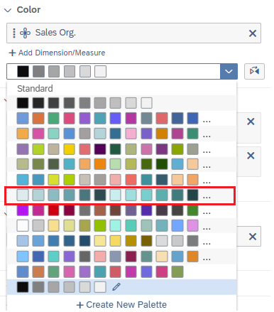
This automatically adjusts the colors of the bar chart.
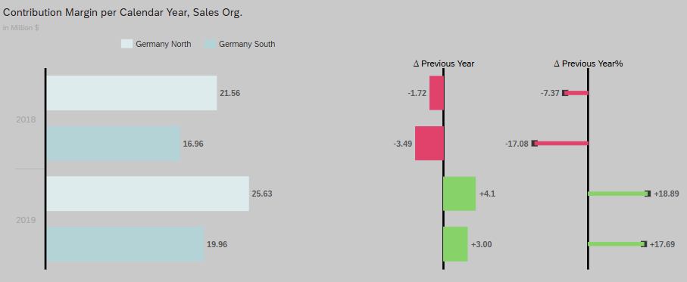
In the menu bar in the File area, choose Save icon to save your changed story. You then switch to the mode view to test your changes. |  | Save  View

