SAP Analytics Cloud -
Story Builder
This case study explains the process of creating a sales dashboard in SAP Analytics Cloud (SAC). The individual work steps explain the structure of a story in the Story Builder.

Product  SAP Analytics Cloud  Global Bike  Level  Bachelor's Degree  Master  Beginner  Focus  Business Intelligence  Data Visualization  Authors  Andreas Hofstetter  Frank Morelli  Anke Thurau  Stefan Weidner  Version  3.0  Last Change  March 2025 | MOTIVATION  An example sales dashboard was demonstrated in the exercises for SAP Analytics Cloud.  In this case study, you work out a sales dashboard yourself in the SAC Story Builder. The required activities include the creation of a story as well as further settings options for the SAC-specific elements.  PREREQUISITES  Before you edit the case study, you should familiarize yourself with the navigation in SAP Analytics Cloud. |  | REMARK  This case study uses a model with historical sales data from the fictitious company Global Bike.    THANK YOU  This case study was developed with the help of students and employees of the Pforzheim University of Applied Sciences as well as scientific and student assistants of the SAP UCC Magdeburg.  

 | Process Overview
Creating a Sales Dashboard as a Story in SAP Analytics Cloud (SAC) learning objective.  Scenario In her weekly video conference, Alex Kuhn (vice president of marketing and sales) informs his colleagues Andrea Marino (sales manager USA) and Hanna Ortmann (head of sales Germany) that the group has now also licensed the SAP Analytics Cloud (SAC) cloud solution in addition to SAP Data Warehouse Cloud. He orders the two to deal with SAC and set up a sales dashboard for Global Bike. It gives them the specifications mentioned below. |  | Time 220 min.
Specifications Alex Kuhn: “I’ve heard that in an SAC story, you can structure the charts into different pages or tabs. I suggest the following pages:
- Overview
- Customer View (3 Years)
- Product View
- Most Popular Bikes 2019
- Dynamic Analysis
“On the Overview page, I want to get a quick overview. I would like to show the most important key figures Revenue GC, Sales Quantity, Costs GC, and Contribution Margin for 2019 with comparative figures for the previous year..“
“It should also be possible to evaluate the key figures Revenue GC and Costs GC over the entire time period of the data.“
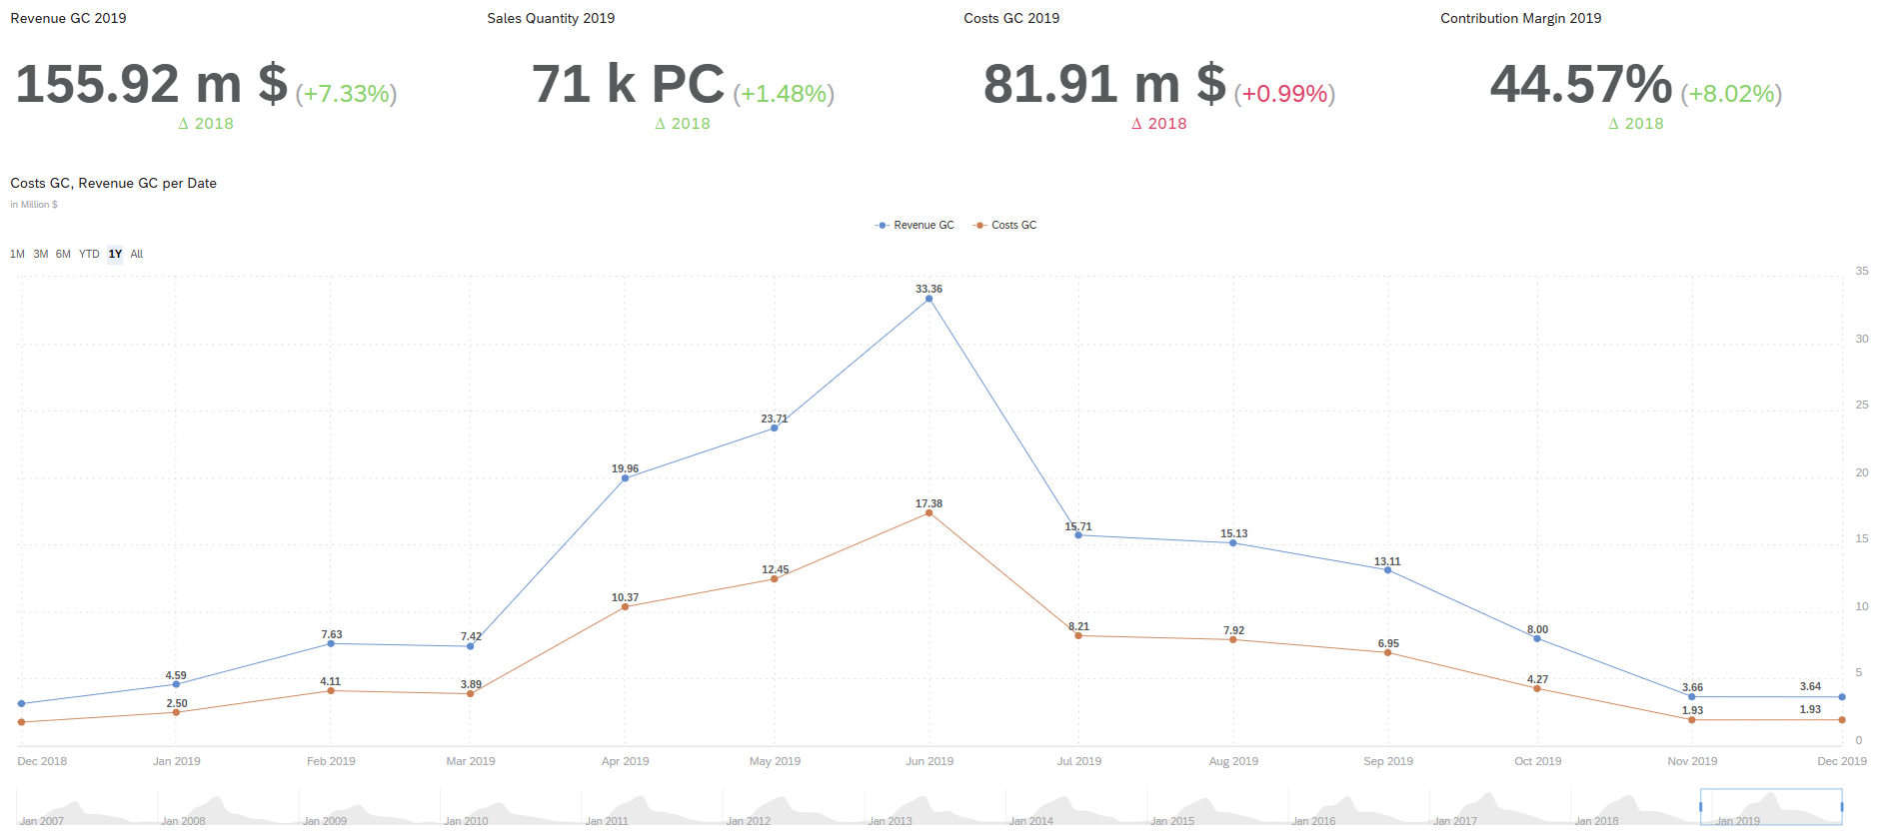
For the customer view of the last three years, I first imagine a table:
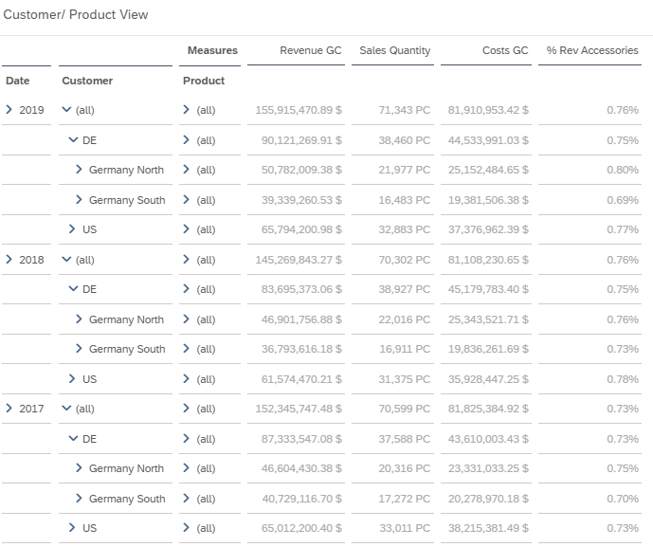
“You may already be able to display additional overviews of sales organizations there.“
“On the Product View page, I’d like an analysis with the sales quantity and contribution margin. It should be possible to filter the entire page by Date, Sales Organization, and Customer.“
“The percentage distribution of the sales quantity by sales organization per product category should be easy to evaluate.“
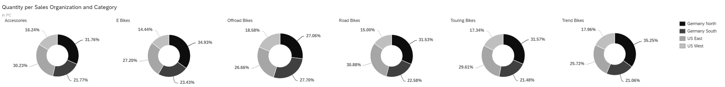
“Mrs Marino, Mrs Ortmann, you know that our contribution margin reaches a critical point at 46%. If it is possible to set up a threshold value for this value and evaluate it graphically, for example:
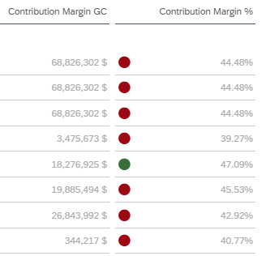
“In addition, the monthly quantities of the Bicycles division are to be displayed in a heat map.“
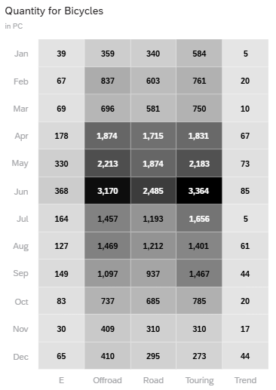
“I also want a presentation of the five most frequently sold products and the five most rarely sold products with previous year’s comparisons.“
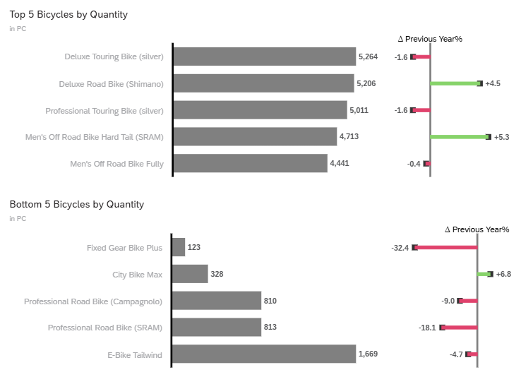
“On the Most Popular Bikes page, I want to see all the bikes of which we sold more than 2000 pieces.“
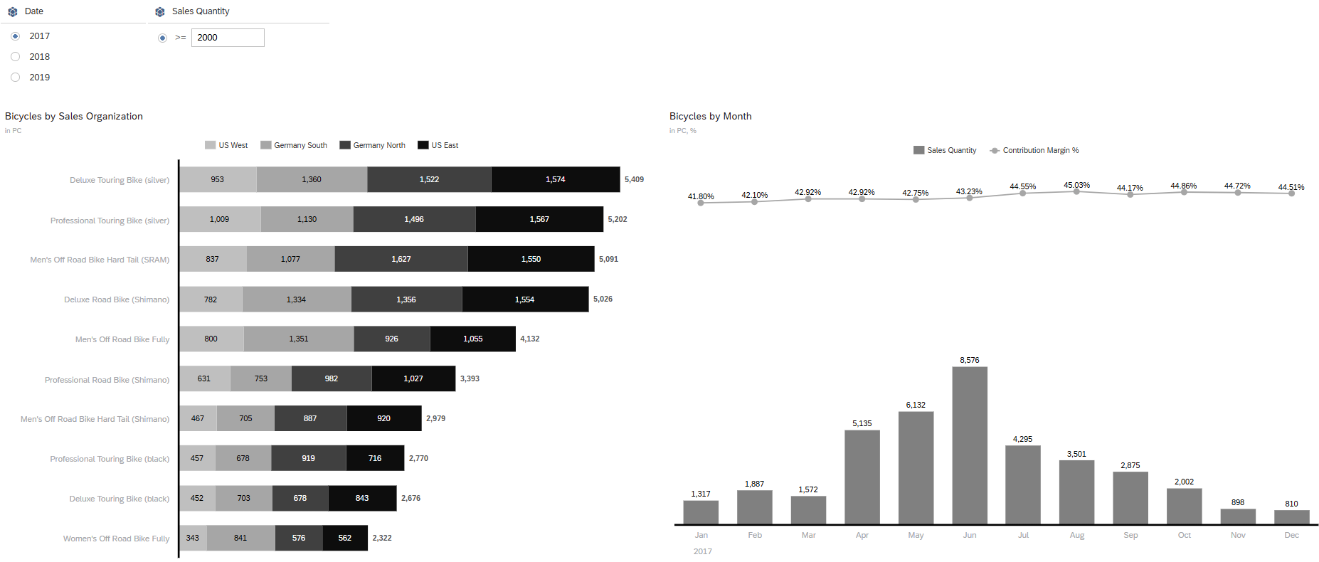
“It would be nice if I can select individual elements in one of the two graphics and then filter on this selection in the second graphic.“
“Finally, I want a dynamic analysis of various measures and dimensions of the last five years.“
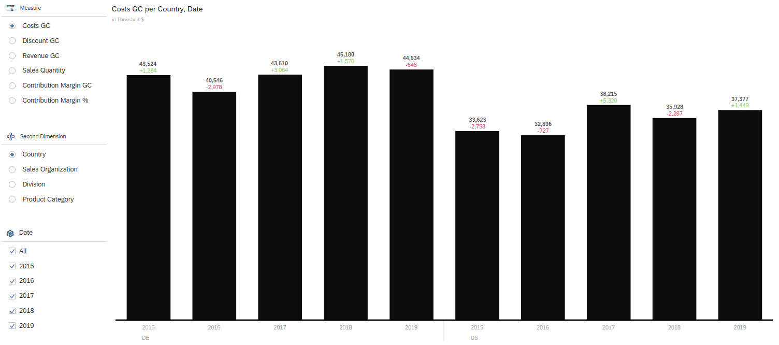

Table of Contents
Process Overview 2
Step 1: Log on to SAC 8
Step 2: View the Analytic Model 10
Step 3: Create a new story 16
Step 4: Create a graphic (time series) 19
Step 5: Structuring the Story 23
Step 6: Create a table 25
Step 7: Filter 32
Step 8: Graphics (Heat Map) 40
Step 9: Graphics (Donut) 44
Step 10: Dynamic Graphics 47
Step 11: Calculated Key Figures 51
Step 12: Restricted Key Figures 54
Step 13: Thresholds 57
Step 14: Ranking Lists 60
Step 15: Variances 63
Step 16: Graphic Numerical Point 67
Step 17: Calculated Characteristics 71
Step 18: Measure Filtering 74
Step 19: Linked Analysis 78
Step 20: [OPTIONAL] Share the story with instructor 82

 | Step 1: Log on to SAC
Task Log on to SAP Analytics Cloud.  Description Log on to the SAC tenant in a web browser. |  | Time 10 min.
Clicking on the following link takes you to the Identity Management System of SAP UCC Magdeburg. This provides anonymous identities for logging on to SAP cloud solutions according to valid data protection rights.  https://ucc-pilot-sac.eu10.hcs.cloud.sap/ |  | Initial Screen
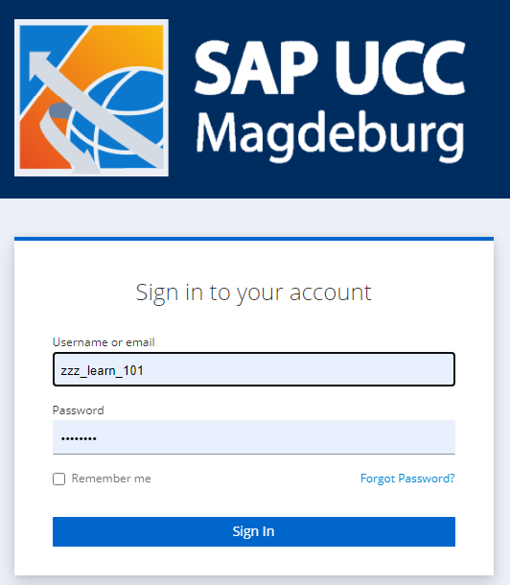
On the login screen, enter the user and password provided by your instructor. Then click Sign In. |  | User  Password  Sign In
Note If you log on to SAC with this user for the first time and with an initial password, you are prompted to enter a personal password for this user.
After you have entered your new password twice in the Update password window, confirm with Submit. |  | Password of your choice
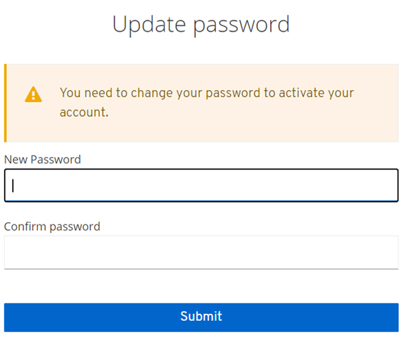
After logging on, you will be taken to the home screen. |  | Home Screen
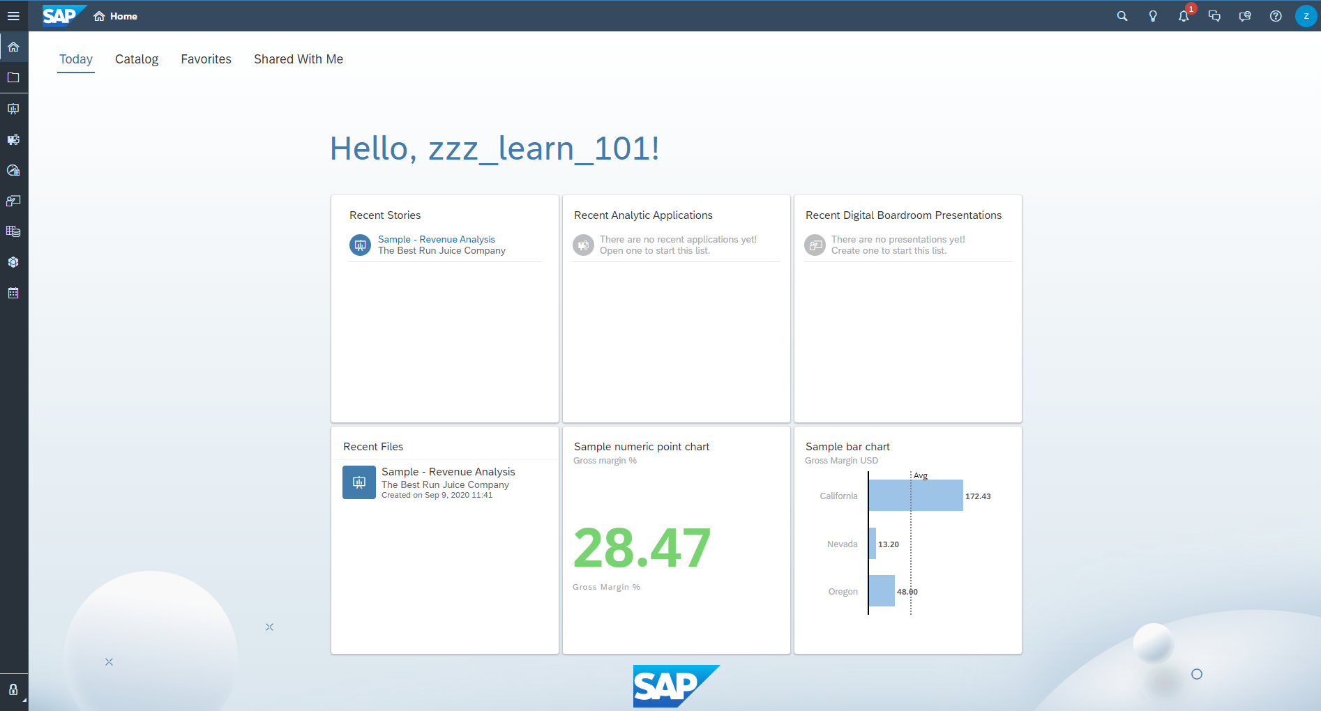

 | Step 2: View the Analytic Model
Task Familiarize yourself with the underlying model.  Description Before you start a story in SAC to visualize the new sales dashboard, start by looking at the analytic model that IT colleagues have created in advance. |  | Time 15 min.
On the home screen, click (Files) in the upper left corner. |  | Initial Screen
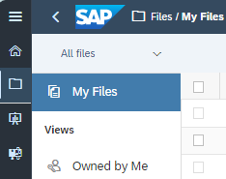
Navigate to the folder Public ►Curriculum 3.0. Here you select the model Global Bike (case study). |  | Public ->Curriculum 3.0  Global Bike (case study)
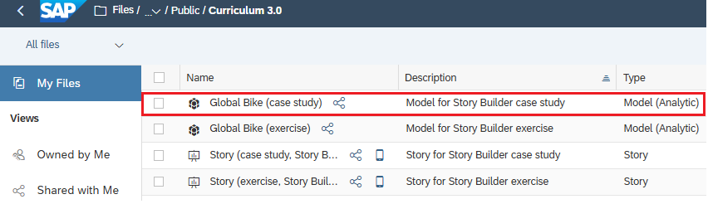
A model represents the business data of an organization or business segment. You can use a model as a basis for your story. |  | Model
There are two types of models available in SAP Analytics Cloud: |  | Model Types
- Imported: Data is imported (copied) and stored in SAP Analytics Cloud. Changes in the source system do not affect the imported data.
- Live: data is stored in the source system. They are not copied to SAP Analytics Cloud, meaning that any changes to the source data are immediately available unless structural changes are made to the table or SQL views.
In addition, there are two types of models: |  | Model Types
- Analytic Model: These are fully functional models that contain business data. It is the more flexible model type. Typically, analytic models are used to analyze data and uncover trends and anomalies. Analytic models can be consumed with live data (see above).
- Planning model: Planning models are used to support business planning tasks, e.g. B. Forecasts,, and used in the optimization of the planning process. Planning models cannot be created from a live data source.
As the name of the Global Bike (case study) model suggests, the model used in this case study is a new analytic model and focuses on the evaluation of defined key figures.
On the right-hand side of the screen in the Model Details, you can see that it is a measure-based analytic model.
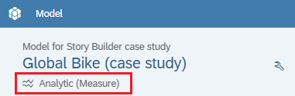
Note If you do not see the model details, click in the upper right corner.
You see a list of six measures and four dimensions of this model.
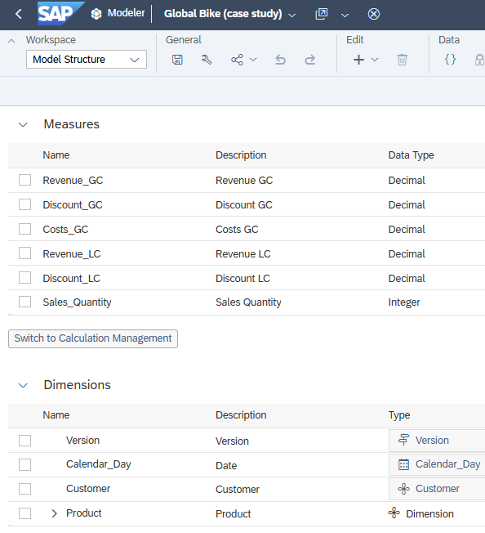
Note Models in financial and business reporting can have different measures that are reported in both global currency (GC) and local currency (LC). Revenue GC (Global Currency) and Revenue LC (Local Currency) are terms used in financial reporting and in the international business environment. They refer to the display of sales in different currencies.
Revenue GC (Global Currency): Refers to the recording and reporting of sales in a single, global currency, often referred to as consolidation currency. This currency is used to standardize the financial performance of a multinational company so that financial information is comparable across different countries and regions. A strong and stable currency such as the US dollar or the euro is often used for this purpose. The conversion is done using exchange rates to transfer local sales to this global currency.
Revenue LC (Local Currency): This key figure shows the revenue as recorded in the respective national currency of the location where the company operates. Sales figures in local currency provide an accurate view of financial performance in a specific market or country without the influence of exchange rate fluctuations.
By using Revenue GC and Revenue LC, companies can both analyze local market performance and get a consolidated view of the entire organization, which is essential for strategic decisions and reporting.
You can also choose to display the calculated key figure ContributionMargin USD. As you can see in the formula above, it is calculated as follows:
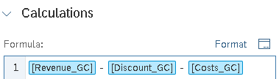
To return to the graphical model structure, choose Model Structure from the dropdown menu at the top left. |  | Model Structure
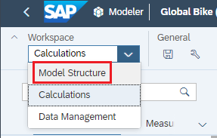
To get started, click the Calendar_Day time dimension to view the Settings dimension on the right. |  | Calendar_Day
Note If you do not see the settings, click in the upper right corner.
Under Dimension Table, click Edit Dimension Table ( ) to see the settings in detail. |  | Edit Dimension Table
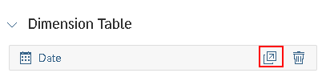
In the Settings dimension, you can see that day (day level) has been selected as the granularity for this time dimension. Year, Month, and Day are also defined as hierarchy levels.
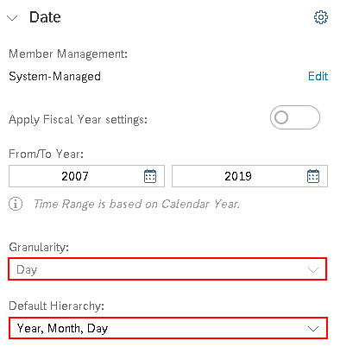
To return to the dimension view, choose Back in the header area. |  | Back
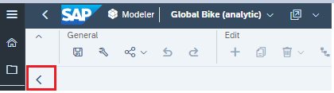
Next, click the Customer dimension in the model and choose Edit Dimension Table under Dimension. If you scroll to the bottom right of the Settings dimension, you can see the six available attributes of this dimension in the Properties area. |  | Customer  Edit Dimension Table
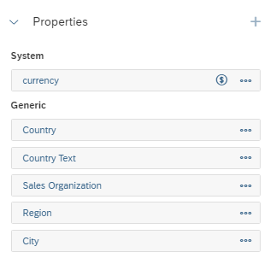
Below this, you find the Hierarchies section. From there, click More and then Edit next to Customer Hierarchy. |  | More  Edit
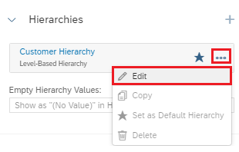
The system displays the defined customer hierarchy with the levels Country, Sales Organization, Region, and Member ID.
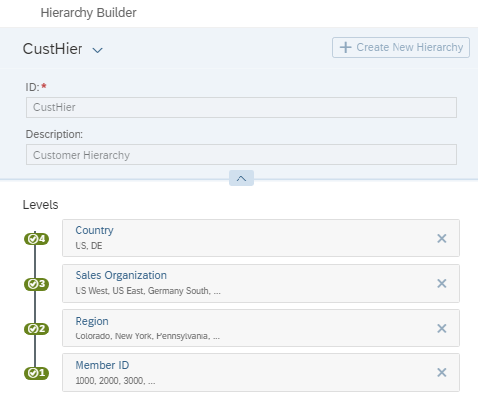
Click OK to close the Hierarchy Builder. You now see all 24 customers of Global Bike in a list with attributes. |  | Ok then
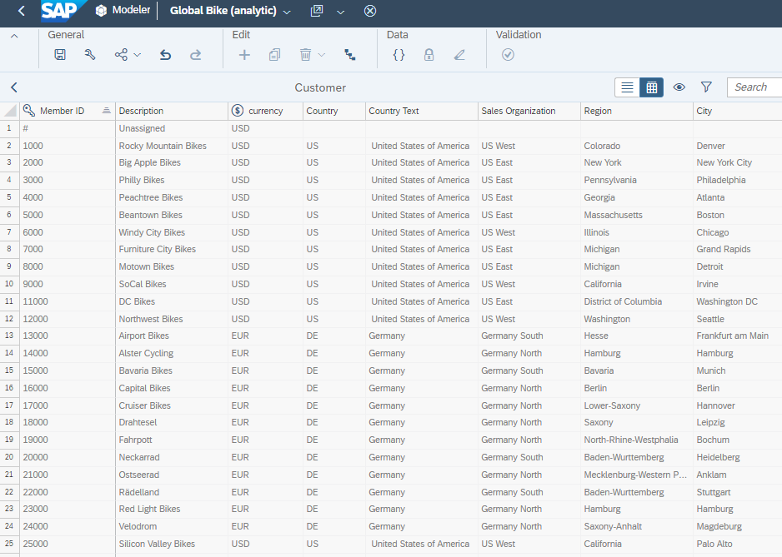
Click Back to return to the Model Structure. |  | Back
Finally, click the Product dimension and look at the available attributes, the hierarchy, and other details. |  | Product
Which hierarchy levels are defined for this dimension?
Level 1:
Level 2:
Level 3:
How many products does the table contain?
You have now understood the structure of the model used in this case study and can start creating your story.

 | Step 3: Create a new story
Task Open SAP Analytics Cloud and create a new story.  Description Open your SAC tenant and log on. You then create a new story based on an existing model. |  | Time 10 min.
To go to the home screen, click Home . |  | Initial Screen
To create a new story, choose Stories . |  | Story
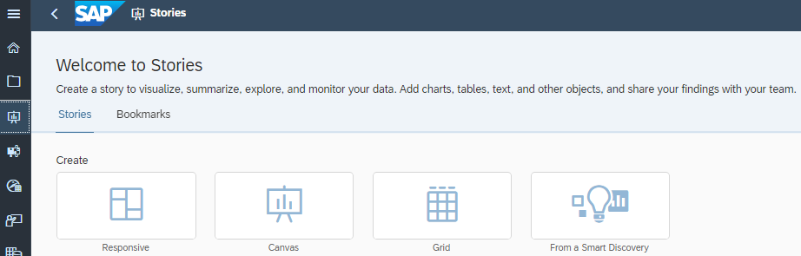
You can choose from four different layouts for your new story: |  | Layouts
- The responsive page allows you to create pages that can be accessed on all mobile devices due to their dynamic adjustment. However, as a result, it is not possible to create charts on top of each other, for example.
- The canvas page allows elements (charts and tables) to be freely arranged on pages. In this form of pages, you can, for example, place elements on top of each other or mix them together. In contrast to a responsive page, the elements on different end devices do not adapt automatically.
- The grid page only supports the display of tables. The page form enables, for example, additional calculations for cells, similar to the spreadsheet MS Excel.
- With From a Smart Discovery, a data model can be examined for correlations automatically and using predefined automatisms. In this way, corresponding charts and tables can be generated, which explain and display the main influencing factors and data connections, supplemented by corresponding texts for explanation.
The Grid Page and From a Smart Discovery are no longer supported in the Optimized Design Experience and are therefore not part of this exercise.
As part of the creation of your story, you will learn about responsive and canvas layouts.
First, start with a responsive page. To do this, click Responsive. |  | Responsive
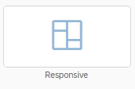
In the window that opens, select the Optimized Design Experience option and click Create. |  | Create
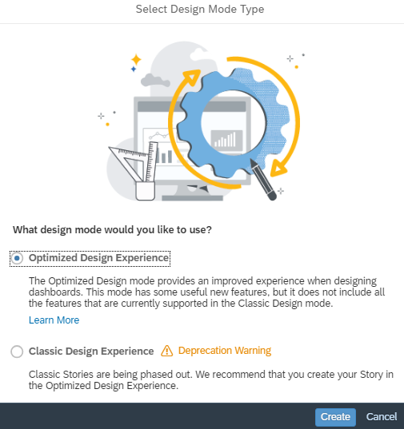
Before proceeding, save the story to your folder. To do this, click the Save icon in the File area of the ribbon and choose Save. |  | Save
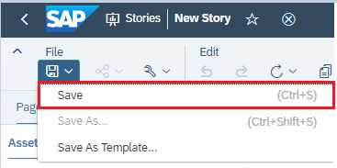
First, select the Stories subfolder as the location in your personal folder. You can access this via My Files ► My SAC course ► Stories.
Then enter ###_Story_Case_Study in the Name field and Story for case study in the Description field. Note that you replace ### with your three-digit number provided by your instructor. Compare your entries with the following screenshot and confirm the window with OK. |  | ###_Story_Case_Study  Story for Case Study  Ok then
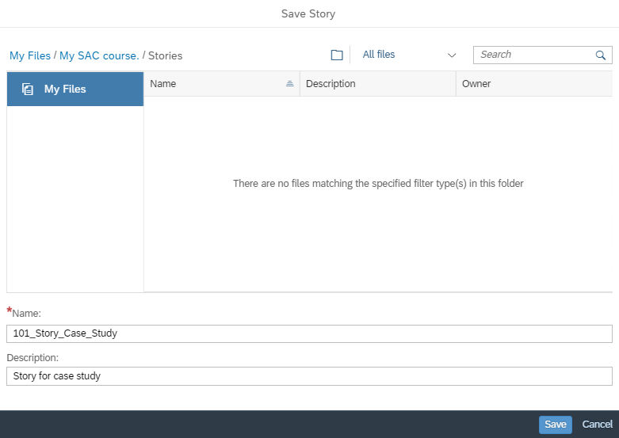

 | Step 4: Create a graphic (time series)
Task Create a graphic of type Time Series based on the Global Bike (analytic) model.  Description Define the graphic of the time series type and adjust the display. |  | Time 15 min.
You have still opened the Story_Case_Study story from the previous step. If you have closed them, search for them and find them in your personal folder. Make sure you are in Edit Mode. |  | Initial Screen
Graphics provide great ways to better visualize your data and present the corresponding key statements in a more conclusive way. |  | Graphic
The SAC story offers you a variety of different graphic types. Some of these graphic types will be presented in detail during the course of this case study.
Start with the Time Series graphic type to visualize sales and costs across the entire dataset.
To insert a graphic into your story, choose the Chart icon in the Insert area of the ribbon. |  | Chart
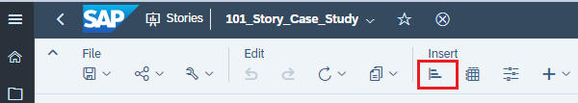
First, you must define which data source is to be used. Open the folder Public ►Curricula 3.0 and select the Model Global Bike (case study). |  | Public -> Curricula 3.0  Global Bike (case study)
After you assign the model, the right-hand side panel opens in the Builder panel.
Change the graphic type to Time Series. To do so, open the dropdown under Current Selected Chart and select the Time Series entry. |  | Current Selected Chart  Time Series
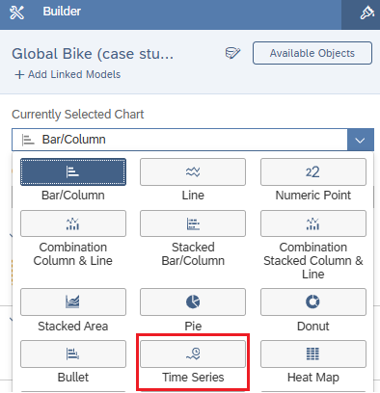
In the Measures section, choose At least 1 Measure required. |  | At least 1 Measure required
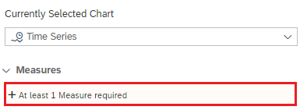
Now select the key figures Revenue GC and Costs GC one after the other. Please compare with the screenshot before proceeding. |  | Revenue GC  Costs GC
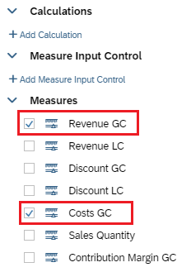
Click in the blue line of the right-hand side panel to return to the definition of the graphic. Then define the time dimension of your graphic.
In the Time section, click the At least 1 Dimension required entry and select Date. |  | At least 1 dimension required  Date
To change the initial display from day to month, choose Date under Time and choose Hierarchy . |  | Hierarchy
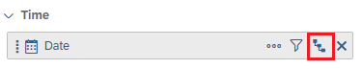
Choose the Month hierarchy level. |  | Month
In the right-hand side panel, switch from the Builder panel to the Styling panel. To do so, click Styling . |  | Styling
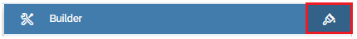
Under Size and Position, change Widht to 36 Grid and Height to 30 Grid. |  | 36 Grid  30 Grid
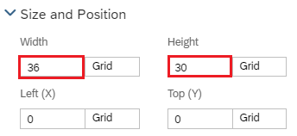 |  | Time -> Show Totals
Now scroll down to the Number Format area. Under Scale, select The value Million and the data in millions. |  | Million
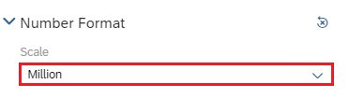
In view mode, it should only be possible to change the drill of time.
For this setting, scroll up again to the Quick Menus area in the right-hand side panel. Select all options here except Drill. |  | Drill
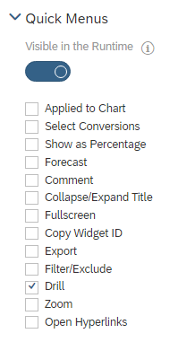
Rename the title of the first page to Overview. To do so, click the arrow next to Page 1 and select Edit Title.
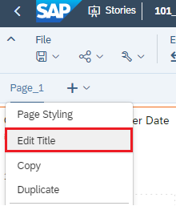
Finally, in the menu bar in the File area, choose Save icon again and then Save to save your changed story. |  | Save

 | Step 5: Structuring the Story
Task Structure your story through a second tab.  Description Create a second tab in your story and give it a meaningful name. |  | Time 10 min.
You are still in the story Story_Case_Study from the last step. If you have closed them, search for them and find them in your personal folder. Make sure you are in Edit Mode. |  | Initial Screen
To better structure your SAC story, you have the option to create multiple pages in your story. This procedure also makes it easier for the end user to use the story. |  | Pages
Within a story, you can specify for each tab whether it is a canvas page or a responsive page. For better usability and consistency, you should generally ensure that you use only one page type within your story, if possible.
This case study intentionally deviates from this procedure so that you can get to know the two page types in practice.
Currently, your story includes a page called Overview. To add another page, go to the area next to the Overview page, choose Add New Page and select the Add Canvas Page entry. |  | Canvas
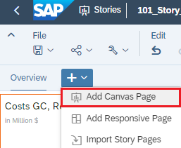
Now you get another page, which you rename to Customer View (3 Years). The navigation bar of your story should now look like this. |  | Customer View  (3 Years)
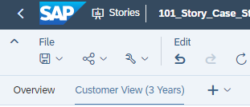
For a story with multiple pages, it should be possible to switch pages using tabs for easy navigation.
Check these settings for easy navigation for your story and make adjustments if necessary.
In the File area of the ribbon, choose The Icon Story Settings and choose View Time Settings ► Navigation. |  | Story Settings  View Time Settings  Navigation
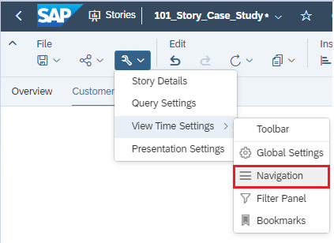
If Tabs is not selected under Configuration in the right navigation pane, use Override default settings to change the setting and select the Tabs option. Confirm your customizations with Done. |  | Override Default Settings  Tabs  Done
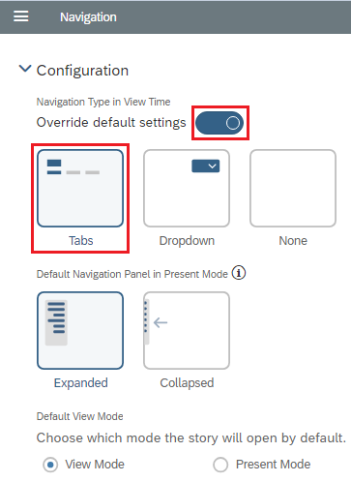
Finally, in the menu bar in the File area, choose Save icon again and then Save to save your changed story. |  | Save

 | Step 6: Create a table
Task Create a table with an individual analysis view on the existing data basis.  Description On the Customer View (3 Years) page, define the rows and columns of the table and adjust their appearance. |  | Time 15 min.
You have still opened the story Story_Case_Study from the previous step. If you have closed them, search for them and find them in your personal folder. Make sure you are in Edit Mode. |  | Initial Screen
In the Insert area of the ribbon, choose the Icon Table . |  | Table
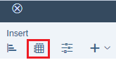
In the right-hand side panel that opens, first make sure that the Builder settings are displayed. Then, in the Rows section, choose Add Dimensions. |  | Add Dimensions
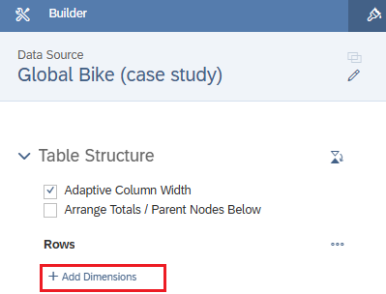
Now select the dimensions Date, Customer, and Product one after the other. Please compare with the screenshot before proceeding. |  | Date  Customer  Product
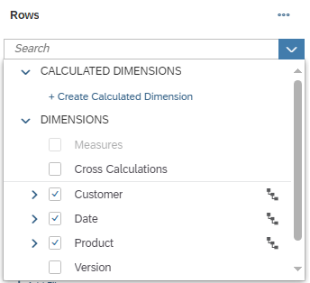
You now define the key figures to be displayed in your table. To do so, move your mouse to the Columns section and click Manage Filters next to Measures. |  | Manage Filters
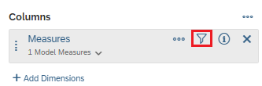
In the window that opens, select the key figures Sales Quantity, Cost GC, and Revenue GC and confirm the window with OK. |  | Sales Quantity  Cost GC  Revenue GC  Ok then
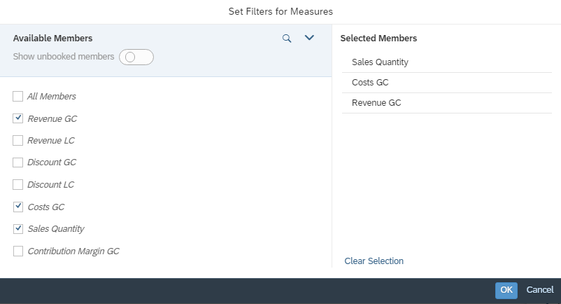
Since you only want to view the data from the last three years in the tabular evaluation, choose Add Filters in the Filter area. |  | Add Filters
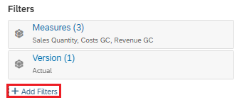
Select Date (Member) and select the last three years. |  | Date (Member)
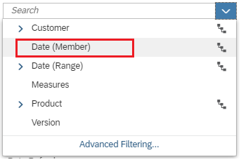
Since this should be a rigid filter, that is, a fixed filter that cannot be changed by the end users, deselect Allow viewers to modify selections and confirm the window with OK. |  | Allow viewers to modify selections  Ok then
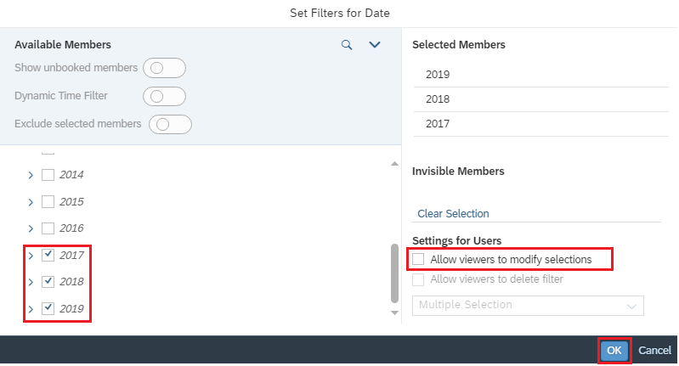
Since you want to see the most recent data first, the Date dimension must be sorted in descending order. To do so, right-click Time ► Sort Options ► Newest to Oldest in the table. |  | Date ->  Sort Options ->  Newest to Oldest
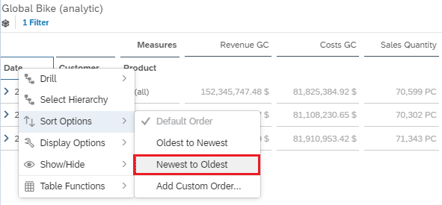
For better readability, the key figures should be displayed in the sequence Revenue GC, Sales Quantity, and Cost GC. To do this, click on the More icon on the right side of the Builder under Measures and choose Edit Member Order. |  | More  Edit Member Order
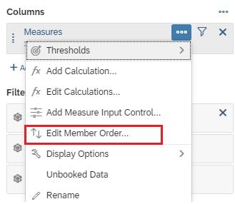
Now use drag and drop to change the sequence to the above and confirm the view at the bottom right with Done. |  | Revenue GC  Sales Quantity  Cost GC  Done
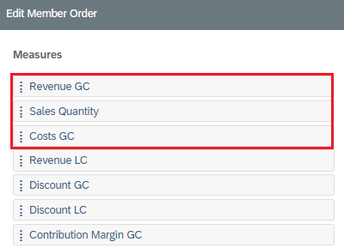 |  | Revenue GC  Sales Quantity  Cost GC  Done
In the menu bar in the File area, choose Save and then Save to save your changed story. |  | Save
Adjust the header of the table. To do this, double-click in the text and enter customer/product view instead of the model name. |  | Customer/Product View
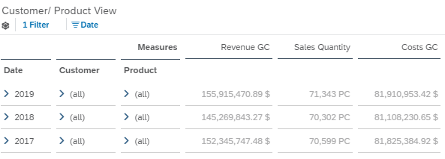
Next, you remove table details. When you click on your table, the option More Actions 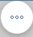 appears in the upper right corner. Click the button. In the context menu, choose Show/Hide. In the following submenu, deselect Table Details. |  | Show/Hide  Table Details
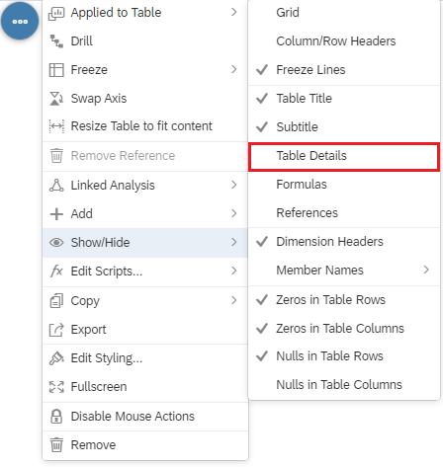
The customer hierarchy should be open in the initial view up to the level of the sales organization (level 3). To do this, right-click Customer ► Drill ► Level 3 in the table. |  | Customer  Drill  Level 3
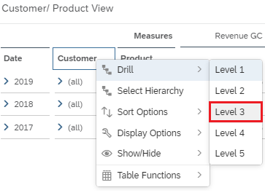
In the right-hand side panel, switch from the Builder panel to the Styling panel. To do so, click Styling . |  | Styling
Under Size and Position, change Widht to 100% and Height to 100%. |  | 100%
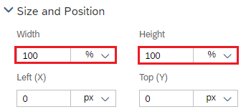
You do not want a context menu to be available in view mode, so you deselect the option under Quick Menus in the right-hand side panel. |  | Quick Menus
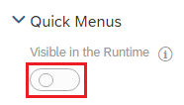
With that, you've built a simple, analyzable table on the second page of your story.
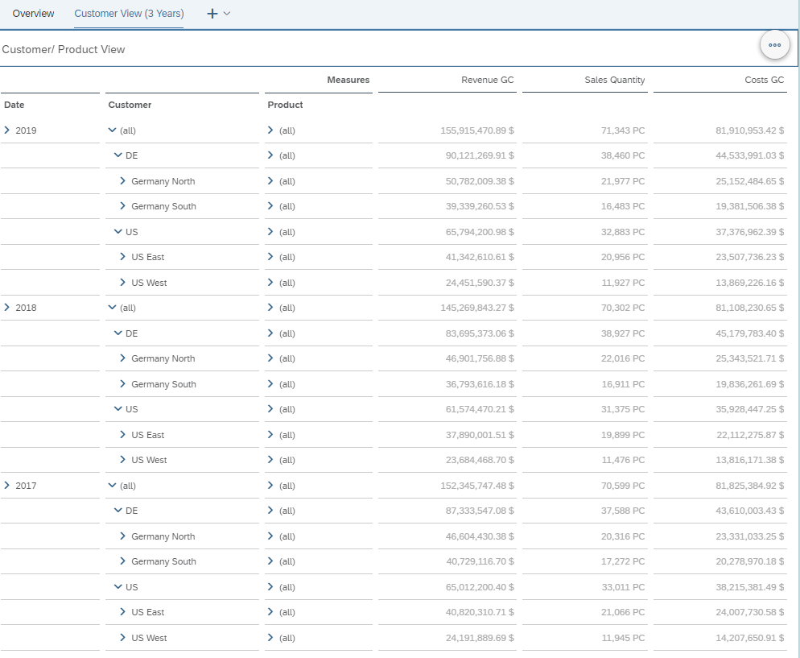
Finally, in the menu bar in the File area, choose Save icon again and then Save to save your changed story. |  | Save

 | Step 7: Filter
Task Create different filters.  Description Create a story filter and a new page with Page Filters. |  | Time 15 min.
You are still in the story Story_Case_Study from the last step. If you have closed them, search for them and find them in your personal folder. Make sure you are in Edit Mode. |  | Initial Screen
You can use the following three types of filters in an SAC story: |  | Filter Types
- The story filter affects all pages and members of a story, so it should not overlap or exclude from the other two types of filters. An important prerequisite for the end-to-end function of the story filter is that all elements are based on one data source or all data sources for the story filters are linked correctly. |  | Story Filter
- As the name suggests, the page filter works on all elements of a specific page at page level (per tab). Here, too, the general conditions apply for a correct function. |  | Page Filter
- The Filters widget is the deepest filter level. It is defined at the level of individual elements (widgets). In particular, make sure that there are no collisions with existing story filters and page filters based on the same dimensions or measures. |  | Widget Filter
You still have the Customer View (3Years) page open. In the upper menu area under View, open the Left Side Panel. |  | Left Side Panel
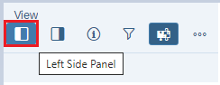
For the story of this case study, you first define a story filter on the dimension Country Text. To do this, switch to the Filters tab in the left-hand side area. |  | Filters
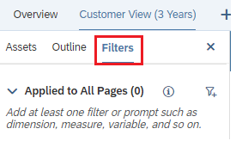
Next to Applied to All Pages (0), click Add New Filters ( ) and set a story filter to Country Text by selecting this attribute via Dimensions ► Customer ► Country Text ► Filter by Member…. |  | Add New Filters  Dimensions  Customer  Country Text  Filter by Member…
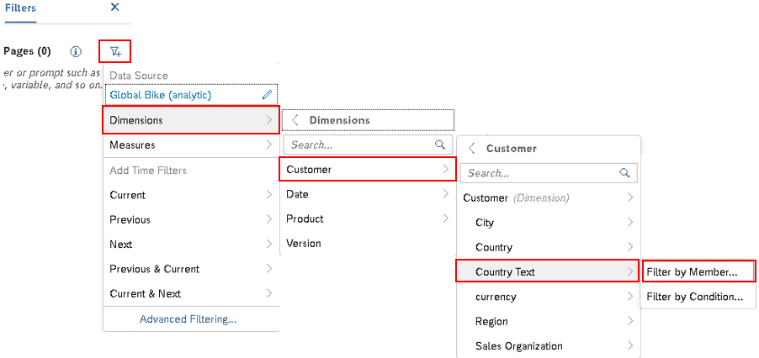
In the dialog box that appears, choose All Members and confirm the window by choosing OK. |  | All Members  Ok then
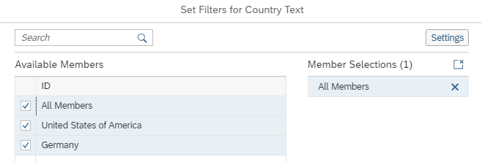
Change the story filter so that the selection is implemented immediately (without confirmation using the Apply Selections button). Click Expand of the filter. |  | Expand
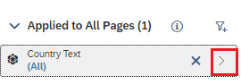
To deactivate the button, select Show/Hide ► Apply Selection Button. |  | Show/Hide  Apply Selection Button
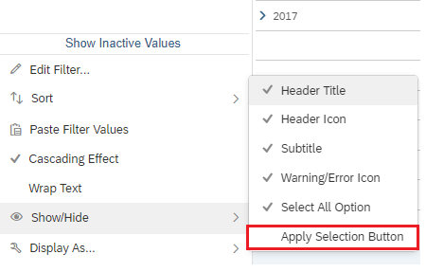
Return to the basic view by choosing Back . |  | Back
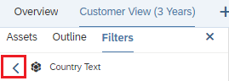
To have the story filter available in the story header, choose Pin to Top in the footer of the Filters tab. |  | Pin to Top
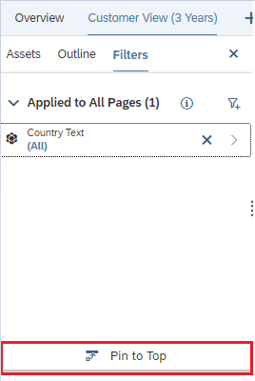
In the story header, you have made it possible to filter text for all pages using the Country dimension.
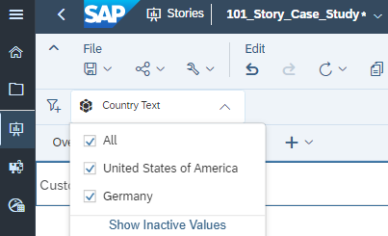
In the File area of the ribbon, choose the Save icon and then Save to save your changed story. |  | Save
Next, create a new Responsive page and name it Product View. |  | Page Product View
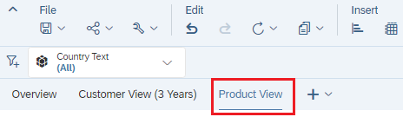
Define page filters for Date, Sales Organization, and Customer. To do this, you first add a new area above the existing area. To do this, click on the existing area and choose More Actions ► Add Lane ► Add Lane Above. |  | More Actions  Add Lane  Add Lane Above
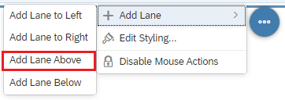
In the new header area of the page, insert the filters. To do this, click in the header area and insert the three filters mentioned above by clicking on the icon input control in the Insert ribbon. |  | Input Control
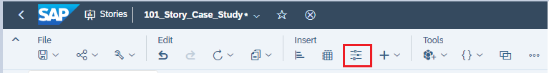
The system then inserts a Page Filter element. You must now define this. To do this, select the entry Dimensions ► Date ► Filter by Member… in the menu that opens. |  | Dimensions  Date  Filter by Member…
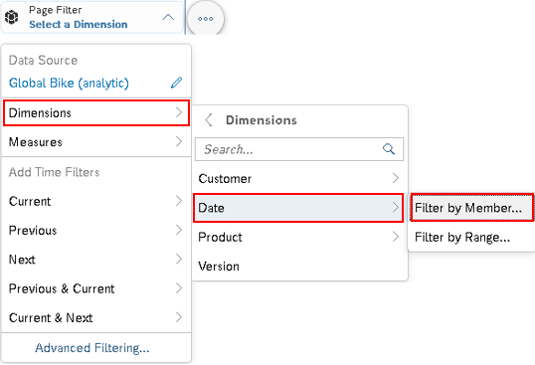
In the following dialog, you select the values for 2017, 2018, and 2019 and the selection type as single selection, since only a single selection of the year should be possible in this filter. Confirm the window with OK. |  | 2017, 2018, 2019  Settings  Single Selection  Ok then
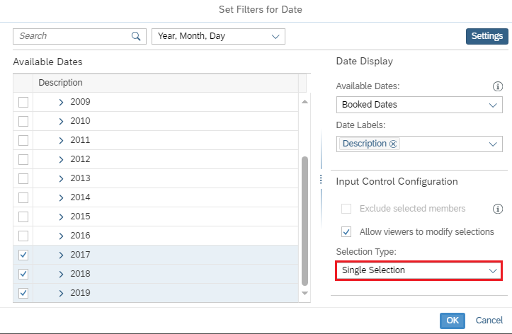
Repeat the steps for Sales Organization (under Customer) Filter by Member… with selection All Members with option Multiple Selection. |  | Sales Organization
Multiple Selection specifies that the end user should be able to select multiple options at the same time.
For Customer (Dimension), also proceed as a filter by member…. Deactivate the hierarchy with the Flat Presentation selection, choose All Members with the Multiple Selection option. |  | Flat Presentation
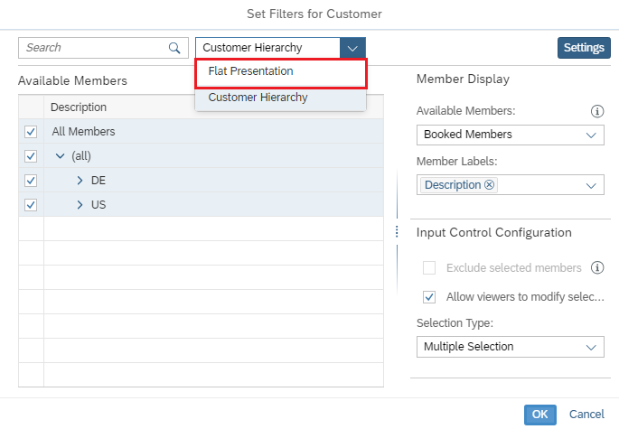
To save space, you want to hide the unnecessary icons next to the filter titles. To do this, right-click the relevant filter and choose Show/Hide ► Header Icon. |  | Show/Hide  Header Icon
For the filters on Sales Organization and Customer, disable the Apply Selection button by right-clicking in the filter and selecting Show/Hide ► Apply Selection Button. |  | Show/Hide  Apply Selection Button
Right-click the filter Customer and choose Sort ► Ascending to sort the customers alphabetically. |  | Sort  Ascending
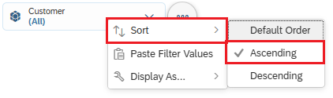
As a result, you can now find the three defined page filters in your page header.
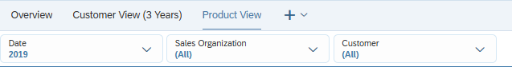
In the lower area, you now want to insert a table that shows you the date and product information.
Click in the area below the filters and choose the Icon Table in the Insert area of the ribbon.
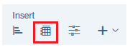
The right-hand side panel in the Builder panel has now opened.
In the Rows section, choose Add Dimensions and, one by one, the Date and Product dimensions. |  | Add Dimensions  Date  Product
You now define the key figures to be displayed in your table. To do so, move your mouse to the Columns section and click Manage Filters next to Measures. |  | Manage Filters
In the window that opens, select the key figures Sales Quantity and Contribution Margin GC, and confirm the window by choosing OK. |  | Sales Quantity  Contribution Margin GC
Since the focus of this page is on the Bicycles division, choose Add Filters in the Filter area. Now choose Dimension ► Product ► Division. In the Set Filters for Division window, select the Bicycles division. |  | Add Filters  Product  Division ->  Bicycles
Since this should be a rigid filter, that is, a fixed filter that cannot be changed by the end users, deselect Allow viewers to modify selections and confirm the window with OK. |  | Allow viewers to modify selections
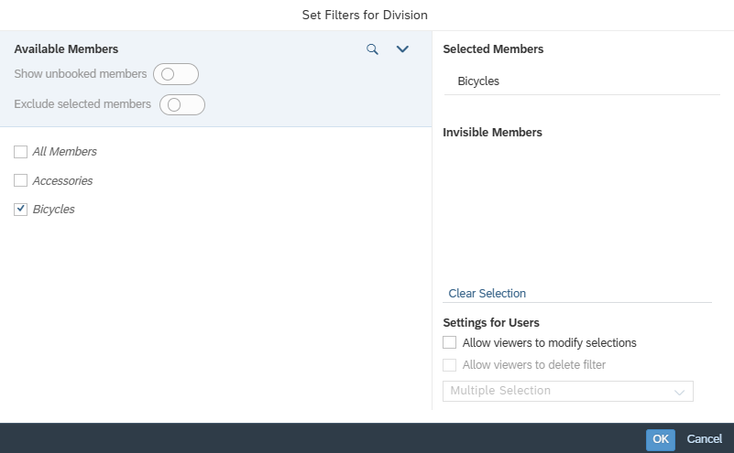
In the File area of the ribbon, choose Save icon and then Save to save your changed story. |  | Save
Compare your settings with the following screen.
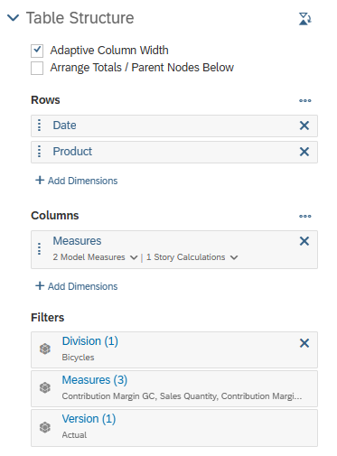
Now adjust the header of the table. To do this, double-click in the text and enter Bicycles instead of the model name. |  | Bicycles
Next, you remove table details. When you click on your table, the option More Actions appears in the upper right corner. Click the button. In the context menu, choose Show/Hide. In the following submenu, deselect Table Details. |  | More Actions  Show/Hide  Table Details
In the table, click the arrow below Date to expand its data to the level of the year.
In the right-hand side panel, switch from the Builder panel to the Styling panel. To do so, click Styling . |  | Styling
In view mode, the users should not have a context menu available.
In the Quick Menus area on the right-hand side of the screen, deselect it. |  | Quick Menus
Also deselect the Quick Menus for all 3 page filters. |  | Quick Menus
Test the functionality of your page filter by selecting the year 2019 for Date. |  | 2019
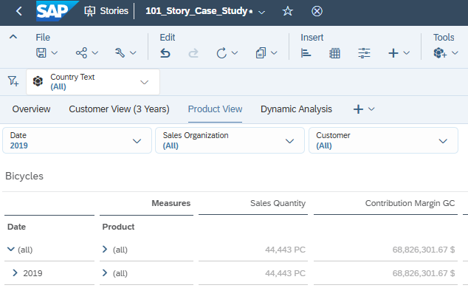
Finally, choose Save icon again in the File area of the ribbon and then Save to save your changed story. |  | Save

 | Step 8: Graphics (Heat Map)
Task Create a Heat Map.  Description On the Product View tab, create a heat map graphic. |  | Time 10 min.
You are still in the story Story_Case_Study from the last step. If you have closed them, search for them and find them in your personal folder. Make sure you are in Edit Mode. |  | Initial Screen
On the Product View page, you first insert a new area next to the area of the table. To do this, click the area of the table and choose More Actions ► Add Lane ► Add Lane to Right. |  | More Actions  Add Lane  Add Lane to Right
In the new area, use the ribbon to insert a graphic in the Insert area by clicking the Chart icon . |  | Insert -> Chart
The right-hand side panel in the Builder panel has now opened.
Change the graphic type to Heat Map. To do so, open the dropdown under Current Selected Chart and select the Heat Map entry. |  | Current Selected Chart  Heat Map
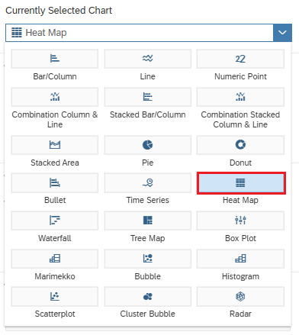
Define Product Category (under Product) as X-Axis, Date as Y-Axis, and Sales Quantity as Color. |  | Product Category  Date  Sales Quantity
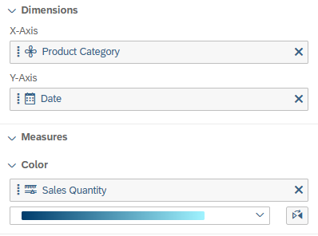
Under Add Filters for the Division dimension, add a filter on bicycles that cannot be changed by the end users. |  | Add Filters  Bicycles
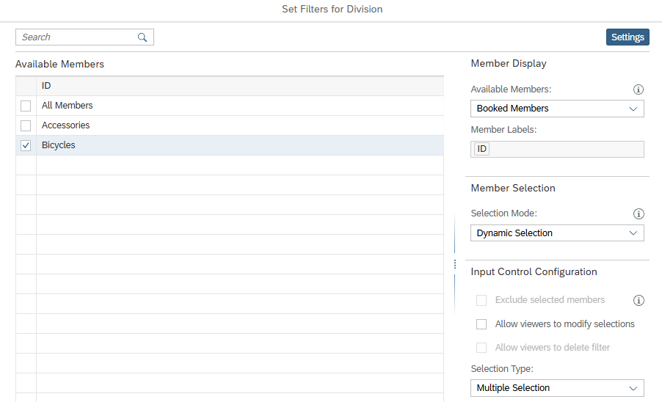
Since you want the dimension Date to be displayed after months, now use the mouse to move to the area of the Dimension Date and select Hierarchy and then Level 3. |  | Hierarchy  Level 3
Next, you change the color gradient to grayscale using the dropdown. |  | Grayscale
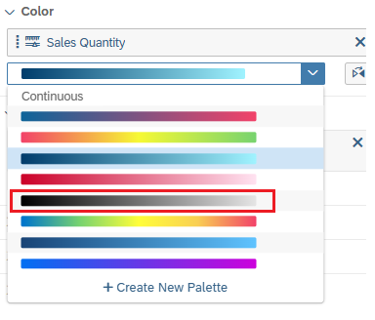
In the right-hand side panel, switch from the Builder panel to the Styling panel, and in the Quick Menus area, deselect all options except Fullscreen. |  | Styling  Fullscreen
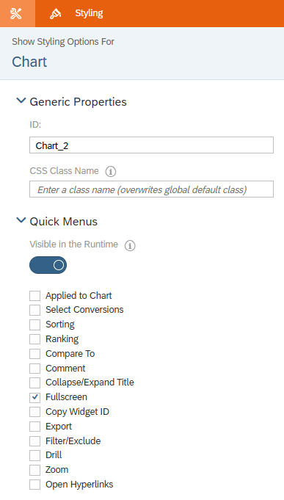
Now adjust the heat map header. To do this, double-click in the text and enter Quantity for Bicycles. |  | Quantity for Bicycles
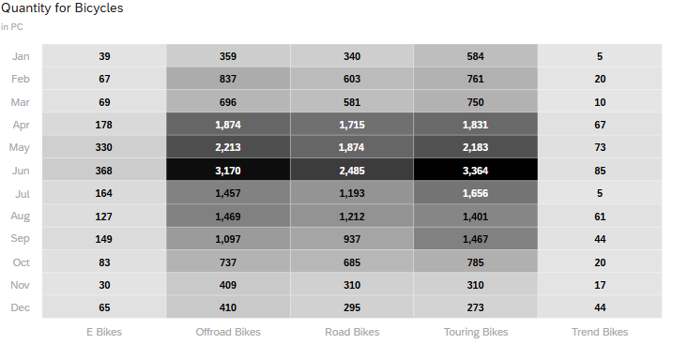
Finally, in the menu bar in the File area, choose Save icon again and then Save to save your changed story. |  | Save

 | Step 9: Graphics (Donut)
Task Create so-called donut graphics.  Description Create a graphic of type Donut on the Product View tab. |  | Time 10 min.
You have still opened the Story_Case_Study story from the previous step. If you have closed them, search for them and find them in your personal folder. Make sure you are in Edit Mode. |  | Initial Screen
On the Product View page, you first insert a new area below the area of the page filters. To do this, click the area of the page filters and choose More Actions ► Add Lane ► Add Lane Below. |  | More Actions  Add Lane  Add Lane Below
Insert a graphic in the new area by clicking the Chart icon ( ) in the Insert area of the ribbon. |  | Chart
The right-hand side panel in the Builder panel has now opened.
Change the graphic type to Donut. To do this, open the dropdown under Current Selected Chart and choose donut. |  | Current Selected Chart  Donut
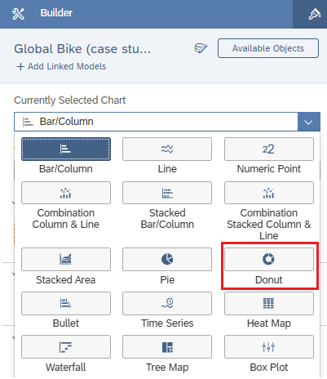
You now define Sales Quantity as Measure, Sales Organization as Color, and Grayscale as Color Scheme. |  | Sales Quantity  Sales Organization  Grayscale
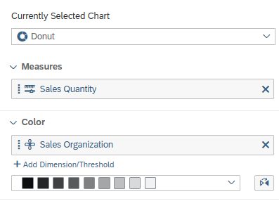
Since the different shades of gray are difficult to distinguish, change the color palette. To do this, choose + next to the color palette. |  | +
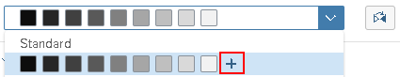
The Create New Palette window opens and now delete every 2. Color by clicking on it and choosing x. Finally, close the window by choosing Create.
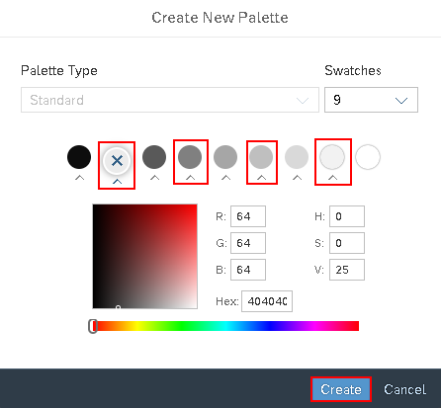
To display a graphic for each product category, use the Trellis option. Open the Chart Add-Ons area and then choose Trellis. |  | Chart Add-Ons  Trellis
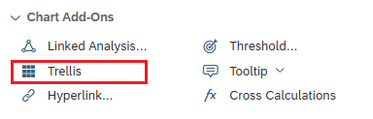
The Trellis area has now been added. Click Add Dimension and select Product Category (under Product). |  | Add Dimension  Product Category
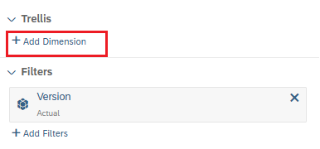 |  | Sales Quantity per Category (3 Years)
On the right-hand side panel, switch from the Builder panel to the Styling panel and deselect Quick Menus. |  | Styling  Quick Menus
Under Size and Position, change Widht to 36 Grid and Height to 11 Grid. |  | 36 Grid  11 Grid
In the right side panel, scroll down to the Legend pane. Under Placement, choose Beside Chart (Right). |  | Beside Chart (Right)
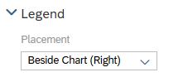
Next, disable the display of all subtitles. When you click on your graphic, the option More Actions ( ) appears in the upper right corner. Click the button. In the context menu, choose More Options ► Show/Hide ►Subtitle ► All. |  | More Actions  More Options  Show/Hide  Subtitle  All
Change the title of the graphic to Quantity per Sales Organization and Category. |  | Quantity per Sales Organization and Category
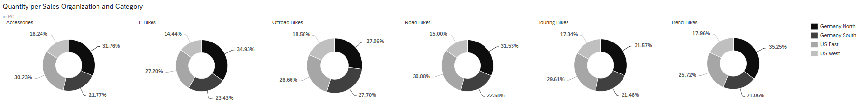
Finally, in the menu bar in the File area, choose Save icon again and then Save to save your changed story. |  | Save

 | Step 10: Dynamic Graphics
Task Create a dynamic graphic.  Description Create a dynamic graphic in which the end user can select the key figures and characteristics of the analysis view at the time of execution. |  | Time 15 min.
You are still in the story Story_Case_Study from the last step. If you have closed them, search for them and find them in your personal folder. Make sure you are in Edit Mode. |  | Initial Screen
So that the end user can dynamically analyze their measure and dimension on a time axis of years, you want to make a dynamic evaluation option available in your story next.
To do this, you define the Dynamic Analysis page by creating a new Responsive page and renaming it to Dynamic Analysis. |  | Add New Page  Dynamic Analysis
Use the ribbon to insert a graphic in the Insert area by clicking the Chart icon. |  | Chart
The right side panel in the Builder panel opens. Leave the graphic type and change the orientation to Vertical using the Chart Orientation dropdown. |  | Chart Orientation  Vertical
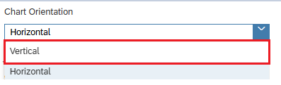
Define dynamic key figure selection. To do so, select At least 1 Measure required under Measures in the Builder panel on the right side panel, and then select Add Measure Input Control. |  | At least 1 measure required  Add Measure Input Control
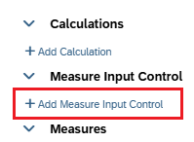
In the window that appears, select the key figures Costs GC, Discount GC, Revenue GC, and Sales Quantity and confirm the window by choosing OK. |  | Costs GC  Discount GC  Revenue GC  Sales Quantity  Ok then
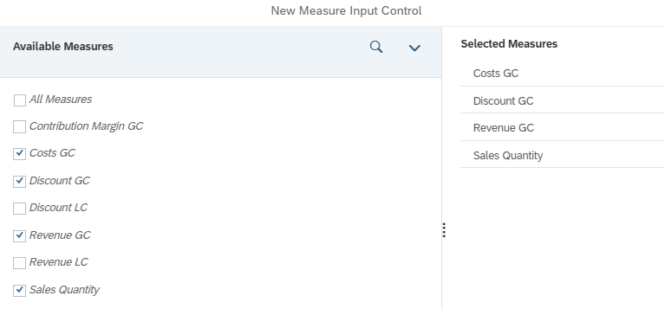 |  | Costs GC  Discount GC  Revenue GC  Sales Quantity  Ok then
A selection filter now appears to the right of your graphic. Move it to the left side of the graphic. Insert a new area to the left of the graphic and move the selection filter to it. |  | Add Lane to Left
To change the dimensions, click on the graphic again and in the Builder, under Dimensions, choose Add Dimension and then choose Add Dimension Input Control. |  | Add Dimension  Add Dimension Input Control
In the window that appears, select the dimensions Country, Sales Organization (both under Customer) and Division and Product Category (both under Product) and confirm the window with OK. |  | Country  Sales Organization  Division  Product Category  Ok then
You also move this selection filter to the left, below the selection filter of the key figure, with a little distance. Next, drag both selection filters so that the selection can be made easily via radio buttons.
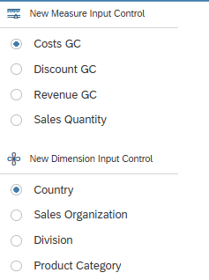
Define a Page Filter on Date, which enables end users to select a maximum of the last five years.
To do this, click in the right-hand area and insert a filter using the Insert ribbon and click on the icon input control . |  | Input Control
The Page Filter element is then inserted. Define the Page Filter. To do this, select the entry Dimensions ► Date ► Filter by Member… in the menu that opens. |  | Dimensions  Date  Filter by Member…
To do this, click in the header area and insert a filter using the menu Insert ► Input Control. |  | Insert -> Input Control
This inserts a Page Filter element. You now need to define this. To do this, in the menu that opens, select Dimensions ► Time ► Filter by Members…. |  | Dimensions -> Time -> Filter by Member…
In the following dialog, select the last five years (2015-2019), select Multiple Selection as the Selection Type under Settings, and confirm the window with OK. |  | last five years  Multiple Selection  Ok then
Now drag the filter below your dimension filter on the left and adjust it to the full size as well.
For the filter on Date, deactivate the Apply Selection button and the Cascading Effect by right-clicking in the filter and choosing Cascading Effect or Cascading Effect. Show/Hide ► Apply Selection Button. |  | Cascading Effect  Show/Hide  Apply Selection Button
Insert Date as the second dimension of the graphic using Add Dimension. |  | Add Dimension  Date
Since you want the Dimension Date to be displayed after years, now use the mouse to move to the area of the Dimension Date and select Hierarchy and then Level 2. |  | Hierarchy  Level 2
Change the color palette to grayscale. |  | Grayscale
In the right-hand side panel, switch from the Builder panel to the Styling panel and resize the Date Page Filter by clicking it and changing the Height to 13 Grid under Size and Position. |  | Styling  Date Height 13 Grid
Under Quick Menus, select Visible in the Runtime for all 3 filter elements. |  | Quick Menus
Rename the selection filter for the measure in the measure and the selection filter for the characteristic to Second Dimension. To do this, double-click the relevant text. Once it's marked in blue, you can adjust the text. |  | Measure  Second Dimension
Adjust the width of the left panel to the width of the filters.
Change the size of the diagram by clicking it and changing the Width to 25 Grid and the Height to 30 Grid under Size and Position. |  | Width 25 Grid  Height 30 Grid
Deactivate the quick menus for the graphic. |  | Quick Menus
To keep the key figures readable, you need to adjust their scaling. To do this, scroll down to the Number Format area and select Thousand for Scale and 0 for Decimal Places. |  | Thousand  0
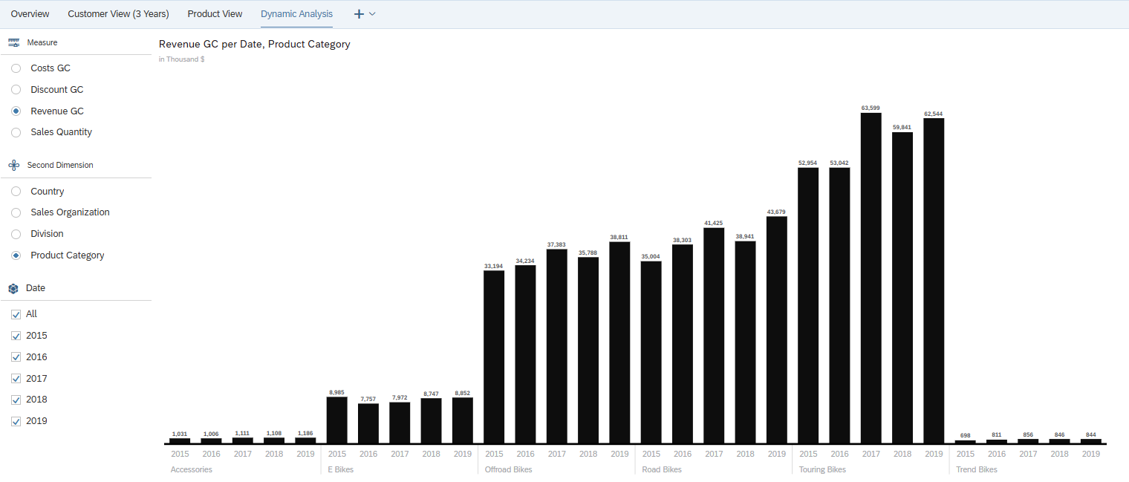
Finally, in the menu bar in the File area, choose Save icon again and then Save to save your changed story. |  | Save

 | Step 11: Calculated Key Figures
Task Create calculated key figures.  Create the calculated key figure Contribution Margin % in the table on the Product View tab page. |  | Time 10 min.
You are still in the story Story_Case_Study from the last step. If you have closed them, search for them and find them in your personal folder. Make sure you are in Edit Mode. |  | Initial Screen
SAC allows you to create calculated measures for a model within a story. For these calculations, you can use all measures in the model as operands. |  | Calculated Key Figures
For a better analysis option of the product data, the key figure Contribution Margin % is to be added as a calculated key figure in the table on the Product View tab page.
To create the calculated contribution margin % key figure, go to the table on the Product View tab and open the Builder panel on the right-hand side panel.
Now move your mouse to the Columns section and then click More next to Measures. Now choose the Add Calculation… entry. |  | Add Calculation…
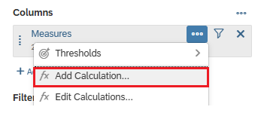
The Calculation Editor window opens. As the type, first select Calculated Measure. Enter Contribution Margin % as the name of the calculated key figure. |  | Calculated Measure  Contribution Margin %
In the formula field (Edit Formula section), you define the formula Contribution Margin GC/ Revenue GC. |  | Formula
Note To insert the key figures, use the key combination CTRL + Space as input help. The measures included in the model are at the bottom of the list.
When you have finished defining your measure, confirm the window with OK so that the new measure is applied to your story. |  | Ok then
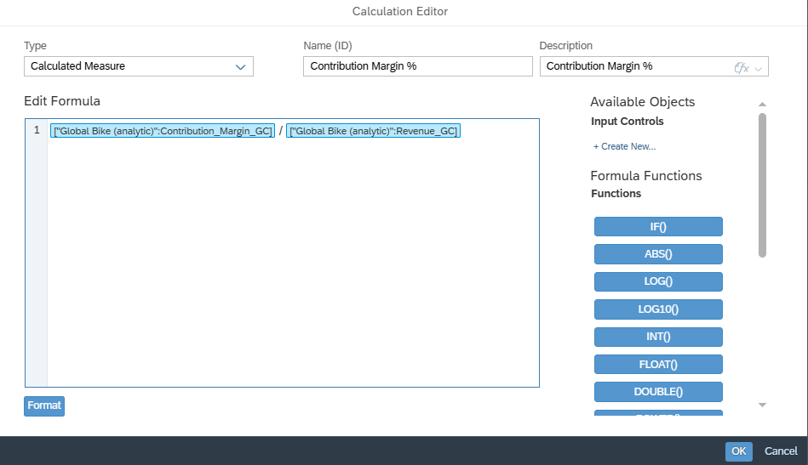
Your new Contribution Margin % key figure is immediately inserted into your table.
After saving the calculated Contribution Margin % key figure, you must adjust the number formatting to display the key figure as a % value.
Move your mouse to the Columns section, then follow the path 1 Story Calculations ► Contribution Margin % and click Edit formatting options .
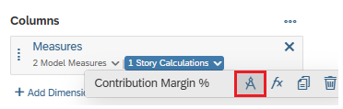
In general, the number format of the underlying measures in the model is always applied. You must deactivate this behavior in the Formatting window by deselecting the option Use unit of underlying measures. |  | Use Unit of Underlying Measures
You can then select a different number format (in our case, Percentage) in the Scale menu option. Confirm the adjustments with OK. |  | Percentage  OK
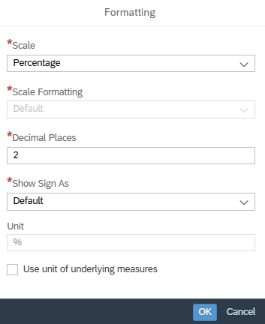
You now increase the size of the table to the full width of the area so that all key figures can be read at first glance.
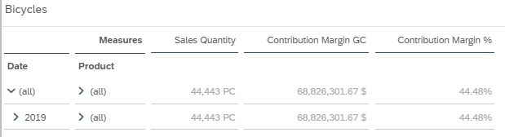
Finally, in the menu bar in the File area, choose Save icon again and then Save to save your changed story. |  | Save

 | Step 12: Restricted Key Figures
Task Create a restricted key figure  Description Create the restricted key figure Revenue Accessories and use it in the calculated key figure % Revenue Accessories in the table of the Customer View (3 Years) tab. |  | Time 10 min.
You are still in the story Story_Case_Study from the last step. If you have closed them, search for them and find them in your personal folder. Make sure you are in Edit Mode. |  | Initial Screen
In SAC, in addition to calculated measures, you also have the option to create restricted measures for a model within a story. All key figures and characteristics (dimensions) defined in the model are available for the restrictions. |  | Restricted Measures
For a better analysis of the customer buying pattern, the key figure % Rev Access (% Revenues Accessories) is to be added to the table of the tab customer view (3 years).
The first step is to create the restricted key figure Revenue Accessories. To do this, go to the table on the Customer View (3 Years) tab and open the right-hand side panel and the Builder panel.
Now move your mouse to the Columns section and click More next to Measures. Now choose the Add Calculation… entry. |  | More  Add Calculation…
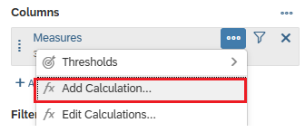
In the calculation editor that opens, select Restricted Measure as the type. Enter Revenue Accessories as the name. |  | Restricted Measure  Revenue Accessories
The underlying logic is:
- Key Figure: Revenue GC
- Dimension: Division (under Product)
- Value: Accessories (Select by Member…)
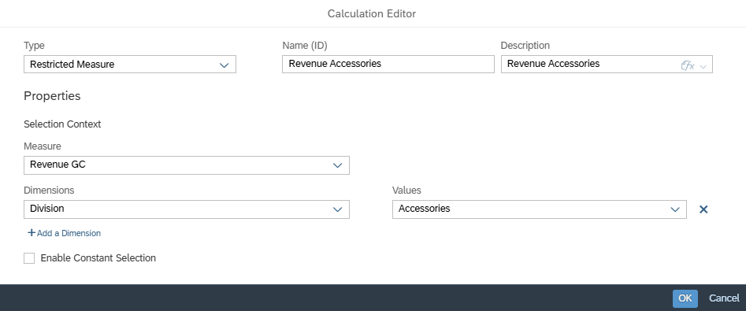
When you have completely defined your key figure, confirm the window with OK. |  | Ok then
Next, you create the calculated key figure % Rev Access. Proceed as for the Contribution Margin % key figure. The underlying formula is Revenue Accessories / Revenue GC. |  | Formula
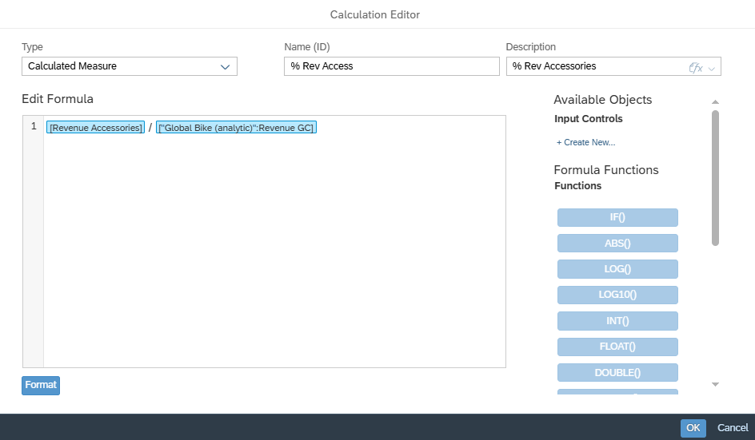
For the % Rev Access key figure, you must now set the output as a % value. To do so, move your mouse to the Columns section, follow the path 2 Story Calculations ► % Rev Access, and click Edit formatting options . |  | 1 Story Calculations  % Rev Access ->  Edit Formatting Options
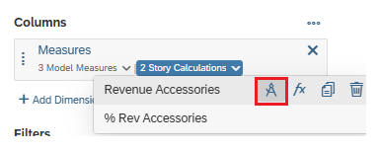
In the Formatting window, deselect the entry Use unit of underlying measures to be able to use a different format for the key figure and select the entry Percentage for Scale. Finally, confirm the window with OK. |  | Use Unit of Underlying Measures  Percentage  Ok then
Since only the calculated measure is to be displayed in the table, hover over the Columns section and click Manage Filters next to Measures. |  | Manage Filters
Deselect the Revenue Accessories entry and confirm the window with OK. |  | Revenue Accessories  Ok then
To prevent the % Rev Access column from taking up as much space, set a line break. To do so, click the % Rev Access text and open the Styling panel in the right-hand side panel. Scroll to Cell and select Wrap. |  | Styling  Wrap
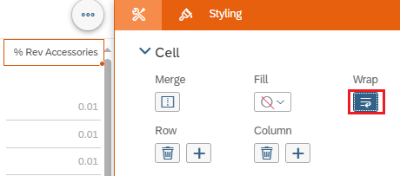
You can now reduce the column width according to the width of the key figure values. Now change the width of the table in such a way that all key figures in the table are easily readable at first glance.
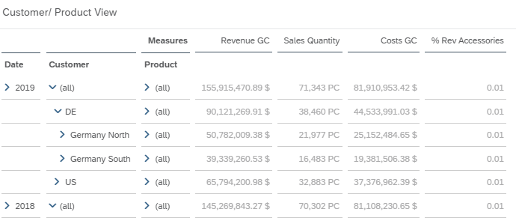
Finally, in the menu bar in the File area, choose Save icon again and then Save to save your changed story. |  | Save

 | Step 13: Thresholds
Task Create a threshold.  Description Create a threshold for the Contribution Margin % measure on the Product View tab. |  | Time 10 min.
You are still in the story Story_Case_Study from the last step. If you have closed them, search for them and find them in your personal folder. Make sure you are in Edit Mode. |  | Initial Screen
Threshold values are used for the fast optical detection of deviations or for exceeding/falling below defined thresholds. Traditionally, a distinction is made between red (bad) and green (good). |  | Thresholds
Since the company wants to achieve a contribution margin ratio of 46% on average with its products, add a corresponding threshold value for the Contribution Margin % key figure on the Product View tab in the table.
Switch to the Product View tab and click the Contribution Margin % heading in the table. Clicking the right mouse button opens the menu. Now choose Thresholds ► New Threshold…. |  | Thresholds -> New Threshold…
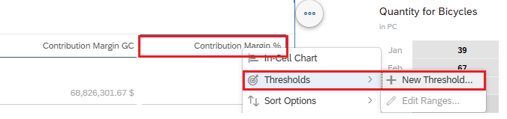
The definition view now opens in the right-hand pane. First, double-click in the text New Threshold. If it is marked in blue, you can change it to Contribution Margin %. |  | Contribution Margin %
Now you define the thresholds. Green is greater than or equal to 46. To be able to define the threshold for red, choose Add Range and select the red circle for the color. You then define the threshold value as less than 46. |  | >= 46  Add Range  < 46
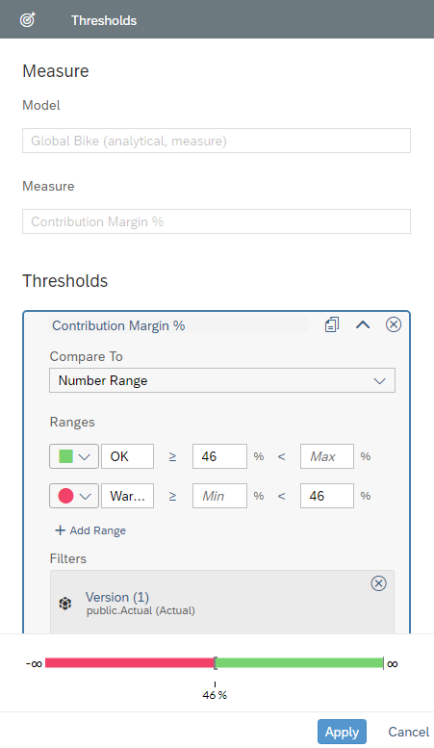
Since a continuous display is desired, you now change the color green to a circle. To do this, click on the green square and choose Customize Symbol. Now select the green circle in the header area of the window and click in the area outside the symbol selection. |  | Customize Symbol  Green Circle
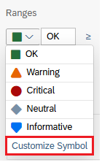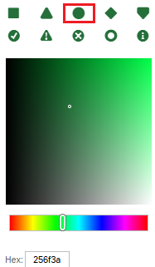
To finish defining the threshold, click Apply in the lower left corner and close the right side panel. |  | Apply
Open the hierarchy of the Product dimension at product category level to check whether your threshold works correctly.
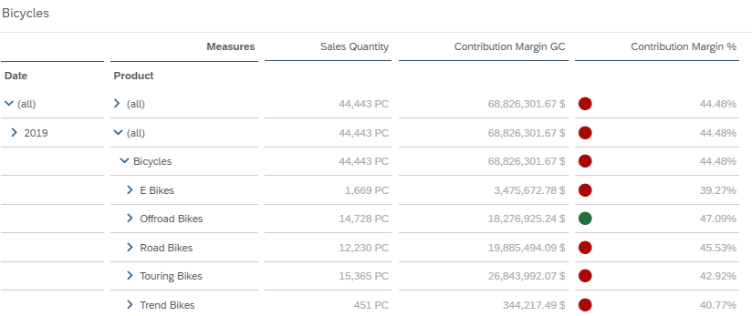
Finally, in the menu bar in the File area, choose Save icon again and then Save to save your changed story. |  | Save

 | Step 14: Ranking Lists
Task Create two ranked lists.  Description Create a Top 5 and a Bottom 5 ranking list based on the sold quantities on the Product View tab page. |  | Time 10 min.
You are still in the story Story_Case_Study from the last step. If you have closed them, search for them and find them in your personal folder. Make sure you are in Edit Mode. |  | Initial Screen
Ranked lists, also known as conditions, are used to display top and top lists. Bottom values. They consist of a condition and a corresponding threshold value. |  | Ranked Lists
Ranking lists are sorted according to the condition so that the statements can also be captured visually quickly.
For decision support, the Top 5 and Bottom 5 bicycles, measured by their quantity sold, are to be displayed as a bar chart on the Product View tab.
Switch to "Product View" tab page. The charts are to be inserted to the right of the heat map.
On the Product View page, first insert a new area next to the heat map area. To do this, click the heat map area and choose More Actions ( ) ► Add Lane ► Add Lane to Right. |  | More Actions  Add Lane  Add Lane to Right
In the new area, use the ribbon to insert a graphic in the Insert area by clicking the Chart icon . |  | Chart
The right side panel opens. In the Builder, define Sales Quantity as the measure, Product as the dimension, grayscale as the color scheme, and select a medium gray tone as the color. |  | Sales Quantity  Product  Grayscale  medium grey tone  Bicycles
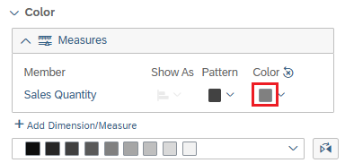
To only evaluate bicycles in the new chart, you then define a corresponding filter on Bicycles on Division (under Product), which cannot be changed by the end user.
Since Product is not to be displayed as a hierarchy, but as a flat list, now use the mouse to move to the area of the Dimension Product and select level 3 after clicking on the symbol (Hierarchy). |  | Level 3
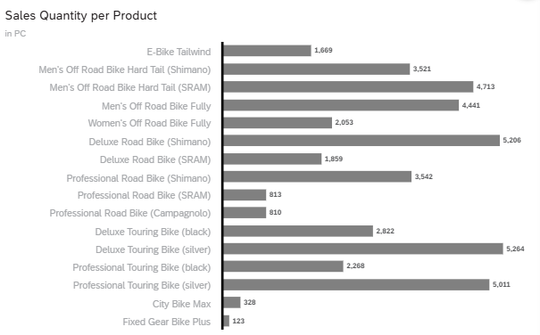
Click on the area of the graphic and choose under More Actions Rank ► Product ► Top 5. |  | More Actions ->Rank -> Product -> Top 5
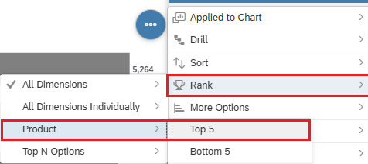
Finally, change the title of the graphic to Top 5 Bicycles by Quantity. To do this, double-click the title text and adjust it accordingly. |  | Top 5 Bicycles by Quantity
In the right-hand side panel, switch from the Builder panel to the Styling panel. |  | Styling
In the Quick Menus area, deselect all options except fullscreen. |  | Fullscreen
Change the size of the graphic by changing the Height to 13 Grid and width to 12 Grid under Size and Position. |  | Height 13 Grid  Width 12 Grid
Since the second chart for the Bottom 5 bikes is to be displayed in the same style, copy the Top 5 chart and change it to a Bottom 5 chart.
When you click on your diagram, the option More Actions appears in the upper right corner and follows the path: Copy ► Duplicate. |  | Copy -> Duplicate
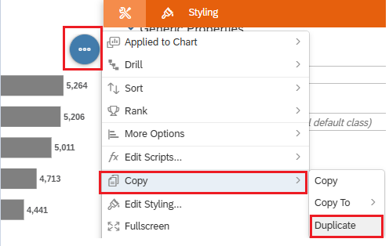
The second chart is now inserted below your Top 5 chart. Change the ranking of the second chart to Bottom 5. When you click on your graphic, More Actions ► Rank ► Product ► Bottom 5 appears at the top right. |  | More Actions  Rank  Product  Bottom 55
Finally, change the title of the chart to Bottom 5 Bicycles by Quantity. |  | Bottom 5 Bicycles by Quantity
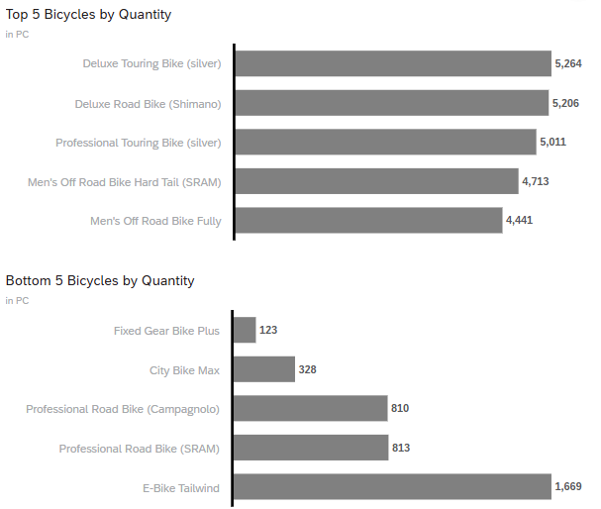
Finally, in the menu bar in the File area, choose Save icon again and then Save to save your changed story. |  | Save

 | Step 15: Variances
Task Create time variances.  Description Create various time differences in graphics on the Product View and Dynamic Analysis tabs. |  | Time 10 min.
You are still in the story Story_Case_Study from the last step. If you have closed them, search for them and find them in your personal folder. Make sure you are in Edit Mode. |  | Initial Screen
Differences between time dimensions provide the simple option of differences with red (negative difference) or Display green (positive difference) without programming knowledge or similar. |  | Variances
Variances are available if a time dimension is available in your model.
You want to set two time variances in your story. On the one hand, on the Product View tab in the Top or Bottom 5 Bicycles by Quantity and in the chart on the Dynamic Analysis tab.
Start with the time variance on the Product View tab and in the Top 5 Bicycles by Quantity chart.
Open the right side panel in the Builder panel and click in the Top 5 Bicycles by Quantity chart.
Navigate to the Chart Add-Ons area and then choose Variance…. |  | Chart Add-Ons  Variance…
The definition view opens in the right-hand pane. First, in the Compare (A) area, under Measure, select the Measure Sales Quantity. Then choose Add Version/ Time. After you have selected Date, select Current Time Interval. |  | Sales Quantity  Add Version/Time  Date  Current Time Interval
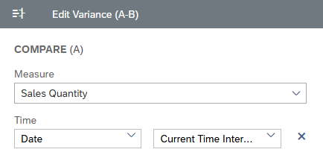
In the Compare (B) area, define the measure Sales Quantity under Measure. Now select Previous Year as the Date. |  | Sales Quantity  Date Previous Year
In the Display Options area, under Show Difference as, select the value Percentage to display the variance as a percentage value rather than an absolute value. |  | Percentage
Set the Decimal Places to 1 and finish the definition with Done. |  | 1  Done
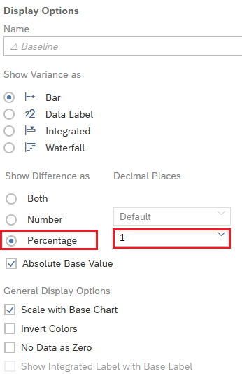
Do the same for the Bottom 5 Bicycles by Quantity graphic.
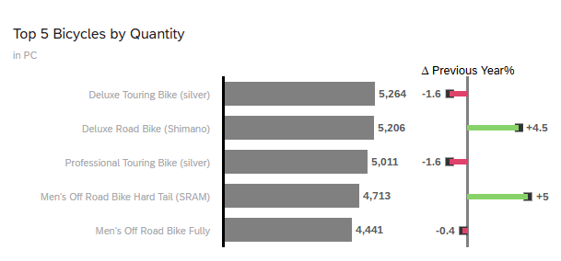
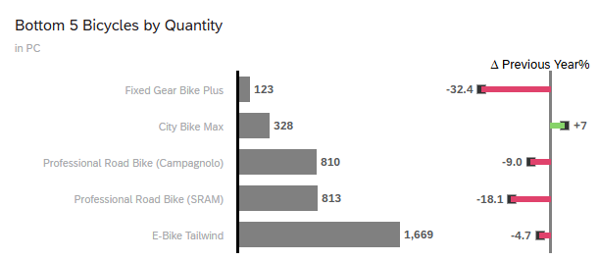
Before you set the time difference on the Dynamic Analysis tab, choose the Save icon in the File area of the ribbon and choose Save to save your changed story. |  | Save
Switch to the Dynamic Analysis tab and also set a time variance Previous Year. To do this, proceed as for the Chart Top 5 Bicycles by Quantity.
Leave the Measure set to All Measures in Use (Dynamic) and the Display to Number without Decimal Places. In the Display Options area, under Show Variances as, select Data Label and complete the definition with Done. |  | Display Options ->  Show Difference as  Percentage  Numeric  Ok then
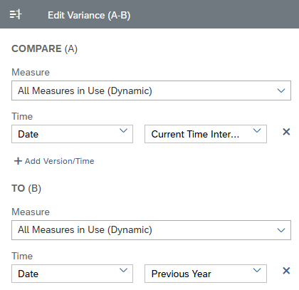
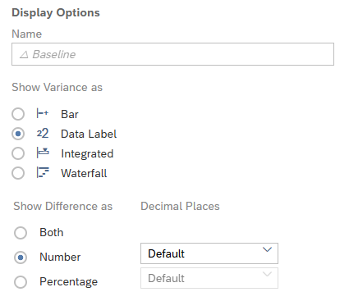
In the Measure selection filter, set the selection option for the contribution margin GC and contribution margin % measures. To do this, right-click in the Measure selection filter, click Edit Input Control, and select the key figures Contribution Margin GC and Contribution Margin %. |  | Edit Input Control  Contribution Margin GC  Contribution Margin %
Now adjust the size and position of the elements so that all key figures can be selected directly using the radio button.
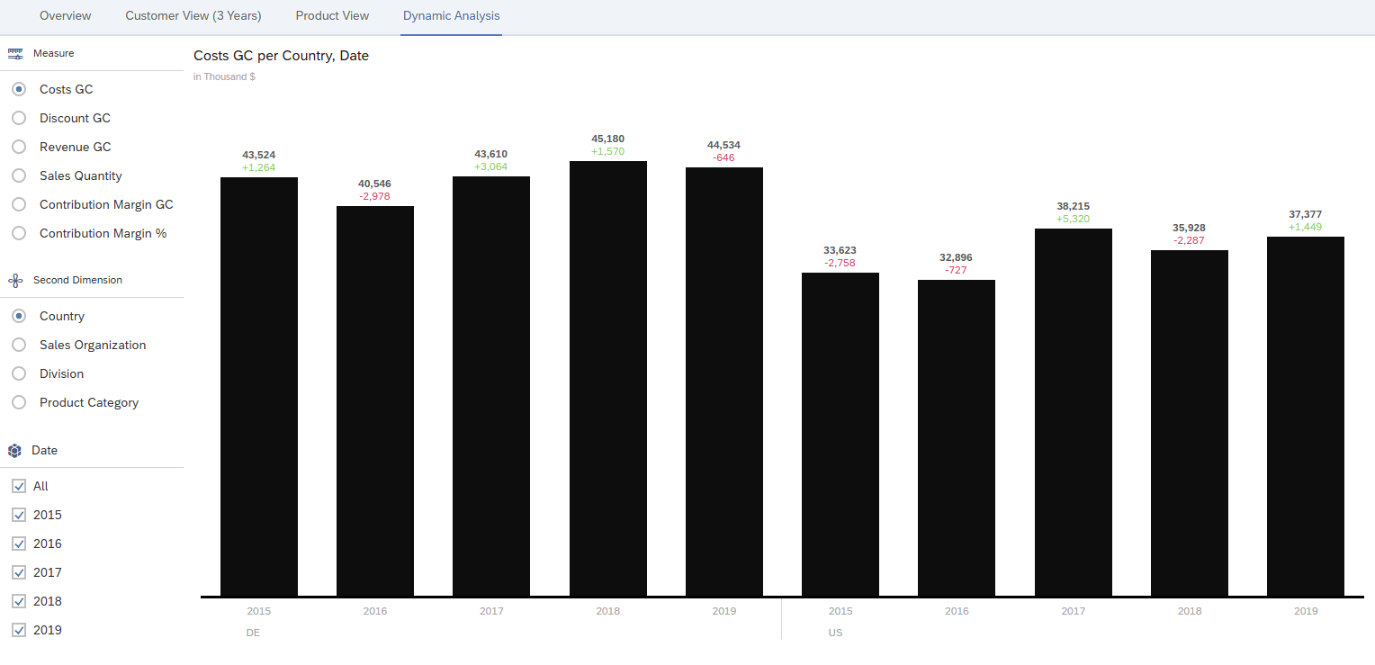
Finally, in the menu bar in the File area, choose Save icon again and then Save to save your changed story. |  | Save

 | Step 16: Graphic Numerical Point
Task Create multiple numeric point graphics.  Description Create four graphics of type Numeric Point incl. Previous year's variances on the "Overview" tab page. |  | Time 10 min.
You are still in the story Story_Case_Study from the last step. If you have closed them, search for them and find them in your personal folder. Make sure you are in Edit Mode. |  | Initial Screen
Numeric point graphics are key figure graphics that enable you to highlight the most important key figures and provide them with different comparisons (for example, for the plan, for the previous month, for the previous year). |  | Numeric Point
For the year 2019, the key figures Revenue GC, Sales Quantity, Costs GC, and Contribution Margin % are to be mapped as numerical point graphics including a comparison of the previous year.
Switch to the Overview tab page. For the graphics, insert a new area above the time series area. To do this, click the time series area and choose More Actions ( ) ► Add Lane ► Add Lane Above. |  | More Actions  Add Lane  Add Lane Above
Use the ribbon to insert a graphic in the Insert area by clicking the Chart icon. |  | Chart
The right side panel has opened. In the business area, change the graphic type to Numeric Point. To do so, open the dropdown under Current Selected Chart and select the Numeric Point entry. |  | Current Selected Chart  Numeric Point
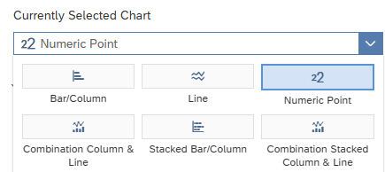
Make the following settings for your graphic.
Define Revenue GC as primary value. |  | Revenue GC
For the Date dimension, you define a filter for 2019, which cannot be changed by the end user. |  | 2019
Open the Chart Add-Ons area and then choose Variance…. |  | Chart Add-Ons  Variance…
Leave the measure as All Measures in Use (Dynamic) and choose Add Version/ Time. After you have selected Date, select Current Time Interval. For the comparison, you define the Time as Previous Year. Finally, under Display Options, you define the difference as a percentage with 2 decimal places. Choose Done to complete the definition. |  | All Measures in Use (Dynamic)  Add Version/Time  Date  Current Time Interval  Previous Year  Percentage  2  Done
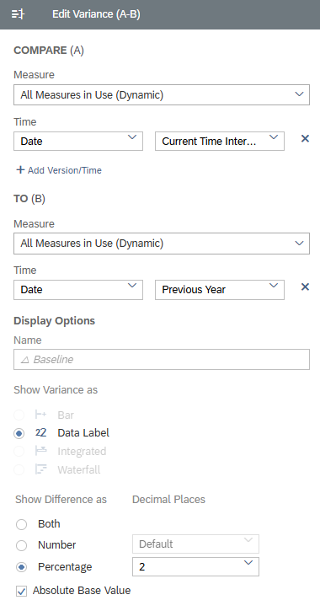
Disable the representation of all subtitles and the primary value label. When you click on your graphic, the option More Actions ( ) appears in the upper right corner. Click the button. In the context menu, choose More Options ► Show/Hide ►Subtitle ► All and Primary Value Labels. |  | More Actions  More Options  Show/Hide  Subtitle  All  Primary Value Labels
In the right-hand side panel, switch from the Builder panel to the Styling panel. |  | Styling
In view mode, the users should not have a context menu available. In the Quick Menus area on the right-hand side of the screen, deselect it. |  | Quick Menus
Now scroll down to the Number Format area. Select Scale as Million and Scale Format as k, m, bn. |  | Million  k, m, bn
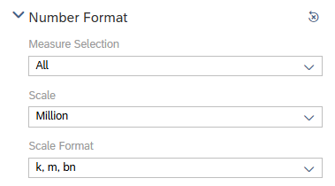
In the Font area under Text Selection, select the listed elements one after the other and change the font settings as specified:  - Primary Alignment Center Text  - Primary Value (155,92) Size 60; Font Style Bold  - Primary Variance Value (+7.33%) Size 28  - Primary Variance Title (2018) Size 18 |  | Primary Center Text  Primary Value 60, Bold  Primary Variance Value 28  Primary Variance Title 18
Change the size of the graphic under Size and Position at Height to 8 Grid. |  | 8 Grid
Finally, change the title to Revenue GC 2019. |  | Revenue USD
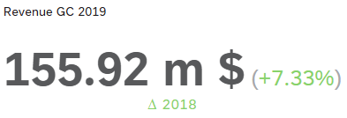
To create the three other graphics, you want to copy the graphics you just created and change the key figures accordingly.
First, you insert 3 more lanes. To do this, click on the area of the graphic and choose More Actions ► Add Lane ► Add Lane to Right. |  | More Actions  Add Lane  Add Lane to Right
Click the area of the graphic and choose More Actions ► Copy ► Copy. |  | More Actions  Copy  Copy
To insert the copied graphic, click in the empty area and press CTRL + V on your keyboard. |  | CTRL + V
Perform these steps 2 more times and then change the settings and titles of the graphics as follows:
- Figure 2: Sales Quantity, Scale-> Thousand  - Figure 3: Costs GC  - Figure 4: Contribution Margin % |  | Sales Quantity Thousand  Costs GC  Contribution Margin %
Since, in contrast to revenue (revenue GC), an increase in the cost of goods manufactured (costs GC) is probably negative, invert the color display of the cost of goods manufactured.
To do this, select the 3 graphic. On the right-hand side panel in the Builder panel, scroll to the Variance area and choose Edit . |  | Edit
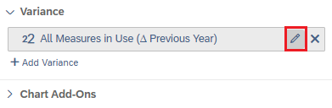
In the Edit Variances (A-B) menu that opens, in the Display Options area, under General Display Options, select the Invert Colors setting and choose Done. |  | Invert Colors  Done
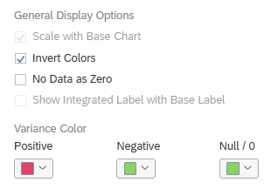
Rename your new graphics to a meaningful name and adjust the height of the time series at Height to 33 Grid. |  | 33 Grid
As a result, your page should look as follows.
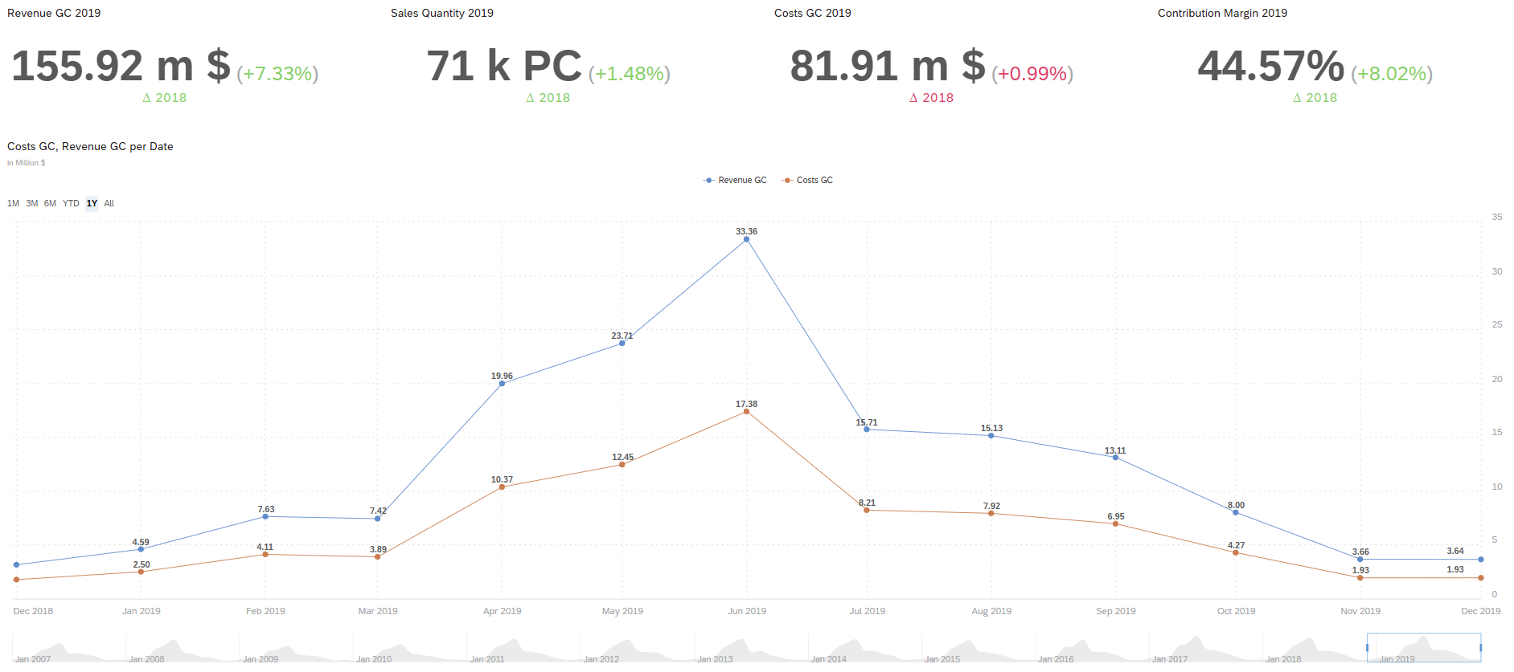
Finally, in the menu bar in the File area, choose Save icon again and then Save to save your changed story. |  | Save

 | Step 17: Calculated Characteristics
Task Create a calculated characteristic.  Description Create a calculated characteristic based on the product category to create a clear heat map. |  | Time 10 min.
You are still in the story Story_Case_Study from the last step. If you have closed them, search for them and find them in your personal folder. Make sure you are in Edit Mode. |  | Initial Screen
Calculated characteristics can be used to format text content, among other things. It is possible to remove fixed text parts or link several texts to a new element. |  | Calculated Characteristics
On the Product View page, the Product Category is currently displayed on the x-axis in the Heat Map. Since the values for the Division Bicycles always contain the addition Bikes, this should be removed so that the label is not unnecessarily wider.
Switch to the "Product View" tab page. Open the right side panel in the Builder panel. Click into the Heat Map Quantity for Bicycles.
Remove the Product Category in the X-Axis area and then choose At least 1 Dimension required and choose Add Calculated Dimension. |  | Product Category  At least 1 dimension required  Add Calculated Dimension
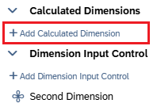
In the calculation editor that opens, first select Calculated Dimension as the type. Enter Product Cat Short as the Name and Description. |  | Calculated Dimension  Product Cat Short
Use the formula to replace "Bikes" with"". [p/…] can only be selected with CTRL + Space or Alt Gr + square bracket. When you have completely defined your dimension, confirm the window with OK. |  | Replace  CTRL + Space  Ok then
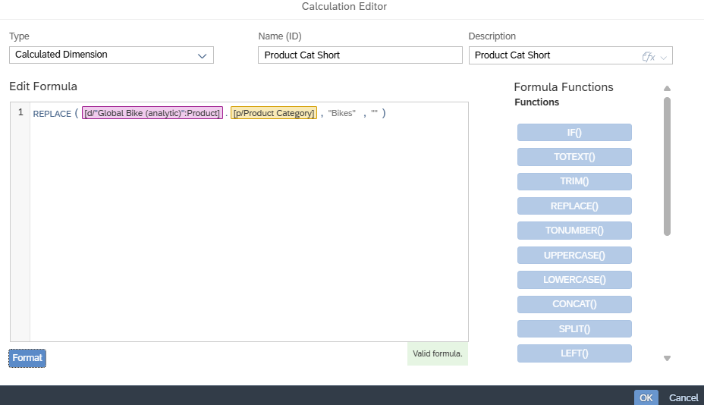
Now adjust the sizes of the heat map and table.
To do so, go to the Styling panel on the right-hand side panel from the Builder panel. |  | Styling
Click in the Heat Map and under Size and Position, change the widget to 7 Grid and Height to 26 Grid. Change the value under Left to 0 Grid so that the graphic on the left starts with the area.
To give the end user of your story a quick overview of the totals, you now set a totals row for Product Cat Short.
Now reduce the heat map area to the size of the graphic on the left-hand side. This increases the space for the table.
Click in the table and under Size and Position, change the widget to 17 Grid and Height to 26 Grid. |  | 17 Grid  26 Grid
Now click in the table in the header Contribution Margin GC and now scroll in the right-hand side area to the area Number Format. Under Decimal Places, select 0. |  | 0
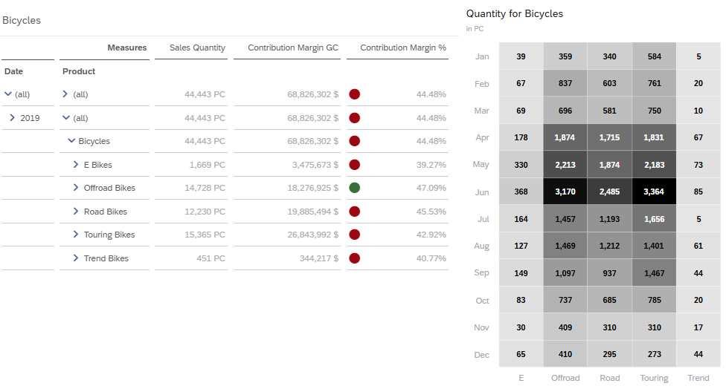
Finally, in the menu bar in the File area, choose Save icon again and then Save to save your changed story. |  | Save

 | Step 18: Measure Filtering
Task Create a measure filtering.  Description Create a measure filter to represent those bikes that have a sales quantity of at least 2000 pieces. |  | Time 10 min.
You are still in the story Story_Case_Study from the last step. If you have closed them, search for them and find them in your personal folder. Make sure you are in Edit Mode. |  | Initial Screen
You can use key figure filtering to evaluate data that exceeds or falls short of a defined value of a key figure. In this form of filtering, note that the characteristics for which the key figure is to exceed or fall below a defined value must be defined. |  | Measure Filtering
A new tab will list the bikes for which a minimum sales volume of 2000 pieces was achieved in 2019. The display should break down the results by sales organizations.
To do this, you define the Most Popular Bikes page by creating a new Responsive page and renaming it to Most Popular Bikes. |  | Most Popular Bikes
Use the ribbon to insert a graphic in the Insert area by clicking the Chart icon. |  | Insert -> Chart
The right side panel is open. In the Builder panel, change the chart type to Stacked Bar/Column. To do this, open the dropdown under Current Selected Chart and choose the entry Stacked Bar/Column. |  | Current Selected Chart  Stacked Bar/Column
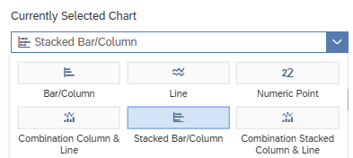
Define Sales Quantity as Measure, Product (Level 4) as Dimension, and Sales Organization as Color, and Grayscale (4 Colors) as Color Scheme. |  | Sales Quantity  Product (Level 4)  Sales Organization  Grayscale
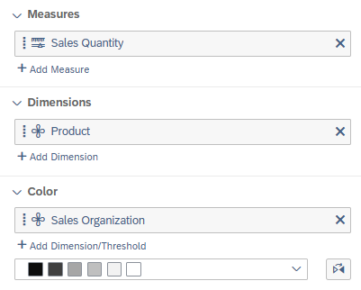 |  | Sales Organization  Grayscale
For the division dimension, you define a filter on bicycles that cannot be changed by the end user. |  | Bicycles
You also insert a new area above the area of the graphic. To do this, click on the area of the graphic and choose More Actions ► Add Lane ► Add Lane Above. |  | More Actions  Add Lane  Add Lane Above
Now define a Page Filter on Date, with which the end users can select a maximum of the last 3 years.
To do this, click in the new area and insert a filter using the Insert ribbon and click on the icon input control . |  | Input Control
The system then inserts a Page Filter element. Choose the following path: Dimensions ► Date ► Filter by Member…. |  | Dimensions  Date  Filter by Member…
In the following dialog, select the values for 2017 - 2019 individually. Since only a single selection of the year is to be possible in this filter, choose the Settings button and define the selection type as Single Selection. Confirm the window with OK. |  | 2017 – 2019  Settings  Single Selection  Ok then
You also want to insert a key figure filter as a page filter so that the end users can lower limits.
To do so, add another filter. In the menu that opens, select Measures ► Sales Quantity. |  | Measures  Sales Quantity
In the following dialog, you first define the dimensions for determining the key figures. Select Below Dimension Context Year (below Date) and Product. |  | Year  Product
Under Range, select Greater Than or Equal To and enter 2000 as the value. |  | Greater than or equal to  2000
Allow end users to change the value as Single Selection. Then confirm the window with OK. |  | Single Selection  Ok then
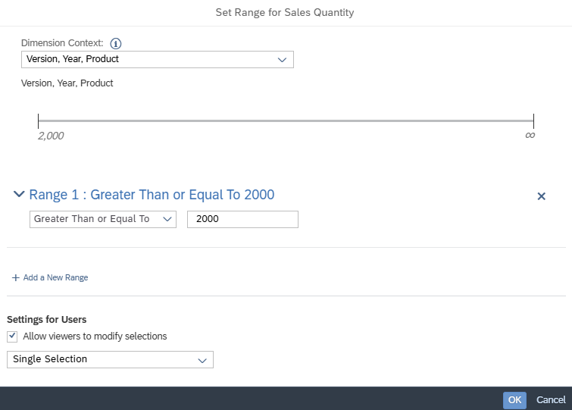
In the right-hand side panel, switch from the Builder panel to the Styling panel. |  | Styling
Change the size of the Page Filter for Date by clicking it and changing the Height to 7 Grid under Size and Position. |  | Height 7 Grid
You change the size of the key figure filter to 5 Grid for Width and 7 Grid for Height. |  | Width 5 Grid  Height 7 Grid
In the Quick Menus area, deselect it for both filter elements. |  | Quick Menus
For the filters on Date, deactivate the Cascading Effect button by right-clicking in the filter and selecting Cascading Effect. |  | Cascading Effect
For the key figure filter, deactivate the range description by choosing Show/Hide ► Range Description. |  | Show/Hide  Range Description
Now change the name of the measure filter to Sales Quantity. |  | Sales Quantity
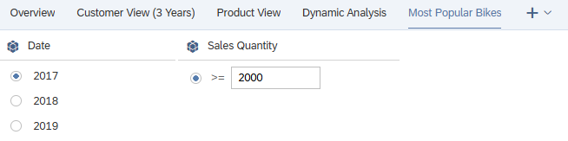
To display the highest-selling bike in the first line, click on the graphic and choose More Actions ► Sort ► Sales Quantity ► Highest to Lowest. |  | More Actions  Sort  Sales Quantity  Highest to Lowest
In the Quick Menus area on the right-hand side of the screen, deselect all options except fullscreen. |  | Fullscreen
Rename the graphic to Bicycles by Sales Organization. |  | Bicycles by Sales Organization
Under Styling, Size and Position, adjust the size of the graphic to Width 15 and Hight 20. |  | Width 15 Grid  Height 20 Grid
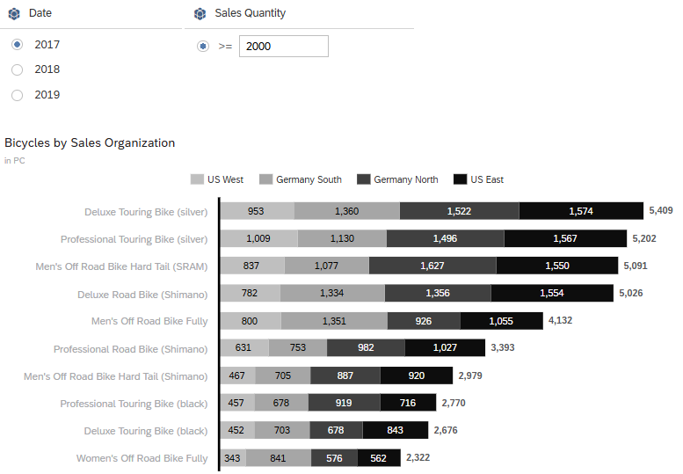
Finally, in the menu bar in the File area, choose Save icon again and then Save to save your changed story. |  | Save

 | Step 19: Linked Analysis
Task Create linked analysis  Description On the Most Popular Bikes tab, create a linked analysis with a 2. Graphic of the type combined graphic. |  | Time 10 min.
You are still in the story Story_Case_Study from the last step. If you have closed them, search for them and find them in your personal folder. Make sure you are in Edit Mode. |  | Initial Screen
Linked analysis can be used to filter further elements using the selection in a graphic. It is possible to select different elements in a graphic to use these values as filtering.  Note that all linked analysis elements must be based on the same model. |  | Measure Filtering
On the Most Popular Bikes tab, you want to show the relationship between the key figures Sales Quantity and Contribution Margin % over the course of the months.
Switch to the Most Popular Bikes tab and insert a new section to the right of the existing graphic. To do this, click the area of the graphic and choose More Actions ( ) ► Add Lane ► Add Lane to Right. |  | More Actions  Add Lane  Add Lane to Right
Use the ribbon to insert a graphic in the Insert area by clicking the Chart icon. |  | Insert -> Chart
The right side panel is open. In the Builder panel, change the chart type to Combined Column & Line. To do this, open the dropdown under Current Selected Chart and choose the combined column & line entry. |  | Current Selected Chart  Combined Column & Line
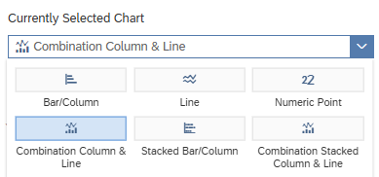
Define the key figure Sales Quantity as column axis, the key figure Contribution Margin % as line axis, Date (Level 3) in the dimensions area and grayscale (4 colors) as color scheme. |  | Sales Quantity  Contribution Margin %  Date (Level 3)  Grayscale
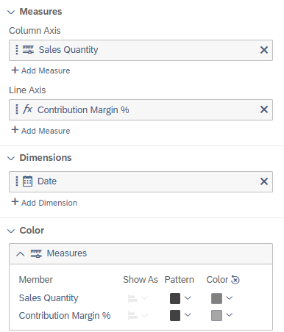
Now define a filter for the division dimension on bicycles, which cannot be changed by the end users. |  | Bicycles
Deactivate the link between the two key figures in order to be able to analyze the histories individually, since there is no connection between them. To do this, disable Y Axes Overlap. |  | Y Axes Overlap
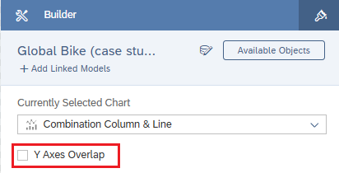
In the right-hand side panel, switch from the Builder panel to the Styling panel. |  | Styling
In the Quick Menus area on the right-hand side of the screen, deselect all options except fullscreen. |  | Fullscreen
You now adjust the heading of the graphic. To do this, double-click in the text and enter Bicycles by Month. |  | Bicycles by Month
Adjust the size of both graphics under Size and Position to 18 Grid for Widht and 32 Grid for Height. |  | Widht 18 Grid  Height 32 Grid
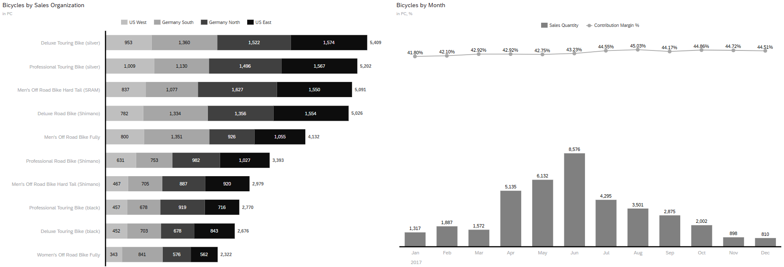
Next, you define the linked analysis for the left graphic. If you click on the left graphic, the option More Actions appears at the top right. Click the button. In the context menu, choose More Options ► Linked Analysis ► Settings. |  | More Actions  More Options  Linked Analysis  Settings
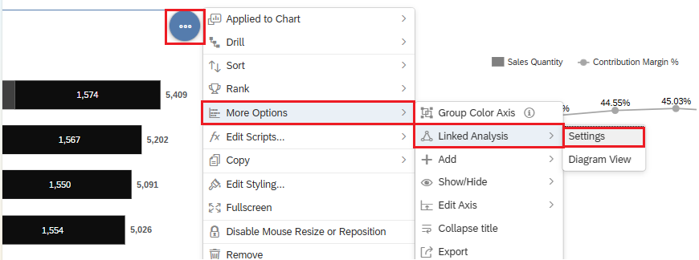
The definition view now opens in the right-hand pane. First, in the Filter Interactions apply to: area, select All Widgets on the Page. In the Settings area that then appears, choose the Filter on Data Point Selection option and close the window by choosing Apply. |  | All Widgets on the Page  Filter on Data Point Selection  Apply
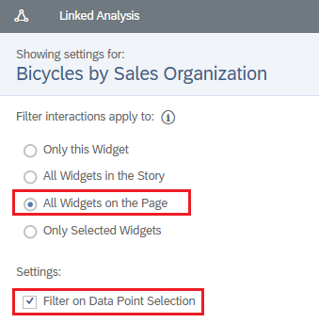
Now proceed in the same way as in the graphic on the right.
Finally, in the menu bar in the File area, choose Save icon again and then Save to save your changed story. |  | Save
Test your link, for example, by selecting a row or a subbar in the stacked graphic.
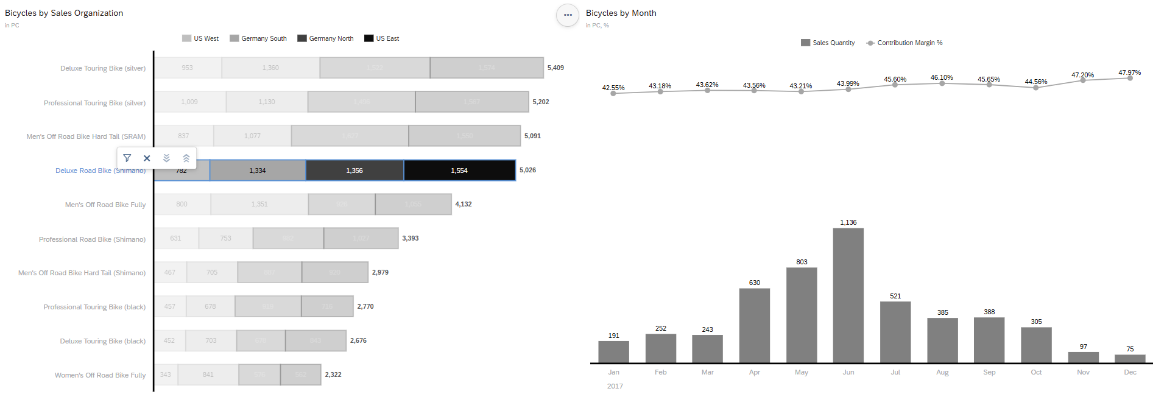

 | Step 20: [OPTIONAL] Share the story with instructor
Task Share your story with your instructor.  Create a copy of your story and place it in the folder named by your instructor. |  | Time 5 min.
On the home screen, click (Files) in the upper left corner. |  | Initial Screen
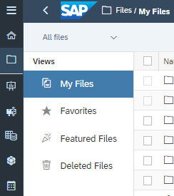
Navigate to your personal folder where you saved the story from this case study, probably My Files ► My SAC course ► Stories. Select your story by selecting the box at the beginning of the row.
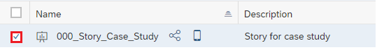
Now click the Copy To icon in the menu bar. |  | Copy To
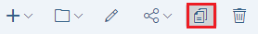
In the window that opens, select a folder to which only your instructor and you have access. If necessary, ask your instructor.
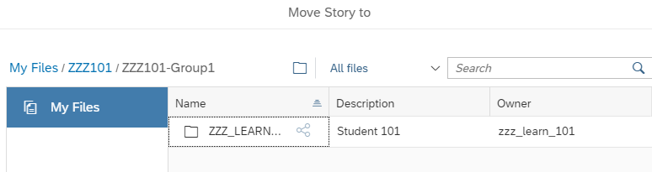
To be able to later distinguish the copied story from the original, add the suffix “_submitted” to the Name field. |  | _submitted
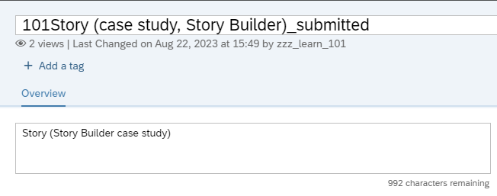
Confirm your entry with OK and inform your instructor. |  | Ok then

