SAP Analytics Cloud -
Modeler
This case study explains the creation process of an analytical model in SAP Analytics Cloud (SAC): from the initial creation and maintenance of properties, to the maintenance of dimensions and measures, to the loading and testing of data.

Product  SAP Analytics Cloud  Global Bike  Level  Bachelor's Degree  Master  Beginner  Focus  Business Intelligence  Data Modeling  Authors  Katerina Drizi  Stefan Weidner  Andreas Hofstetter  Version  3.0  Last Change  March 2025 | MOTIVATION  An example sales dashboard was demonstrated in the exercises for SAP Analytics Cloud.  In the first case study, you developed a sales dashboard in the SAC Story Builder, but based on an existing model filled with data. In this second case study, you create your own model, load it with data, and evaluate it for testing with a simple story.  PREREQUISITES  Before you edit the case study, you should have familiarized yourself with the navigation in SAP Analytics Cloud. In addition, you should have successfully processed the SAC exercises and the first SAC case study on the Story Builder. |  | REMARK  This case study uses a model with historical sales data from the fictitious company Global Bike.    THANK YOU  This case study was developed with the help of students and employees of the Pforzheim University of Applied Sciences as well as scientific and student assistants of the SAP UCC Magdeburg.  

 | Process Overview
Creating an Analytic Model in SAC learning objective.  Scenario Alex Kuhn (Vice President Marketing and Sales) wants to store a data record directly in the CLOUD solution SAP Analytics Cloud (SAC) to evaluate and research past data. Consistent figures from sales orders are defined in the ERP system for the period 1. January 2007 to 31 December 2018 and have already been extracted. The data record 2019 is currently being created and is to be reloaded. The task for Andrea Marino (Sales Manager USA) and Hanna Ortmann (Head of Sales Germany) is now to design the data model with her project team, load the data mentioned, and prepare it for subsequent analysis and visualization. |  | Time 130 min.
Table of Contents
Process Overview 2
Step 1: Log on to SAC 3
Step 2: Create Model 4
Step 3: Change Dimension Date 9
Step 4: Change Dimension Product 11
Step 5: Change Dimension Customer 14
Step 6: Change key figures 18
Step 7: Load Transaction Data 2019 22
Step 8: Create story 28
Challenge 1: Calculated Measures in Model or Story 36

 | Step 1: Log on to SAC
Task Log on to SAP Analytics Cloud.  Description Log on to the SAC tenant in a web browser. |  | Time 5 min.
Clicking on the following link takes you to the Identity Management System of SAP UCC Magdeburg. This provides anonymous identities for logging on to SAP cloud solutions according to valid data protection rights.  https://ucc-pilot-sac.eu10.hcs.cloud.sap/ |  | Initial Screen
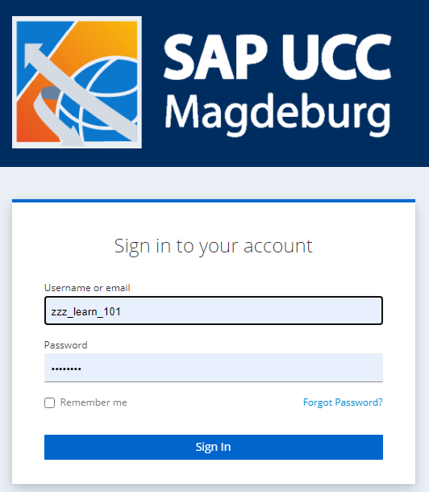
On the login screen, enter the user named by your instructor and your personal password, which you should have already defined. |  | User  Password
Then click Sign In. |  | Sign In
Note If you encounter problems when registering, please check the navigation course or consult your instructor. |  | Navigation Course

 | Step 2: Create Model
Task Create a new model.  Description Use the modeler to start building your model. |  | Time 15 min.
On the home screen, click 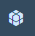 Modeler in the upper left corner. |  | Initial Screen
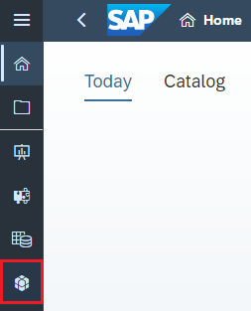
Click the Model (Create New Model) button in the upper left under Create New. |  | Model
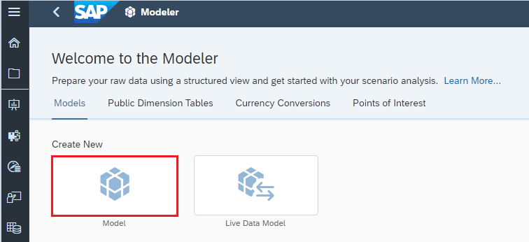
In the window that appears, choose Start with data and confirm your selection with Next. |  | Start with data  Next
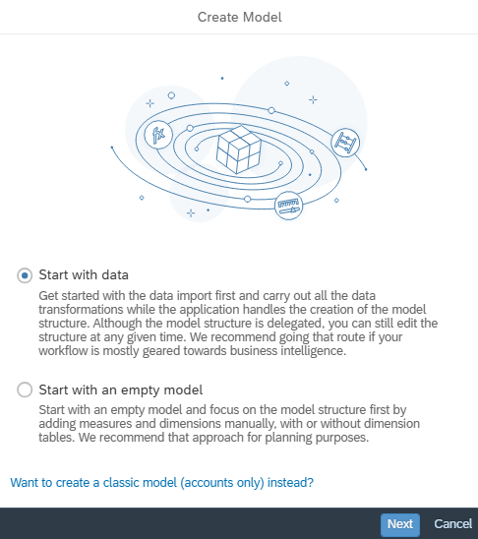
Under Select a data source, choose File (Local File or File Server). |  | File
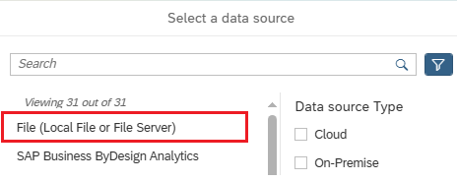
Click the Select Source File button to select your data. |  | Select Source File
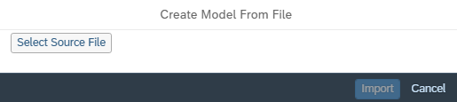
In the window that opens, search for the Excel file Global Bike Transactional Data 2007-2018.xlsx and choose Import.
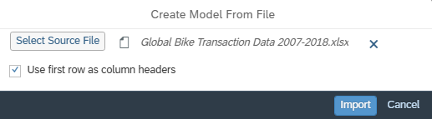
The data is imported. You then make model preferences.
In the menu bar on the upper left, click (Model Preferences).
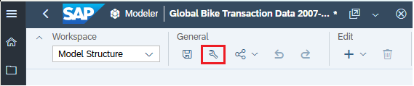
Stay in the window that opens on the current tab (General Settings).
Then enter ### Global Bike (analytic) in the Name field and ### Global Bike Model (analytic) in the Description field. Note that you replace ### with your three-digit number provided by your instructor. |  | ### Global Bike (analytic)  ### Global Bike Model (analytic)
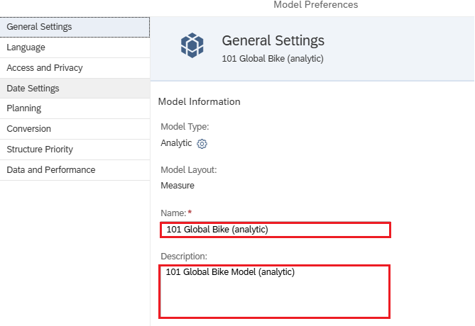
Change the type of your model to Analytic. To do this, go to the Planning tab and deactivate the switch for Planning Capabilities. |  | Planning Capabilities
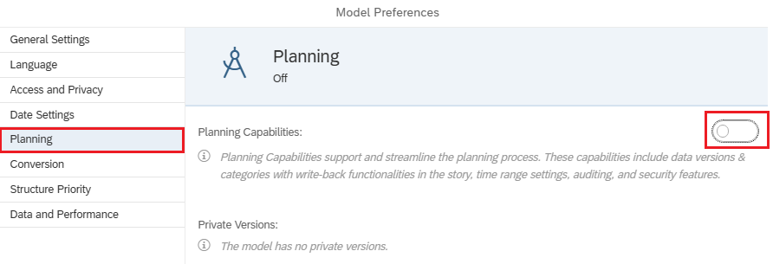
Note After you have saved your model for the first time later, it is no longer possible to change the model type. Therefore, please make sure again that the switch is actually deactivated (colorless).
Confirm your changes with OK. |  | Ok then
Save your model. To do this, click Save icon in the General area of the ribbon. |  | Save
In the window that opens, navigate to your My SAC course folder in the My Files folder and then to the Models subfolder. Check the name and description of your model again, especially if you have replaced ### with your three-digit number. Now click Save to save your model. |  | Save
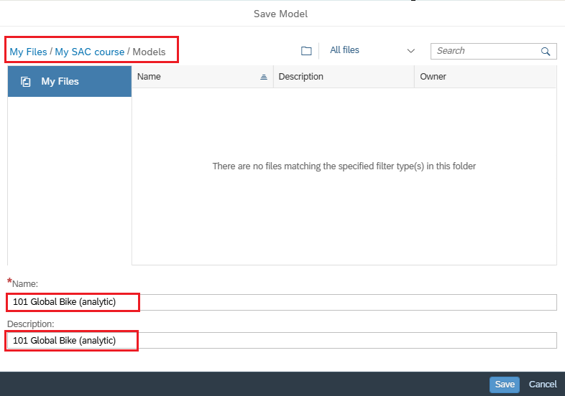
The SAC system confirms the successful backup of your model with a success message.
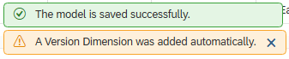
Note Since planning is also possible in SAC, all models are automatically assigned the dimension Version.
Remain in this window for the next step.

 | Step 3: Change Dimension Date
Task Change the Calendar_Day dimension.  Description First, change the name and hierarchy of your time dimension to Year, Month, and Day. |  | Time 5 min.
Your ### Global Bike (analytic) model should still be open. If not, restart the Modeler and open your model. |  | Initial Screen
Under Dimensions, select the Calendar_Day dimension. |  | Calendar_Day
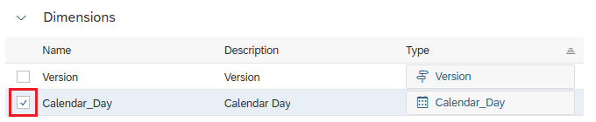
In the right pane, the dimension opens. Change the Description to Date. |  | Date
Here, under Dimension Table, click Edit Dimension Table . |  | Edit Dimension Table
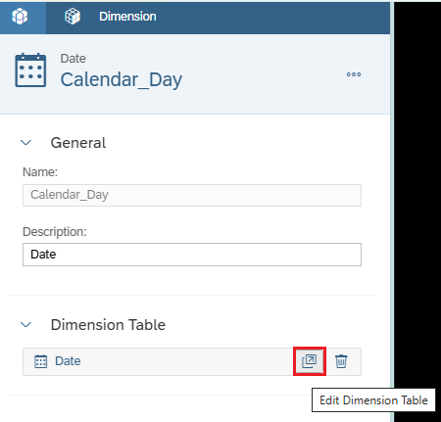
This takes you to the data table and in the right properties window for the Dimension Table. To obtain a granularity of days, in the Default Hierarchy field, choose Year, Month, Day. |  | Year, Month, Day
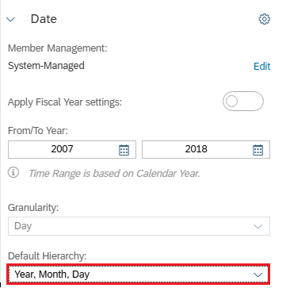
To return to the dimension view, choose Back in the header area. |  | Back
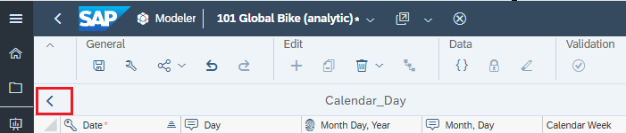
Save your model before proceeding. To do this, click Save icon in the General area of the ribbon. |  | Save
Stay in this window and continue with the next step.
The SAC system confirms the successful backup of your model with a success message.
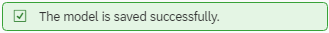
Remain in this window for the next step.

 | Step 4: Change Dimension Product
Task Change the dimension Product.  Description Change the Product dimension for your model. |  | Time 15 min.
Your ### Global Bike (analytic) model should still be open. If not, restart the Modeler and open your model. |  | Initial Screen
Under Dimensions, select the Product_ID dimension and change the Name and Description to Product. |  | Product_ID  Product
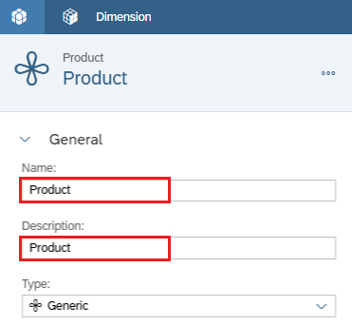
Under Properties, click Description. This defines one of the dimensions from your Excel file as a description field. |  | Description
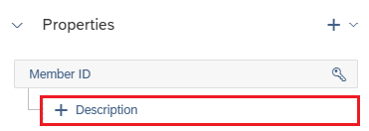
In the Add Description Property window, choose Product Description and confirm the window with OK. |  | Product Description  Ok then
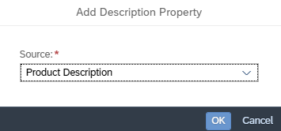
To add an attribute, click the Add Properties icon in the Properties pane and choose From Source. |  | Add Property  From Source
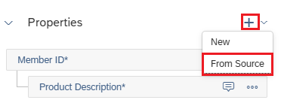
In the Add Property window, choose Division in the Source field. Select Text as the Type. Confirm the window with OK. |  | Division  Text  Ok then
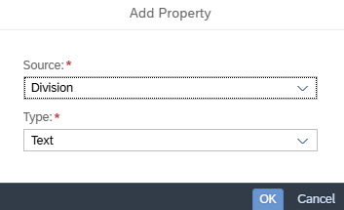
Repeat the step and define the attributes Product Category, Color, and Components. Type is text in each case. At the end, your list of properties should look like this. |  | Product Category  Color  Components  Text
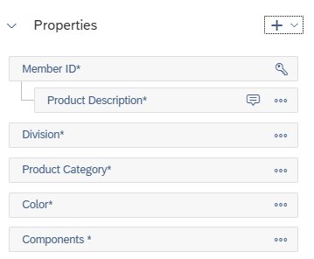
Now create a hierarchy for your dimension. In the right dimension window, scroll to the Hierarchies section. Click Level-Based Hierarchy. |  | Level-Based Hierarchy
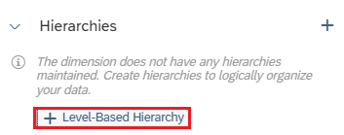
In the upper text box, enter ProdHier as the ID for your hierarchy and Product Hierarchy as the description. |  | ProdHier  Product Hierarchy
By dragging and dropping, choose Product Category and then Division from the list on the left and place it as follows. |  | Product Category  Division
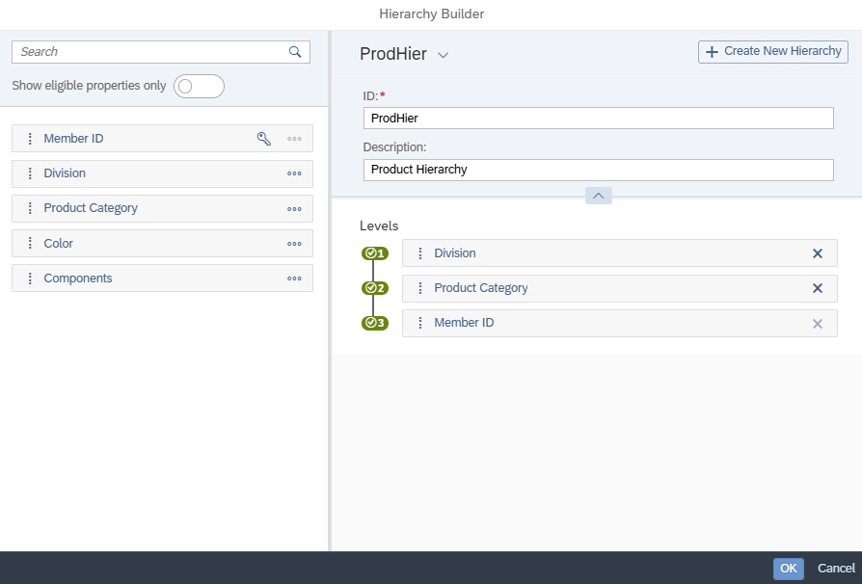
Then click OK. |  | OK
Save your model before proceeding. To do this, click Save icon in the General area of the ribbon. |  | Save

 | Step 5: Change Dimension Customer
Task Change the dimension Customer.  Description Change the Customer dimension for your model. |  | Time 15 min.
Your ### Global Bike (analytic) model should still be open. If not, restart the Modeler and open your model. |  | Initial Screen
Under Dimensions, select the Customer_ID dimension and change the Name and Description to Customer. |  | Customer_ID  Customer
Under Properties, define the Customer_Description field as Description. |  | Customer_Description
Create the following attributes as described in the previous step.
 |  | Country  Country Text  Sales Organization  Region  City
  Source Field | Types
  Country | Text
  Country Text | Text
  Sales Organization | Text
  Region | Text
  City | Text
Now add the currency dimension as an attribute. |  | currency
Under Type, select Currency and choose Next. |  | Currency  Next
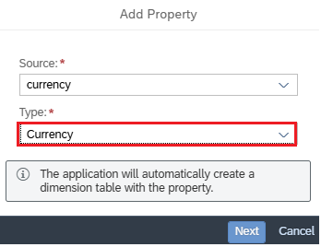
Confirm the Generate Dimension Table window with OK. |  | Ok then
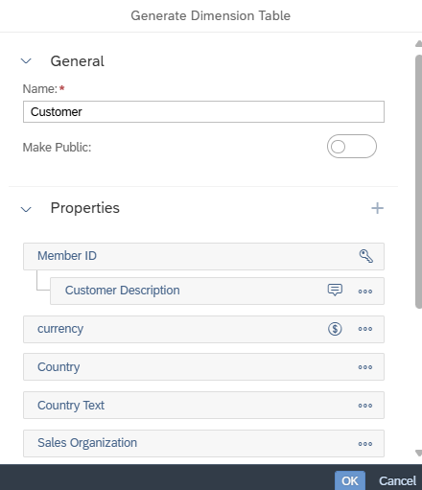
Now your list of properties should look like this.
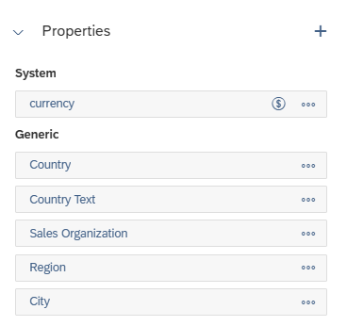
Since currency is created as a system property, each value MUST have a currency. The system automatically creates the proficiency #. A currency must also be assigned to this.
In the list of dimensions, go to the Customer type and choose Edit Dimension Table . |  | Edit Dimension Table
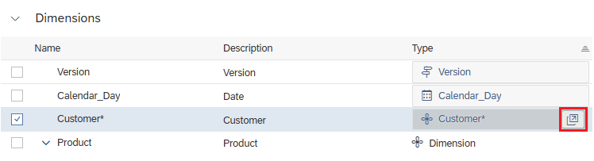
For entry #, enter USD under currency. |  | USD
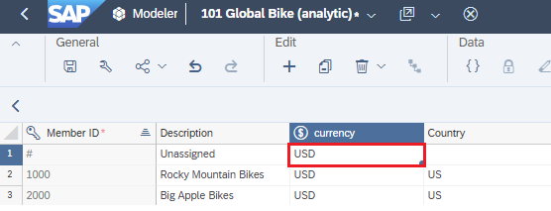
Now create the following hierarchy for your Customer dimension. In the right dimension window, scroll to the Hierarchies section. Click Create Hierarchy and choose Level-Based Hierarchy. |  | Create Hierarchy  Level-Based Hierarchy
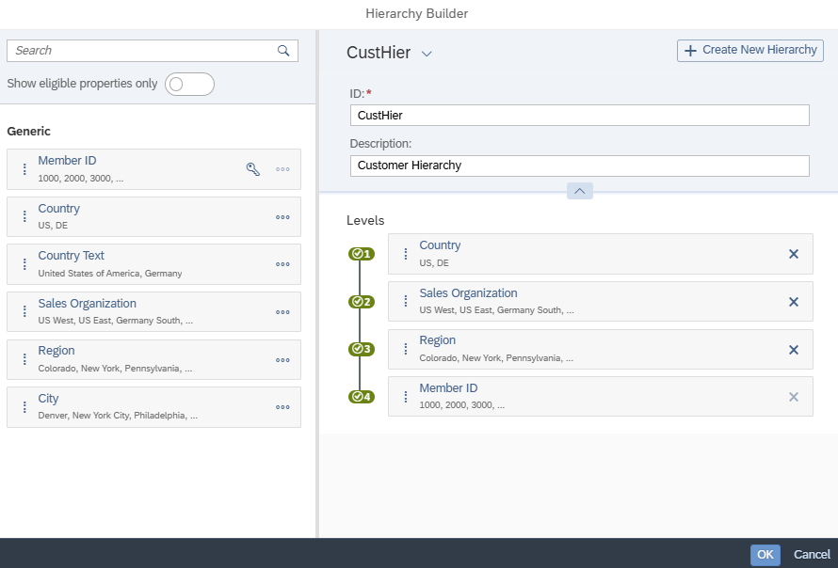
Then click |  | Ok then
To return to the dimension view, choose Back in the header area. |  | Back
Save your model before proceeding. To do this, click Save icon in the General area of the ribbon. |  | Save
Question Does a city hierarchy level make sense in the Customer dimension?

 | Step 6: Change key figures
Task Change the settings of the key figures.  Description Change the six key figures and create a calculated key figure. |  | Time 15 min.
Your ### Global Bike (analytic) model should still be open. If not, restart the Modeler and open your model. |  | Initial Screen
Under Measures, select the measure Revenue_GC by clicking it. |  | Revenue_GC
Note Models in financial and business reporting can have different measures that are reported in both global currency (GC) and local currency (LC). Revenue GC (Global Currency) and Revenue LC (Local Currency) are terms used in financial reporting and in the international business environment. They refer to the display of sales in different currencies.
Revenue GC (Global Currency): Refers to the recording and reporting of sales in a single, global currency, often referred to as consolidation currency. This currency is used to standardize the financial performance of a multinational company so that financial information is comparable across different countries and regions. A strong and stable currency such as the US dollar or the euro is often used for this purpose. The conversion is done using exchange rates to transfer local sales to this global currency.
Revenue LC (Local Currency): This key figure shows the revenue as recorded in the respective national currency of the location where the company operates. Sales figures in local currency provide an accurate view of financial performance in a specific market or country without the influence of exchange rate fluctuations.
By using Revenue GC and Revenue LC, companies can both analyze local market performance and get a consolidated view of the entire organization, which is essential for strategic decisions and reporting.
In the Data Type area, select Decimal (7) by clicking on it. In the Change Data Type window, choose 2 under Decimal Places and confirm the window with OK. |  | 2  OK
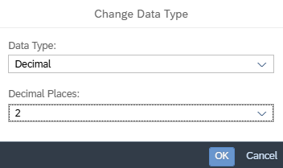
In the Aggregation section, in the Aggregation Type field, choose Sum. Leave all other fields in this area empty. |  | Sum
In the Units & Currencies area, choose Currency in the Unit Type field.  You want to use US dollars as the fixed currency for this key figure. Under Currency, choose Fixed and check that USD is entered as the currency. |  | Currency  Fixed  USD
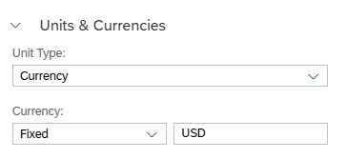
Under Measures, select the measure Revenue_LC by clicking it. |  | Revenue_LC
For the data type, change the Decimal Places to 2 and set sum for the aggregation type. |  | Decimal 2  SUM
In the Units & Currencies area, choose Currency in the Unit Type field.  For this key figure, the respective currency from the Customer dimension should be used instead of the US dollar as the fixed currency.  To do this, choose Currency From Dimension in the field and check that the dimension Customer has been entered. |  | Currency  From Dimension  Customer
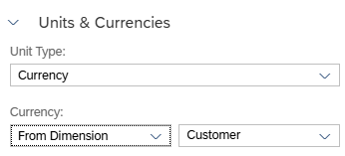
Adjust the following key figures in this way.
Name | Data Type | Decimal Places | Aggregation Type | Unit Type | Unit/  Currency
Discount_GC | Decimal | 2 | Sum | Currency | Fixed USD
Discount_LC | Decimal | 2 | Sum | Currency | From Dimension Customer
Costs_GC | Decimal | 2 | Sum | Currency | Fixed USD

Note You have certainly noticed the following system hint whenever you select a currency unit with reference to a dimension.
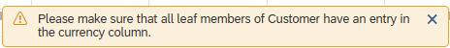
A currency unit can only be used in the key figure if a currency unit is maintained for each customer (that is, each entry in the customer dimension).
To save your previous entries, click Save icon in the General area of the ribbon. |  | Save
Up to now, you have changed five currency key figures. Now adjust the key figure Sales_Quantity. Make sure that integer is set as the data type. |  | Sales_Quantity  Integer
In the Aggregations area, choose Aggregation Type Sum. In the Units & Currencies area, select Unit as the Unit Type. In the new field, enter PC next to Fixed. |  | Sum  Unit  PC
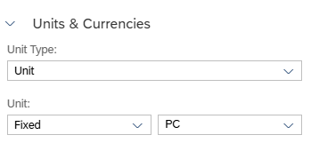
Finally, you create a calculated key figure. To do so, switch to Calculations in the upper left of the Workspace area. |  | Calculations
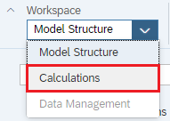
 |  | Add Calculated Measure
  In the Calculated Measures section, click Add Calculated Measure .
  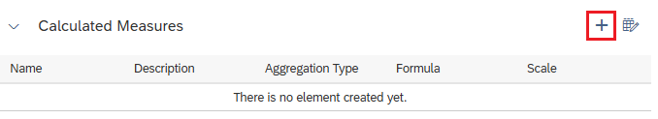
  In the properties window on the right, enter Contribution_Margin_USD as the name and CONTRIBUTION MARGIN USD as the description. | ContributionMarginUSD  Contribution Margin USD
  In the Units & Currencies area, in the Unit Type field, select Currency and verify that USD is filled in as the currency. | Currency  USD
  Now turn to the formula window in the middle. Enter the following formula. Each time you start typing, the system suggests functions (in capital letters) and key figures (in square brackets). In your case, select the right metrics with a simple click.
  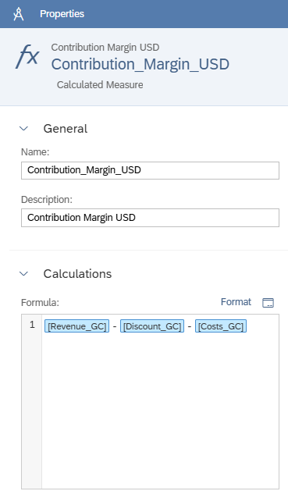
After you have checked the formula again, save your model by clicking Save icon in the General area of the ribbon. |  | Save

 | Step 7: Load Transaction Data 2019
Task Additionally load the transaction data for the year 2019 into your model.  Description Load more sales data into your analytic model annually. |  | Time 15 min.
Your ### Global Bike (analytic) model should still be open. If not, restart the Modeler and open your model. |  | Initial Screen
In this step, load past sales figures into the fact table of your model.
Before you can extend the data model with the 2019 sales figures, you need to extend the time dimension by the year 2019.
Note The time dimension can also be extended in advance for the coming years.
To do so, choose Calendar_Day under Dimensions in the Model Structure pane and navigate to Edit Dimension Table. |  | Calendar_Day  Edit Dimension Table
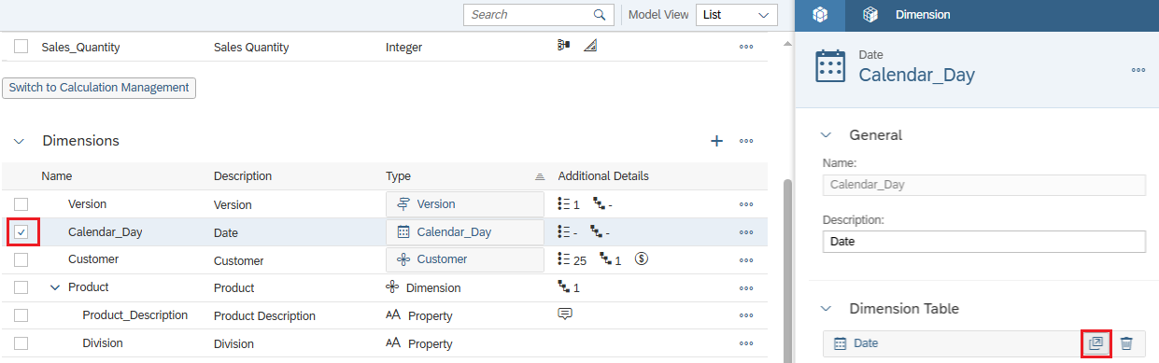
Under Date, extend the time dimension to include the year 2019.
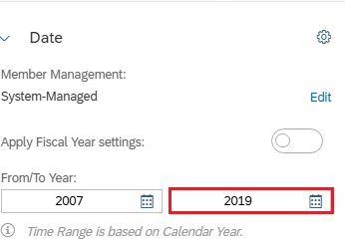
You then see the following message:
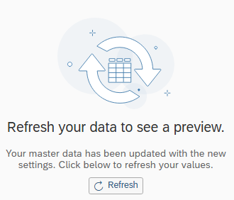
Click Refresh to see the previous data again. |  | Refresh
The transaction data for 2019 must now be loaded.
To do this, switch to Data Management in the Workplace area on the upper left. |  | Data Management
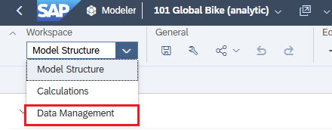
For import jobs, click Import Data and choose.  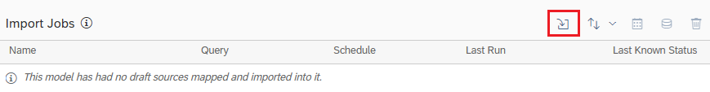 |  | Import Data
Choose File (Local File or File Server). |  | File
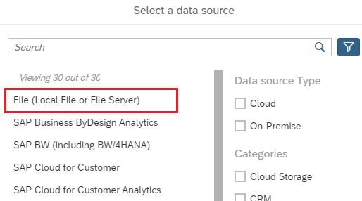
In the window that opens, click Select Source File. Search for the Excel file Global Bike Transaction Data 2019.xlsx and choose . |  | Import
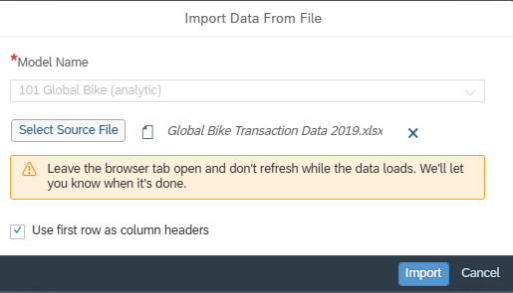
After the file is uploaded, choose Set Up Import. |  | Set Up Import
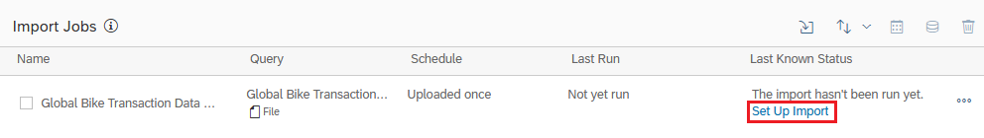
In the following view, choose at the bottom right. |  | Next
On the following screen, on the right, you can see that 9 facts could already be mapped automatically. In the middle of the window, you can see that 6 facts were not found automatically (unmapped).
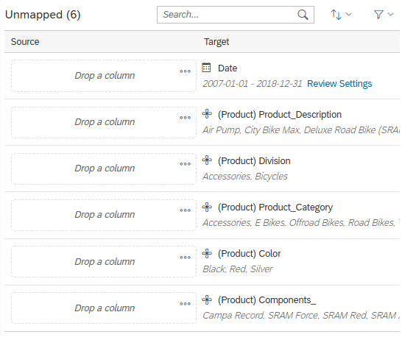
On the left-hand side, in the Source Columns, find Calendar Day. Use drag and drop to drag it to the Drag a column area for the entry Date. |  | Calendar Day
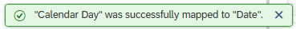
In the same way, assign Product Description, Division, Product Category, Color, and Components to the Target Unmapped (5). |  | Product Description, Division, Product Category, Color, and Components
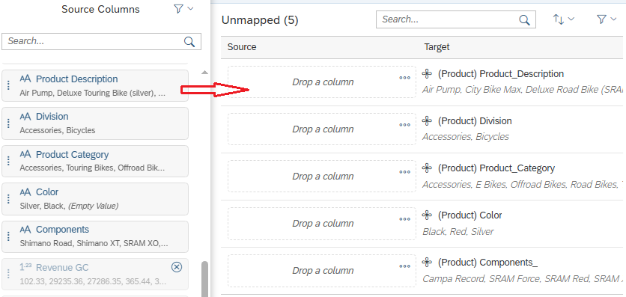
You should now see the following message in the middle of the screen.
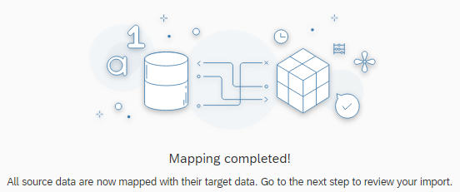
Click in the bottom-right corner. You will receive this notification. |  | Next
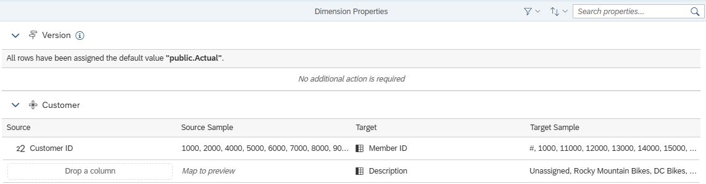
Click on again and you will receive the following success message. |  | Next
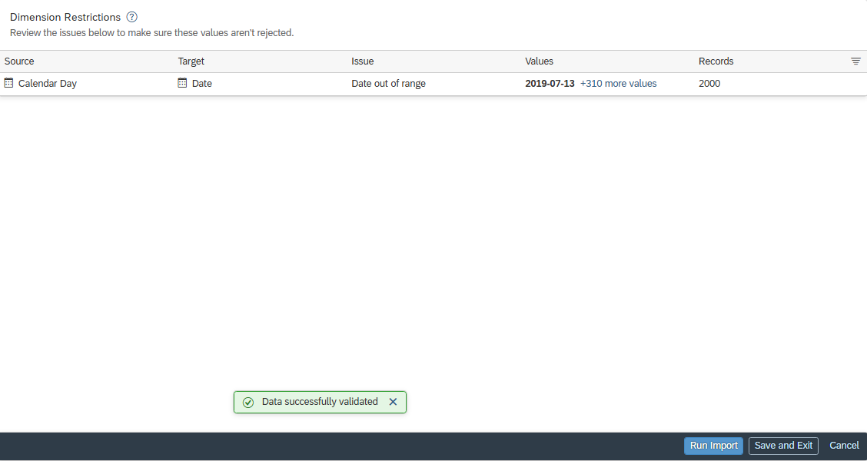
Now click on on the bottom right and then on . As a result, you see the following status display.
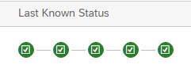
To return to your model, go back to Model Structure in the Workplace area. Your final model should look like this.
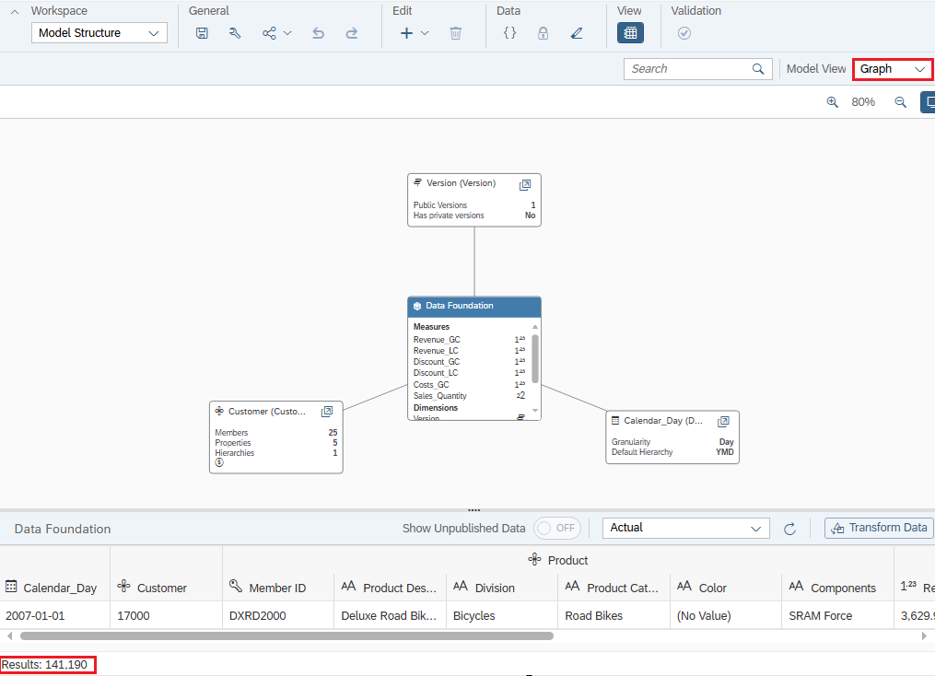
Under your model, you can see in the preview window that a total of 141,190 rows have been loaded.
Save your model by clicking Save in the top menu bar. It is now ready for use. |  | Save

 | Step 8: Create story
Task Create a simple story.  Description Create a story based on your new model to test it. |  | Time 30 min.
To create a new story, open the Story Builder in the left menu bar by clicking (Stories). |  | Initial Screen
In the Create New area, choose Responsive. |  | Responsive
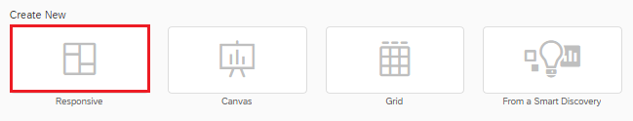
In the window that opens, choose Select Design Mode Type Optimized Design Experience and Create. |  | Optimized Design Experience
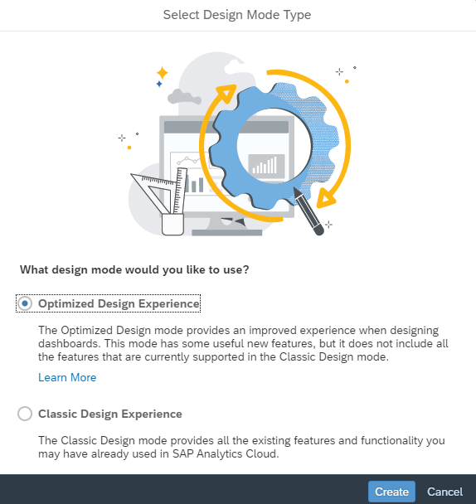
Under View, click left side panel and close it and open the right side panel.
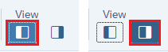
To embed a graphic as an object type in your story first, choose the Chart icon in the Insert area in the upper menu bar. |  | Chart
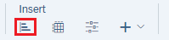
You now need to define which data source is to be used. Navigate to your My SAC course folder and then to the Models subfolder. Choose your Model ### Global Bike (analytic). |  | ### Global Bike (analytic)
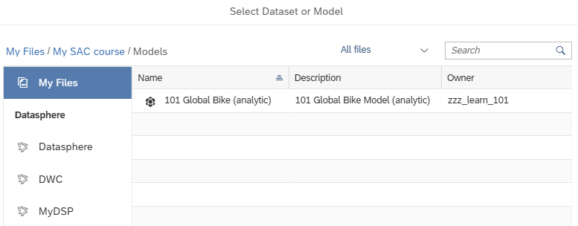 |  | Existing Model
Make sure you are in edit mode and have the Right Side Panel open. |  | Edit Mode  Right Side Panel
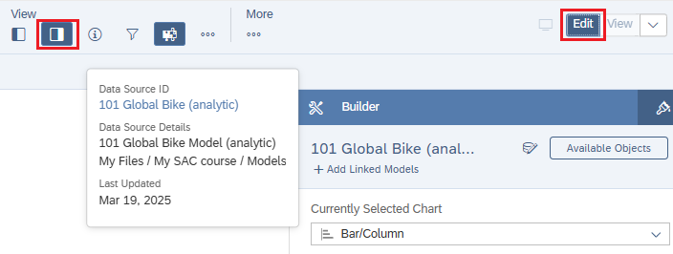
Change the orientation of the chart to Vertical. |  | Vertical
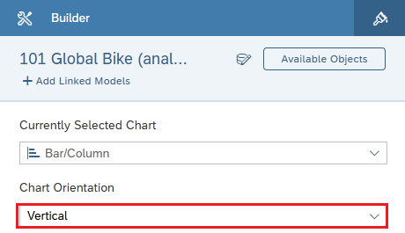
In the Measures section, add the measure Sales Quantity, and in the Dimensions section, the dimensions Country (under Customer) and Product. |  | Sales Quantity  Country  Product
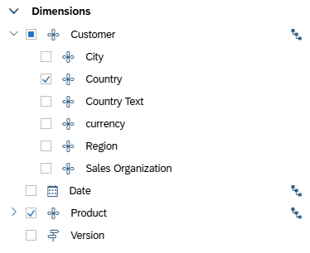
For the dimension Product, set the hierarchy level to level 2 by hovering over the dimension Product and clicking the icon that appears. Select Level 2 here. |  | Level 2
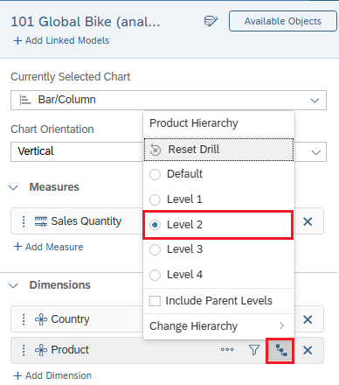
Change the gradient to grayscale and choose a gray tone as the color. |  | Grayscale, grey tone
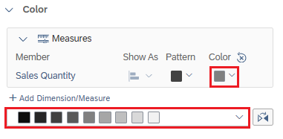
Increase the size of the chart approximately to twice the size. Change the title to Sales Quantity per Country and Product Hierarchy by double-clicking the chart header. |  | Sales Quantity per Country and Product Hierarchy
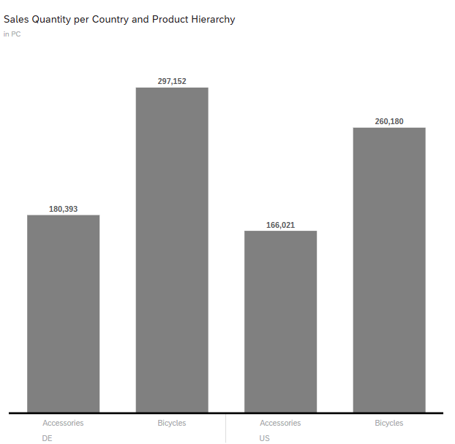
Insert a new area next to the graphic. To do this, click the area next to the graphic and choose More Actions 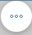 ► Add Lane ► Add Lane to Right. |  | More Actions  Add Lane  Add Lane to Right
In the new area, insert a table using the Table icon. |  | Table
Under Rows, add the dimensions Country Text, Division, Product Category, and Product, and under Columns, add the key figures Sales Quantity, Revenue LC, and Discount LC. |  | Country Text, Division, Product Category, Product  Sales quantity  Revenue LC, Discount LC
Note The order of the checkbox of the boxes determines the order of the key figures in the table.
For Product, switch from the hierarchical display to the flat display. To do so, in the Builder panel on the right side panel, under Measures, click More and choose Hierarchy…. |  | More  Hierarchy…
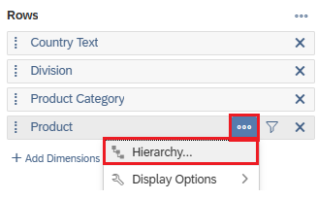
In the window that opens, under Hierarchy, select the Flat Presentation option and close the window by choosing Set. |  | Flat Presentation  Set
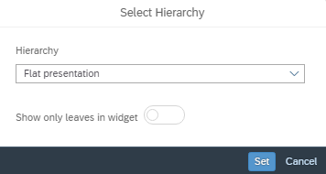
Next, remove the table title, subtitle, and table details by clicking your table and choosing More Actions 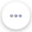 in the upper right corner. In the menu, choose Show/Hide. In the following submenu, deselect Subtitle and Table Details. |  | Show/Hide  Subtitle  Table Details
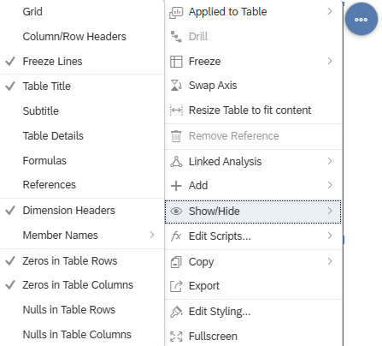
Rename your table to Detail Product Analysis. |  | Detailed Product Analysis
Now enlarge the area of the table using the left side. The table should be visible without horizontal scrollbars.
For filters, insert a new area above the graphic and the table. To do this, click on the area of the graphic and choose More Actions ► Add Lane ► Add Lane Above. |  | More Actions  Add Lane  Add Lane Above
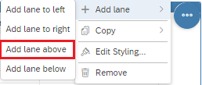
Define a Page Filter on Date that allows end users to select a maximum of the last 5 years.
To do this, click in the new area and insert a filter using the Insert ribbon and click on the icon input control . |  | Input Control
Dimensions
Date
Filter by Member…
The system then inserts a Page Filter element. You must now define this. To do this, select the entry Dimensions ► Date ► Filter by Member… in the menu that opens.
In the following dialog, select the values for 2015 - 2019 individually. |  | 2015 - 2019
Since only a single selection of the year is to be possible in this filter, choose the Settings button and define the selection type as Single Selection. Confirm the window with OK. |  | Settings  Single Selection  Ok then
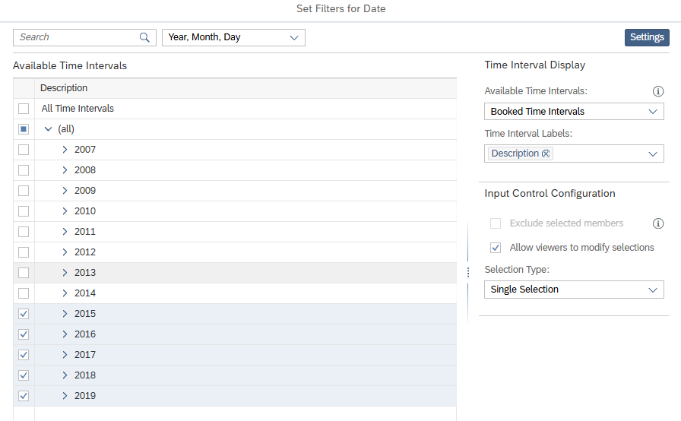
Define a linked analysis in the form that a selection of a graphical element filters the table.
When you click on the graphic, the option More Actions appears in the upper right corner. Click the button. In the context menu, choose More Options ► Linked Analysis ► Settings. |  | More Actions  More Options  Linked Analysis  Settings
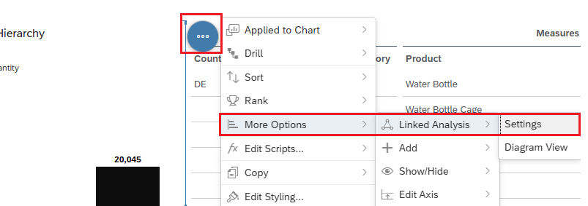
The definition view now opens in the right-hand pane. First, in the Interactions apply to area, select All Widgets on the Page. In the Settings area that then appears, choose the Filter on Data Point Selection option and close the window by choosing Apply. |  | All Widgets on the Page  Filter on Data Point Selection  Apply
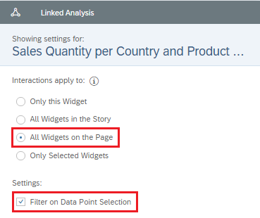
In the right-hand side panel, switch from the Builder panel to the Styling panel. |  | Styling
In the Quick Menus area of the right-hand side panel, deselect it for the graphic, table, and page filter. |  | Quick Menu
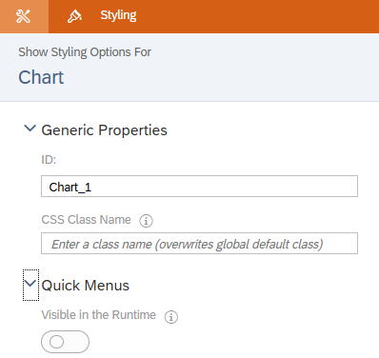
Rename your page from Page_1 to Product Analysis. |  | Product Analysis
Your story should now look like this.
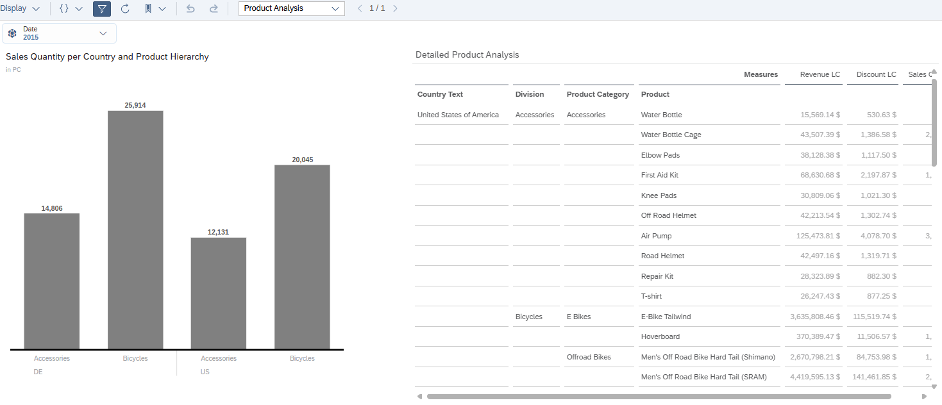
Finally, save your story by clicking Save in the upper left corner. In the window that opens, choose your personal folder My SAC course as the location, go to the stories subfolder, and name your story ### Story 3. |  | Save  ### Story 3

 | Challenge 1: Calculated Measures in Model or Story
Challenge Create a new calculated measure Discount %.  Description Create the measure twice, in the model and in the story, and examine the differences between the two. |  | Time 15 min.
A calculated measure can be created either directly in the model or in a story built on top of it. |  | Initial Screen
In the model: In this case study, you have already created the calculated measure Contribution Margin in your ### Global Bike (analytic) model. |  | Model
In the story: in the SAC Story Builder exercise, you have already used the calculated measure Discount %. In the Story Builder case study, you have created a new calculated measure contribution margin %. |  | Story
In your ### Global Bike (analytic) model, create a new calculated key figure Discount % with the correct formula. |  | Discount %
You then create the same calculated measure in your story ### Story 3.
Question When does it make more sense to create the calculated measure in the model and when in the story?
Note that, depending on the use case, one or more stories can be based on the same model.

