R-LINK USER MANUAL

Latest version 1.0.7.1

Compiled by R&D Dipes Team
10/2024

Contents
Chapter 1 – Introduction 5
R-Link overview 5
System requirements 5
Chapter 2 - Getting Started 6
Installing R-Link 6
Updating R-Link 8
Uninstalling R-Link 8
Chapter 3 – License and Login 9
License to use the software 9
Log in to use the software 10
Chapter 4 – Essential Equipment 11
List of essential system equipment 11
Chapter 5 – Settings 12
Settings menu 12
System settings 13
Camera settings 14
Printer settings 17
PLC Settings 18
Scanner settings 19
Chapter 6 - Job Creation 20
Create a new Job 20
Compare type 21
Database path 22
Comparative data format 22
Template name 26
Save Job 26
Chapter 7 – Job Selection 28
Select job tab 28
Job details 28
Buttons to manipulate Job 29
Job Classification 29
Chapter 8 – Job execution page 30
Job details 30
Image display box 31
Verification results 31
Verification progress 32
Statistics of POD data 32
Database View 33
Job logs 35
Job Logs Detail 36
Chapter 9 – Users management 38
Users Management 38
Users management functions 39
User management operations 40
Chapter 10 – Program history 43
Log datetime filter 45
Chapter 11 – Export reports for Job 46
Export print data report 46
Export verification data report 47
Chapter 12 – Another functions 48
Return to Job selection page 48
Status bar and other information 48
Chapter 13 – Rynan printer settings 49
Check all printer settings function 49
Notification of printer parameters not enabled 51
Printer connection settings 51
Design a template 52
Chapter 14 – Cognex Dataman camera settings 54
Software required 54
Connect to camera 54
Optimize Image 56
Identify barcode type 56
Trigger type 57
Output settings 58
Chapter 15 – Cognex In-Sight Vision camera settings 60

Chapter 1 – Introduction

R-Link overview
R-Link is a barcode verification software used to ensure the reliability of data in printing systems for products such as goods, packaging, etc. The R-Link software is suitable for use in industrial printing systems and is optimized for Rynan R Series printers to perform data printing processes. It supports connection with cameras such as Cognex, Keyence, etc., to capture images of printed data. Finally, R-Link verifies the results and performs the process of sorting and marking errors. Additionally, R-Link can operate in a verification-only mode without coordinating data printing, making it compatible with any printer system. In this mode, R-Link will only read the printed data, compare, and then classify or mark errors.
R-Link is designed to operate in high-speed data printing systems and is continuously upgraded with new features and actively supported by a dedicated team.

System requirements
- Operating System: Windows 10 Professional (64-bit), version 20H2 or later; Windows 11 (64-bit), version 23H2 is recommended
- Screen resolution: Recommended 1920x1080
- Tested CPU: Intel® i5 3th, Intel® 12th Gen or newer, or AMD Ryzen™ 4000 Series or newer
- RAM: 8GB or more
- Local Storage: SSD with 1GB of available disk space
- Internet: Not required
- Additional system requirements: Microsoft .NET 4.8 or later (included)
- Recommended network configuration: Cat5e/Cat6e, Gigabit Ethernet (1 Gbps) or higher, PCIe x4, RJ45/Optical Connector.

Chapter 2 - Getting Started

Installing R-Link
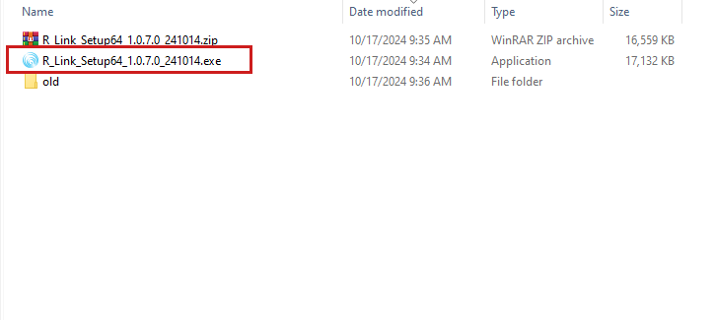
Unzip the installation file (.zip) and run the (.exe) format file
On startup settings interface:
- Select “Create a desktop shortcut” to display the software icon on the desktop, click Next.
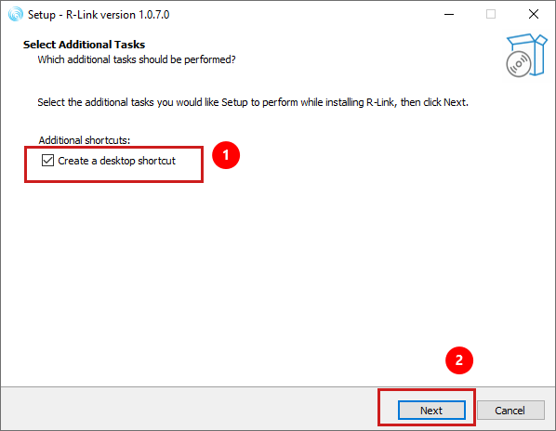

- Click the Install button to start the software installation process
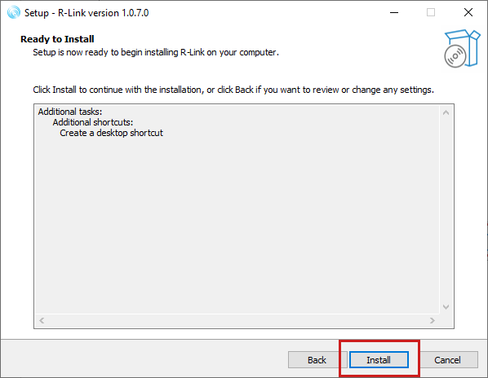
- Once the installation is complete, select Finish to start the software right away (if you choose the Launch R-Link option)
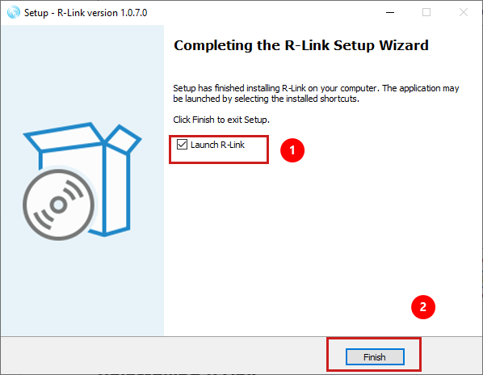

Updating R-Link
To update the R-Link software, a new version software installation file is required and perform the installation normally (no need to uninstall the previous version).

Uninstalling R-Link
To uninstall the R-Link software you need to go to the Control Panel and select Uninstall a program.
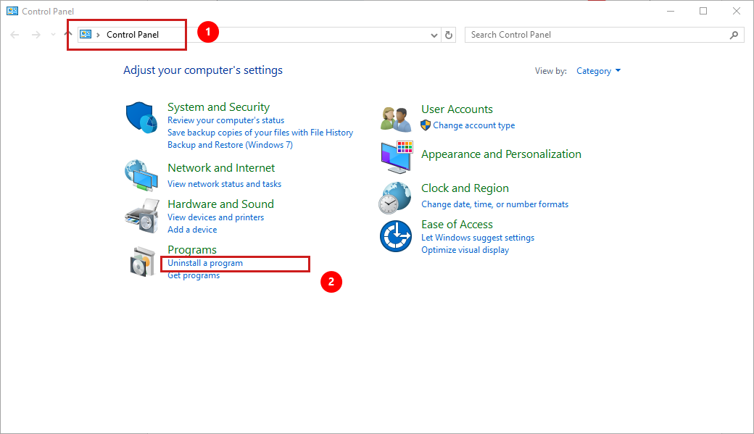
Select the R-Link software and uninstall it.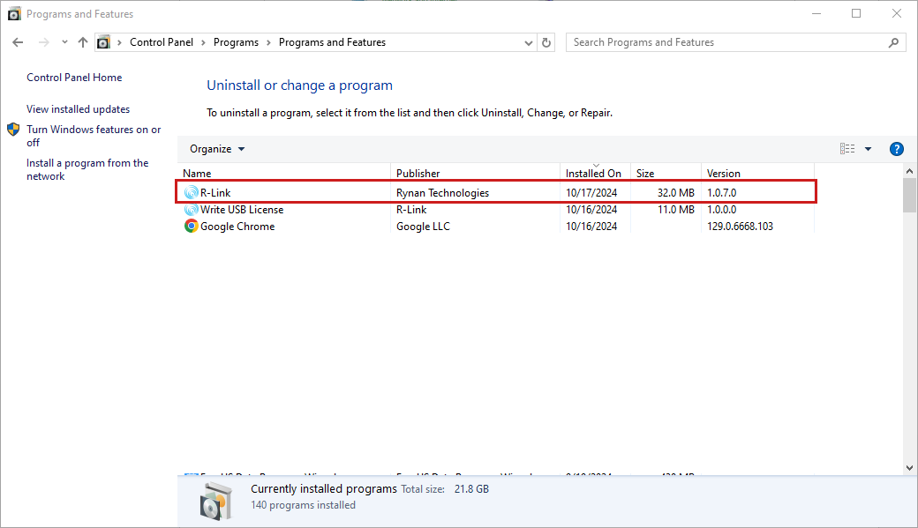

Chapter 3 – License and Login

License to use the software
R-Link uses a USB Secure Dongle for activation. Users will receive a notification if they do not have a license to use the software.
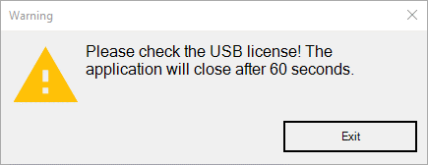
Plug the R-Link keyed USB Dongle Key into the computer to use the R-Link software
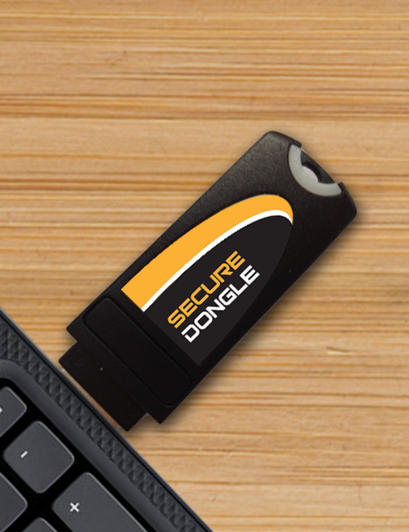

Log in to use the software
Default login account to use the software
- Username: admin
- Password: 123456

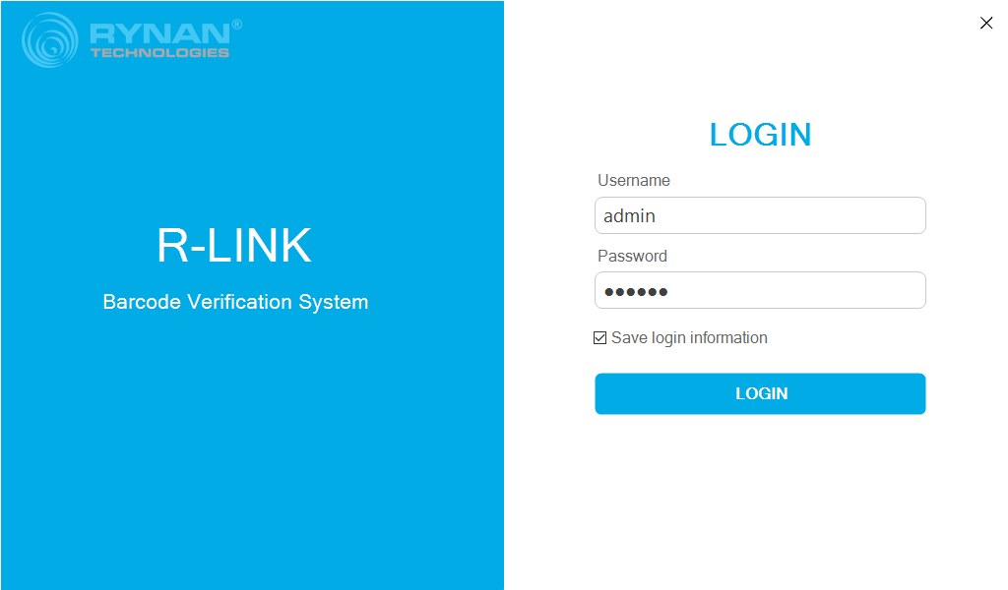

Chapter 4 – Essential Equipment

List of essential system equipment
Devices name | Functions | Minimum quantity
Personal Computer | R-Link installation environment | 1
Printer (accessory) | Print barcodes | 1
Camera (accessory) | Read barcode data | 1
Controller system | Use PLC to classify and mark errors | 1
Sensor 1 | Camera trigger sensor | 1
Sensor 2 | Printer trigger sensor | 1
Encoder 1 | Printer encoder | 1
Encoder 2 | PLC encoder | 1
Encoder 3 | Mark errors printer | 1

Note: This is a list of the minimum basic equipment required to set up a barcode verification system.

Chapter 5 – Settings

Settings menu
After successfully logging in, the interface below will be displayed first
To enter the settings section, you need to select the Settings section in the vertical menu bar
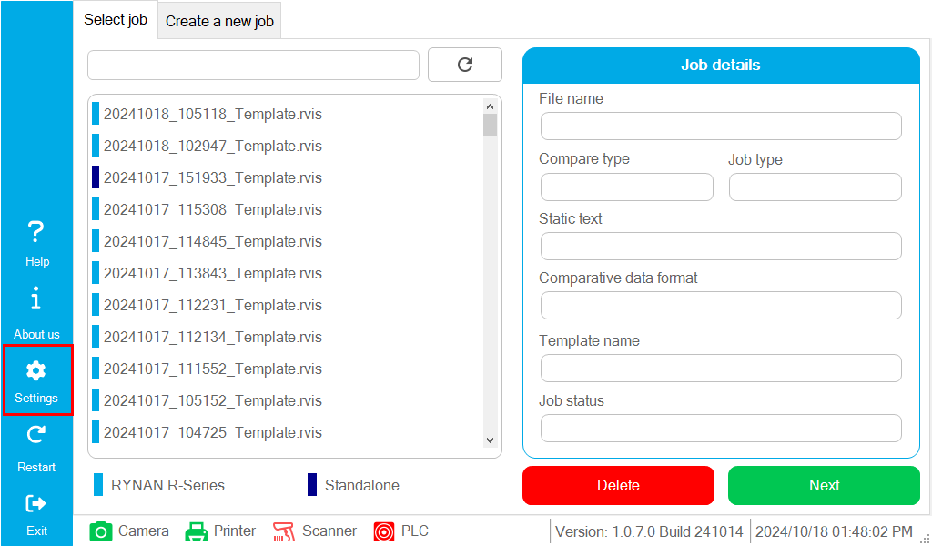
Settings interface
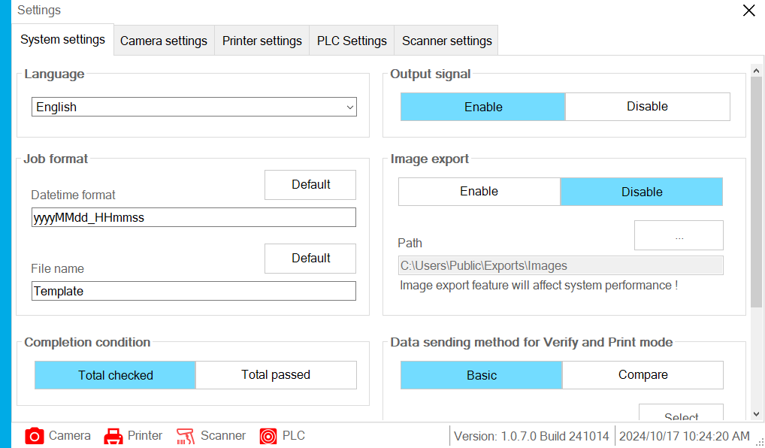

System settings
System settings include:
Language: Support English and Vietnamese
Job format: The name format for Job includes Datetime format and File name
Completion condition: include Total checked & Total passed
- Total checked: The running process will stop when the total amount of checked data is reached, For example: Database has 1000 barcodes, it will stop if the camera captures exactly 1000 of those codes.
- Total passed: The process will stop when the required number of databases have been verified and passed. For example, if there are 1000 barcodes, the process will only stop once all 1000 codes have been checked and passed.
Output signal: The camera output controlled by R-Link toggles between Enable and Disable each time an error code is detected during verification.
Image export: failed image export function to make image log
Data sending method for Verify and Print mode: Customize the data sent to the printer in Verify and Print mode
- Basic: The camera reads and compares data. If the comparison is valid, it sends the data to the printer. If invalid, it sends a user-entered string to the printer (default is 'Failure').
- Compare: The camera also reads and compares data. If correct, it can send fields in the database in a customized way or send all of them. If invalid, it sends a user-entered string to the printer (default is 'Failure').
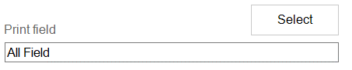
Users can also change the character string sent to the printer when the comparison is invalid.
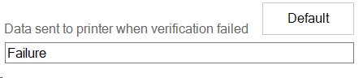

Camera settings
Camera setting interface
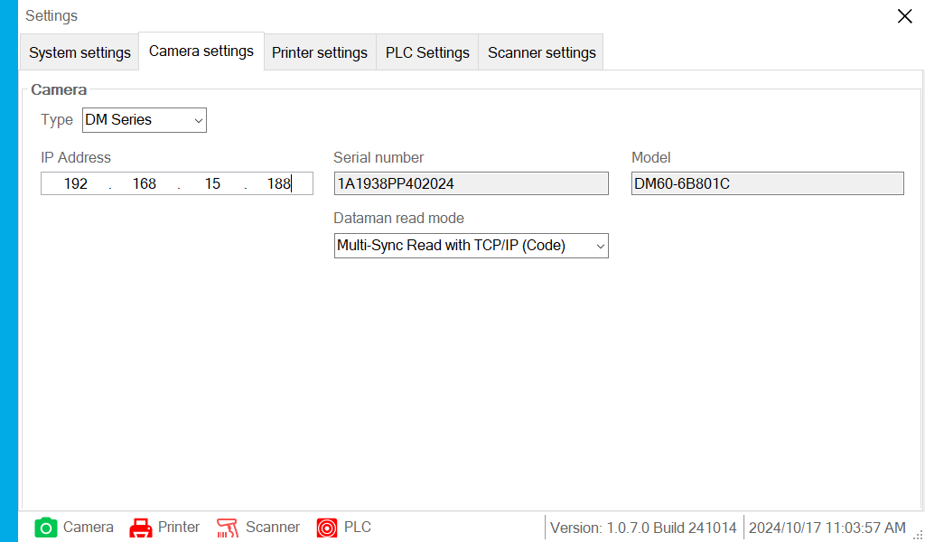
Camera settings include:
Type: camera types
- Cameras supported: Cognex Dataman, Cognex In-Sight Vision
DM Series (Cognex Dataman camera)
- IP Address
- Information about cameras: Serial number, Model, Dataman read mode
Dataman read mode include:
- Basic Read (Image+Code): used for a single camera to retrieve images and code content
- Multi-Sync Read with TCP/IP (Code): Using multiple dataman cameras in combination to produce a single result, it would be impossible to obtain images. This mode requires using the Multi-Sync function on the camera and executing a custom script on Dataman Setup Tool
How to use Multi-Sync Read with TCP/IP (Code)
* Notes: This mode will be performed by R-Link technicians based on customer needs. Customers are not encouraged to configure themselves
- Open Dataman Setup Tool and create new group
Documents :
DataMan Multi-Reader Sync Configuration: https://support.cognex.com/docs/dmst_2421/web/EN/Fixed_Mount_Manual/Content/Topics/FMREF/DataManMasterSlaveConfig/DataManMultiReaderSync.htm
MRS Tutorial 02 - Basic Setup
https://www.cognex.com/videos/barcode-readers/mrs-tutorial-02-basic-setup
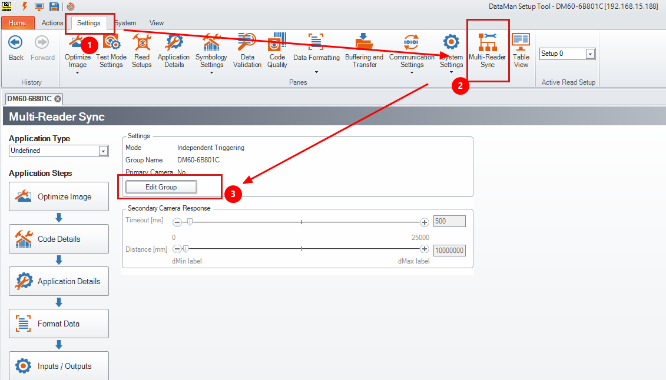
Data formating script:
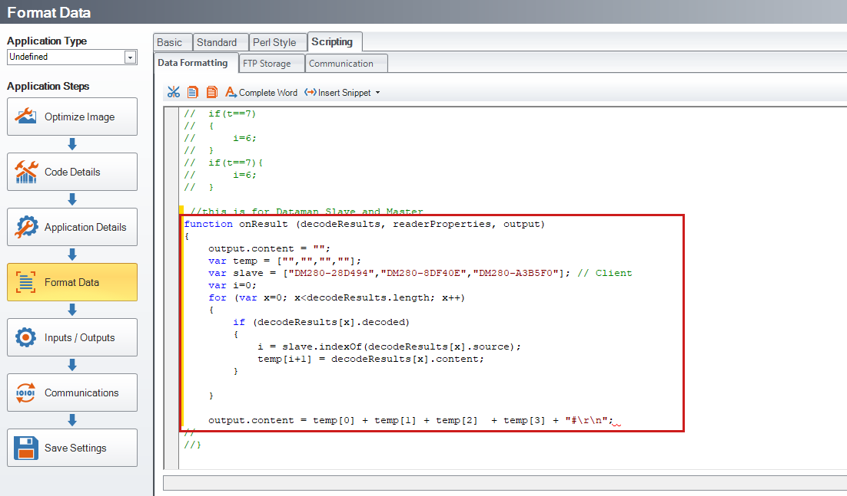
Replace the slave variable values ​​with the camera models
Example: var slave = [“camera slave model 1”,” camera slave model 2”,…]
IS Series (Cognex Insight-Vision camera)
Use an In-Sight vision camera
- IP Address
- Information about cameras: Serial number, Model
- Image Resolution: resolution of the image captured from the camera
Camera Insight-Vision object settings
To install this part, you need to connect the camera on Insight-Vision Suite software
ObjectName: is the name of the object trained on Insight-Vision Suite software
- ID Read: read barcodes
- Character Read: Read characters, strings, numbers
- Single Job file name: name of the job file created on Insight-Vision Suite
IS Series Dual (Combines results from two In-Sight Vision cameras)
Same as IS Series but with an additional slave camera
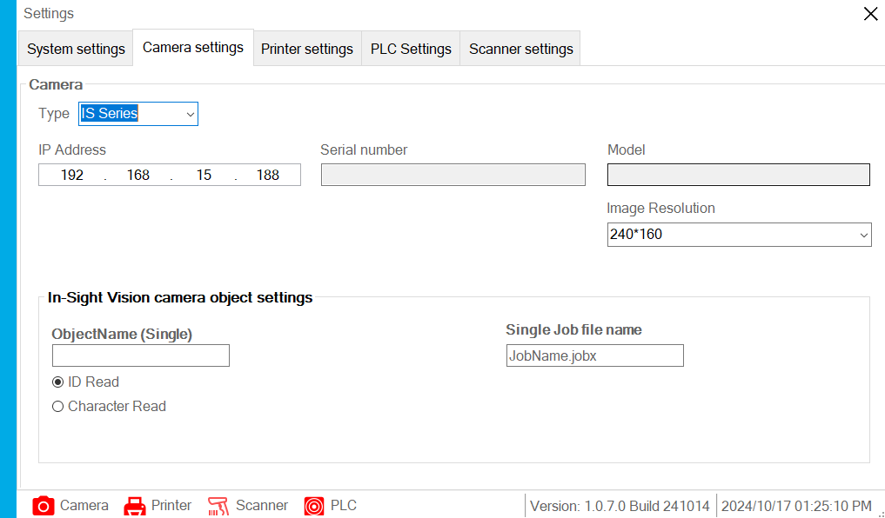

Printer settings
Printer settings interface
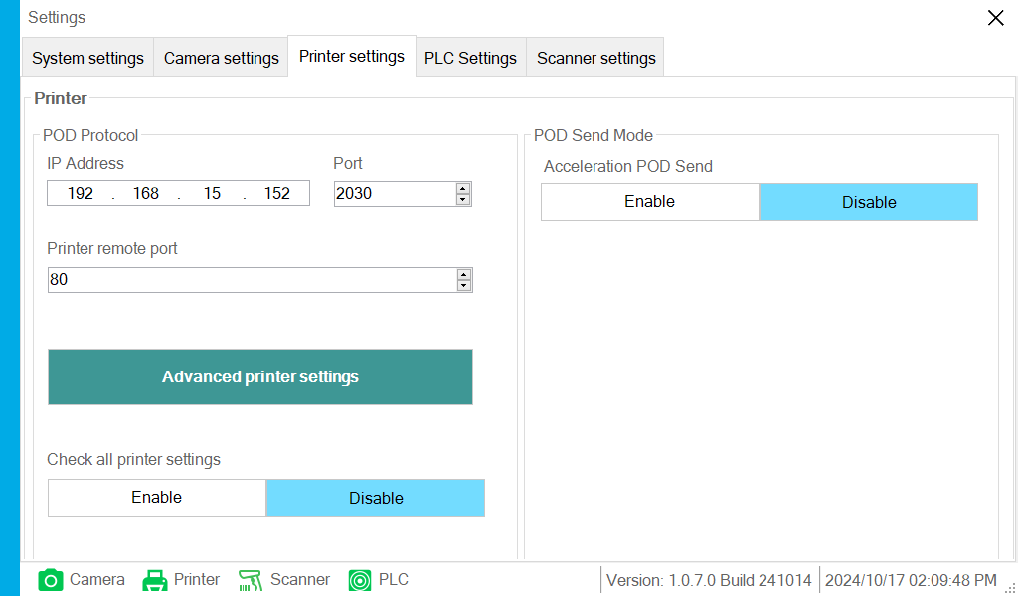
POD Protocol
- Printer connection parameters: IP Address, Port, Printer remote port
- Advanced printer settings: Use the printer configuration via the web interface
- Acceleration POD Send: Increase CPU usage for data transmission from R-Link to the printer (Limit abuse if you don't have to run at high speed)
Successful connection result: the connection icon turns blue

PLC Settings
PLC settings interface
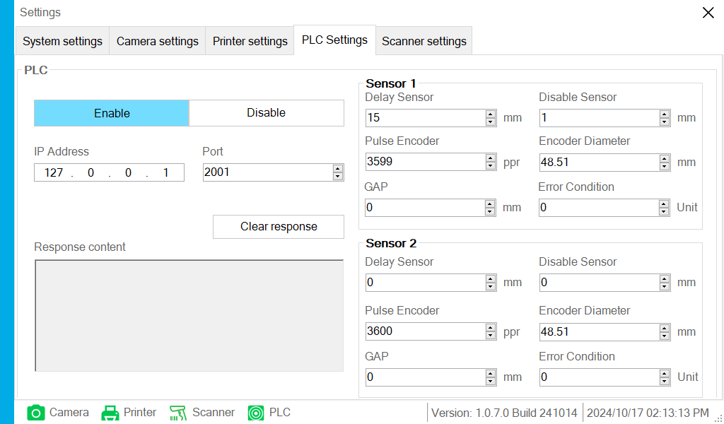
The system will use a PLC to control error marking, connected through the IP address of the PLC. This will create a sensor control mechanism that marks errors.
- Connection parameters: IP Address, Port
- Response content: Feedback data from PLC, Clear response button to clear feedback data
- Sensor parameters: Parameters for error marking at the PLC
Delay sensor (mm), Disable sensor (mm), Pulse Encoder (ppr), Encoder Diameter (mm), GAP, Error Condition (Unit)

Scanner settings
Scanner settings interface
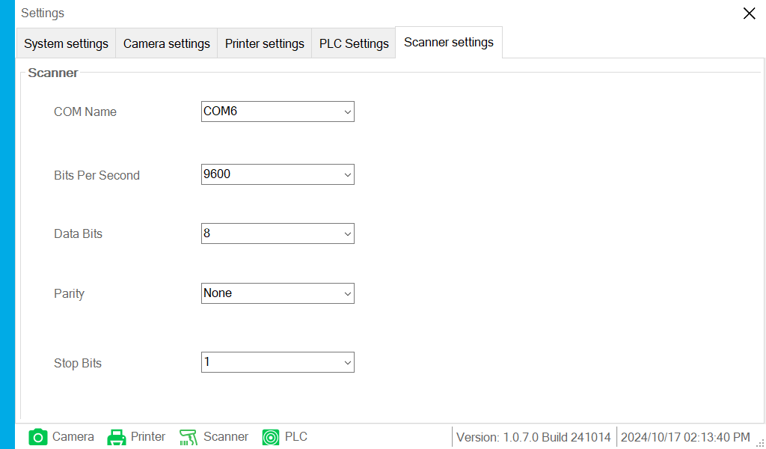
Connect to handheld barcode scanner via serial protocol
Steps to connect to a handheld Barcode scanner
- Configure Barcode Scanner to serial protocol
- Enter the corresponding COM port name
Open Device Manager on your computer to find the COM name of the barcode scanner
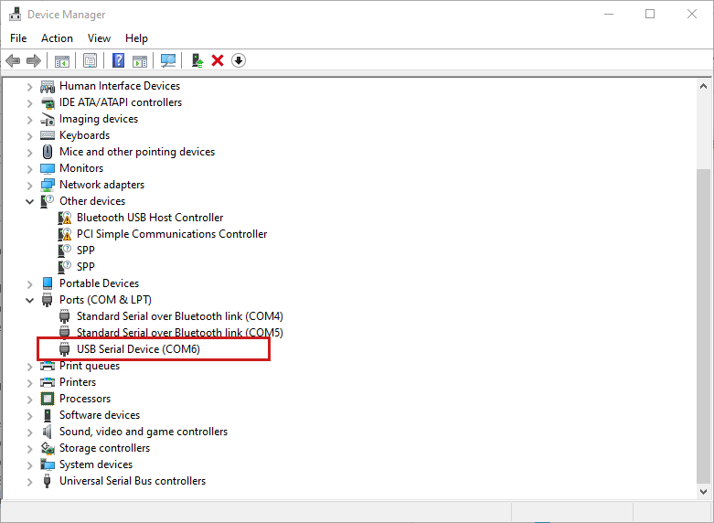

Chapter 6 - Job Creation

Create a new Job
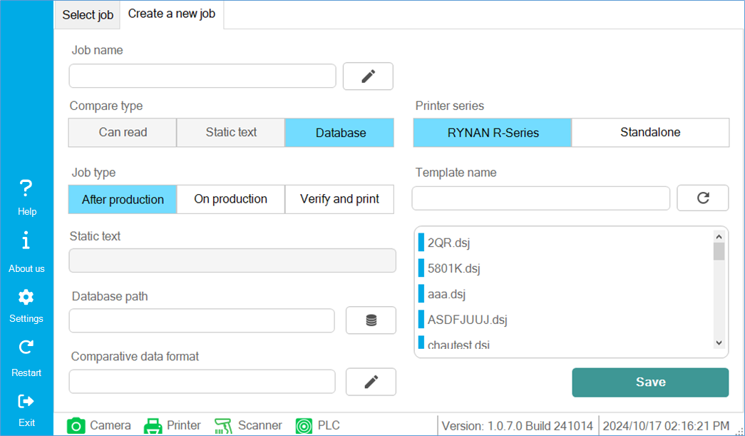
To start a process, you must first create a series of information about the running process, this process creates a file called Job, a Job will include:
Job name: The name for Job can be created with the click of a button 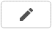

Compare type
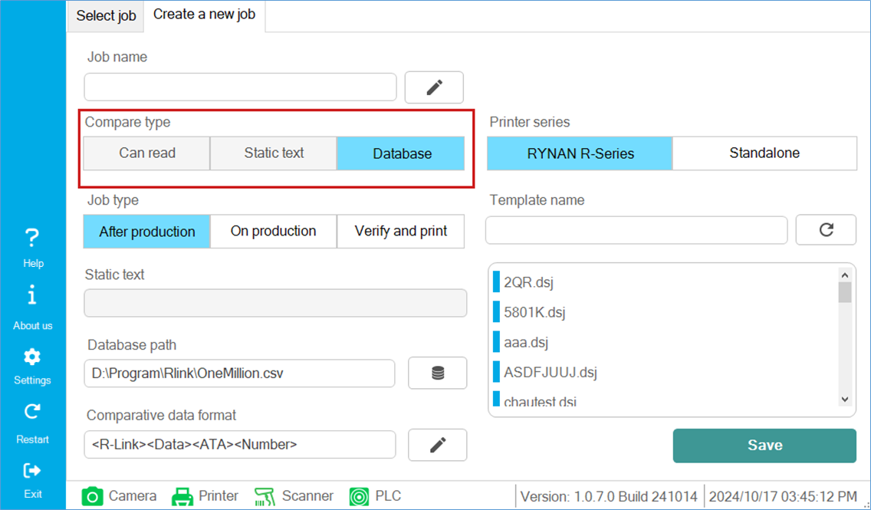
+ Can read: non-printer mode (change the settings in the Printer series section to Standalone). If the camera returns a non-empty result, the result is valid; otherwise, if the result is empty, it is invalid.
+ Static text: non-printer mode (change the settings in the Printer series section to Standalone). If the camera returns a result that matches the static text input, the result is valid; otherwise, it is invalid.
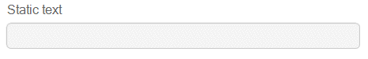
Database: use a database file from the user to compare with camera results. Can be used with RYNAN R-Series printer or Standalone
Job type:
- After production: A mode that prints first, then takes an image of the data and compares with comparative data format to mark errors. This mode requires the use of a database for comparison
- On production: This mode prints first, then takes an image of the data and compares it with the comparative data format. If the result is valid, it prints the next data. Otherwise, it reprints the previous invalid data. The purpose is to ensure the correct printing order of the data series.
- Verify and print: This mode takes an image of the data first and then compares this data with the comparative data format. The result will be sending data according to the settings in the "Data sending method for Verify and Print mode" section, see System settings section.

Database path
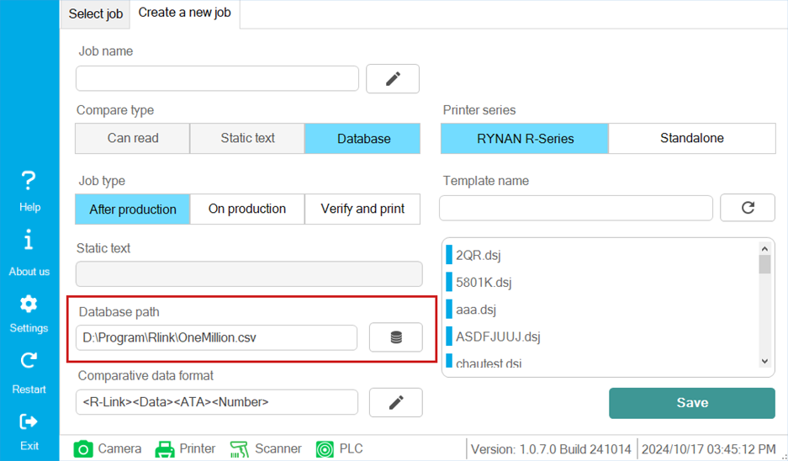
database path in (.csv) format that the user selects

Comparative data format
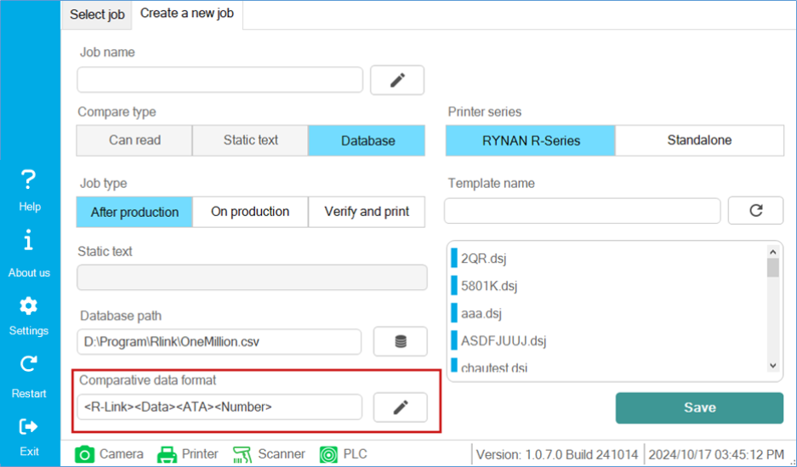
select the comparison format based on the fields in the user's database.
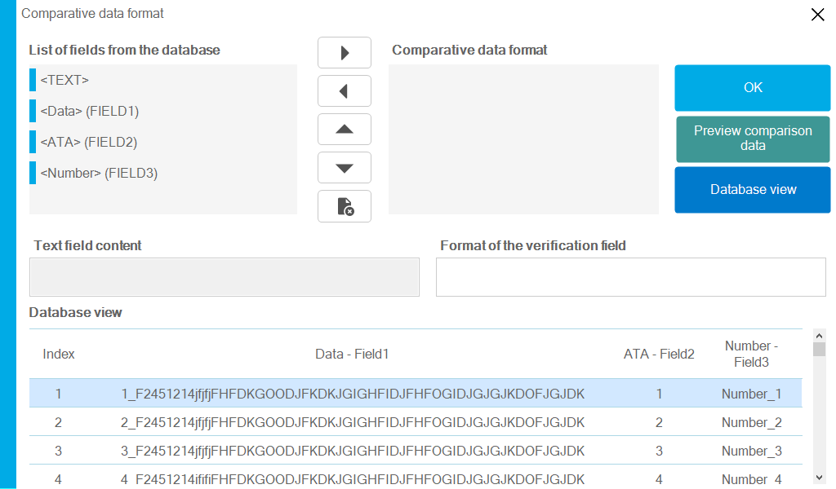

List of fields from the database: List of fields available in the database
Comparative data format: format that the user has selected
Navigation buttons:
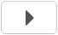 Select desired design school
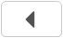 Cancel selected design field
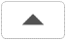 Move selected field up
 Move selected field down
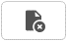 Clear all selected fields
Text field content: optional character or text that the user enters
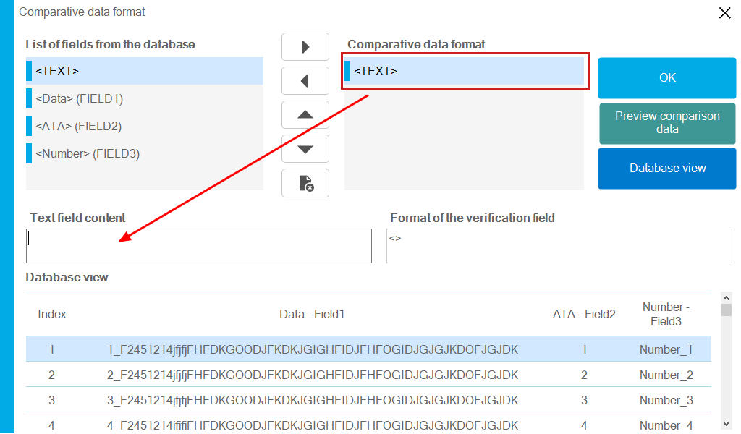
Format of the verification field: formatted fields for syntax preview purposes
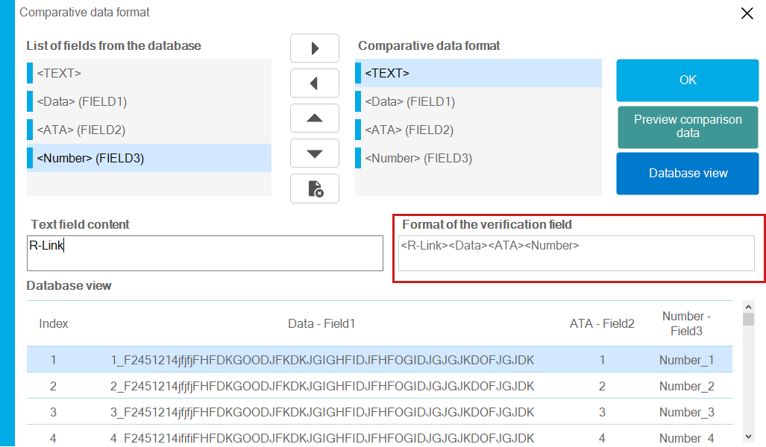
Preview comparison data: Preview formatted data as actual values
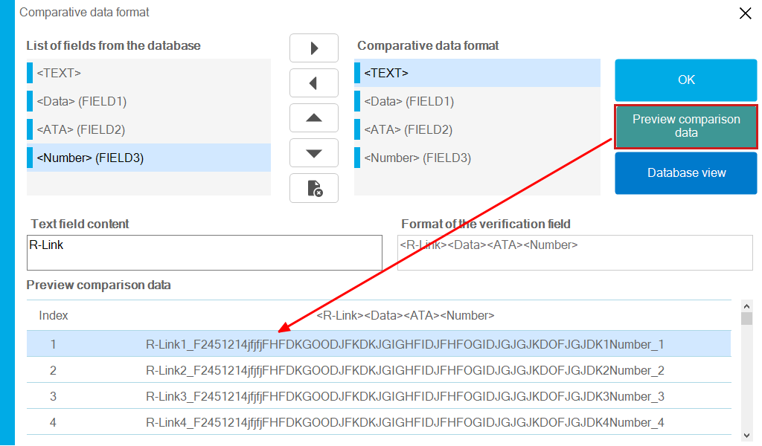
Database view : view original database format
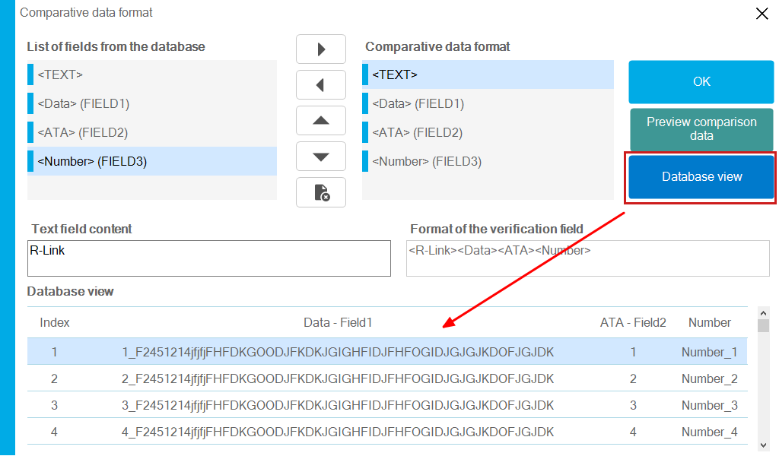

Template name
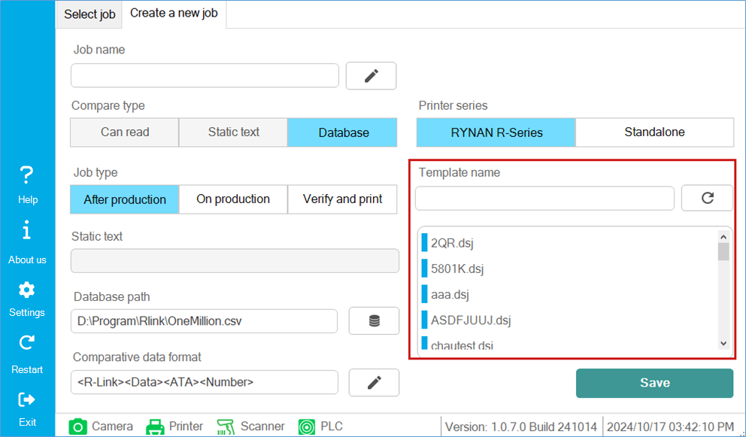
Select the template to print, this template is listed and uploaded from the printer
Use the button 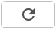 to refresh the template list

Save Job
After entering the necessary options, finally use the Save button to create a new Job. 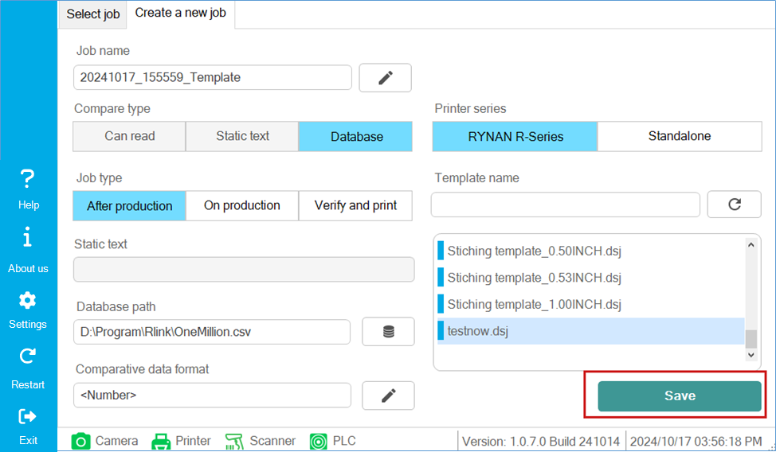
After successfully saving, a confirmation dialog box appears to Start the process immediately
Select Yes if you want to move to the process start page, Select No if you want to do this at another time.
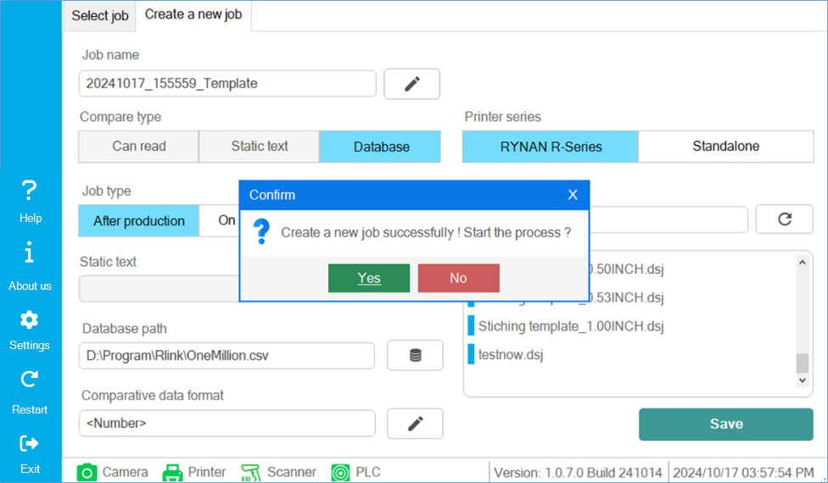

Chapter 7 – Job Selection

Select job tab
After creating a Job, the list of Jobs will be listed in the Select job Tab. Each Job will have a .rvis extension, which will be saved on the system when the software is opened.
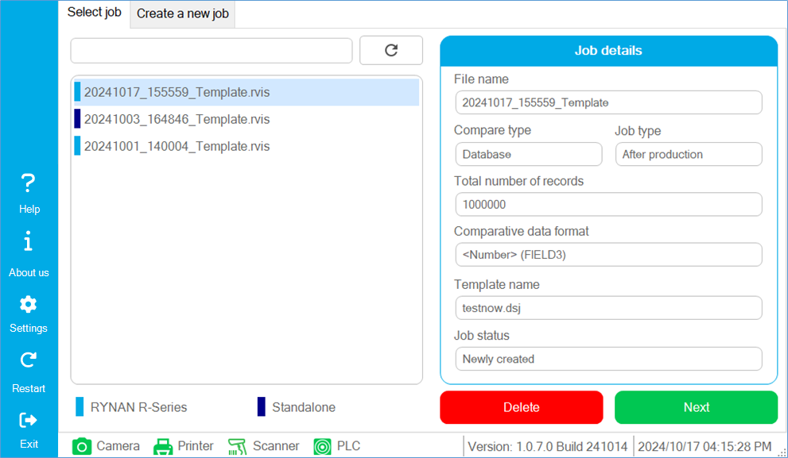

Job details
Job details will summarize the necessary information of a Job so that users can observe before selecting a Job to perform the process.
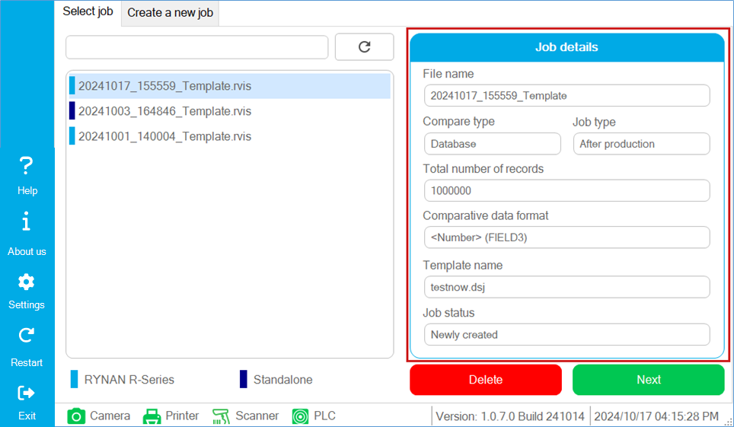
Note: there is an important information that is Job status, which indicates the status of a process.

Buttons to manipulate Job
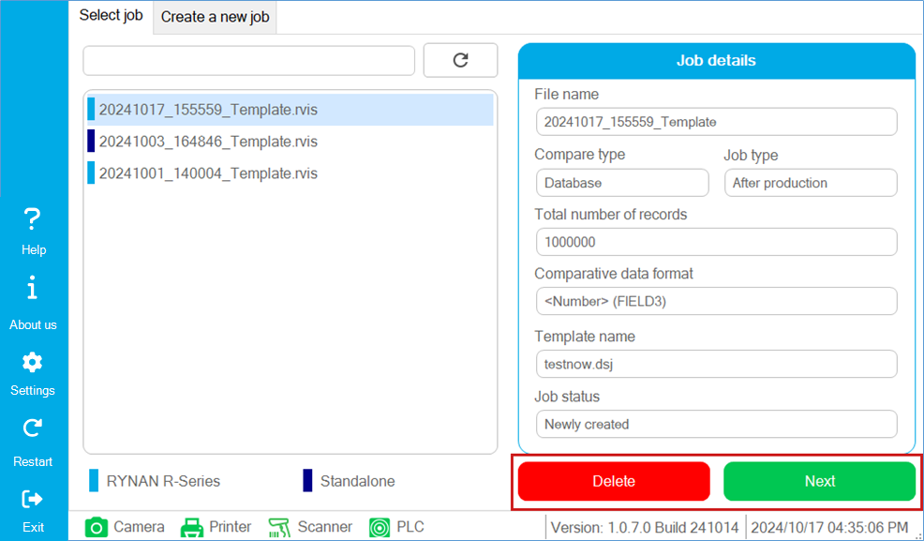
The Delete button will delete the selected Job
Button Next will select Job to move to the process execution page

Job Classification
In the Job list, there is a color bar to categorize whether the Job was created for use with the printer or the Job created for use without the printer (Standalone).
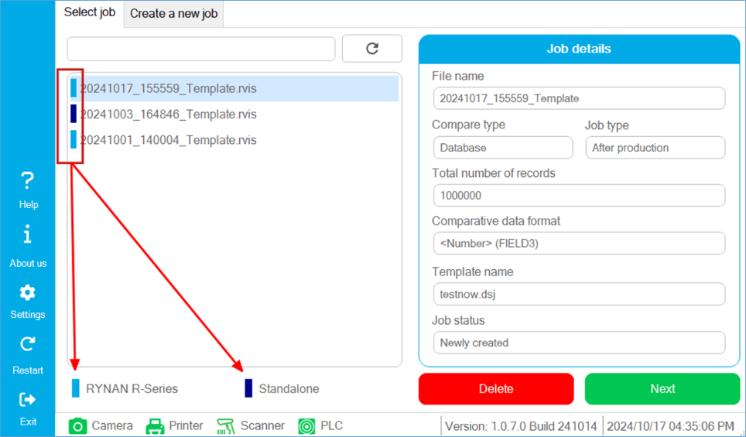

Chapter 8 – Job execution page
This is the page to start running the process of the selected Job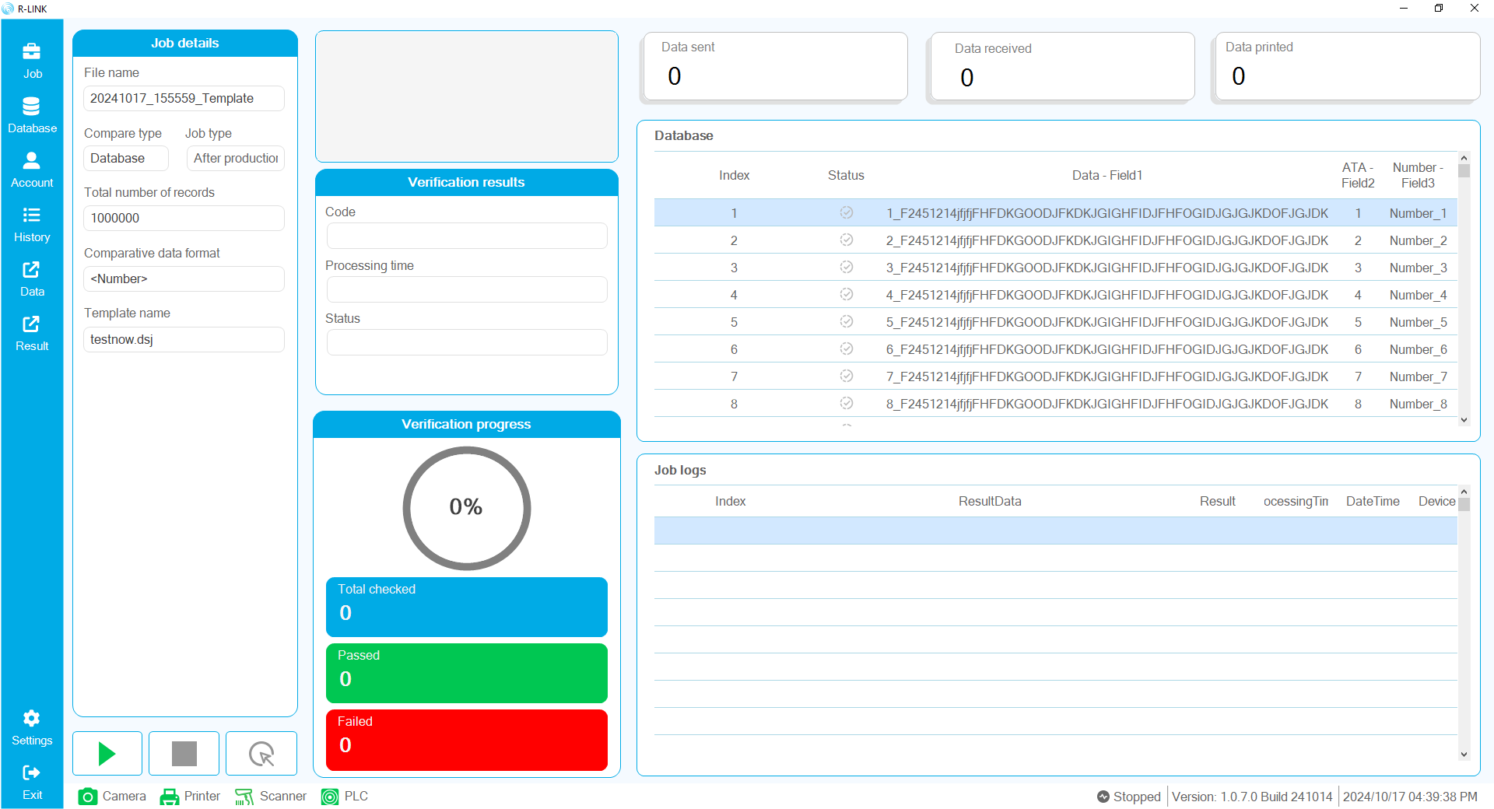

Job details
This section displays overview information of the current active Job.
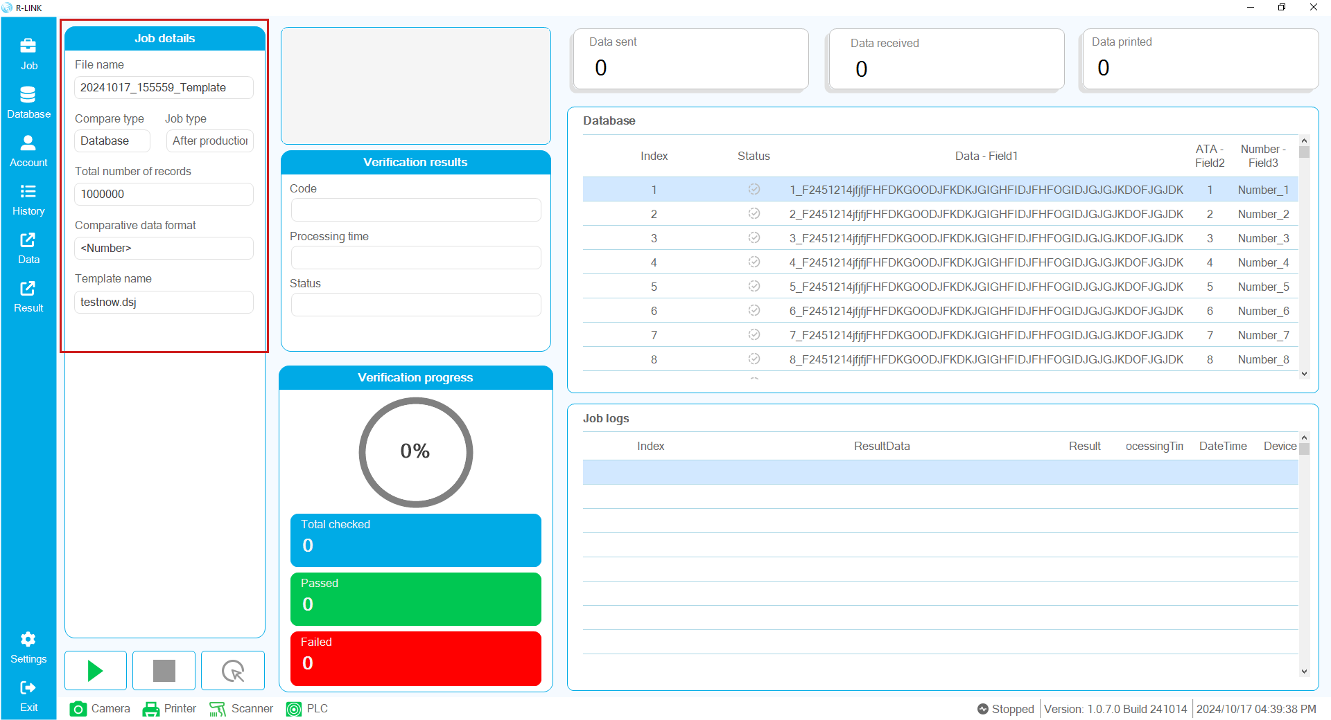

Image display box
When running the process, a photo will be taken by the camera and displayed here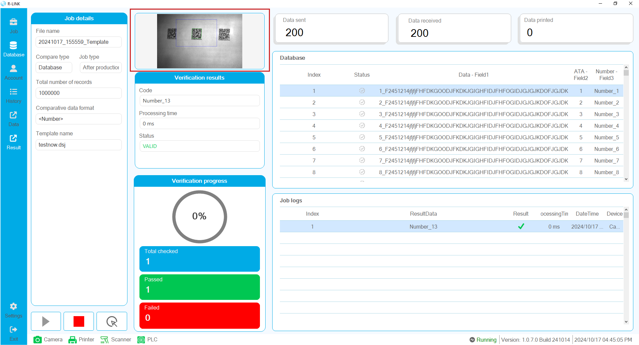

Verification results
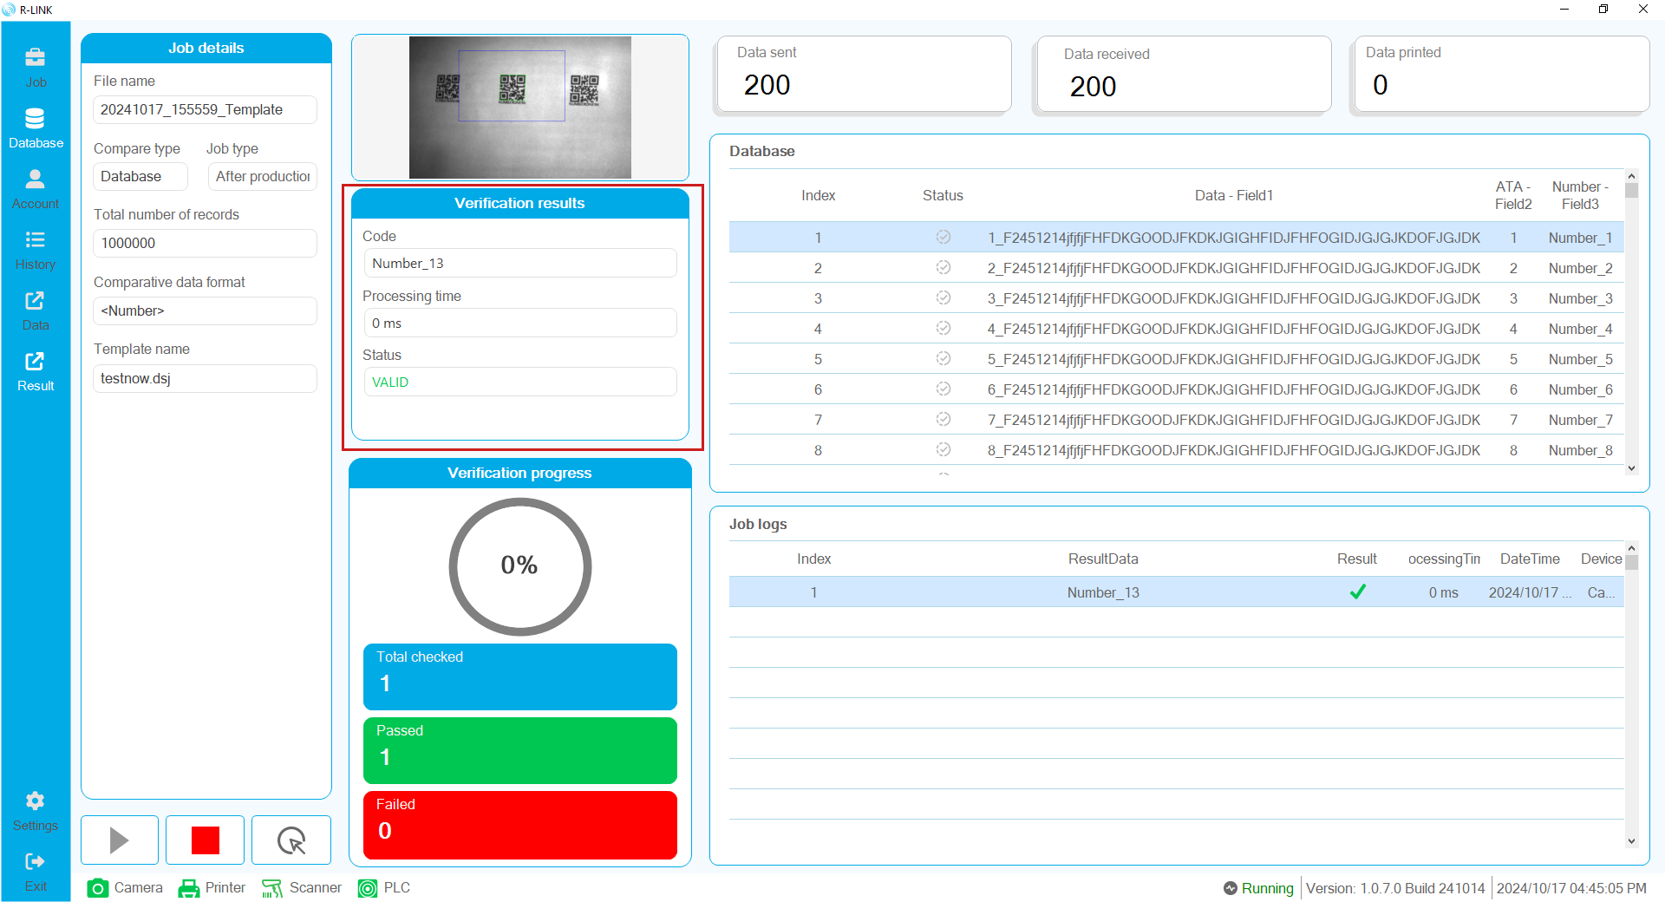
Display data and general information of the data including:
Code: data content read from camera
Processing time: processing time of data comparison
Status: status of comparison result

Verification progress
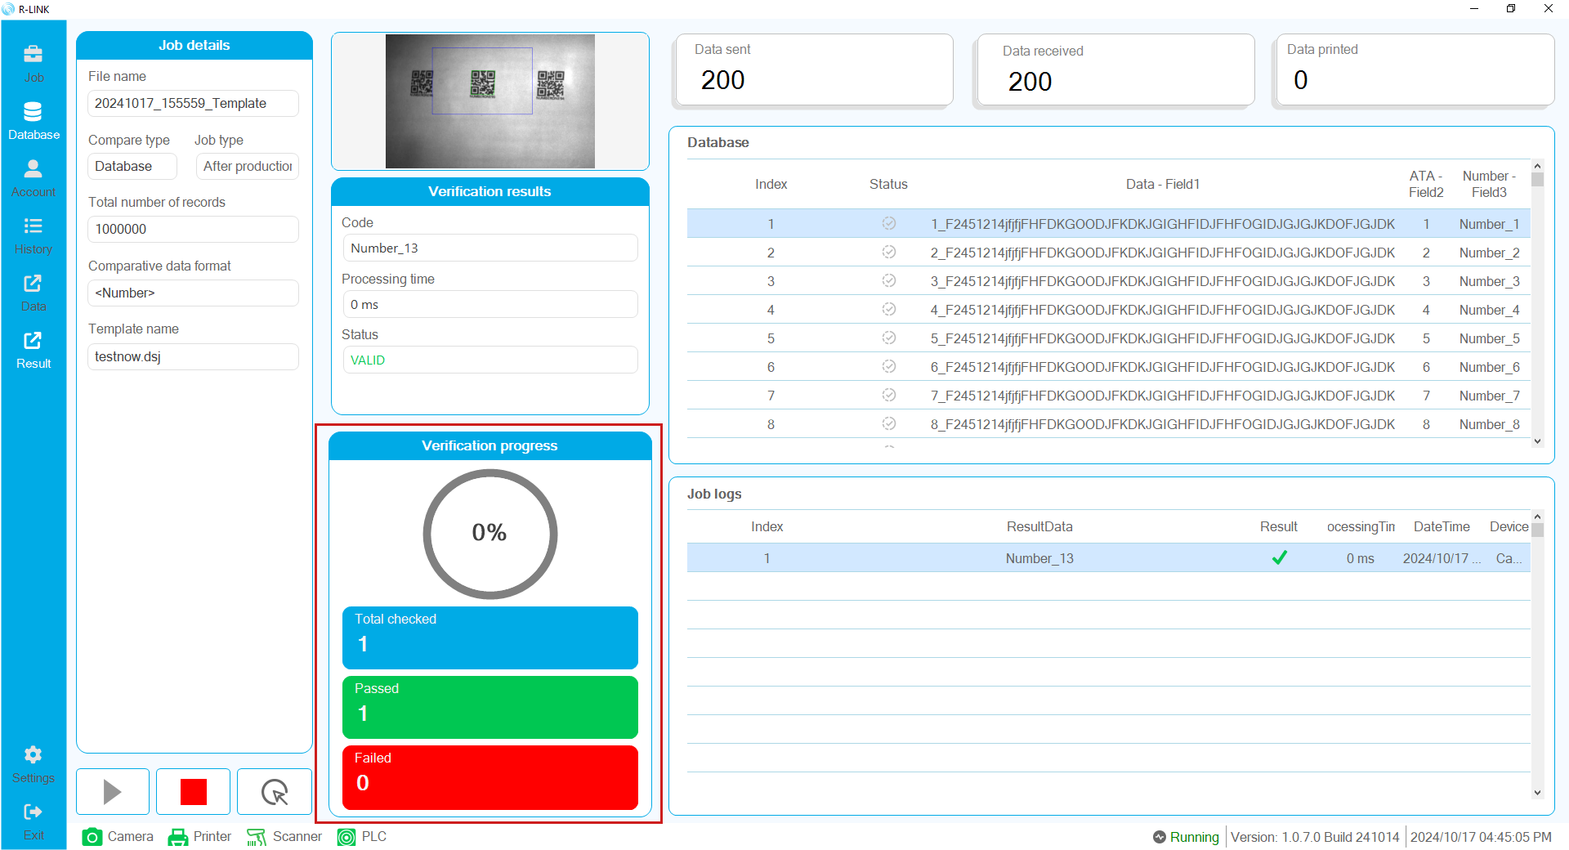
This is where the evaluation results of the process are displayed, such as:
Percentage of the process
Total checked: total number of verified data
Passed: number of barcode data that was successfully verified
Failed: number of barcode data that was failed to be verified

Statistics of POD data
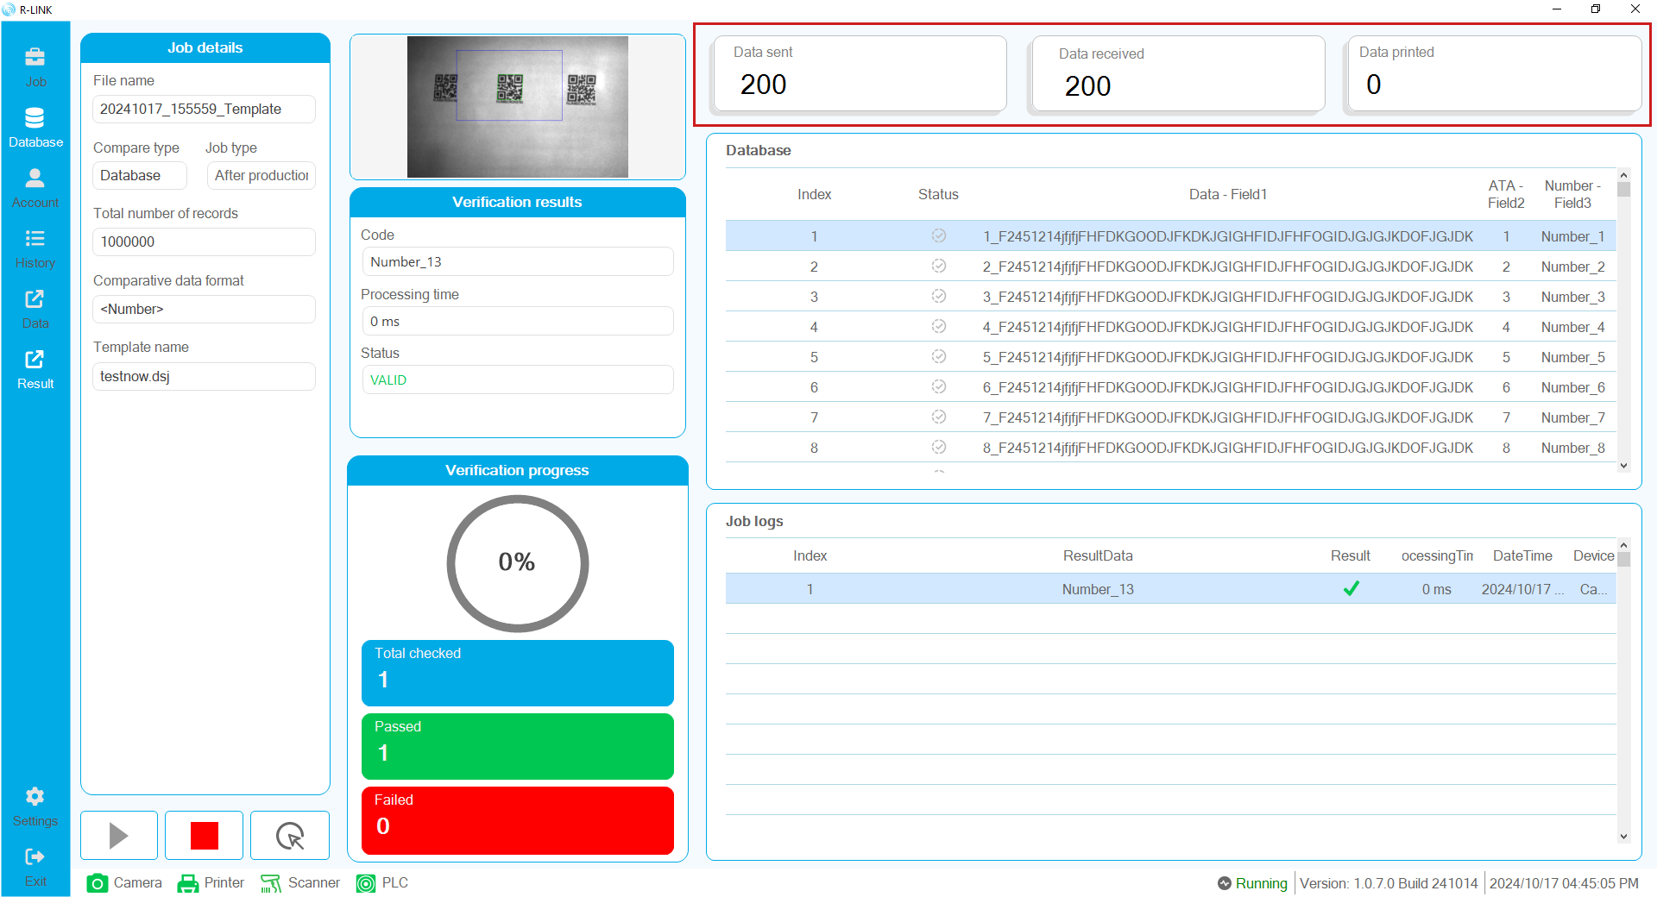
This is where important data is aggregated when working with POD
Data sent: total data sent from R-Link to the printer, only exists in one session.
Data received: total data that the printer has responded to R-Link, only exists in one session.
Data printed: total data that the printer has responded to R-Link, exists and is kept for each Job

Database View
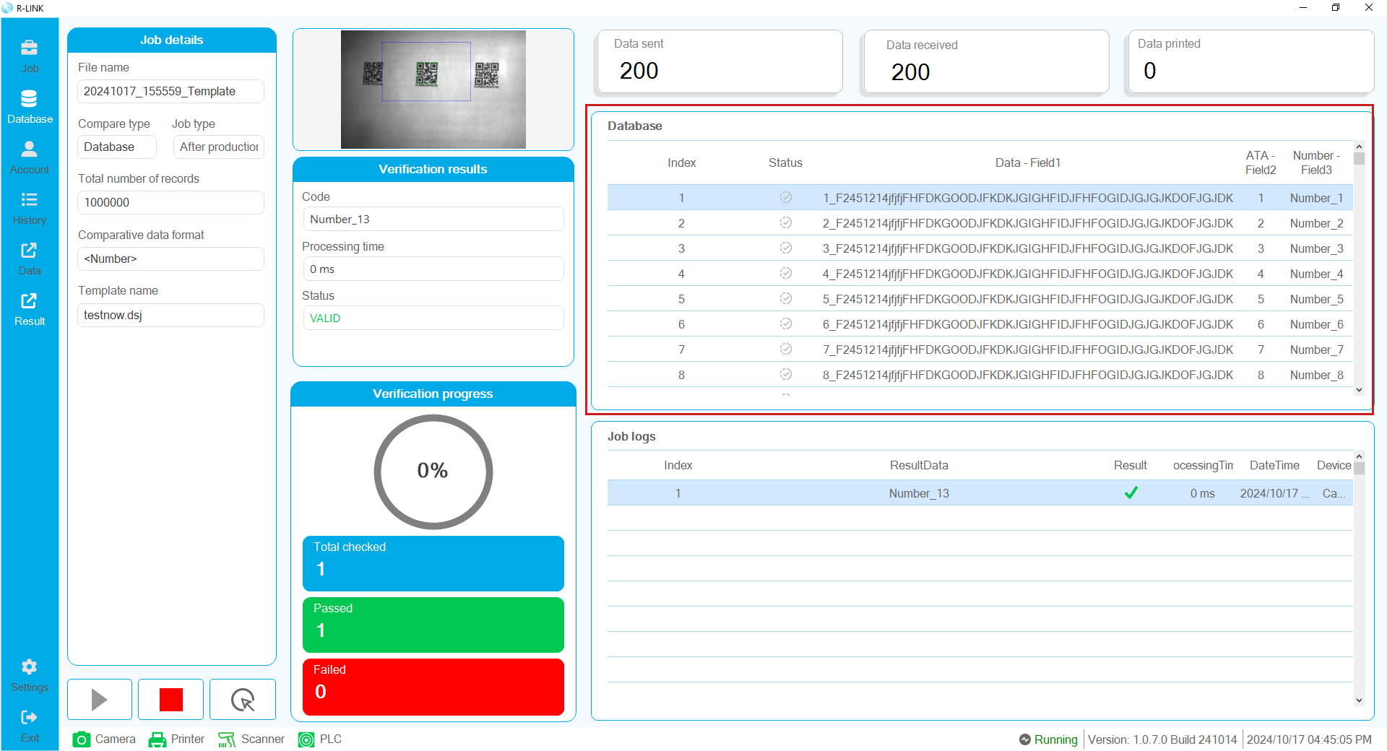
Displays the data list and print status directly with the printing process. The Status column will display two statuses
Click on the Database or Data printed menu to display the Database View window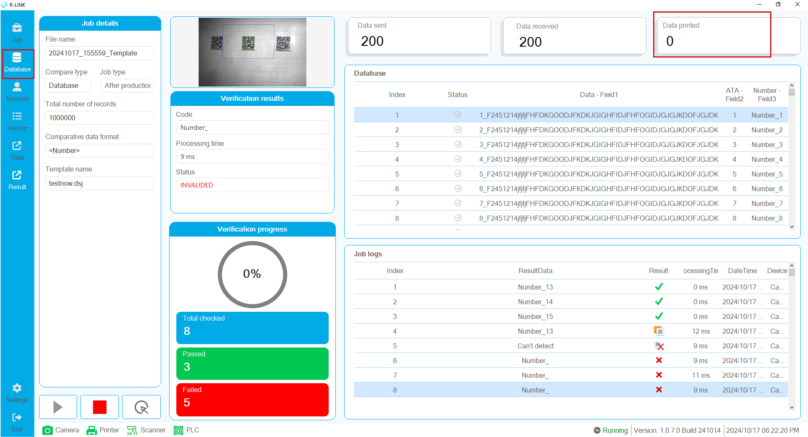
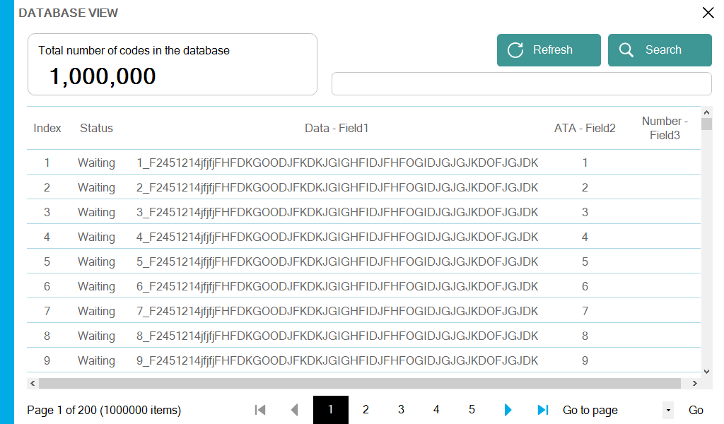
Waiting: data not yet printed
Printed: data already printed
Refresh button: refresh the list
Search button: search data by keyword

Job logs
Where camera data and results are displayed along with verification results
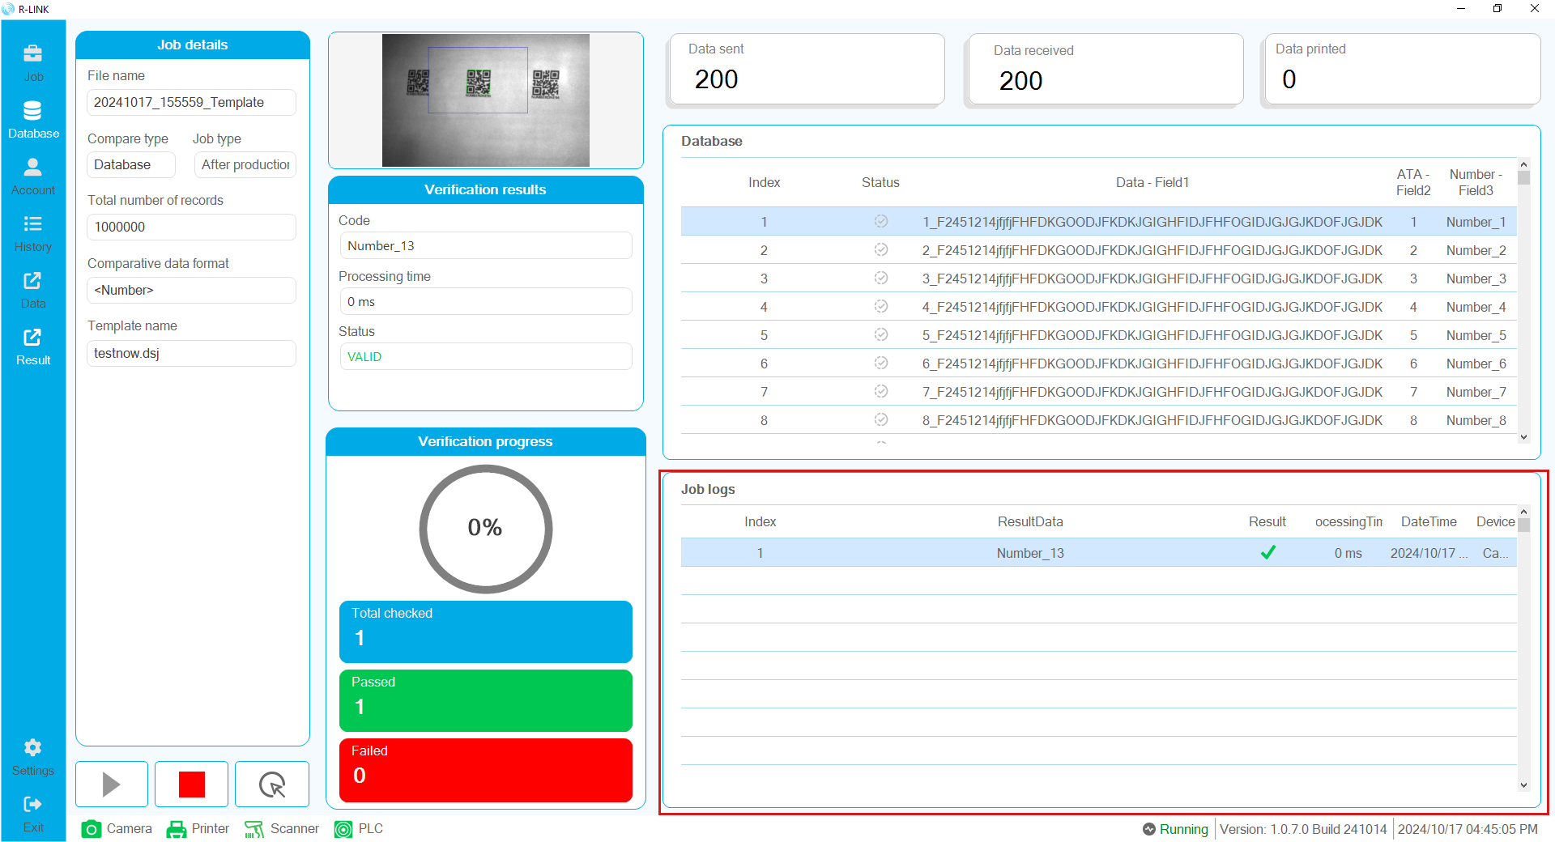
Verification results can be
Valid: Valid verification result
Invalided: Invalid verification result
Duplicated: Duplicate verification results
Null: Verification result is empty
Unknown/Missed: Unverified or unknownOperation Buttons
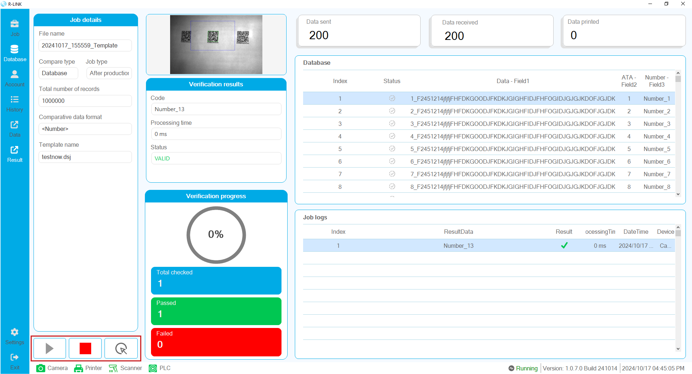
Start button: start running the verification process
Stop button: stop the verification process
Camera trigger button: click to take a picture manually.

Job Logs Detail
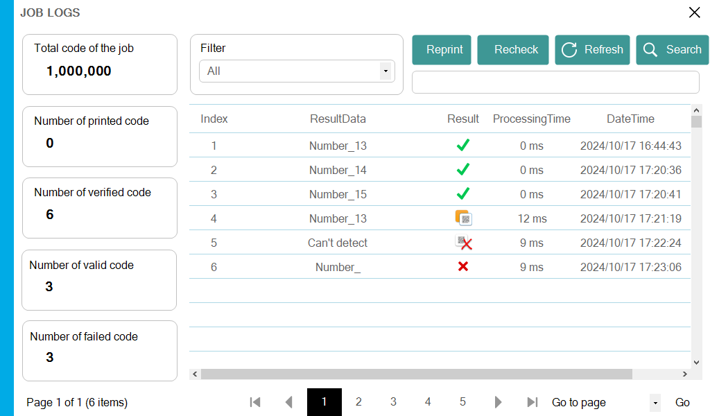
Filter : filter sorts data by results
Reprint: perform the process of reprinting the failed data
Recheck: perform the check process again with Barcode scanner
Refresh: refresh the data list
Search: search data by keyword
Statistics of verification results
- Total code of the job
- Number of printed code
- Number of verified code
- Number of valid code
- Number of failed code

Chapter 9 – Users management

Users Management
On the vertical menu bar, select the Account item to open the user management page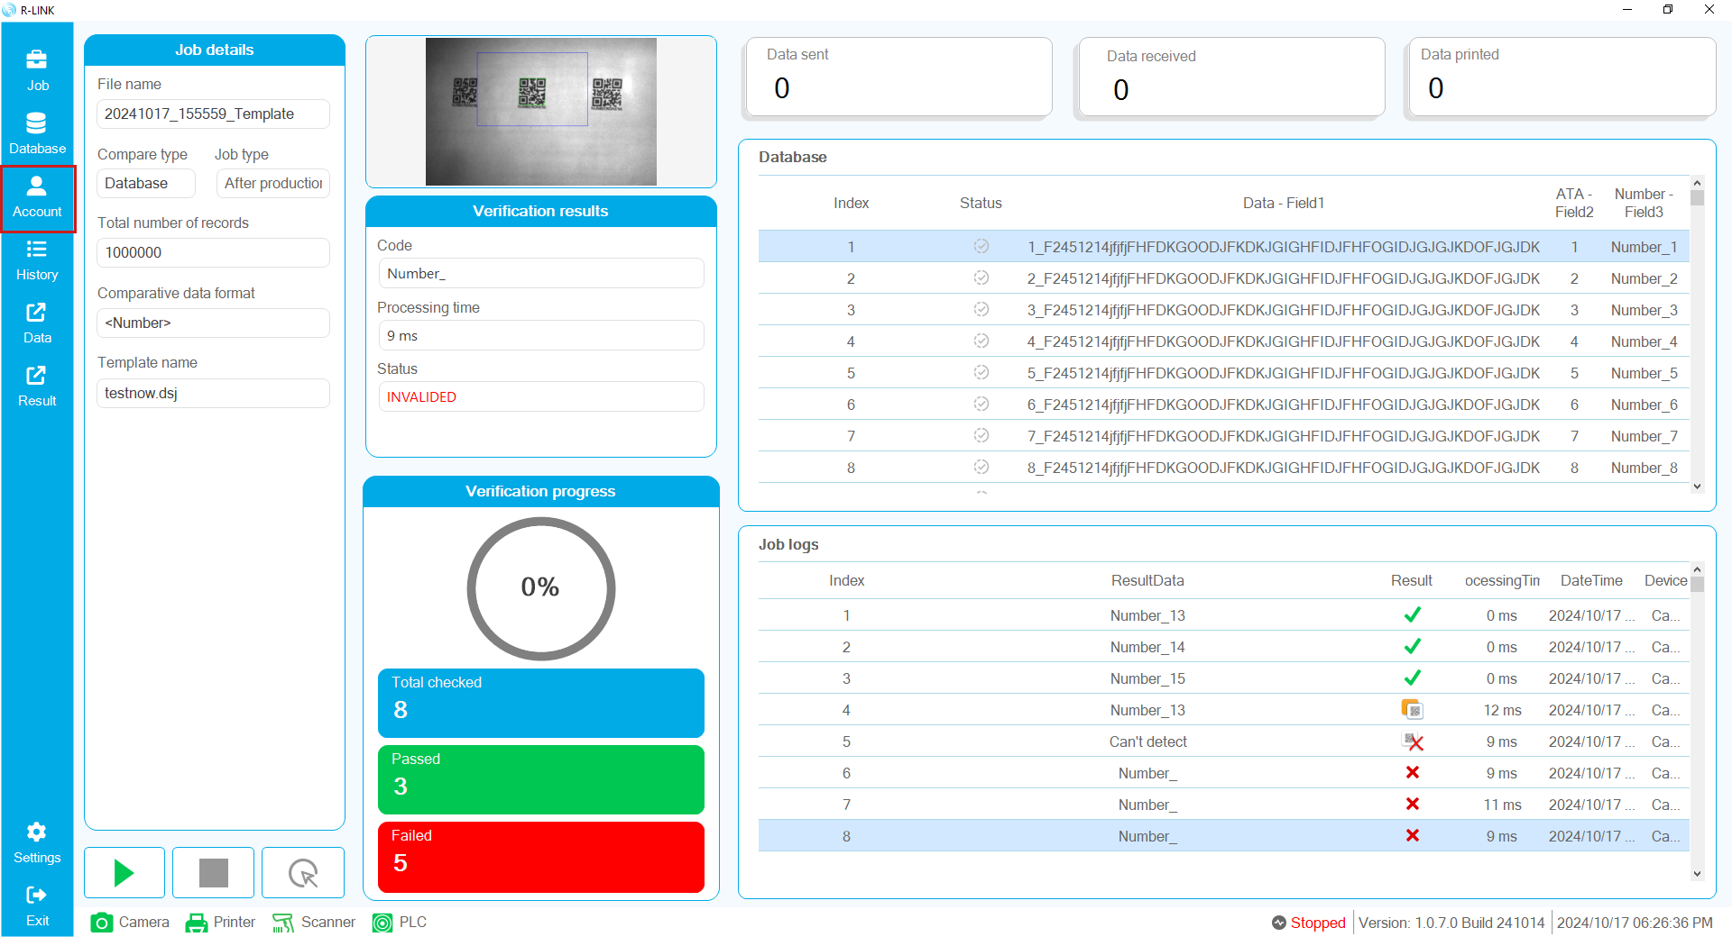
Click Manage
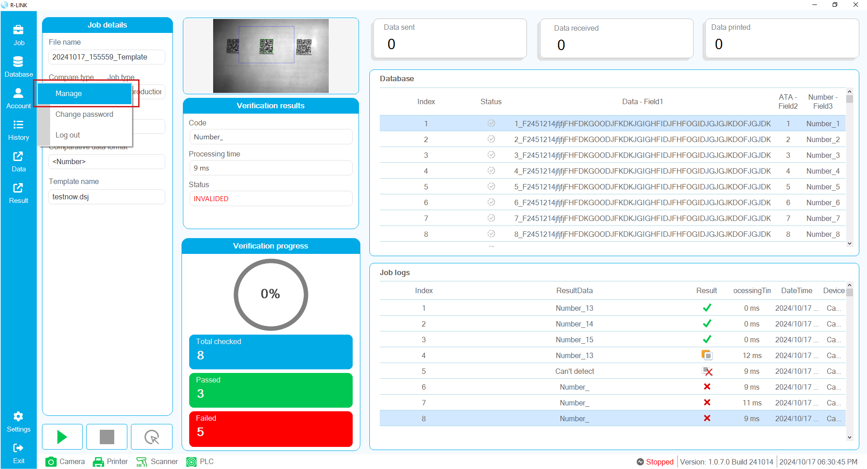
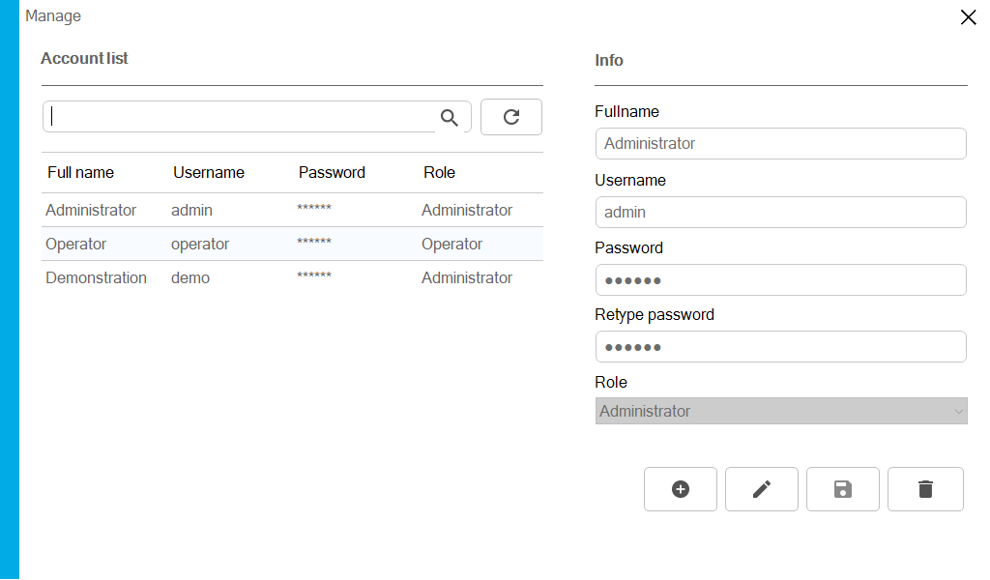
Here, the Account list section is where the list of current users on the software is displayed.

Users management functions
Full name: the name you use to identify yourself, optional
Username: username to log in
Password: password to log in
Retype password: used to confirm the password a second time
Role: user role
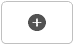 Add user
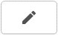 Edit user info
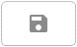 Save user info
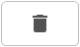 Remove user account

User management operations
Add user
Steps to follow
Step 1: Enter user information
Step 2: Save user
Step 3: Confirm notification of successful user addition
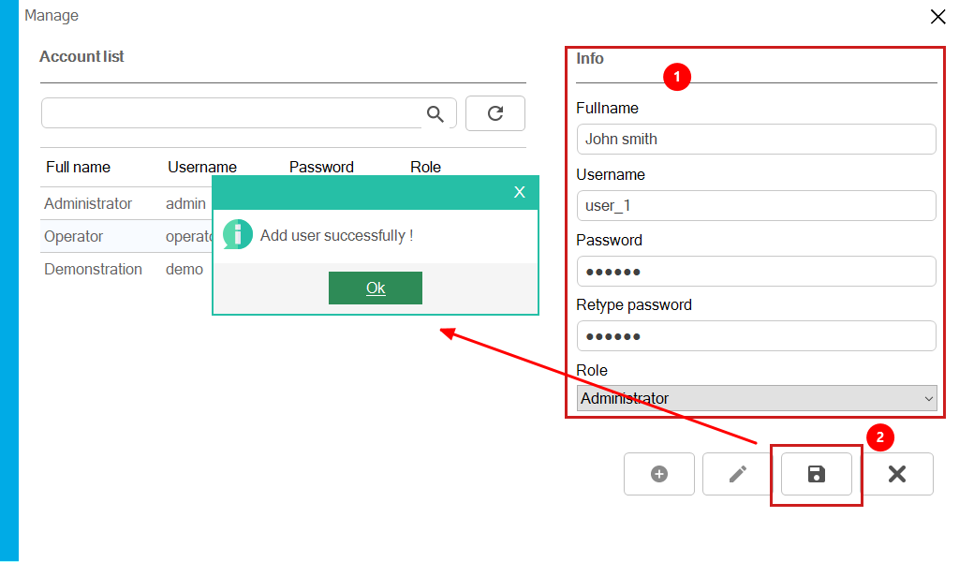
Added users are updated on the list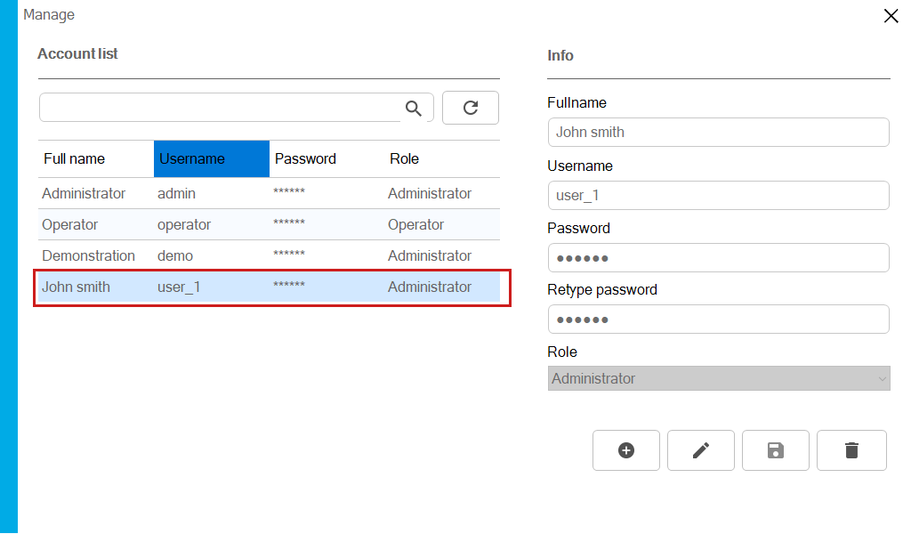
Remove user
Steps to follow
Step 1: Select the user to delete
Step 2: Click the delete user button
Step 3: Confirm user deletion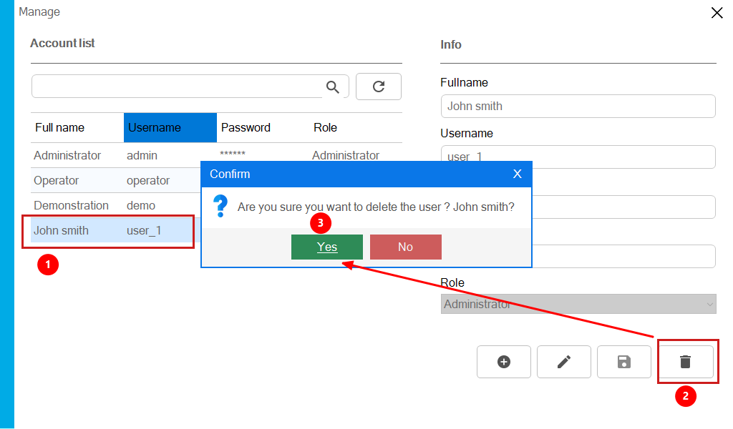
User has been removed from the list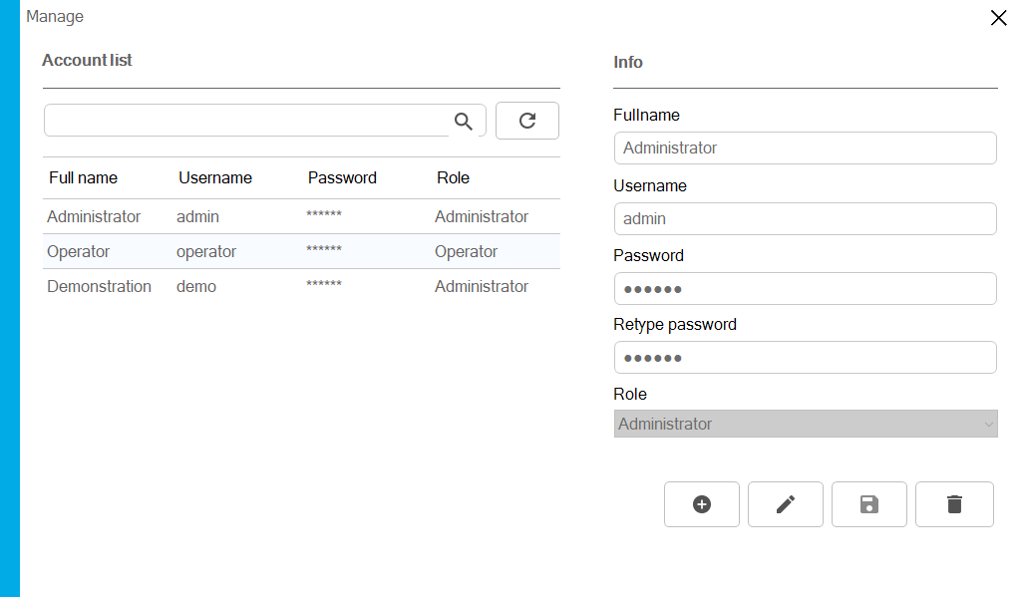
Edit user information
Only user roles can be changed

Chapter 10 – Program history
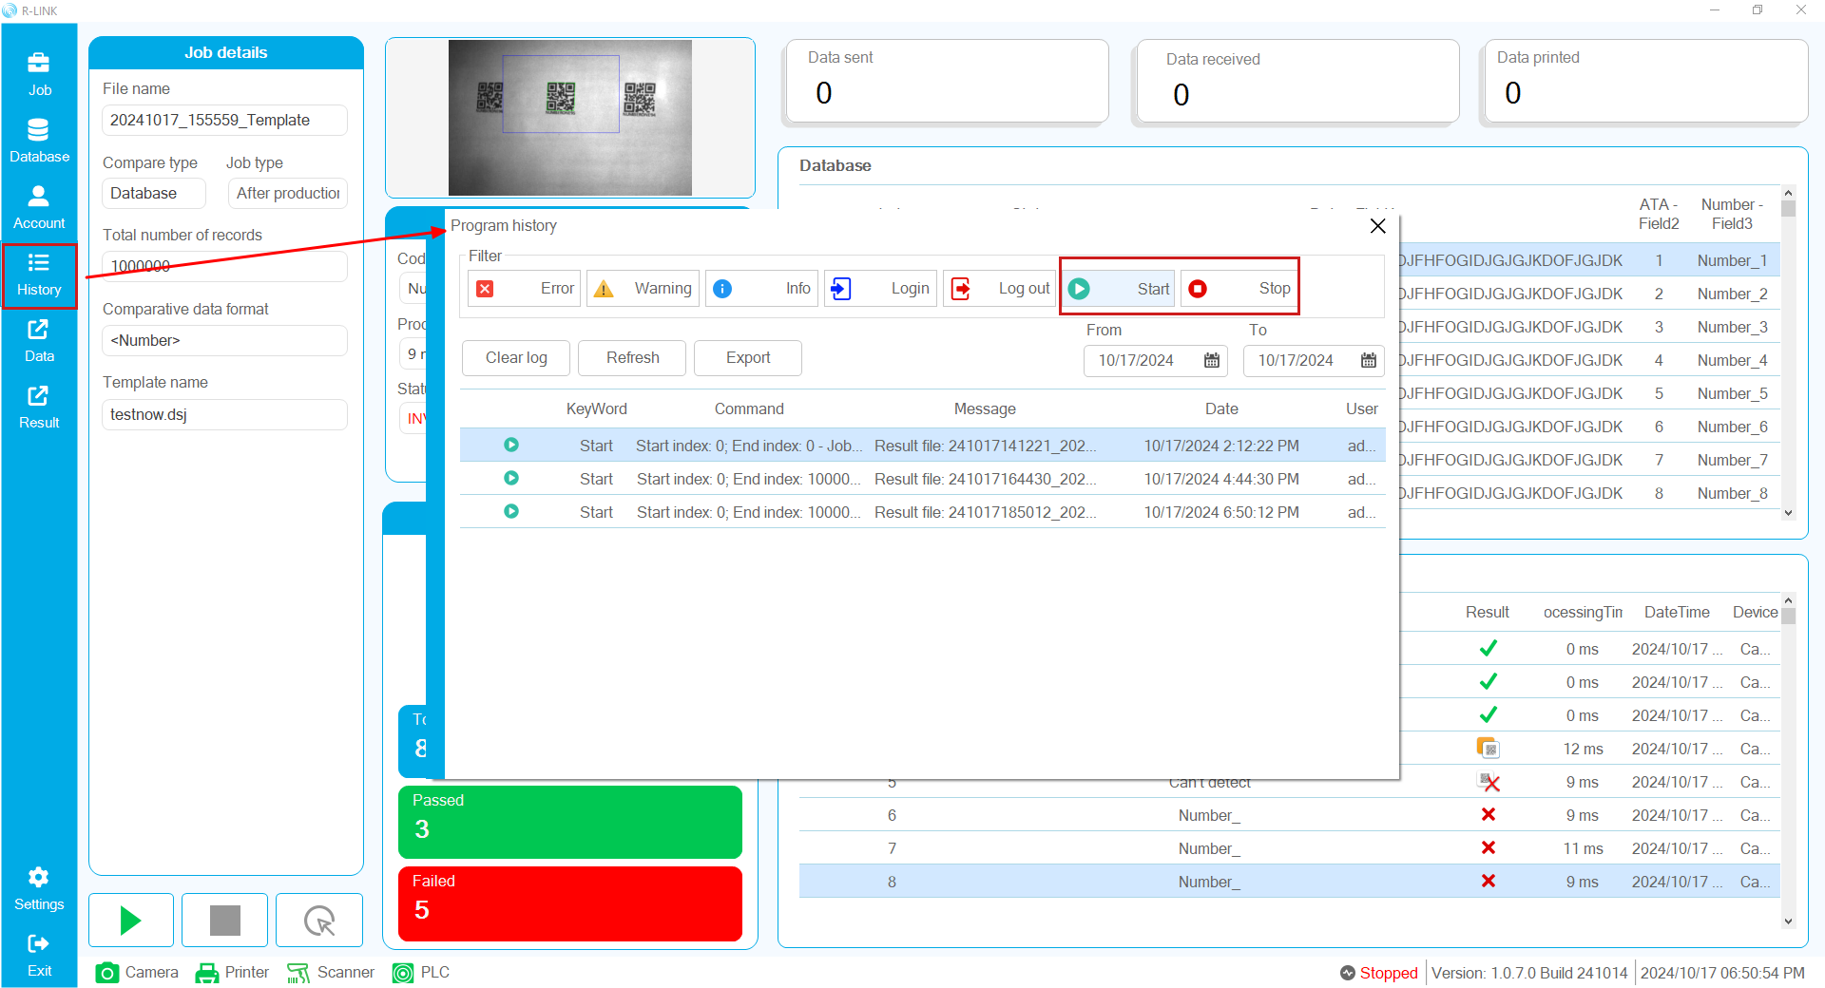
Program history is a function that records the log of the main activities of the verification process. Currently supports logging of:
Login/Logout
Start/Stop
Log Filter
Filters include: Error, Warning, Info, Login, Logout, Start, Stop
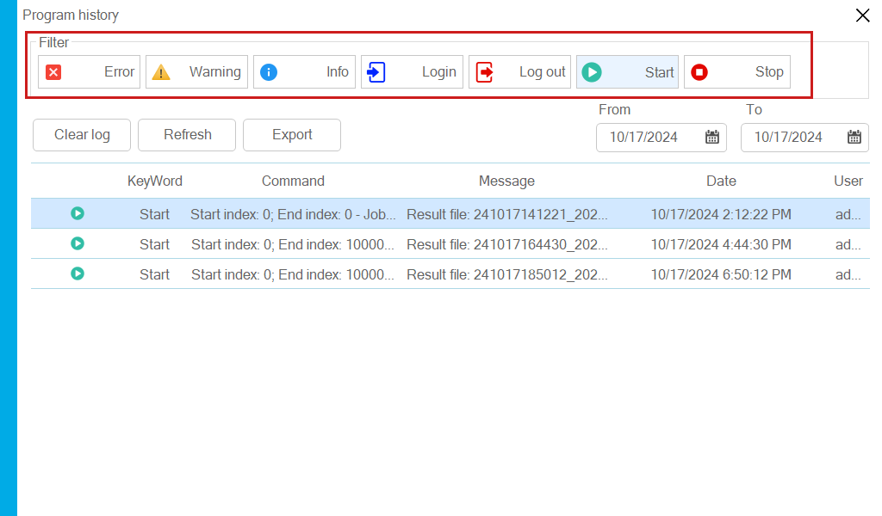
Buttons for working with logs
Clear log: Clear all log
Refresh: Refresh log list
Export : Export log to file
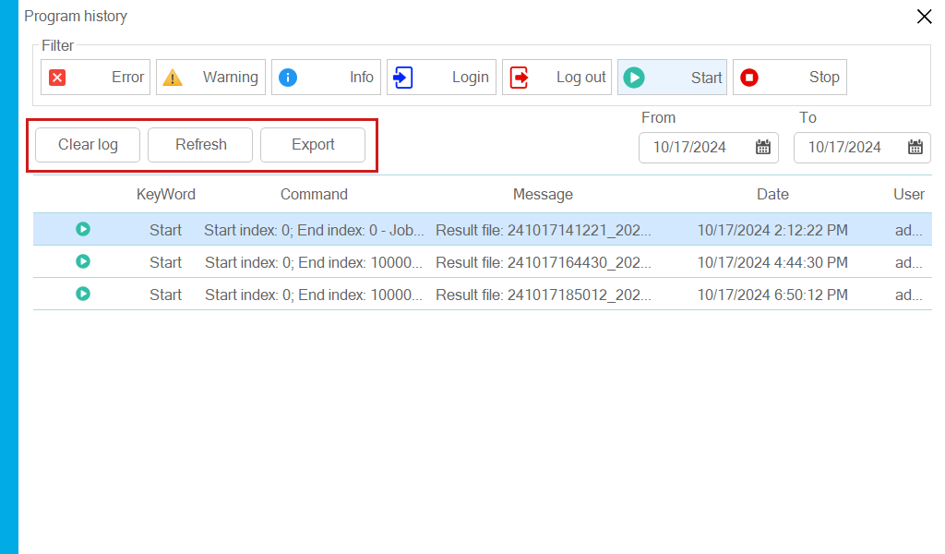

Log datetime filter
Select the time period to display relevant log histories
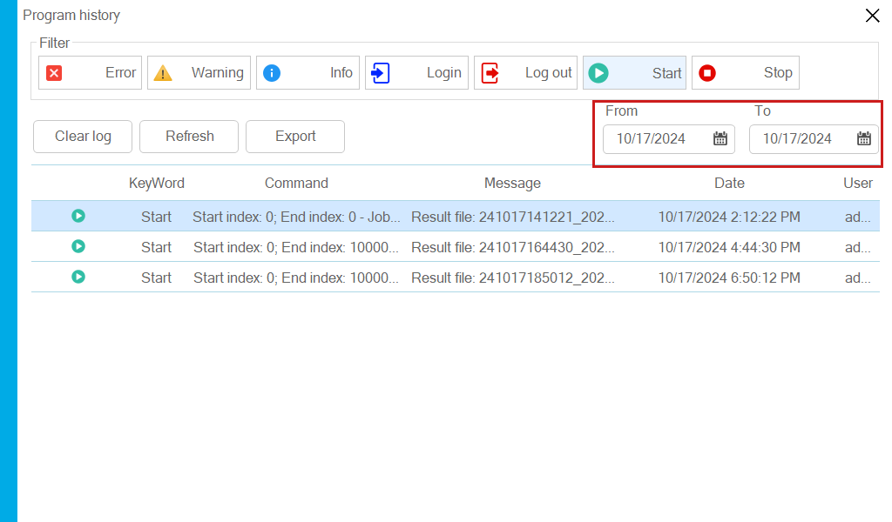

Chapter 11 – Export reports for Job

Export print data report
On the vertical menu bar, select the Data export item as shown below to export data.
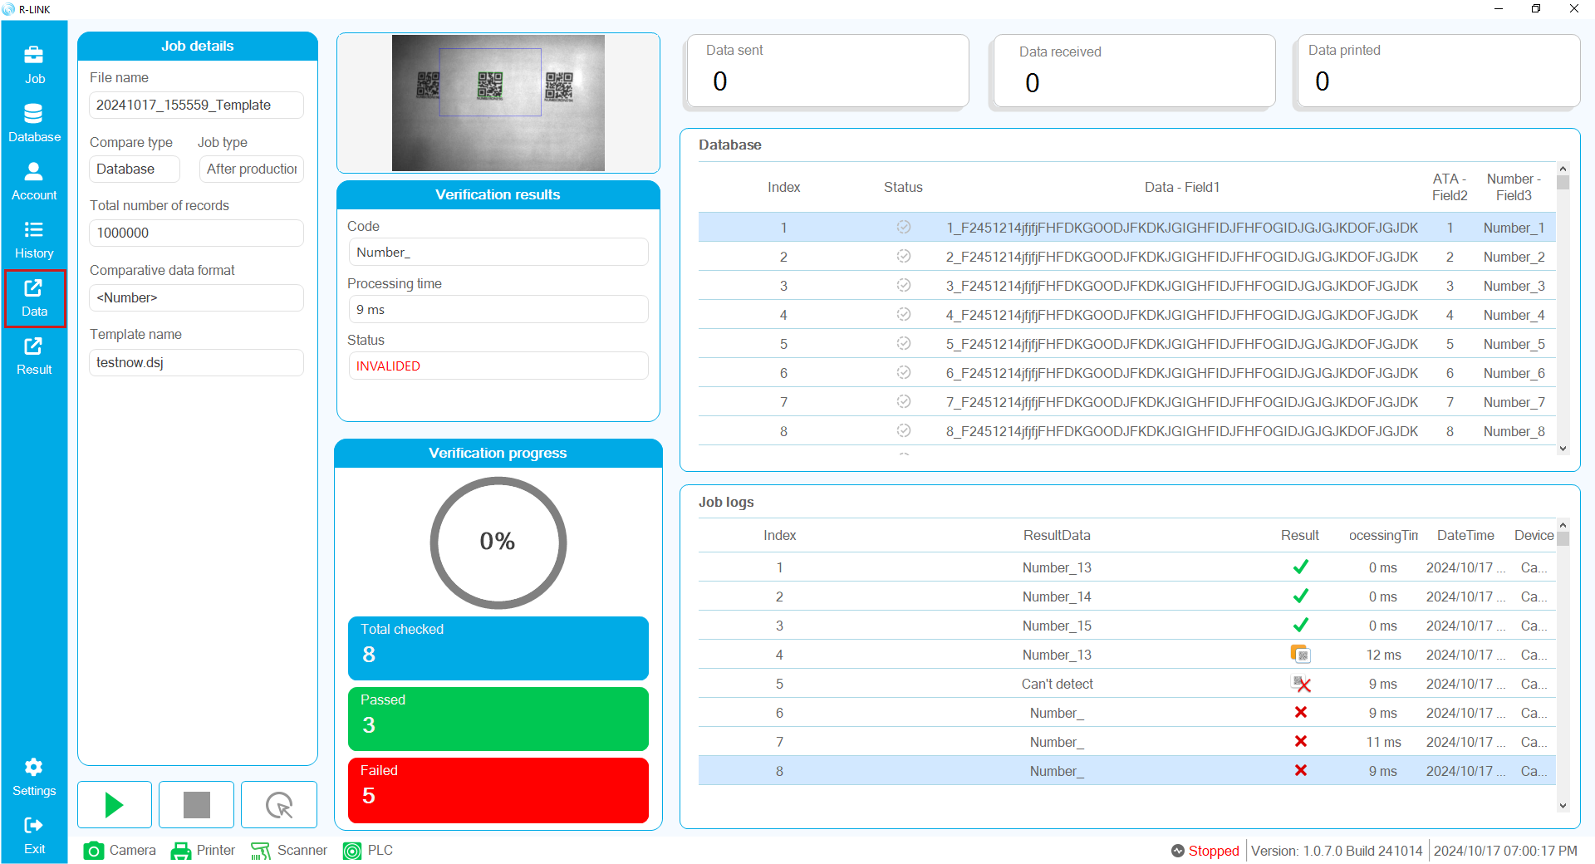
A dialog box appears, select where to save, name the file and click the Save button.
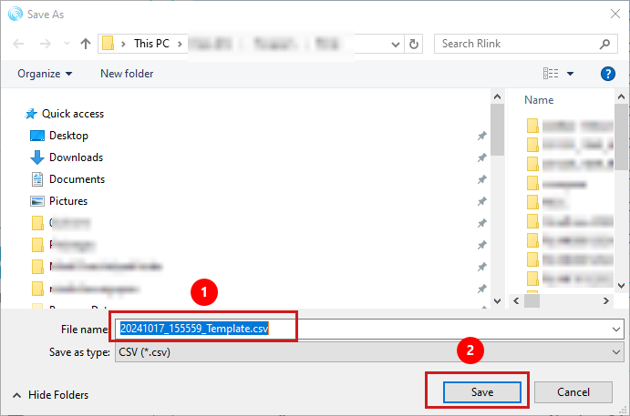

Export verification data report
On the vertical menu bar, select Export Result
A dialog box appears, select where to save, name the file and click the Save button.
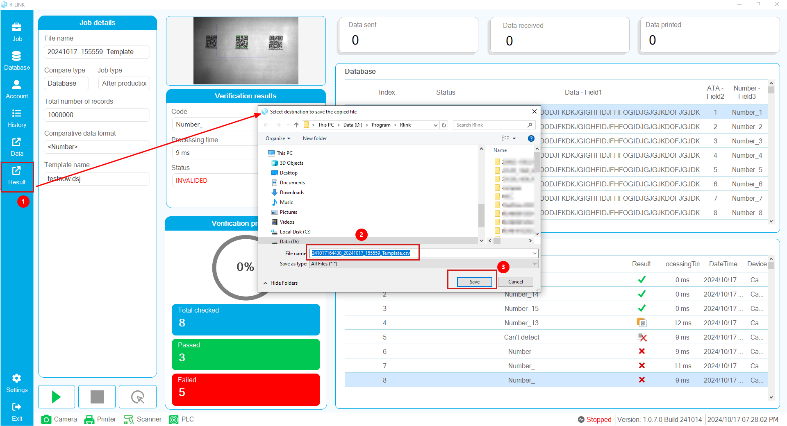

Chapter 12 – Another functions

Return to Job selection page
On the vertical menu bar, select Job to return to the Job selection page interface.
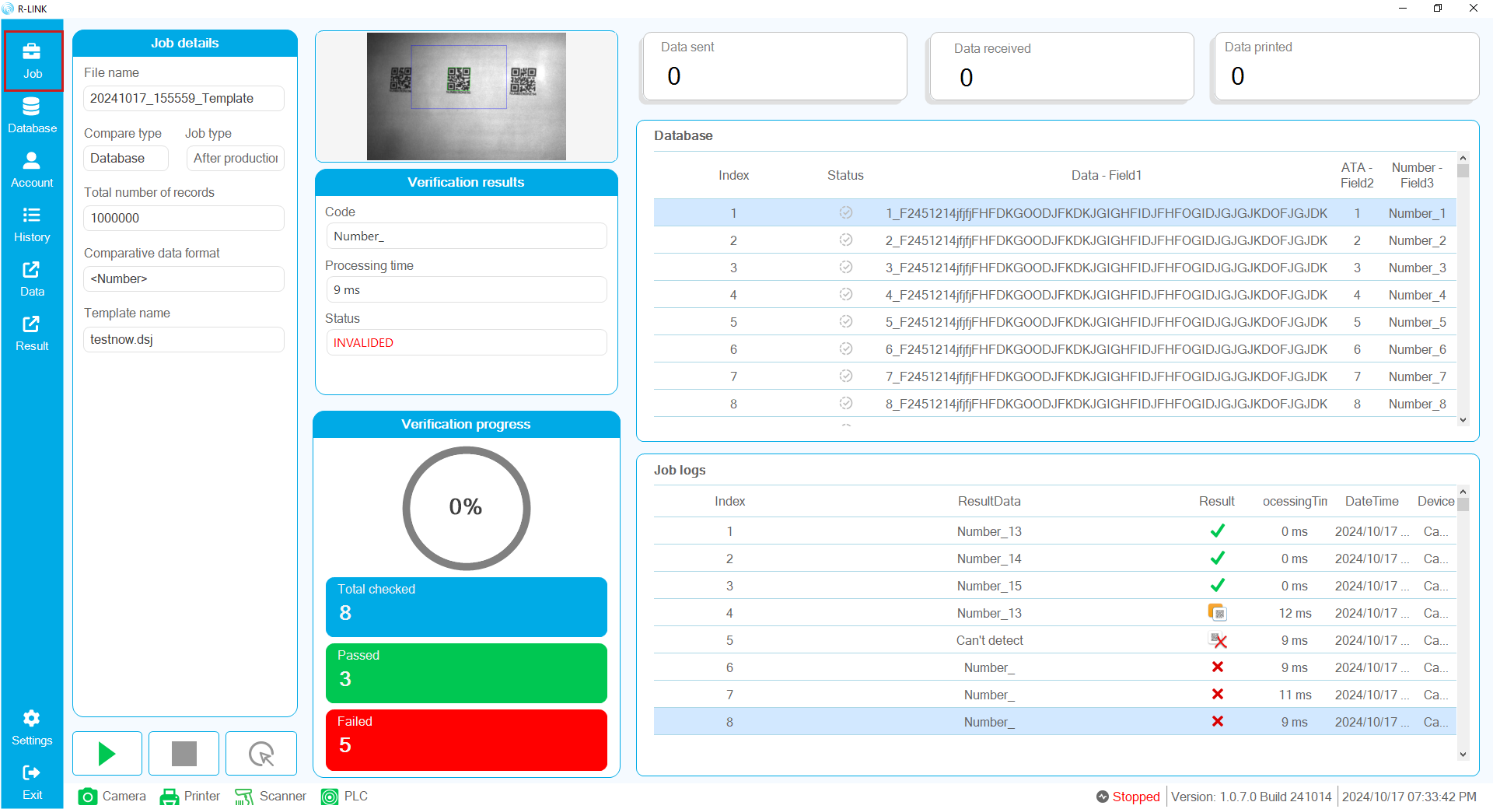

Status bar and other information
Below the Job execution interface is a status bar that shows the device connection status, process status, and other information.
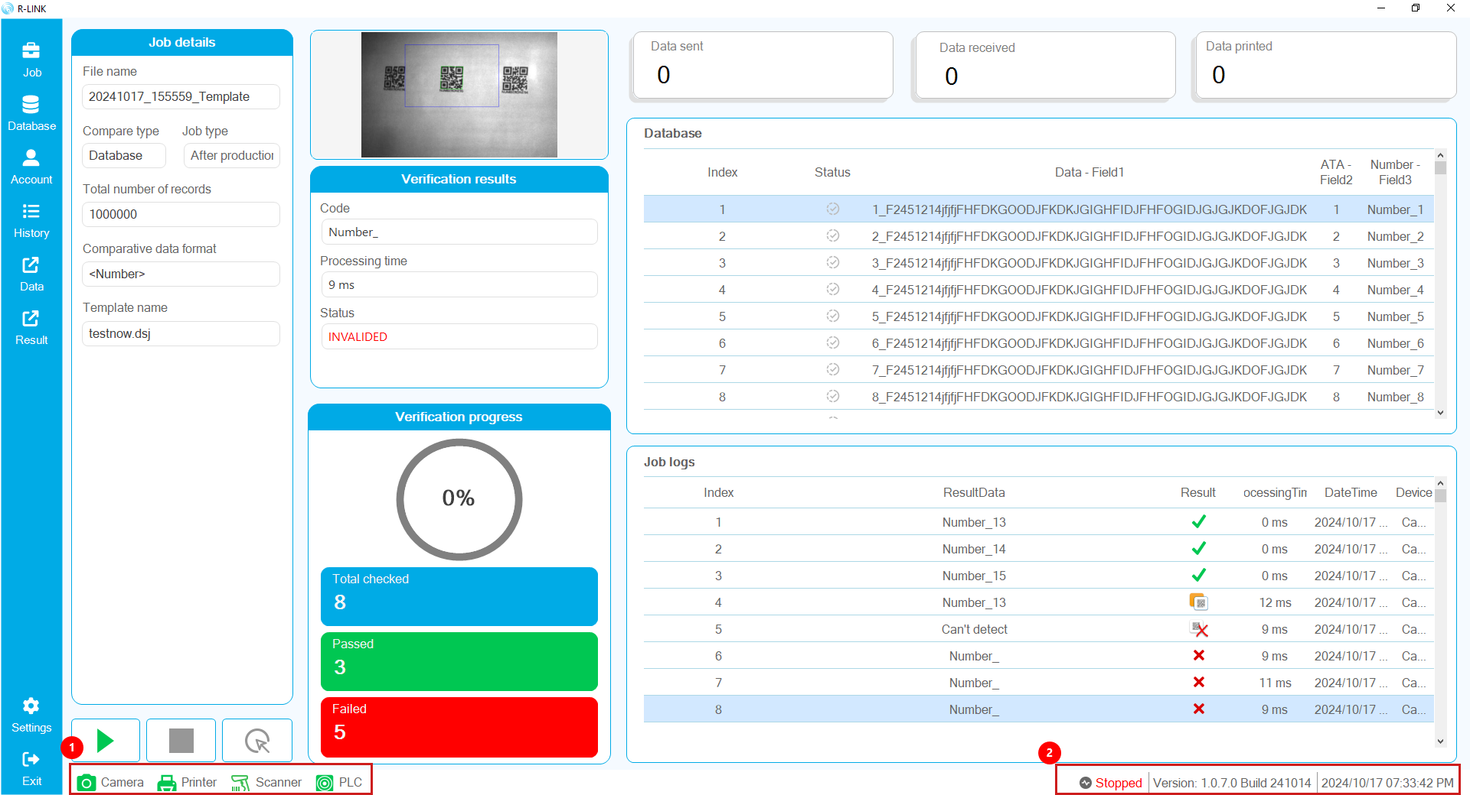
(1) Icons show the connection status of devices such as: Camera, Printer, Scanner, PLC
(2) Process Status (Running, Processing, Stopped) |Software Version |Current Datetime

Chapter 13 – Rynan printer settings
This chapter will cover how to install a printer using the Rynan R series printers.

Check all printer settings function
R-Link has the function of checking the settings on the printer. You need to enable the Check all printer settings function in the Printer settings section to use it or you can install it yourself without this function.
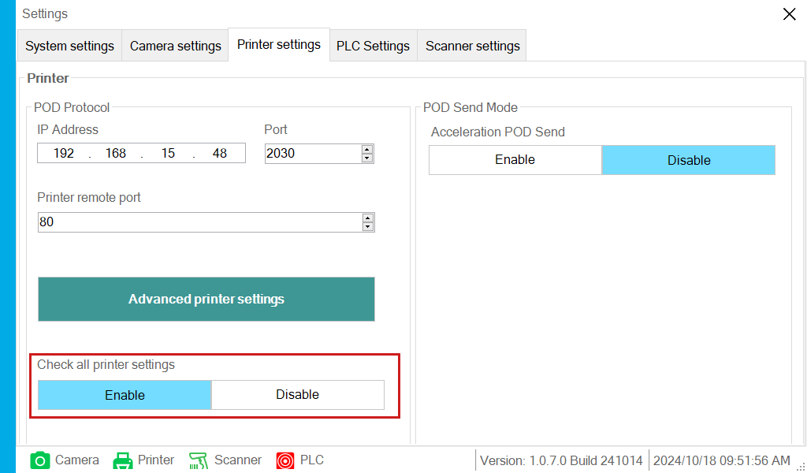
For the printer to work with R-Link you need to enable the following main features:
POD (1)
Response POD Data (2)
Response POD Command (3)
Monitor (4)

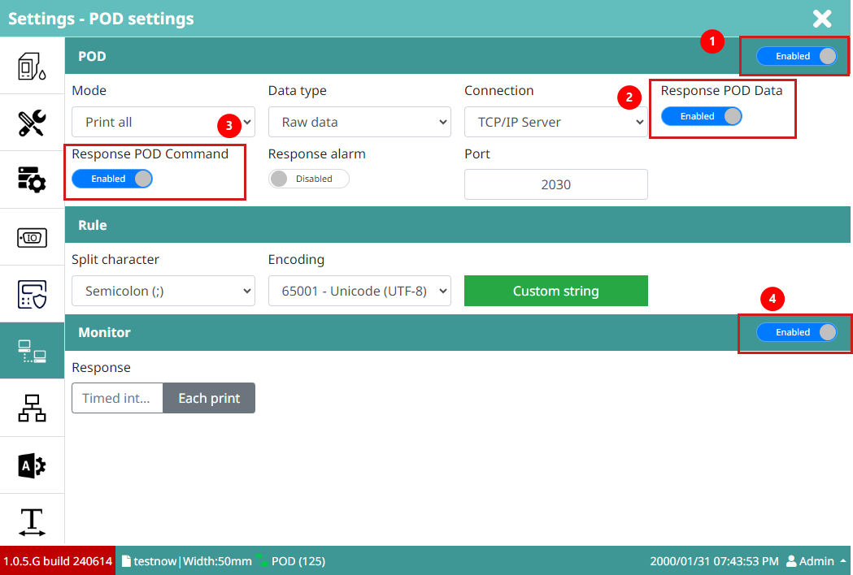
In addition, you need to set the following rules:
Split character: Semicolon
Encoding: 65001 – Unicode (UTF-8)
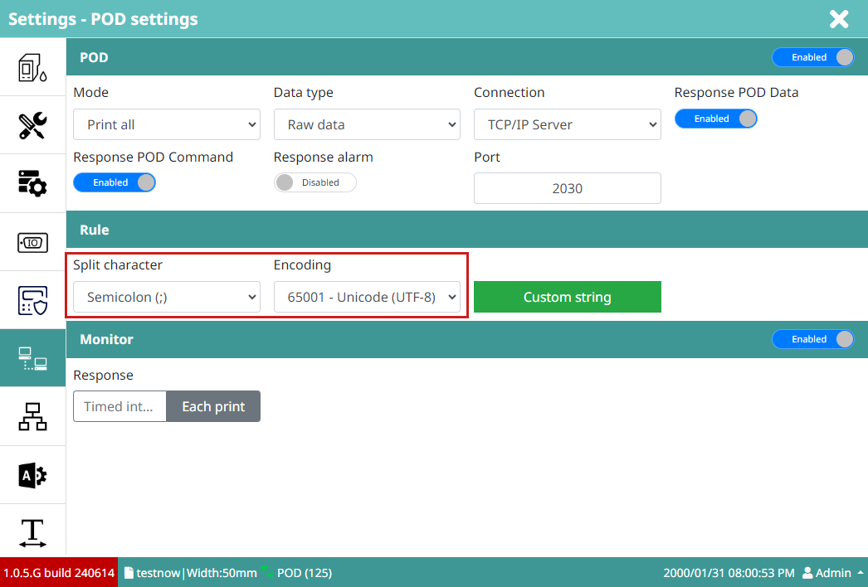

Notification of printer parameters not enabled
If the Check all printer settings function is enabled, if any settings are not satisfied, a notification dialog appears as shown below.
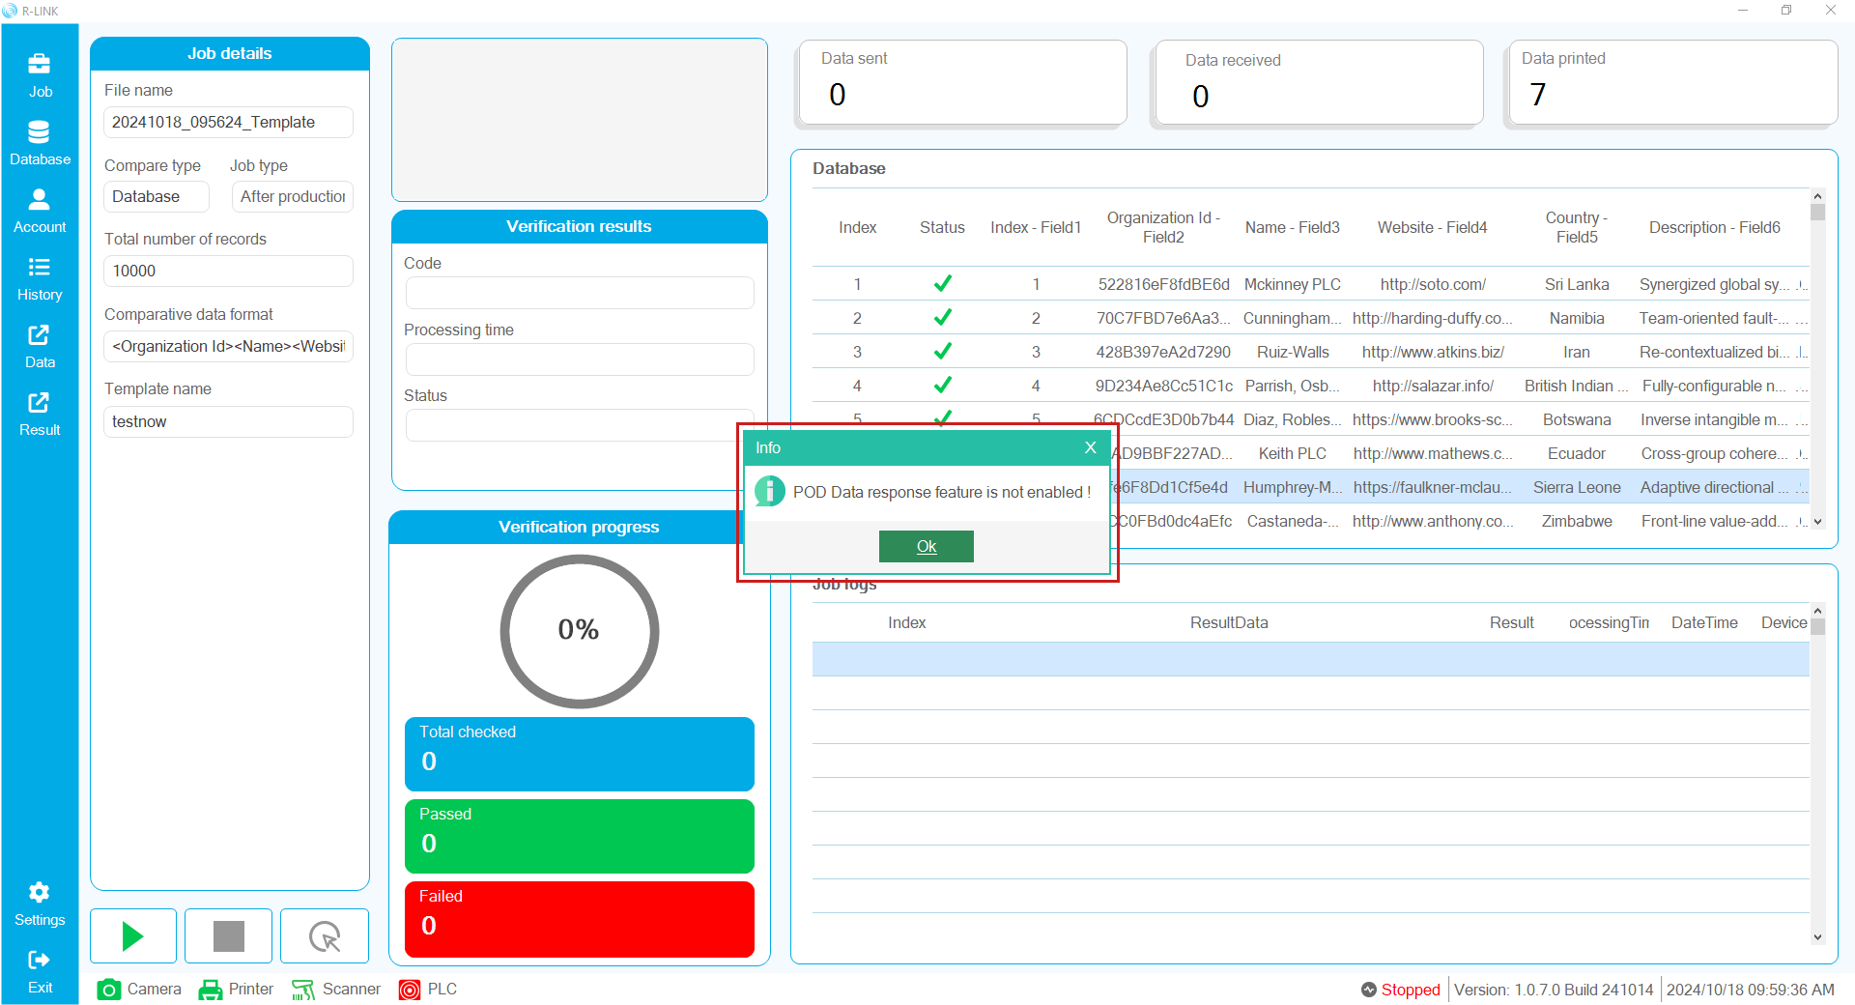

Printer connection settings
The printer will use TCP/IP protocol to communicate with R-Link software so you need to install it to get
IP Address: can use Dynamic or Static IP function depending on usage needs, but must have a specific IP Address
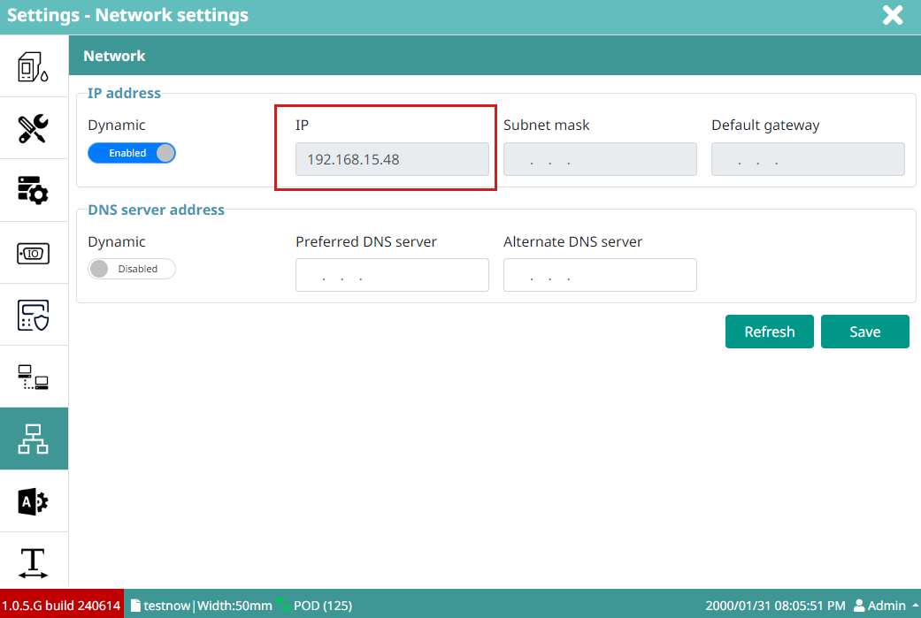
Port: to work with POD, you need to set a specific port, you can customize it here, the default will be 2030
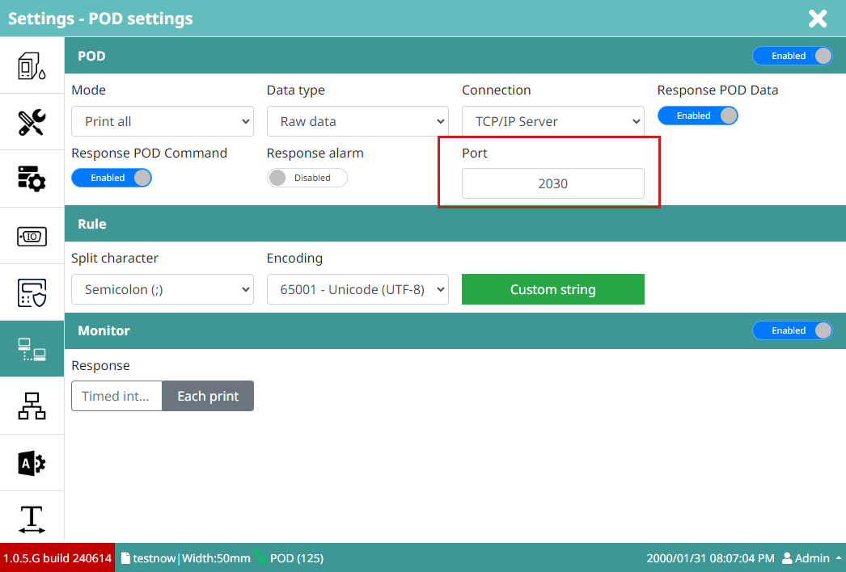

Design a template
In order for R-Link to identify the template to print, you need to design a print template with a specific name. R-Link will find it in the list of print template names.
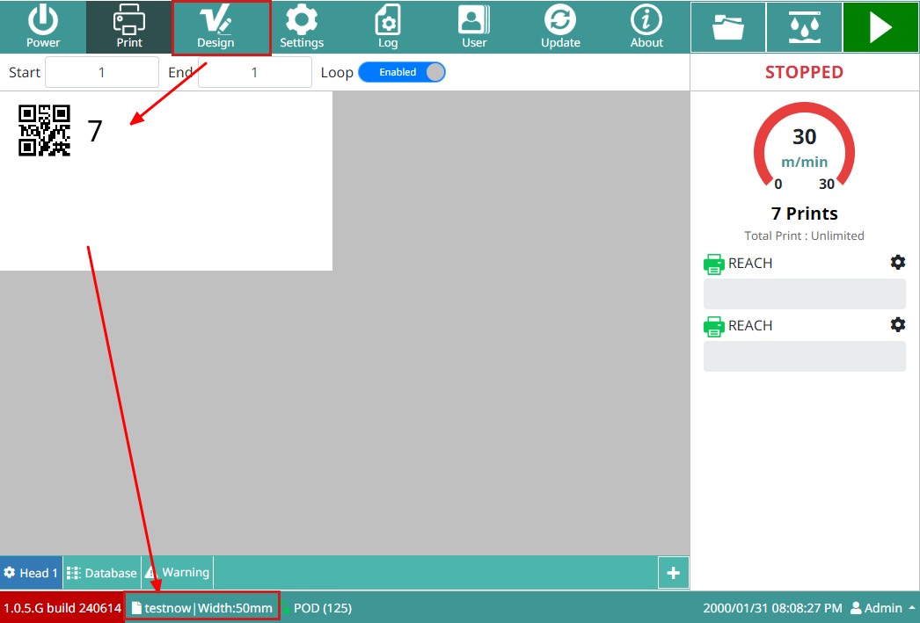
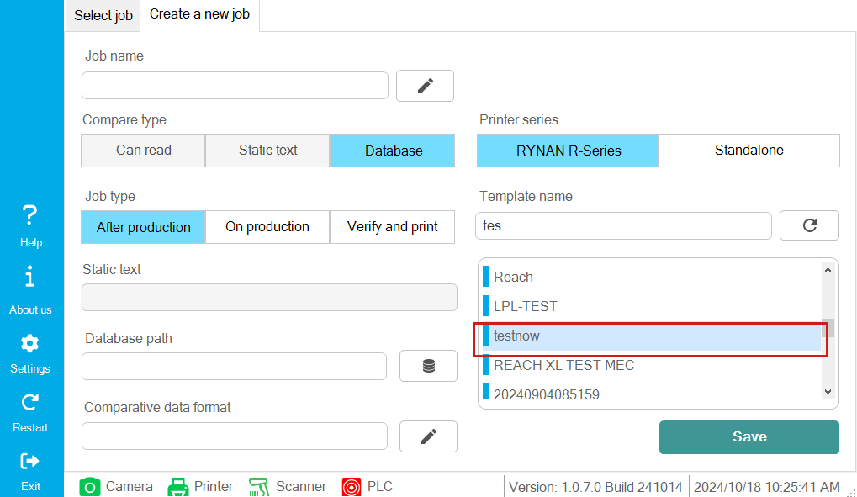

Chapter 14 – Cognex Dataman camera settings

Software required
Software to configure Dataman camera series : Dataman Setup Tool
Download free software on website:
https://support.cognex.com/en/downloads/dataman/software-firmware
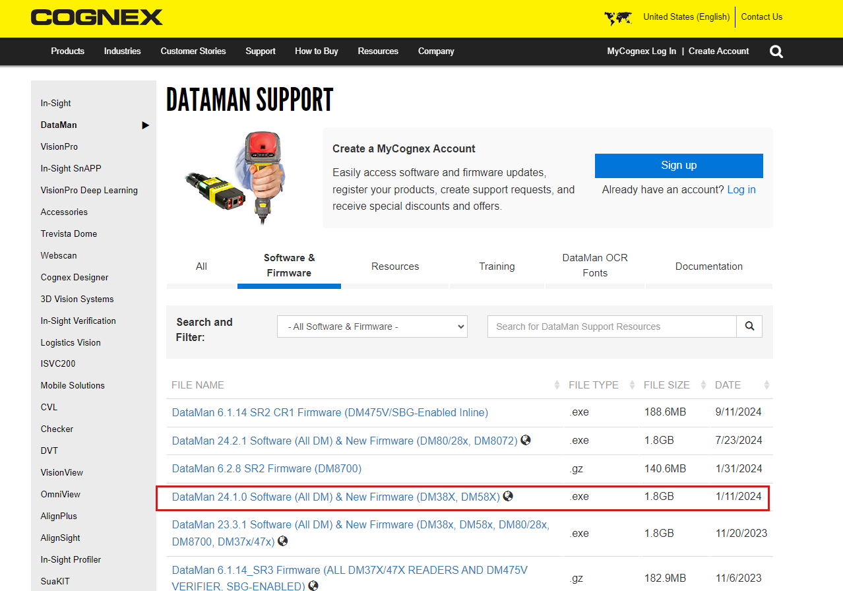

Connect to camera
Open the software with the icon as follows
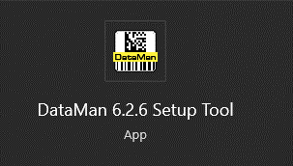
Step 1: First connect the camera and computer via Ethernet Cabble.
Step 2: Predetermine the camera's network layer or use DHCP on the computer to detect.
Step 3: Select the found camera.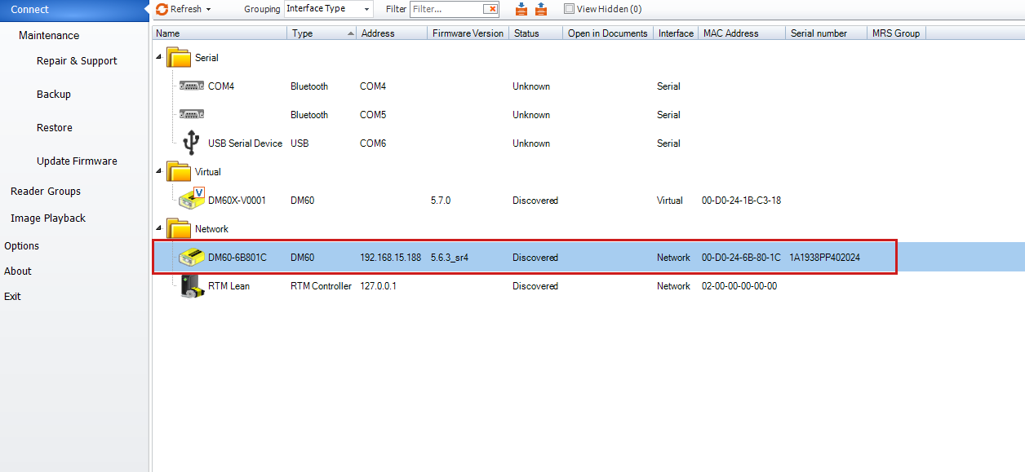
Camera setup interface on Dataman Setup Tool software
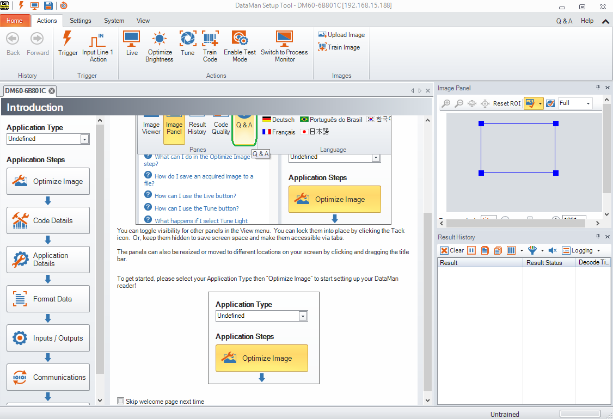

Optimize Image
This function is used to configure the barcode image to be optimal for camera recognition.
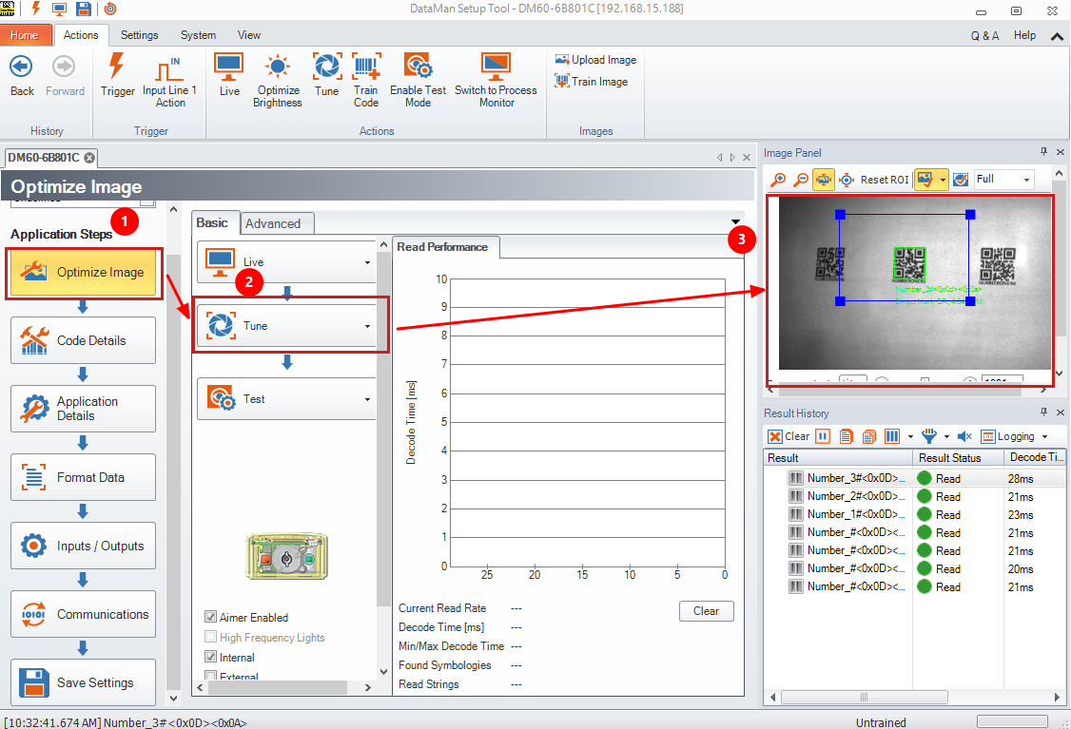
Tune: automatically tunes the image to optimize data reading
You can also manually fine-tune it

Identify barcode type
The camera supports identifying the type of barcode to work with, all can be selected, however to optimize performance, it is necessary to specifically identify the type of barcode to work with.
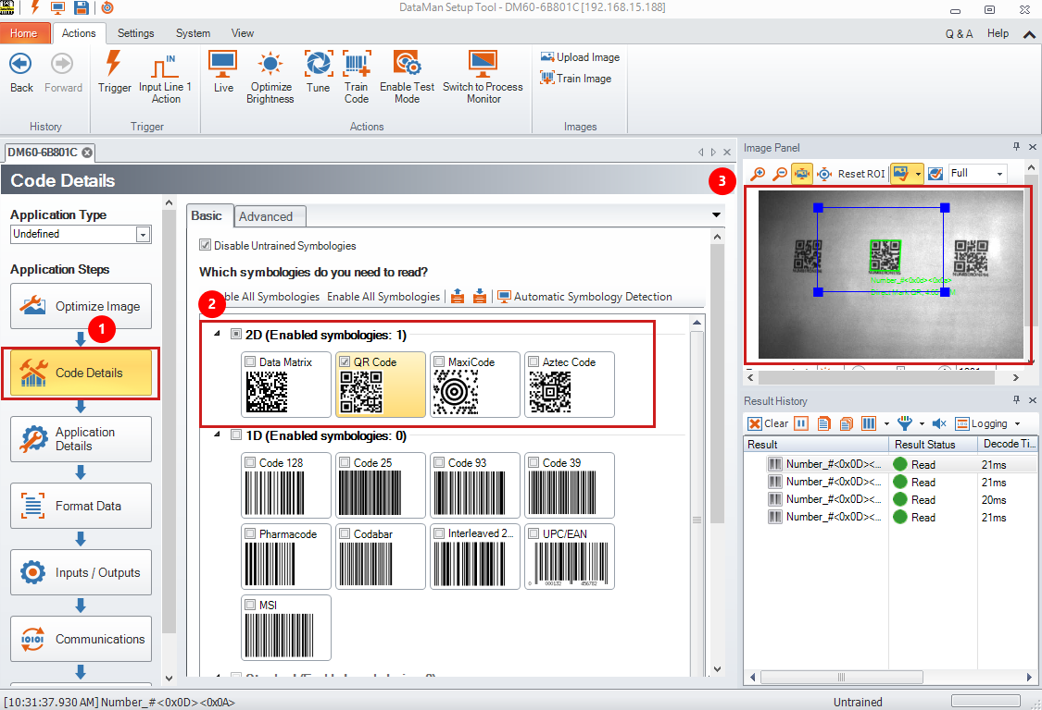

Trigger type
To command the camera to take a photo, you need to configure the trigger type to use. Here, use single (external) to use an external sensor to trigger the camera to take a photo.
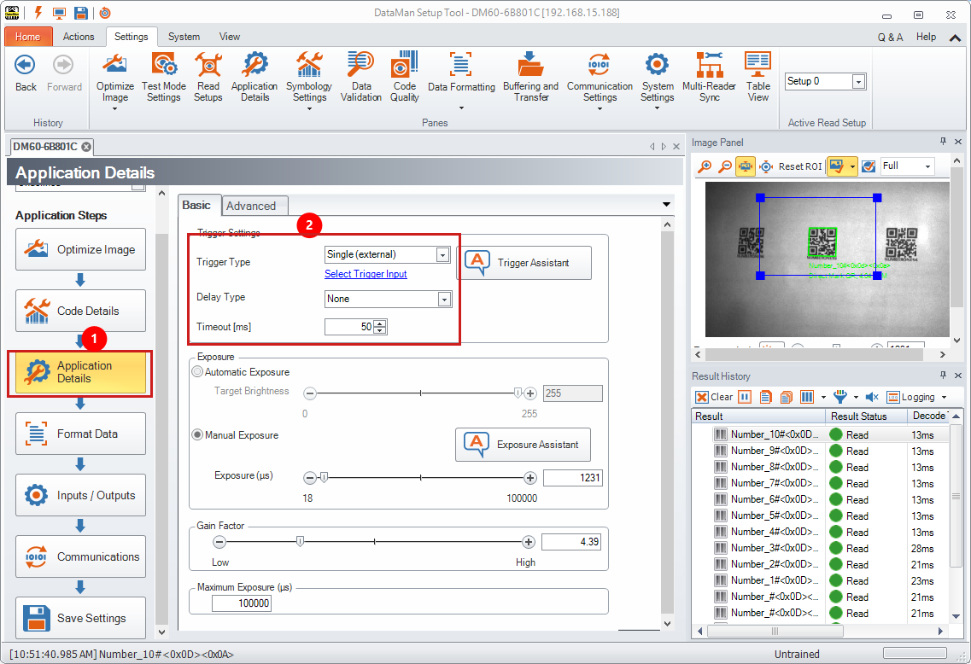

Output settings
To let the camera receive output conditions from the R-Link software, the User Event function needs to be enabled.
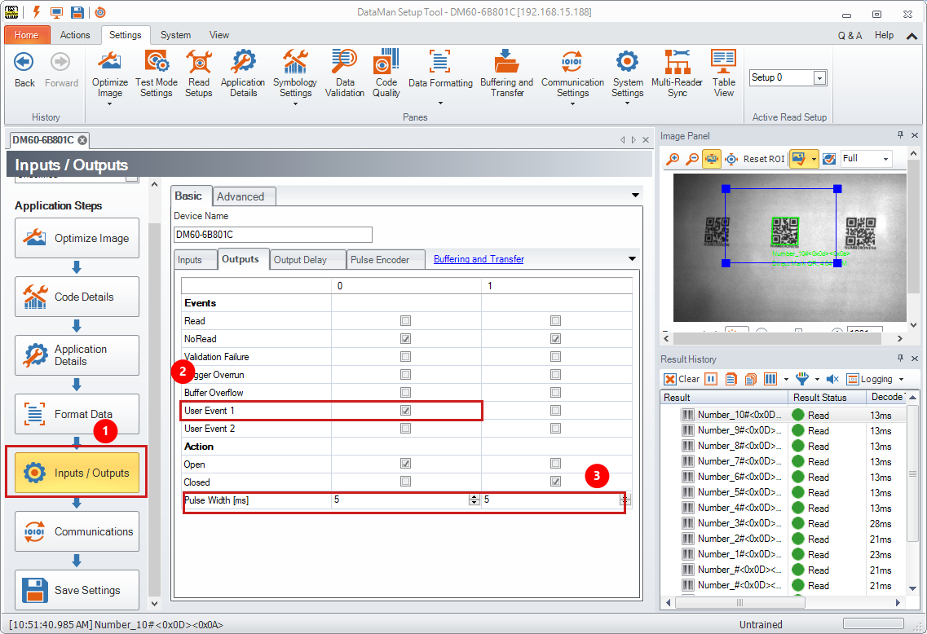
Pulse with (ms): Adjust the output opening time on the camera, adjust it to match the error classification system.

Camera IP address
Go to the Communications menu to set up the camera's IP configuration.
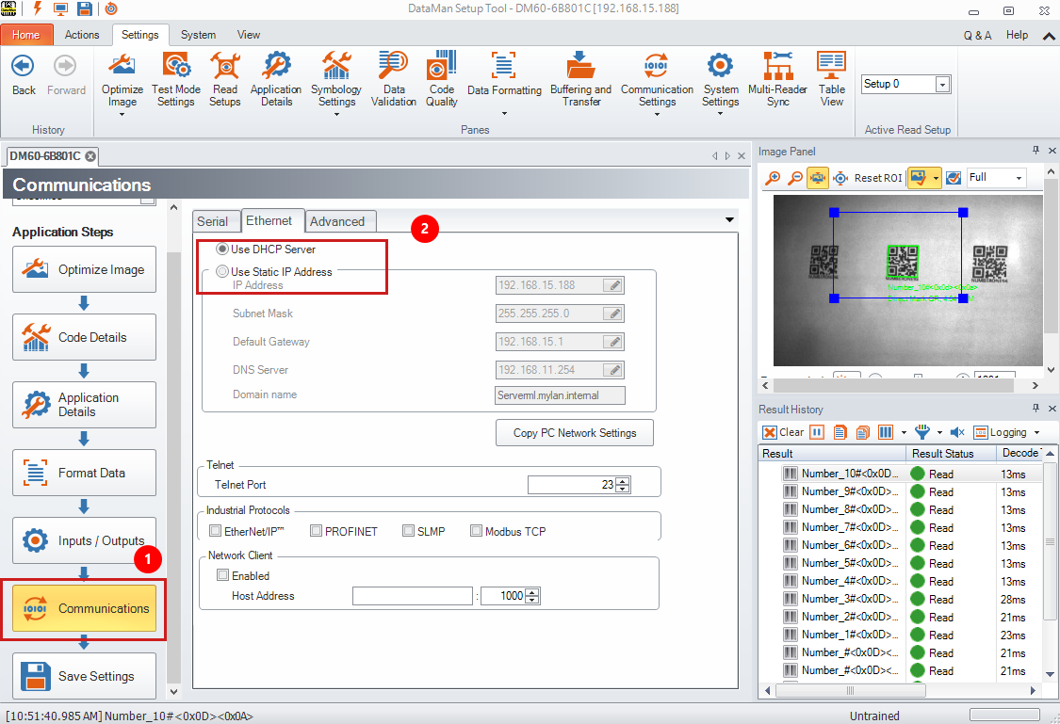
- DHCP is a protocol used to automatically assign IP addresses to devices on a network. The IP address assigned can change over time (dynamic).
- A static IP address is manually assigned to a device and remains constant over time. (recommended)

Chapter 15 – Cognex In-Sight Vision camera settings

Coming soon

