WorldWide Weather Carousel

# Role for Shiro Ishii - IT 102 Quarter Project, Fall 2023

Created the image object arrays that corresponds to 12 city names and pictures such as Seattle, Berlin, New York, Manila, London, Paris, Tokyo, Beijing, Adelaide, Johannesburg, Cairo, and Rio De Janeiro.

Explanation:

An array named imageObjects is created, and it contains 12 elements (indexed from 0 to 11), each holding a new instance of the JavaScript Image object.

(e.g. index 0 is Seattle, (URL for picture of Seattle), index 1 is Berlin, (URL for picture of Berlin))

Each Image object within the array is then assigned a src property, specifying the URL of an image. This URL refers to different images associated with various cities.

Created 2 arrays that corresponds to city name and picture names 1 array for City name, Desktop photo. Another array for City name, Mobile photo. But we did not use for the Mobile photo.

Partitioned our code into multiple files, breaking it down into separate files such as index.html, style.css, and script.js. This approach is a common and organized way of structuring a web project in the real world.

Explanation:

index.html - Contains the structure and content of your webpage.

style.css - Defines the visual presentation of the HTML content.

script.js - Provides interactivity and behavior to the webpage through JavaScript.

Tried to modularize arrays in the script into their own file(s) and API key into separate. However, I encountered Cross-Origin Resource Sharing (CORS) policy error. CORS is a security feature implemented by web browsers to prevent web pages from making requests to a different origin than the one from which the web page was served, unless the server explicitly allows such requests.

Explanation:

The error you're seeing ("Access to script file://... from origin 'null' has been blocked by CORS policy") typically occurs when you're trying to load a script file using the file:// protocol (local file system) in your JavaScript code, and it's being restricted due to CORS policies.

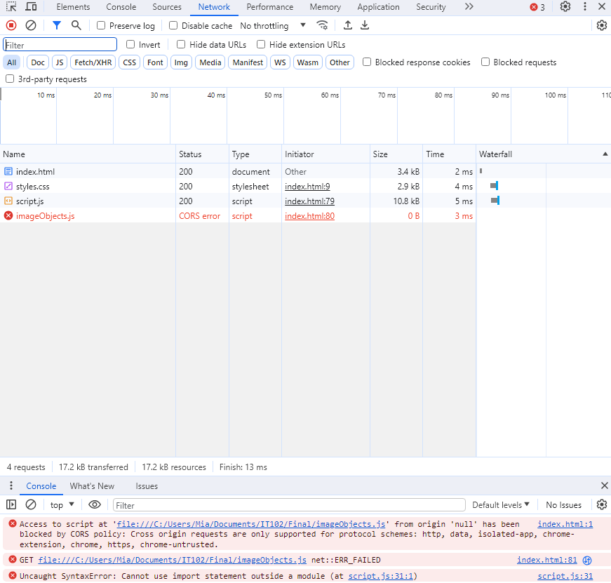

Possible Solutions:

To resolve this CORS-related issue I faced when trying to access local files in the JavaScript code, I researched (Google search and ChatGPT) found below approaches:

1. Use a Local Server: Instead of directly opening the HTML file in your browser (using file:// protocol), set up a local server to serve your files. You can use tools like Node.js with Express or Python's built-in http.server to create a local server. Access your HTML file through http://localhost or http://127.0.0.1.
2. Modify Browser Security Settings: Some browsers might allow you to disable CORS restrictions for local file access during development. However, this isn't recommended for production environments, and the method varies depending on the browser. For example, in Chrome, you might start it with the --allow-file-access-from-files flag, but it's not advised for general use.
3. Serve Files via a Supported Protocol: Instead of accessing files via the file:// protocol, host your files on a server that uses http:// or https:// protocols. You can use services like GitHub Pages, Netlify, or even a local server as mentioned in option 1.
4. Consider Module Bundlers: If you're using modules in JavaScript (e.g., ES6 modules), consider using a module bundler like Webpack, Parcel, or Rollup. These tools can help manage your modules and bundle them into a single file that can be loaded without CORS issues.

Tried the solution 1. Instead of creating the local web server, I used the real web server I built on AWS (because I was working on the web server for IT115 final project). However, I am still not able to resolve the issue…

Tested our code across the 5 browsers listed below.

The program worked for all browsers I tested. Here is the cross browser test result:

|  |  |  |  |  |  |
| --- | --- | --- | --- | --- | --- |
|  | Google Chrome | Edge | Opera | FireFox | Safari |
| Windows 10 (Ver.22H2) | Works (Ver. 119.0.6045.160) | Works (Ver. 119.0.2151.72) | Works(ver. 105.0.4970.21) | Works (Ver. 120.0) |  |
| Mac OS Monterey (Ver.12.7) | Works (Ver. 117.0.5938.149) |  |  | Works (Ver. 72.0.2) | Works (Ver. 17.0) |