Vision & Mission: 

To offer systematic education in fundamental principles of human life by presenting in simple scientific terms essential spiritual wisdom, in order to help balance values in life, and thus realize the real potential of every individual, organization and the world.

Touch stone image: 

Activities:

Conference



The academy hosts conferences on issues of the day to bring aware-ness and galvanize youth into action to adapt to change and creatively solve problems.

Seminar:



The academy hosts seminars related to human behaviors ,scientific ways for managing life.

youthRetreats : 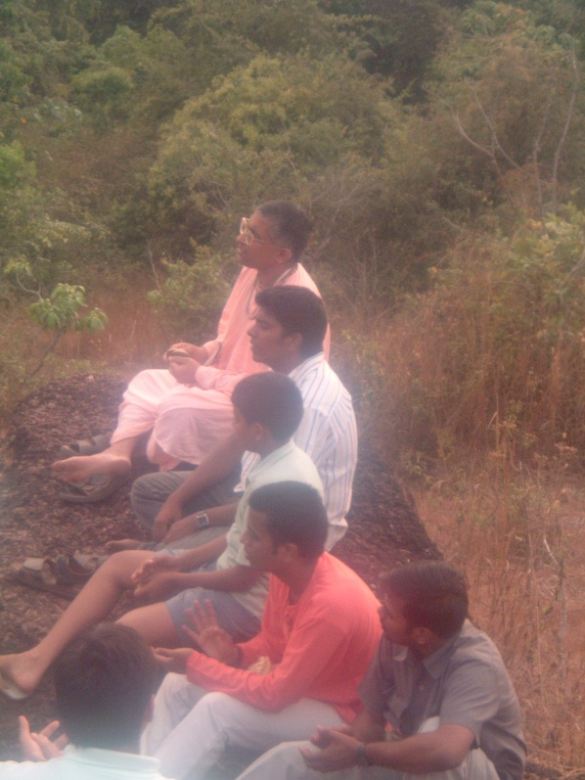

Touch stone encourages youth retret to encourage youth to look inner self. This way we bring the qualities out.

WorkShop:

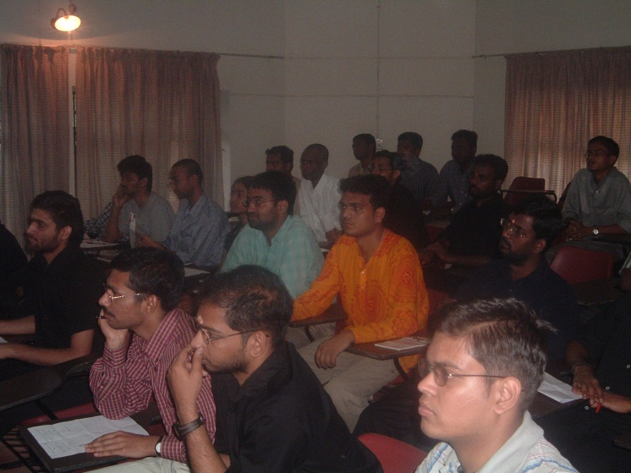

Touch stone conducts workshop to give practical knowledge to youngsters about the current happenings.This mainly consists of topics IQ, EQ & SQ.

Courses:



We offers a variety of courses to enable students to become pioneer in not only academics but beyond academics.

**About us:**

Intoduction:

Touch stone team:

Faculty and advisory board:

Vison & mission:

To offer systematic education in fundamental principles of human life by presenting in simple scientific terms essential spiritual wisdom, in order to help balance values in life, and thus realize the real potential of every individual, organization and the world.

Address:

**Touch stone Academy**

**NIT Calicut campus**

**NIT PO. Kerala**

**Courses:**



**Uncover the mystery of consciousness and its origin. Existence of Soul, near death experiences, past life memories and life after death concepts. The timeless teachings of Vedas and Bhagavadgita brought in the modern context and its practical applications detailedly explained.**

**Textbook: Consciousness the missing link/ Beyond birth and Death**

**Course Duration : 8 hours(two days) with 4 hours/per day.**

**Minimum no of participants : 10**

**Facilitator: Varun Chand B, Civil Engineer/Manager HP, NITC, IIM Kozhikode.**



**Quantum physics has revolutionized the way of thinking. No longer does the demarcation of matter and waves can be strictly made. In the quantum realm, particles defy the known laws of dynamics. After the discovery of antimatter particles, the origin of universe is becoming a mysterious quest. What is this antimatter ? Does the Vedas predict and elucidate them ? Register to know yourself.**

**Textbook: Science of Self-realization / Easy journey to other planets**

**Course Duration : 8 hours(two days) with 4 hours/per day.**

**Minimum no of participants : 10**

**Facilitator: Girish M / Amit Kalra – Scientists, DRDO**



**Habits – rule you. Makes your destiny for you. You are controlled by habits. While it is easy to fall prey to bad habits it is difficult to develop good habits. Why is it ? Einstein once said “Genius is the ability to do the same thing for a long period of time which is a habit actually “ so what is the science behind habit formation and how it affects your life ? Find out more.**

**Textbook: Science of Self-realization /Seven habits of highly effective people**

**Course Duration : 8 hours(two days) with 4 hours/per day.**

**Minimum no of participants : 10**

**Facilitator: Varun Chand B, Civil Engineer/Manager HP, NITC, IIM Kozhikode.**



**Ever wondered what your mind is ? How it thinks feels and wills ? What is the speed of mind ? Your success and failure depends on the state of your mind. Control of mind is so essential to climb the ladder of success. Discover the greatest mind control techniques from the Bhagavadgita.**

**Textbook: Bhagavadgita/Journey of self discovery**

**Course Duration : 8 hours(two days) with 4 hours/per day.**

**Minimum no of participants : 10**

**acilitator: Ranjit Pallerlamudi, Oracle Technologies.**



