appropriate bits in HPCR. The hardware interface between the DSP and the LCD is shown in Figure 4.16.

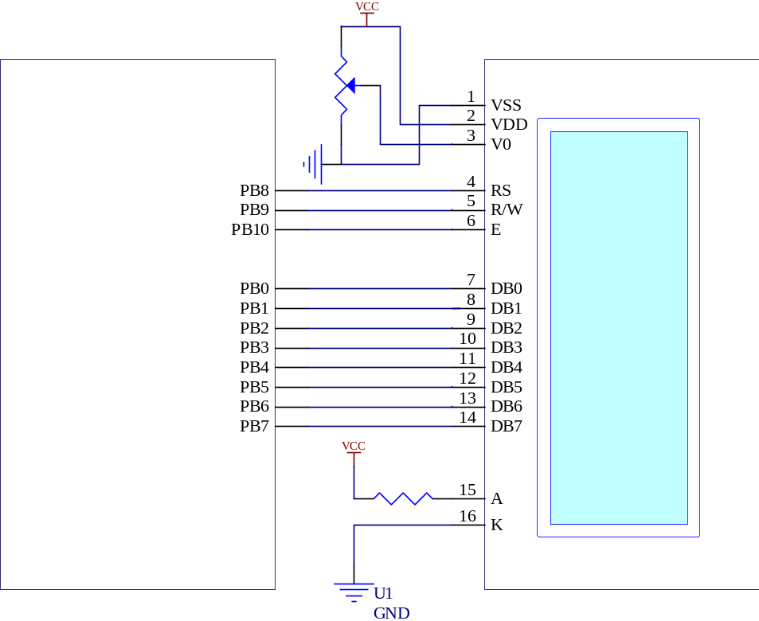
GND
3.9 Ω
10K
POT
LCD
Host Interface Port (HI08)
56311 DSP

PB0
PB1
PB2
PB3
PB4
PB5
PB6
PB7
PB10
PB9
PB8

Figure 4.16 DSP-LCD hardware interface.

4.6.2 Initializing the LCD

Before being able to display any character, the LCD should be initialized by a series of instructions. The initialization routine is used to set the interface length used to communicate with the LCD. It is also used to set the behavior of the cursor and its position in the screen [35]. The flow diagram of the initialization routine that was used in this project is depicted in Figure 4.17 [34-36].

After initializing the LCD and turning it on, it is now ready to display the messages on its screen. Each cursor position of the LCD has a unique address, therefore before displaying any character on the LCD, first the cursor position where we want to display the character should be determined then the desired character is written to that address.

