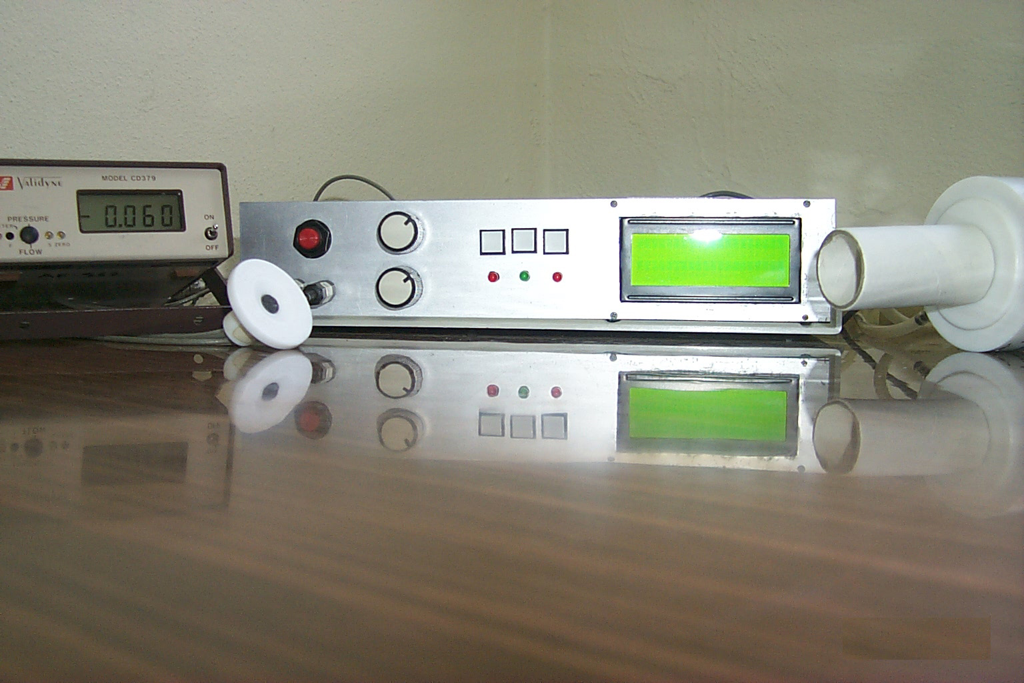
Restart
Select
Menu
LCD
Flowmeter
Microphone
Contrast
Volume
Figure 4.5 The respiratory sound classification system.

Figure 4.6 The internal structure of the device.
Amplifier Card
(upper floor)
DSP56311 EVM
(lower floor)
Power Amp.

