A DSP BASED INSTRUMENT FOR REAL-TIME CLASSIFICATION OF PULMONARY SOUNDS

by

Sameer Alsmadi

B.S. in Electronics & Telecommunication Eng.,
İstanbul Technical University, 1998

Submitted to the Institute of Biomedical Engineering
in partial fulfillment of the requirements
for the degree of
Master of Science
in
Biomedical Engineering

Boğaziçi University
January, 2003

A DSP BASED INSTRUMENT FOR REAL-TIME CLASSIFICATION OF PULMONARY SOUNDS

APPROVED BY:

Assoc. Prof. Yasemin P. Kahya ………………..….…….……..
(Thesis Supervisor)

Assoc. Prof. Ahmet Ademoğlu ………………..….…….……..

Assoc. Prof. Halil Özcan Gülçür ………………..….…….……..

DATE OF APPROVAL: January 23, 2003

ACKNOWLEDGMENTS

First of all, I would like to thank my supervisor Assoc. Prof. Dr. Yasemin P. Kahya for her kind guidance and constant support during the course of my thesis work. I would also like to express my gratitude to Uğur Çini, Mete Yeğiner, Koray Çiftçi and Ömer Ragıp Özkan from Lung Acoustics Laboratory, for sharing their ideas and materials, and for helping me especially during respiratory sound recordings.

I would like to acknowledge and pay special thanks to Prof. Dr. Günseli Kılınç from Cerrahpaşa medical faculty of İstanbul University and Dr. Filiz Süngün from Heybeliada Sanatorium for their hospitality and kind assistance during our visits to their hospitals.

This work would not have been possible without the financial support of Boğaziçi University Research Fund.

Finally, I would like to thank my family for their unrelenting support, patience and encouragement.

A DSP BASED INSTRUMENT FOR REAL-TIME CLASSIFICATION OF PULMONARY SOUNDS

ABSTRACT

The analysis of respiratory sounds is often carried out on digitized signals once they have been sampled and stored as blocks of data. However, the advance of digital signal processing technology and the availability of high speed microprocessors specially designed for digital signal processing have now made it possible to develop systems that can apply complex signal processing algorithms in real time. In this work, a real-time diagnosis system, based on Motorola’s 56311 Digital Signal Processor (DSP), was used to design an instrument capable of classifying lung sounds into two classes: healthy and pathological. The instrument has two inputs the first of which is from a microphone placed on the chest of the patient while the other is from a flowmeter that is used to label the lung sounds as belonging to the inspiration or expiration phase. Based on the information they bear and the different mechanisms that generate them, the stored lung sounds of a full respiratory cycle are divided, with the help of the flow signal, into six distinctive sub-phases. Next, each sub-phase is further divided into ten 25 per cent overlapping segments. After being weighted by a Hamming window with a length of 512 points, each segment is modeled by an autoregressive model of order six by means of the efficient Levinson-Durbin algorithm. The classification of each of the resulting 60 feature vectors can be done using two different types of classifiers: the k-nearest neighbor classifier based on either the Itakura, Euclidean, or city-block distance measure, and the minimum distance classifier based on the quadratic Mahalanobis distance measure. The classification of the whole respiratory cycle, however, is made using the majority voting method. Both of the classifiers were trained using different reference libraries obtained from 21 healthy subjects and 21 patients suffering from various restrictive or/and obstructive pulmonary diseases. The selection of the desired classifier type and the distance measure to be used in the diagnosis process can be done using the push-buttons located on the front panel of the instrument. These buttons also provide the user with the choices of recording, listening and digital filtering of the respiratory data. The software was written entirely in assembly language and a character display (LCD) was used for displaying the selected menu items, diagnosis result and other messages that convey information regarding the current state of the system.

Keywords: Lung sounds, DSP, autoregression, k-nearest neighbor, real-time classification.
GERÇEK ZAMANDA ÇALIŞAN DSP TABANLI SOLUNUM SESLERİ SINIFLANDIRICI AYGITI

ÖZET

Solunum seslerinin analizi genelde sayısal hale dönüştürülüp bloklar halinde saklanan veriler üzerinde gerçekleştirilmektedir. Ancak, sinyal işleme teknolojisi alanında meydana gelen gelişmeler ve sayısal sinyal işlemelerin gerçekleştirilmesi için özel olarak tasarlanan ve yüksek hızda çalışabilen mikroişlemcilerin ortaya çıkmasıyla birlikte, karmaşık sinyal işleme algoritmalarını gerçek zamanda uygulayabilen sistemlerin geliştirilmesi artık mümkün hale gelmiştir. Bu çalışmada, Motorola 56311 Sayısal İşaret İşlemci (DSP) tabanlı, akciğer seslerini sağlıklı ve hastalıklı olmak üzere iki sınıftan birine ayırabilen ve gerçek zamanda çalışan bir tanı sistemi gerçekleştirilmiştir. Bu cihazda iki girdi bulunmaktadır: birinci girdi hastanın göğüs duvarına yerleştirilen bir mikrofondan elde edilen ses işareti, diğeri ise akciğer seslerinin içsoluma ya da dışsoluma evresine ait olduğunu belirleyen akış-ölçerden elde edilen akış işaretinden oluşmaktakır. Taşıdıkları bilgiye ve onları üreten farklı mekanizmalara dayanarak, tam bir nefes süresi boyunca elde edilen akciğer sesleri akış işareti yardımı ile altı adet alt-evreye, ayrıca her bir alt-evre yüzde 25 oranında örtüşen on adet parçaya bölünmektedir. Levinson-Durbin algoritması kullanılarak, 512 noktalık Hamming penceresi ile ağırlıklandırılan her bir parça altıncı dereceden bir özbağlanımlı (AR) model ile temsil edilmektedir. Tam bir solunum çevrimine ait akciğer seslerinden elde edilen 60 öznitelik vektörünün sınıflandırılması iki farklı sınıflandırıcı kullanarak yapılabilmektedir: Itakura, Öklidyan, veya Şehir-bloğu uzaklık ölçütüne dayanan k-en yakın komşu sınıflandırıcısı, ve Mahalanobis uzaklık ölçütüne dayanan minimum uzaklık sınıflandırıcısı. Tüm solunum çevrimine ait seslerin sınıflandırılması ise çoğunluğun oyuna bakarak yapılmaktadır. 21 sağlıklı kişiye ve restriktif veya/ve obstrüktif akciğer hastalıklardan şikayetçi 21 kişiye ait akciğer seslerinden oluşturulan referans kütüphaneler bu iki sınıflandırıcının eğitilmesinde kullanılmıştır. Cihazın ön panelinde bulunan tuşları kullanarak, teşhis işleminde kullanılacak sınıflandırıcı türünün ve uzaklık ölçütünün seçimi kolayca yapılabilmektedir. Buna ilaveten, cihazda bulunan tuşları kullanarak solunum seslerinin kaydedilmesi, sonradan dinlenmesi, sayısal olarak filtrelenmeside isteğe bağlı olarak yapılabilmektedir. Yazılımın tümü çevirici (assembler) dilinde yazılmış olup sınıflandırma sonucu, seçilen menü öğesi ve sistemin genel durumu hakkındaki mesajlar cihaza eklenen LCD ekranda gösterilmektedir.

Anahtar Sözcükler: Akciğer sesleri, DSP, özbağlanım, k-en yakın komşu, gerçek zamanda sınıflandırma.

TABLE OF CONTENTS

Page

ACKNOWLEDGMENTS ................................................................................................ iii
ABSTRACT ...................................................................................................................... iv
ÖZET ................................................................................................................................ v
LIST OF FIGURES .......................................................................................................... ix
LIST OF TABLES ............................................................................................................ xii
LIST OF ABBREVIATIONS ........................................................................................... xiii
1. INTRODUCTION ....................................................................................................... 1
2. BREATH SOUNDS .................................................................................................... 4
2.1 Normal Breath Sounds .......................................................................................... 4
2.1.1 Normal Lung Sounds .................................................................................. 4
2.1.2 Normal Tracheal Sounds ............................................................................. 5
2.2 Abnormal Breath Sounds ...................................................................................... 5
2.2.1 Crackles ....................................................................................................... 6
2.2.2 Wheezes ...................................................................................................... 7
2.3 Modeling the Source of Lung Sounds .................................................................. 9
2.4 Pulmonary Diseases .............................................................................................. 10
3. DIGITAL SIGNAL PROCESSORS ........................................................................... 11
3.1 Digital Signal Processor Architecture ................................................................... 11
3.2 Fixed-Point and Floating-Point DSPs ................................................................... 15
3.2.1 Motorola 56311 Fixed-Point DSP .............................................................. 15
4. SYSTEM DESCRIPTION ........................................................................................... 19
4.1 System Hardware .................................................................................................. 19
4.2 Selecting the Desired Menu Item .......................................................................... 24
4.3 Recording the Lung Sound ................................................................................... 26
4.4 Finite Impulse Response (FIR) Filtering .............................................................. 29
4.4.1 FIR Filter Structure ..................................................................................... 30
4.4.2 The Enhanced Filter Coprocessor (EFCOP) ............................................... 30
4.4.2.1 EFCOP Programming for Multichannel Mode ............................. 31
4.5 Memory Configuration ......................................................................................... 34
Page

4.6 Displaying Messages on the LCD ......................................................................... 37
4.6.1 DSP-LCD Hardware Configuration ............................................................ 38
4.6.2 Initializing the LCD .................................................................................... 39
4.7 Digital Sine Wave Generator ................................................................................ 41
5. AUTOREGRESSIVE MODELING OF RESPIRATORY SOUNDS
USING DSP ................................................................................................................. 43
5.1 Autoregressive Modeling ...................................................................................... 43
5.2 Linear Predictive Coding (LPC) ........................................................................... 45
5.2.1 LPC Estimation Using the Autocorrelation Method ................................... 47
5.2.1.1 Levinson-Durbin Algorithm ......................................................... 48
5.3 Calculating the LPC Coefficients Using a Fixed-Point DSP ................................ 50
5.3.1 Windowing Process .................................................................................... 50
5.3.2 Calculating the Autocorrelation Coefficients ............................................. 51
5.3.3 Fixed-Point Implementation of Levinson-Durbin Algorithm ..................... 51
6. PATTERN CLASSIFICATION .................................................................................. 53
6.1 Bayes Decision Theory ......................................................................................... 53
6.2 Minimum Distance Classifier ............................................................................... 56
6.3 K-Nearest Neighbor (K-NN) Classifier ............................................................... 58
7. RESULTS AND DISCUSSION .................................................................................. 61
7.1 The Classification Algorithms .............................................................................. 61
7.1.1 The Storage and Segmentation of Respiratory Data ................................... 61
7.1.2 Classification with K-NN Classifier ........................................................... 68
7.1.3 Classification with Minimum Distance Classifier ...................................... 70
7.2 Forming the Reference Libraries .......................................................................... 72
7.2.1 Reference Library for the K-NN Classifier ................................................ 72
7.2.2 Reference Library for the Minimum Distance Classifier ........................... 84
7.3 Classification Results ............................................................................................ 86
7.4 Discussion ............................................................................................................. 87
8. CONCLUSIONS ......................................................................................................... 89
APPENDIX A: HARDWARE SCHEMATICS OF DSP56311 AND
STEREO AUDIO CODEC .......................................................................................... 91

Page

APPENDIX B: PATIENT PROFILE ............................................................................... 94
APPENDIX C: USER MANUAL .................................................................................... 95
C.1 The Necessary Hardware Connections ................................................................ 95
C.2 Downloading the Software to the Instrument ...................................................... 96
C.3 Operating the Instrument ...................................................................................... 98
REFERENCES ................................................................................................................. 101
REFERENCES NOT CITED ........................................................................................... 107

LIST OF FIGURES

Page

Figure 1.1 Laënnec while examining a young boy. 1
Figure 2.1 The appearance of crackle waveform. 7
Figure 2.2 A segment of lung sound containing wheezing (left),
and its periodogram (right). 8
Figure 2.3 Model of lung sound source. 9
Figure 3.1 Architectural enhancements included
in digital signal processors. 12
Figure 3.2 Five-stage pipeline process. 13
Figure 3.3 Modulo N circular addressing. 14
Figure 3.4 Block diagram of Motorola DSP56311. 16
Figure 3.5 Two’s complement fractional number representation. 18
Figure 4.1 A simplified block diagram of the system hardware. 20
Figure 4.2 Side view of the microphone capsule. 20
Figure 4.3 Functional block diagram of DSP56311 Evaluation Module. 21
Figure 4.4 Input stage of the codec. 22
Figure 4.5 The respiratory sound classification system. 23
Figure 4.6 The internal structure of the device. 23
Figure 4.7 Functional block diagram of the system. 25
Figure 4.8 The interrupt service routine that is executed
by pressing the 'Menu' button. 27
Figure 4.9 FSRAM pin connections to the 56311 DSP. 28
Figure 4.10 Hardware schematic of the stereo audio amplifier. 29
Figure 4.11 Storage of filter coefficients and input samples in memory. 31
Figure 4.12 Frequency response of a FIR low-pass filter with a cut-off
frequency of 50 Hz. 33
Figure 4.13 Frequency response of 256-coefficient band-pass FIR filter
designed using the boxcar window. . 33
Figure 4.14 FIR filtering process of the EFCOP. 34
Figure 4.15 Memory map used for system implementation. 36
Page

Figure 4.16 DSP-LCD hardware interface. 39
Figure 4.17 LCD initialization sequence. 40
Figure 4.18 Block diagram of the digital sine wave generator. 42
Figure 5.1 All-pole modeling of lung sounds. 44
Figure 6.1 Block diagram of a pattern classifier. 55
Figure 6.2 Decision boundaries of the minimum Euclidean-distance classifier. 56
Figure 6.3 Decision boundaries of the minimum Mahalanobis-distance
classifier. 57
Figure 6.4 The principle of k-nearest neighbor classification. 59
Figure 7.1 The parameters used by the device to identify the
waveform of a flow signal. . 62
Figure 7.2 Flow diagram of the DSP software used to skip over noise
and the unwanted respiratory phases. 63
Figure 7.3 Flow diagram of the software used to store sound and
flow samples corresponding to a full respiratory cycle. 65
Figure 7.4 The process of finding the ten 25% overlapping segments
from each sub-phase of the stored full respiratory cycle. 67
Figure 7.5 Flow diagram of the DSP software that is executed whenever
any of the k-NN based classifiers is selected. 69
Figure 7.6 Flow diagram of the DSP software that is executed whenever
the minimum distance classifier is chosen. 71
Figure 7.7 (a) Lung sound waveform and the superimposed flow rate of
a healthy subject, (b)-(g) show how the corresponding LPC
coefficients change with each segment for each respiratory
sub-phase. 76
Figure 7.8 (a) Lung sound waveform and the superimposed flow rate
of a patient suffering from an obstructive disease (ga_ka5),
(b)-(g) show how the expiratory rhonchus affect the values
and the behavior of the corresponding LPC coefficients. 80

Page

Figure 7.9 (a) Lung sound waveform and the superimposed flow rate
of a patient suffering from a restrictive disease (fa_sa1),
(b)-(g) show how the inspiratory crackles cause abrupt
changes in the corresponding LPC coefficients. 84
Figure A.1 Interface pins of DSP56311. 92
Figure A.2 Input circuitry of the stereo audio codec. 93
Figure C.1 The hardware connections needed to operate the instrument. 96
Figure C.2 User interface of the hardware debugger. 97
Figure C.3 Dialog box used for loading the COFF file to the DSP memory. 98
Figure C.4 The front panel of the instrument. 99

LIST OF TABLES

Page

Table 4.1 Interface pin connections of the LCD. 38
Table 4.2 LCD display character addresses. 41
Table 5.1 The Levinson-Durbin algorithm. 49
Table 5.2 Levinson-Durbin algorithm modified for DSP
implementation. 52
Table 7.1 The mean feature vectors of the healthy class. 85
Table 7.2 The mean feature vectors of the pathological class. 85
Table 7.3 Offline performance results using the leave-one-out method. 86
Table 7.4 Performance results of the online classification. 87
Table B.1 Patient profile (F: female; M: male; Obs.: obstructive;
Res.: restrictive; COPD: chronic obstructive pulmonary
disease; NA: not available.) 94

LIST OF ABBREVIATIONS

2CD Two Cycle Duration
ADC Analog to Digital Converter
ALU Arithmetic Logic Unit
AR Autoregressive
ASCII American Standard Code for Information Interchange
BMI Body Mass Index
CODEC Coder/Decoder
COFF Common Object File Format
CORSA Computerized Respiratory Sound Analysis
CT Computed Tomography
DDRAM Display Data Random Access Memory
DMA Direct Memory Access
DSP Digital Signal Processor
ECG Electrocardiograph
EFCOP Enhanced Filter Coprocessor
ESSI Enhanced Synchronous Serial Interface
EVM Evaluation Module
FCBA Filter Coefficient Buffer Base Address
FCM Filter Coefficient Memory
FCNT Filter Count Register
FCSR Filter Control and Status Register
FDBA Filter Data Buffer Base Address
FDCR Filter Decimation/Channel Count Register
FDIR Filter Data Input Register
FDM Filter Data Memory
FDOR Filter Data Output Register
FEV₁ Forced Expiratory Volume in One Second
FFT Fast Fourier Transform
FIR Finite Impulse Response
FSRAM Fast Static Random Access Memory
GPIO General Purpose Input/Output
GUI Graphic User Interface
HCR Host Control Register
HDDR Host Data Direction Register
HDR Host Data Register
HI Host Interface
IDW Initial Deflection Width
JTAG Joint Test Action Group
K-NN K-Nearest Neighbor
LA Loop End Address
LC Loop Counter
LCD Liquid Crystal Display
LED Light Emitting Diode
LPC Linear Predictive Coding
MAC Multiply and Accumulate
MIPS Million Instructions Per Second
MRI Magnetic Resonance Imaging
OnCE On-Chip Emulation
PARCOR Partial Correlation
PLL Phase Lock Loop
RAM Random Access Memory
SCI Serial Communication Interface
TAP Test Access Port
TEWA Time Expanded Waveform Analysis
WSS Wide Sense Stationary

1. INTRODUCTION

The acoustic signals generated by the lung due to air flow during inspiration and expiration form a powerful source of information about the structure and condition of the lung [1]. In medicine, the lung sounds are known to be closely correlated with pulmonary pathology, where the changes in lung structure that occur in disease affect the amplitude and timing of sound transmission from the airways to the chest surface [1, 2].

Prior to the invention of the stethoscope, lung sounds were detected by direct placement of the ear upon the chest. In France in the mid-nineteenth century, this was not always socially acceptable when the patient was a young woman. Furthermore, this kind of auscultation was either impractical or impossible in obese patients. All these factors led to the invention of the first stethoscope by the French physician René Laënnec in 1816. At first, it was a narrow tube from a rolled piece of paper, but subsequent versions of this tube became the monaural stethoscope [3], which were originally made of wood and modified to fit the contour of the ear and chest (see Figure 1.1). Since then, the stethoscope is widely used by physicians as a simple and noninvasive diagnostic instrument of respiratory diseases [4].


Figure 1.1 Laënnec while examining a young boy [3].

Despite their popularity, stethoscopes are less than ideal acoustic instruments because they do not provide a frequency-independent, uncolored transmission of sounds. Rather, they selectively amplify or attenuate sounds within the spectrum of clinical interest. Amplification tends to occur below 112 Hz and attenuation at higher frequencies. Amplification at low frequencies is appreciated by cardiologists since heart sounds are in this frequency range, which is poorly perceived by the human ear [2]. In addition, auscultation with a stethoscope is a subjective process that depends on the individual’s own hearing, experience and ability to differentiate between different sound patterns, which may lead to a large variability in findings [5].

To overcome the above limitations of conventional stethoscopes, it is clear that the auscultation of the lung could benefit from a more faithful representation of sounds than present stethoscopes provide. Recently, transducers such as microphones have allowed for the collection of more accurate acoustical data over a wider range of frequencies, and advances in computer technology made it possible to analyze respiratory sounds using the procedure of “electronic auscultation”. The procedure of electronic auscultation is neither invasive nor particularly expensive, so it would be suitable as an examination method for high-risk groups such as critical care patients. It may also decrease the burden for some patients, such as infants or pregnant women, while diagnosing some pulmonary diseases such as pneumonia, that may require frequent X-ray exposures [6].

Over the last 30 years and due to the enhancements in digital signal processing techniques, the analysis of waveforms by computer has become an established research technique for the investigation of respiratory sounds [2, 5, 7]. As research in the area of computerized auscultation has developed, many different types of equipment and techniques have been used. Much of the knowledge gained in recent years has resulted from the use of a wide variety of data acquisition, processing and analysis techniques. Although marked similarities in the basic methodology were found, there was considerable variation in the way that sound was processed and analyzed, thus making it difficult to compare and exchange results from different research centers [5, 7].

As part of the efforts to standardize the way the respiratory sounds are recorded, processed and analyzed, the European Community has financed a BIOMED 1 Concerted Action project named Computerized Respiratory Sound Analysis (CORSA), whose main objective was to develop guidelines for research and clinical practice in the field of respiratory sound analysis [5].

The analysis of pulmonary sounds is often carried out on digitized signals once they have been captured and stored as blocks of data. However, the advance of digital signal processing technology and the availability of high speed signal processing microprocessors specifically designed for digital signal processing have now made it possible to develop systems for carrying out the analyses in real-time. This means that the input signals are analyzed as they are being captured and the results are displayed instantaneously [8].

In this work, a real-time diagnosis system, based on Motorola’s 56311 digital signal processor (DSP) was used for designing an instrument capable of classifying lung sounds into two classes: healthy and pathological. The theory behind the instrument is based greatly on a paper published by Sankur, Kahya and coworkers, in which the respiratory sounds of pathological and healthy subjects were analyzed successfully via autoregressive (AR) models [9]. However, instead of analyzing the respiratory cycle in terms of only the inspiration and expiration phases, analysis was made by dividing each respiratory cycle further into six sub-phases: early, mid and late inspiration/expiration sub-phases [10]. The designed instrument has two inputs the first of which is from a microphone placed on the chest of the patient while the other is from a flowmeter that is used to label the lung sounds as belonging to the inspiration or expiration phase. The feature vectors derived from the lung sounds corresponding to one full respiratory cycle are classified using two different types of classifiers: k-nearest neighbor (k-nn) and minimum distance classifiers. Different distance measures can be used with each classifier, and the result of the classification process is displayed on a liquid crystal display (LCD). Despite the fact that assembly code is more difficult to maintain and implement, the software of the instrument was written entirely in assembly language due to the fact that the machine-specific assembly language provides the fastest execution and most compact form of the algorithm, which is a desired property in systems operating in real-time.

2. BREATH SOUNDS

2.1 Normal Breath Sounds

According to the present CORSA definitions, normal breath sounds are those detected on either the chest wall, where it is characterized by a quiet low-frequency noisy sound during inspiration, and where it is hardly audible during expiration; or the trachea, where it is characterized by a broader spectrum of noise than the normal breath sounds from the chest wall, and where it is audible both during inspiration and expiration [11].

2.1.1 Normal Lung Sounds

The breathing-associated sound heard on the chest of a healthy person is called normal lung sound. It is a noise that peaks in frequency below 100 Hz, where it is mixed with and not easily distinguished from muscle and cardiovascular sounds. Those sounds are presumed to be generated due to air turbulence in the airways of the lungs [2]. The resulting noise, coming from the larger airways, has a wide frequency spectrum. It is transmitted to the skin, after being filtered by the lungs and the chest wall, which act acoustically as a low-pass filter. Therefore, the nominal breath sounds recorded over the lungs have their main frequency band up to 200-250 Hz [12].

Normal lung sounds exhibit noticeable amplitude variation across the chest, but they primarily vary with the square of the air flow. There is a strong positive relationship between ventilation and lung sound amplitude, where diminished lung sound intensity is correlated with poor ventilation. O’Donnell and Kraman produced linear maps of inspiratory lung sound in 2 cm increments and found the amplitude to increase toward the base posteriorly, decrease toward the base anteriorly and to remain approximately stable in the horizontal plane. They also found significant right-to-left differences and small-scale variations in amplitude, and marked subject-to-subject variation [2].

Respiratory sounds depend on anatomical and physiological parameters (such as sex, age, type and degree of illness) and they also have a large variability not only among individuals but also within an individual [1]. In investigations of lung sounds of healthy subjects, differences in the frequency spectra of normal breath sounds of men and women were found. No significant difference between smokers and nonsmokers was found. A negligible displacement of the frequency pattern to higher values with progressive age has also been reported. However, these changes are too small to be clinically relevant and there is no need to consider a patient’s age during automated lung auscultation. A very weak correlation between age and body mass index (BMI) was also found, which means that the influence of BMI on the age dependence of lung sounds can be neglected [13].

2.1.2 Normal Tracheal Sounds

Tracheal sounds, heard at the suprasternal notch or at the lateral neck are strong signals covering a wider range of frequencies than lung sounds at the chest wall, with distinctly separate respiratory phases and a close relation to airflow. The generation of tracheal sounds is primarily related to turbulent airflow in upper airways including pharynx, glottis and subglottic regions. Unfortunately, since the spectral shape of tracheal sounds is highly variable between subjects, the parametric representation of tracheal sounds is more complex that that of lung sounds [2].

2.2 Abnormal Breath Sounds

Breath sounds may be abnormal in certain pathological conditions of the airways of lungs. Abnormal breath sounds consist of either absent or reduced intensity normal breath sounds, pathological breath sounds, and adventitious sounds [4]. For example, many diseases with airway obstruction like in asthma and chronic bronchitis result in breath sounds with abnormally high frequencies and intensity with prolonged and long loud expiratory phase [12].

Adventitious breath sounds, those additional sounds not normally present, are defined as either continuous (wheezing if high pitched, rhonchi if low pitched), or discontinuous (fine crackles if high pitched, coarse crackles if low pitched) [4].

2.2.1 Crackles

Crackles are discontinuous adventitious lung sounds, explosive and transient in character and occur frequently in cardiorespiratory diseases. Their duration is less than 20 ms, and their frequency content typically is wide, ranging from 100 to 2,000 Hz or even higher. It is assumed that the explosive opening of small airways, previously held closed by surface forces, causes these sounds. Since the closure of small airways is gravity-dependent, crackles tend to occur first in the basal areas of the lungs, and later, when the disease progresses, in the upper zones of the lungs [12].

Despite the fact that it has been found that about half of the healthy young adults could generate crackles over the anterior lung bases by inhaling slowly from residual volumes, many investigators have explored the potential specificity of crackle features and characteristics to certain diseases. It is now generally accepted that fine and coarse crackles are associated with different conditions and so have diagnostic importance. Those with established clinical utility appear to be in the presence or absence of crackles to distinguish pulmonary fibrosis (crackles usually prominent) from sarcoidosis (crackles usually scant or absent); fine, late inspiratory crackles indicating fibrotic lung disease and early, course crackles indicating obstructive lung disease; crackles as an early (perhaps first) sign of abestosis [2]. The number of crackles has been associated with the severity of pulmonary disease in fibrosing disorders. Moreover, the waveform and timing of crackles may have clinical significance in differential diagnosis of cardiorespiratory disorders [2, 12]. Figure 2.1 shows the most commonly used indices of crackles, which are the time duration of the initial deflection (IDW) and the first two cycles (2CD) of the waveform. In each of these parameters, low values correspond to the clinical concept of fine crackles, whereas large values correspond to coarse crackles [14]. According to CORSA definitions, the 2CD of fine crackles is <10 ms, and that of coarse crackles >10 ms [11, 14].

Because of the limitations of human hearing in distinguishing between individual crackles, automatic counting methods based on computer-assisted analysis have been developed. The basic methods used in automatic crackle recognition can be divided into those based on time-expanded waveform analysis (TEWA), spectral analysis and autoregressive models. Examples of parameter estimation based methods used in crackle detection include adaptive nonlinear filters and wavelet transformation [14].

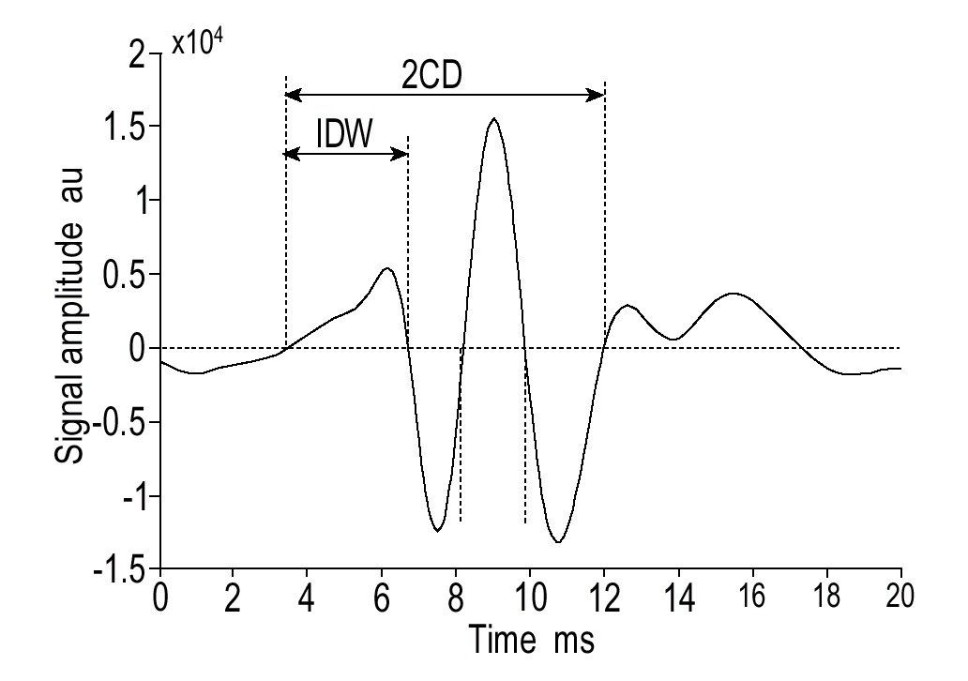
Figure 2.1 The appearance of crackle waveform [14].

2.2.2 Wheezes

Wheezes are pseudoperiodic musical adventitious lung sounds easily detected by a stethoscope, also called “continuous” since their duration is much longer than that of “discontinuous” crackles [2, 12]. According to the new definition of the present CORSA guidelines, the dominant frequency and duration of a wheeze are usually greater than 100 Hz and 100 ms, respectively. On the other hand, the dominant frequency of a rhonchus is ≤300 Hz [11, 12]. The pathophysiologic mechanisms that generate wheezing are still not entirely clear. According to a new model proposed recently by Grotberg and Gavriely, wheezes are produced by fluttering of the airways. The oscillations begin when the airflow velocity reaches a critical value, called flutter velocity. This model shows that wheezes are always accompanied by flow limitation but that flow limitation is not necessarily accompanied by wheezes [2, 12].

Wheezes can be heard in several diseases. They are used as an indicator of airway obstruction in infants, or as a parameter to show the severity of asthma. Quantification of wheeze over time has been used to express wheeze severity relative to flow obstruction. For example, the proportion of the breath cycle occupied by wheezing (Tw/Ttot) was associated with the degree of bronchial obstruction, and this ratio was found to be inversely related to the forced expiratory volume in one second (FEV₁) in adult asthmatics with moderate to severe flow obstruction [2, 12]. Since the waveform of a wheeze resembles that of a sinusoidal sound, a wheezing sound of medium to loud intensity is easy to notice as sharp peaks in the power spectrum of respiratory sound (Figure 2.2). For this reason, automated analyses of wheezes are usually based on their spectral appearance, and they rely on identification of the presence of at least a peak with sufficiently strong amplitude [12].

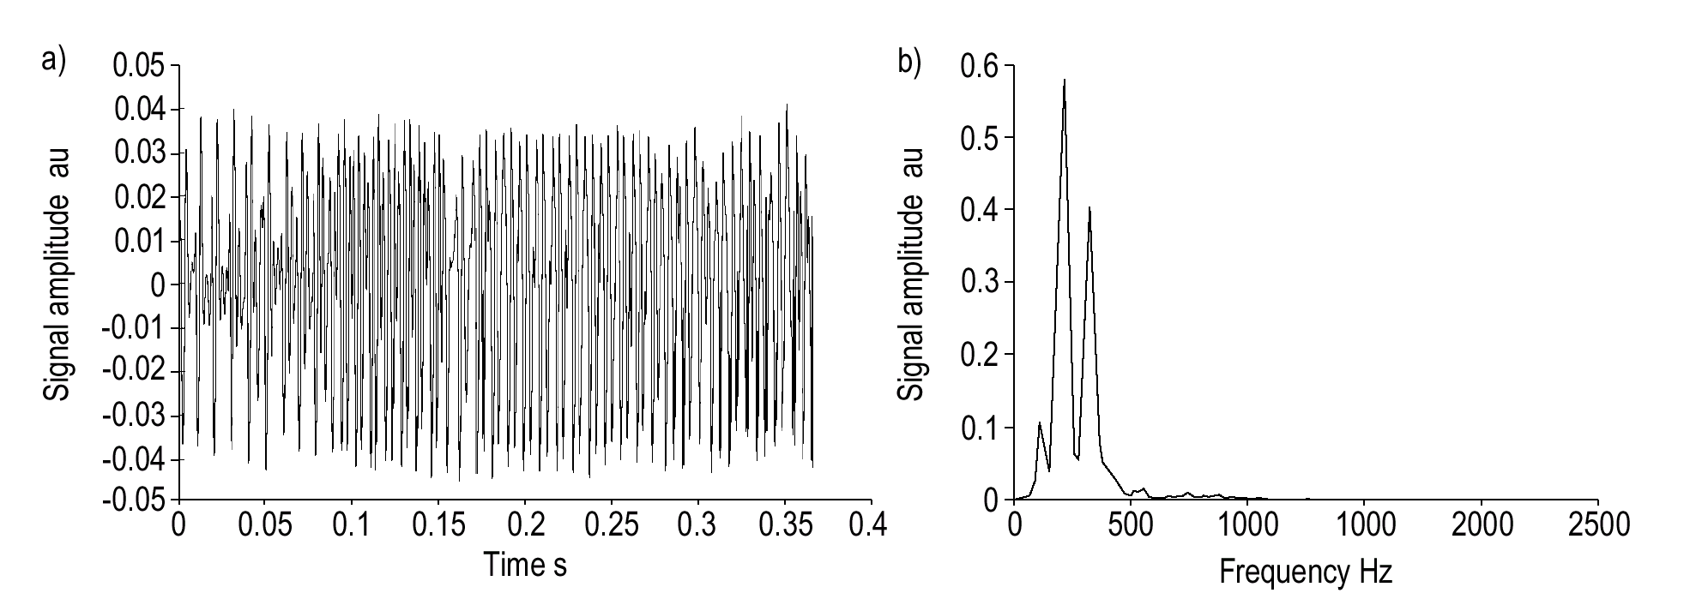
Figure 2.2 A segment of lung sound containing wheezing (left), and its periodogram (right) [14].

Much information about wheezes has been found within frequency bands below about 2kHz. A bandwidth extending up to 2 kHz would therefore appear to be sufficient for many studies of wheeze. On the other hand, the bandwidth of the commonly encountered crackles is 100-2,000 Hz. Although there is evidence that useful information regarding some adventitious sounds, such as fine crackles, may require a wider range of analysis, a maximum frequency of 2 kHz can be taken as working assumption, and the sampling rate in this case should be above 4 kHz [7, 14, 15].

2.3 Modeling the Source of Lung Sounds

The lung sounds originated in the airways of the lung can be modeled as depicted in Figure 2.3. According to this model, the lung sound consists of three kinds of noise sequences. The first sequence (periodic impulse) describes the wheezes and rhonchus sources, since they have characteristic distinct pitches associated with them, and they are believed to be produced by periodic oscillations of the air and airway walls. The second sequence (random intermittent impulse) describes the crackle sources since they are believed to be produced by sudden opening/closing of airways or bubbling of air through extraneous liquids in the airways, both phenomena associated with sudden intermittent bursts of sounds energy. Finally, the third sequence (white non Gaussian noise) describes the breath sound sources since they are believed to be produced by turbulent flow in large range of airway dimensions. Thus, an additive combination of these sequences can produce almost all kinds of lung sounds, resulting in a complete description of the lung sound sources. As will be seen later, this modeling of sound sources will be used in the autoregressive modeling of lung sounds [16, 17].

Periodic
Impulse
Random Inter-
Mittent Impulse
White non-Gaussian Noise
+
Lung Sound Source
Crackles
Wheezes
Breath Sounds
Figure 2.3 Model of lung sound source [17].

2.4 Pulmonary Diseases

Pulmoary diseases are divided into two main categories: restrictive and obstructive lung diseases. In a restrictive lung disease, the compliance of the lung is reduced, which increases the stiffness of the lung and limits expansion. In these cases, a greater pressure than normal is required to give the same increase in volume. Common causes of decreased lung compliance are pulmonary fibrosis, pneumonia and pulmonary edema. In an obstructive lung disease, airway obstruction causes an increase in resistance. During normal breathing, the pressure volume relationship is no different from in a normal lung. However, when breathing rapidly, greater pressure is needed to overcome the resistance to flow, and the volume of each breath gets smaller. Common obstructive diseases include asthma, bronchitis, and emphysema [18].

3. DIGITAL SIGNAL PROCESSORS

A digital signal processor (DSP) can be thought of as a programmable special-purpose chip that is designed to take a stream of digital data and perform complex signal processing algorithms on it. The repetitive nature of the common signal processing routines are taken into account in the architecture of a DSP, and specialized arithmetic hardware and memory access schemes are used extensively to speed up the execution of such routines [19]. The most important architectural enhancements that are introduced to DSPs are summarized next.

3.1 Digital Signal Processor Architecture

The repetitive multiply-and-accumulate (MAC) operation is one of the most common operations encountered in signal processing algorithms. This operation is described by the equation:

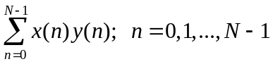, ( 3.1)

where N samples of the signal x(n) are multiplied by the corresponding samples of y(n). Correlation, convolution and finite impulse response (FIR) filtering are some of the common signal processing operations in which the structure given in Equation 3.1 is encountered.

In order for a DSP to perform such operations in real time as quickly as possible, it is clear that it should have architectural features that accelerate the execution of such algorithms. Indeed, all DSPs have dedicated hardware multipliers that perform the multiplication of two data words within one clock cycle. This multiplier is placed directly within the data path of DSP’s Arithmetic Logic Unit (ALU), thus assuring that all data coming into the ALU can be immediately applied to the inputs of the multiplier. Next, the multiplier is cascaded with an adder so that an accumulation is performed immediately following a multiplication process. As a result, when the multiplier at time n is busy doing the operation x(n)y(n), the adder will be operating on the product x(n-1)y(n-1) [20].

Another architectural enhancement that distinguishes DSPs from general-purpose processors is the fact that the memory space found in DSPs is separated into a data memory and a program memory, each with dedicated address calculation circuitry. This separation is known as the Harvard architecture and it differs from the single-memory von Neuman architecture used in general-purpose processors [20, 21]. This architecture can speed up the MAC operation by providing separate data buses for the multiplier inputs, thus avoiding any conflict that can occur while the simultaneous fetching of the samples x(n) and y(n) from the two separate memories X and Y (Figure 3.1) [20].
Figure 3.1 Architectural enhancements included in digital signal processors [20].
X Data Bus
Accumulator & ALU
Hardware
Multiplier
Shifter &
Output
X
Mem.
Y
Mem.
Program Memroy
Address
Calculation
Loop
Hardware
N bits
N bits
2N bits
Y Data Bus
Input
Registers

Another reason for the high speed of DSPs comes from the pipelining of the instruction set so that more than one instruction can be started at the same time in parallel, where each of these instructions is performed by a different resource available within the DSP [20, 21]. To explain how pipelining works, let us reexamine the basic MAC instruction. This instruction can be written in the iterative form:
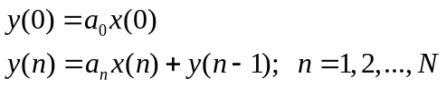 (3.2)

To get the final answer to Equation 3.2, five machine resources are used, each in a different clock cycle. So, the stages of a computation occurring in each of these resources can be summarized as follows:

- The code representing the instruction y(n)=a_{n}x(n)+y(n-1) is fetched from the program memory.

- The operands a_{n} and x(n) are fetched from the separate data memories.

- The multiplication a_{n}x(n) is performed by the hardware multiplier.

- The result is added to the previously found multiplication result y(n-1).

- The result is shifted as necessary before moving it from the accumulator to the data bus.

A reservation table showing the available DSP resources and the instruction cycles required by each instruction can be represented as in Figure 3.2.

Figure 3.2 Five-stage pipeline process [20]. |  | Instruction Cycles
DSP Resource |  | 1 | 2 | 3 | 4 | 5 | 6 | 7 | 8 | 9 | 10
DSP Resource | Program Memory | 1 | 2 |  |  |  | 2
DSP Resource | Operand Memory |  | 1 | 2 |  |  |  | 2
DSP Resource | Multiplier |  |  | 1 | 2 |  |  |  | 2
DSP Resource | Accumulator |  |  |  | 1 | 2 |  |  |  | 2
DSP Resource | Shifter/Output |  |  |  |  | 1 | 2 |  |  |  | 2

Here, each number in a cell represents the instruction and the time slot in which that instruction is being computed by the corresponding machine resource. Let us assume that each instruction requires five cycles to complete. If the pipeline approach was not used, then instruction 2 is normally fetched as soon as the execution of instruction 1 is complete, that is at time slot 6 (the shaded area in Figure 3.2). In the pipelined approach, on the other hand, instruction 2 is fetched as soon as the corresponding processing element is not used, that is immediately after fetching instruction 1 from program memory, which corresponds to time slot 2. Similarly, as soon as the operands a_{n} and x(n) are fetched during time slot 2, the operands a_{n+1} and x(n+1) are fetched at time slot 3, rather than time slot 7. By this way, it is guaranteed that all processor resources are active at the same time, and that a new output is produced at each clock cycle [20].

DSPs also use special addressing modes that assist in implementing some of the common signal processing algorithms like fast Fourier transform (FFT) and FIR filtering. For example, circular addressing mode is used in algorithms that require the sequential accessing of limited amount of data over and over [20-22]. Filtering, waveform generation, convolution and correlation are only some of the examples that require the extensive use of such addressing mode [20]. Figure 3.3 represents the operation of a circular buffer, where the address pointer wraps around whenever it reaches the end of the buffer, and continues accessing the same data from the beginning.

Buffer Start
Buffer End
.
.
.
0
N-1
N-2
1
. . . . .
Memory Array
Figure 3.3 Modulo N circular addressing [20].

Signal processing algorithms usually include iterative loops in which fetching and decoding each instruction on a separate clock cycle may be time consuming. For this reason, advanced DSPs include hardware loop units that provide loop counter (LC) and loop end address (LA) registers through which it is possible to perform such loops with low overhead. So, single instructions or even small portions of code can be repeated more quickly; because the multiple sequencing of fetching and decoding of each instruction is avoided [20, 21].

3.2 Fixed-Point and Floating-Point DSPs

Based on how the they interpret numbers, DSPs can be categorized into two types: fixed-point and floating-point DSPs. In fixed-point DSPs, the numbers are treated as fractions in the range [-1,1), while in floating point DSPs they are expressed through the use of a mantissa and an exponent [19-21]. Since floating-point DSPs have wider dynamic range and there is no need for scaling, their programming is easier and the programmer does not have to worry about precision and dynamic range constraints. So, floating-point DSPs can be used in medical applications where the dynamic range and precision issues are demanding, which is the case in complex 3-D computations such as ECG analysis, catheter signal processing, magnetic resonance imaging (MRI) and computed tomography (CT). But since the floating-point operations require more complex circuitry, the floating-point DSPs are more expensive and power consuming than fixed-point DSPs. In addition, fixed-point DSPs tend to be faster and cheaper, and they have applications that focus more on pixel processing such as X-ray and ultrasound equipment. It is also predicted that DSPs will show rapid growth in the fields of prosthetics (hearing aids), telemedicine and telepathology [19]. As an example of a fixed-point DSP, the Motorola 56311 DSP is presented in the next section.

3.2.1 Motorola 56311 Fixed-Point DSP

The Motorola DSP56311 is designed basically for the development of applications that require high performance and large internal memory while consuming minimal power and board space, such as wire line and wireless communications, multi-line voice/data/FAX processing, video conferencing, and general digital signal processing applications. Taking this into account, DSP56311 has large on-chip RAM memory of 128K 24-bit words, thus eliminating the need for external memory devices, which may reduce performance and consume both power and board space (Figure 3.4). In addition, this DSP also includes a general-purpose fully programmable Enhanced Filter Coprocessor (EFCOP) unit that can perform filtering and echo-cancellation tasks in parallel with the core, thus boosting the overall performance and efficiency of the DSP.

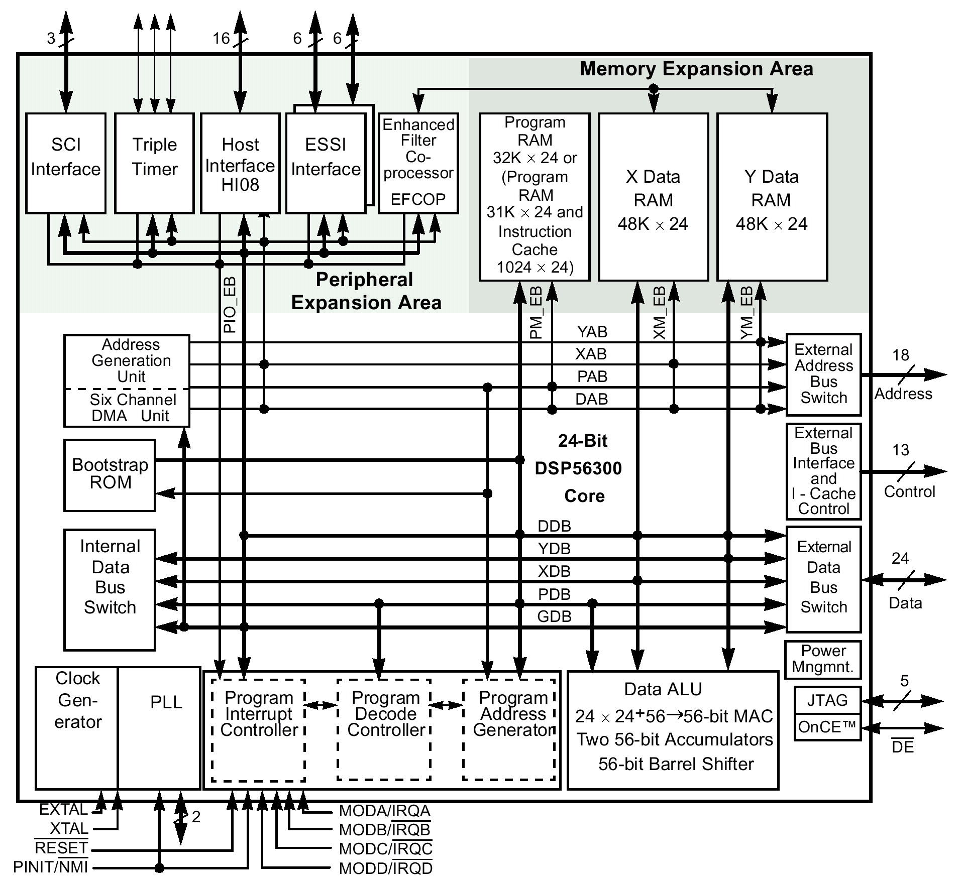
Figure 3.4 Block diagram of Motorola DSP56311 [23].

The DSP56311 uses a high-performance, single-clock-cycle-per-instruction engine, thus offering 150 million instructions per second (MIPS) performance (255 MIPS using the EFCOP in filtering applications) with an internal 150 MHz clock at 1.8 V core. Such a high clock frequency can be generated using an internal Phase Lock Loop (PLL) that allows the processor to operate at a high internal clock frequency using a low-frequency clock input. In addition, the Data Arithmetic Logic Unit (Data ALU) of this DSP includes a fully pipelined 24x24-bit parallel Multiplier-Accumulator (MAC), 56-bit parallel barrel shifter, and it supports conditional ALU instructions.

The DSP56311 provides two independent and identical Enhanced Synchronous Serial Interface peripheral units (ESSIs), where each ESSI can be used for full-duplex serial communication with a variety of serial devices, such as microprocessors and industry-standard codecs. It also includes a Serial Communication Interface (SCI) that can also provide full-duplex serial communication with other DSPs or peripherals such as modems. In addition, a connection can be made directly to the data bus of a host processor using the byte-wide, full-duplex parallel Host Interface port (HI08). The DSP also contains a triple timer module that can be used as general-purpose timer/event counter, a watchdog, or even a pulse width modulator.

The DSP contains six Direct Memory Access (DMA) channels that support data transfers between any combination of internal/external memory and/or internal/external input/output in which its operation does not interfere or slow down the core operation. This DSP also supports hardware debugging using Joint Test Action Group (JTAG) Test Access Port (TAP) and the On-Chip Emulation (OnCE) module by which it is possible to examine the registers, memory, or on-chip peripherals, thus facilitating the hardware and software development process on this processor [23].

DSP56311 is a fixed-point processor in the sense that it uses fractional data representation for all of its arithmetic operations. A fraction, f, is any number that has a magnitude satisfying the inequality: 0≤magnitude(f)<1. In two’s-complement fractional number representation, a binary point is implied to exist in a fixed position immediately after the most significant bit (MSB) of the binary number (Figure 3.5). Thus the dynamic range of any N-bit fractional number represented in two’s-complement number format will be limited by: -1.0 ≤f≤1-2^{-(N-1)}. Since DSP56311 is a 24-bit machine, the word values that can be represented will be limited by the most negative and most positive numbers -1.0 and 1-2⁻²³=0.9999998, respectively. Fortunately, this DSP has two 56-bit accumulators, A and B, that allow the most positive and negative numbers that can be represented in them to grow to the range +255.999999999999993 and -250.0, respectively. In addition, many other data representations can be also defined and used, such as two’s-complement integer numbers, real and mixed numbers, and double-precision (48-bit) numbers. These numbers can be converted from one data representation to another by simply performing shifting or scaling operations on them [22, 24].

f₀
. . . . . . .
S
f₂
f_{N-1}
f_{N-2}
f₁
Sign bit
The implied binary point
N bits
2^{-(N-1)}
. . . . . . .
-2⁰
2^{-(N-3)}
2⁻¹
2⁻²
2^{-(N-2)}
Weighting:
Figure 3.5 Two’s complement fractional number representation [24].

Due to the limitations resulting from representing all the data with fixed-point arithmetic, there is always a possibility of overflow when the value exceeds the available dynamic range. For example, the repetitive usage of multiply-accumulate instruction can result in numbers that are too large or too small to be represented within the limited range of the fixed-point processor. To decrease the probability of overflows to a reasonable extend, the expected worst case, resulting from the implementation of an algorithm, should be taken into account by the programmer and the appropriate scaling should be applied where necessary. The scaling factor should be chosen carefully so that not to increase the round-off noise that can accumulate. Despite this scaling, if an overflow occurs, then saturation arithmetic can be employed in which an overflow occurring in an accumulator is saturated at either the maximum positive or the maximum negative representable value [21].

4. SYSTEM DESCRIPTION

4.1 System Hardware

In this work, a real-time diagnosis system, based on Motorola’s 56311 Digital Signal Processor (DSP) was designed for the classification of lung sounds into two classes: healthy and pathological. The classification process can be done using two classifiers: the k-nearest neighbor (k-nn) and the minimum distance classifiers. Three push-buttons, located on the front panel of the instrument (Menu, Select and Retest buttons), are used to select the desired classifier type and the distance measure to be used in the diagnosis process. A liquid crystal display (LCD) module is used for displaying the selected menu items, diagnosis result and other messages that convey information regarding the current state of the system.

The instrument has two inputs the first of which is from a microphone attached to the posterior base of the right or left lung while the other is from a flowmeter that is used to label the lung sounds as belonging to the inspiration or expiration phase (Figure 4.1). Air-coupled microphones are preferred here because the movements of the chest-wall are very weak which means that the free-field recording of breath sounds is not possible (see Figure 4.2). The signal produced by the microphone is then passed through a low noise preamplifier and a band-pass filter having a flat frequency response in the range 80-2,000 Hz. The band-pass filter is actually realized by cascading a fourth order Bessel high-pass filter with an eighth order Butterworth low-pass filter. The high-pass filter is used in order to reduce the effect of the low-frequency noise resulting from cardiovascular sounds, muscles and even from the patient or microphone motion [25]. The overall gain of the preamplifier and band-pass filter is approximately 60 dB. Simultaneously with the lung sound, the flow signal is recorded using a Fleisch type flowmeter whose output is filtered with a second order Butterworth low-pass filter having a cut-off frequency at 30 Hz and then amplified using a phase-inverting amplifier having a gain of about 12 dB.

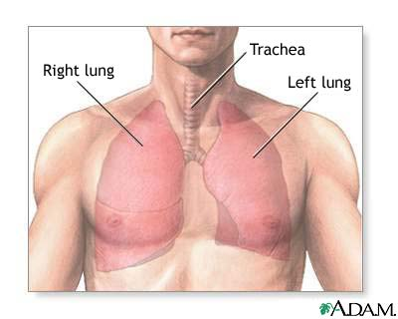
FLOWMETER
DIGITAL SIGNAL PROCESSOR
AMPLIFIER & BAND-PASS FILTER (80-2kHz)
A/D CONVERTER
POWER
AMPLIFIER

AMPLIFIER & LOW-PASS FILTER
(30Hz)

LCD
DISPLAY

MICROPHONE
Figure 4.1 A simplified block diagram of the system hardware.

Figure 4.2 Side view of the microphone capsule.
40mm
10mm
20mm
20mm
Microphone
Cable
cavity
Air
cavity

After amplifying and filtering both of the signals, they are digitized and processed using the DSP56311 evaluation module (EVM) board manufactured by Motorola. This board includes the DSP56311 24-bit digital signal processor, 64Kx24-bit fast static RAM (FSRAM) for expansion memory, 128Kx8-bit flash memory for stand-alone operation, 16-bit CD-quality audio codec and command converter circuitry (Figure 4.3). The EVM also includes nine jumper connectors that can be used to configure various features on the board such as the desired sampling frequency [26]. Hardware schematics showing the signals of the DSP56311 integrated with the EVM is given in Figure A.1 of Appendix A.

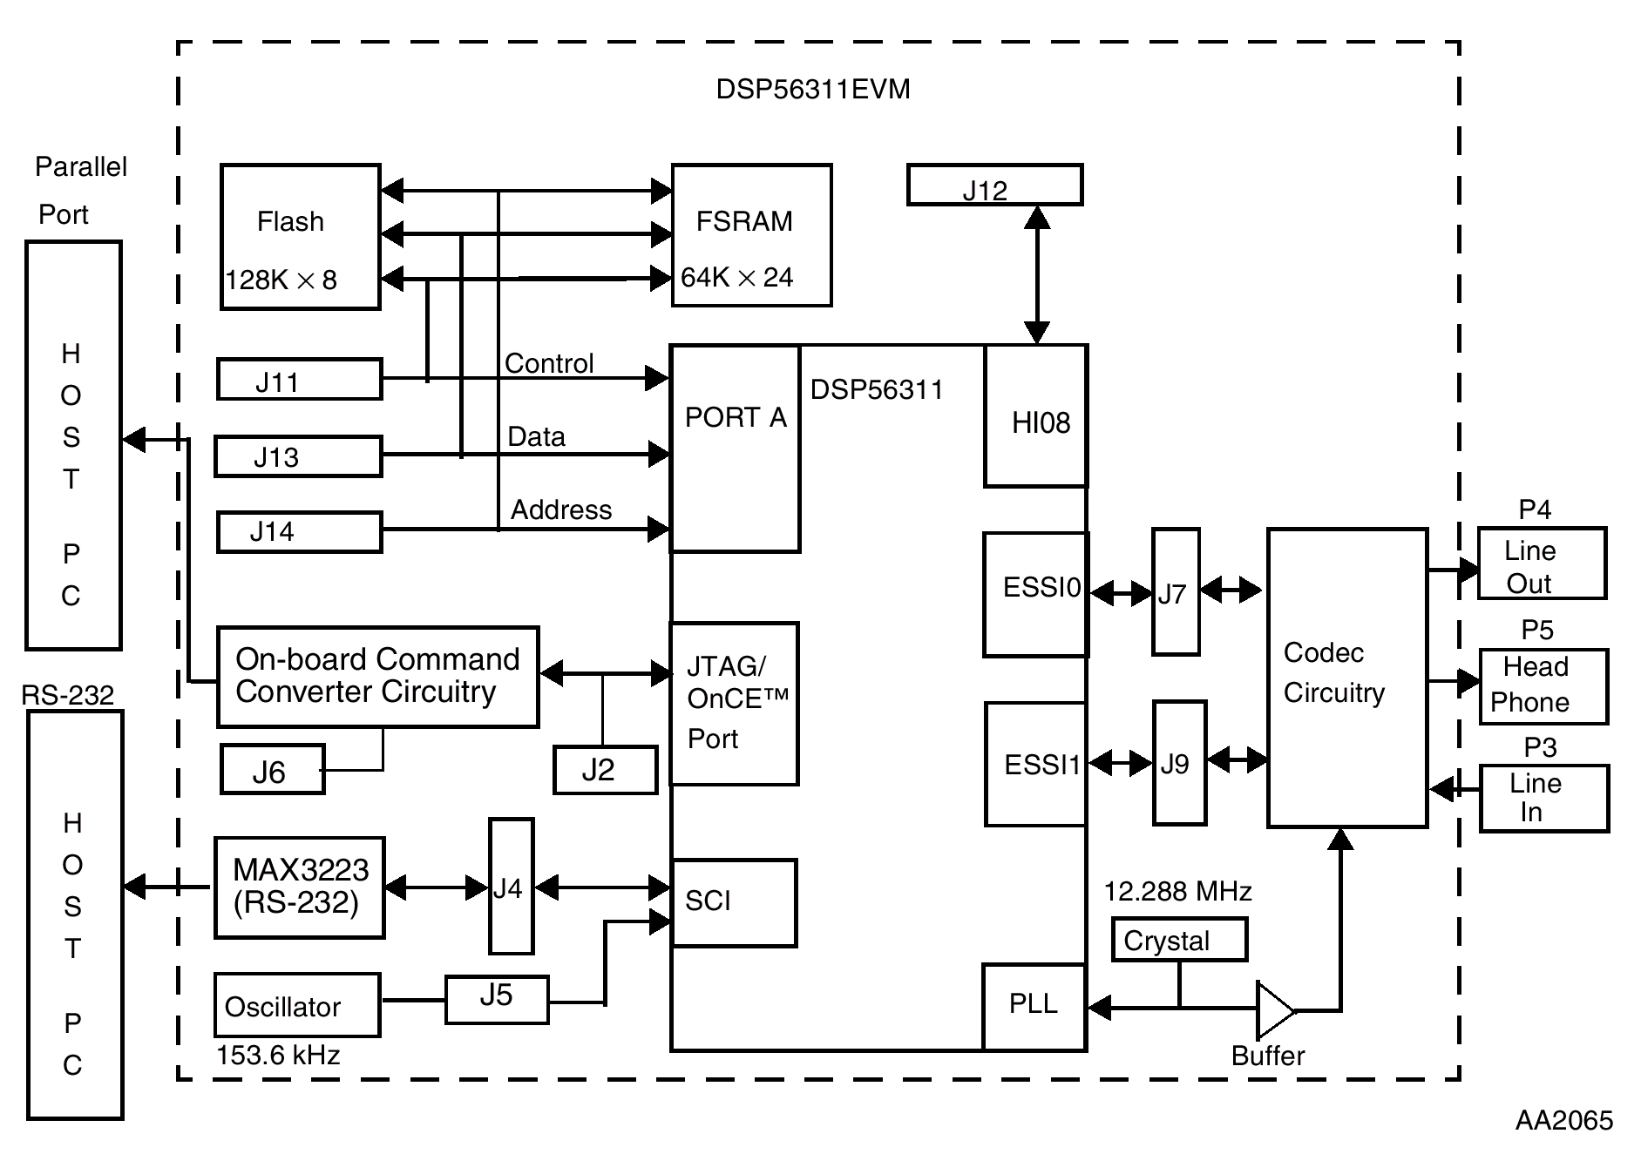
Figure 4.3 Functional block diagram of DSP56311 Evaluation Module [26].

Both of the input channels are digitized at a sampling frequency of 8 kHz using the 16-bit stereo codec integrated with the DSP56311 EVM but the sampling rate of flow signal is reduced to 125 Hz by omitting 63 samples out of every 64. The codec (CS4218) contains two delta-sigma analog-to-digital converters, two delta-sigma digital-to-analog converters, input anti-aliasing filters, and output smoothing filters on-chip which eliminate the need for external anti-aliasing filters. Therefore, this module contains only a single pole filter in the inputs and outputs of this codec (Figure 4.4). But since this codec is intended for stereo audio signals, the flow signal is attenuated with this filter before it reaches the codec input. To prevent this, the value of the serial capacitor C10 was increased from 0.33 μF to 500 μF, thus resulting in the decrease of the cut-off frequency of this filter by a factor of about 1515 times. The codec also contains programmable input gain (adjustable from 0 dB to +22.5 dB in 1.5 dB steps), and programmable output attenuators (adjustable from 0 to –46.5 in 1.5 dB steps) [26, 27]. The attenuators at the output of the codec are used to prevent any saturation that may result while amplifying the lung sound with the power amplifier that feeds the external speakers. The communication between the DSP and the codec is achieved using the enhanced synchronous serial interface ports (ESSI) of the DSP and the codec’s specialized pins. By using these pins the DSP can initialize and transport data/control words to the codec. For proper operation of the codec, some initialization procedures should be made first such as resetting the codec, initializing the ESSI ports and enabling the interrupt mechanism through which the data transfers will be achieved [28].

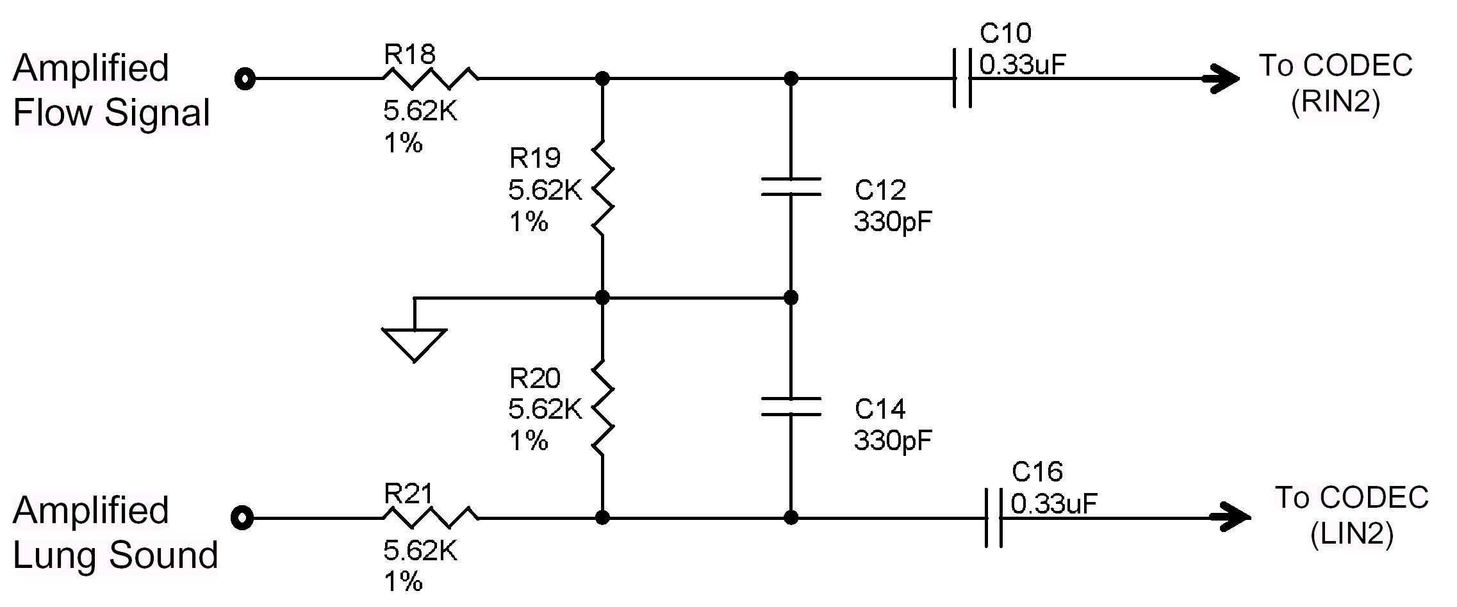

Figure 4.4 Input stage of the codec [26].

The codec right and left input pins (RIN2 and LIN2) normally accept 1 Vrms signal, but the voltage divider networks at the input will yield a full scale input sensitivity of 2 Vrms [26, 27]. This restriction was taken into account when determining the overall gains of the amplifiers used with the lung sound and flow signal. Schematic drawing for the codec’s input stage is given in Figure A.2 of Appendix A. The external appearance of the instrument is shown in Figures 4.5 and 4.6. A more detailed description of each part of the instrument is given in the following sections.
Restart
Select
Menu
LCD
Flowmeter
Microphone
Contrast
Volume
Figure 4.5 The respiratory sound classification system.

Figure 4.6 The internal structure of the device.
Amplifier Card
(upper floor)
DSP56311 EVM
(lower floor)
Power Amp.
4.2 Selecting the Desired Menu Item

Three push-buttons, connected to the external interrupt lines of the DSP, are used to select the desired function to be performed by the device (see Appendix A). By pressing the button connected to the DSP’s external interrupt D pin (IRQD), an interrupt service routine is executed by which the desired distance measure, to be used in the classification process, can be selected. By pressing the same button, the user may also choose to record a total of 64k lung sound samples (16 seconds) to the external memory found on the 56311 EVM. He has the option to listen to this recorded sound later. After pressing any button, the corresponding message that shows the currently selected menu item is displayed on the LCD.

The following menu items can be selected by pressing the button connected to IRQD (Menu button):

- Classify using k-nearest neighbor (Itakura ditance measure).

- Classify using k-nearest neighbor (Euclidean distance measure).

- Classify using k-nearest neighbor (city-block distance measure).

- Classify using minimum distance classifier (Mahalanobis metric).

- Start recording 16 seconds of lung sound to the external memory.

- Listen to the recorded sound.

- Apply digital filters on both of the lung and flow signals.

- Remove the digital filters.

A functional block diagram of the designed system showing all the menu items that can be selected by the user is depicted in Figure 4.7.

Figure 4.7 Functional block diagram of the system.
Flowmeter
Microphone
Windowing &
Autocorrelation
LPC Feature
Extraction
(Levinson-Durbin)
Minimum
Distance Classifier
k-nearest
neighbor Classifier

Majority
Voting
Itakura
Distance
Euclidean Distance
Mahalanobis
Distance
City-block
Distance
Amplification
& Filtering
& ADC
Digital FIR Filtering (optional)
Cycle
Labeling &
Segmentation
Power
Amplifier
Record Lung Sound
Decision
(Healthy or
Pathological)

Each of the above menu items was designated a flag. For example, the first menu item was designated a flag named ‘itakura_flag’, the second menu item was designated a flag named ‘euclidean_flag’ and so on. So, whenever the ‘Menu’ button is pressed then each flag representing the selected function is set and the other unselected flags are reset. After the user selects the desired function another push-button connected to the interrupt line IRQB (Select button) should be pressed. This button is used to inform the DSP that the selection of the MENU item is done and that it can execute the option displayed on the LCD screen. In other words, to initialize any function two flags should be set: the first one
represents the selected menu item (set by pressing the ‘Menu’ button) while the other shows that the desired function can be executed (set by pressing the ‘Select’ button). The status of these flags is continuously checked by the DSP, and whenever both of the flags are set at the same time the DSP interprets it as a valid menu selection and executes the option selected by the user. The flow diagram of the interrupt service routine that is executed by pressing the ‘Menu’ button is shown in Figure 4.8.

When the classification algorithm is finished and the diagnosis result is displayed on the LCD, the DSP enters the ‘Stop Processing State’ in which all the activity of the DSP is halted. This state is the lowest power consumption mode and is enabled after the execution of the STOP instruction. This mode can be exited by a low level signal applied to the IRQA pin of the DSP [23, 29]. So, this interrupt line was connected to a third push-button accessible by the user (Retest button). Whenever this button is pressed the DSP exits this standby mode and the program starts from the beginning, thus giving the chance to make a new test.

4.3 Recording the Lung Sound

Another feature that was added to this instrument is the ability to record a total of 64k lung sound samples at a sampling frequency of 8 kHz to the external fast static RAM (FSRAM) found on the DSP56311 EVM. In order to increase the duration of the recorded data, the sampling rate was reduced by decimation from 8kHz to 4kHz. Thus, the recorded data duration was increased from 8 seconds to 16 seconds. This recording process can be selected by pressing the push-button connected to the external interrupt D (IRQD) of the DSP. By pressing this button an interrupt service routine is executed. This routine is used to display all the menu items found in the device. After the desired selection is made, the desired function is initialized by pressing the push-button connected to the external interrupt pin B (IRQB). Similarly, the user may also choose to listen to this recorded sound later by choosing the appropriate menu item and pressing the same push-buttons.

The external FSRAM found on the DSP56311 EVM is a 64K ×24-bit asynchronous FSRAM (GS71024T-8) that uses a single 3.3 V power supply and has an access time of 8 ns. The basic hardware connection for the FSRAM is given in Figure 4.9.

Figure 4.8 The interrupt service routine that is executed by pressing the 'Menu' button.
Recording Flag
Set?
Clear ‘Mahalanobis Flag’
Interrupt Service Routine (IRQD)
Mahalanobis Flag
Set?
Clear ‘Recording Flag’
Clear ‘Mahalanobis Flag’
Yes
Yes
Clear ‘Remove Filter’ Flag
Set Recording Flag &
Display “Start Recording” Menu Item on the
LCD
Set Listening Flag &
Display the “Listen to Recorded Sound” Menu Item
Set Mahalanobis Flag &
Display the “Classify with Mahalanobis” Menu
Item
Return from the Interrupt Service Routine
......
...........
...........
No
No

The address pins of the DSP are connected to the corresponding address input pins of the FSRAM (A0-A15). The data input/output pins IO0–IO23 of the FSRAM are connected to the DSP56311 D0–D23 pins. The write enable (WE) and output enable (OE) pins of the FSRAM are connected to the DSP56311’s write enable (WR) and read enable (RD) lines, respectively [26].

A0-A15
D0-D23
AA0
RD
WR
DSP56311
A0-A15
IO0-IO23
CE1
OE
WE
FSRAM
Figure 4.9 FSRAM pin connections to the 56311 DSP [26].

As it is seen in Figure 4.9, the FSRAM chip enable (CE1) signal is generated by the DSP56311’s address attribute 0 (AA0) pin and the corresponding register AAR0. So, by programming the register AAR0, the accessed memory type and the external memory addresses that activate the FSRAM can be controlled. In this instrument, the AA0 pin was programmed so that the FSRAM responds to the 64K of Y data memory access between the addresses $040000 and $04FFFF. One wait state was also inserted so that the DSP can communicate with the relatively slower FSRAM.

The user may listen to the recorded lung sound through a speaker added to the instrument. He may also listen to the lung sounds in real time while being sampled by using headphones. A stereo 2x5 Watt audio amplifier kit was used to bring the output signal of the 56311EVM up to a suitable level to drive 4/8 Ω speakers. This module is based on the dual audio amplifier TDA2822M (ST Microelectronics) that may also be configured for bridged mono operation [30]. In this mode, TDA2822 has an in internal fixed gain of approximately 39 dB. Because of its wide supply voltage range (3 to 12 Vdc) this kit is well suited to portable battery operated audio applications and, depending on the supply voltage value, this module can deliver up to 5 Watt per channel into an 8 Ω speaker. The hardware schematic of the amplifier module is given in Figure 4.10. Using the potentiometer at the input, the input signal fed to the amplifier can be changed, thus forming a variable gain amplifier. The capacitors C3 and C4 are used to block the unwanted DC current from reaching the output connections. On the other hand, C9 is used for decoupling of the supply voltage. The resistors R1 and R2 are used to give predetermined output impedance sufficient for driving the speakers [31].

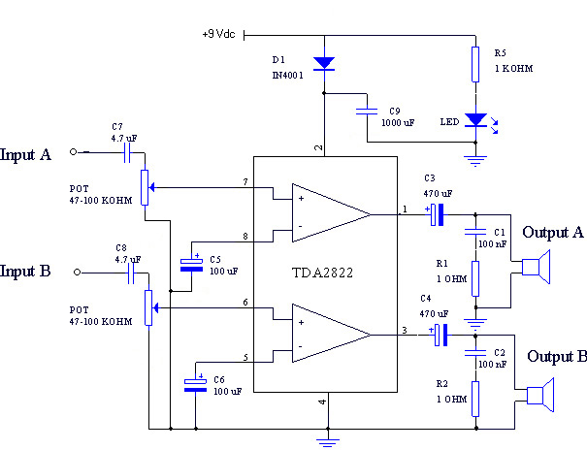
Figure 4.10 Hardware schematic of the stereo audio amplifier.

4.4 Finite Impulse Response (FIR) Filtering

Digital filtering is probably the most common application of DSPs. This comes from the fact that DSPs usually support modulo addressing capability that provides circular data buffers for the storage of the input sequence and filter coefficients. They also have multiply-and-accumulate instruction that multiplies two operands and adds the product to a third operand in a single instruction cycle. A data move capability, in parallel with this instruction, is also supported [21, 22].

Digital FIR filtering capability was added to this device. These filters can be applied or removed as needed by simply pressing push-buttons that are connected to the interrupt lines of the DSP. FIR filtering type was used due to the following well known properties of FIR filters [22]:
- They are guaranteed to be stable because they are all-zero filters (i.e., no feedback).

- They are always realizable.

- They can always be designed to have a linear phase response. This property is important in applications in which the signal shape and relative timing must be preserved. Any non-linear phase introduced by the filter may be damaging to breath sounds containing transient signals such as crackles [25].

4.4.1 FIR Filter Structure

The relationship between a FIR filter’s input sequence x(n) and output sequence y(n) can be written as:

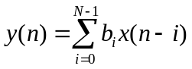, (4.1)

where b_{i} are the filter coefficients and N is the number of those coefficients. The impulse response of the ideal desired filter is infinitely long sequence, so in order to make this filter realizable this impulse response is multiplied by an appropriate window function that has a finite length [22].

4.4.2 The Enhanced Filter Coprocessor (EFCOP)

In this work, the Enhanced Filter Coprocessor (EFCOP) module found on the 56311 DSP was used to do the FIR filtering process. The EFCOP peripheral module functions as a general-purpose, fully programmable filter that can perform two basic types of processing: FIR filter type and IIR filter type processing. However, various sub-options are available with each filter type such as real and complex FIR filtering, adaptive FIR filtering, and multichannel FIR filtering [23].

4.4.2.1 EFCOP Programming for Multichannel Mode. In this work, two digital FIR filters were designed. The first one is a band-pass FIR filter with a bandwidth of 80-2,000 Hz used to filter the lung sound. The second is a FIR low-pass filter with a cut-off frequency of 50 Hz used to filter the flow signal. For this reason, the EFCOP was operated in multichannel mode that enables the processing of multiple, equal-length channels simultaneously. In this mode, the EFCOP expects to receive the samples for each channel sequentially. The applied filter may be chosen to be the same, or a different filter could be used for each channel where the coefficients of each filter should be stored sequentially in memory [23, 32]. The EFCOP uses two memory banks:

- Filter Data Memory (FDM): This memory bank stores input data samples that are going to be filtered by the EFCOP. Here the Data Base Address (FDBA) register is used as a pointer to this memory bank.

- Filter Coefficient Memory (FCM): This memory stores the desired filter coefficients, which are accessed using the Coefficient Base Address (FCBA) register.

Here it should be noticed that the filter coefficients, b(n), are stored in “reverse order,” where b(N-1) is stored at the lowest address of the FCM as shown in Figure 4.11 [22, 23].

b(N-1)
b(N-2)

b(N-3)

-

-

-

b(1)
b(0)

Coefficient
Memory
Bank
(FCM)
x(0)
x(1)

x(2)

x(3)

x(4)

x(6)

-
-

-

Data
Memory
Bank
(FDM)
Figure 4.11 Storage of filter coefficients and input samples in memory [23].

Due to the fact that this DSP is a fractional 24-bit machine, the most negative and the most positive coefficient values that can be represented are -1.0 and 1-2⁻²³=0.9999998, respectively [24]. This quantization of filter coefficients may result in a slight change in the true locations of the poles and/or zeros of the designed filter. This error is more serious in IIR filters than FIR filters. Thus, the stability and linear phase characteristics of FIR filters remain unaffected [21]. Fortunately, the filter coefficients that were calculated in this work have magnitudes less than one, which is compatible with the fractional fixed-point number representation used in this DSP. As a result, no scaling was applied on them and they were stored directly in the allocated memory of the DSP. The coefficients for both of the designed filters were obtained using the Filter Design and Analysis Tool of MATLAB 6.0 at a sampling frequency of 8kHz and using the windowing (boxcar) method. They have a ‘Direct form 2 transpose’ structure. The frequency responses of the designed low-pass and band-pass FIR filters are shown in Figures 4.12 and 4.13, respectively.

There are two filter channels and each channel has 256 coefficients. So, after determining the filter coefficients and storing them in the memory, these filters were implemented by configuring certain registers as follows:

- Set the number of channels to be used in Multichannel Mode by configuring the Filter Decimation/Channel Register (FDCR).

- The length of the filter coefficients minus one (255) was loaded to the filter count register (FCNT).

- The Data and Coefficient Base Address Pointers (FDBA, FCBA) were set so as to point to the circular buffers allocated for both of the filters.

- By configuring the control and status register (FCSR), the operation mode of the EFCOP was set for real data FIR filtering. Configuring this register also enables the multichannel mode.

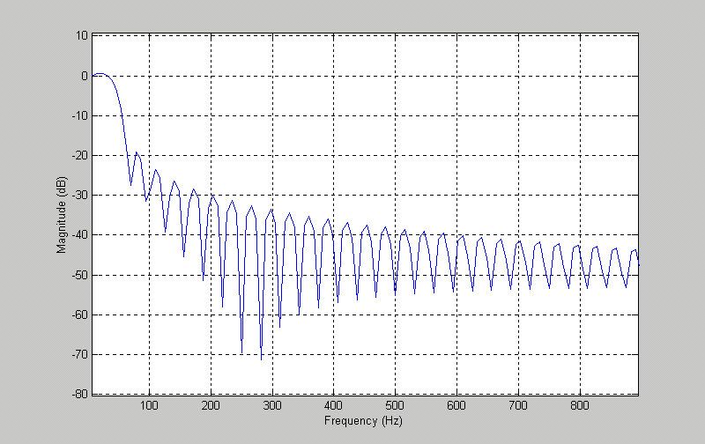
Figure 4.12 Frequency response of a FIR low-pass filter with a cut-off frequency of 50 Hz.

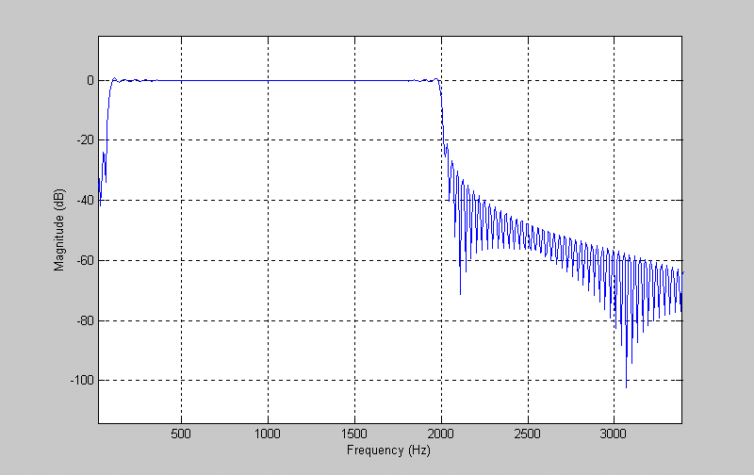
Figure 4.13 Frequency response of 256-coefficient band-pass FIR filter designed using the boxcar window.

To summarize, whenever a sample is to be filtered, it is written to the (FDIR). By polling certain status bits in the FCSR, the filtered sample is read from the Filter Data Output Register (FDOR). When the FDIR register is written with a new input sample, x(n), the EFCOP saves this sample while shifting the previous inputs down in the FDM, then it multiplies each input sample in the FDM by the corresponding filter coefficient Bi, stored in the FCM, and finally it accumulates the results of these multiplications and stores them in the FDOR. In Multichannel mode, the operation for FIR filtering is the same except that the EFCOP takes the input x(n–1) instead of x(n). This process is applied on each sample input to the FDIR for each channel separately [23, 32]. See Figure 4.14.

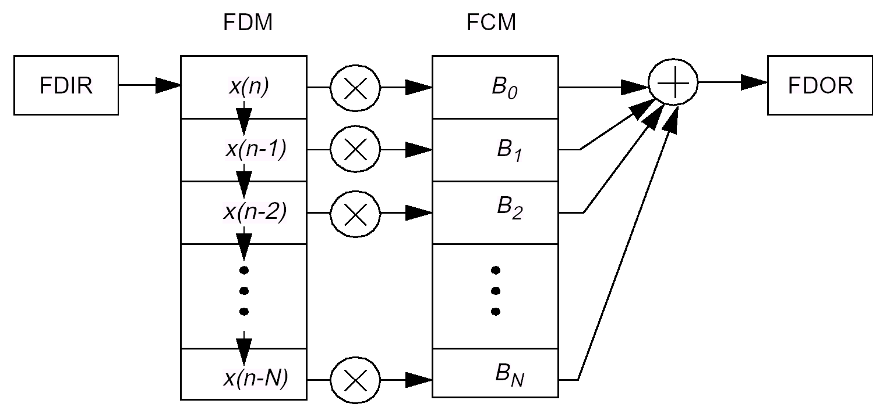
Figure 4.14 FIR filtering process of the EFCOP [23].

4.5 Memory Configuration

As was mentioned in Chapter 3, the separation of the memory space found in DSPs into a data memory and a program memory has the advantage of improving the speed of execution of signal processing algorithms. The DSP56311 can address three sets of high-speed SRAM memory internally. These are: Program (P), X data, and Y data memory. By configuring the memory switch mode found in the DSP, the user can easily reduce and reallocate the available two data memory spaces X and Y to the program memory, thus making it possible to increase or decrease each memory type as needed [23]. In this work, the default memory configuration was used. According to this configuration, the memory sizes and memory locations allocated for each memory type can be summarized as follows:

- Internal Program Memory: The on-chip program memory size is 32K x 24 words occupying the lowest 32K locations ($0 – $7FFF) in program memory space. Here the sign “$” denotes a hexadecimal value.

- Internal X Data Memory: The on-chip X data RAM size is 48 K x 24 occupying the lowest 48 K locations ($0 – $BFFF) in X memory space.

- Internal Y Data Memory Space: The default on-chip Y data RAM size is 48K x 24-bit occupying the lowest 48K locations ($0 – $BFFF) in Y memory space.

In addition to this internal memory, the 56311 EVM contains external FSRAM, which was programmed to respond to the Y data memory accesses between the addresses $040000 and $04FFFF. Figure 4.15 illustrates the memory spaces found in the DSP and how this memory was configured for the storage of the different coefficients and samples to be used by the instrument.

Figure 4.15 Memory map used for system implementation.
Y:$000002
Hamming Window Coefficients
(512 Words)
Y memory
Allocated for the Storage of Different Vairables to be Used in the Program
(A Maximum Space of 1023 Words)
Y:$000201
Band-pass FIR Filter Coefficients
(Lung Sound)
Low-pass FIR Filter Coefficients
(Flow Signal)
Y:$000600
The Final Calculated LPC Coefficients
(60*[lpc_order+2] Words)
The Final Calculated Autocorrelation Coefficients
(60*[lpc_order+1] Words)
Database of Pathological LPC Coefficients
(For k-NN Classifier)
Database of Healthy LPC
Coefficients
(For k-NN Classifier)

Database of Inverse Covariance Matrices
(For Min. Distance Classifer)
Database of Mean Featrue Vectors
(For Min. Distance Classifer)
Y:$0013C6
Y:$040000
External SRAM Used for Recording 16 Seconds of Lung Sound
(64 K Words)
Y:$00BFFF
.
.
Allocated for
the Storage of Flow Samples
to be Used in the Classification Process
Y:$000804
Y:$0013B8
P:$000000
Interrupt Vector Table for the 56311
P memory
Internal Program RAM
Allocated for the
Storage of the Software Used by the Device
(Maximum Space of 32 K Words)
.
.
.
P:$000100
P:$007FFF
Allocated for the Storage of Different Vairables to be Used in the Program
(A Maximum Space of 964Words)
X:$00023c
Circular Data Buffer for Storing Lung Sound Samples to be Filtered by the Band-pass Filter (256 Words)
X:$000600
Circular Data Buffer for Storing Flow Samples to be Filtered by the Low-pass Filter (256 Words)
X:$000700
X:$000000
System Stack Pointer
(100 Words)
X memory
Data Buffer for Temporary Storage of Windowed Lung Sound Segment
(512 Words)
Allocated for
the Storage of Lung Sound Samples to be Used in the
Classification Process
X:$000804
X:$00BFFF
Temporary Storage for the Calculated Autocorr. Values of Each Segment (lpc_order+1 Words)

4.6 Displaying Messages on the LCD

A liquid crystal display (LCD) module manufactured by Xiamen Ocular (GDM2004D) was used for displaying the menu options, diagnosis result and other messages that convey information regarding the current state of the system. This LCD is based on a standard KS0066 dot matrix controller and has 4 lines with 20 characters per line and it also has a yellow-green backlight led [33, 34]. The most common standard used in the vast majority of LCDs is referred to as HD44780U [35]. According to this standard, the interface between the LCD and the processor requires three control lines and four or eight data lines which is determined by the mode of operation selected by the user. In this instrument, 8-bit mode was selected, so each ASCII character to be displayed was sent as eight bits at a time. The three control lines are referred to as E, RS and R/W [36]:

- The E (Enable) control signal is used to tell the LCD that all the control and data signals are ready to be read. So, whenever any data are to be sent to the LCD, this signal is set high for a minimum of 220 ns and the other two control and/or data lines are modified as necessary, then the E signal is reset low again. This pulsing of the E pin tells the LCD to accept the data currently found on the control and data bus and interpret them as necessary.

- The RS (Register Select) is used to tell the LCD whether an instruction or data are being sent to it. When RS is low, then either an instruction is being sent (e.g. blink cursor, clear screen, ..) or the execution status of the last instruction is read back. On the other hand when RS is high, the value on the data bus is interpreted as a character that is displayed on the screen.

- Finally, when the control signal R/W (read/write) is low, the information on the data bus is being written to the LCD. When it is high, the program is effectively reading the LCD. In this instrument, nothing was read back from the LCD, so this signal was always kept low. The description of these signals and the other interface pins of the LCD are summarized in the Table 4.1.

Table 4.1
Interface pin connections of the LCD [33].
PIN NO. | SIGNAL NAME | DESCRIPTION
1 | VSS | Ground
2 | VDD | +5 V Power supply
3 | V0 | Contrast adjustment
4 | RS | Register select signal  “0”: Instruction register (when writing)  “1”: Data register (when writing and reading)
5 | R/W | Read/Write select signal  “0”: Writing  “1”: Reading
6 | E | Operation (data read/write) Enable signal
7-14 | DB0,…,DB7 | Data bus lines
15 | A | +4.2 V power supply for backlight
16 | K | Ground for backlight

4.6.1 DSP-LCD Hardware Configuration

The control and data lines of the LCD were connected to the Host Interface of the DSP (HI08). The HI08 is a byte-wide, full-duplex parallel port that can connect directly to the data bus of several industry-standard DSPs and microprocessors. Each of the 16 pins not used as an HI08 signal can be configured as a General Purpose Input/Output (GPIO) signal. In this mode each individual pin can be set/reset individually via software control, so this port provides a total of 16 pins that are fully programmable by the user (Port B). Three registers control the GPIO functionality of Port B: host control register (HCR), host port GPIO data register (HDR), and host port GPIO direction register (HDDR) [23].

The HDDR controls the direction of the data flow for each pin of this port. If any bit in this register is set then the corresponding port pin is configured as an output signal. In contrast, when it is cleared then it is configured as an input that can be read by the DSP. On the other hand, the HDR register holds the data values of the corresponding bits of the Port B signals. Since nothing was read back from the LCD, these pins were all configured
as an output whose values are determined by the value in HDR. Finally, after determining the bit setting for programming this port in GPIO mode, these registers were configured by writing these predetermined valued to them and this mode was enabled by configuring the appropriate bits in HPCR. The hardware interface between the DSP and the LCD is shown in Figure 4.16.

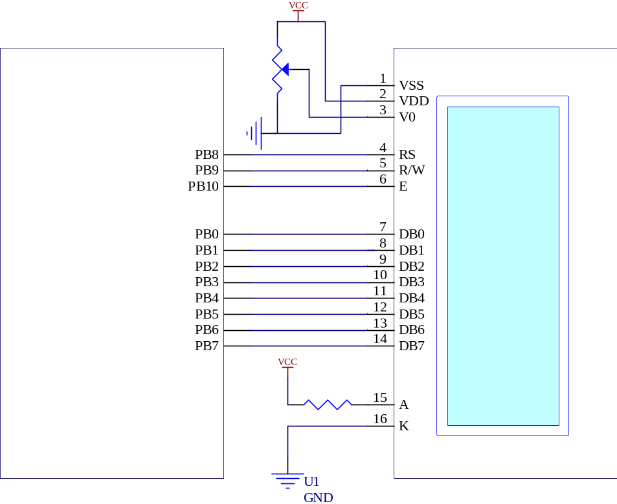
GND
3.9 Ω
10K
POT
LCD
Host Interface Port (HI08)
56311 DSP

PB0
PB1
PB2
PB3
PB4
PB5
PB6
PB7
PB10
PB9
PB8

Figure 4.16 DSP-LCD hardware interface.

4.6.2 Initializing the LCD

Before being able to display any character, the LCD should be initialized by a series of instructions. The initialization routine is used to set the interface length used to communicate with the LCD. It is also used to set the behavior of the cursor and its position in the screen [35]. The flow diagram of the initialization routine that was used in this project is depicted in Figure 4.17 [34-36].

After initializing the LCD and turning it on, it is now ready to display the messages on its screen. Each cursor position of the LCD has a unique address, therefore before displaying any character on the LCD, first the cursor position where we want to display the character should be determined then the desired character is written to that address.
Power ON
Wait more than 15ms after VDD rises to 4.5V
Wait more than 4.1 ms
Wait more than 100 μs
Initialization Complete

RS R/W DB7 DB6 DB5 DB4 DB3 DB2 DB1 DB0
0 0 0 0 1 1 - - - -

Function set-Unlock command (interface is 8 bits long)
RS R/W DB7 DB6 DB5 DB4 DB3 DB2 DB1 DB0
0 0 0 0 1 1 - - - -

Function set-Unlock command (interface is 8 bits long)
RS R/W DB7 DB6 DB5 DB4 DB3 DB2 DB1 DB0
0 0 0 0 1 1 - - - -

Function set-Unlock command (interface is 8 bits long)
RS R/W DB7 DB6 DB5 DB4 DB3 DB2 DB1 DB0
0 0 0 0 1 1 1 0 0 0

Function set command
- Interface is 8 bits long
- Character font=5x7 pixels
- Number of display lines=4
RS R/W DB7 DB6 DB5 DB4 DB3 DB2 DB1 DB0
0 0 0 0 0 0 1 0 0 0

- Turn the display OFF
- Turn cursor OFF
- Cursor blink OFF
RS R/W DB7 DB6 DB5 DB4 DB3 DB2 DB1 DB0
0 0 0 0 0 0 1 1 0 0

- Turn the display ON
- Turn cursor OFF
- Cursor blink OFF
RS R/W DB7 DB6 DB5 DB4 DB3 DB2 DB1 DB0
0 0 0 0 0 0 0 1 1 0

Entry Mode Set command
(sets cursor move direction)
- Increment the cursor after each character displayed
- Without display shift
Figure 4.17 LCD initialization sequence.

For this purpose, the LCD has a certain amount of memory called Display Data Ram (DDRAM) where the characters to be displayed are stored and read by the LCD [35, 36]. The memory map of LCD is given in Table 4.2. According to this table, if, for example, we want to display a character at the left hand corner of the last line, first the cursor is moved to the DDRAM address 54 hexadecimal by the instruction “Set DDRAM Address”. Next, the ASCII code of the character to be displayed is written to the data bus of the LCD and the E pin is pulsed to tell the LCD to accept and display these data.

Table 4.2
LCD display character addresses [33].
 |  | Display Position →
 |  | 1 | 2 | 3 | 4 |  | 18 | 19 | 20
DDRAM Address (Hexadecimal) | Line 1 | 00 | 01 | 02 | 03 | …….. | 11 | 12 | 13
DDRAM Address (Hexadecimal) | Line 2 | 40 | 41 | 42 | 43 | …….. | 51 | 52 | 53
DDRAM Address (Hexadecimal) | Line 3 | 14 | 15 | 16 | 17 | …….. | 25 | 26 | 27
DDRAM Address (Hexadecimal) | Line 4 | 54 | 55 | 56 | 57 | …….. | 65 | 66 | 67

Digital Sine Wave Generator

A digital sine wave oscillator was used to generate a beep sound that indicates the starting and ending time of some system functions such as system initialization, and end of recording. One method of sine-wave generation employs the idea of positive feedback. As is the case in an analog oscillator, a digital oscillator is implemented using a two-pole band-pass filter that satisfies the following difference equation [37, 38]:

. (4.2)

Here α is defined as follows:
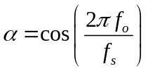, (4.3)

where f_{o} is the desired oscillation frequency, and f_{s} is the sampling frequency.

The starting values for the variables y and x and the coefficient α are determined so that they result in the desired frequency and phase. Then the oscillator uses these values to generate the next sine sample from the previous ones. The values of y[-1] and y[-2] are chosen as follows so that the first sample y[0] is initialized to the desired phase (φ), amplitude (A), and frequency [38]:

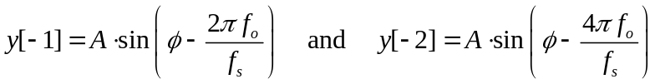 . (4.4)

This oscillator has the advantage of not consuming much memory space and processing power. However since it uses positive feedback, instability in the generated wave may occur [37]. This oscillator was used only to generate an audible sound for a short period of time, so instability was not a problem. The block diagram of this oscillator is shown in Figure 4.18.
Z⁻¹
α
-1
Z⁻¹

+
Oscillator
output
y
x
Figure 4.18 Block diagram of the digital sine wave generator [37].

AUTOREGREASSIVE MODELING

OF RESIRATORY SOUNDS USING DSP

Signal processing of biomedical signals requires the handling of large quantities of data. Quite often, these signals contain some redundancies that may be due to some built in redundancies, added noise, or the fact that the application at hand does not require all the information carried by the signal. For this reason, the first step for sophisticated processing of biological signals is data compression. Feature extraction is one method used for data compression, such that the computed features contain most of the relevant information while most of the redundancies are discarded. However, the computational cost and time required for the feature extraction process usually requires reducing the number of features as much as possible. Feature extraction using autoregressive (AR) modeling can be used in applications where the reconstructed signal has the same spectral characteristics as the original one [39].

5.1 Autoregressive Modeling

Autoregressive modeling techniques are widely used in speech processing due to the fact that the acoustic tube model responsible for speech production can be described accurately by an all-pole model. Even in applications that cannot be justified by an all-pole model, it has been shown that such models can provide sufficiently accurate information regarding the problem at hand [40]. Furthermore, the popularity of this model stems from the fact that such modeling will result in a unique equation structure that can be solved via efficient and fast algorithms, which is an attractive property if such an algorithm is going to be implemented in real-time using a DSP.

In order to perform a reliable AR modeling of a signal, the signal should be nonperiodic with a Gaussian distribution, its mean should be stable, and its variance time-invariant [4]. In general, a practical approach for AR analysis can be summarized as follows [14]:

- Select the number of samples (N) to be analyzed.

- Make an educated guess of model order (p) that results in the smallest prediction error variance.

- Calculate the p AR parameters.

- If needed, adjust p, and go to step 3 (order estimation problem).

- If needed, adjust the sample size N, and go to step 2 (sample size problem).

- Verify that the signal is indeed an AR signal, such that the resulting prediction error is a white noise (model validation problem).

Autoregressive modeling of lung sounds was found to be useful in the estimation of both the source and transmission characteristics of these sounds. Here, the lung sounds generated inside the airways of the lung are assumed to be the input of an all-pole filter that models the transmission of these sounds through the parenchyma and chest wall (see Figure 5.1). It is also assumed that additive Gaussian noise, resulting from the instrumentation, muscle, and skin, are added to these sounds during their transmission to the chest wall. Taking this model into account, it is clear that the recorded lung sounds on the chest can be modeled by finding the coefficients of this all-pole filter [16, 17].

Source of Lung Sounds
+
Heart Sounds
All-pole
Filter
Muscle & Skin Noise
Instrumentation Noise
Recorded Lung Sounds
+
Figure 5.1 All-pole modeling of lung sounds [17].

5.2 Linear Predictive Coding (LPC)

Autoregressive modeling can be explained in terms of another equivalent method known as linear predictive coding (LPC). LPC is a modeling technique in which a weighted sum of the p previous samples are used to predict the current value of the random process 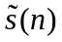, such that

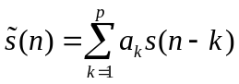, (5.1)

where p is the model order, and the coefficients a₁, a₂,...,a_{p} are the prediction coefficients used to predict the next input sample. By taking the excitation term Gu(n) into account, the above equation can be written in the form

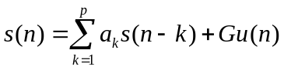, (5.2)

where u(n) is a normalized excitation and G is its gain. By taking the z-transform of Equation 5.2, the transfer function of this filter in terms of the prediction coefficients a_{k} becomes in the form of an all-pole filter

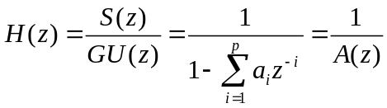 . (5.3)

So, the problem of linear prediction becomes determining the coefficients a_{k} that minimize the mean-squared prediction error over a short segment of the signal, thus resulting in an all-pole filter that has spectral characteristics similar to those of the analyzed signal. Here, the prediction error e(n) is defined as the difference between the actual sample s(n) and predicted one , that is
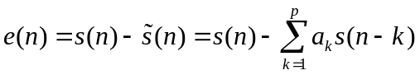. (5.4)
The values of a_{k} are found by minimizing the mean squared error
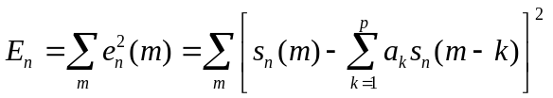. (5.5)

Equation 5.5 is minimized by differentiating E_{n} with respect to each a_{k} and equating the result to zero,

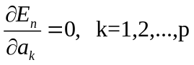. (5.6)

This results in the following set of equations
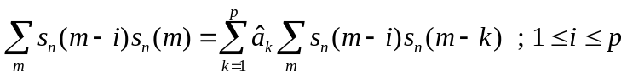. (5.7)

The term 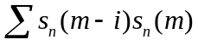 represents the short-term covariance φ_{n}(i,k) of s_{n}(m). So, Equation 5.7 can be written as in the following compact form, in which p unknowns are described by p equations:

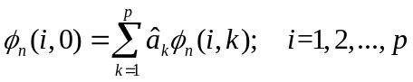. (5.8)

The range of the signal samples to be used in the analysis determines greatly the method by which Equation 5.8 is solved. When s(n) is only known over a finite interval [0,N], then the sum of the squares of e(n) can not be minimized over any interval outside [0,N], unless some restrictions are made on s(n) values outside this interval. Two standard methods are typically used when all-pole modeling a signal over a finite interval: the autocorrelation and the covariance methods [41]. In the autocorrelation method a data window is applied to s(n), thus ensuring that our signal is set to zero outside the interval [0,N]. On the other hand, in the covariance method no window is applied and the LPC coefficients are found by minimizing an error that does not depend on s(n) values outside the interval [0,N]. As a result, the covariance method results in a more accurate model than the autocorrelation method. But unlike the covariance method, the all-pole model generated by the autocorrelation method is guaranteed to be stable. Furthermore, the autocorrelation method results in normal equations that can be solved efficiently. So, this method was preferred here and its theory is discussed in more detail in the next section.

5.2.1 LPC Estimation Using the Autocorrelation Method

When we assume that the signal segment is zero outside the interval 0≤m≤N-1, then this is equivalent to multiplying the original signal s(m+n) by a finite length window w(m), such that

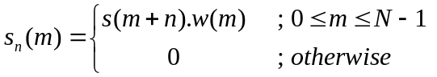 . (5.9)

As a result, the mean-squared error of this new weighted signal will be

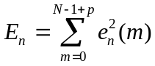. (5.10)

Assuming that our samples are wide-sense stationary (WSS), the covariance function φ_{n}(i,k) reduces to the simple autocorrelation function that depends only on the time lag (i-k)

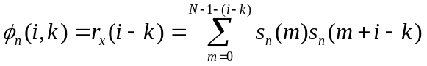. (5.11)

Using the property r_{x}(-k)=r_{x}(k), the LPC equations can be written in the form

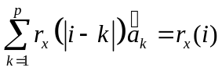. (5.12)

The set of equations in the form of Equation 5.12 are known as the Yule-Walker equations and they arise often in minimum mean square problems [40, 41]. These equations can be represented in the matrix form 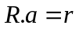, such that

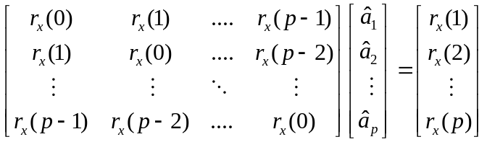 . (5.13)

It is clear from Equation 5.13 that to find the vector of prediction coefficients the inverse of the matrix R is needed, so that 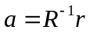. Fortunately, the Toeplitz structure (equal values along each diagonal) of the autocorrelation matrix R leads to normal equations that can be solved using iterative efficient methods such as the Levinson-Durbin algorithm.

5.2.1.1 Levinson-Durbin Algorithm. As was discussed in the previous section, all-pole modeling of stochastic processes requires finding the solution to a set of normal equations of the form R.a=b, where R is a Hermitian Toeplitz matrix of autocorrelation values r_{x}(0), r_{x}(1),..., r_{x}(p-1). The most efficient method for solving such equations is the Levinson-Durbin algorithm, which is described by the equations given in Table 5.1.

The Levinson-Durbin algorithm is considered to be recursive in the model order, which means that the solution to the (j+1)st-order equations are found by solving the normal equations that belong to the jth-order model. As it can be seen from the set of equations in Table 5.1, the first step in the recursion is to initialize it with the zeroth-order solution in which the prediction error between the actual input and predicted input of the jth-order model, E^{(j)}, is initialized with the autocorrelation value at lag zero, r(0). After that, the equations at step 2 are solved recursively for i=1,...,p, where the coefficients of the (j+1)st-order model, α_{i}^{(j+1)}, are found from the coefficients of the jth-order model, α_{i}^{(j)}, using the Levinson order-update equation. On each pass of the recursion, a new coefficient, known as the Parcor (partial correlation) or the reflection coefficient, k_{i,} is found and this value is used to recalculate the new prediction coefficients for that specific

Table 5.1
The Levinson-Durbin algorithm.
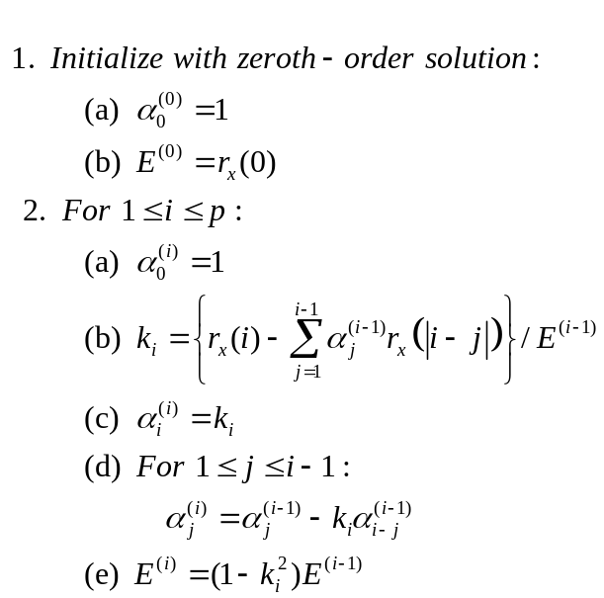

model order and used later in the next pass of the recursion [40, 41]. The final solution of this recursion will be:

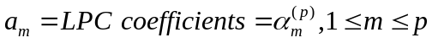. (5.14)

The efficiency of the Levinson-Durbin algorithm can be explained by looking at its computational complexity for solving the p linear equations with p unknowns. The total number of multiplications and divisions is equal to (p²+2p), while the number of the required additions is equal to p². It should be pointed out that despite this efficiency, the computational load of this recursion is usually determined by the process of finding the autocorrelation values r_{x}(0), r_{x}(1),...,r_{x}(p). For a signal of length N, this process requires approximately N(p+1) multiplications and additions. In this work, the segment length and the model order were chosen as 512 and 6, respectively. Since N>>p, the computational cost was determined greatly by the autocorrelation calculation process, which requires about 3584 multiplications and additions. Another advantage of this recursion is the fact that it requires relatively small amount of memory for the storage of the autocorrelation sequence and the calculated error and LPC coefficients, namely about 2(p+1) memory locations [40].

5.3 Calculating the LPC Coefficients Using a Fixed-Point DSP

5.3.1 Windowing Process

During the analysis of the autocorrelation method, it was mentioned that the type of window used was a rectangular one, but in this case there will be a potential of getting relatively large prediction errors at the boundaries of the windowed signal corresponding to m=0 and m=N-1. For example, in region m=0 we are trying to predict the signal s_{n}(m) from previous samples most of which are zero. While in the region of m=N-1 there is another potential of making an error because we are trying to predict a windowed (zero-valued) sample from some non-zero previous samples. For this reason, a window with a taper is often used instead of a rectangular one [41]. The most popular window used with the autocorrelation method of LPC calculation is the Hamming window, which is defined by the following equation:

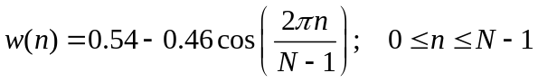, (5.15)

and the resulting windowed signal frame will be in the form:

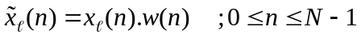. (5.16)

In this work, a Hamming window of length 512 was employed. The coefficients of this window were found using MATLAB 6. Fortunately, these coefficients were found to be in the range [-1,+1), so no scaling was applied on them and they were stored directly in the Y memory of the DSP. Since no scaling was applied, the quantization error can be neglected. On the other hand, the data array containing the lung sound samples to be windowed is stored in the X memory of the DSP. This organization of the memory was intended so as to take advantage of the parallel structure of the DSP, in which the data sample and the corresponding window coefficient are fetched at the same clock cycle in which a multiplication of a previous sample is performed.

5.3.2 Calculating the Autocorrelation Coefficients

The Levinson-Durbin algorithm needs the autocorrelation sequence of the segment under test. So, the autocorrelation function of each segment 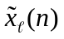 consisting of 512 windowed real data samples is estimated according to the following equation:

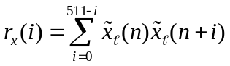. (5.17)

Since each autocorrelation value requires a relatively large amount of multiplications and additions, there is a risk of getting an overflow. The dynamic range of the 56-bit accumulators A and B of the DSP can accommodate such values but the problem will occur when storing these results in 24-bit memory locations. One way to get around this problem is to benefit from the fact that the maximum autocorrelation value will occur at lag zero, r(0). So, the autocorrelation coefficients of each frame are computed in the accumulator, then they are normalized by r(0) so that they all have values in the range ±1, which is compatible with fractional number format of the DSP [42]. Normalization is done using the NORM instruction. When a value is normalized, it is actually split into two parts: exponent e₀ and mantissa m₀. So, r(0) will be represented as follows

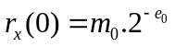. (5.18)

The mantissa is the value that was always used and it is always in the range 0.5≤m₀<1. The resulting exponent value was used only as the amount of shifts that is applied to each of the other calculated autocorrelation values before moving them from the accumulator to the memory. It should be mentioned here that this scaling would not affect the value of the LPC coefficients found using the Levinson-Durbin.

5.3.3 Fixed-Point Implementation of Levinson-Durbin Algorithm

The calculated LPC coefficients are not guaranteed to be in the range [-1,+1), so proper scaling should be applied where necessary in order to prevent internal overflows.
By examining the LPC coefficients of previously recorded lung sounds, a scale down value of 1/8 was found to be adequate to represent the LPC coefficients in the fractional number format without overflow. As a result, Levinson-Durbin algorithm was modified so as to include this scaling. The modified equations are given in Table 5.2 [42]. It should be mentioned that the all-pole model order used in this work was chosen as 6 [43]. So, each respiratory cycle, divided into 60 frames, required the calculation of 6x60 autocorrelation coefficients followed by the calculation of another 6x60 LPC coefficients. Then, these coefficients are stored sequentially in DSP’s memory to be used later in the classification process.

Table 5.2
Levinson-Durbin algorithm modified for DSP implementation [42].
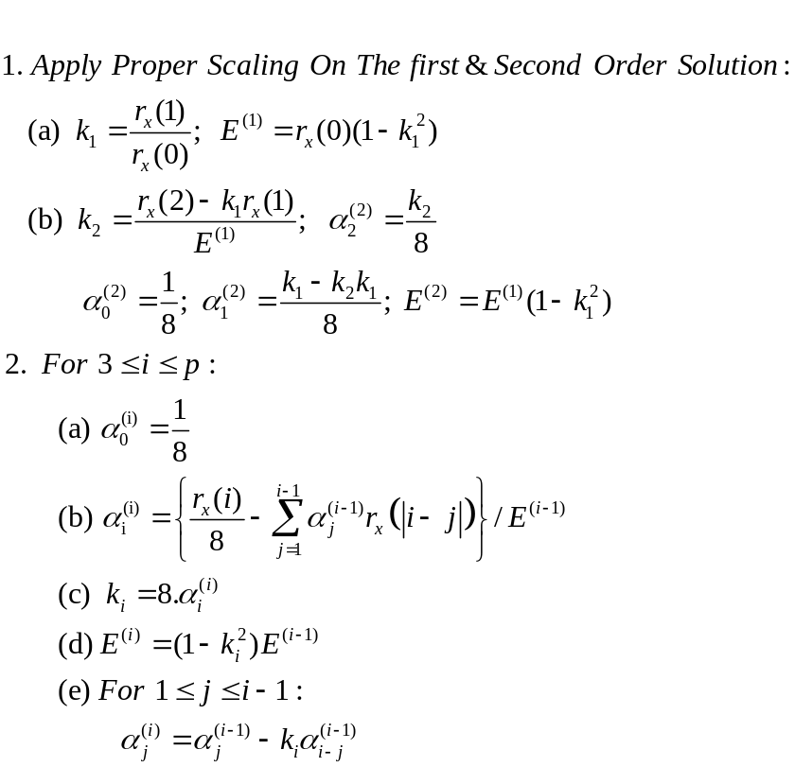

6. PATTERN CLASSIFICATION

6.1 Bayes Decision Theory

The two-category classification problem can be explained with probabilistic terms using the Bayes decision theory [44]. According to this theory, it is assumed that all the necessary probability values relevant to the decision problem are known. Let us use ω_{i} to denote the state of nature, with ω=ω₁ representing healthy and ω=ω₂ representing pathological lung sound. Since the state of nature is unpredictable, ω_{i} is considered to be a random variable. It is assumed that there is some a priori probability P(ω₁) that the next segment to be classified is healthy, and some a priori probabiltiy P(ω₂) that it is pathological. Using the value of the a priori probabilities, the following decision rule for determining the class of the segment seems reasonable, where the unknown vector is assigned to the class of highest probability, that is: Decide ω₁ if P(ω₁)> P(ω₂); otherwise decide ω₂.

Such a decision rule may not always give a right answer. For example, if P(ω₁)=P(ω₂), then we have only a fifty-fifty chance of being correct. In practice, a classification should not be made with so little information. So, a feature vector x extracted from the segment to be classified can be used to make a better decision. Let the density function p(x|ω_{j}) denote the probability density function for x given that the state of nature is ω_{j}. When the feature vector x of the segment to be classified is known, the conditional probability that this signal belongs to the jth class is provided by Bayes Rule:

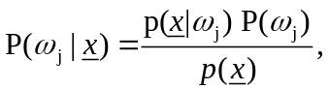 (6.1)

where

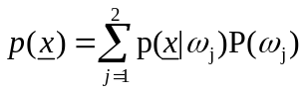. (6.2)
According to this rule, observing the feature x changes the a priori probability P(ω_{j}) to the a posteriori probability P(ω_{j}|x), which is the probability of class ω_{j} having observed vector x. So, the Bayes decision rule for minimizing the probability of error becomes: Decide ω₁ if P(ω₁| x)>P(ω₂| x); otherwise decide ω₂.

Now, upon observing a certain vector x, let us decide taking the action α_{i}. Then the loss, or punishment, λ(α_{i},ω_{j}) will be encountered if the true state of nature is ω_{j}. If the true state of nature is ω_{j} and the action taken is α_{i}, then our decision will be correct only if i=j. The expected loss (conditional risk) resulting from taking action α_{i} will be:

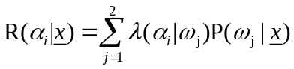. (6.3)

As a result, the optimal Bayes decision procedure can be stated as selecting the action which minimizes the conditional risk R(α_{i}|x).

Pattern classifiers can be represented in terms of a set of discriminant functions g_{i}(x), i=1,...,c. So, the feature vector x is assigned to the class ω_{i} if g_{i}(x)>g_{j}(x) for all j≠i. According to this representation, the classifier can be viewed as a machine that calculates c discriminant functions and selects the class that refers to the largest disciriminant value (Figure 6.1).

This machine will naturally represent a Bayes classifier when g_{i}(x)=-R(α_{i}|x) because a maximum discriminant function will correspond to a minimum conditional risk. On the other hand, if the discriminant function is chosen as g_{i}(x)=P(ω_{i}|x), then this machine will represent the Bayes classifier that satisfies the minimum-error-rate case, where the maximum discriminant function corresponds to the maximum a posteriori probability.

g₁
g₂
g_{c}
.
.
.

maximum
x₁
x₂
x_{c}
.
.
.

Decision
Feature
Vectors
Maximum Selection
Discriminant Functions
x
Figure 6.1 Block diagram of a pattern classifier [44].

If f is defined as a monotically increasing function, then replacing g_{i}(x)with f(g_{i}(x)) will not influence our decision. This f function can be chosen in order to simplify the analysis of the discriminant function without changing the decision rules. Here, the decision rule is used to divide the feature space into c decision regions (ℜ₁,..., ℜ_{c}) that are separated by surfaces in the feature space called decision boundaries. If we choose f as the natural logarithm function, then the minimum-error rate classifier’s discriminant function will be in the form

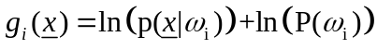. (6.4)

If we assume the functions p(x |ω_{i}) are distributed according to the multivariate normal density function, which is a good approximation of many natural processes, then Equation 6.4 will become

, (6.5)

where μ is the d-component mean vector, and ∑ is a dxd covariance matrix.

6.2 Minimum Distance Classifier

Let us examine Equation 6.5 under the following two special cases:

1) When the features are statistically independent with each feature having the same variance σ², then the simplest case occurs where the covariance matirx becomes equal to σ² times the identity matrix, ∑_{i}=σ²I. Since the inverse of ∑_{i} is simply equal to (1/σ²)I, then the discriminant function becomes equal to:

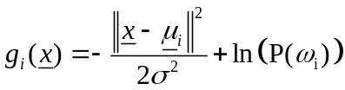. (6.6)

If we assume the a priori probabilities P(ω_{i}) to be the same for all of the c classes, then the second term in the right side of Equation 6.6 is ignored and the optimum decision rule simplifies to the calculation of the Euclidean distance ║x -μ_{i}║from x to each of the c mean vectors. This kind of classifier is called minimum distance classifier where the samples fall in hyperspherical clusters centered about the mean vector μ_{i} (Figure 6.2).

Decision Boundary
Feature Vector x
d₂
d₁
ℜ₁
ℜ₂
μ₁
μ₂
x₂
x₁
Figure 6.2 Decision boundaries of the minimum Euclidean-distance classifier [44].

Minimum distance classifiers are preferred in cases where the classes are well clustered and separated from each other. Here, each class is represented by template μ_{i}, and the classification is performed based on the proximity of the vector to be classified to these templates.

2) When the covariance matrices for all of the classes are equal, then the samples will fall in hyperellipsoidal clusters (Figure 6.3). This will result in the following discriminant function:

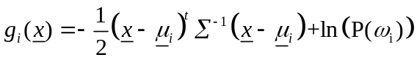. (6.7)

Assuming that the a priori probabilites are the same for all the classes, then the classifier will simplify to measuring the squared Mahalanobis distance (x-μ_{i})^{t}∑⁻¹ (x-μ_{i}) from x to each of the c mean vectors and assigning x to the class of the nearest mean.

Feature Vector x
ℜ₂
μ₁
μ₂
x₂
x₁
ℜ₁
d₁
d₂
Figure 6.3 Decision boundaries of the minimum Mahalanobis-distance classifier [44].

Decision Boundary

The Euclidean distance has the drawback of giving equal importance to each of the samples in the features space. If some a priori information regarding statistics of the problem at hand is known, then we can place weights on the features. For example, the features having large variances are considered to be less reliable. For this reason, the Mahalanobis distance measure was preferred in this work, where the weights are inversely proportional to the features covariance matrix. In other words, the Mahalanobis distance differs basically from the Euclidean distance in that the data is scaled according to the shape of the statistical density, so that the distance represents the number of standard deviations away from the mean. However, the covariance matrices can be hard to determine accurately, and the memory and time requirements grow quadratically rather than linearly with the number of features, which can become quite serious when the number of features become large.

K-Nearest Neighbor (K-NN) Classifier

Using the same feature vectors, the standard Bayes classifier is considered to be the optimum classifier because it results in the optimal decision procedure and the corresponding minimum probability of error while classifying the input patterns.

As it is seen from Equation 6.1, the ideal Bayes classifier requires that the a priori probabilities and probability density functions of all patterns are known. But since this is not always possible in most practical cases, these probabilities should be estimated directly from the sample patterns using nonparametric decision procedures such as the nearest-neighbor rule that bypasses probability estimation and instead estimates the decision functions.

Let us suppose that n samples x₁,x₂,..,x _{n} are independently drawn according to the probability law p(x), then we must estimate the a posteriori probabilities P(ω_{i}|x) from these labeled samples. To estimate the density p(x) at x, the regions ℜ₁, ℜ₂,.. around x are formed, such that the first region contains one sample, the second contains two samples, and so on. Let V_{n} denote the volume of ℜ_{n}, and k_{n} the number of samples captured by ℜ_{n} (see Figure 6.4). Then the nth estimate for p(x) will be
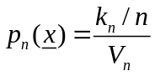. (6.8)

Vector to be classified
Pathological
(ω₂)
Healthy
(ω₁)
V₁
V₅
V₁₁
Figure 6.4 The principle of k-nearest neighbor classification.

One way of ensuring that p_{n}(x) converges to the desired p(x) is to determine k_{n} as some function of n such as k_{n}=(n)^{1/2}. Thus, the volume of the cell V_{n} is grown until it captures k_{n} neighbors of x. This is called k-nearest neighbor (k-nn) estimation method in which x is classified by examining the categories of the nearest neighbors and taking a majority vote. Thus, k-nn can be viewed as a method that tries to estimate the a posteriori probabilities P(ω_{i}|x) from data.

In other words, when we try to capture k samples by placing a cell of volume V around x, then k_{i} samples of this k will may be found to belong to the class labeled ω_{i}. In this case, the joint probability p(x, ω_{i}) will be estimated as:

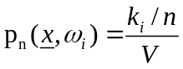. (6.9)

Then, the a posteriori probability that ω_{i} is the state of nature will be equal to the fraction of samples in the cell having the label ω_{i}:
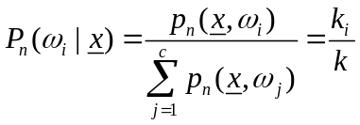 . (6.10)

To have minimum error rate while classifying, the category that is most frequently represented within the cell should be chosen [39, 44].

When it comes to the selection of k value, it should have a large value so as to obtain a reliable estimate. At the same time, we want all of the k neighbors to be very close to x. So, k should be much more smaller than the size of feature space occupied by the smallest class. That is, if p is the minimum of the number of vectors contained in each of the training set classes, then k should be selected in the range 1<k<<p, taking into account that as k increases computational costs also increase [45].

7. RESULTS AND DISCUSSION

7.1 The Classification Algorithms

By pressing the Menu button located on the front panel of the instrument, the user may choose to perform the classification process using either a k-NN (with k=5) based classifier or a minimum distance based classifier. The instrument provides the user with the option of choosing different distance measures with the k-NN classifier. These are the Itakura, Euclidean, and city-block distance measures. The minimum distance classifier, on the other hand, is based on the quadratic Mahalanobis distance measure.

7.1.1 The Storage and Segmentation of Respiratory Data

A single respiratory cycle is used for each subject and only data that correspond to flow rates above a threshold of ten per cent of the maximum flow signal value are needed for the classification process. Therefore, whenever the user selects one of the classifiers, the instrument starts to wait for the patient to start breathing through the flowmeter so as to store flow and lung sound samples that correspond only to one respiratory cycle. Consequently, The DSP was programmed so that it can detect the starting and ending time of one full respiratory cycle. As soon as this cycle is detected, the system starts storing the respiratory sound and the corresponding flow signal. To prevent the storage of false cycles resulting from noise or even from the nature of the flow signal itself, inspiration or expiration phases lasting shorter than 0.6 second are ignored (<5000 samples). Furthermore, to prevent the device from being triggered by noise, positive and negative threshold values are applied on each sampled flow signal (Figure 7.1). If the sampled flow is within these threshold values then this sample is considered to be noisy and it is rejected. Another threshold value is applied on the stored flow samples, thus only data corresponding to flow rates above a threshold of ten per cent of the maximum flow signal value are used in the classification process.

The time the user of the device starts breathing through the flowmeter is not ensured to be the beginning of an inspiratory phase. So, if the first sampled flow signal belongs to an expiratory phase, the device waits until it detects the first sample in the following inspiratory phase then it starts recording.

Positive
Threshold
Inspiration
≥ 5000 sample
Expiration
≥ 5000 sample
Negative
Threshold

Figure 7.1 The parameters used by the device to identify the waveform of a flow signal.

On the other hand, if the first sampled flow signal belongs to an inspiratory phase, the device skips over this phase and the following expiratory phase and starts recording the flow and lung sounds that belong to the next respiratory cycle. By this way it is ensured that a full respiratory cycle is stored and that no sample at the beginning of the inspiratory phase is missed. Thus, in the worst case, the device requires two respiratory cycles before it starts the execution of the classification algorithm. The flow diagram of the software that was used to skip over the undesired respiratory phases and/or noise is given in Figure 7.2. According to this algorithm, a flag named ‘synch_flag’ is polled to see if it is the beginning of the desired inspiratory phase. If synch_flag is set then this shows that we have passed over the undesired inspiratory and/or expiratory phases and that from now on we can store the inspiratory then the expiratory flow/lung samples that constitute a full respiratory cycle. The flags insp_flag and exp_flag are used to track the current status of the flow signal being sampled. These flags are set only if a real respiratory phase, lasting longer than 0.6 s, is detected. The variables pos_sample and neg_sample are used to count the number of inspiratory and expiratory flow samples keeping their sign without change over consecutive flow samples, respectively. So, by checking these variables it is possible to determine whether real or false cycles are being sampled. If it turns out that a false cycle is sampled then the device ignores that cycle and the same process is started over again.
Yes
No
Increment
‘neg_sample’
Get New Flow Sample
Noisy Flow Sample? (Threshold Test)
Start Storing
Is ‘synch_flag’
Set?
Is Flow
Positive?
neg_sample=0
Increment
‘pos_sample’
neg_sample<5000 ?
Are ‘insp_flag’ & ‘exp_flag’ Set?
Set
‘synch_flag’
Start Storing
Clear ‘insp_flag’, ‘exp_flag’, & ‘synch_flag’

pos_sample=neg_sample=0

pos_sample<5000 ?
Set
‘insp_flag’
pos_sample≥5000 ?
pos_sample=0
Set
‘exp_flag’
neg_sample≥5000?
Yes
No
No
Yes
Yes
No
No
Yes
No
No
Yes
Yes
No
Yes

Figure 7.2 Flow diagram of the DSP software used to skip over noise and the undesired respiratory phases.
After skipping the undesired phases, the recording of the desired flow and the corresponding lung sound is started (Figure 7.3). If a false cycle is encountered, the stored samples that correspond to this false cycle are ignored. This process is repeated until these samples are overwritten by the samples that belong to the true respiratory cycle. The flag continue_storing is used to show whether the samples that belong to the inspiratory phase are stored or not. For example, if it is reset then this shows that we have stored the desired inspiratory flow/lung samples, and that only expiratory samples should be stored from now on.

The status of the recording process is reflected in real-time to the user using three light-emitting diodes (LEDs) located on the front panel of the instrument. While the first LED indicates that the breath sounds belonging to the inspiration phase are being stored, the second one shows that the data belonging to the expiration phase are being stored. The third LED blinks whenever the storage process has ended, thus informing the patient that he can stop breathing through the flowmeter. These LEDs are connected to the output pins of the timers found in the DSP56311 internal triple timer module. By configuring the registers of these modules each timer’s output can function as a GPIO signal that can be set/reset by software control. The timer output pins TIO0 and TIO2 of this module were configured in this mode and they were connected to the first and second LEDs, respectively. The timer output pin TIO1 is configured to generate pulses at a predetermined frequency, thus causing the LED connected to it to blink at a rate that can be perceived by the user.

The stored respiratory cycle is divided into six distinctive sub-phases according to the information they bear and the different mechanisms that generate them: early, mid, late inspiration, and early, mid, late expiration sub-phases. Each respiratory sub-phase is further divided into ten 25 per cent overlapping segments. So, after calculating the starting and ending addresses of each sub-phase, this information is used to find the starting address and number of samples in each segment. The starting and end addresses of these sub-phases are determined according to the airflow volume calculated by integrating the stored inspiratory and expiratory flow samples separately.

Get New Flow Sample
Is it Noisy?
(Threshold Test)
Is Flow
Positive?
pos_sample <5000 ?
‘insp_flag’
Set?
Clear ‘continue_storing’
neg_sample ≥5000?

‘continue_storing’
Set?
Storage Ended
Store Insp. Lung/Flow Samples
Increment ‘pos_sample’
Set
‘insp_flag’
Store Exp. Lung/Flow Samples
Increment ‘neg_sample’
False Insp. Cycle Stored
Yes
No
Yes
Yes
No
No
Yes
No
Yes
Yes
No
Clear ‘insp_flag’
pos_sample=0
Clear insp_flag
pos_sample=neg_sample=0
Update Memory Address Pointers so that the Wrong Samples Could be Overwritten with the Correct Ones
Update Memory Address Pointers so that these Wrong Samples Could be Overwritten with the Correct Ones
neg_sample=0
False Exp. Cycle Stored
Start Storing
No

Figure 7.3 Flow diagram of the software used to store sound and flow samples corresponding to a full respiratory cycle.
Since the stored flow samples are scaled down by a factor of 256 (by shifting right eight bits), the summation of these samples is guaranteed not to generate an internal overflow in the accumulator of the DSP. Furthermore, the DSP is a 24-bit machine and the word length of the codec used to sample the flow signal is 16-bits, therefore this scaling of the sampled flow signal does not result in any truncation error. Here, the early, mid and late inspiration/expiration phases correspond to intervals contributing to the first 30 per cent, next 40 per cent and the last 30 per cent of the total inspiration/expiration air flow volume. Figure 7.4 shows the process of finding the ten 25 per cent overlapping segments from each sub-phase of the stored full respiratory cycle, thus resulting in a total of 60 segments from which the linear predictive coding (LPC) coefficients are extracted and used in the classification process.

The algorithm used to divide the area between each sub-phase into ten 25 per cent overlapping segments can be summarized in the following steps:

- The total number of samples in the sub-phase to be segmented is calculated.

- To find the number of samples in each of the ten 25 per cent overlapping segments, the number found in step 1 is divided by eight (by shifting right three bits) and the result is stored in the variable "x:segment_length".

- To calculate the number of the 25 per cent overlapping samples, the result found in step 2 is divided by four (by shifting two bits right) and stored in the variable "x:overlap_length".

- Store the calculated starting addresses and number of samples per segment in the array "x:segments_info", which consists of ten value pairs. The first element in each pair is the starting address of the segment, while the second value is the number of samples in it.

Late
Expiration
51,52,.........,60
Early Inspiration
Inspiration
Expiration
1,2,3,..........,10
Late
Inspiration
Mid
Inspiration
% 30
% 40
% 30
% 30
% 40
% 30
Early
Expiration
Mid
Expiration
21,22,.........,30
31,32,.........,40
11,12,.........,20
41,42,........,50

Figure 7.4 The process of finding the ten 25% overlapping segments from each sub-phase of the stored full respiratory cycle.

7.1.2 Classification with K-NN Classifier

The k-NN classifier is implemented using three different distance measures: Itakura, Euclidean, and city-block distance measures [46]. All these measures require finding the LPC coefficients of each segment to be classified. Flow diagram of the software that is executed when any of the k-NN based classifiers is chosen is given in Figure 7.5.

Itakura distance measure is a popular metric used in the case of LPC modeling. It gives information regarding the similarity between the test pattern and the reference pattern. This metric is defined as the log ratio of the minimum total squared predictor errors of the reference and test patterns. If the LPC coefficients of the lth reference pattern of the ith class and the mth test pattern are denoted as b_{i,l} and a_{m}, respectively, then this distance can be written as :

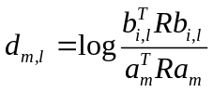. (7.1)

Here R is defined as the autocorrelation matrix formed from the autocorrelation sequence of the segment under test. According to Equation 7.1, the Itakura distance will always be greater than zero because the ratio of the minimum squared predictor errors of the reference and test patterns is always greater than one. However, this fact will cause problems when trying to implement this equation using the fractional logarithm function of a fixed-point DSP. So, instead of Equation 7.1, the Itakura distance is calculated using the equivalent equation

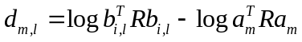. (7.2)

The Euclidean distance measure is simply defined according to the equation

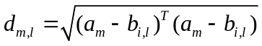. (7.3)

...........
...
The segment belongs to mid insp.sub-phase?
Divide each Resp. Cycle into 6 sub-phases
Divide each sub-phase into10 segments (a total of 60 segments)
Store flow and lung sound samples corresponding to one full resp. cycle
Calculate the autocorr. values for each segment

Apply Hamming window on each segment

Calculate the LPC coeffs. for each segment
Yes
No
No
Yes
Get the sample to be classified
The segment belongs to early insp. sub-phase?
Find the k-nearest vectors
Reference library for early insp. sub-phase
(21 healthy)
Reference library for early insp. sub-phase (21 patho-
logical)
.....

Find the k-nearest vectors
Reference library for mid insp. sub-phase
(21 healthy)
Reference library for mid insp. sub-phase (21 patho-
logical)
.....

The segment belongs to late exp. sub-phase
Find the k-nearest vectors
Reference library for late exp. sub-phase
(21 healthy)
Reference library for late exp. sub-phase (21 patho-
logical)
.....

Classify the current segment according to the majority voting of the k-nearest neighbors
Finished classifying all the 60 segments?
Classify the whole respiratory cycle according to the majority voting of the 60 segments.
Yes
No
....

Figure 7.5 Flow diagram of the DSP software that is executed whenever any of the k-NN based classifiers is selected.

The last distance measure tested with the k-NN classifier is the city-block or Hamming metric, which is defined as the summation of the elements of the vector 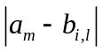. When compared with the Euclidean distance measure, this metric has the advantage of not requiring any multiplication or square root calculation process, thus making its implementation on a fixed-point DSP simpler and more accurate.

7.1.3 Classification with Minimum Distance Classifier

The distance measure used with the minimum distance classifier is the quadratic Mahalanobis metric, which is defined as

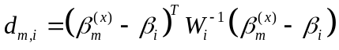, (7.4)

where β_{m}^{(x)} is the feature vector of the segment to be classified, β_{i} is the estimated mean feature vector and W_{i} is the ith class covariance matrix belonging to class i. The modeling error of each segment is added to the LPC coefficients to be used as the feature vector. Thus, each feature vector consists of seven elements (six LPC coefficients + modeling error).

The Mahalanobis distance differs fundamentally from the Euclidean distance in that the data are scaled according to the shape of the statistical density, so that the distance represents the number of standard deviations away from the mean. However, the covariance matrices can be hard to determine accurately although they have to be calculated only once. In addition, when compared with the k-NN classifier, this distance measure requires less memory because each class is represented by only six mean feature vectors and six inverse covariance matrices. The flow diagram the DSP software that is executed when the minimum distance classifier is chosen is given in Figure 7.6.

........
....
.......
Classify the current segment to the class giving the minimum distance
Finished classifying all the 60 segments?
Classify the whole
respiratory cycle according
to the majority voting of the
60 segments.
Divide each Resp. Cycle into 6 sub-phases
Store flow and lung sound samples corresponding to one full resp. cycle
Calculate the autocorr. values for each segment

Apply Hamming window on each segment

Find LPC coeffs. & modeling error of each segment
Yes
No
No
Yes
Get the sample to be classified
The segment belongs to early insp. sub-phase?
Yes
No
Calculate the Mahalanobis distance
β_{early_insp} , W_{early_insp}
(healthy)
β_{early_insp} , W_{early_insp}
(patho-logical)
The segment belongs to mid insp. sub-phase?
Calculate the Mahalanobis distance
β_{mid_insp} , W_{mid_insp}
(healthy)
β_{mid_insp} , W_{mid_insp}
(patho-logical)
The segment belongs to late exp. sub-phase
Calculate the Mahalanobis distance
β_{late_exp} , W_{late_exp}
(healthy)
β_{late_exp} , W_{late_exp}
(patho-logical)
Divide each sub-phase into10 segments (a total of 60 segments)

Figure 7.6 Flow diagram of the DSP software that is executed whenever the minimum distance classifier is chosen.

7.2 Forming the Reference Libraries

The subjects used for forming the feature vectors and templates representing the pathological class consisted of 21 patients having various restrictive and obstructive respiratory diseases. The profile of these patients is given in Appendix B. The respiratory sounds of those subjects representing the healthy class, on the other hand, consisted of 21 non-smoking male subjects whose ages were between 22 and 35.

To find out the dynamic range needed for implementing the different classifiers, a similar program to the one running on the DSP was implemented in MATLAB environment. This program was also used for forming the feature vectors (LPC coefficients) needed for training the k-NN based classifiers, and the templates (mean feature vectors and covariance matrices) needed for training the minimum distance classifier available with the instrument.

7.2.1 Reference Library for the K-NN Classifier

While forming the reference library for the k-NN classifiers, each respiratory cycle referring to each subject was divided into six sub-phases, and each sub-phase was divided further into ten 25 per cent overlapping frames, each consisting of 512 Hamming windowed points. Next, the LPC coefficients of each frame were determined using the Levinson-Durbin function of MATLAB 6. This process was repeated for all the 42 subjects (21 healthy + 21 pathological). As a result, each subject was represented by [(60 segments) x (LPC_order+1)] coefficients, where the LPC order was chosen as six. The simulation results showed that a scaling factor of (1/8) was needed for representing the LPC coefficients in the fractional number format of the DSP, therefore these coefficients were scaled down by this amount before being stored in the allocated memory of the DSP. The DSP memory allocated for storing these coefficients is given in Figure 4.15.

Figures 7.7 through 7.9 show how the LPC coefficients, derived from one healthy and two pathological lung sounds, change over the six respiratory sub-phases that constitute one full respiratory cycle.

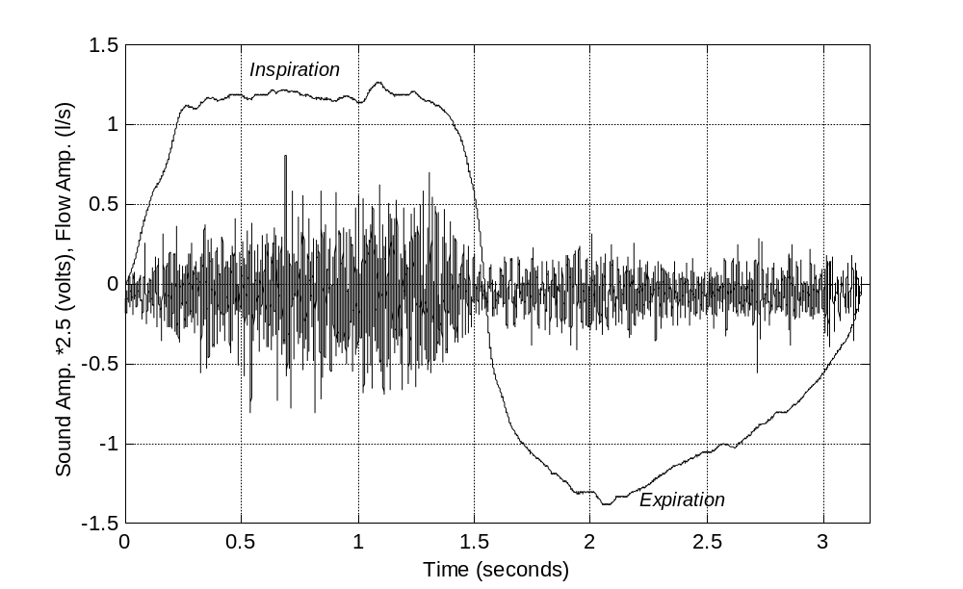
Flow Rate Signal
Lung Sounds
(a)

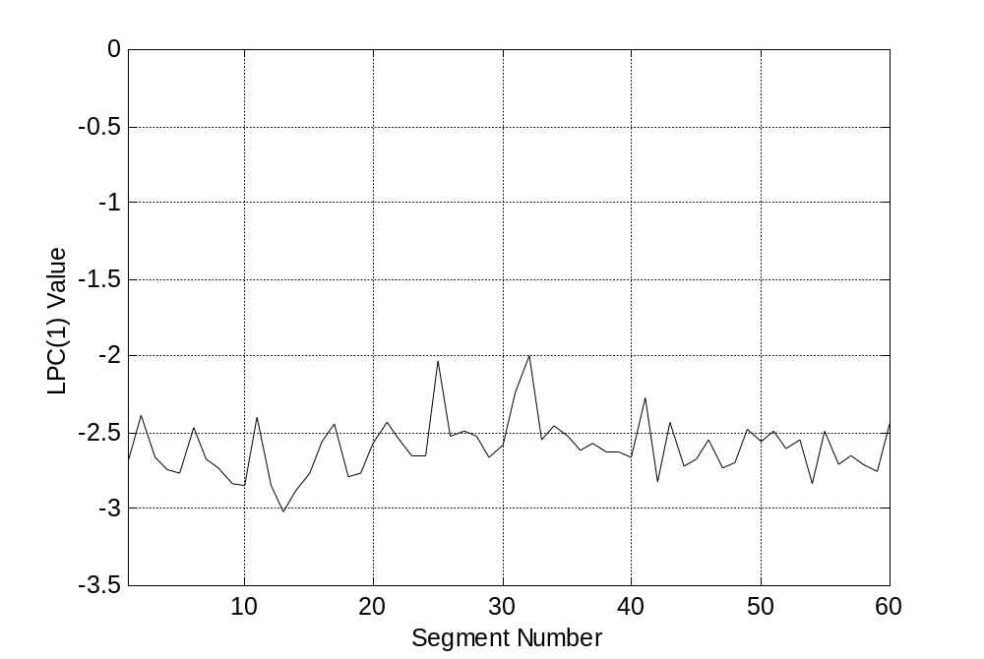
Early insp. sub-phase
Mid insp. sub-phase
Late insp. sub-phase
Early exp. sub-phase
Mid exp. sub-phase
Late exp. sub-phase
(b)

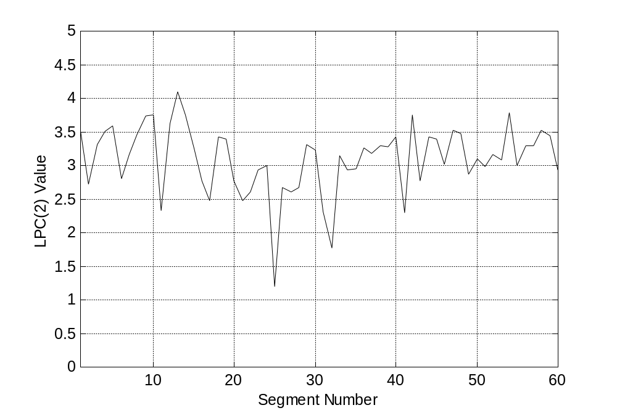
(c)

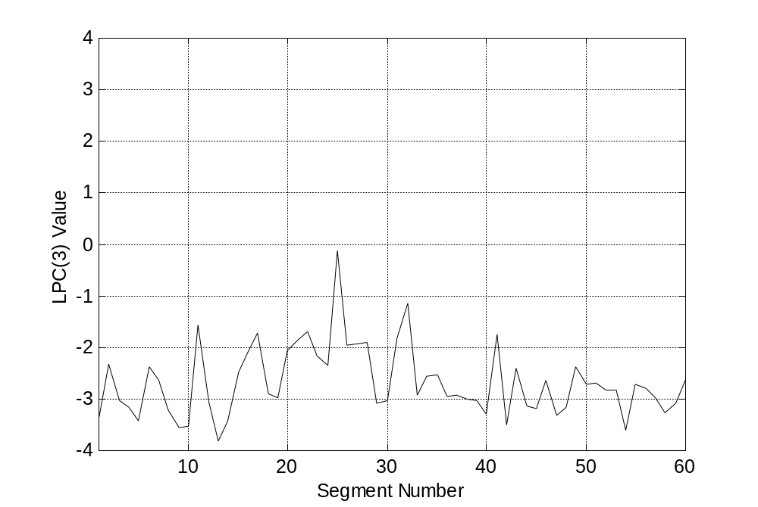
(d)

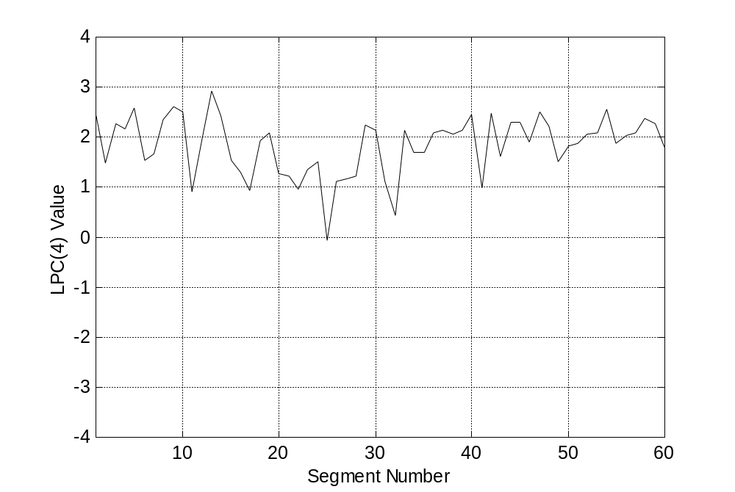
(e)

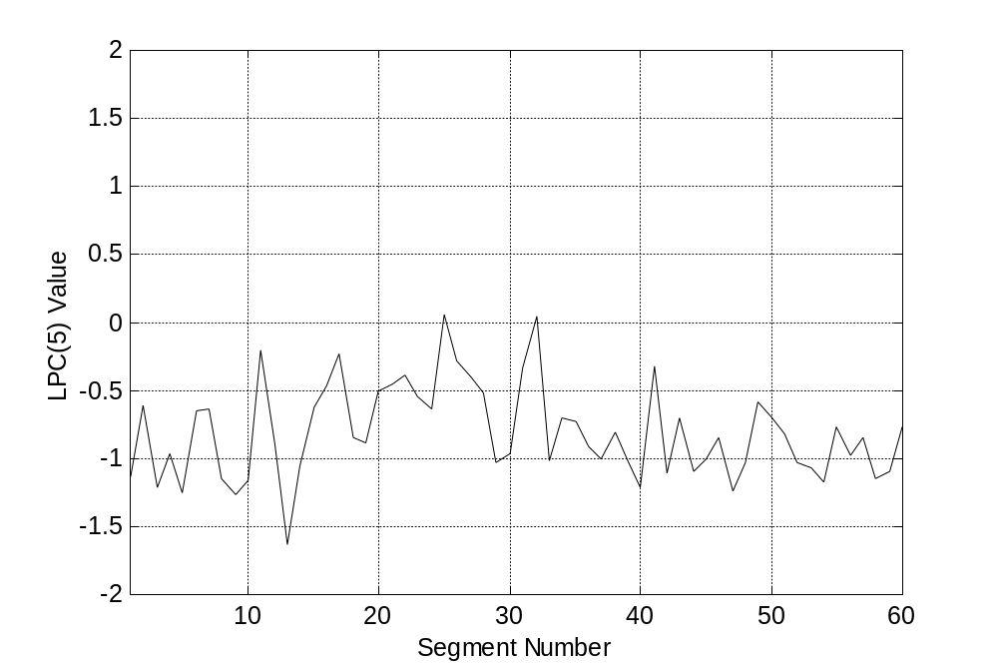
(f)

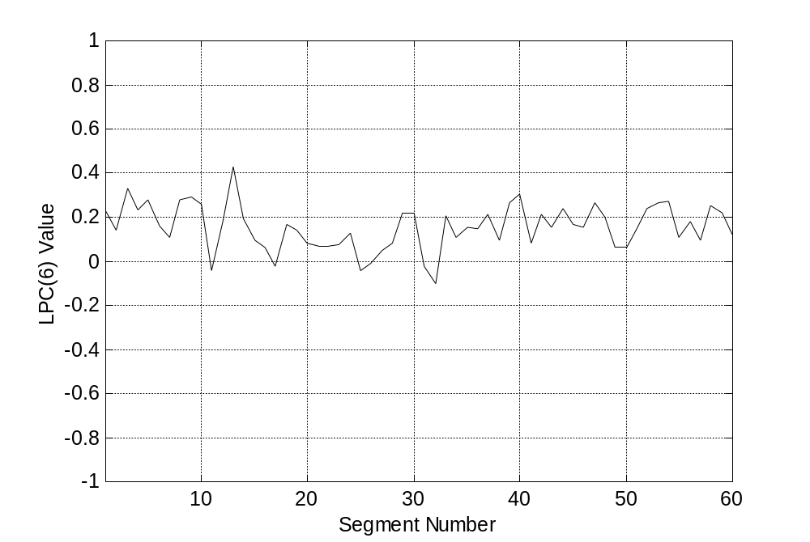
(g)

Figure 7.7 (a) Lung sound waveform and the superimposed flow rate of a healthy subject, (b)-(g) show how the corresponding LPC coefficients change with each segment for each respiratory sub-phase.

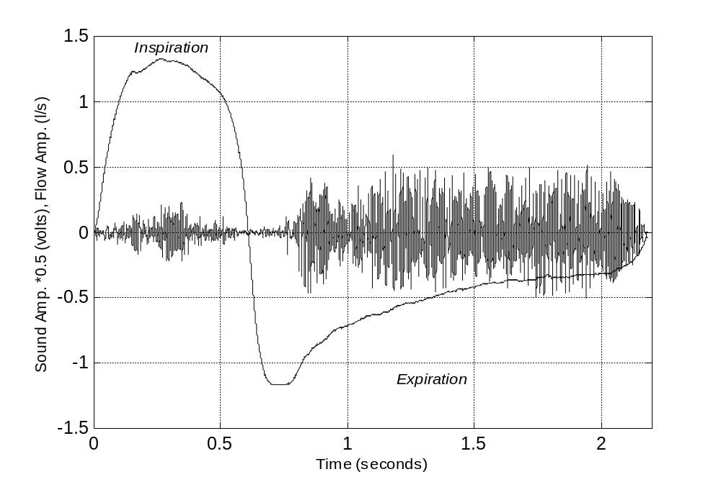
Expiratory rhonchus
(a)

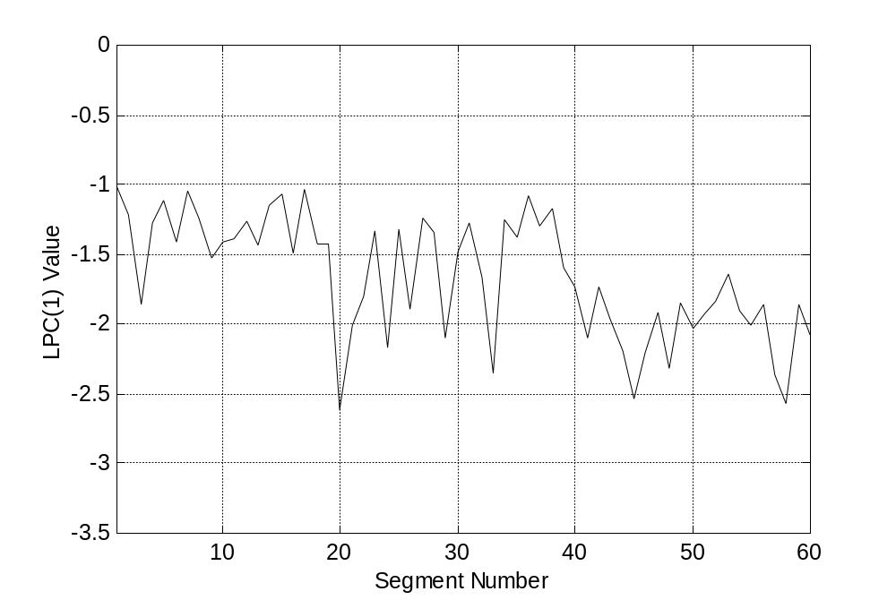
(b)

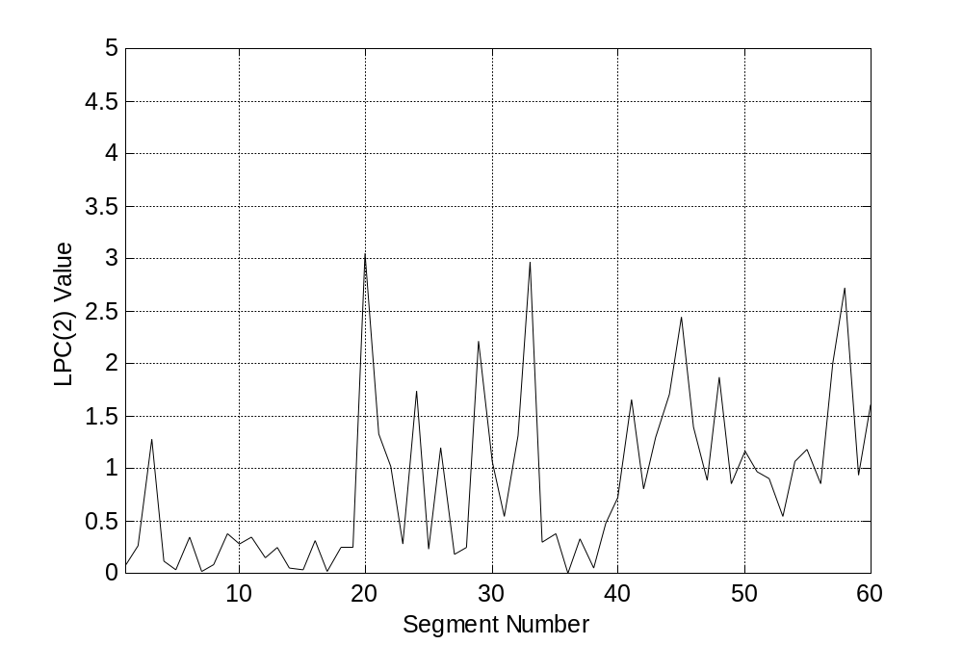
(c)

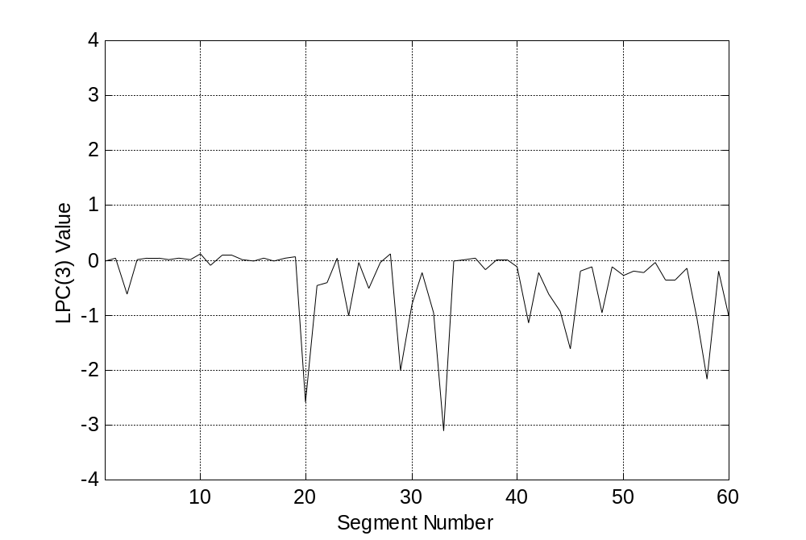
(d)

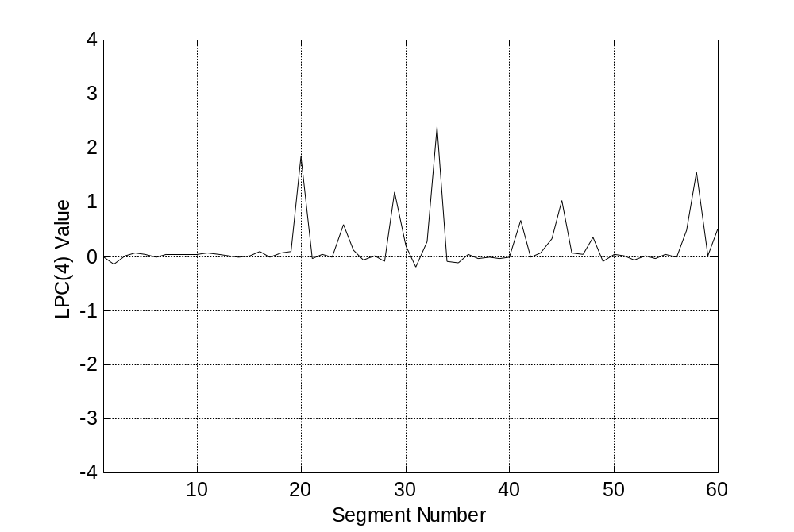
(e)

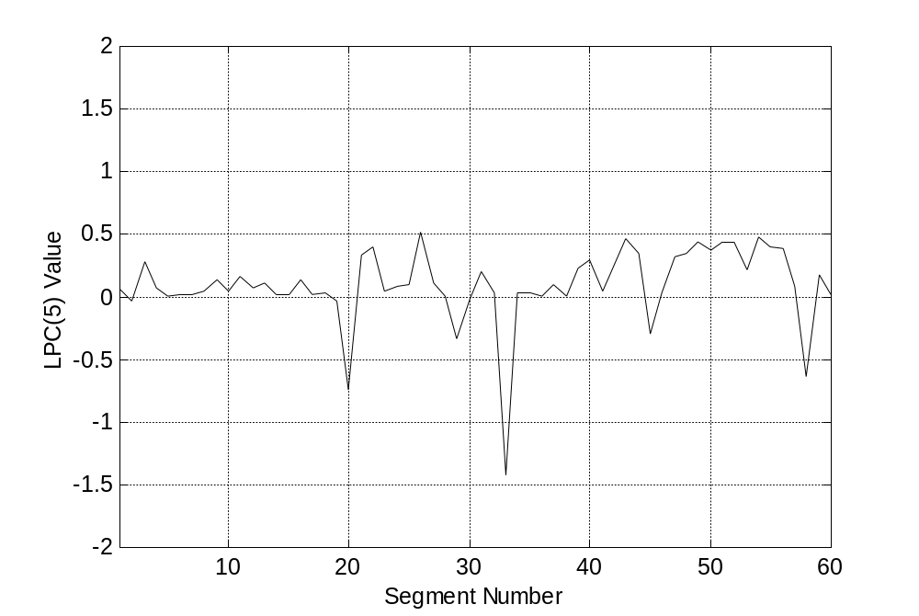
(f)

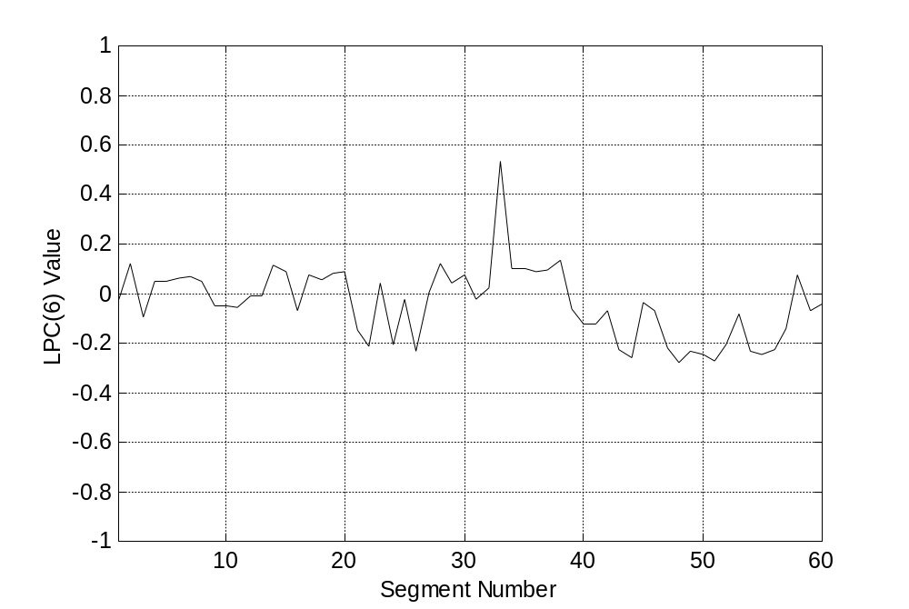
(g)

Figure 7.8 (a) Lung sound waveform and the superimposed flow rate of a patient suffering from an obstructive disease (ga_ka5), (b)-(g) show how the expiratory rhonchus affect the values and the behavior of the corresponding LPC coefficients.

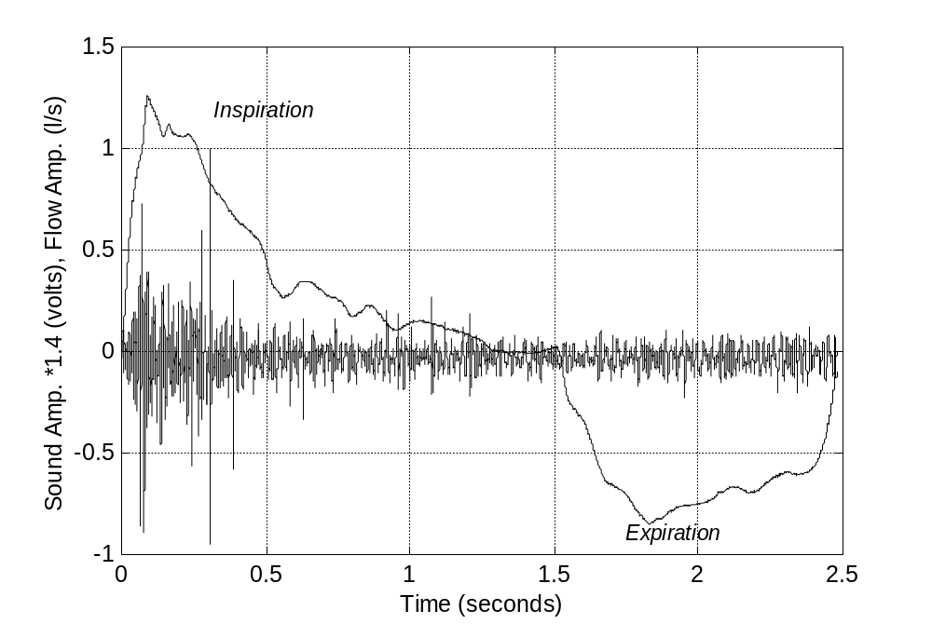
Inspiratory crackles
...
(a)

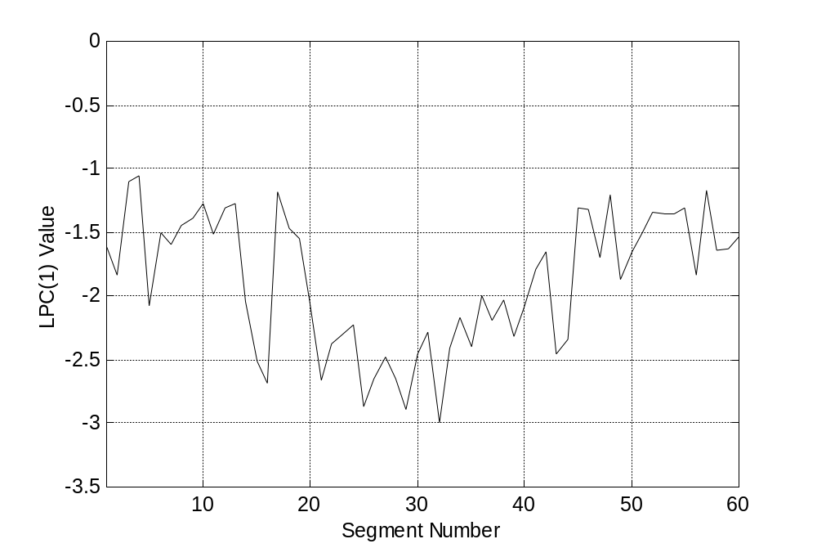
(b)

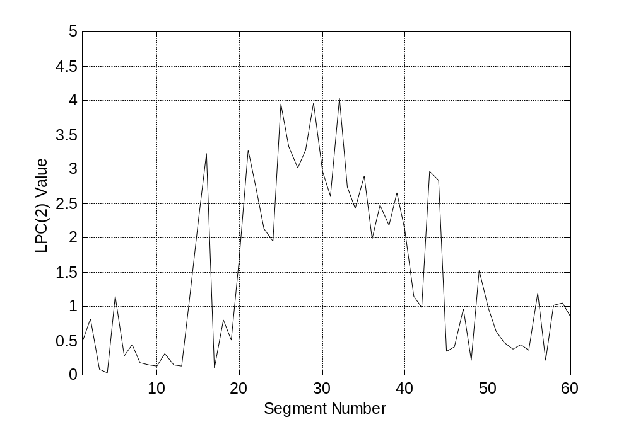
(c)

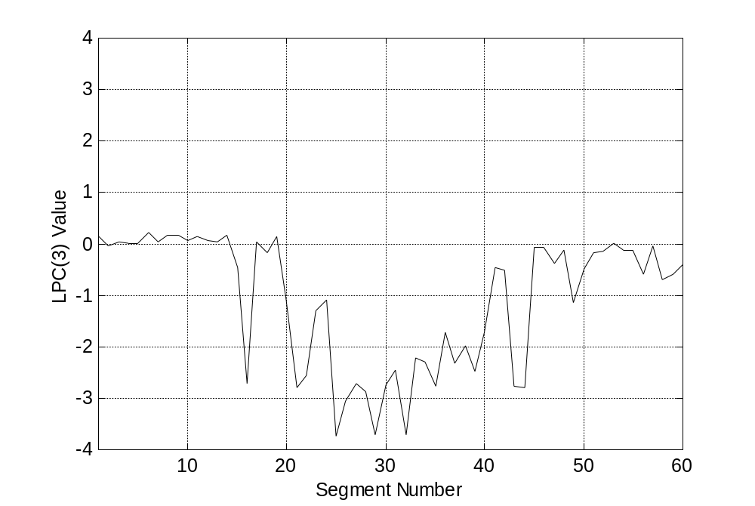
(d)

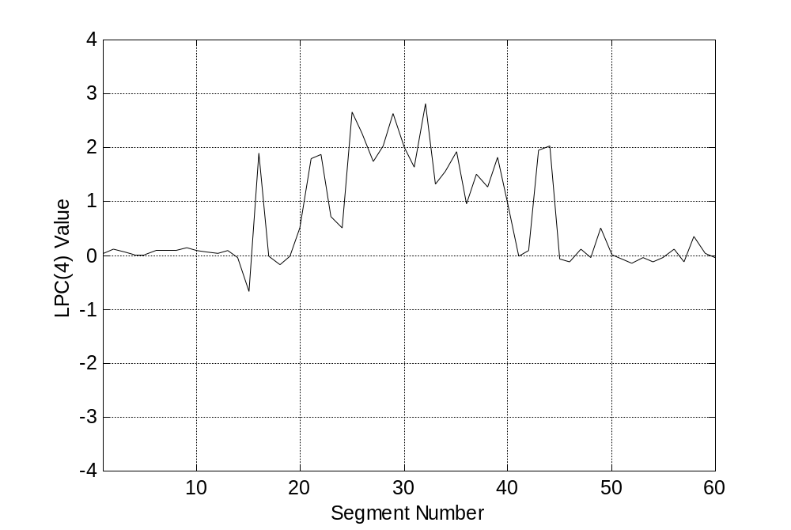
(e)

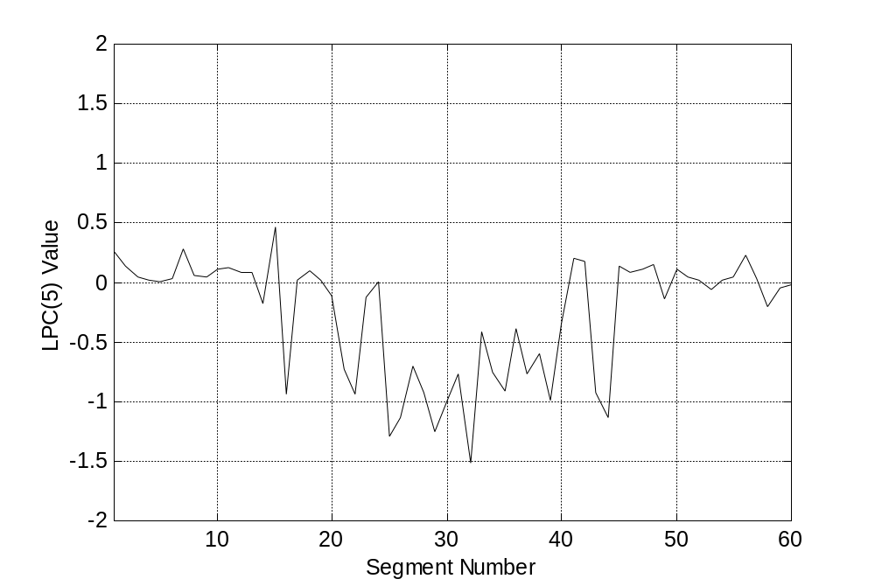
(f)

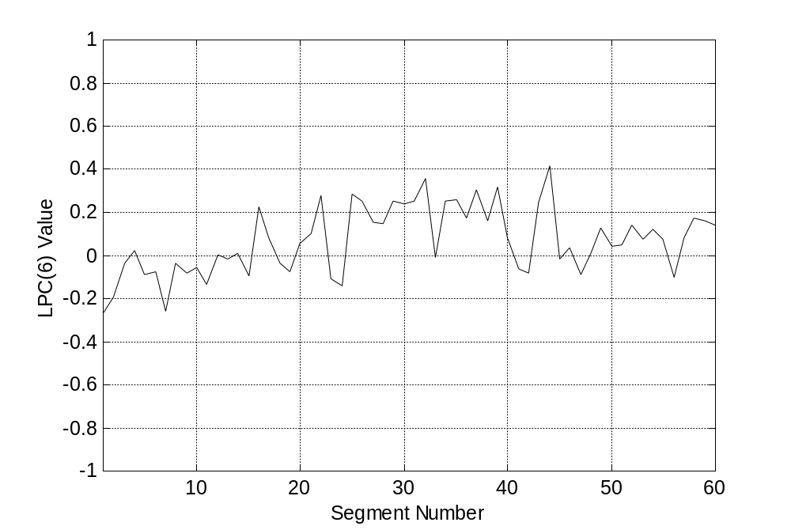
(g)
Figure 7.9 (a) Lung sound waveform and the superimposed flow rate of a patient suffering from a restrictive disease (fa_sa1), (b)-(g) show how the inspiratory crackles cause abrupt changes in the corresponding LPC coefficients.

7.2.2 Reference Library for the Minimum Distance Classifier

As it is seen from Equation 7.4, the classification based on Mahalanobis distance measure requires calculating the mean feature vectors and the inverse covariance matrices that represent the classes to be classified. The reference library consisting of the mean feature vectors and the covariance matrices of the healthy and pathological lung sounds corresponding to the six respiratory sub-phases were computed using MATLAB according to the following two equations:

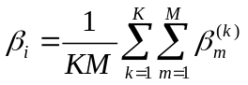, (7.5)

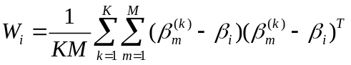, (7.6)

where K is the total number of respiratory cycles in the related class, M is the total number of averaged feature vectors for one respiratory sub-phase. In this work, the number of subjects in each class was 21, and each respiratory sub-phase was divided into 10 overlapping segments. So, the values of K and M were taken as 21 and 10, respectively.

Thus, in the minimum distance classifier each class requires the storage of six inverse covariance matrices and six mean feature vectors, each one corresponding to one of the respiratory sub-phases. The mean feature vectors found for the healthy and pathological cases are given in Tables 7.1 and 7.2, respectively. Before storing them in the DSP memory, the mean feature vectors (except the modeling error) are scaled down by a factor of 1/8, while each of the inverse covariance matrices is divided by its maximum valued element, thus ensuring that these matrices have their values in the range [-1,1).

Table 7.1
The mean feature vectors of the healthy class.
Feature Vector  Element | Early Insp.  Sub-phase | Mid Insp.  Sub-phase | Late Insp.  Sub-phase | Early Exp.  Sub-phase | Mid Exp.  Sub-phase | Late Exp.  Sub-phase
LPC(1) | -1.9227 | -1.9903 | -2.1046 | -2.1241 | -2.1909 | -2.3212
LPC(2) | 1.7304 | 1.7047 | 1.9993 | 2.2100 | 2.3339 | 2.7062
LPC(3) | -1.3952 | -1.2748 | -1.5543 | -1.9053 | -2.0028 | -2.4531
LPC(4) | 0.8035 | 0.7677 | 0.9415 | 1.1928 | 1.2841 | 1.6459
LPC(5) | -0.2692 | -0.2305 | -0.3342 | -0.4831 | -0.5056 | -0.7213
LPC(6) | 0.0681 | 0.0402 | 0.0653 | 0.1203 | 0.0938 | 0.1545
Modeling  Error | 0.0134 | 0.0104 | 0.0095 | 0.0099 | 0.0108 | 0.0097

Table 7.2
The mean feature vectors of the pathological class.
Feature Vector  Element | Early Insp.  Sub-phase | Mid Insp.  Sub-phase | Late Insp.  Sub-phase | Early Exp.  Sub-phase | Mid Exp.  Sub-phase | Late Exp.  Sub-phase
LPC(1) | -1.7287 | -1.8268 | -1.9927 | -1.8353 | -2.1218 | -2.2408
LPC(2) | 1.0165 | 1.0650 | 1.6102 | 1.4133 | 1.9883 | 2.4177
LPC(3) | -0.5332 | -0.4205 | -1.1137 | -1.0767 | -1.5994 | -2.1761
LPC(4) | 0.3410 | 0.2557 | 0.7141 | 0.6915 | 1.0624 | 1.5170
LPC(5) | -0.1052 | -0.0626 | -0.2607 | -0.2694 | -0.4098 | -0.7105
LPC(6) | 0.0321 | 0.0119 | 0.0606 | 0.0928 | 0.0949 | 0.2043
Modeling  Error | 0.0154 | 0.0108 | 0.0094 | 0.0109 | 0.0065 | 0.0049

7.3 Classification Results

To have an initial idea about the performance of the instrument before using it with real subjects, the performance of the different classifiers available in the DSP was measured offline using the leave-one-out method. According to this method, the training set of each classifier was formed from all subjects’ feature vectors except the one sample to be classified. Next, the feature vectors corresponding to the subject to be classified were stored directly in the allocated memory of the DSP. This process was repeated for all the 42 subjects found in the training set. Three parameters (sensivity, specifity, and accuracy) were calculated for measuring the performance of all the classifiers (Table 7.3). Here, sensitivity is defined as the ratio of the number of pathological subjects classified correctly to the total number of pathological subjects. Specificity is the number of healthy subjects classified correctly divided by the total number of healthy subjects, while accuracy is defined as the number of subjects correctly classified divided by the total number of subjects in the training set.

Table 7.3
Offline performance results using the leave-one-out method.
Classifier Name | Distance Measure | Sensivity  (%) | Specifity  (%) | Accuracy  (%)
k-nearest  neighbor | Itakura | 100 | 95.24 | 97.62
k-nearest  neighbor | Euclidean | 52.38 | 100 | 76.19
k-nearest  neighbor | City-block | 52.38 | 100 | 76.19
Minimum Distance | Mahalanobis | 57.14 | 61.9 | 59.52

To further investigate the performance of the instrument when operated in real time, only the k-NN based classifiers were used to classify a total of 20 real subjects: 9 with pathological and 11 with healthy respiratory sounds. Those subjects with pathological sounds consisted of four female and five male patients suffering from various restrictive or/and obstructive respiratory diseases. The performance tests of these patients were conducted in silent rooms both in Cerrahpaşa medical faculty of Istanbul University and in Heybeliada Sanatorium located at Heybeli Island. The tests of the healthy subjects (10 male+1 female), on the other hand, were made in our laboratory at Boğaziçi University. The calculated performance parameters for these subjects are given in Table 7.4. A more detailed information regarding how to operate the instrument is given in Appendix C.

In addition to the diagnosis result, the ratio of the votes of the winner class to the total number of segments classified by the DSP is also displayed on the LCD. Before being displayed on the LCD, the votes representing the winner class are converted to ASCII format by a subroutine running on the DSP. This information is added to the diagnosis result so as to give the user an idea about the severity of the pathology. However, it should be mentioned here that the displayed number is only a measure of the similarity between the feature vectors of the lung sounds to be classified and the reference library representative of the winner class.

Table 7.4
Performance results of the online classification.
Classifier Name | Distance Measure | Sensivity  (%) | Specifity  (%) | Accuracy  (%)
k-nearest  neighbor | Itakura | 100 | 72.73 |  | 85
k-nearest  neighbor | Euclidean | 88.89 | 90.91 |  | 90
k-nearest  neighbor | City block | 100 | 90.96 |  | 95

7.4 Discussion

As it is seen in Table 7.3, k-NN based classifiers gave better results than the minimum distance classifier. This result is consistent with the one obtained by Sankur, Kahya and coworkers [9]. To be more specific, k-NN based on Itakura distance measure was able to classify all the subjects except one healthy subject, thus giving an accuracy value of 97.62 per cent. The low accuracy value of the minimum distance classifier, however, can be explained by the fact that in this classifier each class was represented by only six averaged feature vectors and six averaged covariance matrices representing each respiratory sub-phase. For the pathological case, these values were obtained by averaging the feature vectors of 21 subjects having a wide variety of pulmonary diseases, with each disease having distinct characteristics. For this reason, this averaging of the feature vectors, probably, did not yield a faithful representation of this class.

The leave-one-out performance results also showed that the Euclidean and city-block distance measures gave equal but relatively low accuracy values. Interestingly, however, the online classification results showed that the relatively simpler city-block distance measure showed the best accuracy value among all the k-NN classifiers (Table 7.4).
In general, the only means by which the performance of the k-NN classifier can be improved is by increasing the number of training set patterns. However, these patterns have to be stored individually, which requires large memory. Another disadvantage of the k-NN classifier is that it requires large computing power; because for classifying a segment its distance to all the segments in training set has to be calculated.

8. CONCLUSIONS

High speed DSPs make it possible to apply complex signal processing algorithms on respiratory sounds in real time. In this study, a real time DSP based instrument was designed for the classification of lung sounds as belonging to only two classes and very encouraging results were obtained. In general, it has been shown that the performance of k-NN based classifiers was much better than that of the minimum distance classifier. To be more specific, the performance measurements made using the leave-one-out method showed that k-NN based on Itakura distance measure gave the highest accuracy value among all the other distance measures.

The analysis of respiratory sounds in real time is considered to be important for several reasons. First of all, almost instantaneous results are obtained. Therefore, the effect of changes due to treatment, for example, may be observed and measured as they occur. In addition, any errors in the environment or the equipment can be identified immediately, thus reducing the chance of producing wrong conclusions [8]. Since the analysis is made on the respiratory sounds as they are being captured, this reduces the storage requirements.

Although very satisfactory results were obtained, there are some improvements that should be made to the instrument. These improvements can be regarded as our recommendations for future studies and they are suggested as possible solutions to some practical difficulties that we faced during testing the instrument with real subjects:

- During testing the instrument in a hospital environment, our experiments were often disturbed by ambient noise. Therefore, there is a need to make the instrument immune to this noise. The ability to perform adaptive filtering in real-time, for example, should be investigated further [47].

- The polarity of signal produced by the flowmeter is used only to label the lung sounds as belonging to the inspiration or expiration phase. However, we observed that some patients were unable to breathe properly through the flowmeter, which resulted in excluding them from our experiments. It is clear that finding an alternative technique of airflow measurement will solve this problem. It will also reduce the complexity and cost of the system. In fact, there are some ongoing studies that have the final aim of detecting the respiratory phases using the respiratory sounds [48, 49].

- Before the classification of the pathological sounds, the physician was asked to mark the regions of the lungs where the pathological sounds were most audible, next the microphone was attached to that area. However, this process is not totally objective. One way to automate this process will be developing a multichannel system, where array of microphones will be covering all the regions of the lungs. This will eventually localize the pathological areas of the lungs. Some parameters, such as the votes of the pathological class, can even be used to describe the severity of the pathology near each microphone location.

- In this study, the classification of lung sounds to only two classes was investigated. The next step can be the classification into three classes: restrictive, obstructive and healthy lung sounds. However, this requires increasing the database representative of each class. The only obstacle here will be the large amount of memory and computing power that will be needed.

APPENDIX A

HARDWARE SCHEMATICS OF DSP56311 AND

STEREO AUDIO CODEC

This section provides the schematic drawings for the 56311 DSP and the input circuitry of the stereo audio codec integrated with the DSP56311 Evaluation Module.

Pins of 56311

Audio Codec

A

APPENDIX B

PATIENT PROFILE

Table B.1
Patient profile (F: female; M: male; Obs.: obstructive; Res.: restrictive; COPD: chronic obstructive pulmonary disease; NA: not available.)
Patient No. | Patient Name (Sex) | Age (year) | Disease Type | Clinical Diagnosis
1 | Gu_il3 (F) | 62 | Obs. | COPD
2 | Ha_sa2 (M) | NA | Obs. | COPD+Bronchiectasis
3 | Ad_sa4 (M) | 60 | Obs. | COPD+Obs. Sleep Apnea Syndrome+Congestive Heart Failure
4 | Ali_du2 (M) | 68 | Obs. | Asthma+Bronchiectasis
5 | Ar_kul1 (M) | 70 | Obs. | COPD
6 | Ay_ak4 (F) | 62 | Obs. | Bronchiectasis
7 | Ga_ka5 (F) | 64 | Obs. | COPD
8 | Ha_oz4 (M) | 46 | Obs. | Asthma+Tuberculous
9 | Ha_yi5 (F) | 58 | Obs. | Asthma+Bronchitis
10 | Is_co2 (M) | 68 | Obs. | COPD
11 | Me_al3 (M) | 77 | Obs. | COPD
12 | Mu_ay4 (M) | 52 | Obs. | COPD+Nephrolic Syndrome
13 | Ru_ba3 (F) | 73 | Obs. | Bronchiectasis
14 | Do_bi4 (M) | 70 | Res. | Ischemic Heart Disease+Congestive Heart Failure
15 | Ca_sa3 (F) | 12 | Res. | Right Parapneumonic Effusion
16 | Fa_sa1 (F) | 56 | Res. | Pneumonia
17 | Ha_ay3 (F) | 66 | Res. | Interstitial Lung Disease+Hypertension
18 | Ha_de4 (F) | 67 | Res. | Pneumonia+Congestive Heart Failure
19 | Lu_uz2 (F) | 62 | Res. | Idiopathic Pulmonary Fibrosis
20 | Os_di3 (M) | 61 | Res. | Pneumonia
21 | Saf_oz2 (F) | 42 | Res. | Sarcoidosis

APPENDIX C

USER MANUAL

This section summarizes the hardware and software requirements needed to operate the system.

C.1 The Necessary Hardware Connections

Perform the following steps to complete the hardware connections:

- Make sure that the power switch located on the front panel of the instrument is turned off.

- The male end of the parallel port extender cable should be connected to the parallel port connection of the PC. The female end of the cable, on the other hand, should be connected to the parallel port connector found on the instrument. The PC here is used only to download the classification program to the instrument.

- The output power plug of an external 12VDC power supply should be connected to the power input of the instrument so as to supply power to the DSP56311 EVM.

- Make sure that the batteries needed to operate the power amplifier, LCD, and amplifier card are installed (a total of seven 9V batteries).

- External headphones or speakers should be connected to the instrument so as to listen to the lung sounds as they are being sampled. The instrument contains an internal speaker that is used only to listen to the recorded sound and to generate beep sounds.

- Connect the microphone and flowmeter to the connectors located on the front panel of the instrument.

The hardware connections needed to operate the instrument are summarized in Figure C.1

External 7-12V AC or DC
Power
External Headphone/Speakers
(Amplified Output)
External Speakers
(Output not Amplified)
Microphone
Flowmeter
Parallel Port Extender Cable
Windows PC
7x9V Batteries
Placed Here
Upper view
Of the Instrument
LCD Backlight Switch
Parallel Port of PC

Figure C.1 The hardware connections needed to operate the instrument.

C.2 Downloading the Software to the Instrument

The software to be loaded to the instrument was generated using the Motorola DSP Assembler. The generated file is in Common Object File Format (COFF). COFF is a formal definition for the structure of machine code files [50]. The object file in this format can be identified by the ‘.cld’ extension. The hardware debugger supplied with the DSP56311EVM can be used to download this software to the instrument. The hardware debugger offers a graphic user interface (GUI) with windows, menus, and online help for interactive debugging (Figure C.2). Therefore, before performing the following steps, make sure that the Motorola DSP56311EVM Development Tools are installed on your PC:

- After making all the necessary connections mentioned in Section C.1 turn on the power switch located on the front panel of the instrument.
- Run the hardware debugger for the DSP56300 family as follows: from the Start menu, choose Programs; then choose Motorola DSP Software Development Tools. Next, select DSP56300 Hardware Debugger (GUI). Alternatively, if available, the debugger can be started by double-clicking its shortcut icon on the desktop.

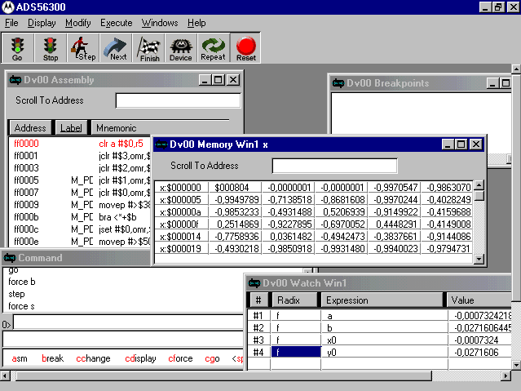
Figure C.2 User interface of the hardware debugger.

- Set the PATH of the working directory as follows: from the File menu, choose Path. Then select Set and define the directory containing the file to be loaded.

- RESET the system by clicking on the Reset button located on the toolbar of the GUI of the hardware debugger.

- LOAD the COFF file as follows: from the File menu, choose Load. Then select Memory COFF. Figure C.3 shows the dialog box that will appear. Under Filename specify the filename of the object file to be loaded or click on the File button to browse for the file. Finally click OK. Next, click on the Go button.
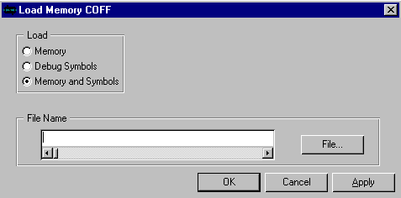
Figure C.3 Dialog box used for loading the COFF file to the DSP memory.

C.3 Operating the Instrument

After performing the steps given in Sections C.1 and C.2, the LCD should display a message prompting the user to select the function to be executed by the instrument. Three push-buttons, located on the front panel of the instrument, are used to select the desired function (Figure C.4). The Menu push-button is used to navigate through all the menu items. There are a total of eight menu items available with the instrument, and at each time the Menu push-button is pressed a new item is displayed on the LCD. Whenever the user wants to execute the function displayed on the LCD, he must press the push-button named Select.

The following steps should be performed before executing any of the classification algorithms available in the system:

- The microphone should be attached to the posterior base of the right or left lung.

- Make sure that you have selected the desired classifier type by pressing the Menu push-button.

- Next, the subject should be trained on how to breathe through the flowmeter. This process is critical due to the fact that airflow has a fundamental influence on respiratory sounds. In fact, it was observed that in some cases different breathing rates from the same subjects resulted in extremely different diagnosis results.
- Whenever you observe that the subject is breathing properly through the flowmeter, press the Select push-button only while he is either inhaling or exhaling. This is important so as to ensure that the system will store the correct respiratory cycle. As a visual feedback, the status of the recording process is reflected in real-time to the user using the three LEDs located on the front panel of the instrument (Figure C.4). While the Insp. LED indicates that the breath sounds belonging to the inspiration phase are being stored, the Exp. LED shows that the data belonging to the expiration phase are being stored. The Test End LED blinks whenever the storage process has ended, thus informing the patient that he can stop breathing through the flowmeter. If an error is observed during this stage, it may be necessary to reset the system and reload the software to the DSP’s memory.

Menu
Select
Retest
Exp. LED
Insp. LED
Test End LED
Microphone
Flowmeter
Power Switch
LCD
Contrast
Volume Control
Figure C.4 The front panel of the instrument.

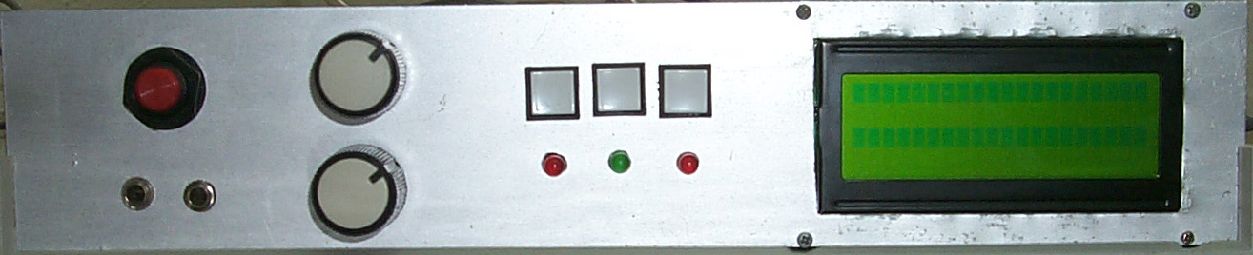

- In the worst case, two respiratory cycles may be needed by the system before displaying the diagnosis result. When the necessary respiratory cycle is detected and stored by the system, the system will generate a beep sound and the Test End LED will blink for a short period of time, thus informing the patient that he can stop breathing through the flowmeter. The diagnosis result and the votes of the winning class are displayed next.

- After displaying the diagnosis result, the system will enter the standby mode. At this stage, only the Retest push-button becomes active. So, whenever this button is pressed the DSP exits this mode and the program starts from the beginning, thus giving the chance to make a new test.

REFERENCES

- Oud, M., E.H. Dooijes, and J.S. Zee, “Asthmatic Airways Obstruction Assessment Based on Detailed Analysis of Respiratory Sound Spectra,” IEEE Transactions on Biomedical Engineering, Vol. 47, No. 11, pp. 1450-1455, November 2000.

- Pasterkamp, H., S.S. Kraman, and G.R. Wodicka, “Respiratory Sounds. Advances Beyond the Stethoscope,” American Journal of Respiratory and Critical Care Medicine, Vol. 156, pp. 974-987, 1997.

- The Monaural Stethoscope. On-line:
http://www.antiquemed.com/monaural_stethoscope.htm.

- Gavriely, N., and D.W. Cugell, Breath Sounds Methodology, CRC Press, Florida, 1995.

- Sovijärvi, A.R.A., J. Vanderschoot, and J.E. Earis, “Standardization of Computerized Respiratory Sound Analysis,” European Respiratory Review, Vol. 10, No. 77, pp.585, 2000.

- Gross, V., T. Penzel, L. Hadjileontiadis, U. Koehler, and C. Vogelmeier, “Electronic Auscultation Based on Wavelet Transformation in Clinical Use,” Proceedings of the Second Joint EMBS/BMES Conference, pp. 1531-1532, Houston, TX, USA, October 23-26, 2002.

- Earis, J.E., and B.M.G. Cheetham, "Current Methods Used for Computerized Respiratory Sound Analysis," European Respiratory Review, Vol. 10, No. 77, pp. 586-590, 2000.

- Sun, X., B.M.G. Cheetham, and J.E. Earis, “Real Time Analysis of Lung Sounds,” Technology and Health Care, Vol. 6, pp. 3-10, 1998.

- Sankur, B., Y.P. Kahya, E.Ç. Güler, and T. Engin, “Comparison of AR Based Algorithms for Respiratory Sound Classification,” Computers in Biology and Medicine, Vol. 23, No. 4, pp. 67 –76, January 1994.

- Güler, E.Ç., “Classification, Visualization and Transient Analysis of Respiratory Sound Patterns,” Ph.D. Dissertation, Boğaziçi University, 1998.

- Sovijärvi, A.R.A., F. Dalmasso, J. Vanderschoot, L.P. Malmberg, G. Righini, and S.A.T. Stoneman, “Definition of Terms for Applications of Respiratory Sounds,” European Respiratory Review, Vol. 10, No. 77, pp. 597-610, 2000.

- Sovijärvi, A.R.A., L.P. Malmberg, G. Charbonneau, J. Vanderschoot, F. Dalmasso, C. Sacco, M. Rossi, and J.E. Earis, “Characteristics of Breath Sounds and Adventitious Respiratory Sounds,” European Respiratory Review, Vol. 10, No. 77, pp. 591-596, 2000.

- Gross, V., A. Dittmar, T. Penzel, F. Schüttler, and P. von Wichert, “The Relationship Between Normal Lung Sounds, Age, and Gender,” American Journal of Respiratory and Critical Care Medicine, Vol. 162, pp 905-909, 2000.

- Charbonneau, G., E. Ademovič, B.M.G. Cheetham, L.P. Malmberg, J. Vanderschoot, and A.R.A. Sovijärvi, “Basic Techniques for Respiratory Sound Analysis,” European Respiratory Review, Vol. 10, No. 77, pp. 625–635, 2000.

- Cheetham, B.M.G, G. Charbonneau, A. Giordano, P. Helistö, and J. Vanderschoot, “Digitization of Data for Respiratory Sound Recordings,” European Respiratory Review, Vol. 10, No. 77, pp. 621–624, 2000.

- Iyer, V.K., A. Ramamoorthy, and Y. Ploysongsang, “Autoregressive Modeling of Lung Sounds: Characterization of Source and Transmission,” IEEE Transactions on Biomedical Engineering, Vol. 36, pp. 1133-1137, 1989.

- Hadjileontiadis, L.J., and S.M. Panas, "Autoregressive Modeling of Lung Sounds Using Higher-Order Statistics: Estimation of Source and Transmission," IEEE Signal Processing Workshop on Higher-Order Statistics, pp. 4-8, Banff, Alberta, Canada, 1997.

- Geddes, L.A., and L.E. Baker, Principles of Applied Biomedical Instrumentation, John Wiley, New York, 1989.

- Spera, G., “DSPs: A Growing Option for Medical Applications,” Medical Electronics Manufacturing, spring 1998. On-line: http://www.devicelink.com/mem/archive/98/04/001.html.

- Ackenhusen, J.G., Real-Time Signal Processing: Design and Implementation of Signal Processing Systems, Prentice-Hall, New Jersey, 1999.

- Bateman, A., and W. Yates, Digital Signal Processing Design, Computer Science Press, New York, 1989.

- El-Sharkawy, M., Real Time Digital Signal Processing Applications with Motorola's DSP56000 Family, Prentice Hall, Englewood Cliffs, N.J., 1990.

- DSP 56311 User’s Manual, DSP56311UM/D Revision 1.0, Motorola Inc., October 1999.

- Chrysafis, A., Fractional and Integer Arithmetic Using the DSP56000 Family of General-Purpose Digital Signal Processors, APR3/D, Motorola Inc., 1988.

- Vannuccini, L., J.E. Earis, P. Helistö, B.M.G. Cheetham, M. Rossi, A.R.A. Sovijärvi, and J. Vanderschoot, "Capturing and Preprocessing of Respiratory Sounds," European Respiratory Review, Vol. 10, No. 77, pp. 616-620, 2000.

- DSP56311 Evaluation Module. Hardware Reference Manual, DSP56311EVMUM/D Rev. 1.8, Motorola Inc., 1999.
- CS4218 Stereo Audio Codec Data Sheet, DS135F1, Crystal Semiconductor Corporation, September 1996.

- Lay, T., Programming the CS4218 Codec for Use with DSP56300 Devices, AN1790/D Rev. 0, Motorola Inc., 1999.

- DSP56300 24-Bit Digital Signal Processor Family Manual, DSP56300FM/AD, Motorola Inc., Austin, 1995.

- TDA2822M Data Sheet, SGS-THOMSON (ST) Microelectronics, March 1995.

- Archer, A., “CDDA (CD Digital Audio) Mixer Project,” CU Amiga Magazine-Features Online, December 1997. On-line: http://www.u-net.com/cuamiga/features/mixer.html.

- Montgomery, J.M., Implementing a 10-Band Stereo Equalizer on the DSP56311 EVM Board, AN2110/D Rev. 0, Motorola Inc., 2001.

- GDM2004D LCD Data Sheet, Xiamen Ocular LCD Devices CO. Ltd.

- Specifications of LCD Module-GDM2004D Series, Xiamen Ocular LCD Devices CO. Ltd, July 1998.

- Tutorial: Introduction to LCD Programming. On-line: http://www.8052.com/tutlcd.phtml.

- HD44780U (LCD-II) Dot Matrix Liquid Crystal Display Controller/Driver, ADE-207-272(Z) Rev. 0.0, Hitachi Ltd., 1999.

- Kua, F., Generation of a Sine Wave Using a TMS320C54x Digital Signal Processor, Application Report SPRA819, Texas Instruments, May 2002.
- Hodes, T., J. Hauser, A. Freed, J. Wawrzynek, and D. Wessel, "A Fixed-Point Recursive Digital Oscillator for Additive Synthesis of Audio," Proc. IEEE Int. Conf. Acoustics, Speech, and Signal Processing, Phoenix, AZ, March 1999.

- Cohen, A., Biomedical Signal Processing, CRC Press, Florida, Vol. 2, 1988.

- Hayes, M.H., Statistical Digital Signal Processing and Modeling, John Wiley & Sons, New York, 1996.

- Rabiner, L.R., and B. Juang, Fundamentals of Speech Recognition, Prentice Hall, Englewood Cliffs, N.J., 1993.

- Grassi, S., “Optimized Implementation of Speech Processing Algorithms”, PhD Dissertation, University of Neuchâtel, IMT, Switzerland, February 1998. On-line: http://www-imt.unine.ch/www/grp_pe/people/people/grassi/personal/welcome.html

- Vanderschoot, J., N.G.J. Coppello, and H.J.W. Schreur, “AR Model Orders of Lung Sounds,” Proceedings of the Annual International Conference of the IEEE Engineering in Medicine and Biology Society, Vol. 14, pp. 2531-2532, 1992.

- Duda, R.O., and P.E. Hart, Pattern Classification and Scene Analysis, John Wiley, New York, 1973.

- Cover, T.M., and P.E. Hart, “Nearest Neighbor Pattern Classification,” in B.V. Dasarathy (Editor), Nearest Neighbor (NN) Norms: NN Pattern Classification Techniques, pp. 57-63, Los Alamitos, Calif.: IEEE Computer Society Press, 1991.

- Allerhand, M., Knowledge-Based Speech Pattern Recognition, Kogan Page, London, 1987.

- Suzuki, A., C. Sumi, K. Nakayama, and M. Mori, “Real-Time Adaptive Cancelling of Ambient Noise in Lung Sound Measurement,” Medical & Biological Engineering & Computing, Vol. 33, pp. 704-708, September 1995.
- Charbonneau, G., M. Sudraud, and G. Soufflet, “Method for the Evaluation of Flow Rate from Pulmonary Sounds,” Bull. Eur Physiopathol. Respir., Vol. 23, pp. 265-270, 1987.

- Pressler, G.A., J.P. Mansfield, H. Pasterkamp, and G.R. Wodicka, “Detection of Respiratory Sounds within the Ear Canal,” Proceedings of the Second Joint EMBS/BMES Conference, pp. 1529-1530, Houston, TX, USA, October 23-26, 2002.

- Motorola DSP Assembler Reference Manual, Motorola Inc., 1994.

REFERENCES NOT CITED

Earis, J.E., and B.M.G. Cheetham, “Future Perspectives for Respiratory Sound Research”, European Respiratory Review, Vol. 10, No. 77, pp. 641-646, 2000.

Piirilä, P., A.R.A. Sovijärvi, J.E. Earis, M. Rossi, F. Dalmasso, S.A.T. Stoneman, and J. Vanderschoot, “Reporting Results of Respiratory Sound Analysis,” European Respiratory Review, Vol. 10, No. 77, pp. 636-640, 2000.

Rossi, M., A.R.A. Sovijärvi, P. Piirilä, L. Vannuccini, F. Dalmasso, and J. Vanderschoot, “Enviromental and Subject Conditions and Breathing Manoeuvers for Respiratory Sound Recordings,” European Respiratory Review, Vol. 10, No. 77, pp. 611-615, 2000.

Sovijärvi, A.R.A., P. Helistö, L.P. Malmberg, K. Kallio, E. Paajanen, A. Saarinen, P. Lipponen, S. Haltsonen, L. Pekkanen, P. Piirilä, L. Näveri, and T. Katila, “A New Versatile PC-Based Lung Sound Analyzer with Automatic Crackle Analysis (HELSA); Repeatability of Spectral Parameters and Sound Amplitude in Healthy Subjects,” Technology and Health Care, Vol. 6, pp. 11-22, 1998.

