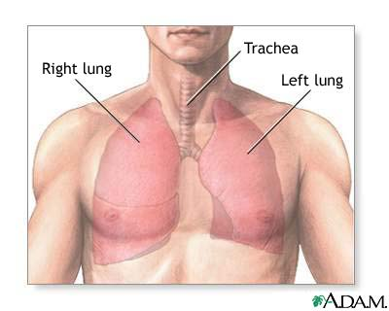
Amplifier & Band-Pass Filter
(80-2kHz)
A/D Converter
Amplifier & Low-Pass
Filter
(30Hz)

Digital Signal
Processor
Power Amplifier
LCD
Display
Microphone
Flowmeter

