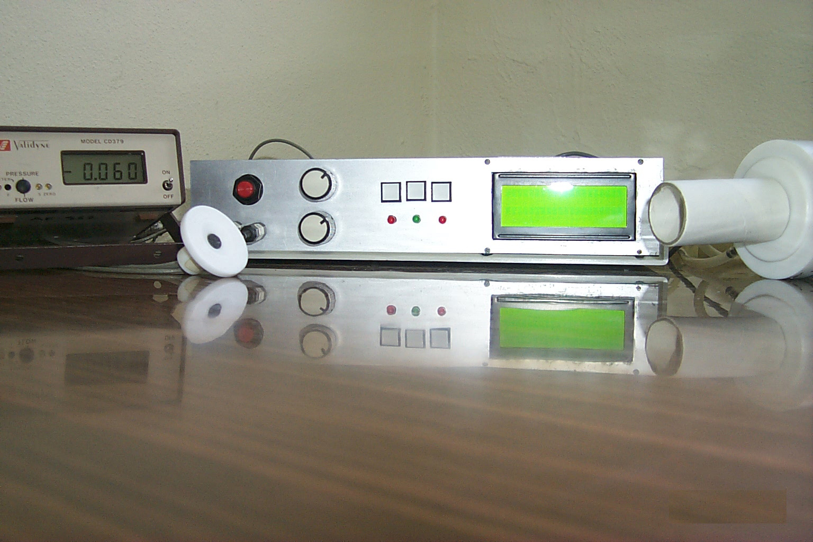
Restart
Select
Menu
LCD
Flowmeter
Microphone
Contrast
Volume

