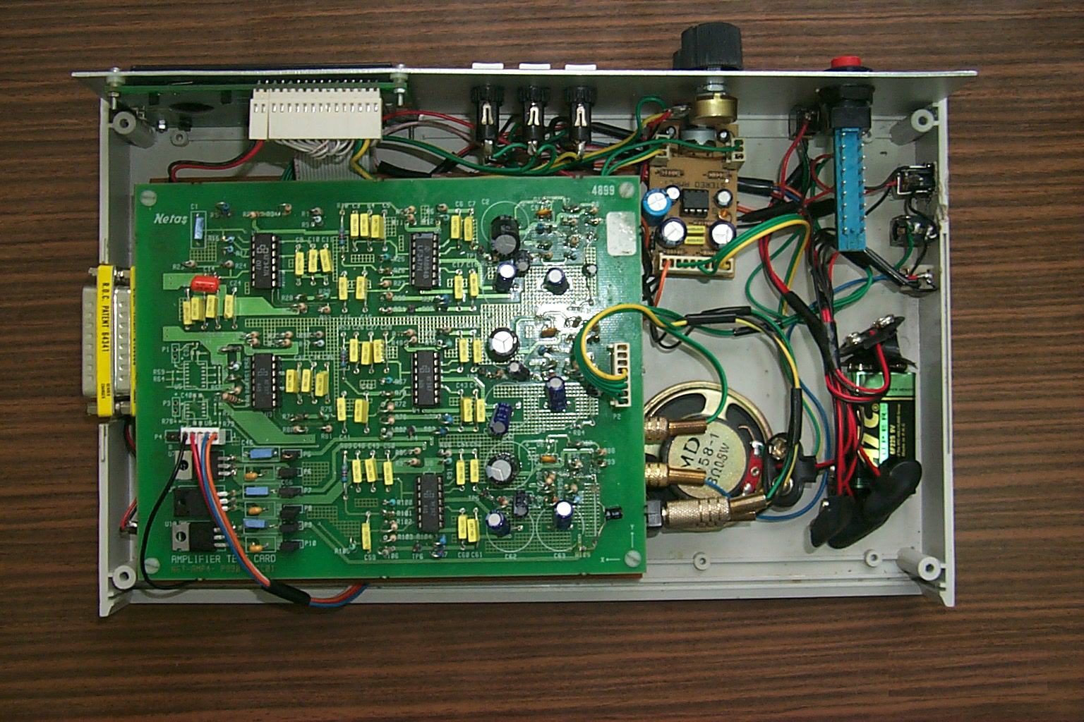
Amplifier Card
(upper floor)
DSP56311 EVM
(lower floor)
Power Amp.

