Maroc Telecom
Al Akhawayn University in Ifrane
School of Busines Administration
Hanine Toudghi, 78400
MGT 3305 01
Professor Abderrahman Hassi
April 28, 2021

Introduction:
Organizational behavior is the study of the behavioral dynamics of individuals and groups in organizational settings, including corporate offices. To meet their short- and long-term goals, business leaders need to understand what motivates their employees and how they interact with each other. That information can help in a host of areas, including employee training and development, and innovation and collaboration ("What is organizational behavior and why is it important?" 2020). From the courses of organizational behavior, I learned that motivation is one of the most important things to deal with employees in order to get the best of them. Without forgetting the major role that skill development and trainings play in the success of the company and in showing the presence of great leaders among the company. In this research paper I used Maroc Telecom as a model to see if it gives an importance to employee’s motivation, also to answer the question “Is Maroc Telecom aware of the importance of employee skill development and motivation?”. It is known that Maroc telecom is one of the most successful companies in telecommunication not only in Morocco but also in many other countries. Maroc telecom is the leader and the largest telecommunication company in morocco. It has around 12000 employees in 8 regional delegations with 220 offices present on all the territory of morocco. The company is listed on both the Casablanca Stock Exchange and Euronext Paris.

Methodology:
In my process I started with some research concerning motivation and the importance of employees skills development to enforce my knowledge about the topic. I used many sources that have peer reviewed and scholar articls, such as, google scholar and AUI ‘s library. Then I moved to collect data about the company and its field of production. Because the company is very known inside and outside Morocco, I thought it will be easier to find helpful information about how it deals with its employees, but it was not the case. I have done my reseach in French because was more helpful than English and information were more available using that language.
To collect data I used internet, but I did not find information about the relationship of Maroc Telecom and its employees which make it difficult. So, I used the web site of the company directly even if I did not find many helpful information. Second, I used a template called indeed which contains a session dedicated to company pages, where we can read reviews on many companies written either by current or former employees at the company we are interested in. Finally, I used the application Survey Monkey in order to know the direct responses of Maroc Telecom employees around morocco and they can say about their experience at this company.

Description:
Concerning the findings from the internet a find an article posted in “Le Matin” journal saying that Maroc Telecom is among the winners of the “50 Best Workplaces 2017” list, bringing together the best employers selected by the American magazine “Silicon Review”. The list, produced by the magazine specializing in ICT, highlights a selection of companies operating in new information and communication technologies (ICT), which offer the best working environment and where it is good to work. . “Silicon Review” was based on criteria related to human resources management “to which Maroc Telecom has successfully responded, which stands out for the excellence of its favorable working conditions and which contribute to professional development”, indicates the telecoms operator in a press release. According to the latter, human resources are the group's “first asset”. "Because the men and women of the company are the main lever for growth, the group focuses its human resources policy on the recognition of performance and the enhancement of skills, equity and equal opportunities", declares Maroc Telecom. The operator specifies that it is pursuing a forward-looking employment management approach, by making training and mobility privileged tools for skills development. "The group acts on a daily basis for the well-being and health of its employees through continuous improvement of working conditions, regular social dialogue and social benefits that take their priorities into account," says Maroc Telecom.
Second, the findings from the website of the company. Under the tab “Skill development” I found that skills development is at the heart of Maroc Telecom's HR strategy. It is particularly based on first, Career opportunities offered to employees at national and international level, allowing them to give new impetus to their professional careers within the group. Second, a very diversified and regularly enriched training offer to take into account changes in the environment and employee expectations. Finally, an annual interview that provides an update on the performance, expectations and career prospects of the employee.
Concerning the template indeed the comments that I found are as follow:
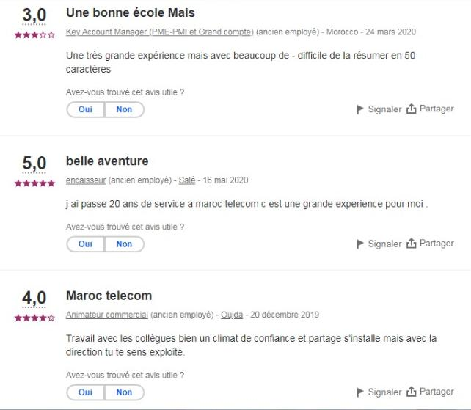
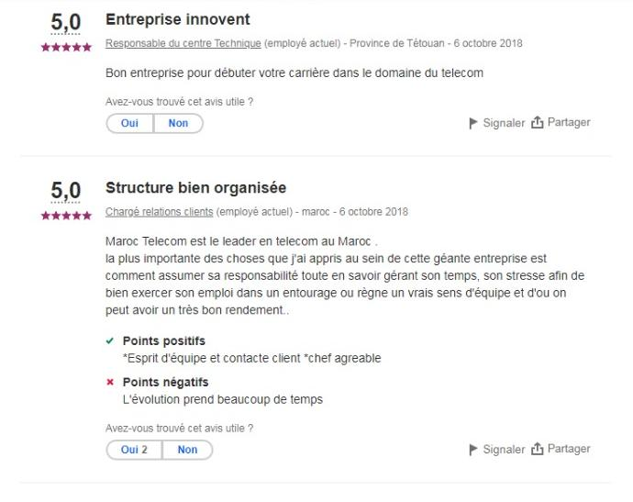
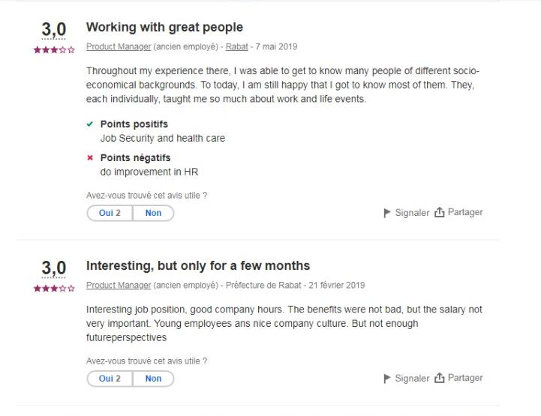
Finally, I have done a survey of five questions that are stated as follow:
Q1: What level of motivation you receive at Maroc Telecom?
Q2: Is Maroc Telecom offering you many trainings?
Q3: Do you have programs to develop your skills?
Q4: Do Maroc Telecom guarantee you a better future?
Q5: What can you add to this about your experience at Maroc Telecom?
I received ten answers from many places around Morocco (Ifrane, Azrou, Laayoun, Errachidia, and Fez). The answers were as follow:
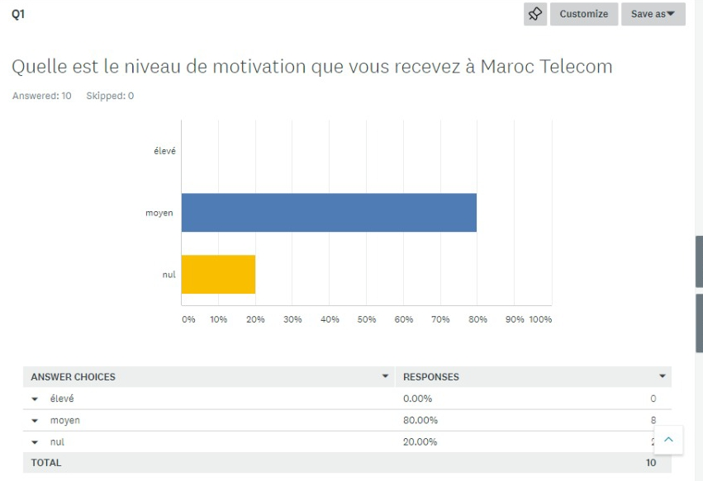
Here we can see that the majority have chosen the second choice. 80% of employees that filed this survey say that the level of motivation at Maroc Telem is not very high as it is mentioned in the website of the company.
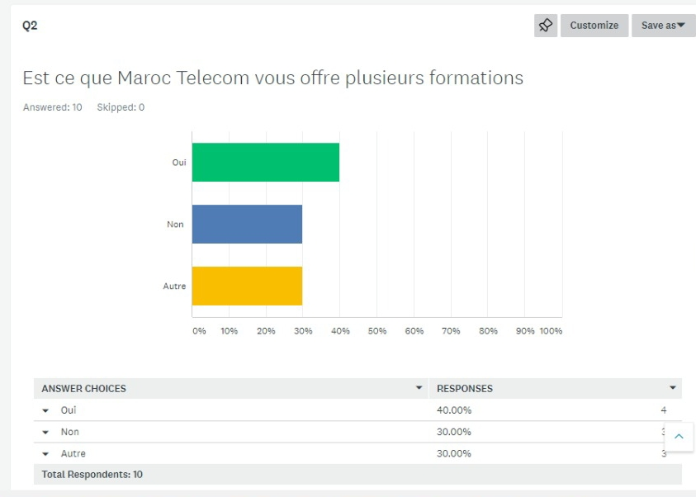
As we can see in the second question 40% of people that answered the survey said that they get training at Maroc Telecom, 30% answered with a no, and the other 30% chose the choice “other”.
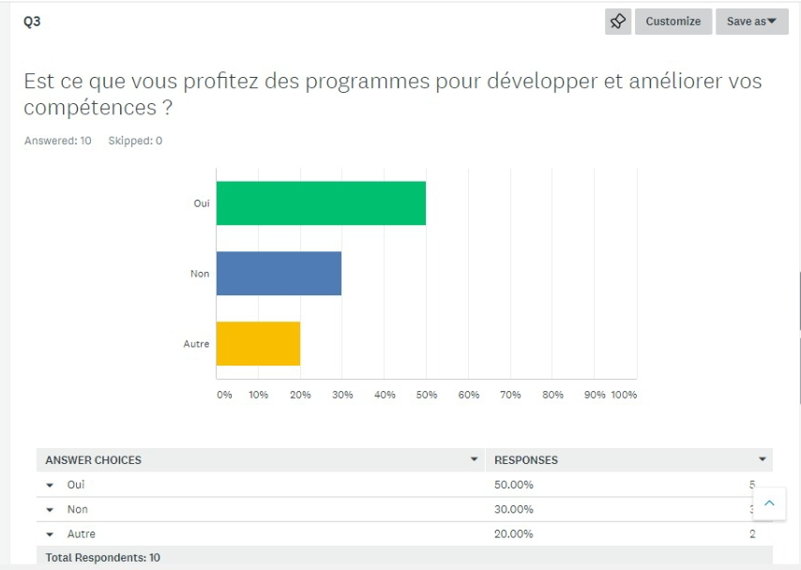
The answer of this question is on the favor of Maroc Telecom. 50% of the employees said that there are programs that help them develop their skills. 30% answered with a No. and 20% chose the alternative “other”.
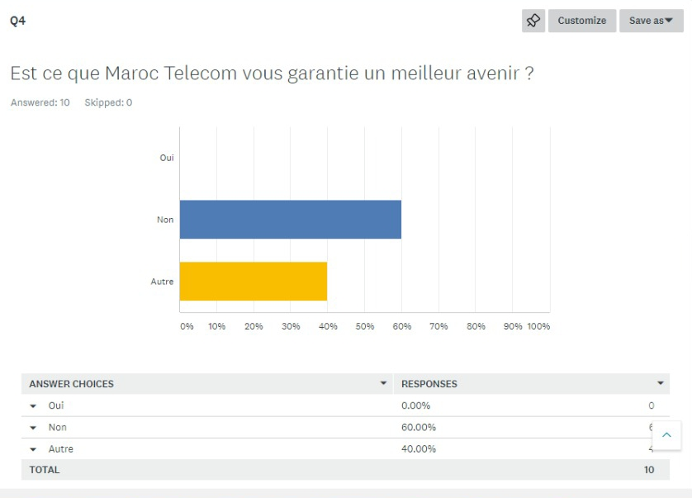All people that answered this survey agreed that Maroc Telecom do not guarantee a better future. 60% answered with a No and 40% chose “other”.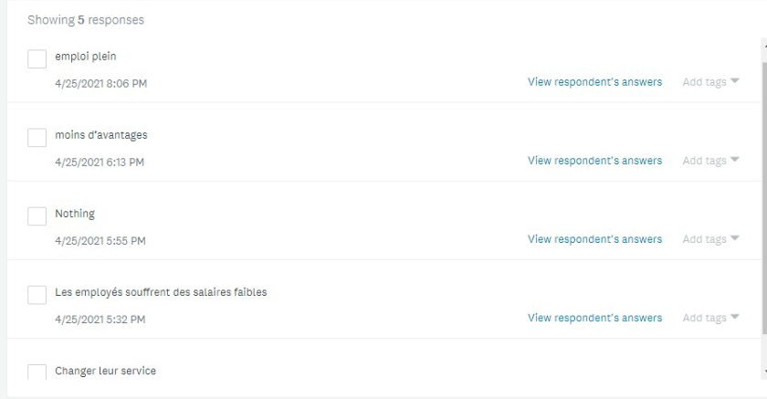
Here we can see that we have just 5 responses and most of them are negative.

Discussion:
Starting with the article and the fact that Maroc Telecom was from the top 50 companies that give importance to their employees by carrying about their skills, developing their knowledge about the industry, and how to deal with each other. As we have learned in the course employees feel valued when you provide with the recognition they deserve; in addition employees feel also valued when you give them positive and valuable feedbacks, because they feel that their work is more appreciated and that the manager have paid attention to what they have done. Moreover, always ask your employees about they opinion before deciding how to complete the task, this will make them feel that they point of view and their knowledge are very important and valuable. Moving to another point which is communicating with you employees frequently and clearly. When you talk to your employees directly and you determine the exact goals that you are waiting from them, they feel that they are responsible of achieving that specific goals which will make them feel that they have a value and a role in the success of the company. Adding to that, by Providing work that gives the right level of challenge, you show that you trust your employee’s capabilities. Give them increasing levels of responsibility to let them grow and develop ("How to make employees feel valued," 2018). When employees feel valued, they’re more motivated to remain loyal to the organization, even if it’s not perfect. Increased job satisfaction can lead to improved performance and reduced turnover.
Moving to the other point which is developing employees skills. this specific factor is very important for maroc telecom as it is mentioned in the website of the company: “employee skills development is at the heart of Maroc Telecom” which means that this company is giving a huge importance to developing its employees by organizing many training in multiple fields. When employees spend a long perioed without getting any training or without developing any new skills, they feel like if they need to be updated which will decrease their self-worth. Training and development opportunities should be seen as an investment in vital human resources. When companies offer training to their employees, they must remember the importance of illustrating the value their people have. Clearly demonstrating succession planning, a commitment to training and development, and a long-term commitment to employee career progression is vital. ("psychology of motivating employees through training and development," 2020). Companies such Maroc Telecom knew the importance of increase employees self-worth because it is considered as an important factor in managing the company. By developing employees skills, the employees self-worth will be developed automatically which can promote attachment, loyalty, and enthusiasm. Furthermore, it makes employees keen to structure their learning and development so that it meets organizational needs. As a result, the organization will develop an ideal atmosphere for learning and growing.
Moving to another important point which is remuneration. From employees feedback we can observe that Maroc Telecom is not offering good salaries to their employees which can affect their motivation. From the course and some articles I have read, I can say that remuneration is having a major role in motivating employees. Herzberg states that there are Two Factors Theory the first one is the carrier of satisfaction which include: achievements, recognition, the work itself, responsibility, the opportunity to improve career, and a good incentive. Good incentive is often regarded as remuneration by the employees. (“Remuneration, motivation, and performance: Employee perspectives / KnE social science,” n.d). As we have said before the recognition, the work itself, and responsibility give the employee more value which make them motivated. In the same sequence good remuneration that make employee responsible and willing to do their jobs perfectly.
The culture of the company is also very important. Concerning Maroc Telecom, it is very known for job security and health case insurances that provide to its employees and their families. Regarding what have in the website of the company, Maroc Telecom ensure the well-being of employees and their families. Maroc Telecom offers a range of social services intended for its employees and their families and is committed to continuously improving them ("Recrutement et Carriere chez Maroc telecom," n.d.). Furthermore, Maroc Telecom offers enhanced social protection, by securing medical and retirement devices. Each employee can thus benefit from additional medical coverage and a supplementary retirement plan allowing them to enjoy a peaceful future. Without forgetting to say that Maroc Telecom financially supports its employees to gain access to home ownership at subsidized rates, to acquire individual means of transport, to carry out pilgrimage duties or to spend family vacations in summer centers or resorts. tourist residences under agreement. In short, all these things are part of Maroc Telecom and can not be changed. Maroc Telecom focusses on the well being of its employees as part of motivating them to do their job in a comfortable environment and without being stressed about health problems. Let’s relate this to Maslow’s pyramid and McGregor theory of X and Y, starting from Maslow needs theory, McGregor argues that unsatisfied needs no longer motivate. Firms rely on money and benefits to satisfy employees’ lower needs and when the needs are satisfied and the motivation towards work is lost. Hence, the only way that employees can attempt to satisfy their higher needs in their work is by seeking compensation on which predictably financial rewards may be good to focus on. Theory Y assumes that work can be as natural as play that people will be moved to meet their work goals if they are committed to them and that rewards should be in place to address their higher order needs (the role of financial incentives on employees’ motivation in financial institutions in Tanzania). Managers should therefore provide a room that gives employees commitment to their jobs and hence scope for personal development. Thus, we can say that Theory X presents a pessimistic view of employees’ nature and behavior at work, while Theory Y presents an optimistic view of the employees’ nature and behavior at work. If correlate it with Maslow’s theory, we can say that Theory X is based on the assumption that the employees emphasize on the physiological needs and the safety needs; while Theory X is based on the assumption that the social needs, esteem needs and the self-actualization needs dominate the employees.

Conclusion:
In brief, my finding prove that people are having different experiences at Maroc Telecom. The website of the company and the article at “Le Matin” journal and some comments in indeed template show that Maroc Telecom care about its employees and it gives priorities to human resource development and that it gives more importance to make its employees more comfortable and develop their skills so they can benefit from them in their future lives. However, the survey that was done and some comment from indeed show that employees at Maroc Telecom do not get valuable formation nor useful programs to develop their skills. By answering our question “Is Maroc Telecom aware of the importance of employee skill development and motivation?” we can say yes Maroc Telecom gives a huge importance to developing its employees skills because it is a way to motivate them and give them more value.

References
How to make employees feel valued. (2018, December 17). HR Daily Advisor. https://hrdailyadvisor.blr.com/2018/12/27/how-to-make-employees-feel-valued/
M.A.H., & LETIN. (2018, January 15). Maroc telecom parmi Les 50 meilleurs employeurs en 2017. Le Matin. https://lematin.ma/journal/2018/maroc-telecom-parmi-50-meilleurs-employeurs-2017/285439.html
Maroc telecom. (2006, May 28). Wikipedia, the free encyclopedia. Retrieved March 8, 2021, from https://en.wikipedia.org/wiki/Maroc_Telecom
The psychology of motivating employees through training and development. (2020, September2). Training Industry. https://trainingindustry.com/blog/performance- management/the-psychology-of-motivating-employees-through-training-and-development/
“The Role of Financial Incentives on Employees’ Motivation in Financial Institutions in Tanzania” Edmund Kyaruzi Barongo (n.d). https://core.ac.uk/download/pdf/33426057.pdf
Toutes Les infos du Groupe Maroc telecom : Actualités, gouvernance ... (n.d.). Maroc Telecom : forfaits téléphone mobile, fixe, internet, adsl, wifi, 4G, 3G Maroc. https://www.iam.ma/groupe-maroc-telecom
Travailler chez MAROC telecom : Avis de salaries | Indeed.com. (n.d.). Job Search | Indeed. https://ma.indeed.com/cmp/Maroc-Telecom/reviews
Remuneration, motivation, and performance: Employee perspectives | KnE social sciences. (n.d.). KnE Publishing Platform. https://knepublishing.com/index.php/KnE- Social/article/view/3119/6619
Recrutement et Carriere chez Maroc telecom. (n.d.). Maroc Telecom : forfaits téléphone mobile, fixe, internet, adsl, wifi, 4G, 3G Maroc. https://www.iam.ma/groupe-maroc- telecom/carrieres/carriere-chez-maroc-telecom.aspx
What is organizational behavior and why is it important? (2020, August 17). Rider University. https://online.rider.edu/blog/what-is-organizational-behavior-why-is-it- important/
Link to the survey: https://fr.surveymonkey.com/r/BPZZR6M

