Project: Healthy You


Healthy You

Prepared by: Supervised by:
Achraf Mrani Pr. Hind Bouzekri
Nassima Ait Benichou Hanine Toudghi Manar Hafed
Amine Benslimane

Outline:

- The project charter

- The project scope document

  - Work Breakdown structure

  - Responsibility Assignment Matrix

  - List of activities

  - Network Diagram

- The project schedule

- The project budget

- The resource requirement plan

- The risk assessment matrix

- The post-project evaluation

Introduction:

Eating Healthy is a must for everyone who wants a good health, to be fit, or to make muscles. For You Restaurant noticed that many of its customers -AUI students, AUI professors, and even customers who are just passing by- are asking for a new menu that contains healthy food, as they had enough of all the Oily and not healthy food. This is why Our team in collaboration with this restaurant are working on a project called “Healthy You” that contains a new menu, new potential collaborations and one big space for healthy meals, in order to gain new customers.

1st deliverable:

Project Charter
Project Title: | Healthy You
Project Start Date | May 1, 2022 |  | Project End Date: |  | June 1,  2022 | Sponsor: |  | For You
Project’s Purpose:
For You noticed that some customers ask for healthy meals rather than what they offer
We plan to create another menu a healthy one that will target new customers (people who do care about their health and fit people)
Project’s Objective:
Grow our market share through gaining the trust of a new range of customers by adding a healthy space at For You within a duration of 32 days, using a budget of 600,000 MAD
Project’s Description:
This project is the creation of a healthy space that can host up to 30 clients. It consists of totally new menu with just healthy meals with counted calories, carbs..
Funding:
The maximum funding the sponsor agreed to allocate to this project is 600,000 MAD. The budget estimation however is 560,490 MAD.
Project Team:
 |  | Name |  | Department |  |  | E-mail
Project Manager: |  | HanineToudghi |  | Management |  |  | H.toudghi@aui.ma
Team Members: |  | Khalid Achraf Mrani |  | Human Resources |  |  | A.mrani@aui.ma
 |  | Nassima Ait  Benichou |  | Finance |  |  | N.aitbenichou @aui.ma
 |  | Manar Hafed |  | Marketing |  |  | M.hafedd@aui.ma
 |  | Amine Benslimane |  | Design |  |  | A.benslimane@aui.ma

Project’s Scope: | Major Project’s Milestones:
Contact our sponsor For You and The protein companies (Whey, Casein, Protein bars...), choose the right healthy meals that will be put on the menu, agree on the terms of the contract, design the menu, do a great promotional campaign to promote the new product. | - Initiating: meeting with the clients and the team to plan the new  concepet  From: May 1, 2022, To: May 7, 2022  - Planning: Dividing tasks, start the work  From: May 7, 2022 To: May 14, 2021  - Perfoming: Importing, purchasing bio, designing, promoting  From: May 15, 2022 To: May 28, 2022  - Closing: Making final payments, post-project evaluation  From: May 29, 2022 To: May 31, 2022
Major Risks: | Risk Rating:
Import restrictions (Vending Machines) | High
Late Delivery | Medium
Cost risks | Medium
Scope Creep | Low
Damaged books | Low
Success Criteria: | Key Assumptions:
- New market share  - More Revenue  - Athletes come more often to Ifrane to train, and they prefer to eat healthy to keep their body  fit  - Target AUI professors and students who used to teach in big cities and we were used to eat healthy food and they couldn’t find anything in Ifrane.  - There is no concurrence, everyone in Ifrane is focused on Fast food, Pancakes… | The space will operate after the opening day, and the sponsor will start immediate executive management of it.
Approval requirements: | Reporting requirements:
- We should show them are previous projects.  - Word of mouth of our previous customers | - Laws: we should provide healthy food with quality and respecting the criteria of the ONSA. We have the ISO 9001 so that won’t cause a problem  - Rules:

- We have the certificate Of Quality ISO 9001 | - we should respect the deadline set by For YOU  - We shouldn’t exceed the budget  - We should keep the new menu somehow related to the old one (do healthy meals based on chicken, meat, sushi and pizza, do not forget vegetables and fruitd.) and we may provide protein shakes with powder protein ready to serve, one scoop of whey, masstech, creatine…
Major Deliverables: | Constraints:
-Administration permits  -Internal design drawing  -Engineering reports  -Completed construction  -Quality Check reports | -A total budget of 600,000 MAD  -A duration of 32 days  -Customer satisfaction

2nd deliverable:

Work breakdown structure:

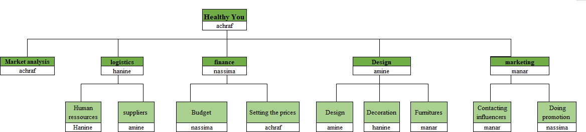
The WBS is a crucial element in the project scope document of any project. It breaks down the project into smaller components while representing them in a hierarchical decomposition. For the study space project, this work decomposition will be done on three main levels: level 0, level 1, and level 2, where we tried to assign the major deliverables under each of the departments responsible for the task.

Responsibility Assignment Matrix

In order to divide responsibilities among the team members, we used the responsibility assignment matrix tool, where we listed all our work items and made sure that each one of them has only one Primary Responsible and at least one Support Responsible.

Responsibility Assignment Matrix
WBS | Work item | Achraf | Nasima | Amine | Hanine | Manar
1 | Market analysis | P | S
2 | Logistics |  |  | S | P
2.1 | Human resources |  |  | S | p
2.2 | suppliers | S | S | P
3 | Finance |  | P |  |  | S
3.1 | budget |  | P | S |  | S
3.2 | setting the prices | P |  |  | S
4 | Design |  | S | P |  | S
4.1 | design |  |  | P |  | S
4.2 | decoration | S |  |  | P
4.3 | Furnitures | S | S |  |  | P
5 | Marketing |  |  | S |  | P
5.1 | contacting influencers | S |  |  | S | P
5.2 | doing promotion |  | P |  | S

List of activities
Our project will be executed through a list of 24 activities. This list starts with Doing a survey to Know how many people are willing to eat healthy and is followed by other activities related to the necessary purchases, the required installation, as well as the hiring process. We organize all of these in the table below, which has the activity number and description, the linked work package, and the activity’s predecessor.

Activity number | Activity description | Work package | Predecessor s
1 | Doing a survey to Know how many people are willing to eat healthy | Market research | none

2 | Look if there are any competitors (doing the SWOT analysis) | Market research | none
3 | designing the healthy you space | Design | 1,2
4 | Making a list of charges (Resources needed) | Budget | 1,2
5 | Estimating the cost of hiring new people, their training and the cost of the material | Budget | 1,2
6 | Contacting the suppliers and ask for a proposal | suppliers | 3
7 | determine the ingredients and their quantities | suppliers | 3
8 | hiring workers | Human resources | 4
9 | Designing the menu | Design | 6
10 | Setting the prices | Setting the prices | 6
11 | Decoration of the space dedicated to “healthy you” | Design | 3
12 | purchase plant | Decoration | 11
13 | paint the space | Decoration | 11
14 | prepare the flooring | Decoration | 11
15 | purchase tables | Furnitures | 13,14
16 | purchase chairs and sofas | Furnitures | 13,14
17 | purchase heaters | Furnitures | 16
18 | Creating a social media page on all platforms | Doing Promotion | 17
19 | Setting a list of influencers that we should contact for promotion (opening day) | Doing promotion | 18
20 | Signing the contracts with the influencers | Contacting influencers | 19
21 | Booking housing and transportation for the guests and the influencers | Contacting influencers | 20
22 | Creation of flyers and banners for the promotion of opening day date | Doing promotion | 18
23 | Doing promotion in the city of Ifrane, through banners appearing in the hot spots of Ifrane( the Marche, near  the lion, Ain Vittel…) | Doing Promotion | 22
24 | Welcoming people on the opening day | Doing promotion | 23

3rd deliverable:
The following table presents the schedule for our projects. We have identified the ES EF LS LF and the TS for each activity. We have also identified the critical path which are the activities highlighted in ORANGE. The total slack is 0 which means that our project will be ready on time. Therefore, we should make sure to respect the durations given to each activity, so we avoid the risk of being late.

Activit y numbe r | Durati on | ES | EF | LS | LF | Total slack
1 | 7 | 0 | 7 | 0 | 7 | 0
2 | 3 | 0 | 3 | 4 | 7 | 4
3 | 4 | 7 | 11 | 7 | 11 | 0
4 | 2 | 7 | 9 | 22 | 24 | 15
5 | 5 | 7 | 12 | 27 | 32 | 20
6 | 7 | 11 | 18 | 21 | 28 | 10
7 | 7 | 11 | 18 | 25 | 32 | 14
8 | 8 | 9 | 17 | 24 | 32 | 15
9 | 2 | 18 | 20 | 30 | 32 | 12
10 | 4 | 18 | 22 | 28 | 32 | 10
11 | 5 | 11 | 16 | 11 | 16 | 0
12 | 2 | 16 | 18 | 30 | 32 | 14
13 | 2 | 16 | 18 | 16 | 18 | 0
14 | 2 | 16 | 18 | 30 | 32 | 14
15 | 1 | 18 | 19 | 31 | 32 | 13
16 | 1 | 18 | 19 | 18 | 19 | 0
17 | 3 | 19 | 22 | 19 | 22 | 0
18 | 1 | 22 | 23 | 22 | 23 | 0
19 | 3 | 23 | 26 | 23 | 26 | 0
20 | 2 | 26 | 28 | 26 | 28 | 0
21 | 4 | 28 | 32 | 28 | 32 | 0
22 | 3 | 23 | 26 | 25 | 28 | 2
23 | 3 | 26 | 29 | 28 | 31 | 2
24 | 1 | 29 | 30 | 31 | 32 | 2

Network diagram

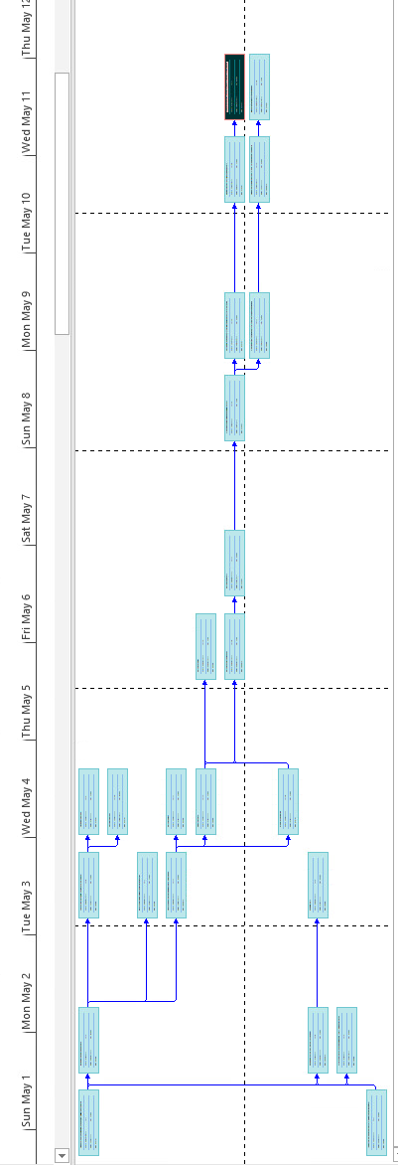

4th deliverable:

PROJECT BUDGET:
Every endeavor, no matter how large or little, incurs expenses. It is uncommon to have unending amounts of money on hand, therefore establishing a budget for a project is essential. As the project manager, you will be held accountable for keeping to the budget, so make sure it is correct

Activities | Responsible | Work period (days) | Labor cost | Material cost | Cost estimated
Doing a survey to Know how many people are willing to eat healthy | Achraf | 7 | 200 | 100 | 300
Look if there are any competitors (doing the SWOT analysis) | Hanine | 3 | 350 |  | 350
designing the healthy you space | Amine | 4 | 12 000 | 5 400 | 17 400
Making a list of charges (Resources needed) | Nassima | 2 | 670 |  | 670
Estimating the cost of hiring new people, their training and the cost of the material | Achraf | 5 | 47 000 | 60 000 | 107 000
Contacting the suppliers and ask for a proposal | Hanine | 7 | 9 000 | 1 200 | 102 000
determine the ingredients and their quantities | Amine | 7 | 32 000 | 21 000 | 53 000
hiring workers | Hanins | 8 |  | 35 000 | 35 000
Designing the menu | Manar | 2 | 2 000 | 1 000 | 3 000
Setting the prices | Achraf | 4 | 1 600 | 650 | 2 250
Decoration of the space dedicated to “healthy you” | Nassima | 5 | 13 000 | 6 700 | 19 700
purchase plant | Amine | 2 | 55 000 |  | 55 000
paint the space | Hanine | 2 | 30 000 |  | 30 000

prepare the flooring | Achraf | 2 | 4 500 |  | 4500
purchase tables | Amine | 1 | 6 000 |  | 6 000
purchase chairs and sofas | Nassima | 1 | 8 900 | 7 000 | 15 900
purchase heaters | Manar | 3 | 17 000 | 34 000 | 51 00
Creating a social media page on all platforms | Manar | 1 | 3 700 | 2 000 | 5700
Setting a list of influencers that we should contact for promotion (opening day)  Signing the contracts with the influencers | Achraf Manar | 3  2 | 23 000  4 000 | 15 500 | 23 000  19500
Booking housing and transportation for the guests and the influencers | Achraf | 4 | 10 000 | 6 000 | 7000
Creation of flyers and banners for the promotion of opening day date | Hanine | 3 | 600 | 320 | 920
Doing promotion in the city of Ifrane, through banners appearing in the hot spots of Ifrane( the Marche, near the lion, Ain  Vittel…) | Nassima | 3 | 800 | 500 | 1300
Welcoming people on the opening day  Total cost | Manar | 1 |  |  | 560 490

5th deliverable:
Resource Requirement Plan

Name | Activity | Working days
Hanine | 2.6.8.13.22 | 23
Nassima | 4.11.16.23 | 11
Manar | 9.17.18.20.24 | 9
Amine | 3.7.12.15 | 14
Achraf | 1.10.14.19.21 | 19

6th deliverable
Risk assessment matrix

We live in a constantly changing world. When a project is completed, it is reviewed in detail by the team. There is no guarantee, however, that everything will go as planned. We won't be able to account for all possible dangers, but we can predict some of the most likely ones. To aid in the evaluation and management of risk, a risk assessment matrix is employed. This matrix contains the risk description, its impact, its likelihood of occurrence, its degree of impact, the action on trigger, the responsibility, and the response plan.

Risk | Impact | Likelihoo d of occurrenc e (L,M,H) | Degree of Impact | Action on trigger | Responsibilit y | Response Plan
Lack of success among costumers | Failure of the project | M | H | -Not the expected sales at the launching | Achraf | -Reassess the need of costumers.  -Look for alternative suppliers

Cost risks | Make the new menu not profitable enough | L | H | -Increase in the price of raw materials | Amine | -Look for alternatives that are less costly  -look for less expensive suppliers
Scope creep | -Delay in the finish date  -conflict with customer  -damage to the scope | M | L | -Multiple meetings with the client to discuss all details  -Include clauses in the contract about the rationality of requirements | Achraf | -Flexible management  -Negotiate the most beneficial arrangements for the completion of the project
Low quality foods | -revulsing costumers of For you | L | H | -a lot of merchandise unfit for consumption  -complaints from the kitchen staff | Manar | -Arrange  for suitable tra nsportation for the merchandise  -Work with suppliers that  have good reputation
The teams in charge of kitchen is not effective enough | Slow service Quality issues | H | H | -complaints from costumers  Staff overwhelmed with tasks | Hanine | -Train the staff more
The contractor does not like our conception | Unsatisfied contractor | M | H | -The contractor’s reaction | Hanine | Have a wide range of meals to make replacements  -Look for innovative recipe from the  all around the world
The competition retaliates with similar products | High competition Lower market share | L | M | -The competition’s reaction | Nasima | Always innovate by replacing low sale products with new meals

Supply chain issues | Lack of ingredients Inability to offer everything in the menu | H | H | -Orders are not complete  -The merchandise does not arrive on time | Manar | Give a warning to the supplier Look for other suppliers
The promotion (advertisements) is not effective enough | Less costumers than expected | L | M | There are not enough clients aware of these new offers | Nasima | Revise the marketing strategy to find the reason it wasn’t effective Spend more in advertisement
Budget risks | The budget allowed by the contractor is not enough | M | M | The first activities cost significantly more than expected | Amine | Expose the fact to the contractor Remove less impactful activities  Look for alternatives that are less  costly.

7th deliverable:

Post project evaluation:

The problem-solving method was extremely beneficial in preventing exposure to situations that could jeopardize the project's completion. Also helpful were the WBS's organizational structure and clearly defined roles for each member. Reporting difficulties and delegating the problem- solving process to the appropriate resource was the technique. Regular meetings among team members also aided in the identification of problems. However, there is room for improvement, notably in terms of communication between team members and between team members and their respective supervisors.
The issues that were discovered and rectified are as follows:
- Our client was not very enthusiastic concerning the concept during the first days
  - We made multiple meetings with him and made sure that he could oversee each step of the project before execution. We also looked for feedbacks using a questionnaire. We rectified the parts he was not agreeing with in order to fit his requirements (appendix 1)

- The staff had difficulties at the beginning to adapt
  - We gave them additional trainings and got their insights by survey in order to make their work conditions better. We proposed to either add additional staff or increase their wages accordingly to the increase in workload (appendix 2)

- There was a lack of communication between the different members of the team
  - We made sure that everyone could voice its concerns. We also created work channels through social media in order to stay in touch. We also made the members of the teams bond by making them do activities together.

- We had some trouble looking for a chef willing to move to Ifrane
  - We looked thoroughly in internet and social media to finds the adequate profile. We tried to negotiate an offer that will suit both parties in terms of salary and advantages. After that, we trained him concerning the menu and got his insight on the possible improvements

Lessons Learned:
Some lessons were learned and documented for future reference based on the mistakes made, the problems and issues that arose, and the overall experience:
- Lack of Communication: We ran into certain issues due to a lack of communication.
- Employee performance should be monitored on a regular basis, particularly early in the project, and motivational solutions should be encouraged, as a precautionary measure in future scenarios
- Lack of Team Spirit: Some teams were disjointed and worked in a tense manner with one another. Plan a casual meet-together to help team members get to know one another and, as a result, address this problem.
- Knowledge Sharing: When younger team members (junior resources) do not receive assistance from seniors, knowledge sharing becomes an issue. The problem can be solved by assigning senior team members to mentor new team members.
- Some assumptions resulted in a discrepancy between the project's actual results and the client's expectations. Meetings with the client should be scheduled before each phase that was not included in the design to convey the vision for those features and obtain their consent.
- Improved collaboration amongst all project teams through regular reviews to avoid costly mistakes

