The impact of Moroccan culture in negotiation

Reflection Paper
Al Akhawayn University in Ifrane
School of Business Administration
MGT 4314 01
Professor Abderrahman Hassi
Hanine Toudghi, 78400
December 2, 2021

Negotiation can be defined as the process of discussion an issue or a deal and getting at the end to a point of agreement. In the negotiating process we always have the negotiating part which can be one person or more representing either themselves or another party and we do have the counterpart that can also be the same thing either one individual or a group representing themselves or an organization. Negotiation play a huge role the management and business world in general as well as it is used daily. We are negotiating in a daily basis for example while buying something we can negotiate for the price, delivery, or paying taxes.
Negotiating across cultural divides adds a whole new dimension to any negotiation, bringing language barriers, variances in body language and clothing, and new methods of expressing satisfaction or disapproval with deal elements. As a result, many negotiators are concerned that they may accidentally destroy an important deal or do something that would bring them long-term embarrassment. To overcome these worries, rethink negotiation in an international context, and better know and learn how to negotiate in cross-cultural circumstances, a handful of basic negotiating skills may be simply put into practice.
For collecting data, I relied on primary and secondary data. Concerning the primary data, I am doing interviews with professors here in our university in order to know more about the concepts. Also, with shop workers that have direct contact with customers, so they can give me the real picture of the negotiation process about prices or any other deals. In addition, I will do interviews with managers that deals with suppliers and other companies. My interview is composed of multiple questions such as:
What is your main job?
How many years have you been working?
What degree do you have?
What is the most common type of negotiation that you are required to do?
Did you get any communication, negotiation, or conflict resolution training?
What about negotiation? Do you have any old experiences in negotiation before this job?
What do you think is important while negotiating with your Moroccan customers/ suppliers?
For this point I have done five interviews, most of them were fluent and I did not find any problem with people that were interviewed.
Moving to the secondary data I will rely on the course material at first and what I have learned from it, second the course tat I have took in Coursera about cross cultural negotiation and the case studies that were discussed. In addition to a very important factor which is the key dimensions to profile the Moroccan culture, so I can see the impact of it on the negotiation style in our country. According to Hofstede insights:
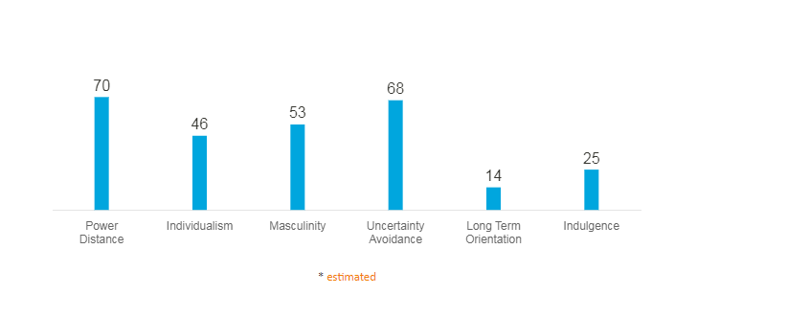
Moreover, I will be also using The Weiss strategic framework Weiss' framework organizes the culturally responsive methods that might be used based on each negotiator's level of awareness with the culture of the other. The strategies in brackets reflect a collaborative effort among the parties involved.
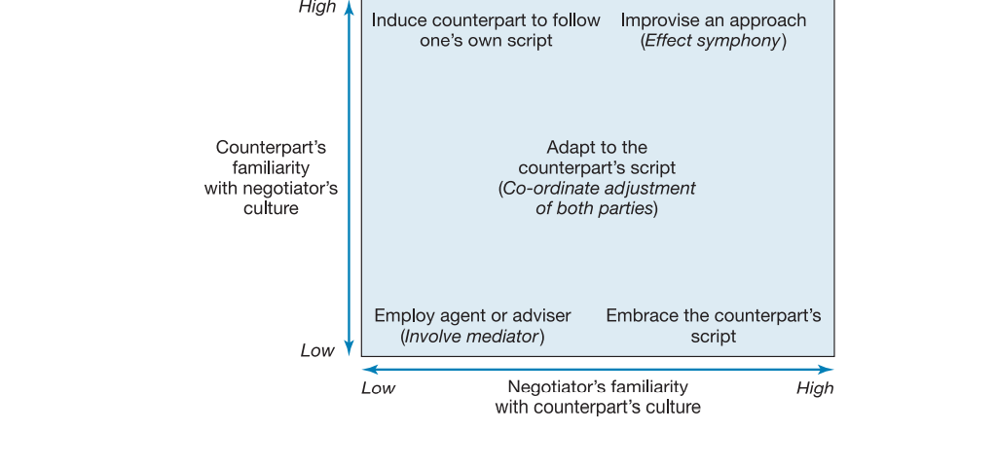
I will be using two other articles that were reviewed by Massachusetts Institute of Technology Sloan management review, which are “Negotiating with Romans” part one and part two. For the first article it presents five steps for selecting a culturally responsive strategy and then offers various tips for implementation, such as making the first move, monitoring feedback, and modifying the approach. These guidelines reflect four basic, ongoing considerations for a strategy which are feasibility, coherent interaction, appropriateness, and acceptability. For the other article it represents eight culturally responsive strategies. That are cited as follow
- Low Familiarity with Counterpart’s Culture
Employ Agent or Adviser.
Involve a Mediator.
Induce the Counterpart to Follow One’s Own Script.
Moderate Familiarity with Counterpart’s Culture
Adapt to the Counterpart’s Script.
Coordinate Adjustment of Both Parties.
- High Familiarity with Counterpart’s Culture
Embrace the Counterpart’s Script.
Improvise an Approach.
Lastly I will be basing on an articles showing all the tips that can help negotiate in Morocco it is entitled “How to Negotiate in Morocco” it has the etiquette to be used while having a B to B negotiation what is the cultural aspects that should be respected and how the Moroccan culture affect negotiation in general.

References
Browaeys, M.-J., & Price, R. (2020). Understanding cross-cultural management. Pearson.
How to negotiate in cross-cultural situations. PON. (2021, November 20). Retrieved December 1, 2021, from https://www.pon.harvard.edu/daily/leadership-skills-daily/how-to-negotiate-in-cross-cultural-situations/.
Morocco. Hofstede Insights. (n.d.). Retrieved December 1, 2021, from https://www.hofstede-insights.com/country/morocco/.
Weiss, S. E. (1994, April 15). Negotiating with "romans" - part 2. MIT Sloan Management Review. Retrieved December 1, 2021, from https://sloanreview.mit.edu/article/negotiating-with-romans-part-2/.
Weiss, S. E. (1994, January 15). Negotiating with "romans" - part 1. MIT Sloan Management Review. Retrieved December 1, 2021, from https://sloanreview.mit.edu/article/negotiating-with-romans-part/.

