Task

1. **Project Selection:**
   * You can choose any existing Django project. If you don't have one, you can clone a project from https://github.com/AvinashAnand02/Django-Blog.git
   * You may use a cloud server or your local system for deployment.
2. **Deployment Requirements:**
   * Deploy the Django project using Nginx and Gunicorn.
   * Ensure the deployed project is accessible via a web browser.

🡺

* Launching AWS EC2 linux machine, installing git, docker, nginx on virtual machine.
* Cloning github repository and creating Dockerfile to run a python container on 8000 port, build the image and running the container.

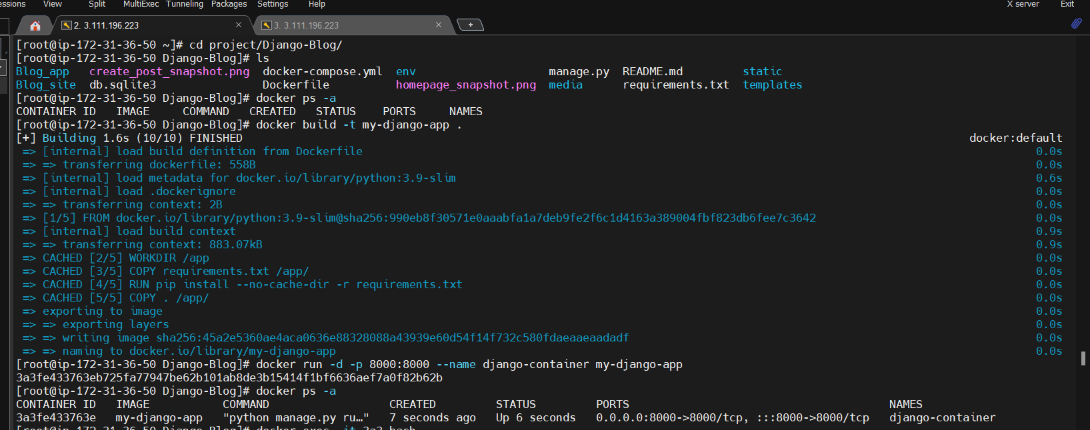

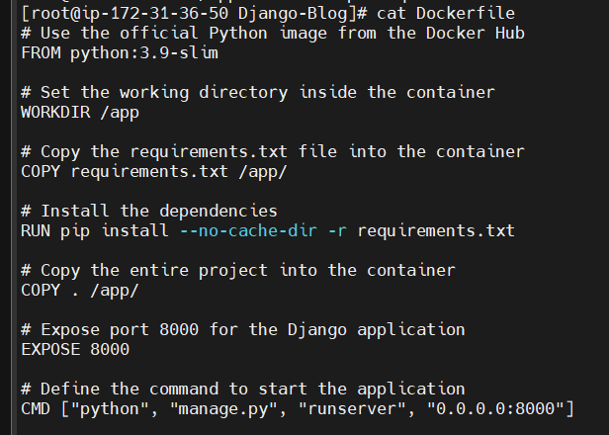

* Starting nginx server and creating myapp.conf configuration file in /etc/nginx/conf.d that send the request from 80 to 8000 port.

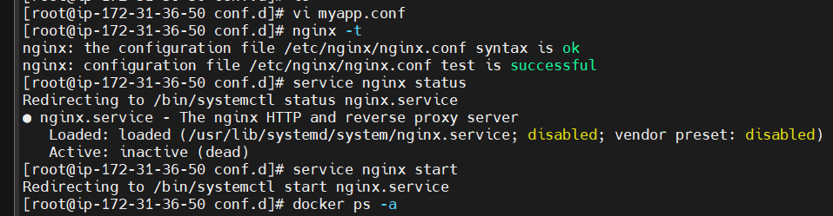

* Binding gunicorn and nginx from inside the container that is running Django-blog application.

