Assignment DATE- 22/3/24

Deploying LoginWebApp.war on tomcat container and connecting its database to another mysql container.

🡺

Installed java-11 , git , maven, docker

Pulled repo using git clone , and created .war file using mvn clean install

Created custom bridge network

Created tomcat container with 8080 port mapping, and copied .war in webapps

Created my mysql container using this cmd

**docker run -it --network toufik mysql mysql -h database-1.c9y4qaq0cohk.ap-south-1.rds.amazonaws.com -u admin -p**

created database in container.

Configured database link in application.

Started tomcat using ./catalina.sh run

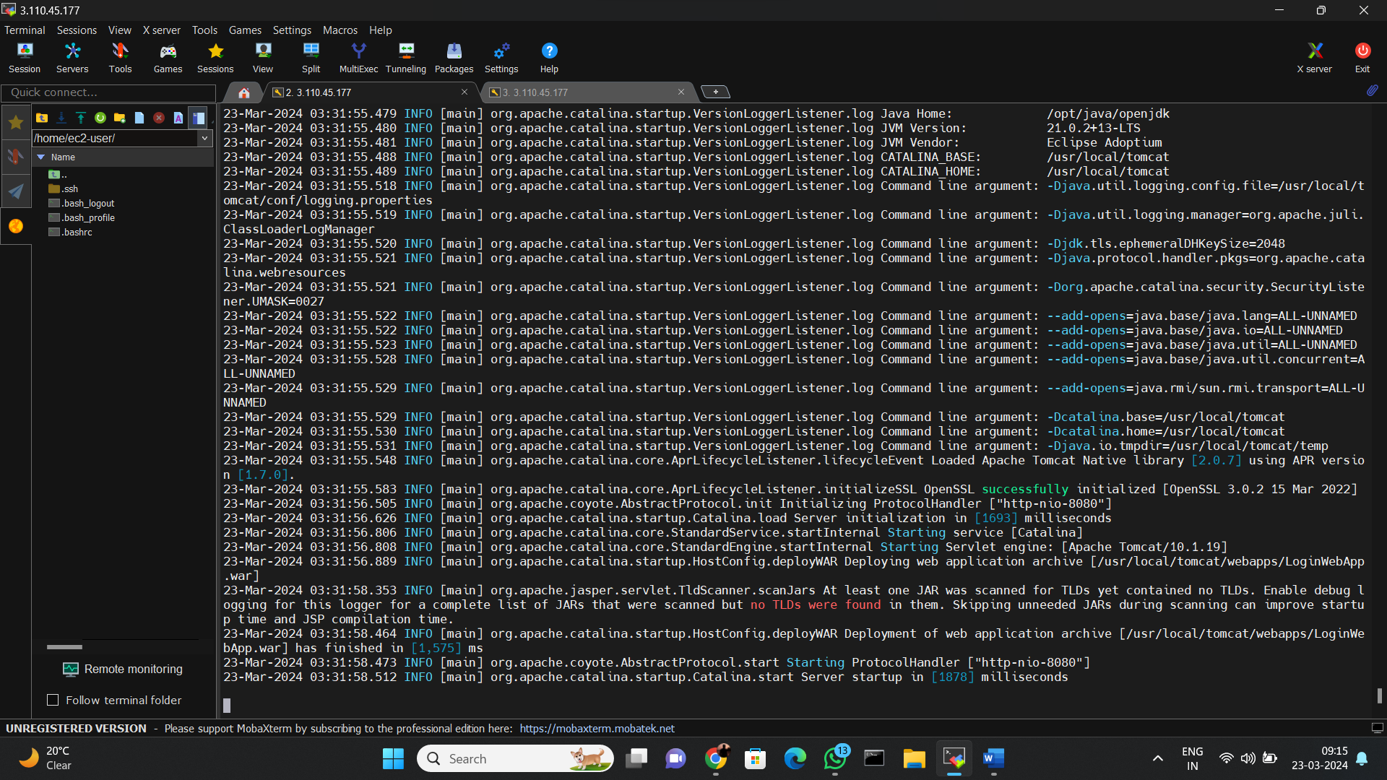

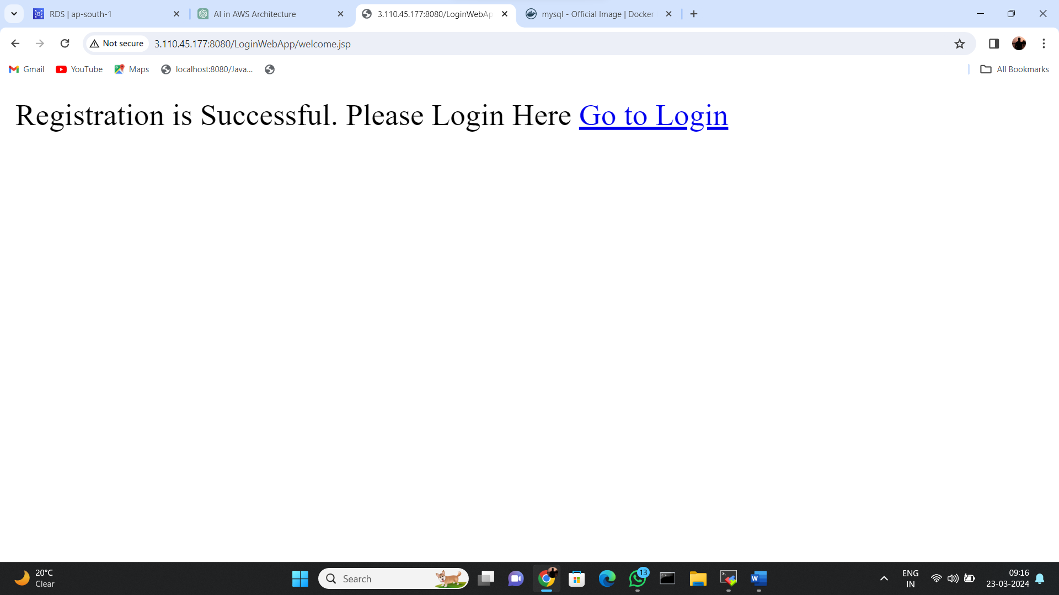

Fetching data in database

