Assignment 1

Deploying index.html from 4 branches q1 q2 q3 q4 using JDP , docker container , httpd , on individual ports 80, 90, 8001, 8090

=🡺

Installing tomcat , Jenkins , java , docker on machine

Then creating pipeline

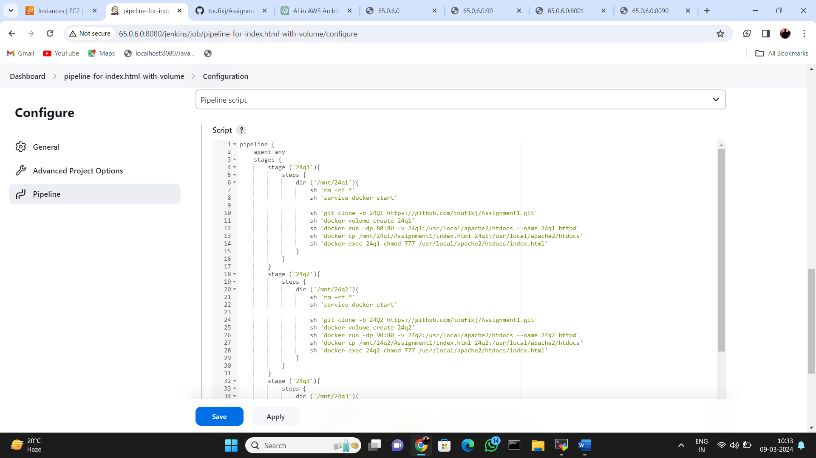

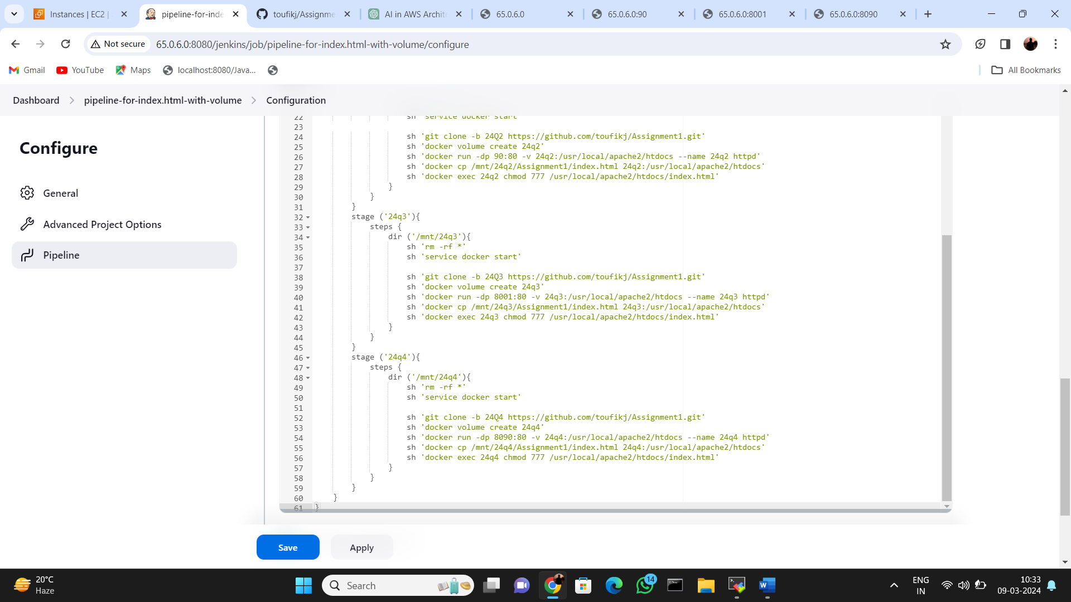

Building the job

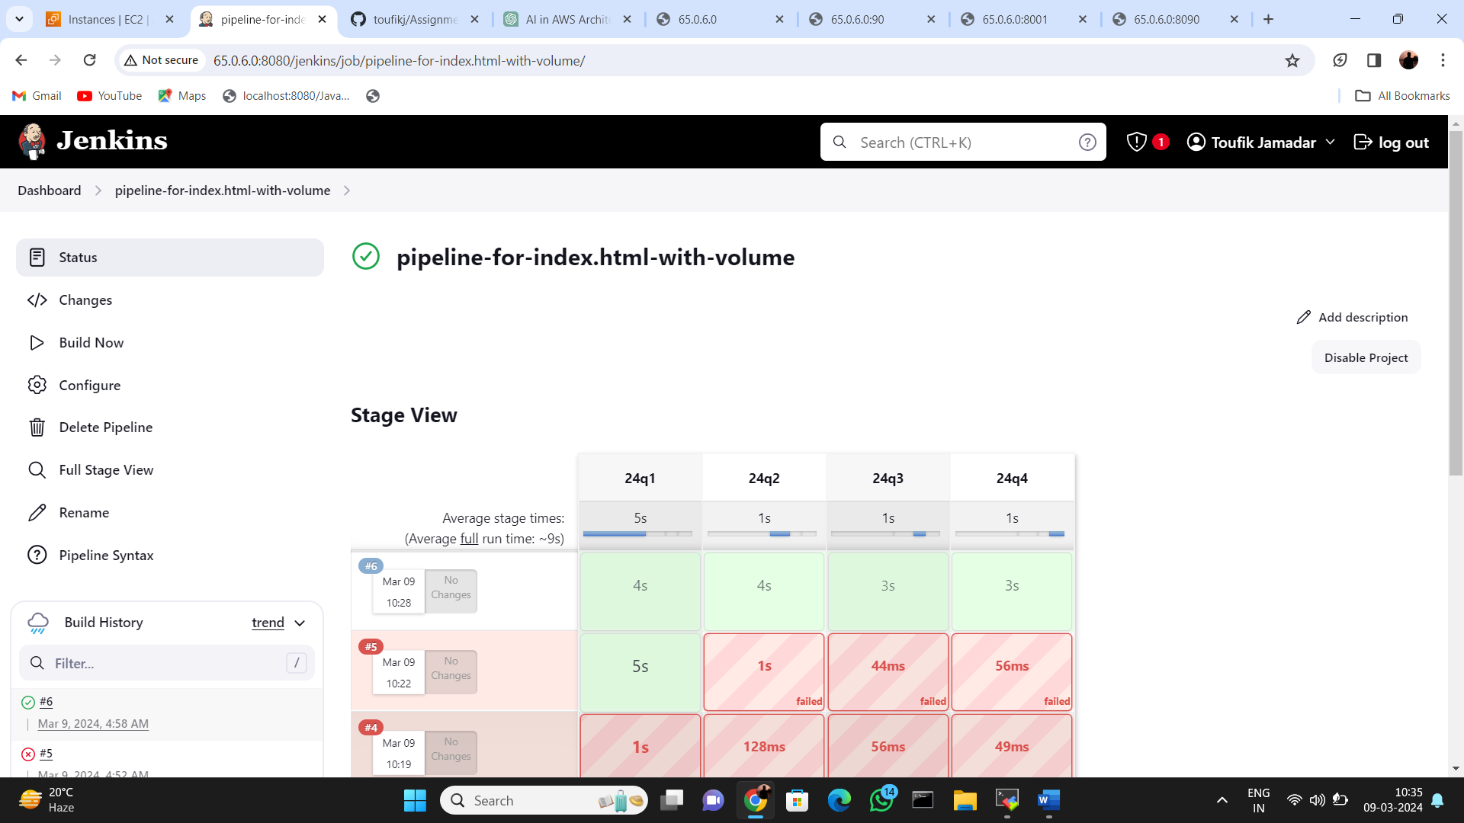

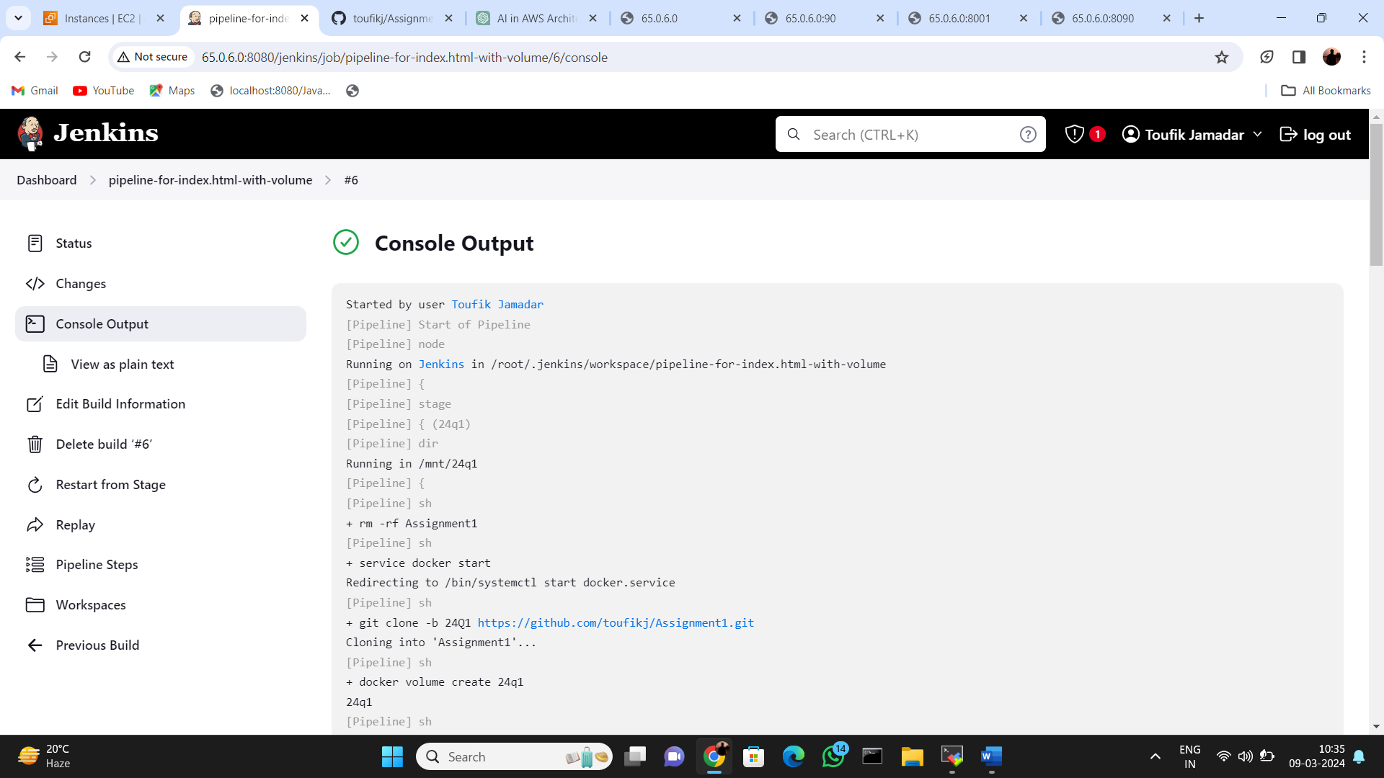

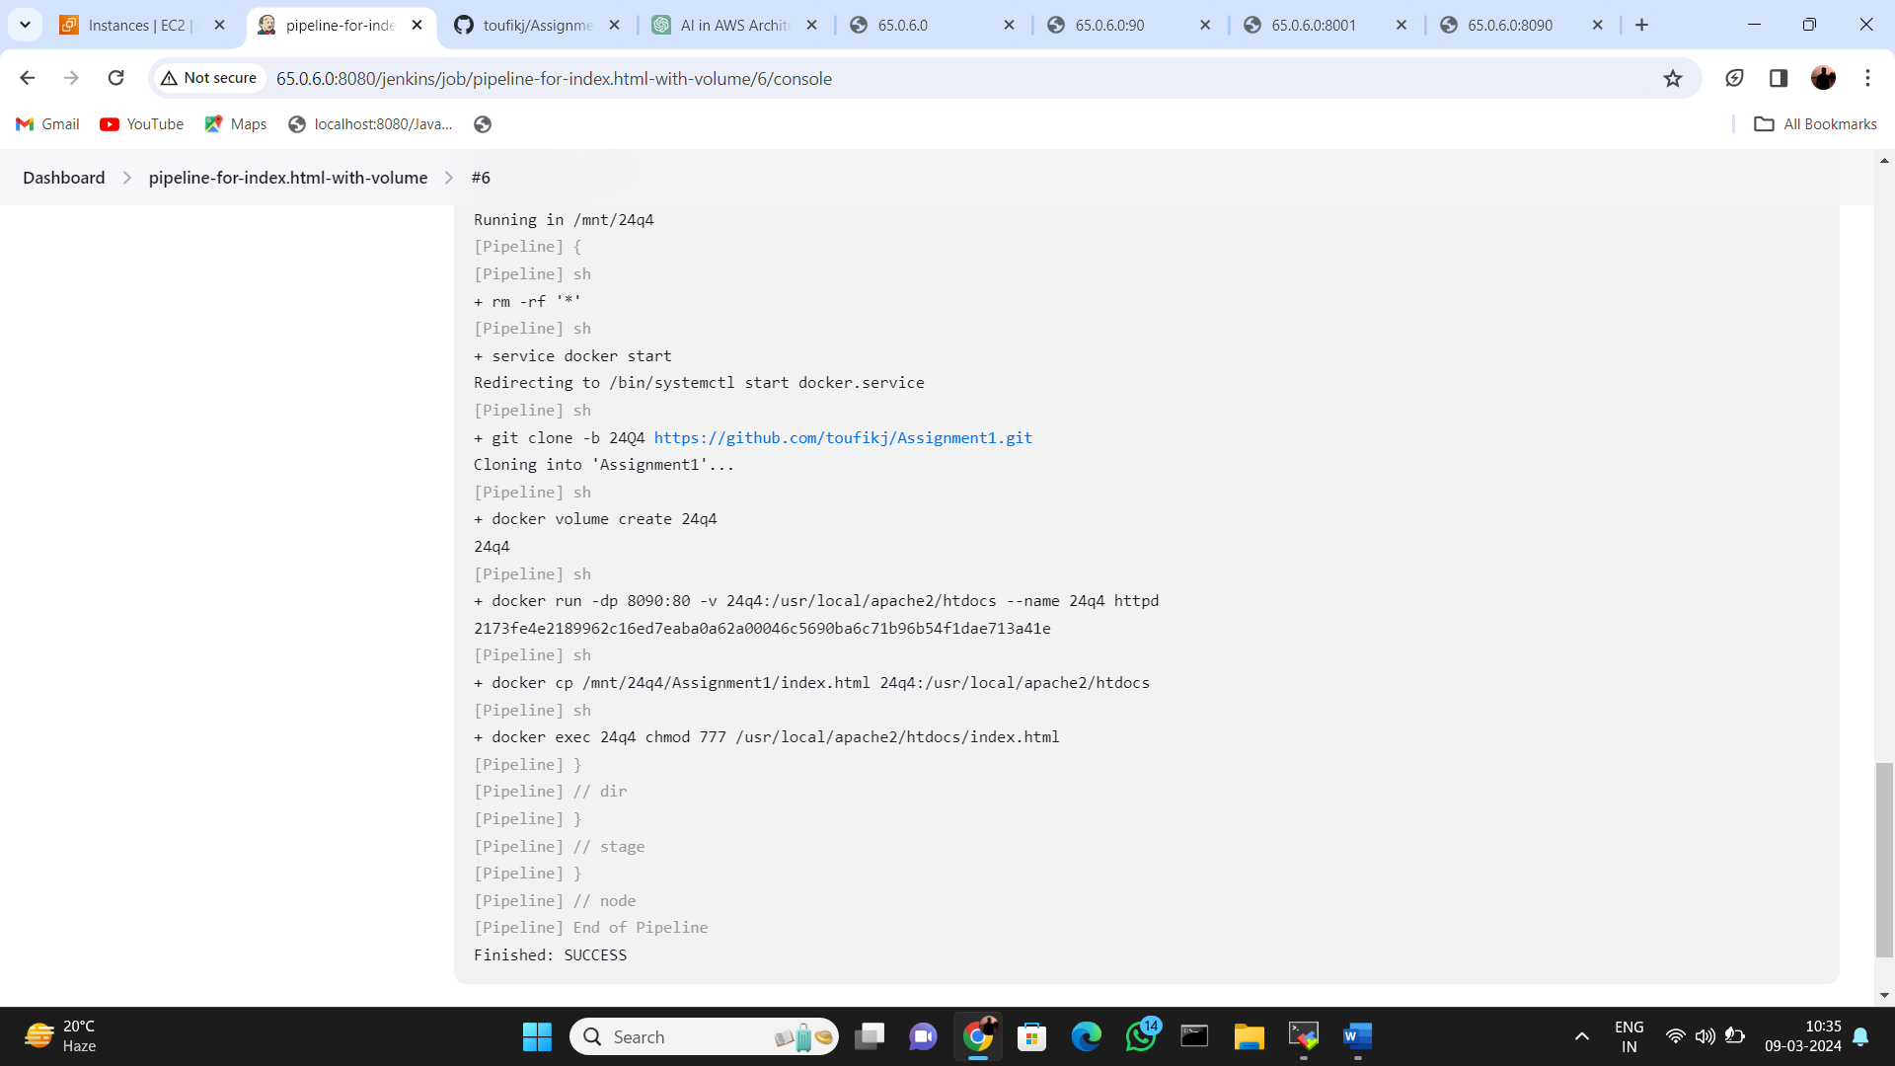

Running web on port 80

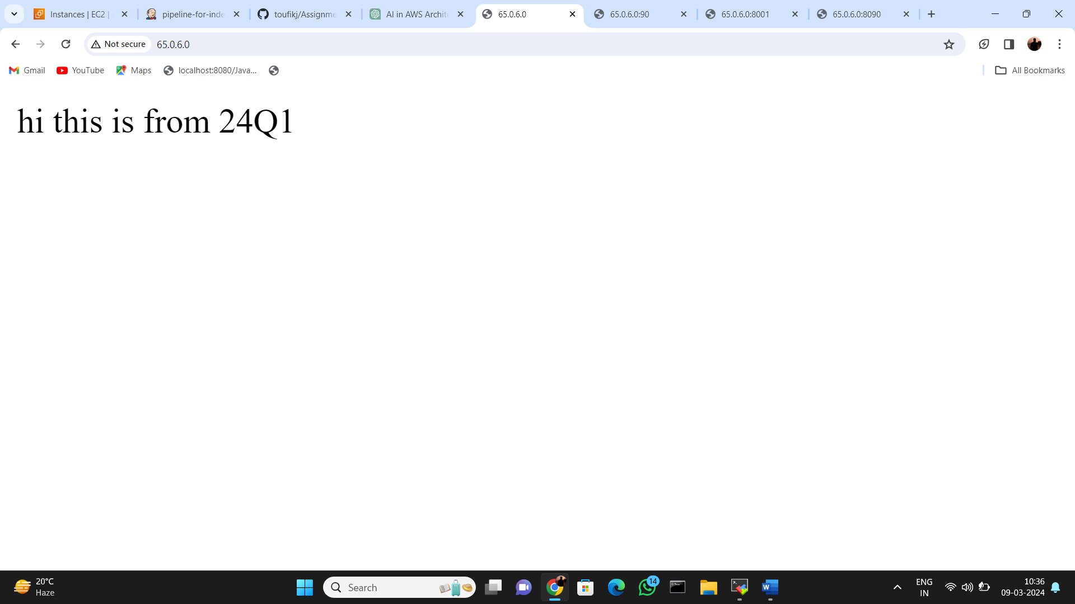

Running web on port 90

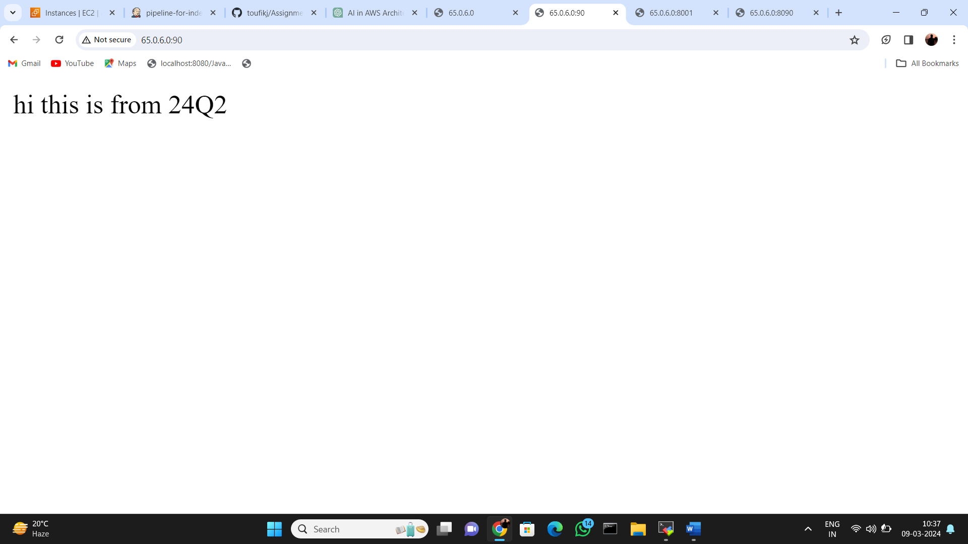

Running web on port 8001

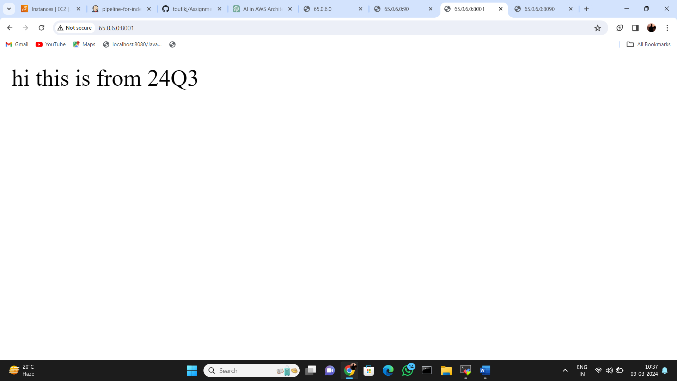

Running web on port 8090

