Docker Assignment

Creating custom network bridge and creating 2 containers ,1 in default bridge, 1 in custom bridge, trying to connect 2 different networks

🡺

Downloaded docker , created custom bridge network , creating containers in both networks

There’s a command to connect containers from different networks

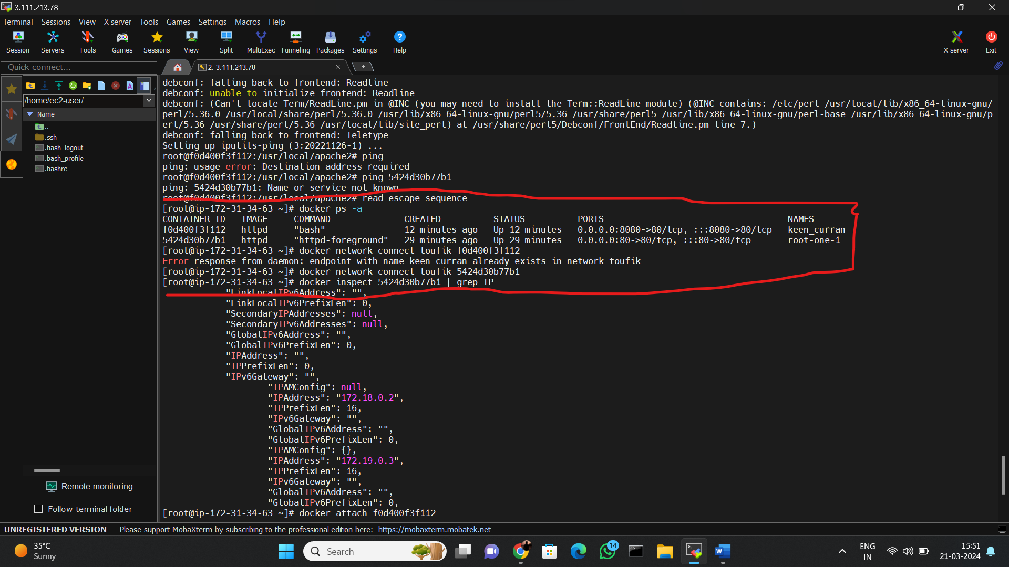

Accessing container from container which both in different network

