Assignment 1

Launching index.html of 3 branches on container with Jenkins job

==🡺

Installing java , docker , tomcat , Jenkins manually

Creating pipeline job to clone repo with different branches to different workspace , and creating 4 docker containers of httpd copying index.html from branches to container /htdocs giving permissions to index.html , all containers have different port binding.

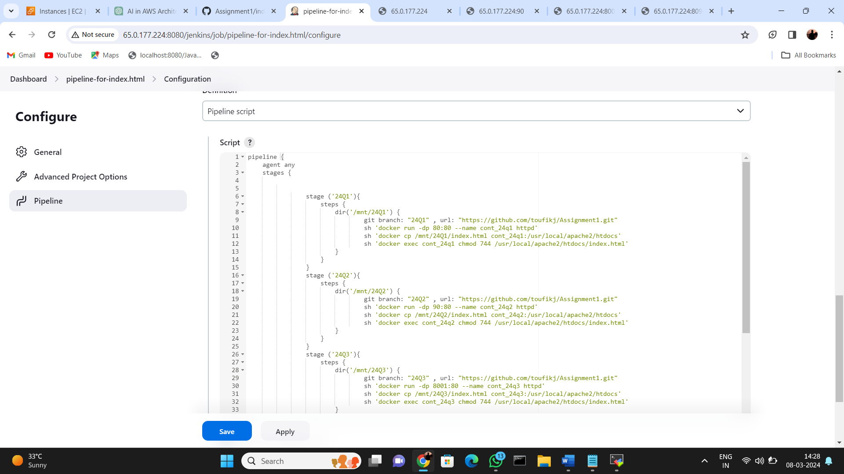

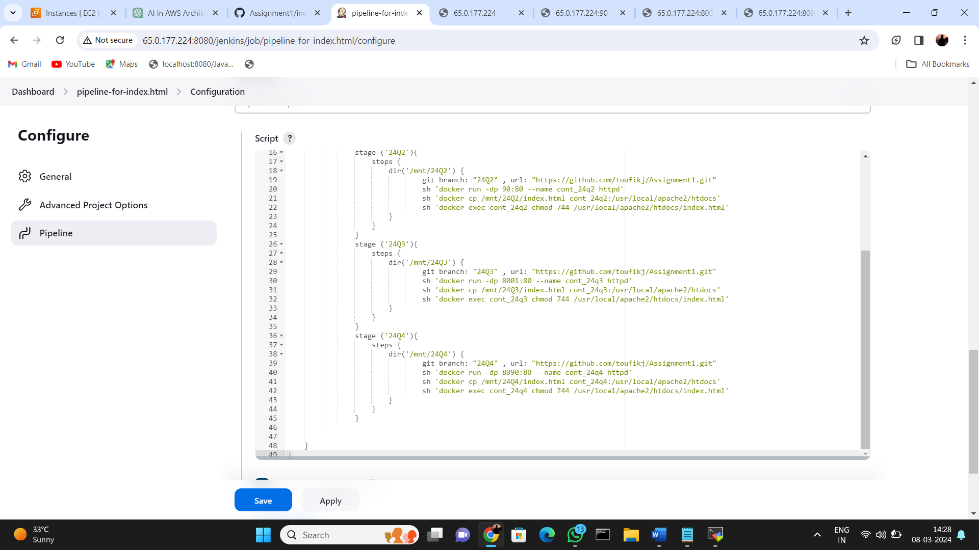

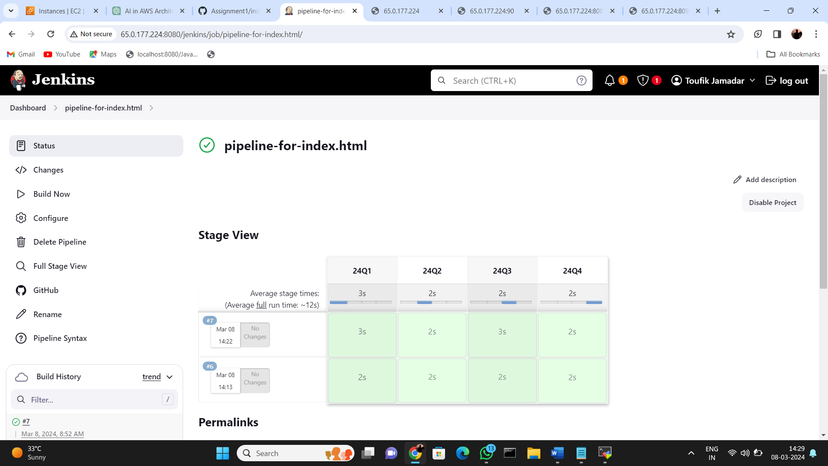

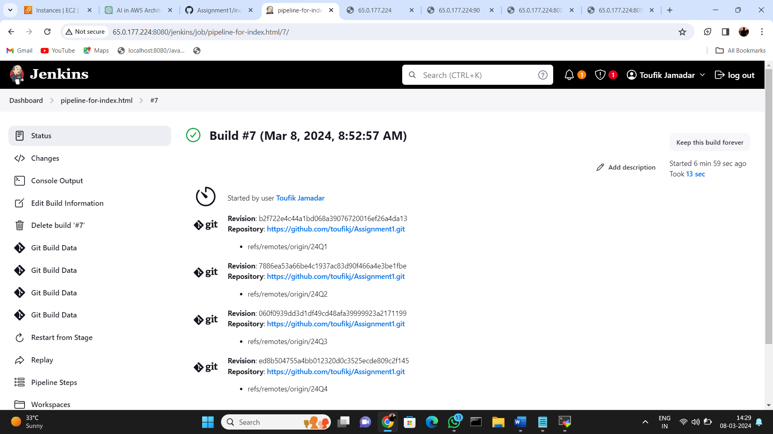

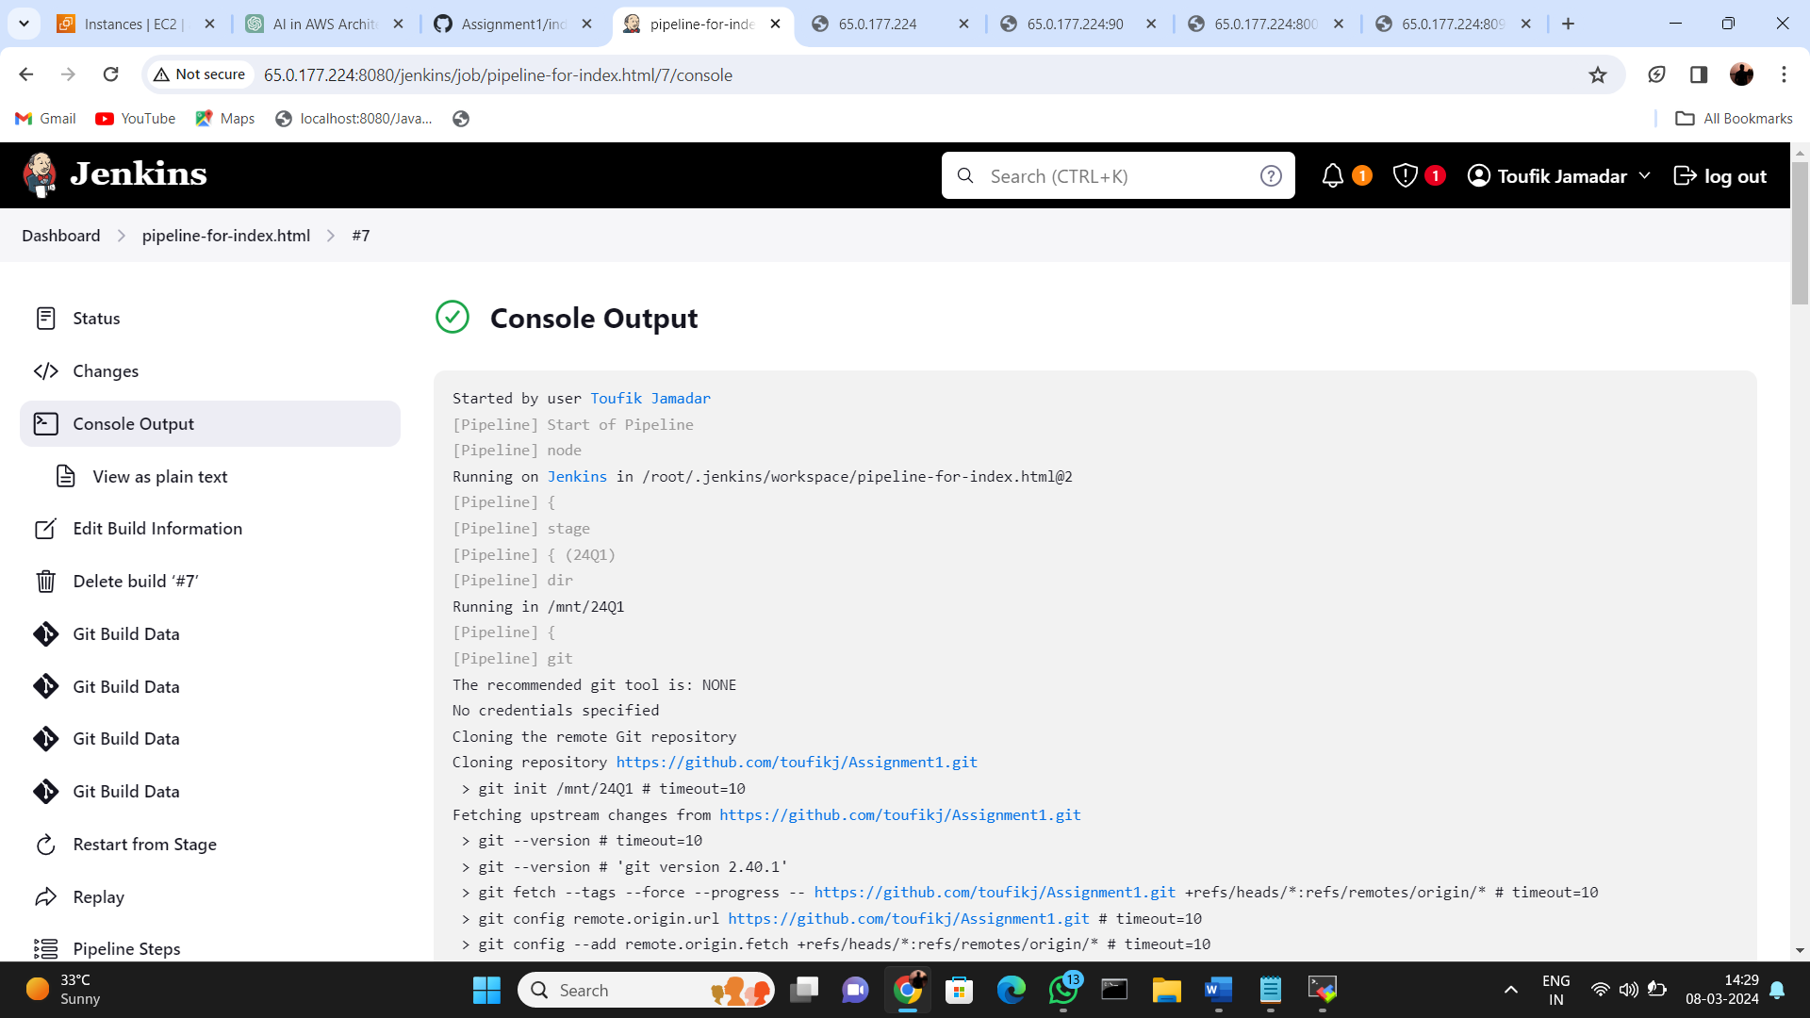

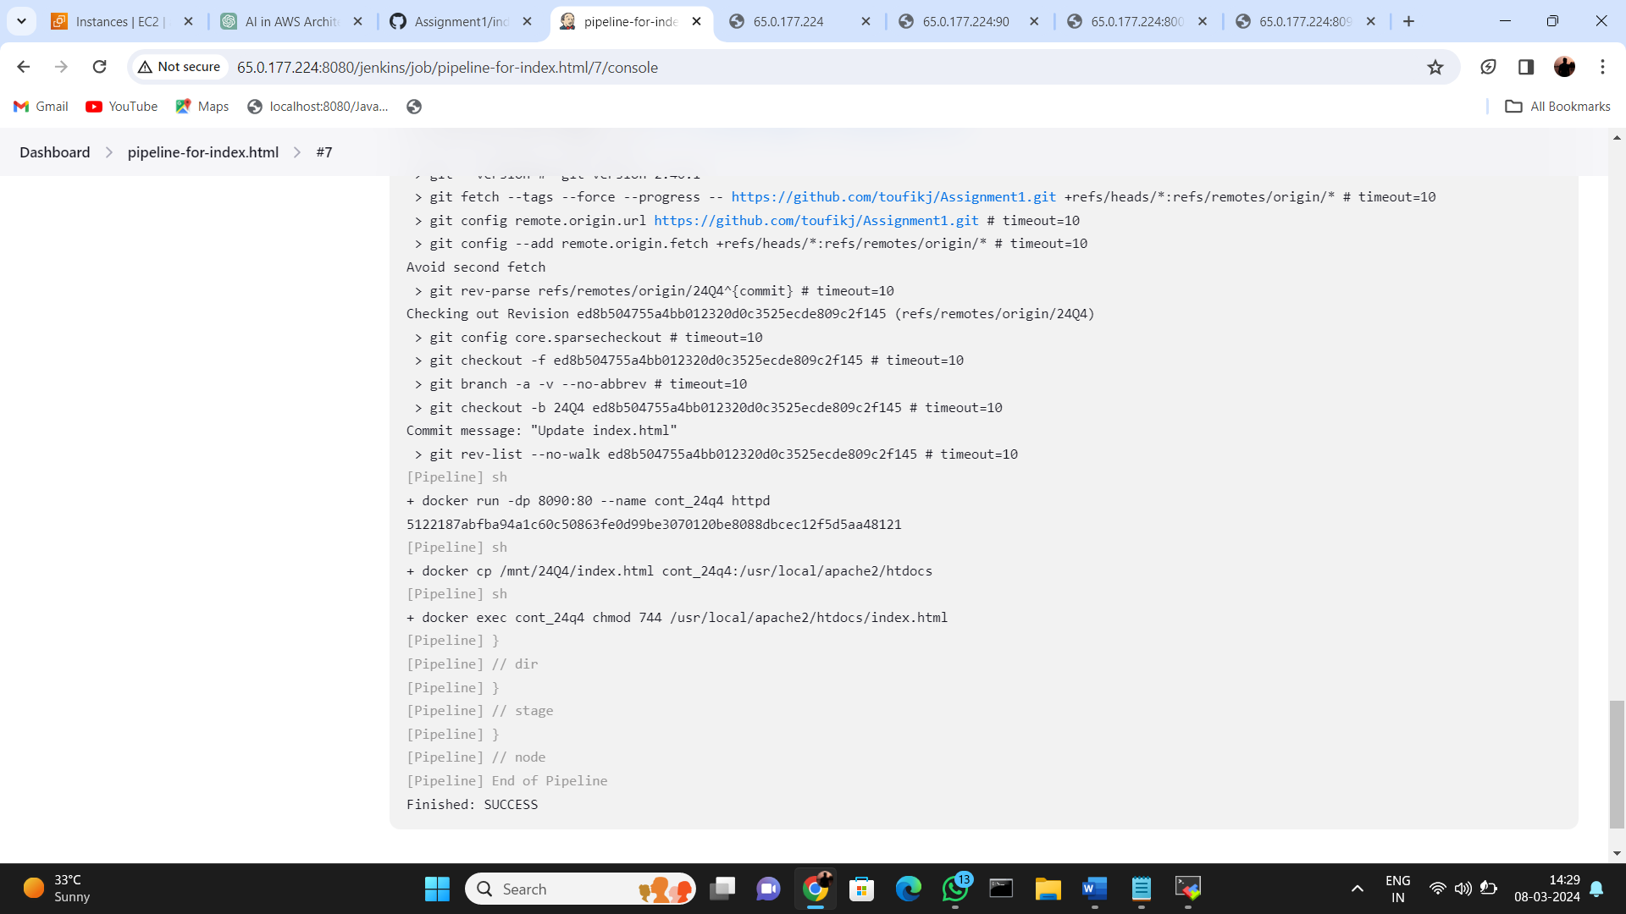

Website online with port 80

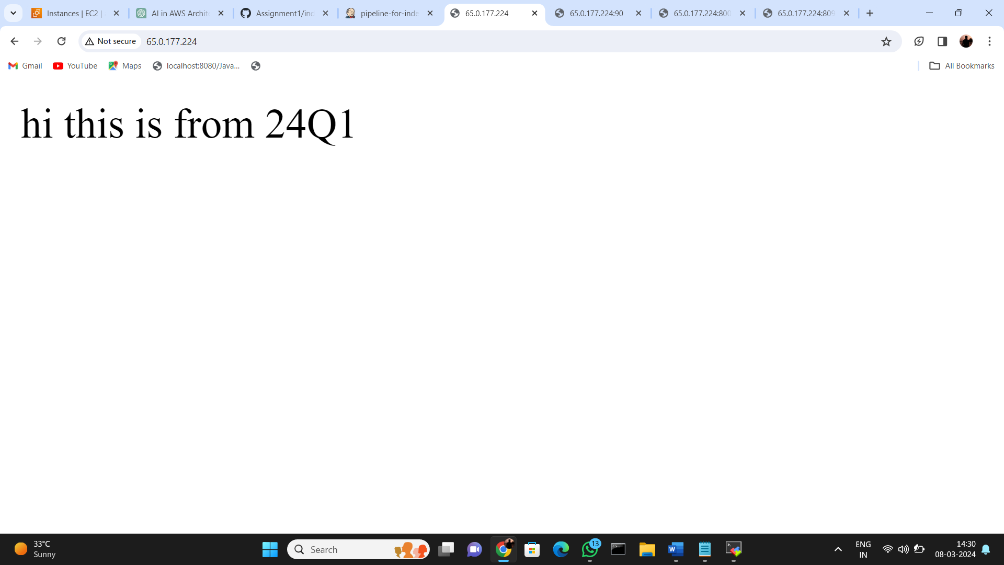

Website online with port 90

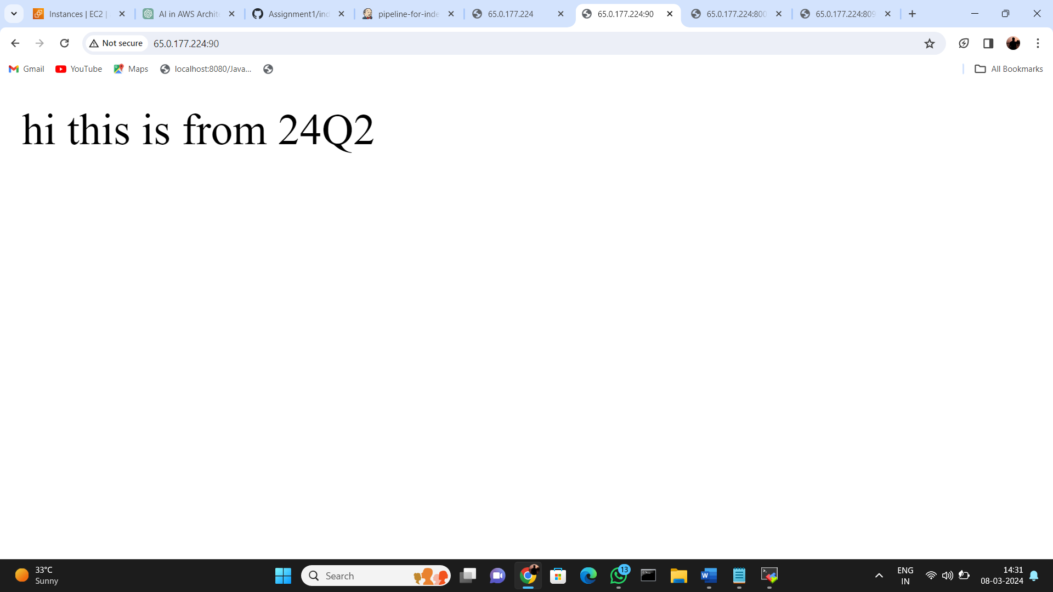

Website online with port 8001

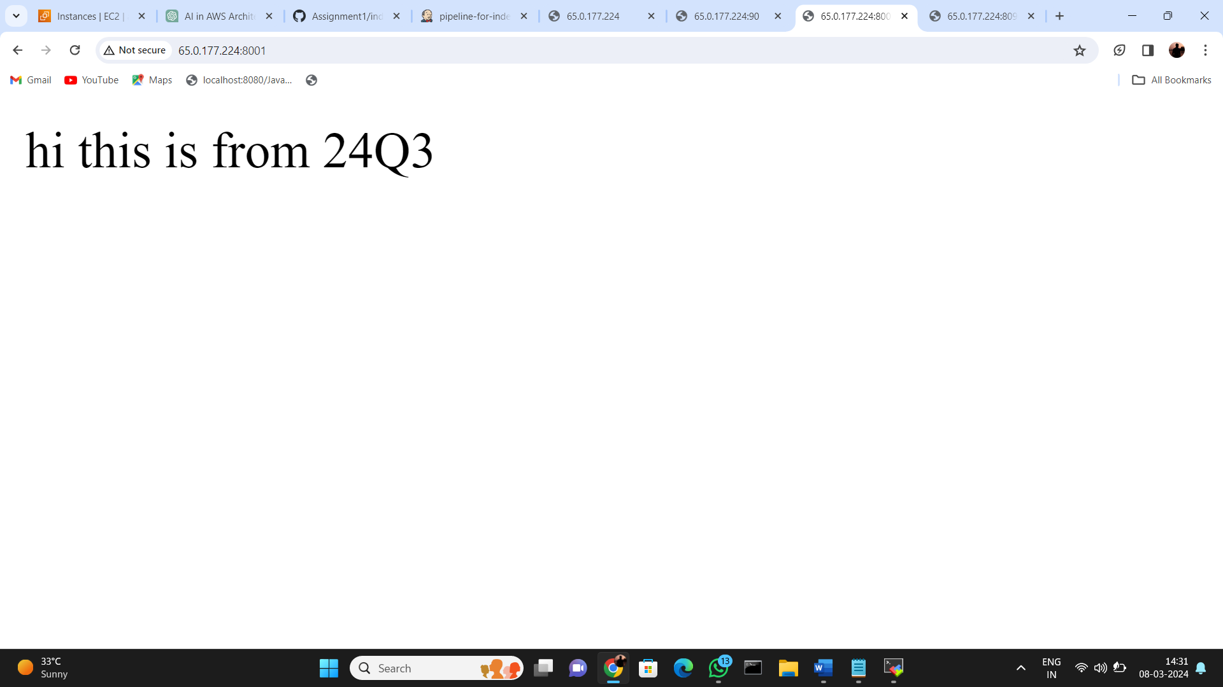

Website online with port 8090

