Assignment 2

Creating pipeline to deploy index.html of 2 branches on slave-1 (jnlp connection )and slave-2 (ssh connection).

🡺

Installing java , docker on slaves

Creating pipeline

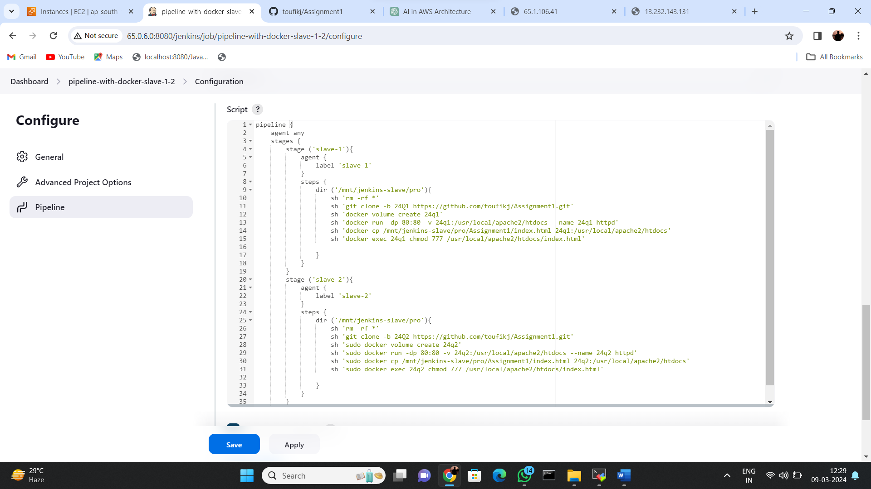

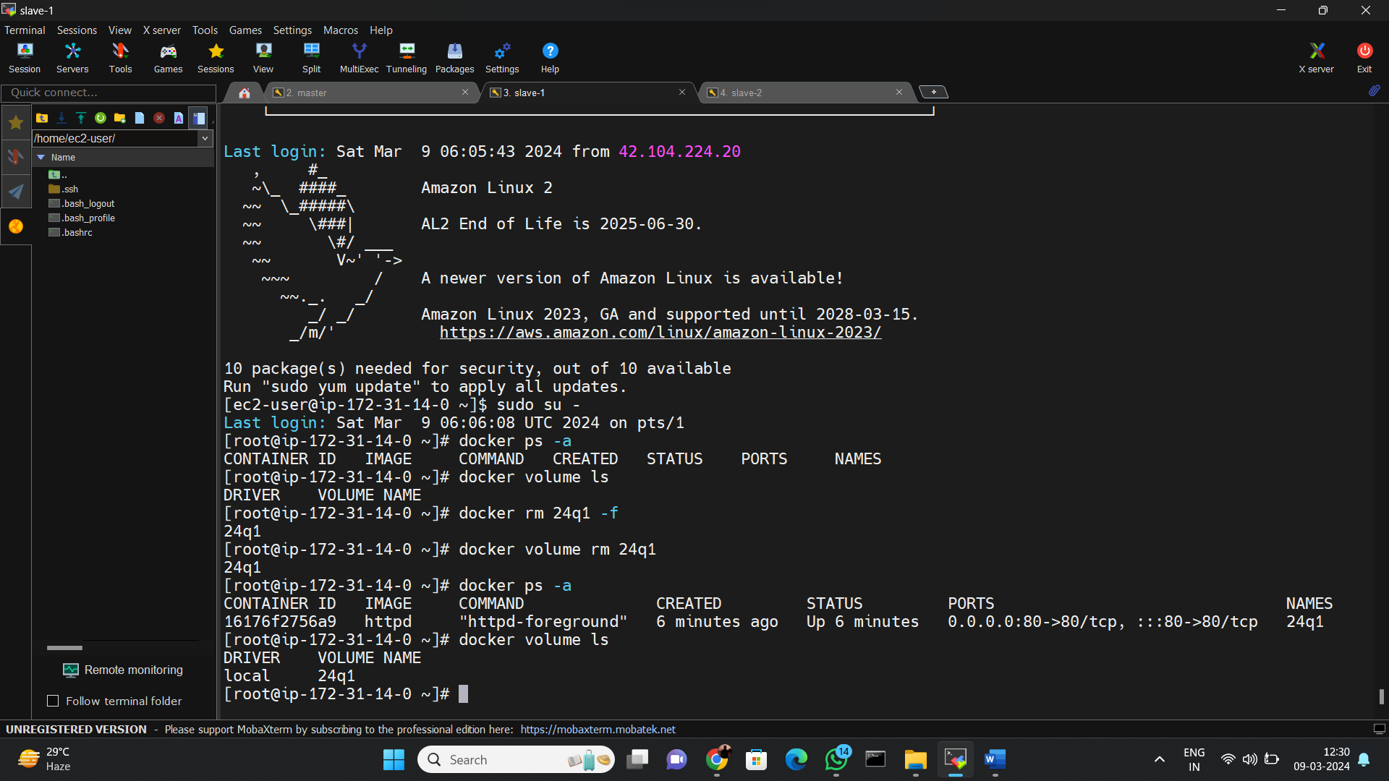

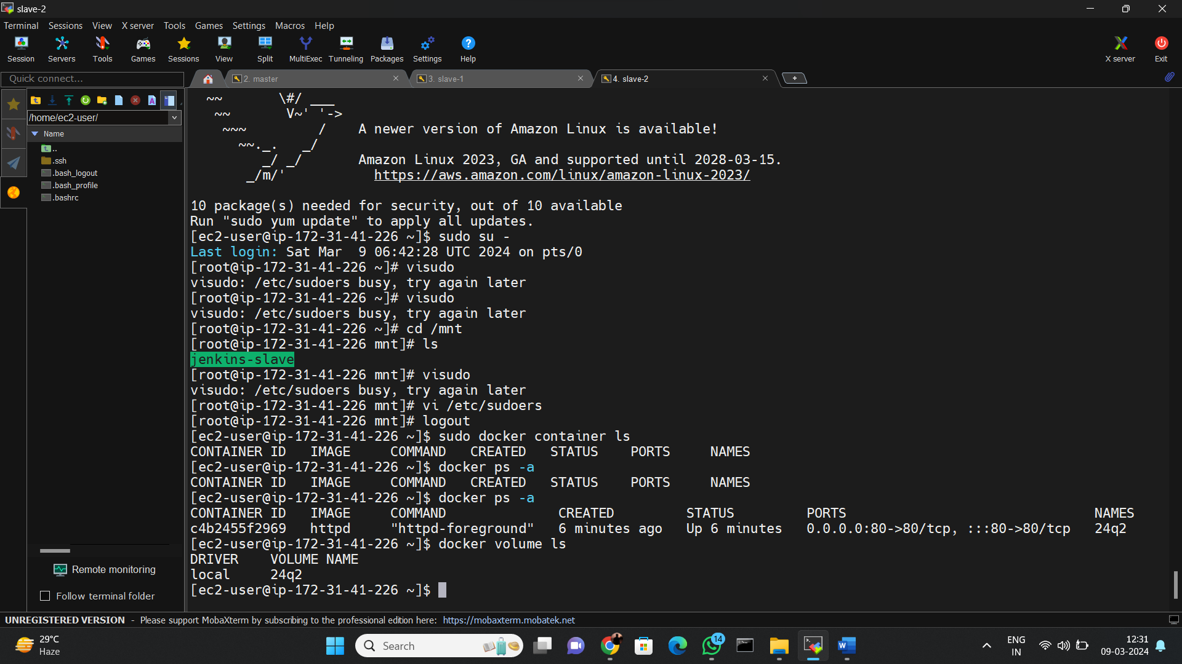

Running web on slave-1

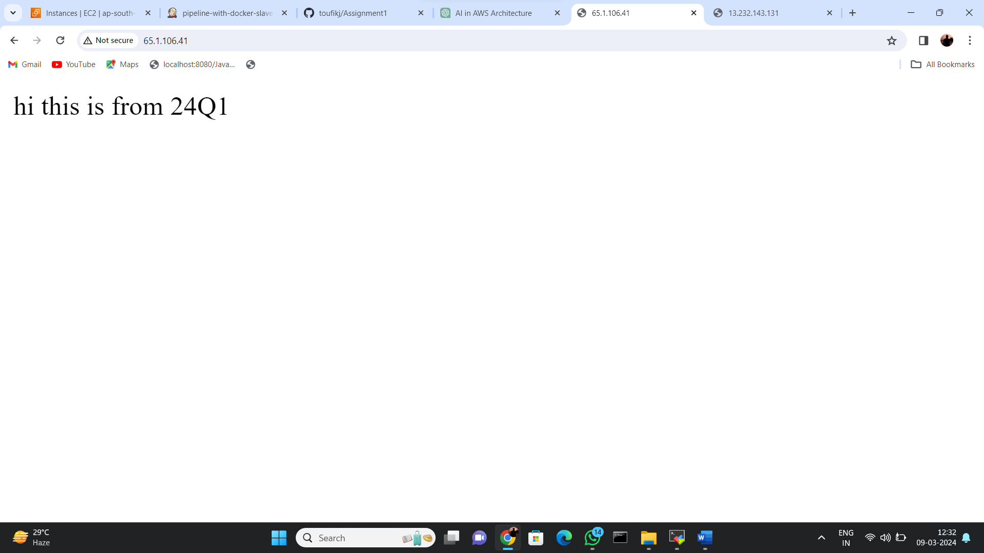

Running web on slave-2

