Assignment 2

Launching 2 websites from repo of 2 branches and using Jenkins pipeline and jnlp, ssh agent for 2 slaves

=🡺

Installing java , docker on master and 2 slaves

Installing apache, Jenkins on master

Connecting slave1 with jnlp , slave2 with ssh

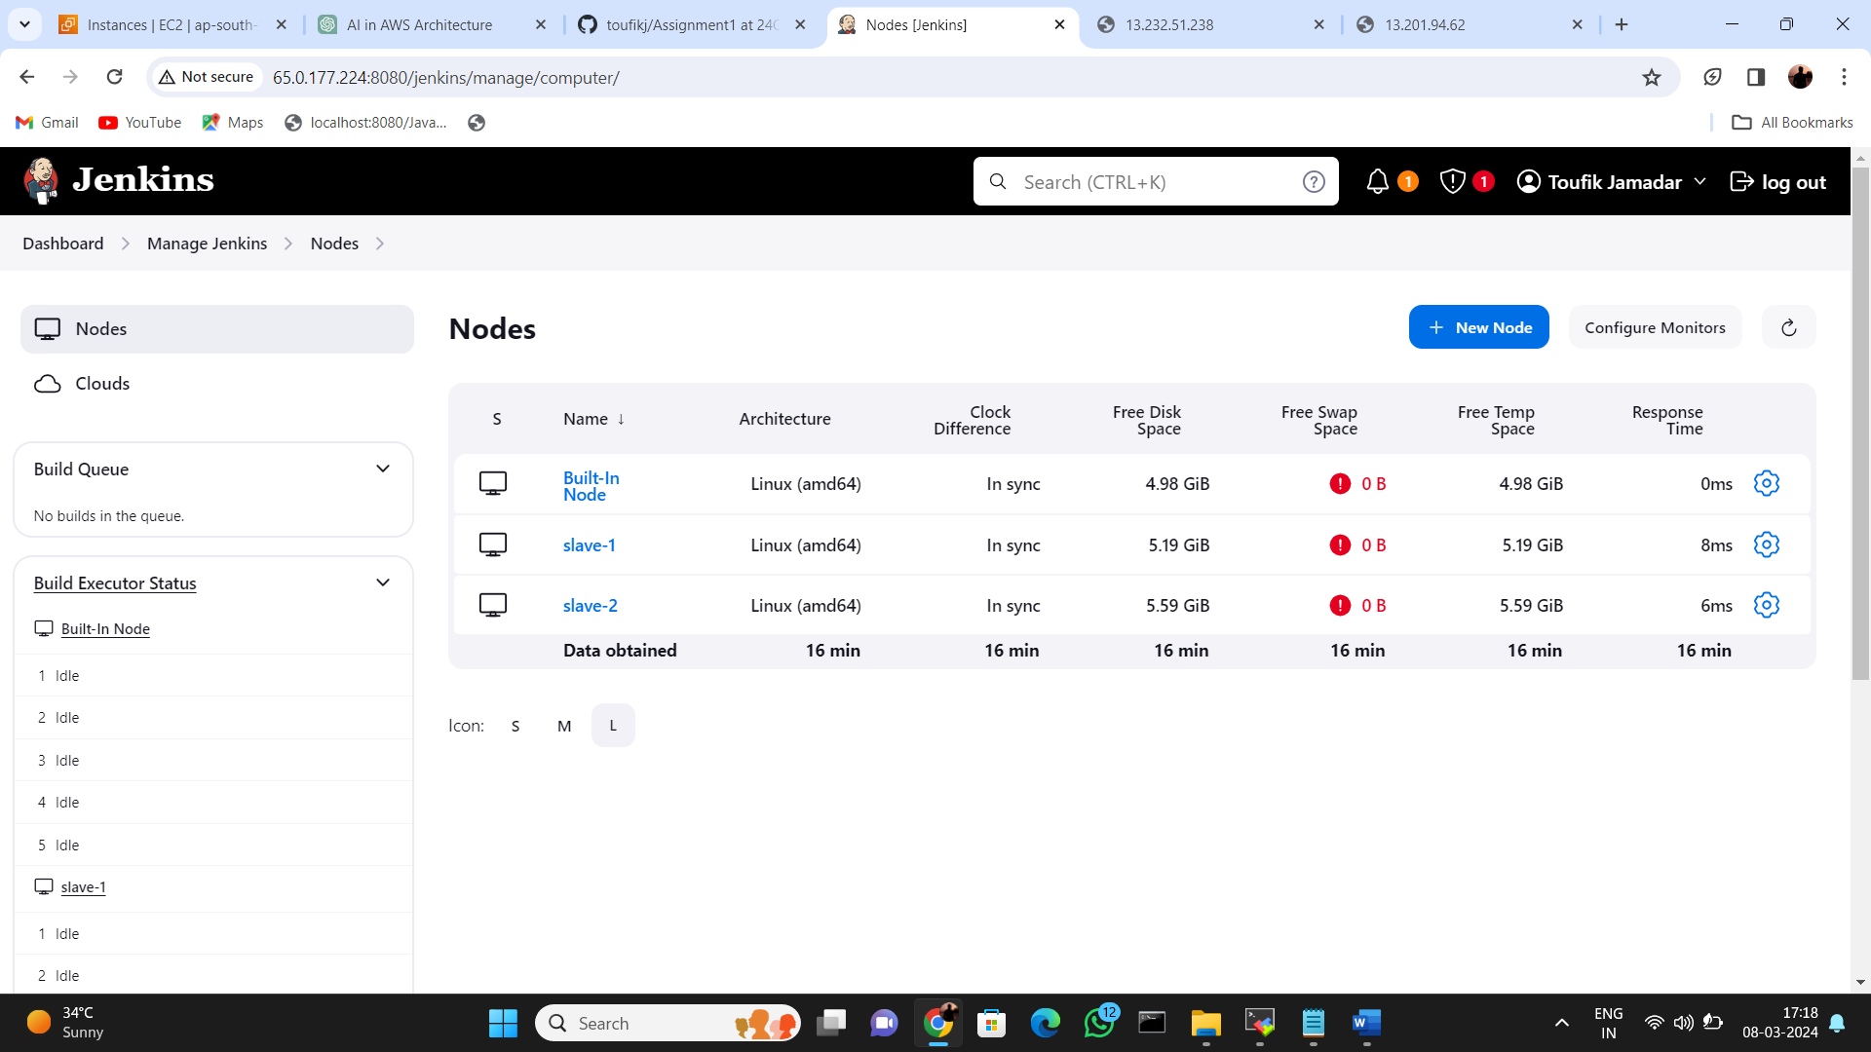

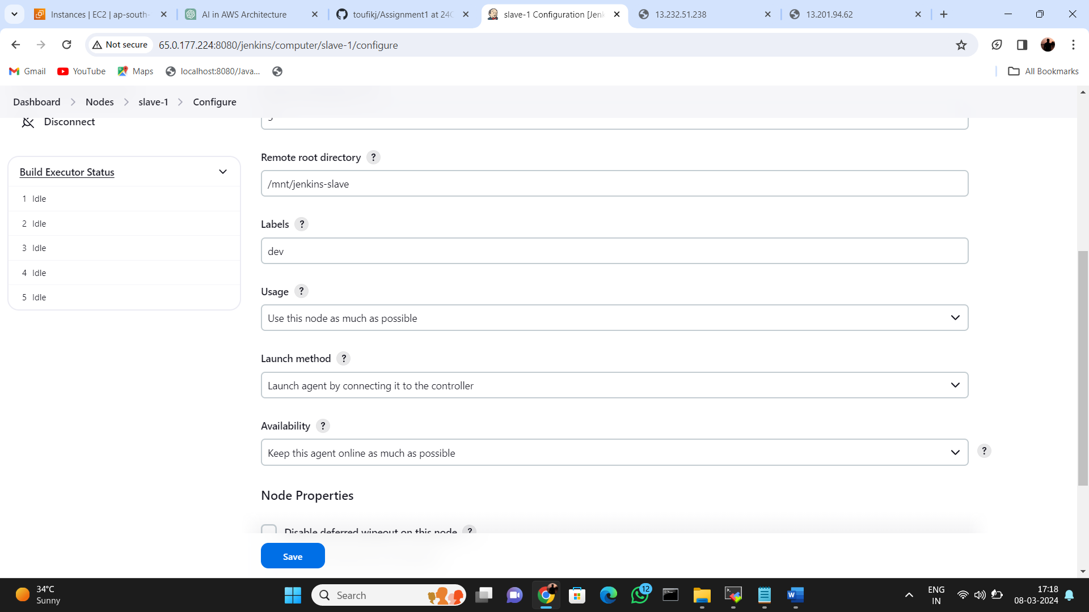

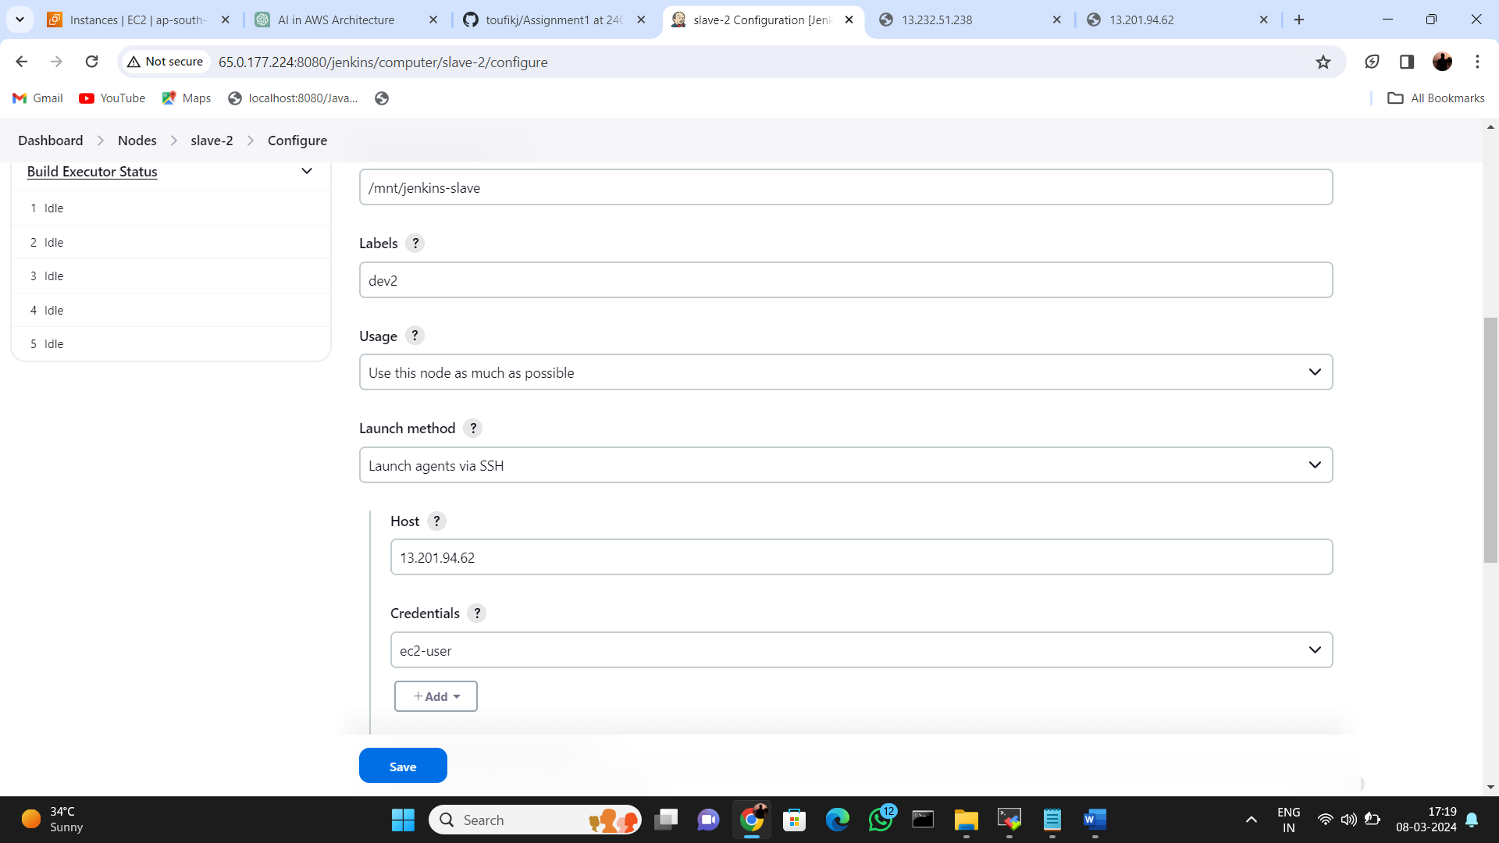

Building job with jdp

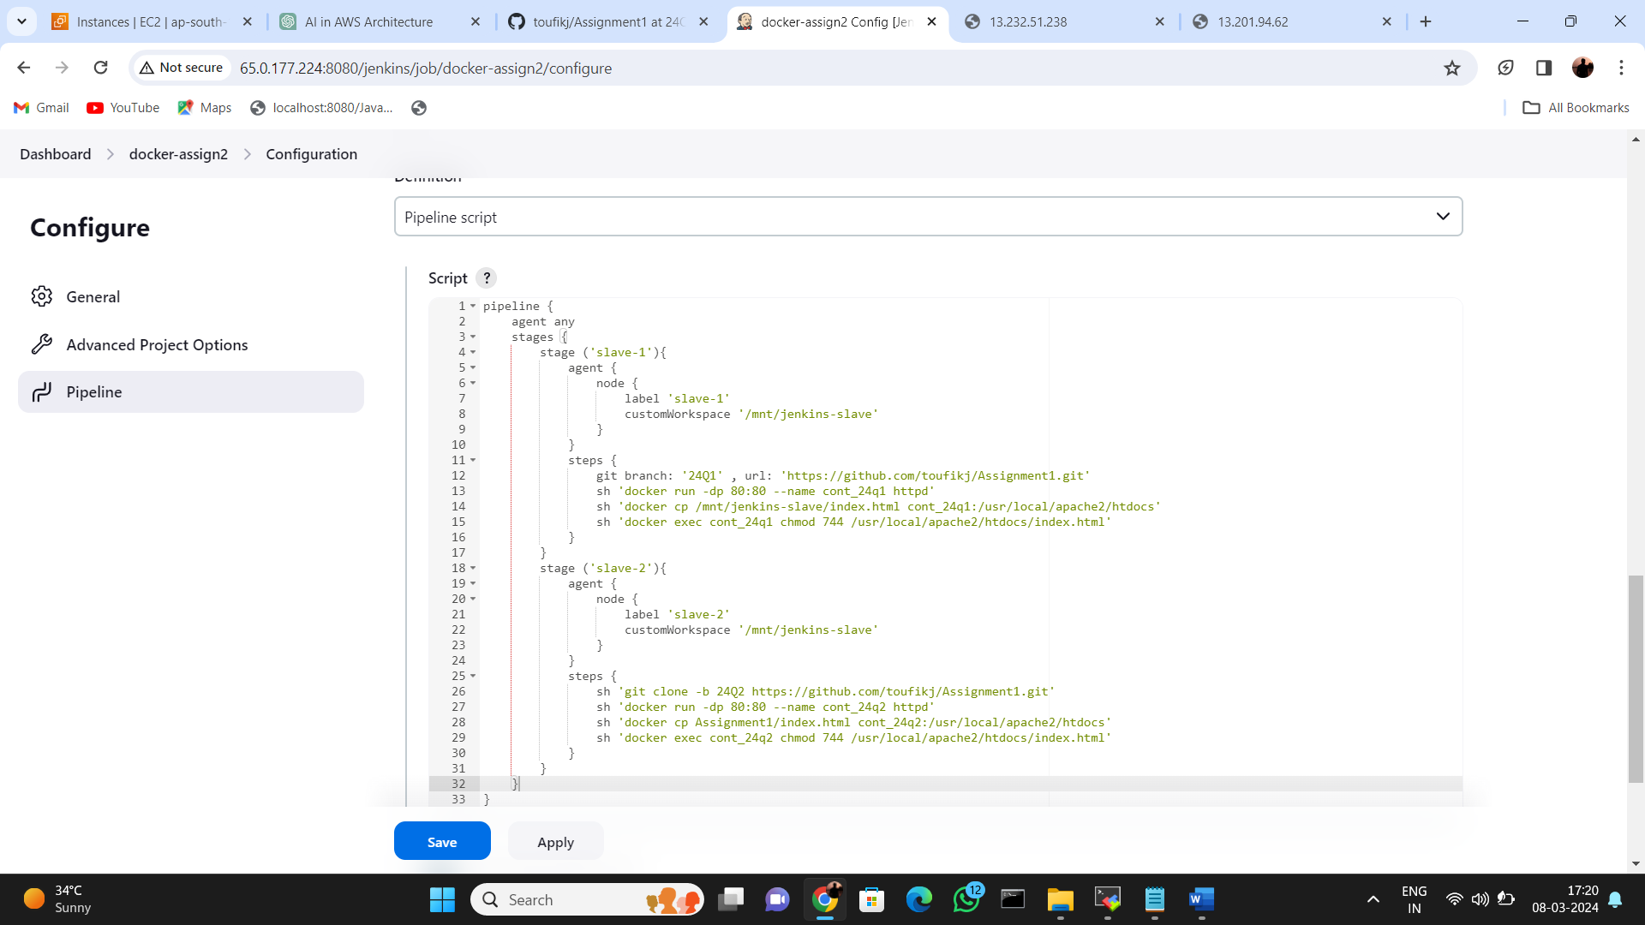

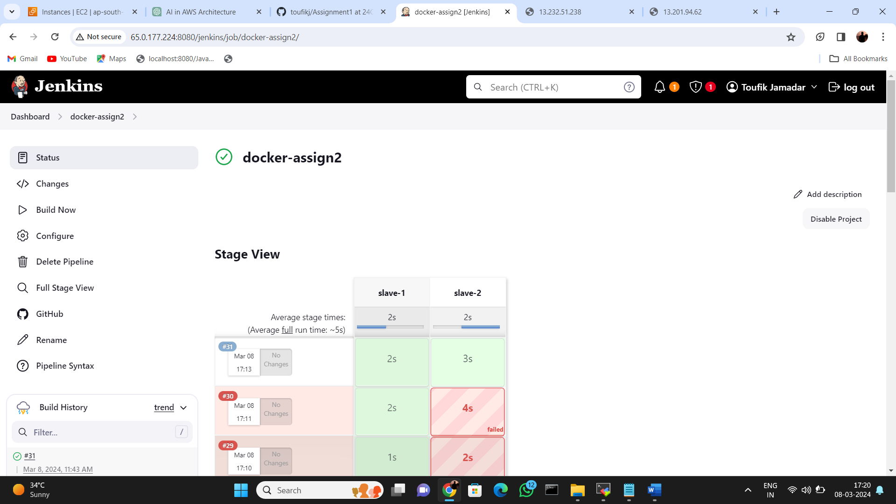



Online web from slave1

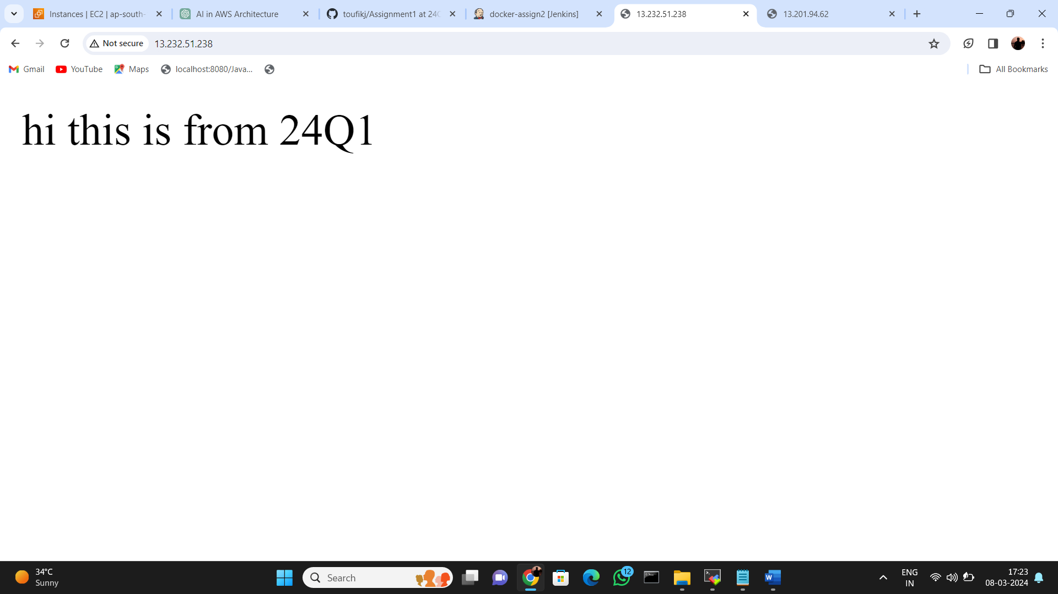

Online web form slave2

