R Notebook

# First steps

## Loading Librairies

##Loading Devices data In that case the csv generated used the tabulation separator. Adapt the delim parameter to your specific use case (coma, semicolon etc).

## # A tibble: 6 x 86  
## Name `AD site` `Device type` `Device manufac… `Device model` `CPU model`  
## <chr> <chr> <chr> <chr> <chr> <chr>   
## 1 ABD-… SloughVPN laptop Dell Latitude 7490 Intel Core…  
## 2 ABD-… SloughVPN laptop Dell Latitude 7490 Intel Core…  
## 3 ATL-… Virginia… laptop Lenovo 4180C84 Intel Core…  
## 4 BAL-… Virginia… laptop Lenovo 20JTS0HD06 Intel Core…  
## 5 BAL-… Carlstad… laptop Lenovo 20JTS0HA04 Intel Core…  
## 6 BAL-… Baltimore desktop HP HP EliteDesk … Intel Core…  
## # … with 80 more variables: `CPU frequency [Mhz]` <dbl>, `Number of  
## # CPUs` <chr>, `Number of cores` <dbl>, `Number of logical  
## # processors` <dbl>, `Total RAM [bytes]` <dbl>, `Disks S.M.A.R.T. index  
## # [%]` <chr>, `Total drive capacity [bytes]` <dbl>, `System drive free  
## # space [bytes]` <dbl>, `Device product version` <chr>, `OS version and  
## # architecture` <chr>, `OS build` <chr>, `Number of days since last  
## # system update` <chr>, `Windows Update status` <chr>, `System boot  
## # duration baseline [s]` <dbl>, `Last system boot duration [s]` <chr>,  
## # `Number of days since last system boot` <chr>, `Logon duration  
## # baseline [s]` <dbl>, `Extended logon duration baseline [s]` <chr>,  
## # `Last logon duration [s]` <chr>, `Last extended logon duration  
## # [s]` <chr>, `Last logged on user's privileges` <chr>, `Number of  
## # antiviruses` <dbl>, `Number of antispyware` <dbl>, `Number of  
## # firewalls` <dbl>, Entity <chr>, `Last seen` <chr>, `Antivirus  
## # RTP` <chr>, `Antivirus up-to-date` <chr>, `Antispyware RTP` <chr>,  
## # `Antispyware up-to-date` <chr>, `Firewall RTP` <chr>, `Firewall  
## # display name` <chr>, `DXS - Device (DXS - Device)` <dbl>, `Boot speed  
## # (DXS - Device)` <dbl>, `Logon duration (DXS - Device)` <dbl>, `BSODs  
## # (DXS - Device)` <dbl>, `Hard resets (DXS - Device)` <dbl>, `System  
## # free space (DXS - Device)` <dbl>, `CPU usage (DXS - Device)` <dbl>,  
## # `Memory usage (DXS - Device)` <dbl>, `DXS - Security (DXS -  
## # Security)` <dbl>, `DXS - Web browsing (DXS - Web browsing)` <dbl>,  
## # `DXS - Business apps (DXS - Business apps)` <dbl>, `DXS - Productivity  
## # (DXS - Productivity)` <dbl>, `Digital Experience Score (Digital  
## # Experience Score)` <dbl>, `Average system boot duration [s]` <chr>,  
## # `Average logon duration [s]` <chr>, `Average extended logon duration  
## # [s]` <chr>, `Number of users` <dbl>, `Interaction time ratio  
## # [%]` <dbl>, `CPU usage ratio [%]` <dbl>, `Average memory usage per  
## # execution [bytes]` <chr>, `Highest local privilege level  
## # reached` <chr>, `Number of connections` <dbl>, `Number of web  
## # requests` <dbl>, `Average web request duration [s]` <dbl>, `Web  
## # interaction time [s]` <dbl>, `Total network traffic [bytes]` <dbl>,  
## # `Incoming network traffic [bytes]` <dbl>, `Outgoing network traffic  
## # [bytes]` <dbl>, `Total web traffic [bytes]` <dbl>, `Incoming web  
## # traffic [bytes]` <dbl>, `Outgoing web traffic [bytes]` <dbl>, `Network  
## # availability level` <chr>, `Successful network connections ratio  
## # [%]` <dbl>, `Average network response time [ms]` <dbl>, `Average  
## # incoming network bitrate [bps]` <dbl>, `Average outgoing network  
## # bitrate [bps]` <dbl>, `High device overall CPU time ratio [%]` <dbl>,  
## # `High device memory time ratio [%]` <dbl>, `High device IO throughput  
## # time ratio [%]` <dbl>, `High device page faults time ratio [%]` <dbl>,  
## # `Number of system crashes` <dbl>, `Number of hard resets` <dbl>,  
## # `Number of application crashes` <dbl>, `Application crash ratio  
## # [%]` <dbl>, `Number of application not responding events` <dbl>,  
## # `Number of system boots` <dbl>, `Number of logons` <dbl>, `Application  
## # not responding event ratio [%]` <dbl>

## Loading Application data

## # A tibble: 6 x 7  
## `Executable nam… Version `Application na… `Application ca…  
## <chr> <chr> <chr> <chr>   
## 1 zwiftapp.exe 0.0.0.0 unknown -   
## 2 iisexpress.exe 10.0.1… Internet Inform… Network applica…  
## 3 thedivision.exe 1.0.0.0 Tom Clancy's Th… -   
## 4 goland64.exe 2019.3… GoLand -   
## 5 photoshop.exe 20.0.9… Adobe Photoshop… -   
## 6 photoshop.exe 21.1.1… Adobe Photoshop… -   
## # … with 3 more variables: `Number of devices` <dbl>, `Number of  
## # executions` <dbl>, `Average memory usage per execution [MB]` <dbl>

## Loading Chrome Data

## # A tibble: 6 x 6  
## `Executable nam… Version `Number of exec… `Number of devi…  
## <chr> <chr> <dbl> <dbl>  
## 1 chrome.exe 64.0.3… 94 1  
## 2 chrome.exe 70.0.3… 625 1  
## 3 chrome.exe 73.0.3… 778 1  
## 4 chrome.exe 73.0.3… 108893 75  
## 5 chrome.exe 74.0.3… 163164 129  
## 6 chrome.exe 75.0.3… 225 1  
## # … with 2 more variables: `Application name` <chr>, `Average memory usage  
## # per execution [MB]` <dbl>

## Load Office Data

## # A tibble: 6 x 5  
## `Executable nam… Version `Number of exec… `Number of devi…  
## <chr> <chr> <dbl> <dbl>  
## 1 excel.exe 16.0.1… 3 1  
## 2 excel.exe 16.0.1… 108 1  
## 3 excel.exe 14.0.7… 350 15  
## 4 excel.exe 15.0.5… 166 10  
## 5 excel.exe 14.0.7… 374 13  
## 6 excel.exe 16.0.9… 111 3  
## # … with 1 more variable: `Average memory usage per execution [MB]` <dbl>

# Devices

## DXS vs. OS Version and architecture

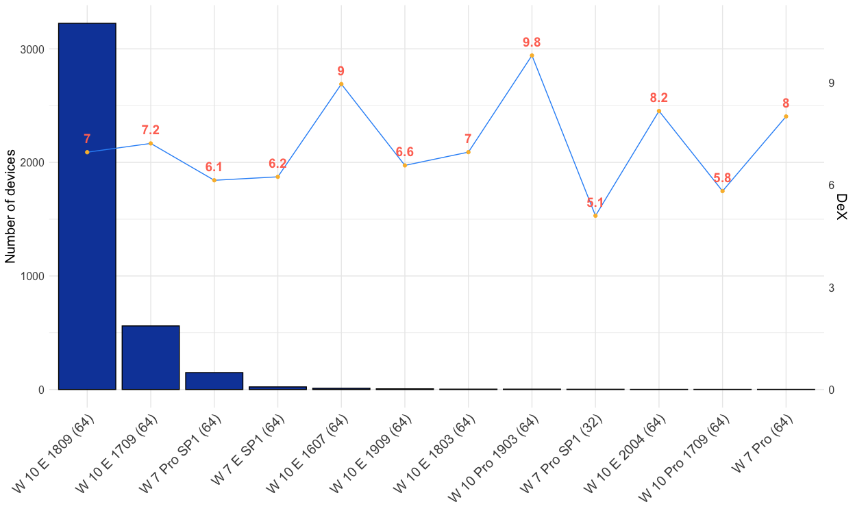

## DXS by Device Model

### All but Lenovo

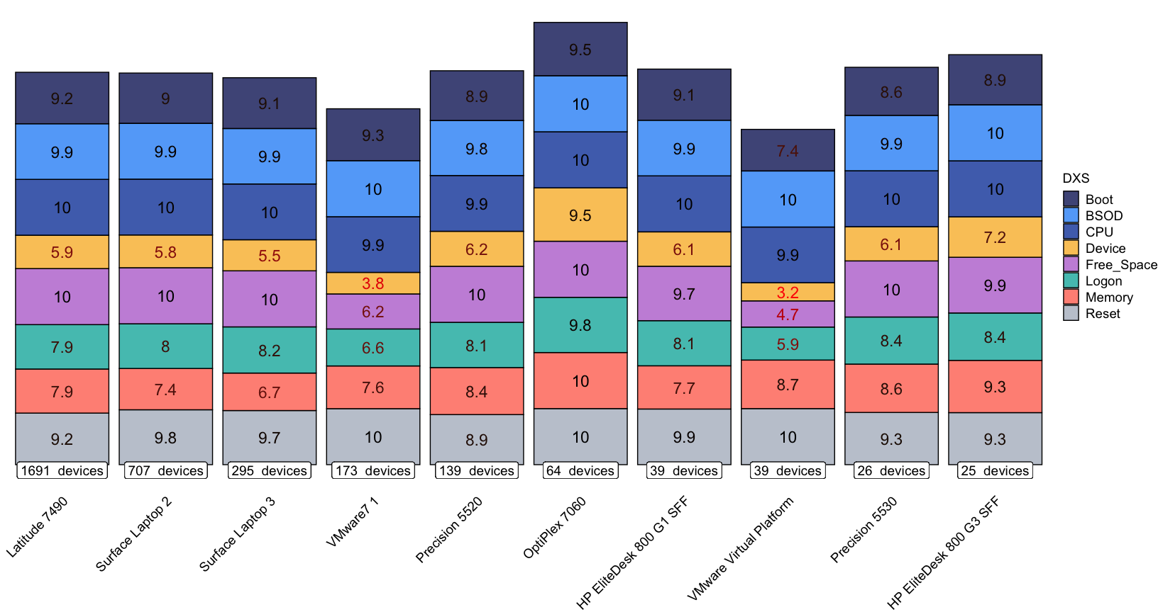

### Lenovo

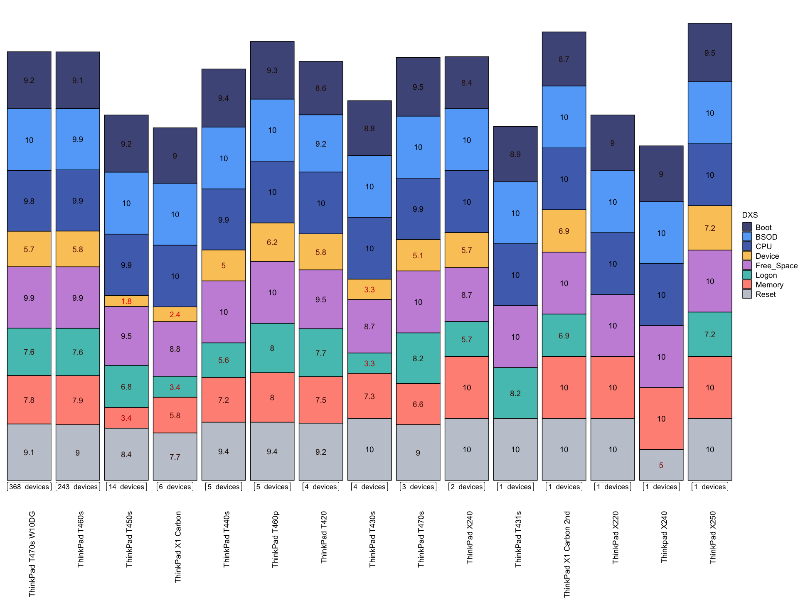

## CPU

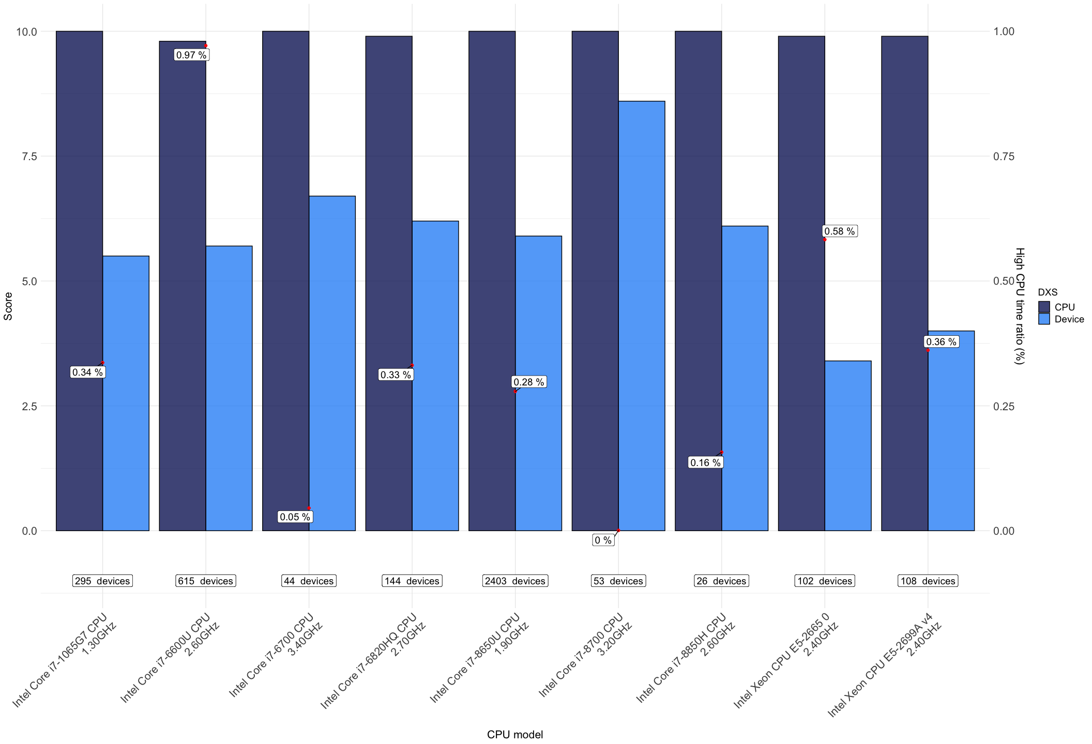

## Memory

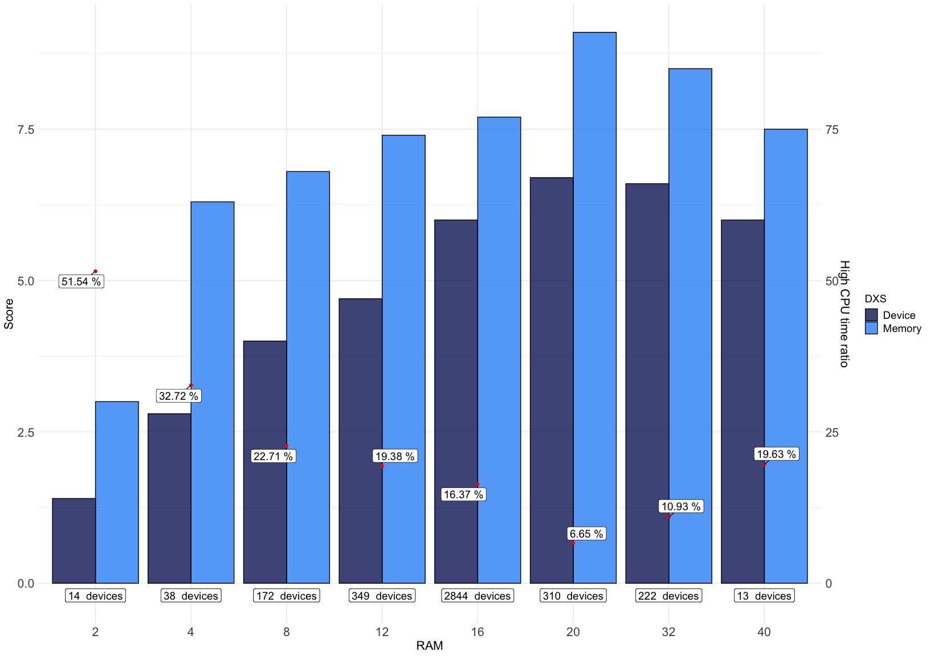

## Boot

### General

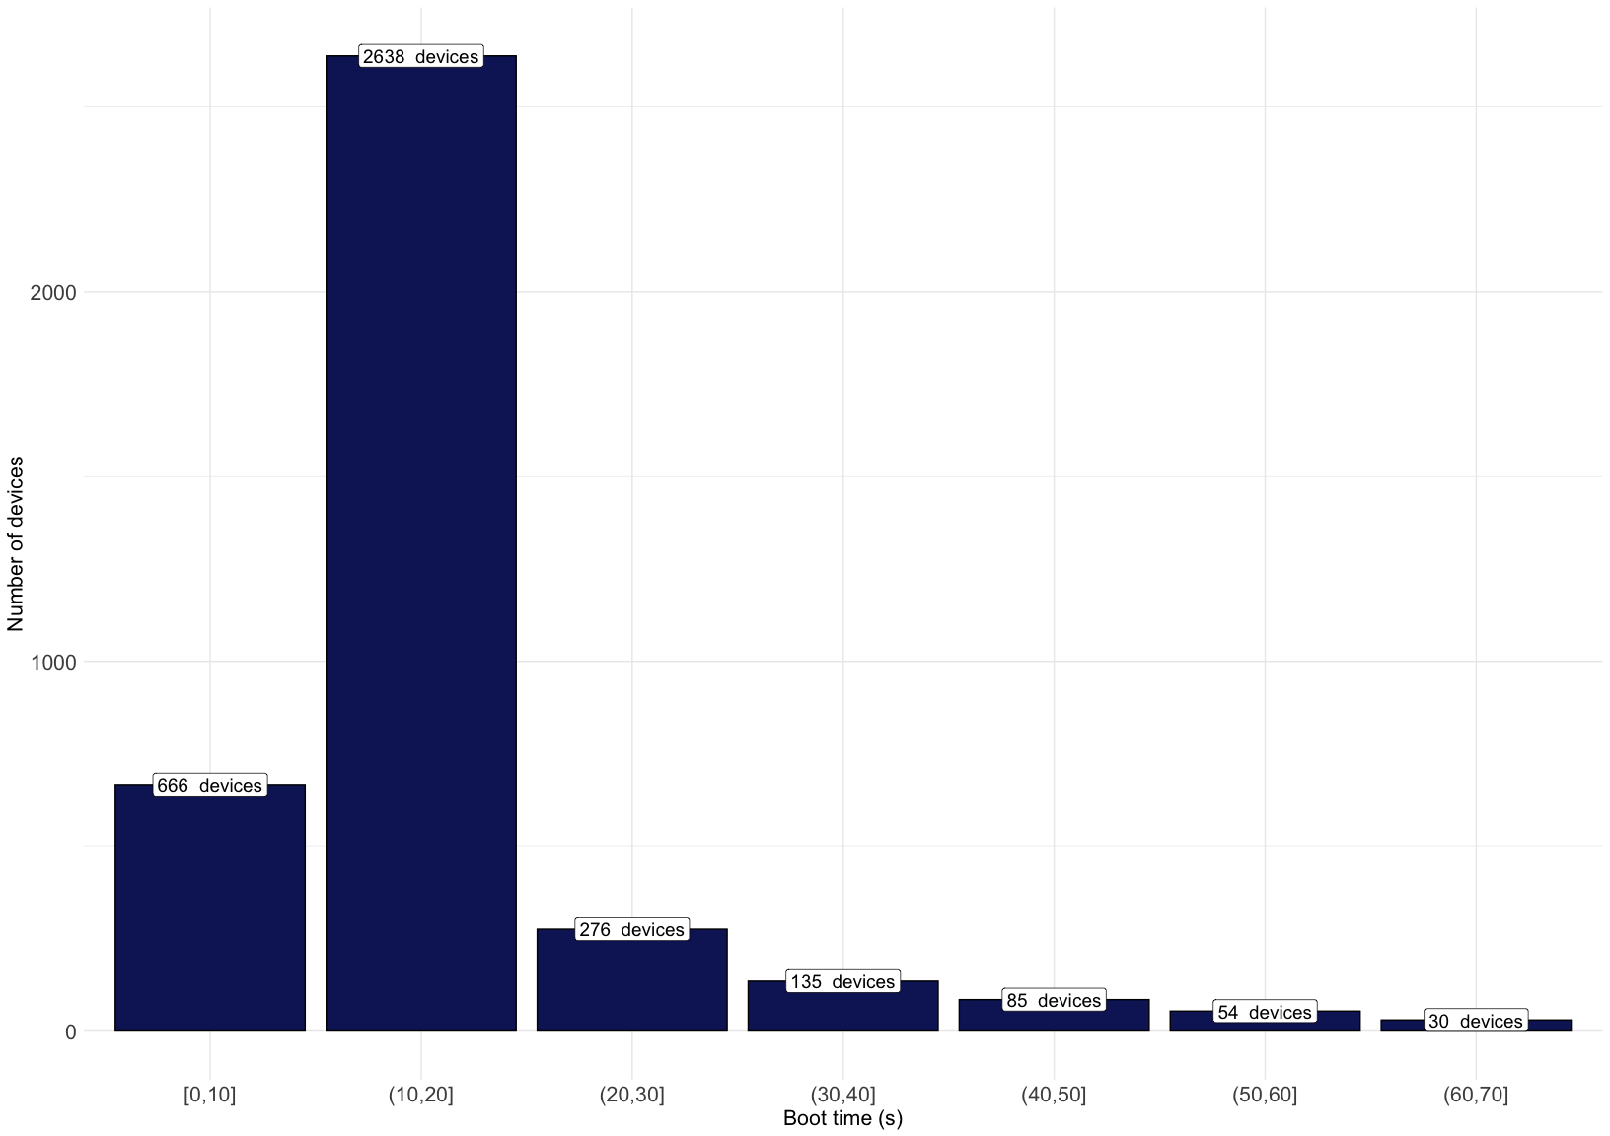

### All Models (exluding Lenovo)

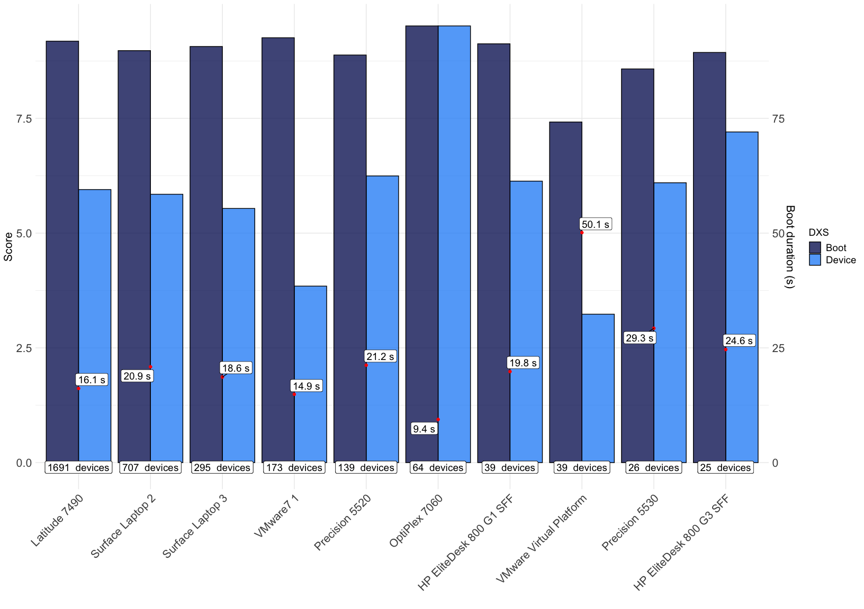

### Lenovo only

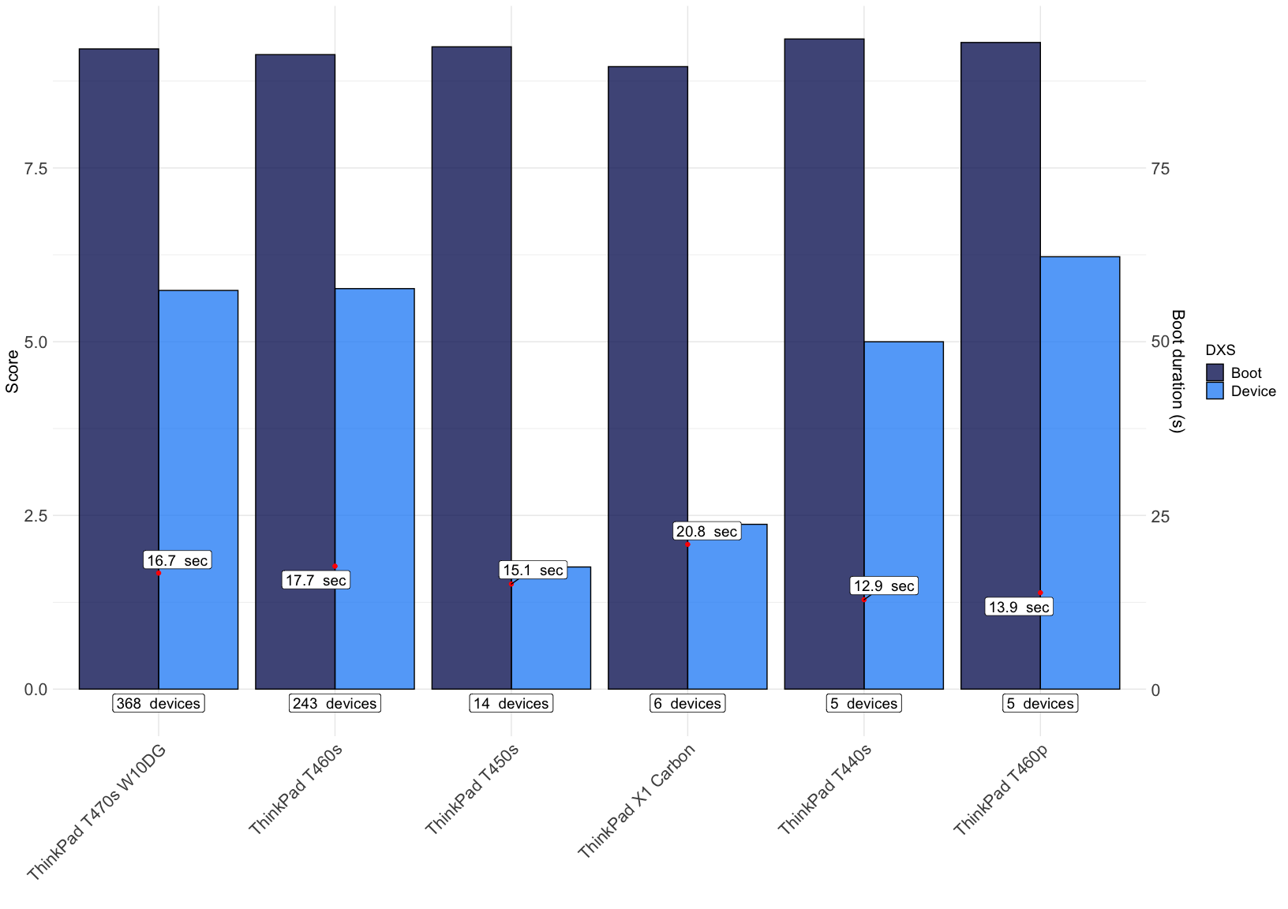

### OS

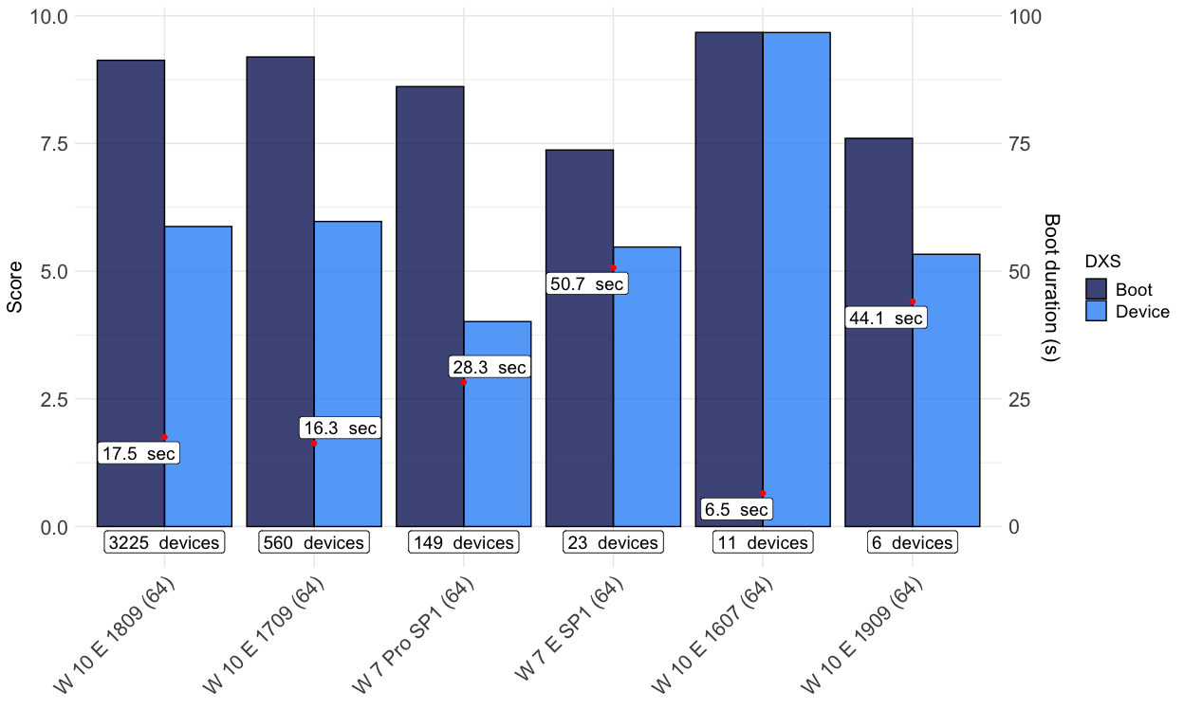

## Logon

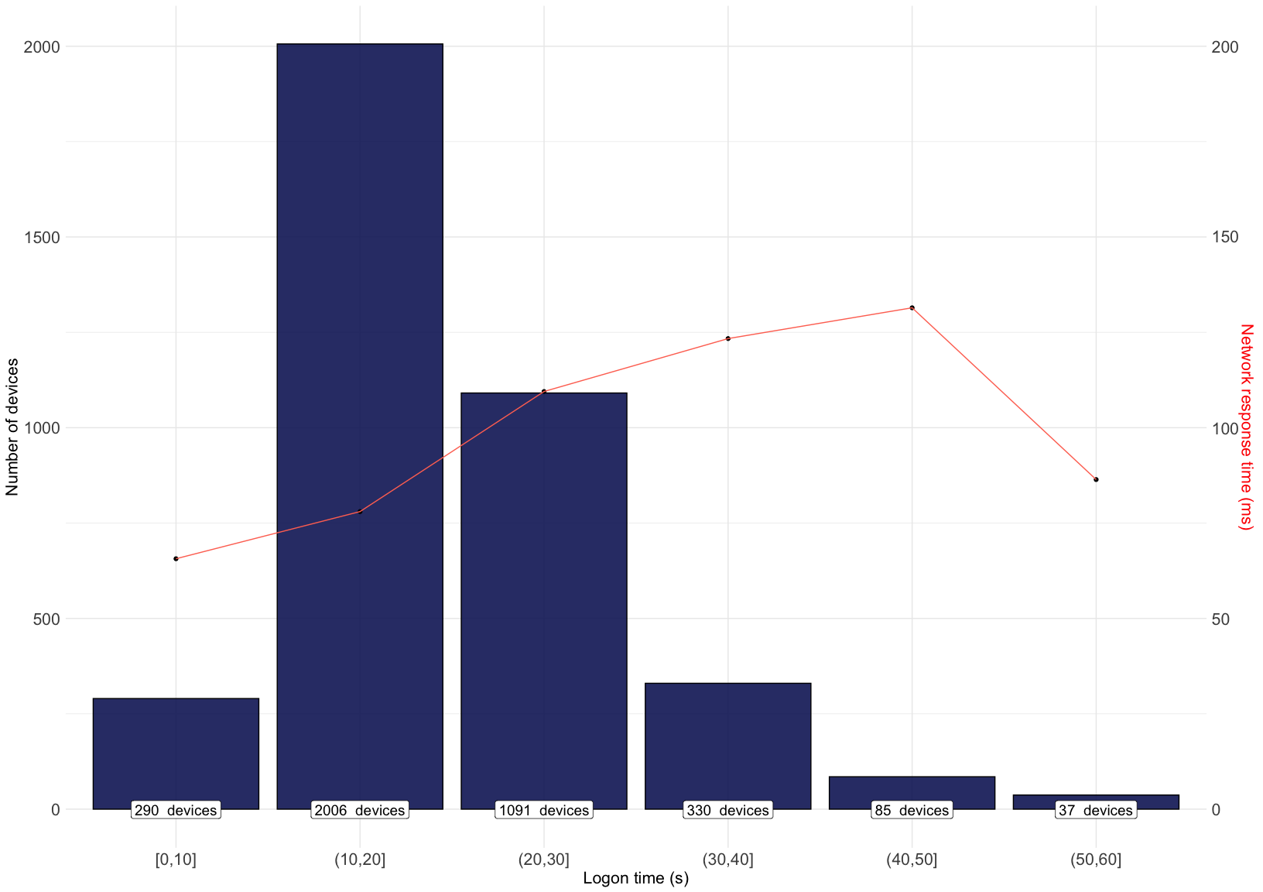

### AD Site

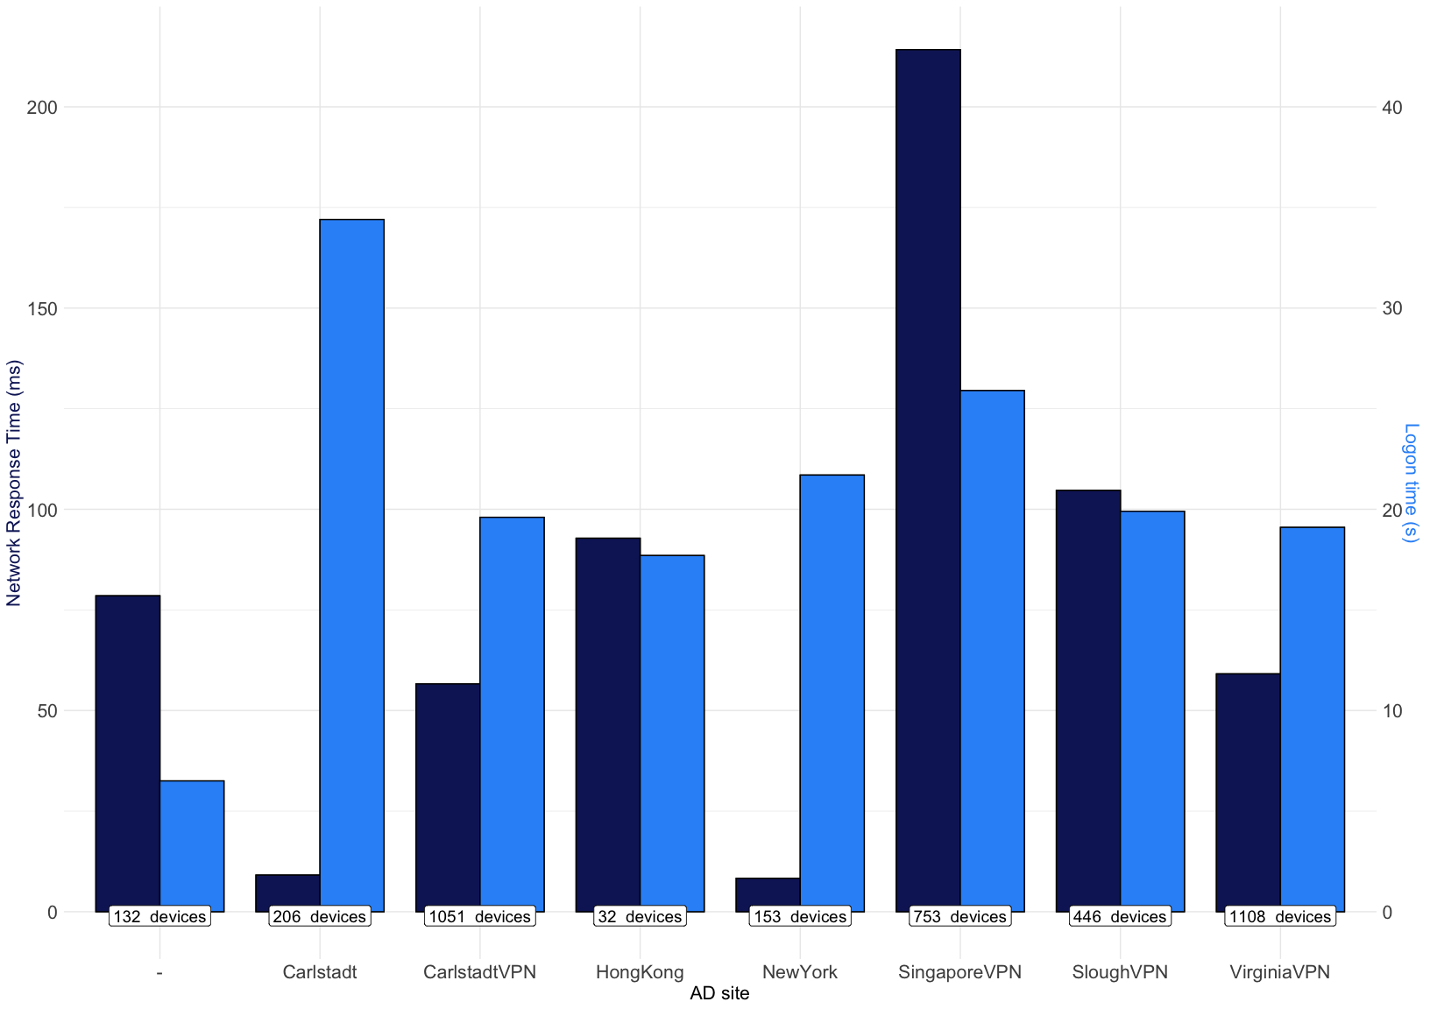

### Devices (no Lenovo)

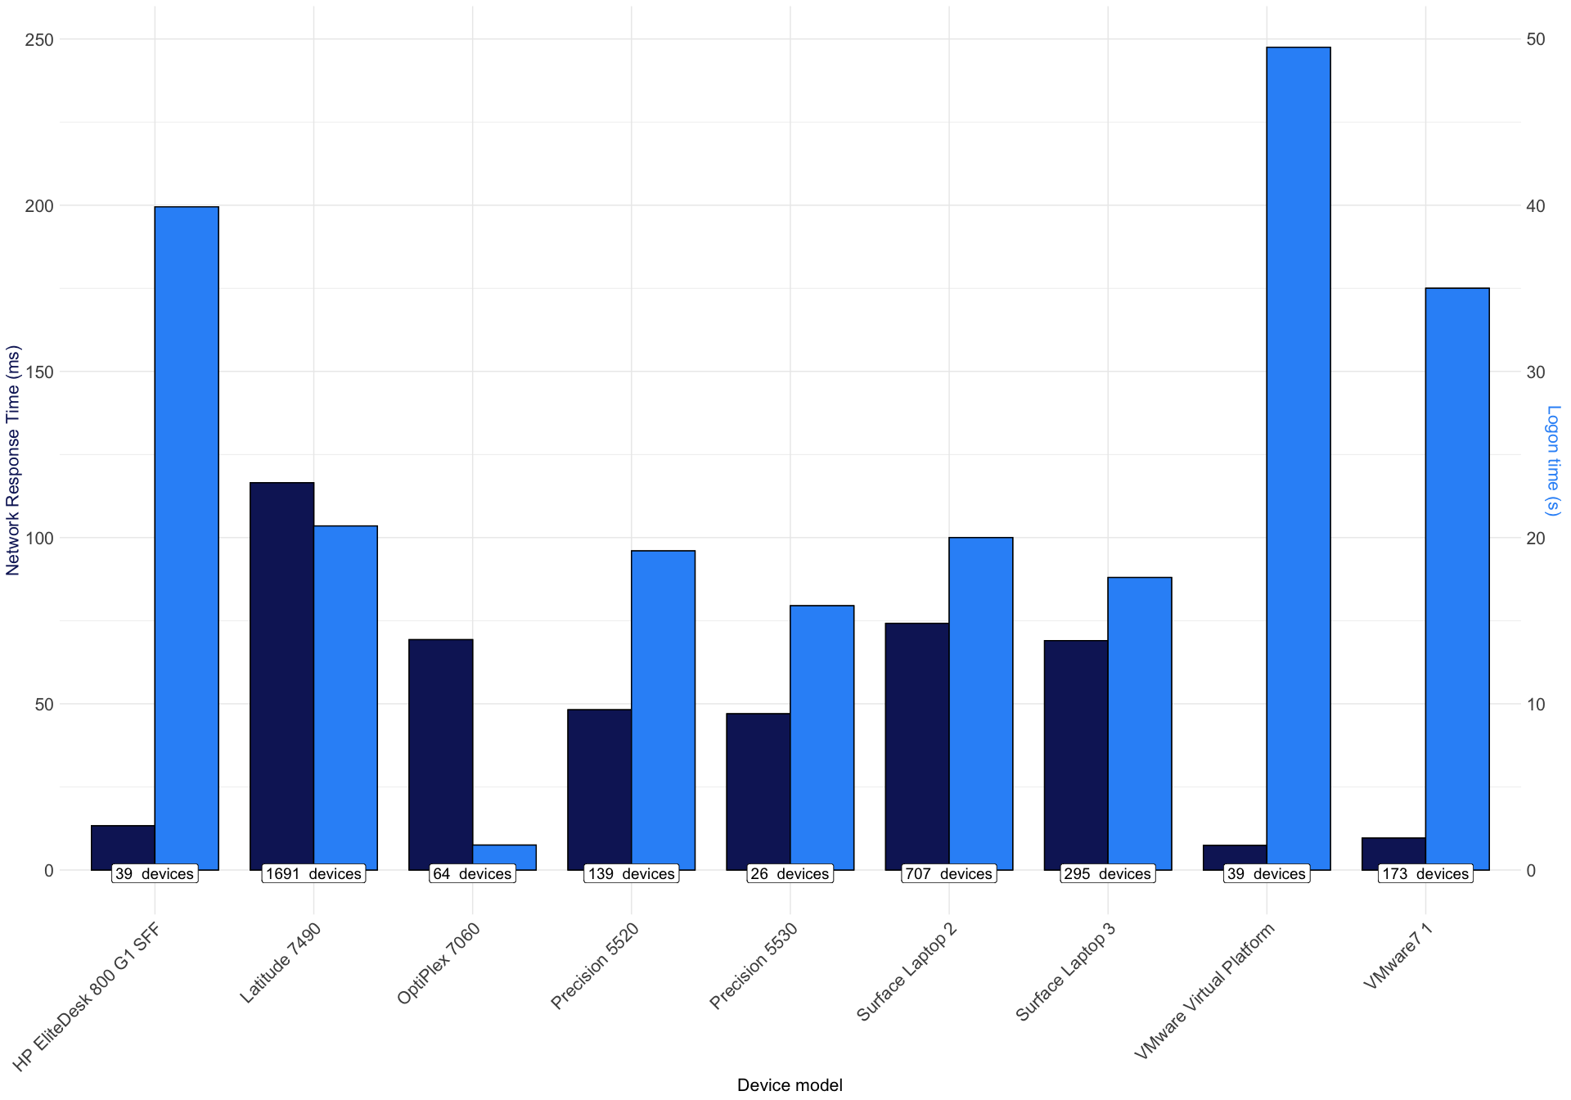

### Devices (only Lenovo)

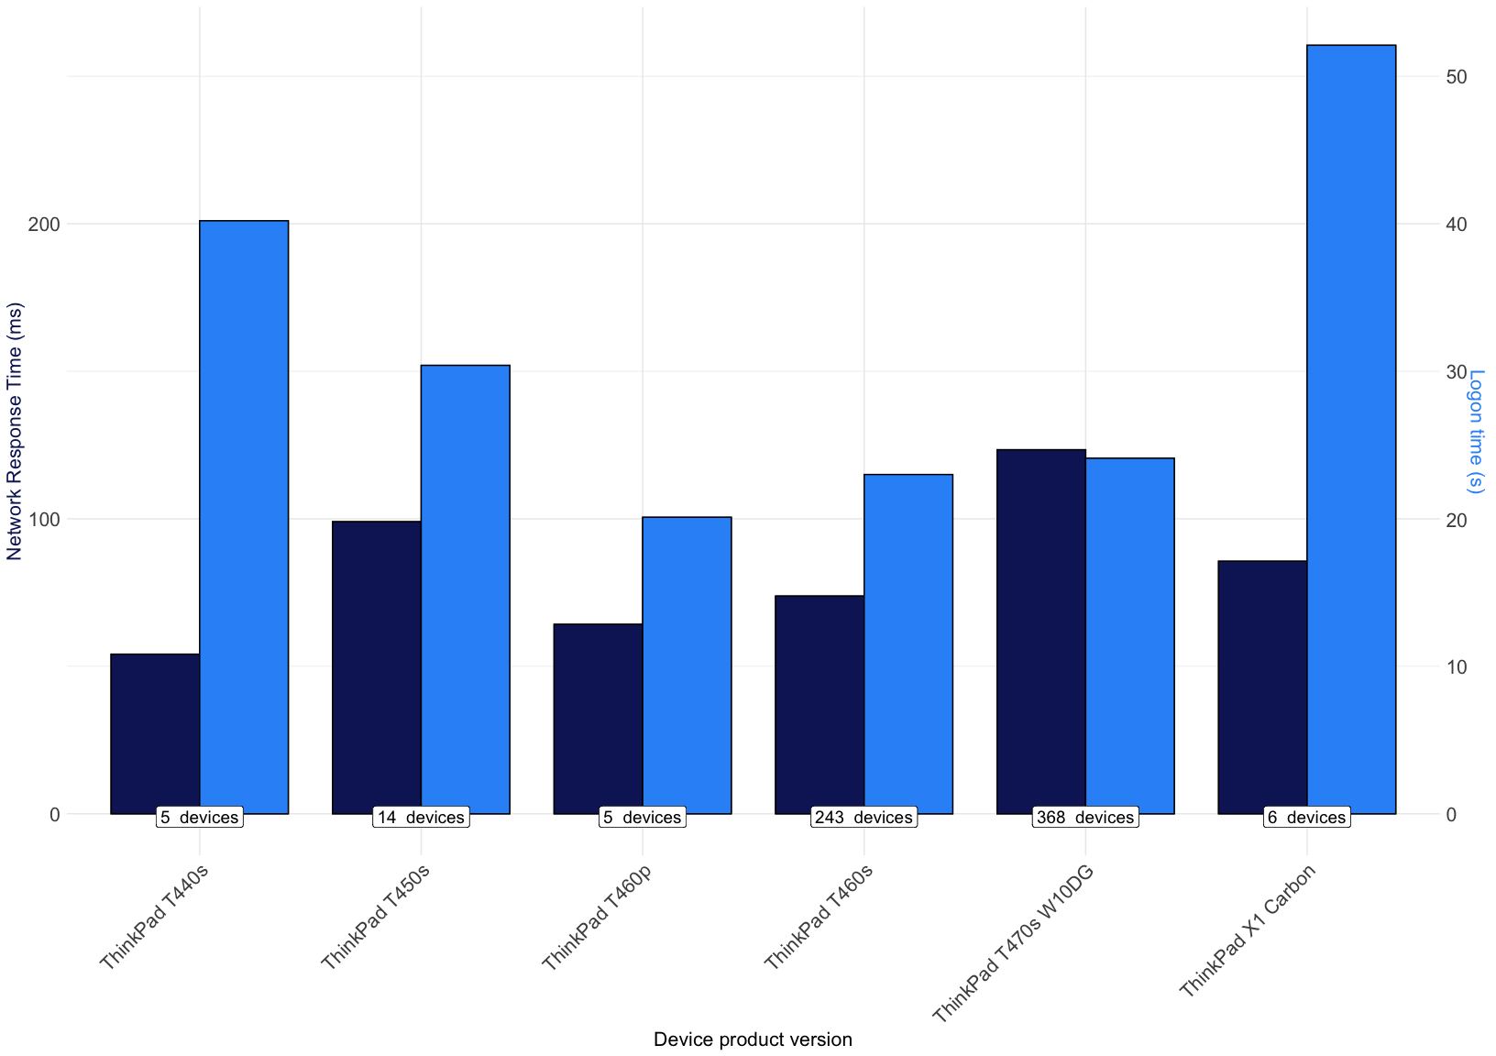

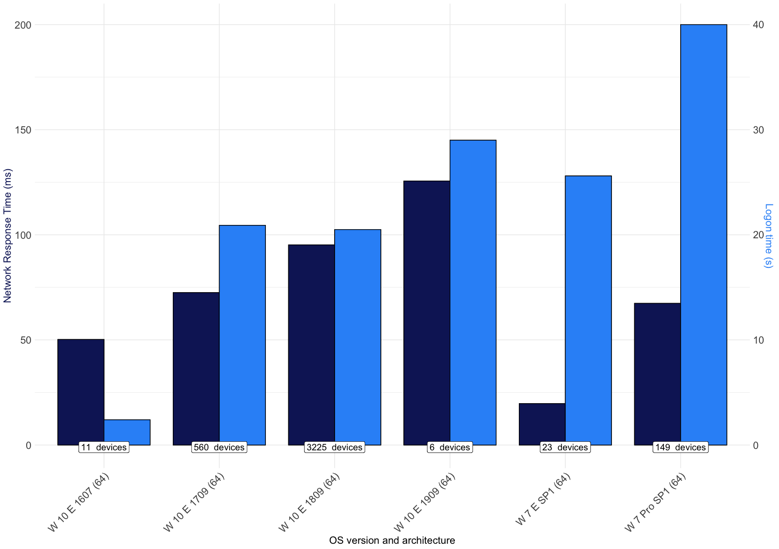

### RAM

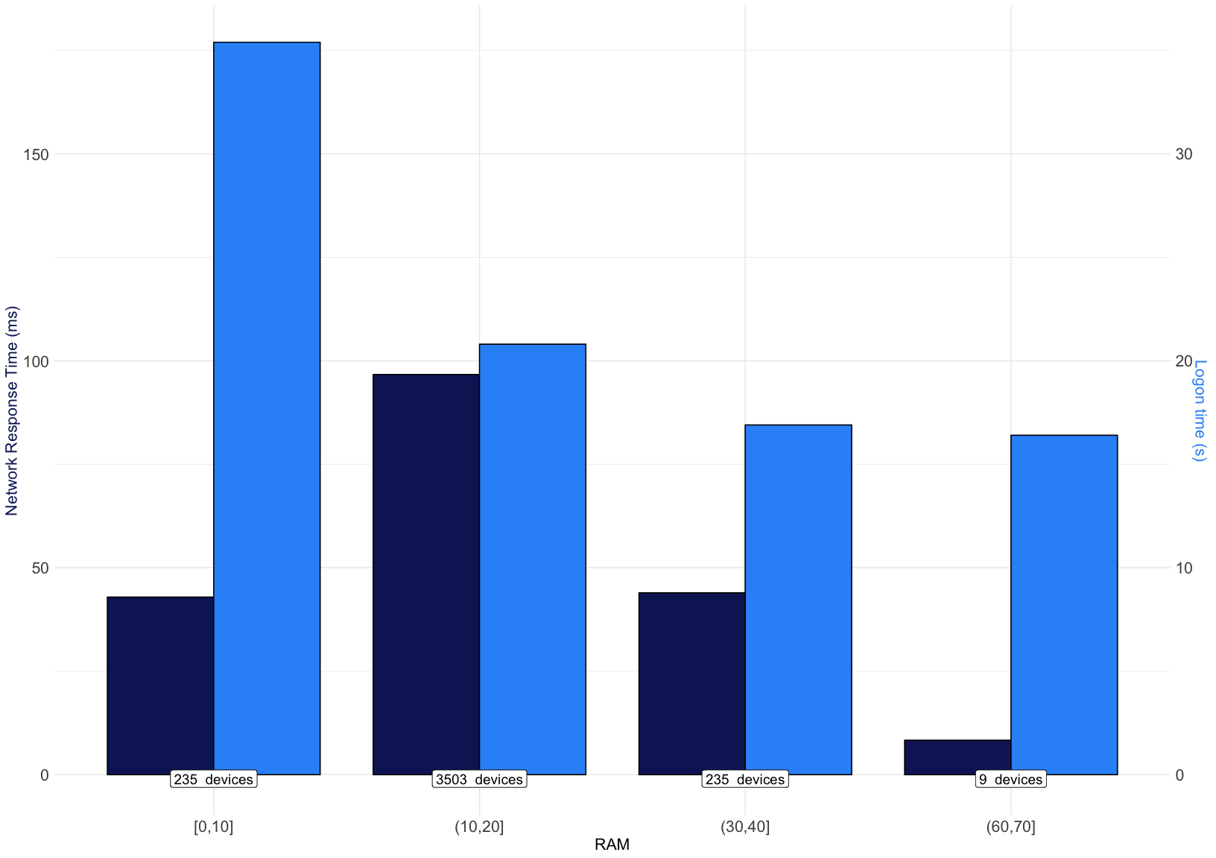

## BSOD and Hard Resets

### Hard Resets

Number of hard resets

number_of_devices

0

3475

1

406

2

56

3

29

4

9

5

6

6

2

7

1

8

1

### Crahses

Number of system crashes

number_of_devices

0

3922

1

53

2

6

3

4

## # A tibble: 9 x 5  
## `Number of hard… number_of_devic… average_ram average_crashes  
## <dbl> <int> <dbl> <dbl>  
## 1 0 3475 16 1  
## 2 1 406 17 1  
## 3 2 56 18 1  
## 4 3 29 17 2  
## 5 4 9 14 1  
## 6 5 6 15 2  
## 7 6 2 12 4  
## 8 7 1 16 0  
## 9 8 1 12 2  
## # … with 1 more variable: average_freezes <dbl>

## # A tibble: 4 x 5  
## `Number of syst… number_of_devic… average_ram average_crashes  
## <dbl> <int> <dbl> <dbl>  
## 1 0 3922 16 1  
## 2 1 53 18 3  
## 3 2 6 18 4  
## 4 3 4 20 2  
## # … with 1 more variable: average_freezes <dbl>

## Disk Space

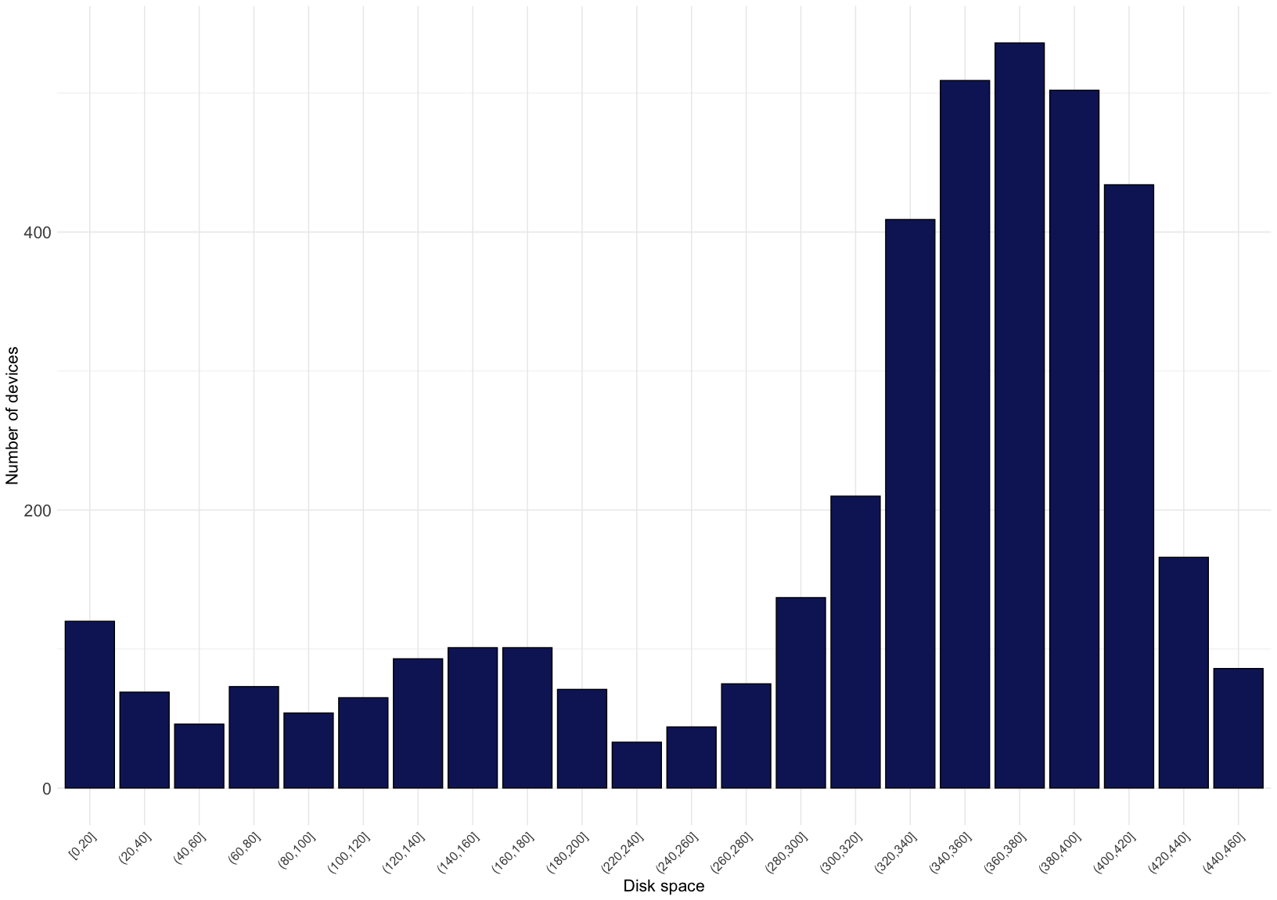

## Memory

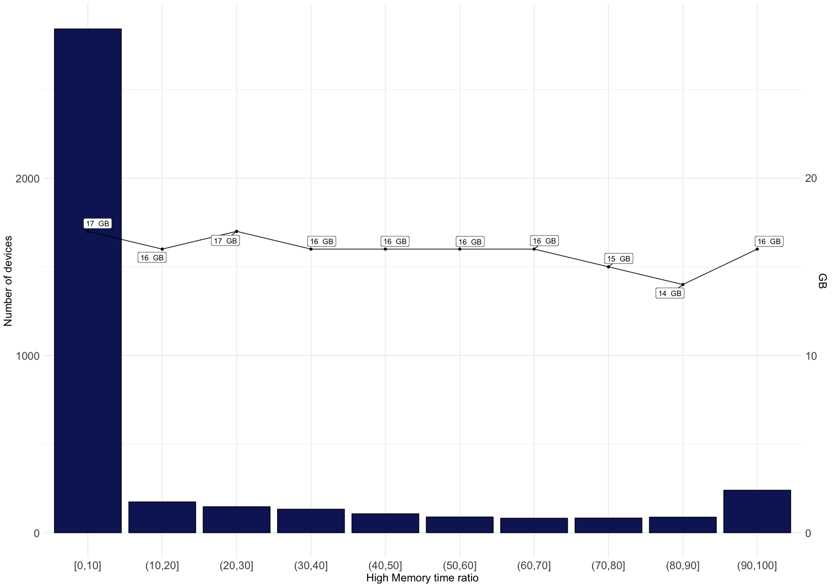

## CPU

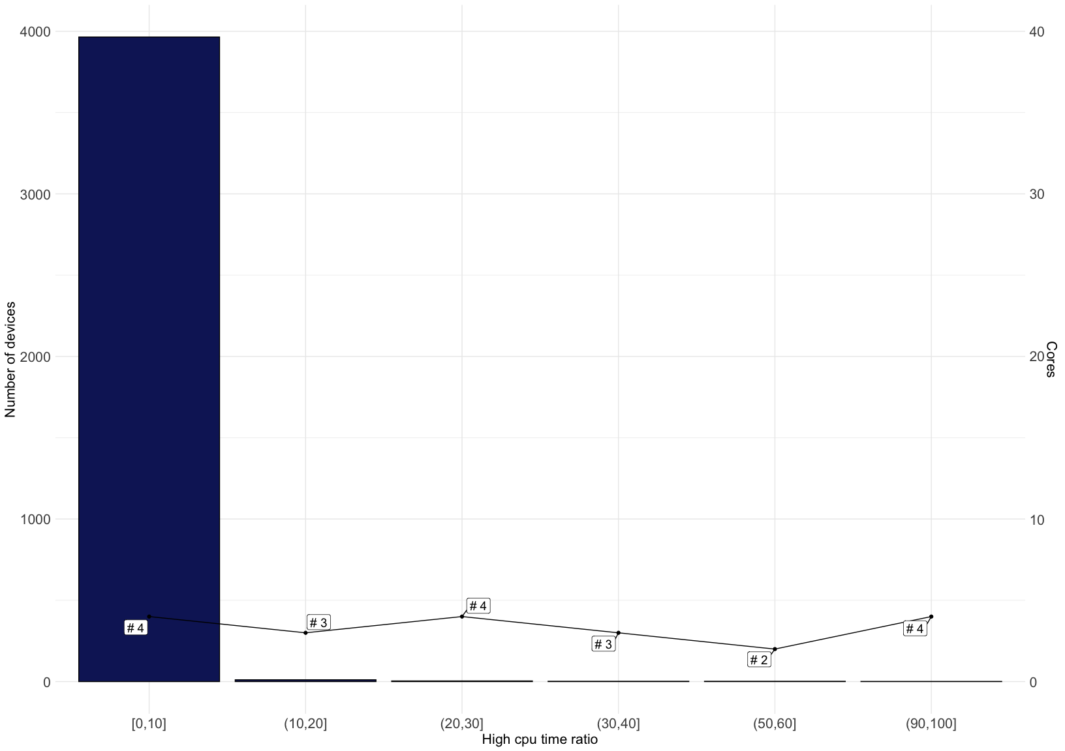

# Applications

## Overview

Application name

number_of_devices

number_of_executions

avg_memory_excecution

HedgeHog.Wpf.Client

152

1350

683.5975

Bloomberg LP wintrv

406

3405

401.2700

Hubble

120

910

342.6800

nVision Desktop

131

603

277.5070

Internet Information Services

313

4972

244.1122

Microsoft Outlook

3623

55691

209.0598

Java Platform SE 8

724

47512

191.0737

VBCSCompiler

121

1092

183.3460

Adobe Acrobat DC

1926

120522

182.0610

## High number of Excecutions

Application name

number_of_executions

avg_memory_excecution

Google Chrome

6051703

44.48237

Microsoft Office

458232

48.40932

Bloomberg LP bplus

193428

52.82500

Zoom Meetings

141769

53.00200

Adobe Acrobat DC

120522

182.06100

Microsoft Office 2010

90190

69.38460

Slack

74417

48.82300

Python

72771

61.43560

Microsoft Outlook

55691

209.05980

## Chrome

Version

Number of executions

Number of devices

Average memory usage per execution [MB]

79.0.3945.130

3838683

2345

49.74

80.0.3987.149

721818

419

43.36

78.0.3904.87

487349

339

54.06

80.0.3987.163

332431

256

40.89

80.0.3987.132

200181

115

41.45

74.0.3729.108

163164

129

43.54

73.0.3683.86

108893

75

51.34

80.0.3987.122

68500

46

41.69

81.0.4044.92

41712

28

41.89

80.0.3987.162

27264

16

42.11

78.0.3904.108

9635

10

63.04

## Office

Executable name

Version

Number of executions

Number of devices

Average memory usage per execution [MB]

excel.exe

16.0.11328.20512

35795

736

209.26

excel.exe

16.0.11328.20368

13175

313

206.52

excel.exe

16.0.11328.20512

14013

202

179.08

powerpnt.exe

16.0.11328.20512

7226

470

166.29

lync.exe

16.0.11328.20512

9366

742

155.39

excel.exe

14.0.7235.5000

18682

663

110.86

excel.exe

14.0.7015.1000

15983

569

105.06

excel.exe

14.0.7237.5000

9983

410

104.14

lync.exe

15.0.4551.1007

11832

1115

102.27

winword.exe

16.0.11328.20512

10055

646

87.96

winword.exe

16.0.11328.20368

4264

274

87.26

powerpnt.exe

14.0.6009.1000

12479

923

63.88

excel.exe

16.0.11929.20562

4230

65

42.06

winword.exe

14.0.7236.5000

4399

336

36.75

winword.exe

14.0.7015.1000

16178

925

33.80

lynchtmlconv.exe

16.0.11328.20512

6889

692

25.88

excel.exe

16.0.11929.20562

4890

115

24.60

officeclicktorun.exe

16.0.11328.20362

4912

508

20.16

officeclicktorun.exe

16.0.11328.20512

13813

1107

19.34

ucmapi.exe

16.0.11328.20512

8499

727

13.91

lynchtmlconv.exe

15.0.4551.1001

9098

1005

10.53

ucmapi.exe

15.0.4551.1007

11422

1088

8.54

sdxhelper.exe

16.0.11929.20562

5317

79

6.91

officec2rclient.exe

16.0.11328.20512

75742

1079

6.38

officec2rclient.exe

16.0.11328.20362

26900

496

6.28

officec2rclient.exe

16.0.11929.20536

14795

219

5.79

officec2rclient.exe

16.0.11328.20554

5514

147

5.75

sdxhelper.exe

16.0.11328.20368

14442

455

5.38

sdxhelper.exe

16.0.11328.20512

8256

239

5.33

sdxhelper.exe

16.0.11929.20562

10201

137

5.13

sdxhelper.exe

16.0.11328.20512

32743

810

5.04

msoia.exe

16.0.10730.20264

24628

1745

3.39

msoia.exe

16.0.11328.20362

6457

447

3.11

msoia.exe

16.0.11328.20512

12142

780

2.74

osppsvc.exe

14.0.370.400

20193

1933

2.68

### Excel

Executable name

Version

Number of executions

Number of devices

Average memory usage per execution [MB]

excel.exe

16.0.11328.20554

1159

27

214.98

excel.exe

16.0.11328.20512

35795

736

209.26

excel.exe

16.0.11328.20368

13175

313

206.52

excel.exe

16.0.11328.20368

2613

20

191.27

excel.exe

14.0.7015.1000

1722

50

185.70

excel.exe

16.0.11328.20512

14013

202

179.08

excel.exe

14.0.7235.5000

18682

663

110.86

excel.exe

14.0.7015.1000

15983

569

105.06

excel.exe

14.0.7237.5000

9983

410

104.14

excel.exe

16.0.11929.20648

1429

17

101.99

excel.exe

16.0.11929.20562

4230

65

42.06

excel.exe

16.0.11929.20562

4890

115

24.60

### Word

Executable name

Version

Number of executions

Number of devices

Average memory usage per execution [MB]

winword.exe

16.0.11328.20512

10055

646

87.96

winword.exe

16.0.11328.20368

4264

274

87.26

winword.exe

16.0.11328.20512

1476

154

60.52

winword.exe

14.0.7228.5000

1026

79

55.47

winword.exe

14.0.7246.5000

1163

61

48.78

winword.exe

14.0.7234.5000

1295

85

37.31

winword.exe

14.0.7236.5000

4399

336

36.75

winword.exe

14.0.7015.1000

16178

925

33.80

### PowerPoint

Executable name

Version

Number of executions

Number of devices

Average memory usage per execution [MB]

powerpnt.exe

16.0.11328.20512

7226

470

166.29

powerpnt.exe

16.0.11328.20368

1966

169

144.89

powerpnt.exe

14.0.7162.5000

1524

97

92.49

powerpnt.exe

14.0.6009.1000

12479

923

63.88